COLLEGE BUSINESS EDUCATION
DAR ES SALAAM

GROUP ASSIGNMENT
COURSE: BACHELOR DEGREE IN INFORMATION TECHINOLOGY.
MODULE: PROGRAMMING IN JAVA
MODULE CODE: ITU07312
FACILITATOR: Dr. AHMED KIJAZI
YEAR OF STUDY: Second Year
SEMESTER : 1st
ACADEMIC YEAR: 2025/2026
STREAM: TNC
GROUP NUMBER THREE
Date of Submitition: 2026/01/09

GROUP MEMBERS
S/N | FULL NAME | REGISTRATION NUMBER
1. | ADAM AJIDA ABDALLAH | 03.9711.01.01.2024
2. | FATMA MOHAMED MUSA | 03.9607.02.01.2024
3. | FRANCE GAUFRID FUSSY | 03.3154.01.01.2024
4. | GOODLUCK JULIUS ABRAHAM | 03.1535.02.01.2024
5. | JOSHUA M SAMWEL | 03.4813.02.01.2024
6. | REGINA CHARLES | 03.4512.02.01.2024
7. | TAITUS THOBIAS ELIAS | 03.3506.01.01.2024
8. | VICTORIA EMANUEL MBOKO | 03.3559.01.01.2022
9. | WILSON MAPE MAPANDE | 03.4228.02.01.2024
- Write a Java program to perform arithmetic operations (Addition, subtraction, multiplication, and division) on two input numbers. Your program should accept and display inputs from the interface implemented by AWT components

Answers

package com.cbe;

import java.awt.*;
import java.awt.event.*;

public class ArthimeticAWT extends Frame implements ActionListener {

// Components Declaration
TextField num1Field, num2Field, resultField;
Button addButton, subButton, multButton, divButton;

public ArthimeticAWT() {

//Frame properties
setTitle("Arithmetic Operations Using AWT");
setSize(400, 300);
setLayout(new GridLayout(5, 2, 10, 10));

//Components Initialization
Label num1Label = new Label("Enter First Number: ");
num1Field = new TextField();

Label num2Label = new Label("Enter Second Number: ");
num2Field = new TextField();

Label resultLabel = new Label("Result: ");
resultField = new TextField();
resultField.setEditable(false);

//Arithmetic Button Initialization
addButton = new Button("Addition");
subButton = new Button("Subtraction");
multButton = new Button("Multiplication");
divButton = new Button("Divition");

//Add Components to Frame
add(num1Label);
add(num1Field);
add(num2Label);
add(num2Field);
add(resultLabel);
add(resultField);
add(addButton);
add(subButton);
add(multButton);
add(divButton);

//Register Event Listeners
addButton.addActionListener(this);
subButton.addActionListener(this);
multButton.addActionListener(this);
divButton.addActionListener(this);

//Window Closing Event
addWindowListener(new WindowAdapter() {
public void windowClosing(WindowEvent we) {
dispose();
}
});

setVisible(true);

}

//Event Handling
public void actionPerformed(ActionEvent ae) {
try {
double num1 = Double.parseDouble(num1Field.getText());
double num2 = Double.parseDouble(num2Field.getText());
double result = 0;

if (ae.getSource() == addButton) {
result = num1 + num2;
} else if (ae.getSource() == subButton) {
result = num1 - num2;
} else if (ae.getSource() == multButton) {
result = num1 * num2;
} else if (ae.getSource() == divButton) {
if (num2 != 0) {
result = num1 / num2;
} else {
resultField.setText("Error: Division by Zero.");
}
}
resultField.setText(String.valueOf(result));
} catch (NumberFormatException e) {
resultField.setText("Invalid Input");
}
}

//Calling Main method
public static void main(String[] args) {
new ArthimeticAWT();
}
}

OUTPUT

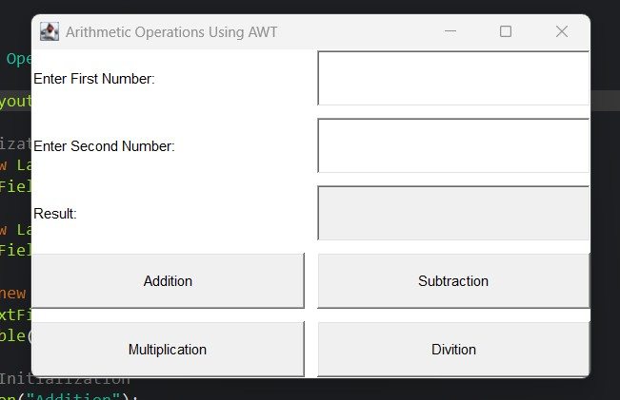

- Write a Java program to perform arithmetic operations (Addition, subtraction, multiplication, and division) on two input numbers. Your program should accept and display inputs from the interface implemented by Java Swing components

Answer
package com.cbe.swingdemo;

import javax.swing.*;
import java.awt.*;
import java.awt.event.*;

public class ArithmeticSwing extends JFrame implements ActionListener {
// Declare components
private JTextField num1Field, num2Field, resultField;
private JButton addButton, subButton, mulButton, divButton;

public ArithmeticSwing() {
// Set frame properties
setTitle("Arithmetic Operations using Swing");
setSize(400, 250);
setDefaultCloseOperation(JFrame.EXIT_ON_CLOSE);
setLayout(new GridLayout(5, 2, 10, 10));

// Initialize components
JLabel num1Label = new JLabel("Enter First Number:");
num1Field = new JTextField();

JLabel num2Label = new JLabel("Enter Second Number:");
num2Field = new JTextField();

JLabel resultLabel = new JLabel("Result:");
resultField = new JTextField();
resultField.setEditable(false);

addButton = new JButton("Addition");
subButton = new JButton("Subtraction");
mulButton = new JButton("Multiplication");
divButton = new JButton("Division");

// Add components to frame
add(num1Label);
add(num1Field);
add(num2Label);
add(num2Field);
add(resultLabel);
add(resultField);
add(addButton);
add(subButton);
add(mulButton);
add(divButton);

// Register event listeners
addButton.addActionListener(this);
subButton.addActionListener(this);
mulButton.addActionListener(this);
divButton.addActionListener(this);

// Make frame visible
setVisible(true);
}

// Event handling
public void actionPerformed(ActionEvent ae) {
try {
double num1 = Double.parseDouble(num1Field.getText());
double num2 = Double.parseDouble(num2Field.getText());
double result = 0;

if (ae.getSource() == addButton) {
result = num1 + num2;
} else if (ae.getSource() == subButton) {
result = num1 - num2;
} else if (ae.getSource() == mulButton) {
result = num1 * num2;
} else if (ae.getSource() == divButton) {
if (num2 != 0) {
result = num1 / num2;
} else {
resultField.setText("Error: Division by zero");
return;
}
}

resultField.setText(String.valueOf(result));
} catch (NumberFormatException e) {
resultField.setText("Invalid Input");
}
}

// Main method
public static void main(String[] args) {
new ArithmeticSwing();
}
}

OUTPUT

