MONEY COLLECOTOR
Game Introduction
Guiding Ozalima left and right across a city street to catch falling banknotes (+10 score) while avoiding coins (lose 1 life, −5 score). Collect 75 notes to win. Lose all 3 lives and it is game over.
The game Uses :-
Language Engine
Python 3.10+ Pygame

Goal: Collect 75 banknotes to win. Avoid coins or lose lives. Game over when all 3 lives are gone.

Requirements
- Python 3.13
- Pygame {pygame>}=2.5.0 (pip install pygame)
- Optional: asset images in an assets

Controls
Key | Actions
← Left Arrow | Move Ozalima left
→ Right Arrow | Move Ozalima right
P | Pause / Resume the game
R | Restart (only on game-over screen)
Escape | Quit the game immediately

Level System
Levels unlock automatically as Ozalima collects more banknotes. Each level increases fall speed via a speed bonus multiplier.
Note Collected | Levels | Speed Change | Banner Shown
0 – 24 | 1 | +0 | ——
25 – 49 | 2 | +2 | Level 1 Finished
50 – 74 | 3 | +4 | Level 2 Finished
75+ |  | +6 | Level 3 Won → WIN

Difficulty formula: difficulty = elapsed_seconds / 14.0
Spawn interval: max(0.30, 1.0 − difficulty×0.05 − speed_bonus×0.02)

Project Structure
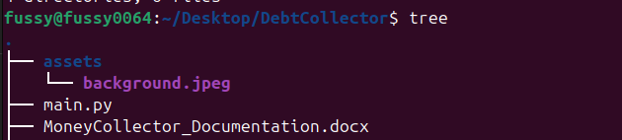

Demo Screens
