Computer Graphics - Exam Answers

Section A

Question 1 - Multiple Choice (20 marks)
i. Which of the following algorithms is used for hidden surface removal in computer graphics?
a. DDA algorithm
b. Bresenham's algorithm
c. Cohen-Sutherland algorithm
d. Z-buffer algorithm
Why: The Z-buffer stores a depth value for every pixel. When two surfaces cover the same pixel, it keeps the one closer to the camera and discards (hides) the other.
ii. In computer graphics, what does the term 'rasterization' refer to?
a. Converting vector graphics to bitmap images
b. Transforming 3D coordinates to 2D
c. Clipping polygons outside a viewing volume
d. Generating 3D primitives from 2D coordinates
Why: Rasterization takes shapes made of points, lines and polygons (vector data) and converts them into a grid of pixels (a bitmap) so they can be shown on screen.
iii. Which transformation is used to change the size of an object in computer graphics?
a. Translation
b. Rotation
c. Scaling
d. Reflection
Why: Scaling multiplies an object's coordinates by a factor, making it bigger or smaller. Translation moves it, rotation turns it, reflection mirrors it - none of these change size.
iv. Which algorithm is commonly used for anti-aliasing in computer graphics?
a. Bresenham's line algorithm
b. DDA algorithm
c. Midpoint circle algorithm
d. Xiaolin Wu's line algorithm
Why: Xiaolin Wu's algorithm smooths jagged edges by shading pixels next to the line with partial intensity, based on how close they are to the true line. Bresenham and DDA just draw solid, jagged lines.
v. In OpenGL, what does the gluPerspective function define?
a. Orthographic projection
b. Perspective projection
c. Scaling transformation
d. Rotation transformation
Why: gluPerspective sets up a viewing frustum where far objects appear smaller than near ones, which is how perspective projection mimics human vision.
vi. What is the purpose of a shader program in OpenGL?
a. To define the 3D model geometry
b. To control the rendering pipeline
c. To handle hidden surface removal
d. To define lighting equations
Why: A shader is a small GPU program that controls how vertices and pixels are processed as they move through the rendering pipeline (position, color, lighting, texture, etc.).
vii. Which of the following is a disadvantage of using the Z-buffer algorithm for hidden surface removal?
a. It requires sorting polygons
b. It consumes more memory
c. It is slower than scan-line algorithms
d. It cannot handle complex scenes
Why: The Z-buffer needs a separate depth value stored for every single pixel on the screen, which uses extra memory compared to methods that do not store per-pixel depth.
viii. Which technique is used to remove hidden surfaces in a scene where objects can overlap each other?
a. Back-face culling
b. Painter's algorithm
c. Depth sorting
d. Z-buffering
Why: Z-buffering checks the depth of every pixel independently, so it correctly handles overlapping objects no matter what order they are drawn in.
ix. What does the term 'fragment' typically refer to in computer graphics?
a. A visible portion of a polygon
b. A shaded pixel on the screen
c. A point in 3D space
d. A transformed vertex coordinate
Why: In the rendering pipeline, a fragment is the data (color, depth) generated by rasterization for a potential pixel, before it is finally written to the screen.

Question 2 - True or False (20 marks)
i. Bresenham's line algorithm is the most efficient way to draw circles in computer graphics.
Answer: False. Bresenham's line algorithm is for straight lines. Circles use the separate Midpoint (Bresenham's) circle algorithm.
ii. The model-view-projection matrix combines all the transformations needed to position an object in a 3D scene.
Answer: True. It multiplies the model matrix, view matrix and projection matrix together, so one matrix places, orients and projects the object in one step.
iii. Phong shading calculates lighting for each pixel on the screen, resulting in smoother shading compared to Gouraud shading.
Answer: True. Phong shading interpolates normals and computes lighting per pixel, giving smoother highlights than Gouraud shading, which only interpolates color from vertices.
iv. Pygame is the only graphics API used for game development on Windows.
Answer: False. Windows game development also uses DirectX, OpenGL, Vulkan and other engines/APIs. Pygame is just one simple option.
v. Z-buffering is a technique for applying textures to polygon surfaces.
Answer: False. Z-buffering is for hidden surface removal using depth values. Applying textures to surfaces is done through texture/UV mapping.
vi. UV mapping is a process of wrapping a 2D texture onto a 3D model.
Answer: True. UV mapping assigns 2D texture coordinates (U, V) to each vertex of a 3D model so a flat image can wrap correctly onto its surface.
vii. Vertex Buffer Objects (VBOs) are a core concept in both DirectX and OpenGL for managing graphical resources.
Answer: False. VBO is an OpenGL-specific term. DirectX uses its own equivalent called a vertex buffer, not called 'VBO'.
viii. Orthographic projection creates a realistic perspective view where objects appear smaller further away.
Answer: False. That describes perspective projection. Orthographic projection keeps object size the same no matter the distance, so it looks less realistic but keeps true proportions.
ix. Subsurface scattering is a shading technique that simulates light bouncing just beneath the surface of a material.
Answer: True. Subsurface scattering models how light enters a material (like skin or wax), scatters inside it, and exits at a different point, giving a soft, glowing look.
x. Clipping removes geometry that is outside the viewing frustum, improving rendering performance.
Answer: True. Clipping discards parts of a scene outside the camera's view before rendering, so the GPU does not waste time drawing things you cannot see.
xi. The process of creating a series of images or frames that, when played in sequence, gives the illusion of movement.
Answer: True. This is the basic definition of animation - our eyes blend a fast sequence of still frames into perceived motion.
xii. Animation software can be used to create only 2D animations.
Answer: False. Modern animation software (like Blender, Maya) supports both 2D and 3D animation.
xiii. In 2D animation, keyframes define the start and end points of an animation sequence.
Answer: True. Keyframes mark the important poses/positions in an animation; the frames between them are filled in afterward.
xiv. The process of creating the animation frames that occur between keyframes is called in-betweening.
Answer: True. In-betweening (or 'tweening') is exactly the process of generating the frames that connect one keyframe to the next.
xv. Animators use timing sheets to plan out the timing and movement of an animation.
Answer: True. A timing/exposure sheet lists frame-by-frame timing so animators know exactly when each action and sound should happen.
xvi. 3D animation involves creating environments that appear three-dimensional.
Answer: True. 3D animation builds models and scenes with depth (x, y, z), which is what makes them look three-dimensional.
xvii. The animation principle of follow-through ensures that an action continues after the main action has finished.
Answer: True. Follow-through means parts of a character (like hair or clothing) keep moving briefly after the main body stops, making motion feel natural.
xviii. The technique of drawing every frame to create fluid motion is called frame-by-frame animation.
Answer: True. Frame-by-frame animation means every single frame is drawn individually, rather than generated automatically between keyframes.
xix. The animation principle of squash and stretch makes an object or character follow the laws of physics.
Answer: False. Squash and stretch actually exaggerates shape changes beyond real physics to emphasize weight, speed and flexibility - it is a stylized effect, not strict physical accuracy.
xx. Rigging is the process of creating a skeleton for a 3D model to control its movement.
Answer: True. Rigging builds a bone/joint structure (skeleton) inside a 3D model so animators can pose and move it easily.

Question 3 - Matching (15 marks)
A few matches below are my best judgement, since this page of the photo was harder to read clearly.
i. Which algorithm is commonly used for drawing lines efficiently?
Answer: Bresenham's line algorithm. It uses only integer addition/subtraction (no division or floating point), making it fast and efficient for drawing straight lines pixel by pixel.
ii. Which transformation matrix combines translation, rotation and scaling?
Answer: Model-view-projection matrix. This matrix is built by multiplying the model, view and projection matrices, so it carries all three transformations in one matrix.
iii. Which technique calculates the intensity of light at each vertex and interpolates across the surface?
Answer: Gouraud shading. Gouraud shading computes lighting only at the vertices, then blends (interpolates) those colors smoothly across each polygon face.
iv. Which API is commonly used for game development on Windows?
Answer: Direct3D. Direct3D is part of Microsoft's DirectX suite, built specifically for Windows game and graphics development.
v. What method ensures that only visible surfaces are rendered in a 3D scene?
Answer: Z-buffering. It stores per-pixel depth and only keeps the closest surface at each pixel, so hidden surfaces behind others are not drawn.
vi. How is texture mapping applied to polygon surfaces?
Answer: UV mapping. UV mapping gives each vertex a 2D coordinate that tells the renderer exactly which part of the texture image belongs on that part of the surface.
vii. What is used to manage graphical resources such as textures and buffers in DirectX?
Answer: Vertex Buffer Object (VBO). Buffer objects store vertex, texture and other resource data on the GPU so it can be reused efficiently during rendering.
viii. Which projection maintains the size and shape of objects regardless of their distance from the viewer?
Answer: Orthographic projection. Orthographic projection uses parallel projection lines, so objects do not shrink with distance, keeping their true size and shape.
ix. What technique enhances the appearance of curved surfaces by simulating the reflection of light?
Answer: Lambertian shading. Lambertian (diffuse) shading models how light reflects evenly off a matte curved surface based on the angle between the light and the surface normal.
x. What algorithm optimizes rendering performance by discarding non-visible polygons?
Answer: Back-face culling. It checks which way a polygon is facing and skips drawing polygons that face away from the camera, since they cannot be seen.
xi. Which method is used to remove hidden surfaces in a scene where objects can overlap each other?
Answer: Scanline algorithm. The scan-line method processes the scene one horizontal line at a time, working out which surface is visible at each point along that line.
xii. What type of shading calculates color values at each pixel rather than at vertices?
Answer: Phong shading. Phong shading interpolates the surface normal across each pixel and computes lighting per pixel, unlike Gouraud which only works per vertex.
xiii. Which algorithm is used for converting 3D scenes into 2D images by projecting vertices onto a plane?
Answer: Rasterization. Rasterization takes the projected 2D vertex positions and fills in the pixels to turn the 3D scene into a flat image.
xiv. What is used to define the position and orientation of a virtual camera in a 3D scene?
Answer: View matrix. The view matrix transforms world coordinates into camera (eye) space, effectively representing where the camera is and which way it is looking.
xv. Which technique simulates the effect of light scattering through semi-transparent objects?
Answer: Subsurface scattering. It models light entering a translucent material, bouncing around inside, and exiting elsewhere, which is how light appears to scatter through it.
xvi. What technique reduces jagged edges in computer graphics?
Answer: Anti-aliasing. Anti-aliasing blends the color of edge pixels with their surroundings, softening the stair-step look of diagonal or curved lines.
xvii. Which method is used to limit the rendering to a specified region?
Answer: Clipping. Clipping cuts away any geometry outside a defined boundary (like the screen or viewing frustum) so only the region inside is rendered.
xviii. What algorithm is used for rendering smooth shaded surfaces?
Answer: Phong shading. Because it shades per pixel using interpolated normals, Phong shading produces the smoothest highlights and curved-surface look of the common shading models.
xix. Which API is commonly used for cross-platform 3D graphics development?
Answer: OpenGL. OpenGL is supported across Windows, macOS, Linux and more, making it a standard choice when an application needs to run on multiple platforms.
xx. What algorithm is used for efficiently drawing circles?
Answer: Bresenham's algorithm (circle version). The midpoint/Bresenham circle algorithm uses the same kind of integer decision-parameter logic as the line algorithm, adapted to plot circles efficiently.

Section B

Question 4
a) Ten main features of Blender (12 marks)
- Modeling tools - box modeling, mesh editing, modifiers
- Sculpting - digital sculpting for organic shapes
- UV unwrapping and texture painting
- Node-based shader/material editor
- Rigging and animation tools (armatures, keyframes)
- Physics simulation - cloth, fluid, smoke, rigid body
- Particle system for hair, sparks, crowds, etc.
- Two render engines - Eevee (real-time) and Cycles (ray-traced)
- Video sequence editor for basic video editing
- Grease Pencil for 2D animation inside a 3D workspace
- Python scripting API to write add-ons and automate tasks
- Camera and motion tracking for VFX
b) Four types of reflection transformations (8 marks)
Reflection flips a shape across a line or point, like a mirror image. Below are four common types with a diagram for each.
1. Reflection about the X-axis - every point (x, y) becomes (x, -y).
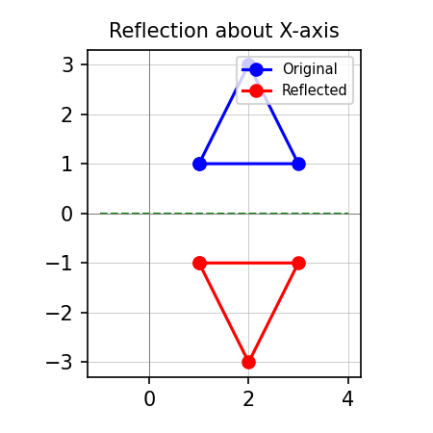
2. Reflection about the Y-axis - every point (x, y) becomes (-x, y).
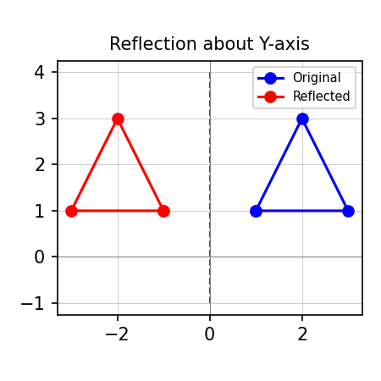
3. Reflection about the origin - every point (x, y) becomes (-x, -y).
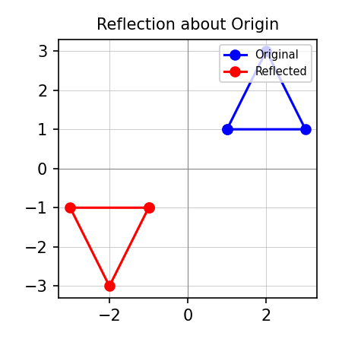
4. Reflection about the line y = x - every point (x, y) becomes (y, x).
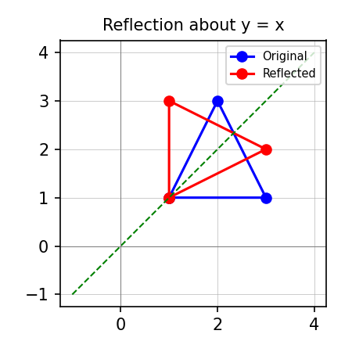

Question 5
a) Privacy and security in AR/VR (10 marks)
AR and VR headsets collect a lot of personal data, which raises privacy and security concerns:
- Biometric data - eye tracking, facial expressions, hand and body movement can identify a person uniquely.
- Spatial mapping - devices scan a user's home or workplace, revealing private layouts.
- Always-on cameras and microphones - risk of unauthorized recording of the user or bystanders.
- Third-party data sharing - apps may sell behavioural data to advertisers.
- Account and device hacking - stolen login credentials can expose personal spaces and data.
- Physical safety - a hacked headset can disorient a user in the real world.
Measures to address these issues:
- Encrypt data both on the device and during transmission.
- Process sensitive data (like eye tracking) on the device instead of sending it to the cloud.
- Ask for clear user consent before collecting biometric or spatial data.
- Give users control to delete or limit data collection.
- Use strong authentication (PIN, biometrics) to lock the headset.
- Keep software updated to patch security holes.
- Sandbox apps so one app cannot access another app's data.
b) Bresenham's Line Algorithm in Python (10 marks)
def bresenham_line(x0, y0, x1, y1):
"""
Draws a line from (x0,y0) to (x1,y1) using Bresenham's algorithm.
Works for all 8 octants (any direction).
"""
points = []

dx = abs(x1 - x0) # distance to travel in x
dy = abs(y1 - y0) # distance to travel in y

sx = 1 if x1 > x0 else -1 # step direction on x-axis
sy = 1 if y1 > y0 else -1 # step direction on y-axis

x, y = x0, y0

if dx > dy:
# line is more horizontal -> step x each time, decide when to step y
err = dx / 2.0
while x != x1:
points.append((x, y))
err -= dy
if err < 0: # decision parameter says move y too
y += sy
err += dx
x += sx
else:
# line is more vertical -> step y each time, decide when to step x
err = dy / 2.0
while y != y1:
points.append((x, y))
err -= dx
if err < 0: # decision parameter says move x too
x += sx
err += dy
y += sy

points.append((x1, y1)) # include the final point
return points

# Example run / output
if __name__ == "__main__":
line_points = bresenham_line(2, 2, 8, 5)
print("Pixel coordinates:")
for pt in line_points:
print(pt)

Sample output (for points (2,2) to (8,5)):
Pixel coordinates:
(2, 2)
(3, 2)
(4, 3)
(5, 3)
(6, 4)
(7, 4)
(8, 5)

