Topology
Topology requirements

IP planning
Segment | Network | Gateway
VLAN 10 = IT | 192.168.10.0/24 | 192.168.10.1
VLAN 20 = Marketing | 192.168.20.0/24 | 192.168.20.1
WAN link R1 to R-ISP | 200.200.200.0/30 | R1=.1 / R-ISP=.2
Internet server | 8.8.8.0/24 | 8.8.8.1 (on R-ISP)

End Devices IP planning
Devices | IP address | Mask | Gateway
PC1 | 192.168.10.10 | /24 | 192.168.10.1
PC2 | 192.168.10.11 | /24 | 192.168.10.1
Server0 | 192.168.10.20 | /24 | 192.168.10.1
PC3 | 192.168.20.10 | /24 | 192.168.20.1
PC4 | 192.168.20.11 | /24 | 192.168.20.1

DNS = 8.8.8.8
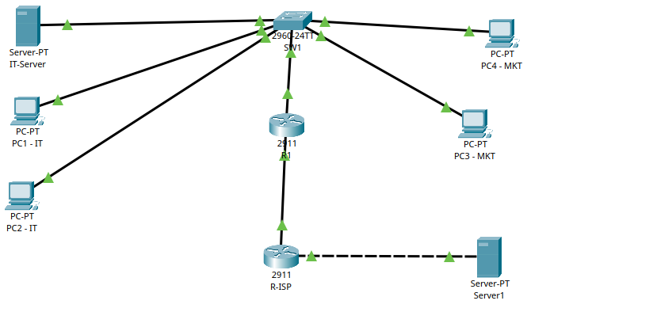

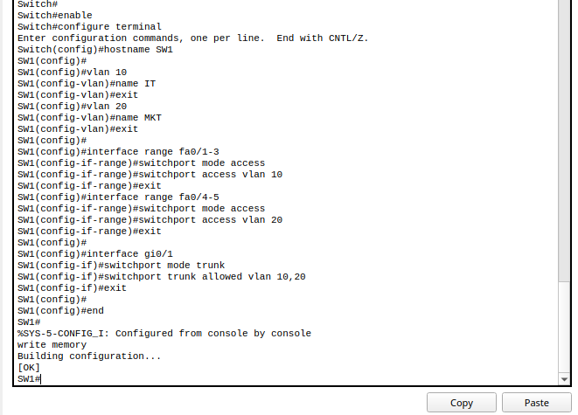
Switch (SW1) Configuration

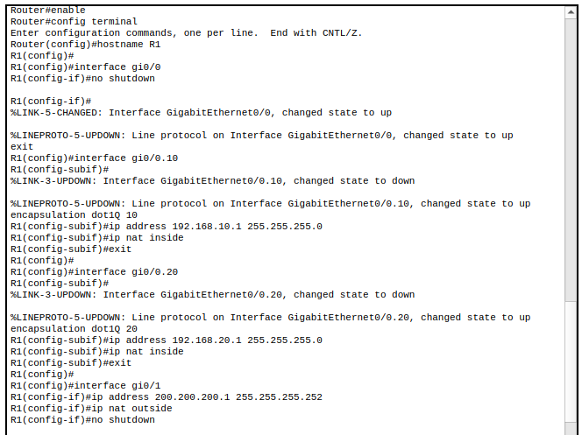
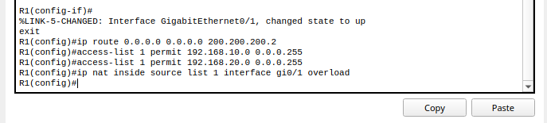
Router (R1) Configuration

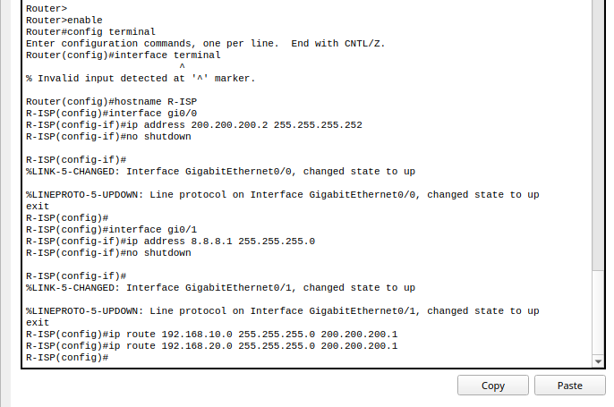
R-ISP Configuration

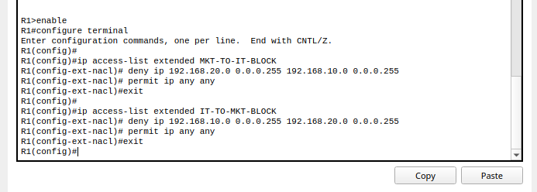
Extended ACL Configuration on R1
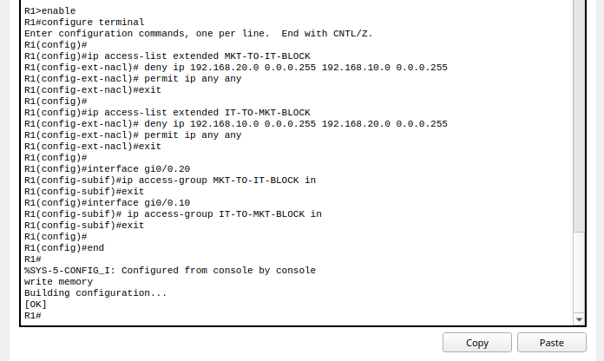

Verifying ACL
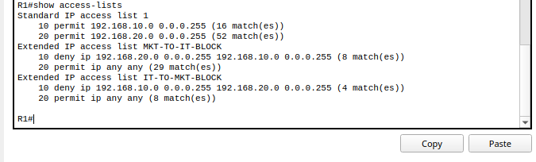

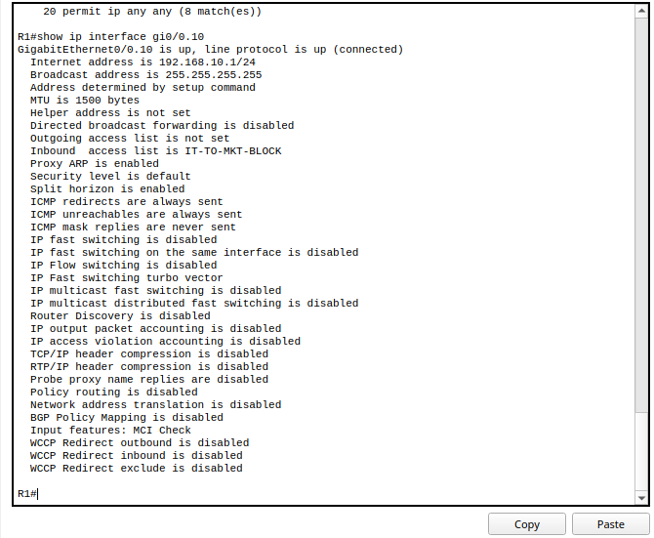
Confirms Inbound access list is IT-TO-MKT-BLOCK

Ping Verification for The Topology

