AWS DEPLOYMENT GUIDE

1. Launch the EC2 instance
- EC2 console → Launch instance
- AMI: Ubuntu Server 24.04 LTS
- Instance type: t2.micro / t3.micro is enough for this app
- Key pair: create/select one (you'll need the .pem to SSH in)
- Security group — allow:
  - SSH (22) — restrict to your IP if possible
  - HTTP (80) — anywhere
  - HTTPS (443) — anywhere (for later, once you add SSL
6. Launch, then note the public IPv4 address
16.170.204.159 => Public IP
Connect:

Prompt: Are you sure you want to continue connecting (yes/no/[fingerprint])? Yes

2. Install Apache, PHP, and MySQL

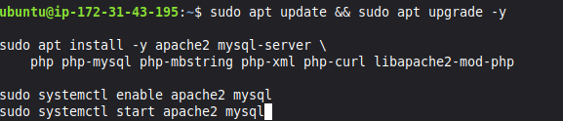
Secure MySQL (sets root password, removes test DB, etc.):

Prompt: Press y|Y for Yes, any other key for No: No
Remove anonymous users? (Press y|Y for Yes, any other key for No) : No
Disallow root login remotely? (Press y|Y for Yes, any other key for No) : Y

Remove test database and access to it? (Press y|Y for Yes, any other key for No) : No

Reload privilege tables now? (Press y|Y for Yes, any other key for No) : No

3. Create the app's database user

CREATE USER 'busapp'@'localhost' IDENTIFIED BY 'Fussy0906'
GRANT ALL PRIVILEGES ON bus_booking_system.* TO 'busapp'@'localhost';
FLUSH PRIVILEGES;
EXIT;

4. Clone the repo to the Server-side

5. Import the schema

CREATE USER 'busapp'@'localhost' IDENTIFIED BY 'Fussy0906'
GRANT ALL PRIVILEGES ON bus_booking_system.* TO 'busapp'@'localhost';
FLUSH PRIVILEGES;
EXIT;

sudo nano /etc/apache2/sites-available/ticketbooking.conf

<VirtualHost *:80>
ServerName 16.170.204.159
DocumentRoot /var/www/TicketBooking-System/public

<Directory /var/www/TicketBooking-System/public>
AllowOverride All
Require all granted
</Directory>

ErrorLog ${APACHE_LOG_DIR}/ticketbooking_error.log
CustomLog ${APACHE_LOG_DIR}/ticketbooking_access.log combined
</VirtualHost>

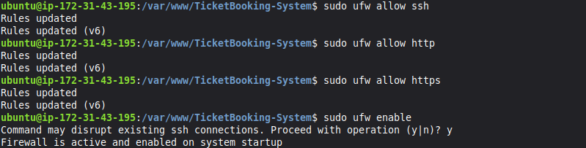

sudo nano /etc/mysql/mysql.conf.d/mysqld.cnf

