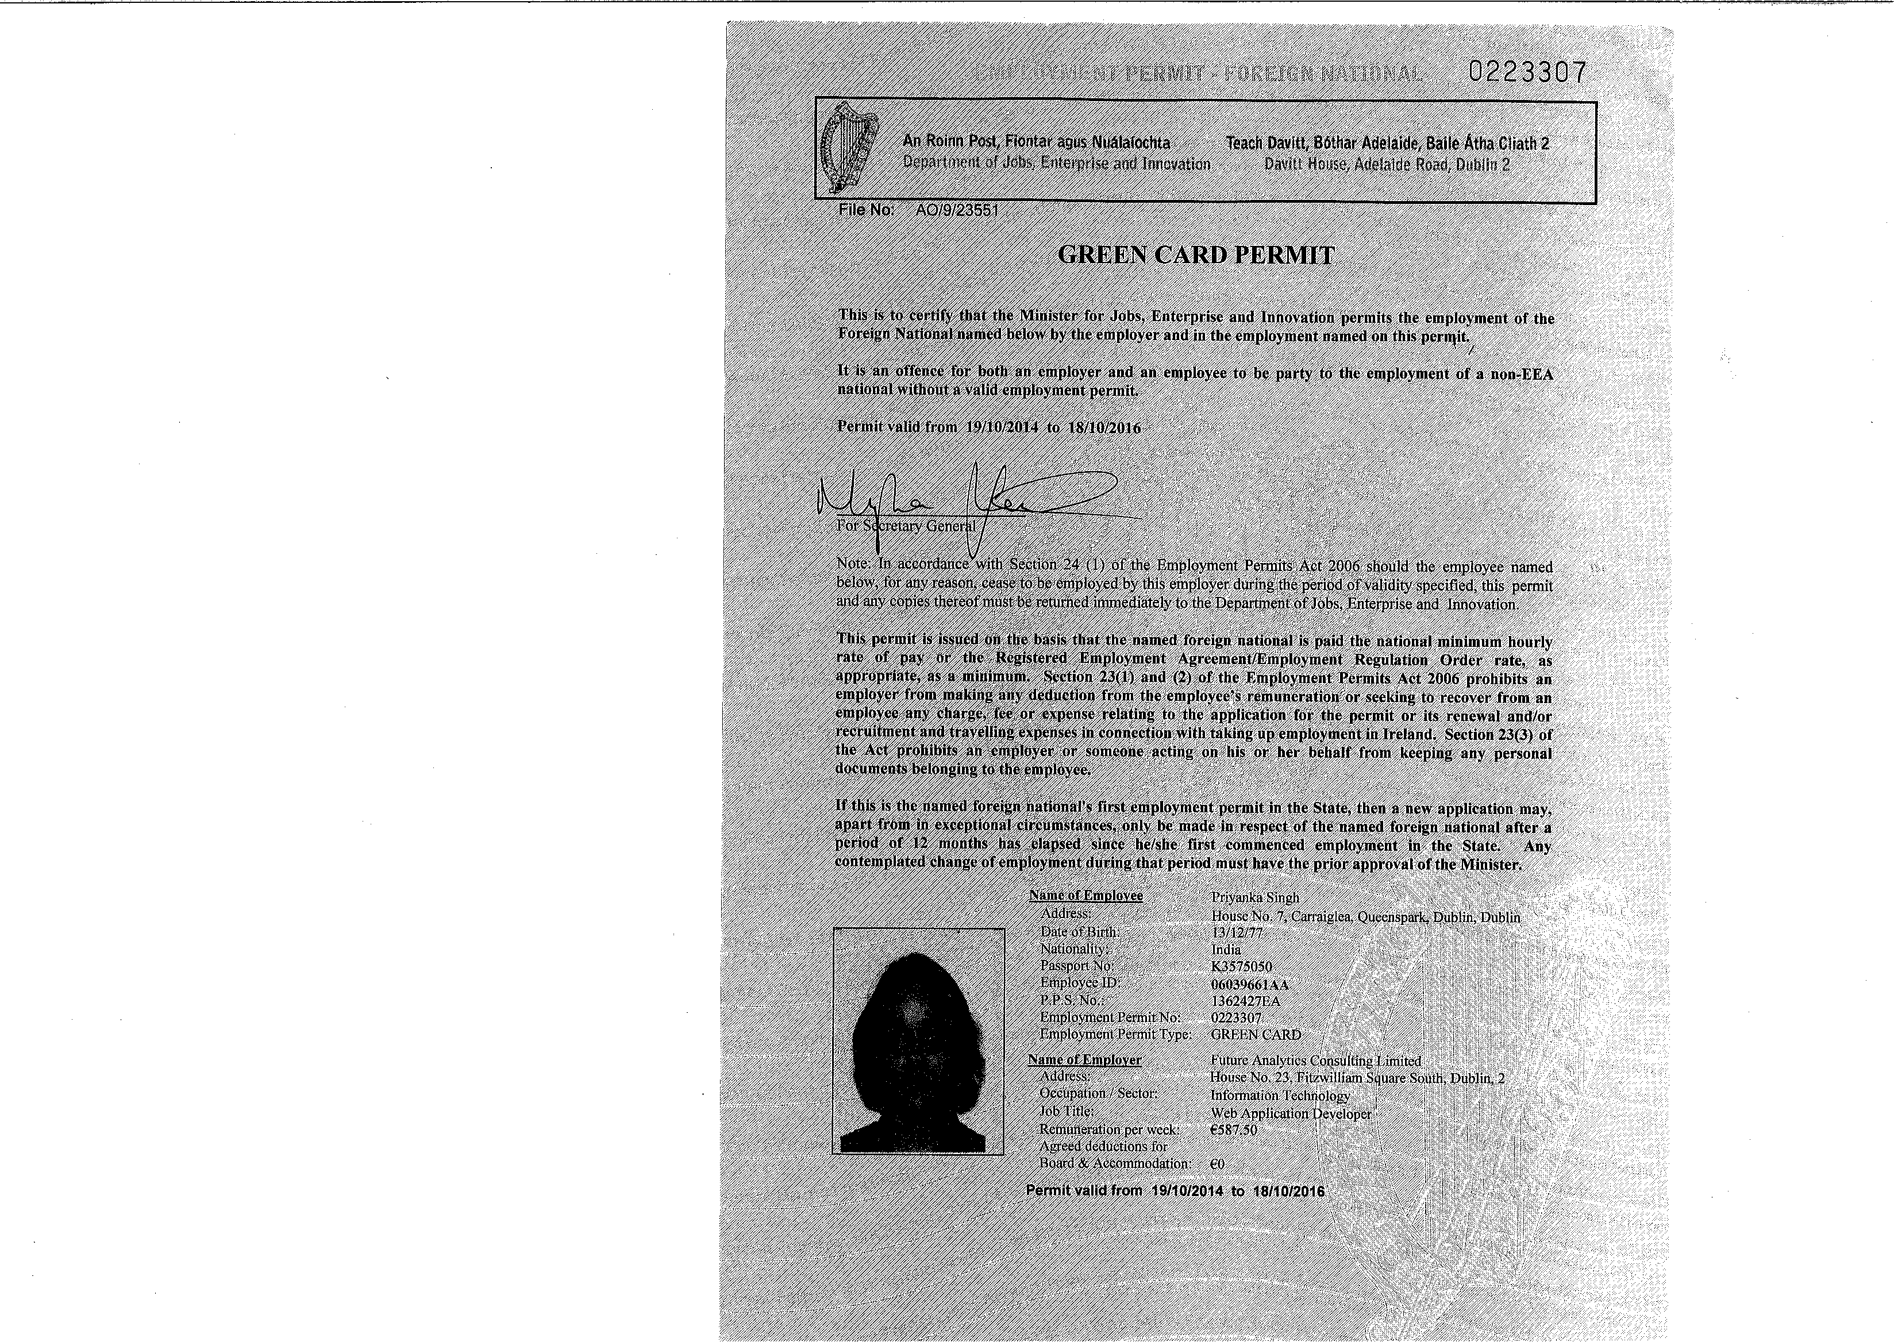

FutureAnalytics
1
Planning • Research • Economics
9 23 Fitzwilliam Square CS:·:·': 0_::)_" 2 i·,:,.a .::;
f_9 Tel: +353 (O) 1639 483E; Fax: +353 (D) 1554 733·!.
Q info@futureanalytics.ie .v. ·;, f ..:L•sa··.c - ::1s

Ms. Priyanka Singh
House no 7
Carraiglea
f I
Queenspark
Monkstown Road
Co. Dublin.

19 May 2014

CONFIDENTIAL: Contract of employment

Priyanka,

I am very pleased to set out below the terms and conditions of your employment with Future Analytics
Consulting Limited (the Company) trading as Future Analytics Consulting (FAC).

1. Commencement date: The date of commencement of this contract shall be 19 May 2014.

2. Position: Your position within the Company shall be that of: Web Application Developer.

3. Duties: The duties you will be expected to perform within the Company will be those generally associated with the position of a Web Application Developer within a professional planning, research and economic consultancy. You will be required to report to the Directors of the Company, to liaise closely with staff in the company, and to carry out the duties and tasks allocated to you in a timely and professional manner. You will be required to be flexible in this position and will be expected to undertake such other works or tasks as may be assigned to you by the Company from time to time.

In addition to discharging the assignments allocated to you, you are expected to actively promote the Company's services in order both to maintain the existing client base of the Company and where possible develop new clients and sources of work for the Company.

You must devote the whole of your time, attention and abilities during your hours of work for the Company to the tasks and duties assigned to you by the Company and shall not under any circumstances undertake any other duties of any kind during this time.

You shall not engage in work similar to that undertaken by the Company outside of working hours without the express written permission of the Company.

Since all matters aris!ng from your work with the Company are confidential you are required to maintain in strict confidence all matters pertaining to the Company and its clients.

4. Remuneration: Your remuneration will be €24,000.00 gross per annum (subject to successful completion of the probationary period set out in '23' below). This will be paid monthly in arrears on the last working day of each month by electronic transfer to a bank account nominated by you.

Supplementary inclusion (01 September 2014): Your remuneration will be €30,000.00 gross per annum, commencing 01September 2014.

• • - • • ICS

Your salary will be reviewed annually in line with your own performance and the overall performance of the Company. A bonus may be paid each year strictly at the discretion of the Company based on criteria decided by the Company.

Travelling or other expenses incurred by you in the performance of your duties for the Company will be paid on receiptby the Company of appropriate documentation and receipts which must be submitted by the lOth day of each month. It should be noted that all expenditure of this nature which may be presented by you to the Company for reimbursement must be agreed with the Company in advance of the expenditure being
incurred.
! I

Relevant professional fees will be paid by the Company but you should note that any such fees must be disclosed to the Company in advance.

5. Retirement: Your employment with the Company will cease, without notice, at the end of the month in which your 651 birthday occurs, or in accordance with relevant amendments to legislation in this respect.
h

6. Place af work: Your normal place of work shall be 23 Fitzwilliam Square (South), Dublin 2. However it is a fundamental condition of your employment by the Company that you shall carry out your work at whatever place or site or client premises that the Company may from time to time designate on either a temporary or permanent basis.

7. Hours of work: The normal offices hours are from 9.00hrs to 13.00hrs and from 14.00hrs to 17.30hrs Monday to Friday inclusive. However, and as you have already been made aware, you will from time to time be required to work outside of these hours. Allowance has already been made for this commitment in the calculation of your remuneration.

By signing this contract you acknowledge that you are responsible for determining the duration of your working time and that Part II of the Organisation of Working Time Act 1997 does not apply to your employment with the Company.

You are entitled to a daily break for lunch between 13.00hrs and 14.00hrs each day.

8. Holidays: You are entitled to 22 days annual leave in additional to statutory public holidays. The holiday year runs from 1January to 31December each year. Annual leave entitlement shall accrue at the rate of 1.83 days per calendar month of service. Typically up to one fifth of your annual leave entitlement may be carried over to the subsequent year, but must be expressly agreed with the Company beforehand. Three/Four days of your annual leave entitlement must be taken during the Christmas period.

The organisation of all holidays is to be undertaken by giving the Company reasonable notice of the intention to take annual leave and is at all times at the discretion of the Company.

9. Sickness/Incapacity/Inability to work: The Company's policy relating to absence from work including absence due to sickness or injury and to payment during such absence is as follows;

A. In the event of your being unable to attend work for any reason whatsoever you are required to contact a
Company director by telephone by 09.30hrs on the first or any subsequent day of absence.

B. A certificate from a qualified medical practitioner must be submitted to the Company on the third day of a continuous absence and each week thereafter. The medical certificate must state the reason for the absence and its likely duration. In the case of an ongoing absence the Company reserves the right to have you examined by its own medical practitioner at its own expense;

C. Subject to the discretion of the Company those who are absent due to certified illness or injury may be remunerated as follows;

-Prior to one year's service no payment will be made for absence due to illness or injury,

-After one year's service two weeks full pay (less social welfare payments) and if necessary two further weeks at half pay,

-After two years service four weeks full pay (less social welfare payments) and if necessary a further four weeks at half pay.
I I

D. In the event of illness or injury the Company reserves the right, at its own expense, to require you to attend for examination by a medical practitioner of its choice and the Company will be entitled to the disclosure of the results.

10. Grievance and disciplinary procedures: The Company's policy on grievance and disciplinary matters shall apply to your employment. In the event that a disciplinary matter arises you may be suspended with pay pending the outcome of an investigation and /or any disciplinary process.

11. Car parking: The Company will not provide you with a dedicated car parking space.

12. Office manuals: You are required to familiarise yourself with the practices and procedures and policies contained in the office manuals namely the Health and Safety Statement.

13. Data protection: In accordance with the Data Protection Acts 1998 to 2003 as amended you may write to the Directors of the Company at any time and request a copy of any personal date which the Company may hold relating to you.

14. Termination of your employment: Your employment may be terminated by the company at any time should you;

-commit any serious, material or repeated breach of your obligations to the company,

-are guilty of any serious or persistent neglect in the discharge of your duties or any serious misconduct or
gross incompetence,

-for downloading illegal or inappropriate content or sending inappropriate emails out from the Company's
server,

-become unsound of mind or become a patient for the purposes of the Mental Health acts,

-are unable due to illness or injury to discharge your duties for a consecutive period of 4 months or for an aggregate period of four months in any period of 18 months,

-are guilty of dishonesty or conduct yourself in a manner which could bring the Company into disrepute.

Further the Company reserves the right to terminate your employment at any time by giving you 4 weeks notice in writing.

You may terminate your employment with the company at any time by your giving the Company 4 weeks
notice in writing.

The company reserves the right to pay your basic salary in lieu of any period of notice.

l5. Obligations an termination of your employment with the Company: Upon termination of your employment with the Company you will deliver up to the Company all materials, documentation, equipment, correspondence, client data or files or other company property which may be in your possession. You shall not be entitled to retain any data relating to the Company or its business or its clients upon the termination of your employment with the company.

l6. Confidentiality: You are required at all times to retain all information, documentation, data etc relating to the Company or its business or its clients in the strictest confidence. You are similarly required at all times to
retain all information, documentation, data, etc relating to the Company's clients in the striftest of confidence.
. I
17. Deductions from wages and salary: The Company may deduct from any wages or salary due to you any sums that may be owed by you to the Company including for any amounts which may have been overpaid to you by the Company.

lB. Lateness: Good time keeping is considered essential by the Company. Persistent lateness may result in disciplinary action up to and including dismissal.

l9. Payments: Unless otherwise expressly provided for all payments made to you by the Company will be subject to the deduction of PAVE, PRSI and other statutory levies which from time to time may be in force.

20. Variation to terms of employment: You are hereby informed that it may be necessary for the Company to vary your terms of employment from time to time. In this regard your conditions of employment as per this agreement expressly provide for your consent to any such alterations, without limitation, from the terms set out in this agreement.

2l. Applicable law: This agreement is governed by the laws of Ireland and the parties agree to the exclusive jurisdiction of the Irish courts.

22. Lay-off and/or Short-time: The Company reserves the right to lay you off work or reduce your working hours in circumstances where it is unable to maintain you in employment. You will receive notice of any such lay-off period or short-time period and will only in these circumstances be entitled to payment for any actual hours of work completed.

23. Probationary Period: In accordance with the standard terms of employment with FAC, this contract provides for a probationary period of 6 months, and can allow for this period to be extended up to a total of 12 months. The Unfair Dismissals Acts 1997-2007 will not apply to the dismissal of an employee during a period at the beginning of employment when he/she is on probation or undergoing training.
I
' I again take this opportunity of wishing you every success in your employment with the Company.

Yours sincerely,


Dr William Hynes
Managing Director ,
Future Analytics Consulting Limited.

1, Priyanka Singh, hereby wish to accept the position of Web Application Developer with Future Analytics
6

Consulting Limited and accepcyrthe._rms of this contract 'as outlined above. Signed: Date: 8@11 I / &0 /Cf

·: \'

Priyank Singh I

