Setting up your environment

To get your system ready to be able to take part on the seminar you need to follow these instructions. Otherwise you will not be able to attend the course properly!

**Windows 10 (7 and 8)**

1. Head to <https://nodejs.org/en/download/> and get the newest stable version of node.js (windows installer) and install it.
2. You need to setup your environmental variable for the use of npm (node package manager) to install plugins need for the hector seminar.  
   Press the windows button and search for *“Environment Variables“* on german OS *„Systemumgebungsvariablen”.*

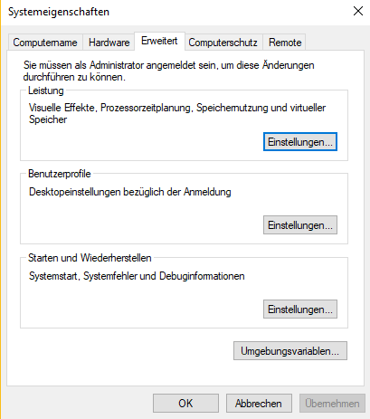

1. Double-Click on the button within the red circle and select path (green circle, shown in the picture below)

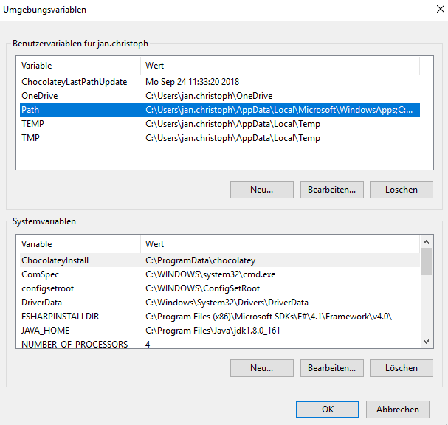

1. Click on edit Text (blue circle in the picture below) to put in the path of node.js  
   In my case it is: *C:\Users\jan.christoph\AppData\Roaming\npm*For **Windows 7** in you might need a second path added as well (installation folder of node.js):  
   *C:\Program Files\nodejs*

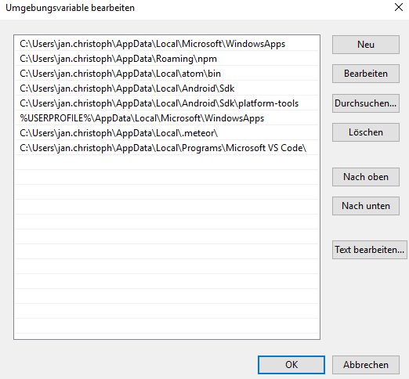

Figure 1

Try if node is installed correctly by open the console (press windows button and type “cmd”) and use the following commands:

node -v

npm -v

You should get the version number.

1. The next step is to install the java sdk which is needed to run android studio. This is needed to develop the app for android.  
     
   Keep in mind you can’t develop apps for iOS on Windows!!!  
     
   <https://www.oracle.com/technetwork/java/javase/downloads/jdk11-downloads-5066655.html> follow the link, accept the license agreement (yellow circle on the picture below)   
   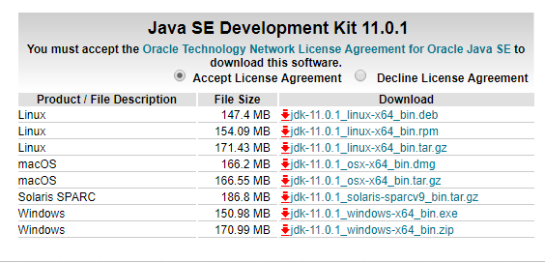  
   and download the version which fits your system (64 bit or 32 bit; you can find that with a rightclick on your windows symbol in the taskbar 🡪 “*System*”)  
   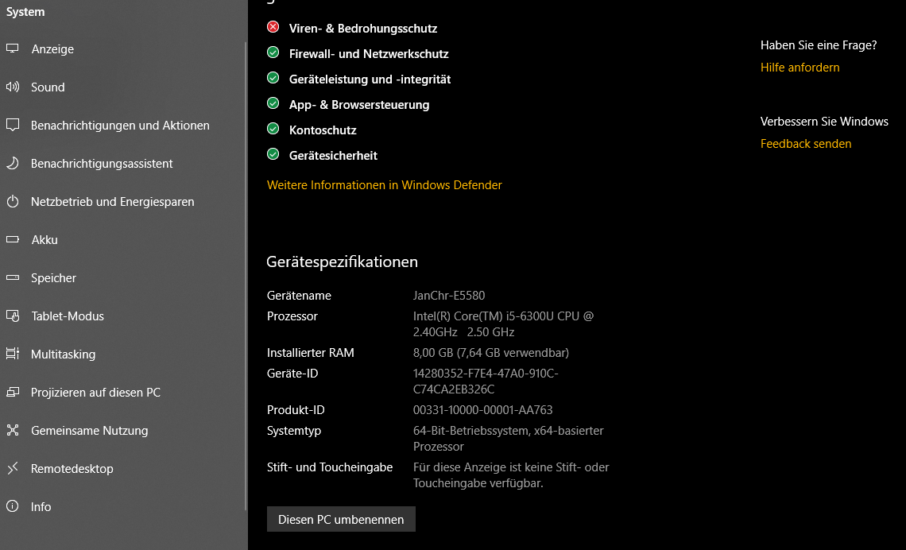
2. You also need to put the path of the android sdk into your environmental variables as done before with node.js. In my case the path is:  
   *C:\Users\jan.christoph\AppData\Local\Android\Sdk*
3. Furthermore, you should set the JAVA_HOME environmental-variable as shown in the image below

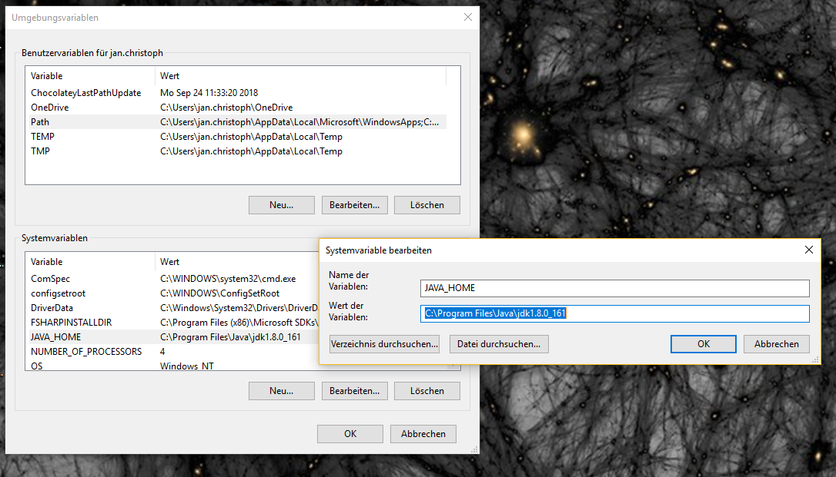

1. Install Android Studio from <https://developer.android.com/studio/> and follow the instructions.
2. After the installation head to the SDK Manager built in Android Stuido (See picture below, pink circle)  
   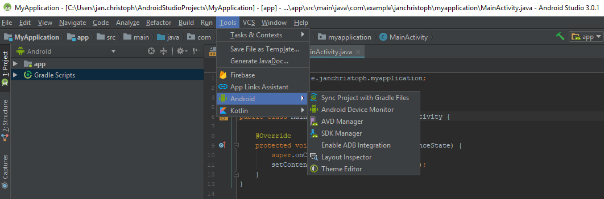
3. Here you need to install and update SDK Platforms and SDK Tools.  
   Must have:

|  |  |
| --- | --- |
| SDK Platforms | SDK Tools |
| Android API 28 | Android SDK Build-Tools |
| Android P Preview | Android SDK Platform-Tools |
| Android API 27 | Android SKD Tools |
| Android 8.0 |  |
| Android 7.1.1 |  |
| Android 7.0 |  |

It should then somehow look like the following picture

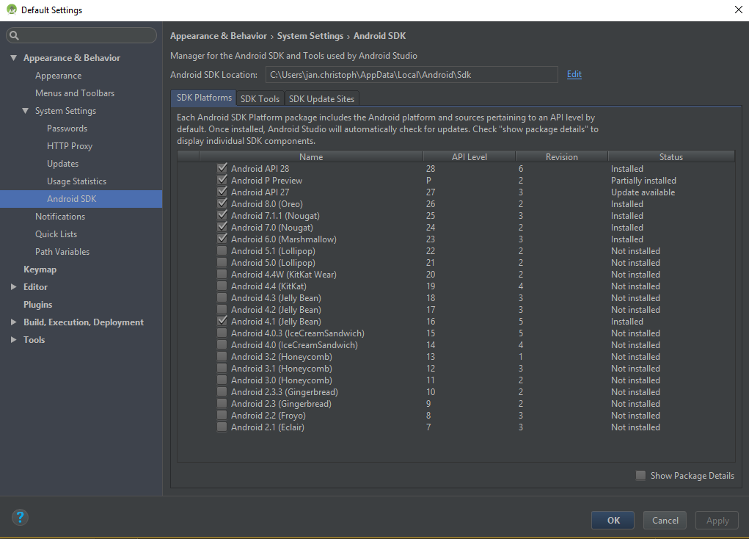

Follow the steps from <https://ionicframework.com/docs/intro/installation/> to install Ionic which will be the framework we use to develop our app.

**Mac (High Sierra 10.13.4)**

1. Install XCode from the App Store
2. Then install XCode’s command line tools in the terminal wit following command:

Xcode-select --install

If an error occurs while installing the tools might already be installed on your device!

1. Next you will need a package manager to install things like node via terminal.  
   You will find homebrew here: <https://brew.sh/>

Follow the instructions there and read something about it, or use the following command in the terminal:

/usr/bin/ruby -e "$(curl -fsSL https://raw.githubusercontent.com/Homebrew/install/master/install)"

1. Now it is time to install nodejs and npm. Therefore, use the following command in the terminal:

brew install node

1. Use the command node -v and npm -v to verify everything works as expected
2. The next step is to install Ionic and Cordova. This is achieved by using the following command in the terminal: sudo npm install – g cordova ionic
3. Install iOS deploy from <https://github.com/phonegap/ios-deploy>       
   or Install iOS-deploy from the terminal:  
   sudo npm install --global --unsafe-perm ios-deploy
4. Register the apple id as developer team in Xcode

**IDE (Software used to develop apps)**

Since Ionic uses TypeScript (JavaScript), HTML and CSS choosing the IDE is quite simple because most of them support web development, which in fact we do.

Here is a small list of IDE’s from which you can choose whatever one you like the most.

* *Visual Studio Code (recommended)*
* *Atom (recommended)*
* *PhPStorm*
* *WebStorm*
* *SublimeText*
* *Netbeans*
* *Brackets*

# References and further literature

We will use HTML5, CSS/SCSS, TypeScript and Angular inside of Ionic so it might be useful if you learn the basics of these. Information about them can be found here:  
  
<https://www.w3schools.com/html/html5_intro.asp>  
<https://www.w3schools.com/css/>  
<https://sass-lang.com/>  
<https://www.typescriptlang.org/>  
<https://angular.io/>

For more help here are some links to useful installation guides:

Ionic:  
<https://www.youtube.com/user/LittlejTFS>  
<https://ionicframework.com/docs/>

Node.js:  
<https://www.guru99.com/download-install-node-js.html>

Java SDK:  
<https://www.theserverside.com/tutorial/How-to-install-the-JDK-on-Windows-and-setup-JAVA_HOME>

Android Studio:  
<https://www.wikihow.tech/Set-up-an-Android-Development-Environment>

Brew:  
<https://brew.sh/>

Xcode:  
<https://developer.apple.com/xcode/>