MoneyTuber (Tuber Platform)

Petition Exhibit Documentation Package
Counsel-ready exhibit materials — inspectable method over prediction; demo data illustrative; no overclaims.
Product: MoneyTuber / Tuber Platform · Maturity: Phase 1 · Date: 8 August 2026

MoneyTuber (Tuber Platform) — Petition Exhibit Documentation Package
Audience: Client sponsors, consultants, and counsel preparing a petition exhibit
Purpose: Equip non-engineering readers with end-to-end understanding so they can position MoneyTuber / Tuber Platform accurately — without overclaiming
Product identity: MoneyTuber (public brand) · Tuber Platform (engineering/repo name)
Maturity label: Phase 1 (explicit deferrals documented in README)
Date: 8 August 2026
————————————————————

Does this use case make sense?
Yes. For an exhibit attached to a petition, counsel does not need to become software engineers. They need:
1. A clear, defensible description of what the platform is and is not
2. Language that connects the work to public-interest / national-importance themes without overreach
3. Enough operational and integrity depth to answer hard questions
4. A live or recorded demonstration path that makes the exhibit tangible
This package is written for that purpose.
————————————————————

Discovered product identity (auto-discovery summary)
Fact — Discovery
Public name — **MoneyTuber** (“Digital Real Estate for YouTube”)
Engineering name — **Tuber Platform**
Plain-English purpose — Unified web platform that trains/operates clipper and producer squads, wraps production tools, and sells related digital products (marketplace, master class, affiliates)
Domains — Role-gated Clipper (`/clip`), Producer (`/produce`), AI suggest-queue (suggest-only), channel marketplace, 0→1k Master Class, affiliate program, admin monitoring
Stack — Flask + SQLAlchemy; Postgres (Supabase) / SQLite local; Paystack; optional Groq/HF AI; Render deploy
License — **No root LICENSE found** in this workspace copy; do not assert Apache/MIT/etc. without the Petitioner’s authoritative license
Repo URL — **No git remote configured** in this workspace copy; obtain from Petitioner
Version string — No semver tag discovered; treat as **Phase 1** per README
Geography — Product copy is general; payments use Paystack (amounts in kobo/NGN subunits in code comments) — do not invent a jurisdiction claim
Local-first? — **No** — multi-user hosted web platform
Open-source? — Source is present and inspectable in-repo; **public open-source status not confirmed** without remote + LICENSE
AI-based? — **Partially** — optional AI for clip *suggestions* only; humans review; agent never cuts/publishes
Formula-based decision engine? — **No** — this is an operations/commerce platform, not a scoring model
————————————————————

Recommended reading order
Order — Document — Who reads it — Time
1 — [01 — Executive Brief](./01-EXECUTIVE-BRIEF.md) — Everyone; petition decision-makers — 5–10 min
2 — [02 — Counsel Briefing](./02-COUNSEL-BRIEFING.md) — Lawyer / consultant drafting language — 20–30 min
3 — [06 — Visual Appendix](./06-VISUAL-APPENDIX.md) — Everyone — diagrams + screenshots — 10–15 min
4 — [03 — Technical White Paper](./03-TECHNICAL-WHITEPAPER.md) — Counsel + technical advisor for depth — 30–45 min
5 — [04 — Exhibit Statement](./04-EXHIBIT-STATEMENT.md) — Attachment / appendix language — 10 min
6 — [05 — Demonstration Script](./05-DEMONSTRATION-SCRIPT.md) — Live showcase / hearing prep — 15 min + practice
Supporting (already in repo):
Document — Role
[../../README.md](../../README.md) — Architecture overview, tests, Phase-1 deferrals
[../../DEPLOYMENT.md](../../DEPLOYMENT.md) — Render + Supabase deployment walkthrough
————————————————————

What this package is designed to prevent
- Calling MoneyTuber a **government program**, **certified training standard**, or **YouTube partner product**
- Claiming the AI agent **automatically cuts or publishes** content
- Treating **illustrative / demo numbers** as production metrics or earnings proof
- Asserting a specific **open-source license** without a LICENSE file / remote confirmation
- Overstating Phase-1 features that README marks as **deferred** (per-user YouTube OAuth, granular activity semantics, computed rewards, durable multi-worker job state)
- Understating value: it is still a real, role-gated, payment-integrity-aware operating platform with automated tests
————————————————————

Suggested exhibit set for the petition binder
1. Exhibit A — Executive Brief (01)
2. Exhibit B — Formal Exhibit Statement (04)
3. Exhibit C — Visual Appendix (06): diagrams + screenshots
4. Exhibit D — Technical White Paper (03)
5. Exhibit E — Source tree reference + Petitioner-supplied LICENSE / repository URL
6. Optional — Live demo guided by Demonstration Script (05)
Counsel should customize national-importance framing to the specific petition theory; documents here provide accurate product substance and safe articulation patterns.

MoneyTuber — Executive Brief
For: Petition sponsors, counsel, and consultants
Subject: What MoneyTuber / Tuber Platform is, why it matters, and how it can be exhibited
Maturity: Phase 1 · August 2026
————————————————————

One-sentence summary
MoneyTuber is a role-gated YouTube operations and commerce platform that unifies clipper and producer tooling, human-reviewed AI clip suggestions, channel marketplace checkout, Master Class enrollment, and affiliate attribution behind one Flask application with admin oversight.
————————————————————

What problem it addresses
Growing and monetizing YouTube channels typically requires coordinated human work (clipping, production), tool access that should not be public, and commercial workflows (training offers, channel sales, referrals). Without a unifying system, that work fragments across:
- Standalone tools with no accounts or role separation
- Informal referral tracking
- Payment flows that trust the browser
- No operational audit trail for a managed squad
MoneyTuber responds by providing an inspectable operating platform: who can access which tools, how suggestions are reviewed, how payments finalize, and how admins monitor activity.
————————————————————

What the platform does (plain language)
1. Public visitors see MoneyTuber offers: grow/monetize interest, buy a channel (when open), 0→1k Master Class (when open), and affiliate signup.
2. Internal roles (admin, clipper, producer) log in; affiliates have a separate self-serve path.
3. Clippers use the mounted Clipper app at `/clip`; producers use ytproduction at `/produce`.
4. Suggest-agent can queue AI clip ideas from watched channels for human approve/reject — it does not cut or publish.
5. Payments for Master Class and marketplace go through Paystack with signature verification and server-side amounts.
6. Admins manage users, listings, affiliates, watched channels, and review login/activity logs.
Figure 1 — End-to-end flow
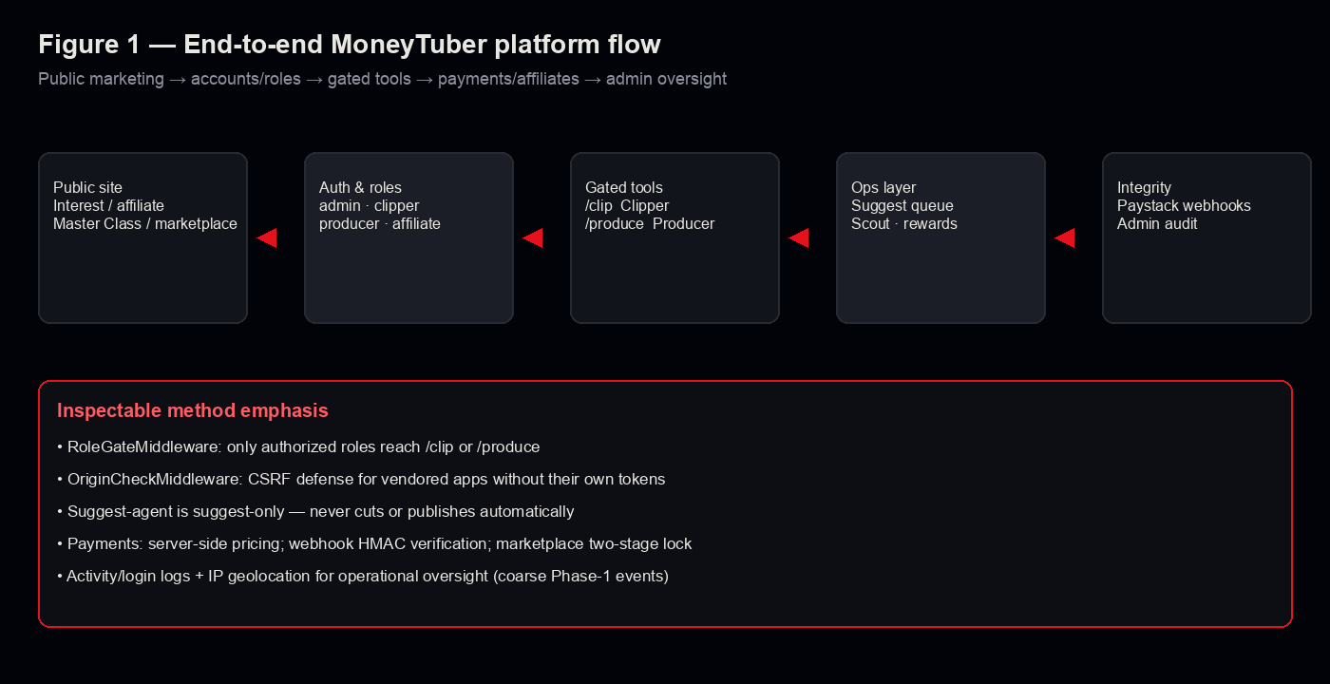
Figure 4 — Integrity safeguards
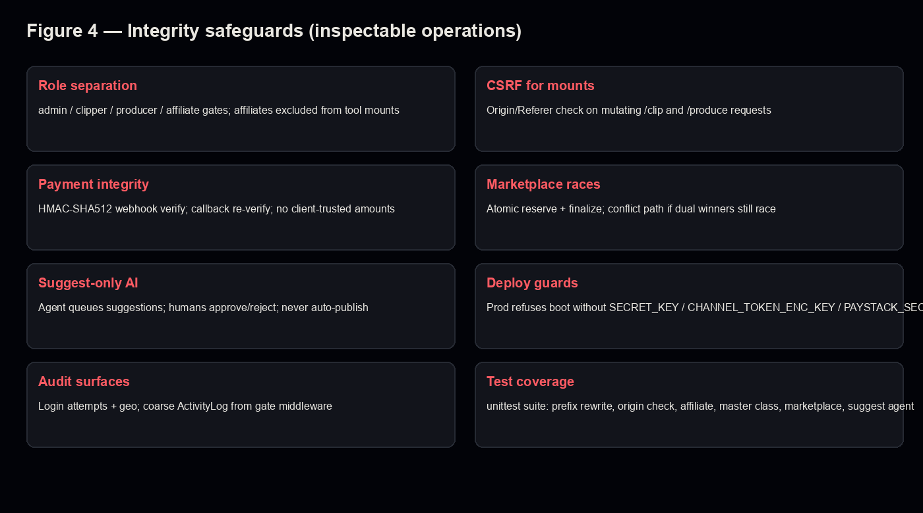
*Full screenshot set: [Visual Appendix (06)](./06-VISUAL-APPENDIX.md).*
————————————————————

Major capability areas
Area — Question it helps answer
Clipper (`/clip`) — Can authorized clippers cut/export short-form clips with a controlled tool?
Producer (`/produce`) — Can authorized producers run production workflows in a gated mount?
Suggest queue — Can AI propose clips while humans remain the decision-makers?
Marketplace — Can unique channel listings be sold without double-selling?
Master Class — Can paid enrollment be verified server-side rather than trusting the client?
Affiliates — Can referrals be attributed and commissions created on verified conversions?
Admin oversight — Can operators see users, coarse activity, and login geography?
————————————————————

Why this can support “national importance” positioning
Counsel can fairly argue themes of digital skills capacity, lawful creator-economy operations, and trustworthy platform engineering — *if* those themes match the petition theory — because MoneyTuber:
- Implements **role separation** so production tools are not anonymously public
- Treats AI as **assistive and reviewable**, not autonomous publishing
- Builds **payment and marketplace integrity** (HMAC webhooks, re-verification, atomic reservation)
- Documents **Phase-1 limits** honestly in the README
- Ships **automated tests** for security-sensitive middleware and commerce races

What counsel should not say
- That MoneyTuber is endorsed by YouTube, Google, or any government
- That the AI agent autonomously creates or posts finished content
- That marketplace/master-class “Coming soon” surfaces are already open at scale
- That demo dashboard numbers are audited earnings or subscriber outcomes
- That the product is open-source under a named license **unless** LICENSE + repo URL are confirmed
————————————————————

Maturity limits (Phase 1 — from README)
Explicitly deferred:
- Real **per-user YouTube OAuth** (`connected_channels` table exists; Clipper still uses shared token file)
- **Granular** activity semantics (Phase 1 logs coarse route hits)
- **Computed reward evaluation** (CRUD only)
- **Multi-worker durable job state** (in-process jobs; gunicorn pinned to one worker)
————————————————————

Bottom-line paragraph (reusable)
MoneyTuber (Tuber Platform) is an implemented Phase-1 web platform that unifies role-gated YouTube clipper and producer tooling with human-reviewed suggestion queues, Paystack-backed commercial flows, affiliate attribution, and admin monitoring. Its exhibit value is the inspectable operating method — authorization boundaries, payment verification, race-safe marketplace reservation, and tested middleware — not any claim of guaranteed channel growth, autonomous AI publishing, or government endorsement. Demo interfaces and sample numbers in this package are illustrative unless separately evidenced from production records.

MoneyTuber — Counsel & Consultant Briefing
Purpose: Give lawyers and consultants the depth needed to articulate MoneyTuber / Tuber Platform accurately in a petition, hearing, or stakeholder briefing — including safe claims, national-importance framing, and anticipated hard questions.
Companion docs: Executive Brief (01), Technical White Paper (03), Exhibit Statement (04), Demo Script (05)
————————————————————

1. Positioning statement (use this)
Primary positioning (recommended):
MoneyTuber is a Phase-1 YouTube operations and commerce platform. It combines role-gated clipper and producer tools, a human-reviewed AI suggestion queue, channel marketplace checkout, Master Class enrollment, affiliate referral attribution, and an admin dashboard with login/activity monitoring. Sensitive actions are constrained by middleware (role gates, origin checks) and payment events are verified server-side. The platform’s value as an exhibit is that these controls are implemented and testable — not that channel growth or monetization outcomes are guaranteed.
What that buys you in a petition narrative:
- Credibility through **implemented controls** (not a slide deck)
- Relevance through **digital workforce / creator-economy operations**
- Integrity through **explicit Phase-1 limitations**
- Practicality through **demonstrable workflows** with role separation
————————————————————

2. End-to-end understanding (non-technical)

2.1 Public surface
The homepage markets three pillars: Grow & Monetize, Buy a Channel, and 0→1k Master Class, plus affiliate recruitment. Marketplace and Master Class can display “Coming soon” when not opened by configuration/data.

2.2 Accounts and roles
Roles in code: `admin`, `clipper`, `producer`, `affiliate`.
- Internal squad roles are created by admin (no public signup for those roles).
- Affiliates self-serve at `/affiliate/signup`.
- Clipper role may access `/clip`; producer role may access `/produce`; admin may access both; affiliates may not.

2.3 Tooling mounts
Two previously standalone apps are vendored into the repo and mounted:
- `/clip` — Youtube-Clipper (cut segments, progress, downloads, related integrations)
- `/produce` — ytproduction (generation/assembly workflows)
Middleware rewrites root-relative URLs, enforces roles, logs coarse activity, and checks Origin/Referer for mutating requests.

2.4 Suggest-agent (AI — limited)
A CLI/cron-style command polls watched channels, discovers uploads, and queues suggested clips. Code comments and README-aligned behavior: suggest-only; never cuts or publishes. Humans use a review queue to approve/reject.

2.5 Commerce
- **Master Class:** server-side pricing; Paystack initialize; webhook HMAC verification; callback re-verifies rather than trusting query string; commissions at override-or-default rate.
- **Marketplace:** unique listings; reserve at checkout; finalize at payment; conflict path if races remain; shared `/webhooks/paystack` endpoint.

2.6 Admin oversight
Dashboard shows tuber counts, recent activity, recent logins with IP geolocation. Additional admin pages cover users, affiliates, listings/orders, rewards CRUD, watched channels.
————————————————————

3. National importance — how to argue it without overreach

3.1 Themes counsel can fairly develop
Theme — Why MoneyTuber can support it
**Digital skills & youth employment pathways** — Platform organizes clipper/producer work and a Master Class enrollment path for creator skills.
**Creator-economy infrastructure** — Tools + marketplace + affiliates form an operating stack for channel growth businesses.
**Trustworthy platform engineering** — Role gates, CSRF-for-mounts, payment HMAC, race-safe reservations, automated tests.
**Human accountability with AI assistance** — AI suggests; humans decide — useful contrast to “autonomous content bots.”
**Documented engineering honesty** — README states Phase-1 deferrals rather than hiding unfinished OAuth/rewards/job durability.

3.2 Sample petition language (customize to your theory)
Petitioner respectfully submits that building accountable digital platforms for creator-economy workforce operations serves a substantial public interest. MoneyTuber implements role-separated access to production tools, human review of AI clip suggestions, server-verified payment flows, and administrative monitoring. Its exhibit value is not a guarantee of subscriber growth or monetization, but an implemented, inspectable method for operating and supervising digital media production workflows with integrity controls appropriate to a multi-user platform.

3.3 Do not rest national importance on
- Specific illustrative dashboard counts or “earnings”
- Claims of YouTube/Google partnership
- Claims that AI autonomously produces or publishes finished content at scale
- Unverified open-source license assertions
————————————————————

4. Claims matrix (safe vs unsafe)
Claim type — Safe? — Guidance
Implemented multi-role YouTube ops platform — Yes — Core truth
Role-gated `/clip` and `/produce` mounts — Yes — Middleware + roles
AI suggestions require human review — Yes — Suggest-only agent
Paystack webhook signature verification — Yes — Code + tests
Marketplace two-stage reserve/finalize — Yes — Code + tests
Phase-1 with documented deferrals — Yes — README
Guarantees 0→1,000 subscribers in 30 days — **No** — Marketing offer language ≠ proven outcome; do not treat as empirical result
YouTube-endorsed / official partner — **No** — No evidence in repo
Fully open-source under Apache/MIT — **No** — LICENSE/remote not confirmed here
Autonomous AI clipping & publishing — **No** — Explicitly opposite
Per-user YouTube OAuth complete — **No** — Deferred in README
Granular action analytics complete — **No** — Coarse route hits only
Multi-worker durable job queue — **No** — In-process; workers=1
————————————————————

5. Anticipated hard questions (Q&A for counsel)
Q: Is this just a marketing website?
A: No. Marketing is one surface. The platform also mounts production tools, enforces roles, runs payment verification, and includes an admin/ops layer with tests.
Q: Does the AI automatically post to TikTok/YouTube?
A: No. The suggest-agent queues suggestions for human review. It does not cut or publish by itself.
Q: Are channel sales and Master Class live?
A: They are implemented in code with Paystack flows and tests. The public UI can show “Coming soon” when not opened. Counsel should verify production configuration before claiming public availability.
Q: Is source code publicly open-source?
A: This workspace copy contains full source and tests, but no root LICENSE and no configured git remote. Obtain the Petitioner’s authoritative repository URL and license before filing open-source claims.
Q: Does the platform store everyone’s YouTube OAuth tokens securely today?
A: Encryption scaffolding exists (`CHANNEL_TOKEN_ENC_KEY` / Fernet), and production refuses to boot without the key when `DATABASE_URL` is set — but README states real per-tuber OAuth is deferred; Clipper still uses a shared token file in Phase 1.
Q: Can you prove earnings or subscriber outcomes from the demo?
A: No. Demo/illustrative UI numbers are not findings of fact. Use production records if outcomes are claimed.
Q: What about YouTube Terms of Service / copyright?
A: Vendored Clipper README warns users are responsible for rights-compliant use. Do not imply the platform immunizes ToS or copyright risk.
Q: Why should USCIS / a reviewer care?
A: Because the Petitioner can show an implemented system with inspectable integrity controls and honest scope limits — evidence of substantial progress and engineering seriousness — not because the software decrees national policy outcomes.
————————————————————

6. Glossary
Term — Meaning
MoneyTuber — Public brand / marketing name
Tuber Platform — Engineering name for the Flask platform
Clipper — Role + `/clip` tool for cutting short-form clips
Producer — Role + `/produce` tool for production workflows
Suggest-agent — Job that proposes clips; never publishes
RoleGate — Middleware enforcing role access to mounts
OriginCheck — CSRF defense for vendored mount mutating requests
PrefixRewrite — Rewrites root-relative URLs under `/clip`/`/produce`
Paystack — Payment processor used for Master Class / marketplace
Phase 1 — Current maturity with explicit deferrals in README
————————————————————

7. Petition workstream steps (practical)
1. Confirm petition theory themes with Petitioner (skills, infrastructure, entrepreneurship, etc.).
2. Obtain authoritative repo URL + LICENSE.
3. Decide which live screens to show (marketing, admin, suggestions, marketplace).
4. Label all demo data illustrative.
5. Attach Exhibit Statement (04) + Visual Appendix (06).
6. Prepare Demo Script (05); rehearse “do not say” lines.
7. Keep Technical White Paper (03) available for deep questions.

MoneyTuber / Tuber Platform — Technical White Paper
Audience: Counsel with a technical advisor, or technically literate consultants
Scope: Architecture, modules, integrity mechanisms, limits, petition suitability
Sources: Repository README, `app/`, `vendor/`, `tests/`, `DEPLOYMENT.md`
————————————————————

Abstract
Tuber Platform is a Flask-based WSGI application that mounts two vendored media tools — Youtube-Clipper at `/clip` and ytproduction at `/produce` — behind shared authentication, role authorization, admin monitoring, affiliate attribution, and Paystack-backed commercial products. Public marketing uses the MoneyTuber brand. Phase 1 deliberately defers per-user YouTube OAuth, granular activity semantics, computed rewards, and multi-worker durable job state. AI is used for clip *suggestion* only. Automated tests cover middleware, affiliate flows, Master Class webhooks, marketplace locking, and the suggest-agent data model.
————————————————————

1. Principles
1. One deployable service — platform + tools share one Render web service.
2. Role boundaries first — tool mounts are not anonymously public.
3. Vendored, not submodule-fragile — Clipper and ytproduction are committed directories with small platform tweaks.
4. Commerce integrity over UI trust — amounts and payment success are server-verified.
5. Human-in-the-loop for AI — suggestions are queued; cutting/publishing remain human actions.
6. Honest deferrals — unfinished capabilities are documented rather than silently implied.
————————————————————

2. Architecture
Figure 2 — System architecture
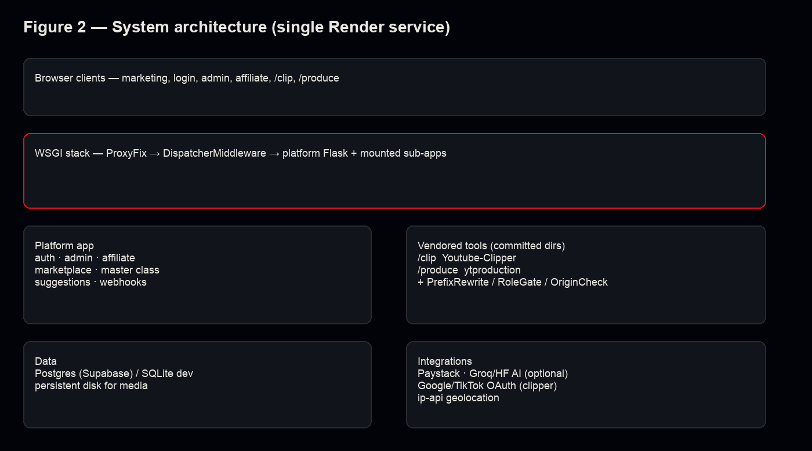

2.1 Runtime composition
`wsgi.py` builds `platform_app = create_app()` and wraps it with `build_wsgi_app()`:
- `ProxyFix` for reverse-proxy headers
- `DispatcherMiddleware` mapping `/` → platform, `/clip` → Clipper, `/produce` → ytproduction
Each mount is wrapped (outer → inner conceptually for request entry):
1. OriginCheckMiddleware — CSRF defense for mutating methods
2. PrefixRewriteMiddleware — fixes root-relative URLs/JSON paths for the mount prefix
3. RoleGateMiddleware — session/role check + coarse `ActivityLog` writes

2.2 Platform modules (Flask blueprints)
Blueprint / area — Responsibility
`auth` — Login/logout, homepage routing
`admin` — Users, activity, logins, affiliates, marketplace admin, master class admin, rewards, watched channels
`suggestions` — Human review queue for AI suggestions
`producer_scout` — Producer-side scout UI
`affiliate` — Signup, referral `/r/<code>`, interest capture, dashboard
`master_class` — Sales, checkout, pending/success
`marketplace` — Browse, detail, buy, pending/success/conflict
`webhooks` — Consolidated Paystack webhook

2.3 Data & deploy
- SQLAlchemy models; Flask-Migrate migrations
- Postgres via `DATABASE_URL` (Supabase in deployment docs); SQLite default for local
- Persistent disk paths for clipper downloads / ytproduction output
- Gunicorn: intentionally `--workers 1` because vendored apps keep job state in-process
————————————————————

3. Capability modules → outcomes
Figure 3 — Capabilities → outcomes
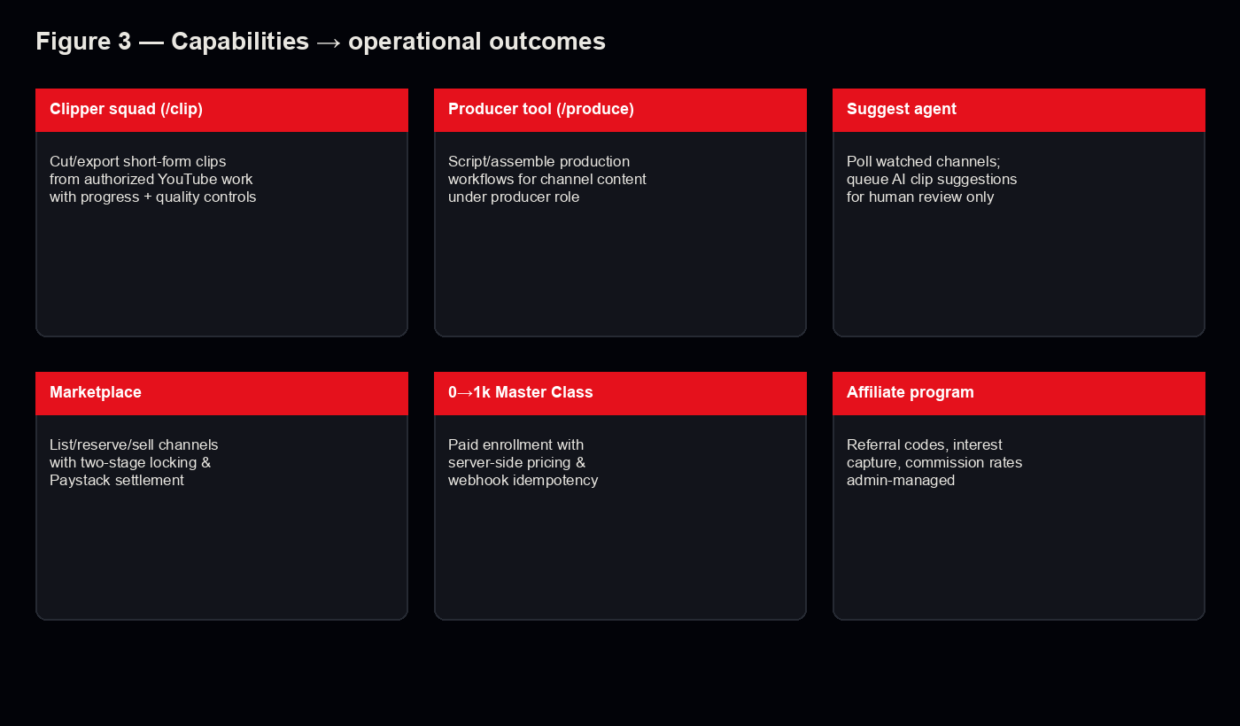

3.1 Clipper (`/clip`)
Local-style clipping UX (URL → in/out → cut → download), quality options, progress streaming, and related integrations present in the vendored app. Platform contribution: mount prefix, role gate, origin check, URL rewrite.

3.2 Producer (`/produce`)
Production generation/assembly workflows from ytproduction, similarly gated and rewritten.

3.3 Suggest-agent
`flask run-suggest-agent` polls active `WatchedChannel` rows, lists uploads, fetches transcripts, calls suggestion helpers, and writes `SuggestedClip` rows. Status transitions and review-queue race guards are tested. No autonomous publish path.

3.4 Marketplace
Listings with availability states; `reserve_listing` uses atomic `UPDATE…WHERE`; finalize on payment; stale reservations self-heal; `payment_conflict` path covered in tests.

3.5 Master Class
Server-side pricing only; webhook signature verification (valid/missing/tampered); idempotent duplicate delivery handling; callback re-verify; commission creation.

3.6 Affiliates
Referral codes, cookie/attribution paths, interest intake types, admin commission CRUD / rate resolution, dashboard authorization. Affiliates excluded from tool mounts.
————————————————————

4. Methodology integrity rules (platform engineering)
Figure 4 — Integrity safeguards

Rule — Implementation signal
Least privilege to tools — `User.can_access` + RoleGate
CSRF for tokenless mounts — Origin/Referer matching middleware
No client-trusted prices — Paystack amounts from server
Verify payment events — HMAC-SHA512 webhook + callback verify
Prevent double-sale — Two-stage lock + conflict handling
AI non-autonomy — Suggest-only agent docstring/CLI
Fail closed on secrets in prod — RuntimeError if critical keys missing when `DATABASE_URL` set
Token-at-rest intent — Fernet via `CHANNEL_TOKEN_ENC_KEY` (OAuth write path still Phase-1 deferred)
Regression safety — `unittest` suites listed in README
————————————————————

5. Interpretive limits
- **Not a forecasting model** for subscriber growth or revenue.
- **Not a certification** of creator skill or channel quality.
- **Not proof** of YouTube partnership or ToS compliance for every user action.
- **Marketing claims** (e.g., “0 to 1,000 subscribers in 30 days”) are offer copy — counsel must not treat them as validated experimental results unless separately evidenced.
- **Demo data** in screenshots is illustrative.
- **License/public repo** must be confirmed outside this workspace copy before open-source characterizations.
————————————————————

6. Petition suitability
MoneyTuber is suitable as a software exhibit when the petition theory needs evidence of:
- An implemented multi-user digital operations platform
- Engineering attention to authorization, payment integrity, and concurrency
- Responsible AI assistance (human review)
- Transparent scope management (Phase-1 deferrals)
It is a weak exhibit if counsel needs a scientific scoring engine, peer-reviewed economic model, or government-certified dataset — those are different genres (see, e.g., decision-support frameworks with published formulas).
————————————————————

7. Verification line for counsel
Independent technical reviewers can:
1. Read `README.md` and `app/mounting/*.py`
2. Run `python3 -m unittest discover -s tests -v`
3. Inspect Paystack verification in `app/paystack.py` and webhook routes
4. Inspect marketplace reservation in `app/marketplace/services.py`
5. Confirm suggest-only language in `app/__init__.py` (`run-suggest-agent`)

Exhibit Statement — MoneyTuber (Tuber Platform)
Title for binder: Software Exhibit — MoneyTuber / Tuber Platform
Document type: Formal attachable statement
Date: 8 August 2026
————————————————————

Statement
1. Identity. The software system described herein is publicly branded MoneyTuber and implemented in source as Tuber Platform, a Flask web application that unifies accounts, roles, admin monitoring, affiliate attribution, commercial checkout flows, and two role-gated media tools.
2. Purpose. The system is designed to operate clipper and producer workflows for YouTube-oriented content operations, to queue human-reviewed AI clip suggestions, and to support related commercial offerings (channel marketplace and Master Class enrollment) with server-side payment verification.
3. Architecture. The platform mounts Youtube-Clipper at `/clip` and ytproduction at `/produce` via WSGI dispatcher middleware, with role gating, URL prefix rewriting, and Origin/Referer checks for mutating requests to the mounted applications.
4. Roles. Supported roles include `admin`, `clipper`, `producer`, and `affiliate`. Access to `/clip` and `/produce` is restricted by role; affiliate accounts are not authorized for those tool mounts.
5. AI limitation. The suggest-agent component may propose clip suggestions from watched channels for human review. It does not, by its documented design, cut or publish content autonomously.
6. Payment integrity. Master Class and marketplace payments integrate with Paystack. Webhook signatures are verified using HMAC-SHA512; callback handling re-verifies transactions rather than trusting client query parameters alone; pricing used for initialization is determined server-side.
7. Marketplace concurrency controls. Channel listings use a two-stage reservation and finalization approach intended to prevent a unique listing from being sold to two buyers, with an explicit conflict path if races still occur.
8. Monitoring. The admin interface provides user management, coarse activity logging from gate middleware, and login attempt records that may include IP geolocation lookups.
9. Phase-1 limitations. The repository README expressly defers: real per-tuber YouTube OAuth wiring; granular activity instrumentation beyond coarse route hits; computed reward evaluation against metric events; and multi-worker durable job state for vendored in-process jobs.
10. Licensing & repository. Counsel should attach the Petitioner’s authoritative public repository URL and LICENSE. This documentation package was generated from a workspace copy in which a root LICENSE file and git remote were not present; therefore this Statement does not assert a specific open-source license.
11. Non-claims. This Exhibit does not assert government endorsement, YouTube partnership, guaranteed subscriber or revenue outcomes, or that illustrative demonstration data are production findings of fact.
12. Verification. The source tree, middleware modules, payment/marketplace services, and automated test suites are available for independent technical inspection consistent with the Technical White Paper accompanying this Exhibit.
————————————————————

Verification line
I understand that the foregoing describes the MoneyTuber / Tuber Platform software as implemented in the referenced source tree and supporting documentation, and that demonstration interfaces may include illustrative data not representing audited production results.
_Petitioner / authorized technologist: _______________________ Date: _________
————————————————————

Sub-exhibit checklist
Sub-exhibit — Item
A — Executive Brief (`01-EXECUTIVE-BRIEF.md`)
B — This Exhibit Statement
C — Visual Appendix diagrams + screenshots (`06-VISUAL-APPENDIX.md`)
D — Technical White Paper (`03-TECHNICAL-WHITEPAPER.md`)
E — Repository URL + LICENSE (Petitioner-supplied)
F — Optional: unittest run log / demo recording per `05-DEMONSTRATION-SCRIPT.md`

MoneyTuber — Demonstration Script
Audience: Live showcase for counsel, consultants, or petition prep
Duration: ~12–15 minutes
Environment: Local `python3 wsgi.py` on `:8000` or deployed staging URL
————————————————————

Opening disclaimer (say this first)
What you will see is a **working software platform**. Any user counts, listings, or commissions shown in a demo environment are **illustrative** unless we explicitly switch to production records. MoneyTuber does **not** guarantee subscriber growth or earnings. The AI suggestion feature **proposes** clips for human review — it does **not** automatically cut or publish. We are demonstrating an **inspectable operating method**, not a prediction of market outcomes.
————————————————————

Do not say
- “This is an official YouTube partner product.”
- “The AI runs the channel by itself.”
- “Everyone who takes the Master Class hits 1,000 subscribers.”
- “We’re open-source under [license]” — unless LICENSE + repo URL are confirmed.
- “These dashboard numbers are our audited production metrics” — unless they are.
————————————————————

Timed walkthrough
Min — Screen — Action — Talk track
0:00 — — — Read opening disclaimer — Set integrity frame
0:45 — Landing `/` — Scroll pillars — Public MoneyTuber offers: grow, buy channel, Master Class, affiliates
2:00 — Login — Log in as admin — Accounts are role-based; squad roles are admin-created
3:00 — Admin dashboard — Show stats, activity, logins — Oversight: coarse activity + login geo
5:00 — Users — Point at roles — admin / clipper / producer / affiliate separation
6:30 — Suggestions queue — Show pending approve/reject — AI suggests; humans decide
8:00 — `/clip` (clipper user) — Paste a **rights-cleared** demo URL or show UI only — Role-gated tool mount; do not demo piracy
10:00 — Marketplace or Master Class — Browse UI; explain Paystack verify — Server-side price; webhook HMAC; reserve/finalize
12:00 — Affiliate signup/dashboard — Referral link concept — Attribution + commissions on verified conversions
13:30 — Close — Return to disclaimer themes — Phase-1 limits: OAuth deferral, coarse logs, workers=1
————————————————————

Screenshot checklist (for binders)
1. Landing / pillars
2. Login
3. Admin dashboard
4. Suggestions queue
5. Marketplace browse (or Coming soon state — either is honest)
6. Clipper tool (`/clip`)
7. Affiliate surface
8. Source/license status plate (until LICENSE confirmed)
See [06 — Visual Appendix](./06-VISUAL-APPENDIX.md).
————————————————————

Hard-question rebound lines
“So it’s automated content spam?”
→ “No. Roles gate tools, and the suggestion agent only queues ideas for people to review.”
“Prove the Master Class works.”
→ “We can prove the enrollment and payment verification system works. Learning outcomes require separate evidence.”
“Is the marketplace live?”
→ “The code path is implemented and tested; the public storefront may be closed (‘Coming soon’). We’ll state the configured state accurately.”

MoneyTuber — Visual Appendix
Purpose: Binder-ready figures and screenshots with captions
Caption rule: Prefer LIVE captures; plates below marked ILLUSTRATIVE unless noted
————————————————————

Binder insert order
Order — File — Caption
1 — `figures/fig-01-end-to-end-flow.png` — Fig 1 — End-to-end MoneyTuber platform flow
2 — `figures/fig-02-architecture.png` — Fig 2 — System architecture (single Render service)
3 — `figures/fig-03-modules.png` — Fig 3 — Capabilities → operational outcomes
4 — `figures/fig-04-integrity.png` — Fig 4 — Integrity safeguards
5 — `screenshots/01-landing.png` — Landing — MoneyTuber public pillars (**ILLUSTRATIVE**)
6 — `screenshots/02-login.png` — Login (**ILLUSTRATIVE**)
7 — `screenshots/03-admin-dashboard.png` — Admin dashboard (**ILLUSTRATIVE** demo rows)
8 — `screenshots/04-suggestions-queue.png` — Suggestions review queue (**ILLUSTRATIVE**)
9 — `screenshots/05-marketplace.png` — Marketplace browse (**ILLUSTRATIVE** listings)
10 — `screenshots/06-clipper-tool.png` — Clipper UI — vendor plate mounted at `/clip`
11 — `screenshots/07-affiliate.png` — Affiliate dashboard (**ILLUSTRATIVE**)
12 — `screenshots/08-source-license-status.png` — Source/licensing discovery status
————————————————————

Diagrams

Figure 1 — End-to-end flow
Fig 1

Public marketing and intake → authentication/roles → gated `/clip` & `/produce` → ops (suggestions, scout, rewards) → payment/admin integrity layer.

Figure 2 — Architecture
Fig 2

Browser clients over a WSGI stack assembling the platform Flask app with vendored mounts, Postgres/disk, and Paystack/AI/OAuth/geo integrations.

Figure 3 — Modules → outcomes
Fig 3

Clipper, producer, suggest-agent, marketplace, Master Class, and affiliate program mapped to operational outcomes.

Figure 4 — Integrity safeguards
Fig 4

Role separation, CSRF-for-mounts, payment HMAC, marketplace locking, suggest-only AI, deploy secret guards, audit surfaces, tests.
————————————————————

Screenshots

01 — Landing (**ILLUSTRATIVE**)
Landing
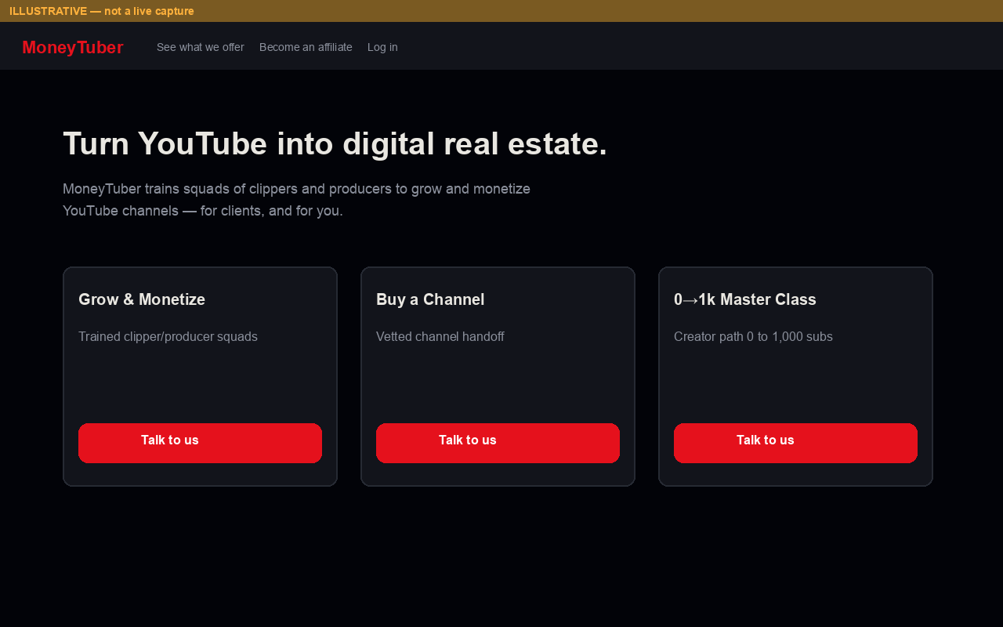
Matches public copy: “Turn YouTube into digital real estate” and three pillars.

02 — Login (**ILLUSTRATIVE**)
Login
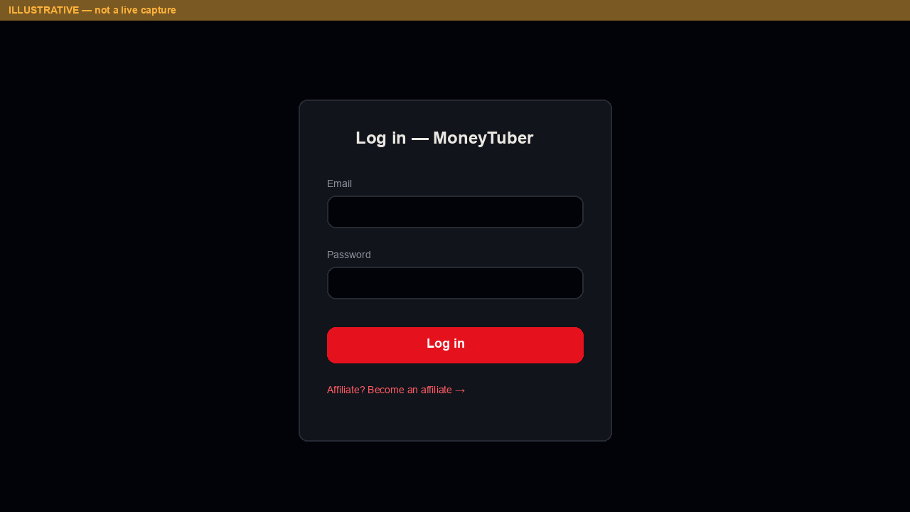

03 — Admin dashboard (**ILLUSTRATIVE**)
Admin
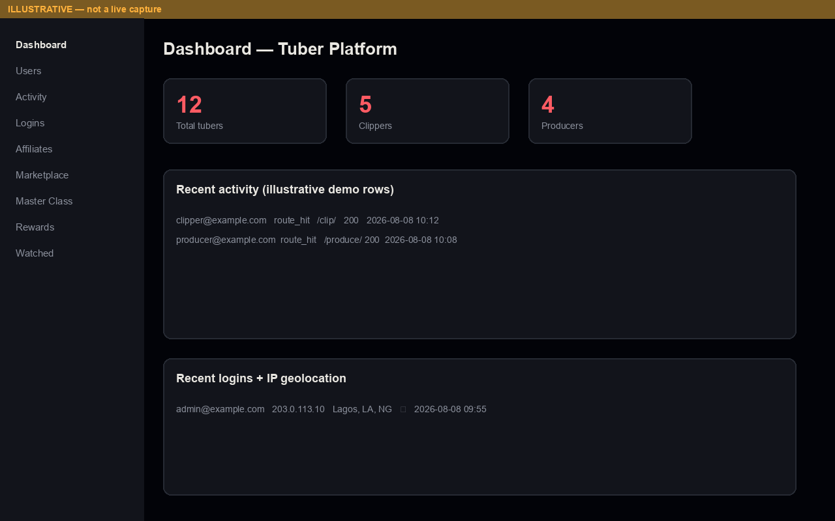
Counts and table rows are demo placeholders — not production findings.

04 — Suggestions queue (**ILLUSTRATIVE**)
Suggestions
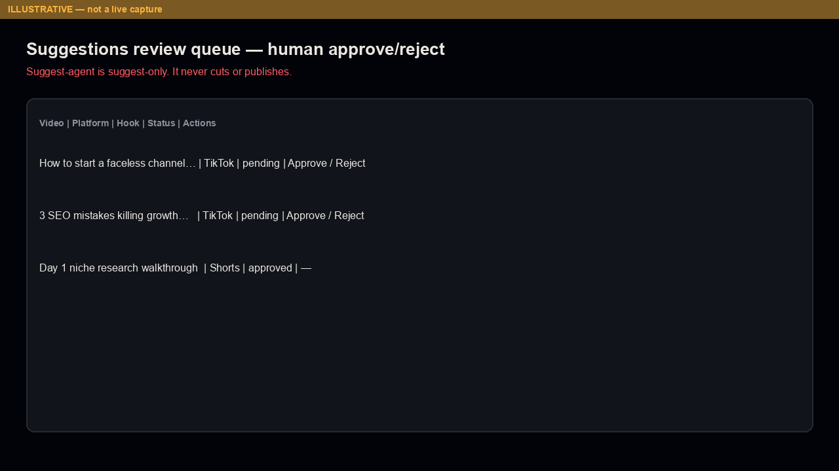
Emphasizes human approve/reject.

05 — Marketplace (**ILLUSTRATIVE**)
Marketplace
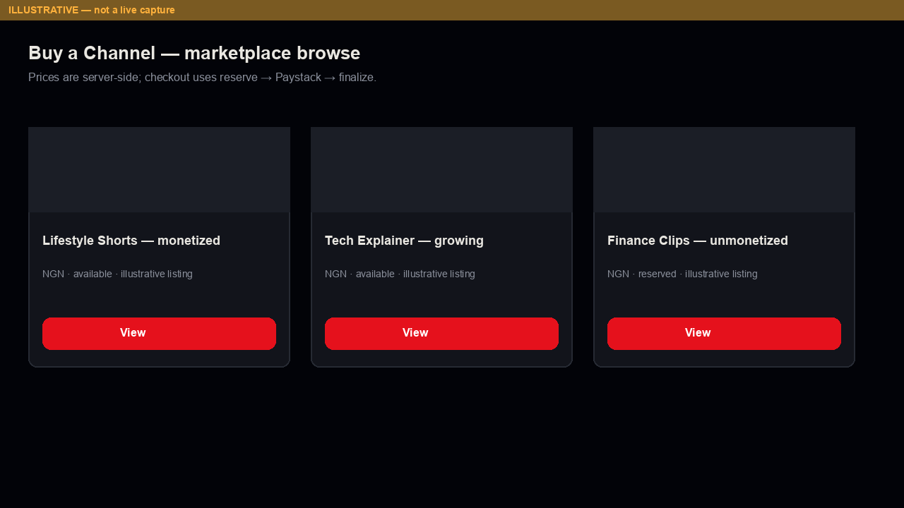

06 — Clipper tool
Clipper
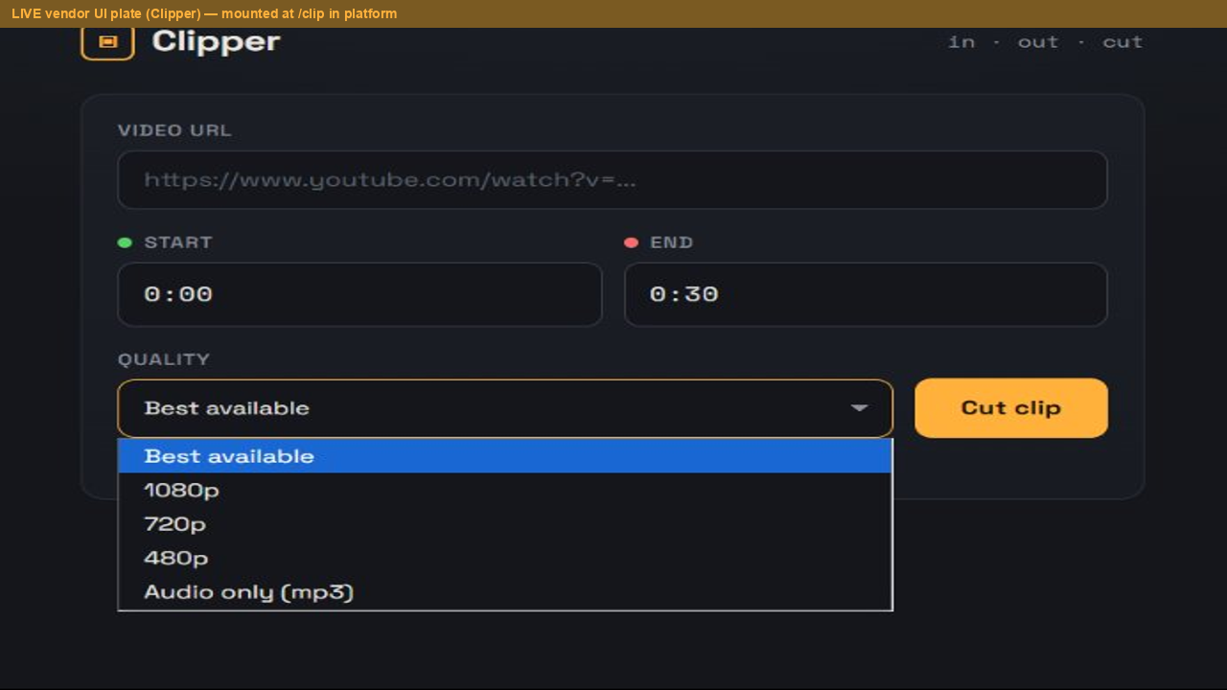
Derived from vendored Clipper screenshot assets; in platform context this UI is served under `/clip` for authorized roles.

07 — Affiliate (**ILLUSTRATIVE**)
Affiliate
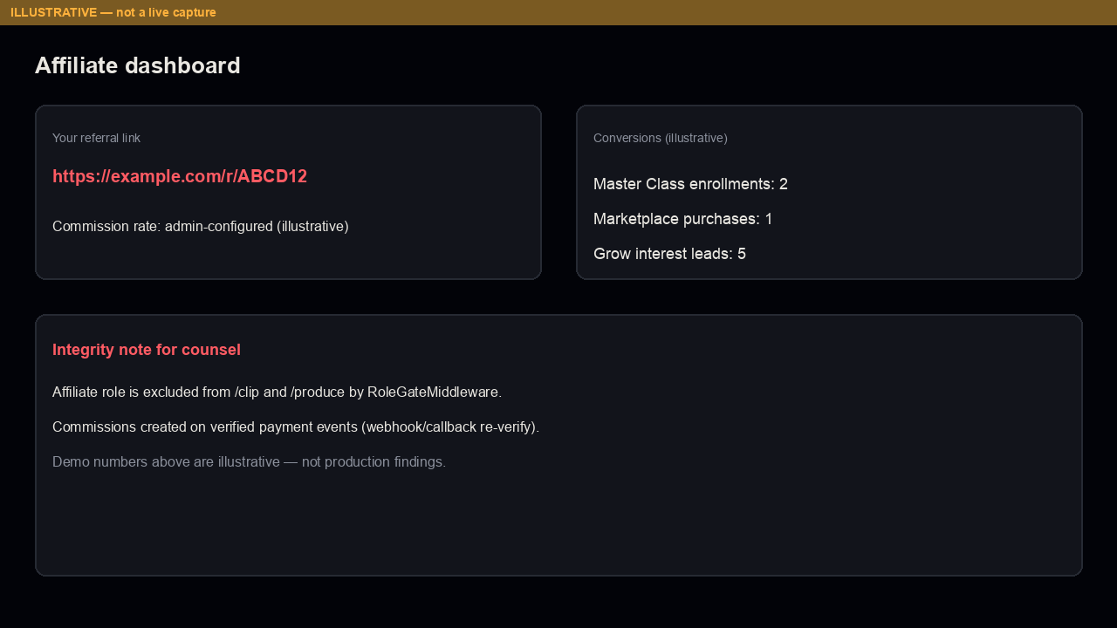

08 — Source / license status
License status
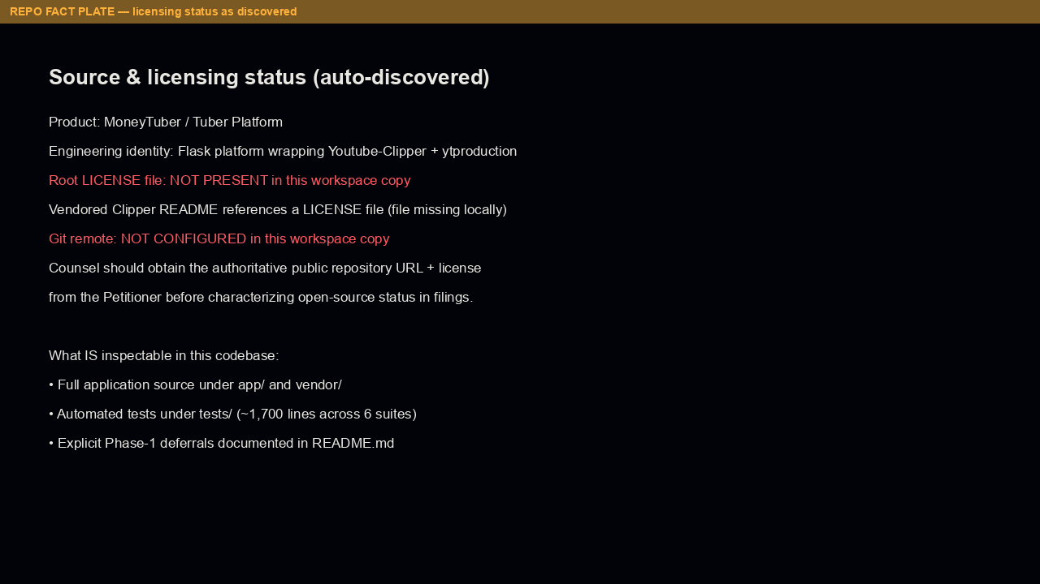
Honest discovery plate: no root LICENSE / no git remote in this workspace copy.
————————————————————

Note on LIVE vs ILLUSTRATIVE
Replace ILLUSTRATIVE plates with LIVE staging/production captures when counsel schedules a controlled demo. Keep banners until replacement. Never present illustrative commerce metrics as audited results.

Embedded visual set (binder order)

Figure 1 — End-to-end flow


Figure 2 — Architecture


Figure 3 — Modules → outcomes


Figure 4 — Integrity safeguards


Screenshot — Landing (ILLUSTRATIVE)


Screenshot — Login (ILLUSTRATIVE)


Screenshot — Admin dashboard (ILLUSTRATIVE)


Screenshot — Suggestions queue (ILLUSTRATIVE)


Screenshot — Marketplace (ILLUSTRATIVE)


Screenshot — Clipper tool


Screenshot — Affiliate (ILLUSTRATIVE)


Screenshot — Source/license status


