**FCS**[2019-2020] Sc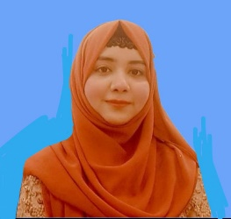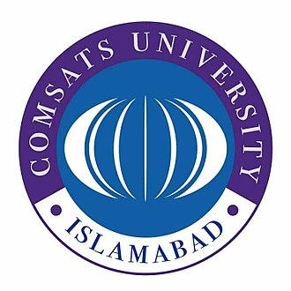

**Certificate Of Participation**

Workshop in stepping in career (organizer)

* Leadership skill
* Conflict resolution
* Compensation management
* Ai proficiency

***Aleena Tariq***

A dedicated BBA student at COMSATS University Wah Campus with practical experience through an HR internship at SNGPL. Skilled in communication, teamwork, and committed to pursuing a professional career in business management. I strive to cultivate a strong foundation of knowledge and leadership to contribute effectively to any organization.

ACTIVITIES

**Certificate of fundamental Digital Marketing**

EDUCATION

**FCS[2019-2021]**

Scholars Science College

**Bachelor of Business Administration[2021 -2025]**

COMSATS UNIVERSITY ISLAMABAD, WAH CAMPUS

**Internship**

The six-week internship in the Human Resources Department at SNGPL was successfully completed, providing valuable practical experience.

**Report on environmental pollution**

Gather data from people through

survey, questionnaire and make a report

**Proposal of Business idea**

Development of Marketing and financial strategies that support business structure

PROJECTS

ABOUT

+923200430719 [aleenatariq060@gmail.com](mailto:aleenatariq060@gmail.com) Lala Zar, Awan chowk Wah cantt

Website designing

Learning and development

Reading books

**English:** Read/Write/Speak

**Chinese:** Read/Speak

**Urdu:** Read/Write/Speak

INTERESTS

SKILLS

LANGUAGES