**CAR Rental Website**

**By Donghyeok Seo and Wei Wang**

**Purpose:**

This project is to implement a car-rental website (<https://www.enterprise.ca/en/home.html>).

It provides information of available cars by car types, prices and different cities. User can select cars and date/time. Admin can get the analysis from database based on user activities.

**Major features:**

User can search cars from cities.

User can select store from map.

User can schedule reservation.

User can modify/cancel reservation.

Company can push notification/advertisement to user.

Company can analyze data.

**Technologies:**

Google map API

Websocket for message pushing./2min

Facebook graph API – login using PHP library. HybridAuth=

Email verification/reset password,

HTML canvas library – find charting library

Automated testing, selenium

Payment through stripe,

**recaptcha/**registration

Multi-languages,

youtube dataAPI/ziggeophpsdk

Kartik-v/yii2-widget-rating(rating star)

//Gettext(localization)

//Eluceo/ical, send ical attachement in confirmation

//WebRTC real-time video

//Yelp api to fetch reviews, ratings of restaurants

Password encription

XCRUD for database

Slim php crud

Combine orders and reservations. Users/members. Image path, user-photo

**Database diagram**

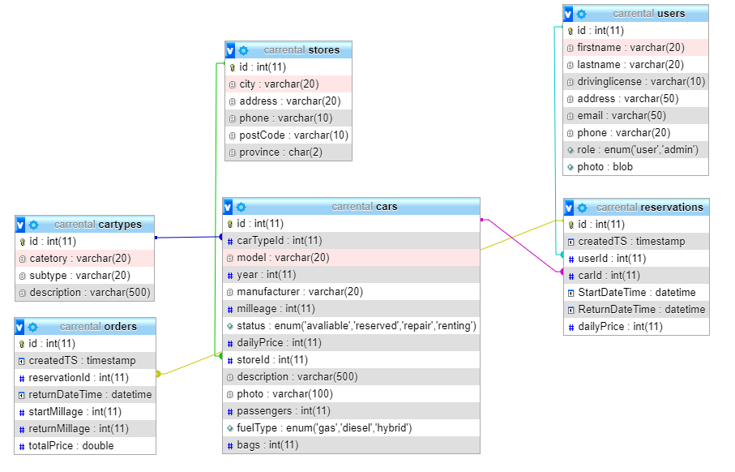

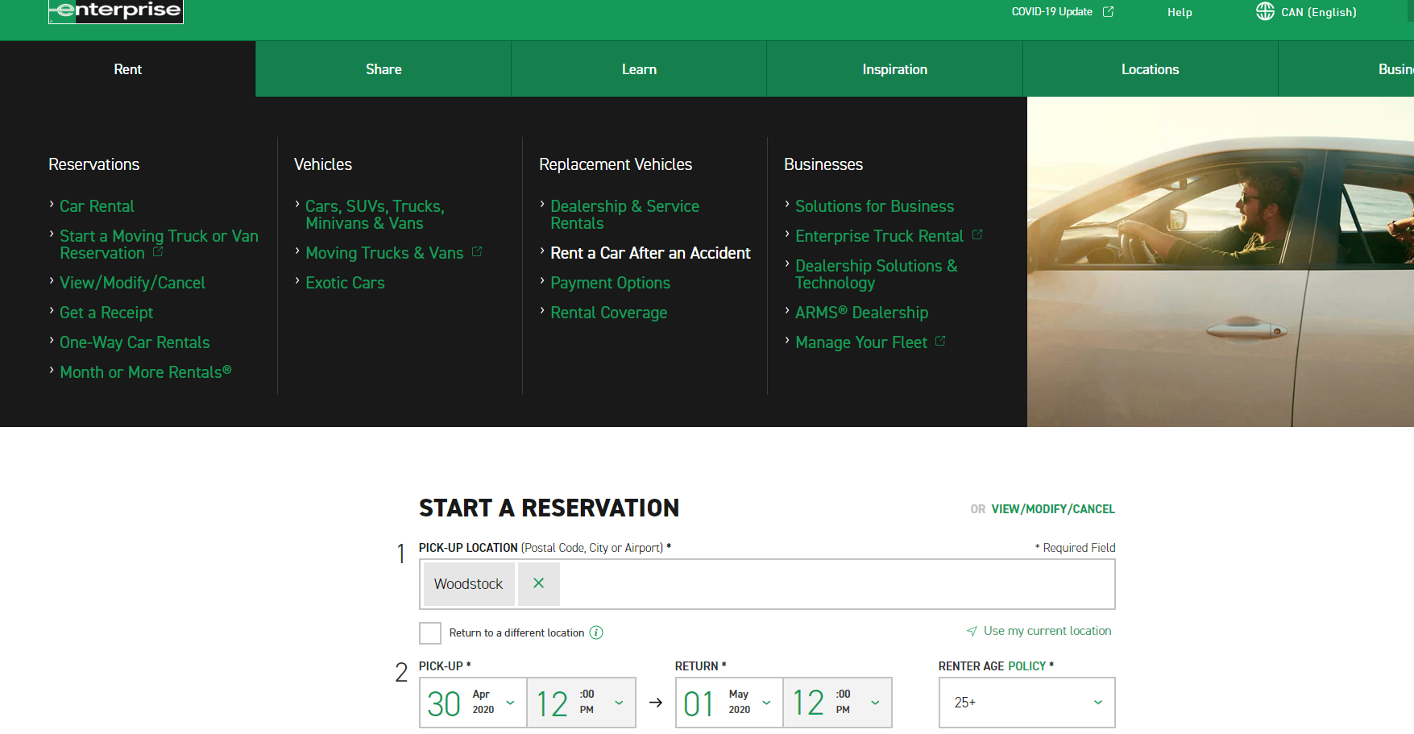**Design screenshot**



