Supplementary S3. Correlation matrix of main explanatory variables
Pearson correlation coefficients between the main explanatory variables used in the nested logit models, computed across all observations. Alternative-level variables (availability, price, wind speed, distance) were averaged across fishing alternatives before computing correlations. Values close to 1 or -1 indicate strong linear association; values near 0 indicate no linear association.

Cluster c4
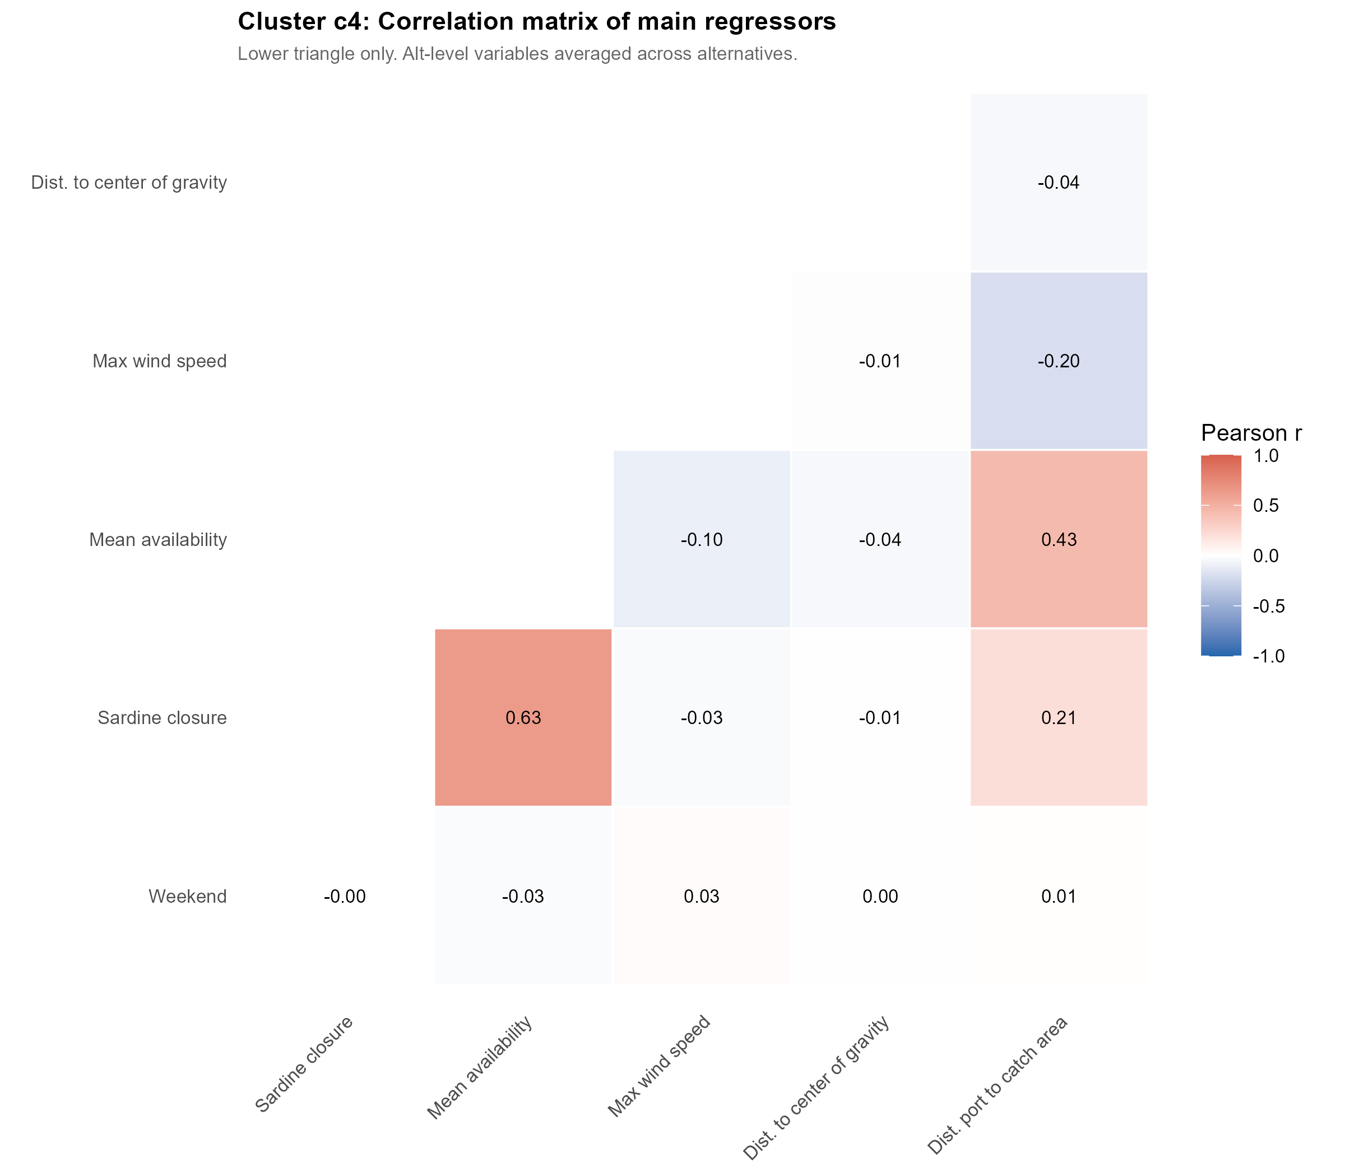

Cluster c5
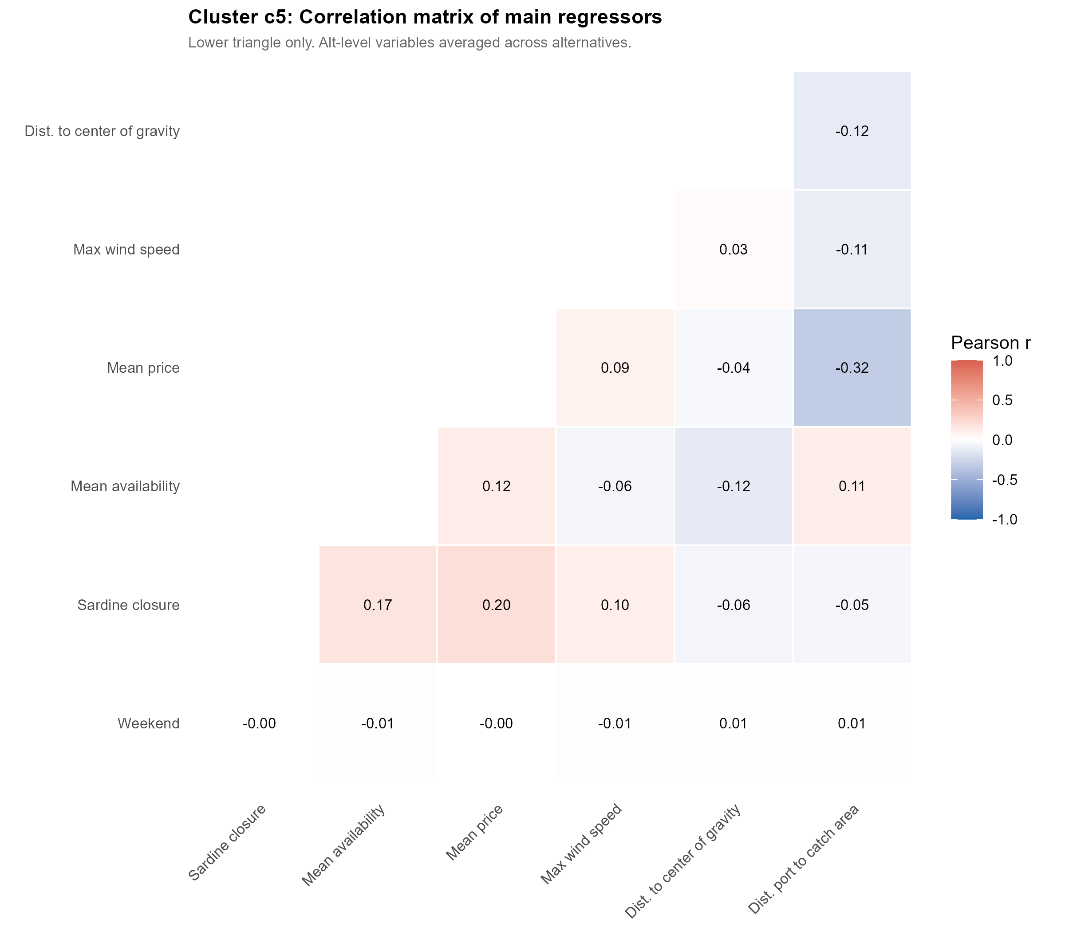

Cluster c6
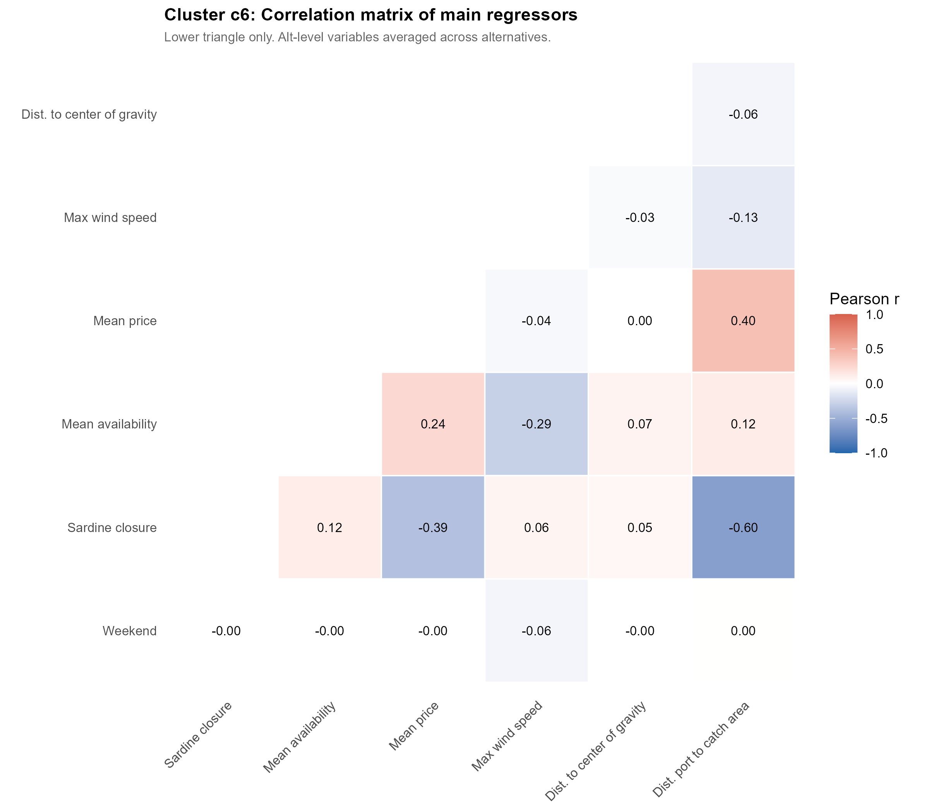

Cluster c7
