Disease Monitor System

Indiana University Data Science project for course BDAA

By Eden Barnett, Priyanka Jha, and Siva Kumar

edenbarn@umail.iu.edu
prijha@umail.iu.edu
sivannam@umail.iu.edu

Contents

Executive Summary 3
Solution Overview 4
The Database Objects 7
Software Installation requirements and guidelines 11
The Operating System 11
The Software 11
Steps to Run\ Replicate the Application 13
Scalability 19
Conclusion 20
Acknowledgements 21
References 21

Section 1

Executive Summary

Goals and Objectives:

The purpose of this project is to create a real time Disease Monitor System using Twitter data streams. Social media postings are used by a lot of users to express their health condition, concerns, and opinions. This publically available data can be used to extract valuable insights using Data Analytics. This project is an attempt to utilize the social media Twitter data to generate near real time visualizations. The Disease Monitor System will use the live tweets collected from Twitter API (https://apps.twitter.com). By using medical keywords, time-stamps, and locations queries on these tweets, this project tracks the occurrences and spread of Flu (Influenza) across the world. The insights drawn from data mining (Geographical Mining, Temporal Mining, and Text Mining) are displayed as spatial and temporal visualizations and activity maps. It also visually displays the distribution of tweets across its symptoms.
The design of the software is such that the functionality is easily scalable to track other diseases like Cancer, Diabetes, Tumor, etc. To map the diseases to correct symptoms, data from Centre of Disease Control and Prevention (CDC) is used. The Disease Monitoring System can be used to minimize the outbreaks by tracking disease progression and can be leveraged as a tool to manage Population Health (PHM).

Key functionalities:

- Fetch live tweets on the diseases using Microsoft StreamInsight and store it in MongoDB database.
- Geographical Mining analyzes the severity of the disease across the world using heat map.
- Temporal Analysis tracks the changes in volume of the tweets related to the disease over the time.
- Text Mining is leveraged to get the pie-chart distribution of the tweets for the disease symptoms.

Section 2

Solution Overview

Below is a pictorial representation of high-level project workflow. The twitter data is filtered based on disease related keywords (in this case for flu) using Microsoft StreamInsight. This data is stored in MongoDB, which is then queried to exact meaningful insights. These insights are presented in the form of visualizations using ASP.Net and JavaScript.
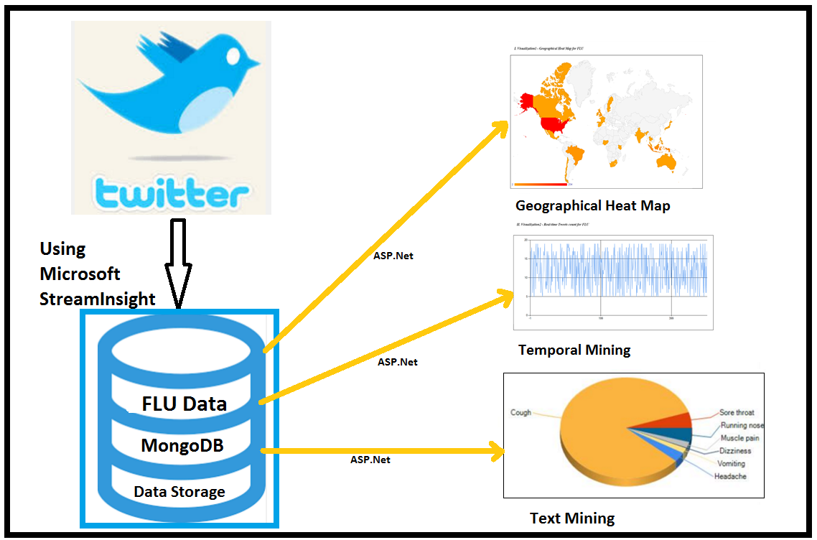

Twitter allows users to interact with its data, i.e. tweets & several attributes about tweets, using Twitter APIs. A server side language is required to make requests to Twitter API and the results are sent back in JSON format. Microsoft StreamInsight is a platform for Complex Event Processing (CEP) that enables the processing of high-speed data streams from multiple data sources. Twitter is a good data source for StreamInsight because it provides a streaming API.

Events in StreamInsight can be of three temporal types – Point, Interval, and Edge. For this project, we are using Point event as Twitter messages posted at a point in time, and therefore is a more logical choice. In general, if there is a need, these point events can be transformed into Interval or edge events.

The event data in StreamInsight is managed using a C# class. Another class file ‘TweetType.cs’ holds the definition of class TweetType. Below is a snapshot of this file –
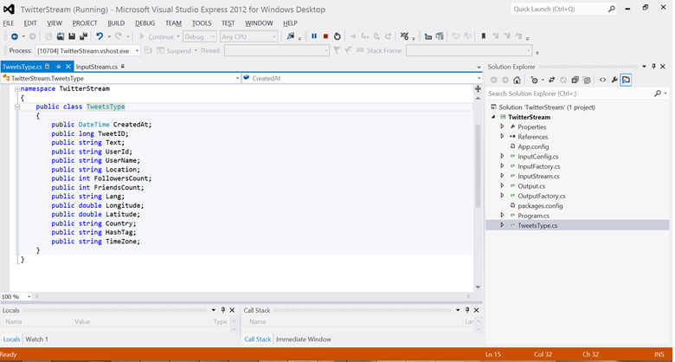

This class is instantiated to hold temporarily one record of what the Twitter API sends. Additionally, a new field call ‘HashTag’ is added to identify the record based on its disease type and holds the values Flu or Cancer. The keywords are added using a method called ‘AddTrack’. The C# file ‘InputStream.cs’ is the entry point of the program - it extracts the twitter record into this object and then sends to the ‘Enqueue’ stream, which is StreamInsight Engine.

After the input stream is created, the query needs to be defined, which is done in ‘Program.cs’ file. Here, no ‘Where’ clause was used as no additional filtering was needed on the input stream. Next the stream is ‘dequeued’ using output adapter ‘Output.cs’. The latitude and longitude values are used to fetch the country of the user using google API –
http://maps.googleapis.com/maps/api/geocode/xml?latlng=" + latitude + "," + longitude + "&sensor=false

Next, a new ‘BSONDocument’ document type is created to insert in
MongoDB database ‘DiseaseMonitor’in a collection called ‘tweets’. This completes the first step of fetching data from Twitter and storing IT in MongoDB.

The project uses ‘ProcessEngine.py’ to read the MongoDB ‘DiseaseMonitor’ collection ‘tweets’ to now divide the tweets based on the Flu symptoms and get individual count of those symptoms and store it in another collection called ‘FluSymptoms’.

For visualization, ASP.Net is used to read data from MongoDB to perform geographical, temporal, and text analysis and display in form of graphs. The solution file DMChart.sln is created for this purpose. ‘FLU-Homepage.aspx’ is the entry point of the program.’Visualization1 – Geographic Heat Map’ reads from ‘FluLocationCount’ collection in MongoDB. JavaScript is used for basic library loading and drawing the map in ASP.Net using the below methods –
google.load('visualization', '1.0', { 'packages': ['geochart'] });
google.setOnLoadCallback(drawChart);

Visualization2 is a temporal graph of the count of tweets received on Flu. It reads from the MongoDB collection ‘FluRealTimeCount’ to demonstrate the tweet volume (number of Flu tweets per 10 seconds) for last 10 minutes and continues to show live inflow.

Visualization3 is a pie-chart distribution of the Flu tweets across its symptoms. The data it reads comes from the MongoDB collection ‘FluSymptoms’, which holds the count of tweets for various Flu symptoms. Then calculates the percentage of each symptom and presents in the form of pie-chart. ASP.Net ‘DataVisualization.Charting.Chart’ control is used for the purpose. The properties are set at the runtime and Legend is set to display value as percentage P2 (precision up to 2 decimal places).

Section 3

The Database Objects

As mentioned above, the project uses MongoDB for the data storage and manipulation. This section briefly shows the database objects created for Disease Monitor System. The database name is ‘DiseaseMonitor’ and below are the list of collections –

- Tweets – A collection of flu related tweets where one document maps to one tweet posted on flu, the user id who tweeted it, the count of followers of this user id, location of the user, the date & time of the tweet, and other details. Here is a snapshot of a document in this collection.
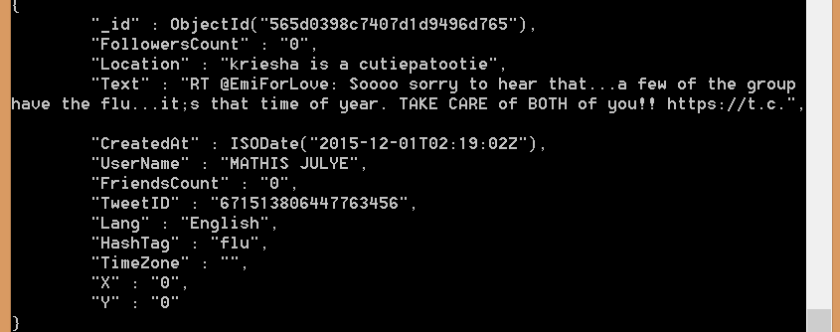

- FluSymptoms – This collection holds the count of various flu symptoms like headache, cough, sore throat, running nose, muscle pain, dizziness, and vomiting. Here is a snapshot of this collection –
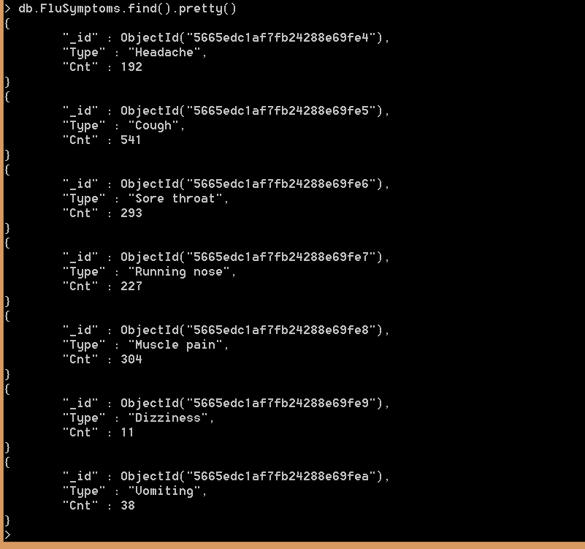

- FluLocationCount – This collection holds the count of the Flu tweets created from a particular location. This collection is used to create the geographical heat map visualization. Below is a snapshot of the collection’s documents. Not all users have updated valid location and missing data is not accounted for.
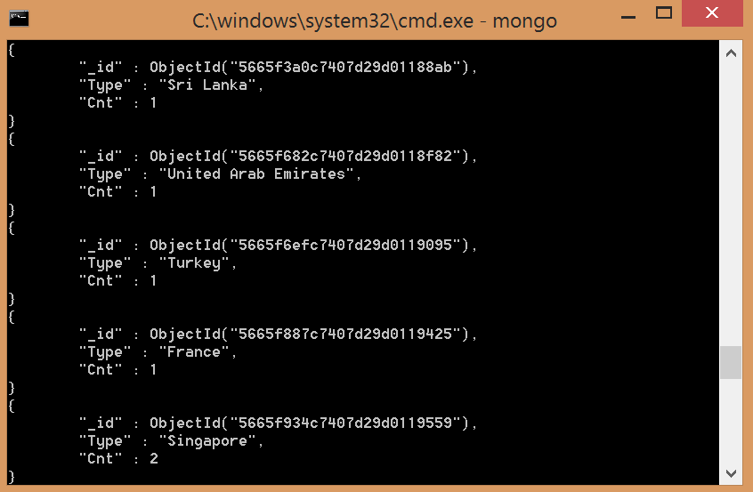

- CancerLocationCount – This collection holds the count of the Flu tweets created from a particular location. This collection is used to create the geographical heat map visualization. Below is a snapshot of the collection’s documents. Not all users have updated valid location and missing data is not accounted for.

- CancerCount – To demonstrate the scalability of this project, an extention of the Disease Monitor System beyond Flu was i.e. a proof of concept on cancer monitoring. This collection holds the count of different cancers, which will be used to generate the pie-chart visualization of cancer types. Here is a snapshot of this collection.
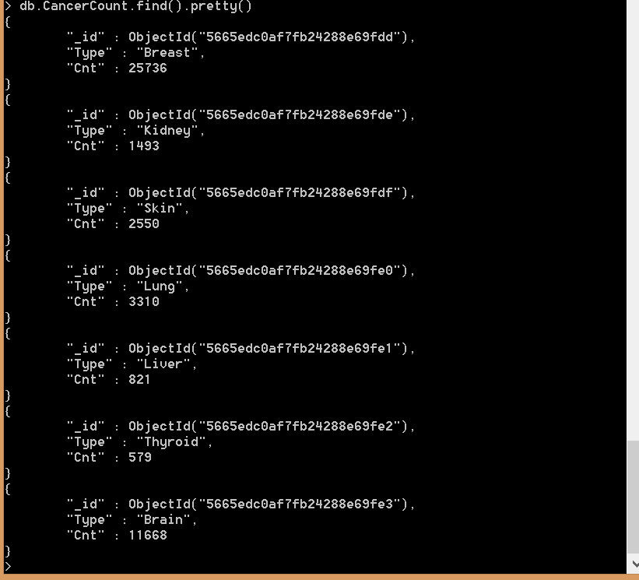

- FluRealTimeCount
This collection is used to create the temporal graph.
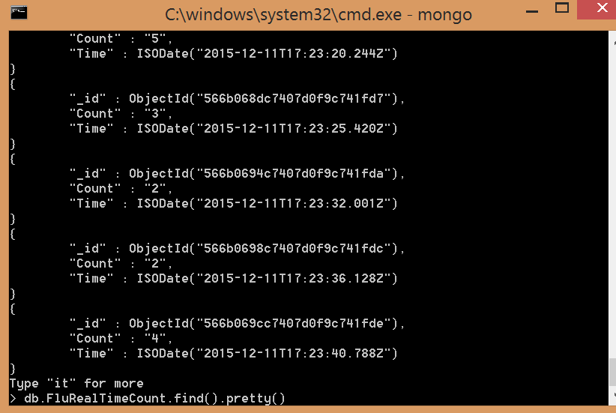

- CancerRealTimeCount
Like FluRealTimeCount, CancerRealTimeCount is the collection used for Temporal graphs.
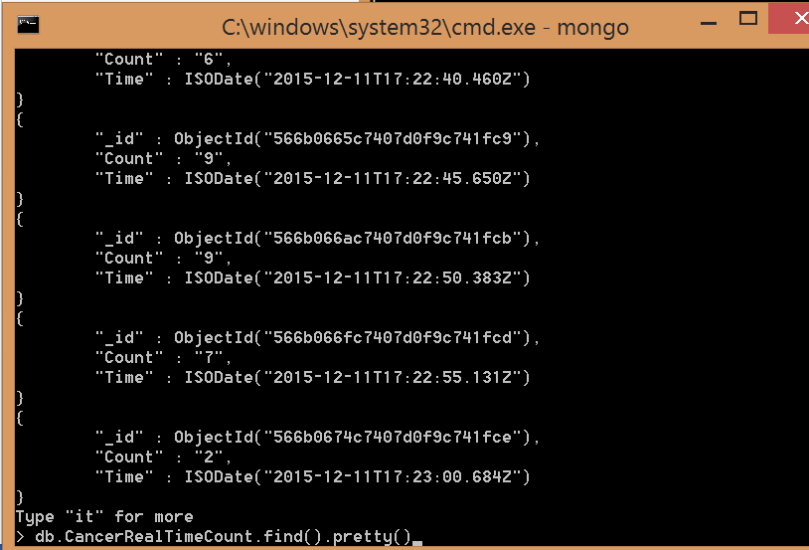

Section 4

Software Installation requirements and guidelines

The Operating System

This project was created and run on Windows 8.1. In order to replicate it on other OS will require further PoC, which is out of scope of this project.

The Software

- Microsoft Visual Studio 2012 Express for Windows Desktop and Web. Windows Desktop version is required for using StreamInsight. The Web version is needed for the visualization.
  - http://www.microsoft.com/en-us/download/details.aspx?id=34673
  - https://www.microsoft.com/en-us/download/details.aspx?id=30669
- Microsoft SQL Server Stream Insight 2.0. When running the .msi, on step 2 select ‘install instance’ and on step 3 name the instance as ‘localhost’.
  - http://www.microsoft.com/en-us/download/details.aspx?id=29070
- SQL Server CE 3.5 SP2 (Cumulative Update 4)
  - https://support.microsoft.com/en-us/kb/2516828
- Install Tweetinvi
  - https://tweetinvi.codeplex.com/
- Install MongoDB Driver for C# (Use Nuget in Visual Studio)
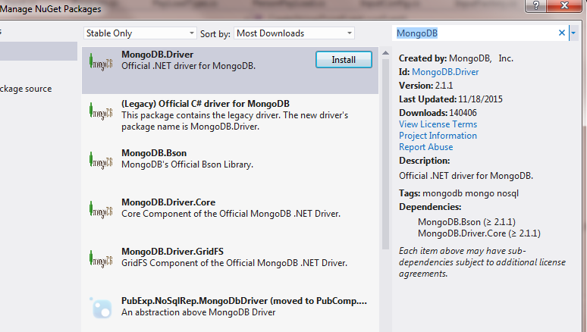

- Install MongoDB 3.0
  - https://www.mongodb.org/downloads#production
- Install Python 3.4.2 for Windows
  - https://www.python.org/downloads/release/python-342/
- Install PyMongo, the Python driver for MongoDB
  - https://pypi.python.org/pypi/pymongo/

Section 5

Steps to Run\ Replicate the Application

This is done is three parts –
- The part A is the App registration on Twitter API to get Twitter API keys,
- The part B is the setup of StreamInsight project to collect the live tweets from Twitter and save it to MongoDB,
- The part C is the visualization using Text Mining, Geographic Mining, and Temporal analysis of Twitter data.

PART A – App registration on Twitter API to get Twitter API keys
In order to access Twitter API to get live tweets, we need 4 elements – API Key (Consumer Key), API Secret (Consumer Secret), Access Token, and Access Token Secret. Below are the steps to obtain the same –
- Create a twitter account if you do not already have one.
- Go to https://apps.twitter.com/ and log in with your twitter credentials.
- Click "Create New App"
- Fill out the form, agree to the terms, and click "Create your Twitter application"
- In the next page, click on "API keys" tab, and copy your "API key" and "API secret".
- Scroll down and click "Create my access token", and copy your "Access token" and "Access token secret".

Part B - StreamInsight project to collect the live tweets from Twitter and save it to MongoDB

- Start the MongoDB Server.
- Start windows command prompt (Go to Run, type cmd, and enter)
- In command prompt change to MondoDB bin directory (cd C:\Program Files\MongoDB\Server\3.0\bin)
- Type mongod and enter
- Leave this MongoDB server running at all times.
- Open MongoDB in command prompt and create database DiseaseMonitor
- Start windows command prompt (Go to Run, type cmd, and enter)
- In command prompt change to MondoDB bin directory (cd C:\Program Files\MongoDB\Server\3.0\bin)
- Type ‘mongo’ and press enter
- Type ‘use DiseaseMonitor’ and press enter (This will create and switch to a database called DiseaseMonitor in MongoDB).
- Download and Extract the file ‘TwitterStream.zip’ from the archive folder. After extracting, launch TwitterStream.sln in Visual Studio 2012 Window Desktop version.
- In the Visual Studio, open the file InputStreams.cs. Go to the method ProductEvent() and provide the Twitter API credentials (that was created in Part A) in Auth.SetUserCredentials(string consumerKey, string consumerSecret, string userAccessToken, string userAccessSecret). Save the changes. For convenience, one set of credentials are provided in the file, but the app will be deleted after the completion of the project.
- From Visual Studio, run the application by clicking on green start arrow on the toolbar. This will start the StreamInsight and you should be able to see the stream of user id of the incoming tweets being displayed. Leave this application running at all times so the incoming tweets will be stored in the database.
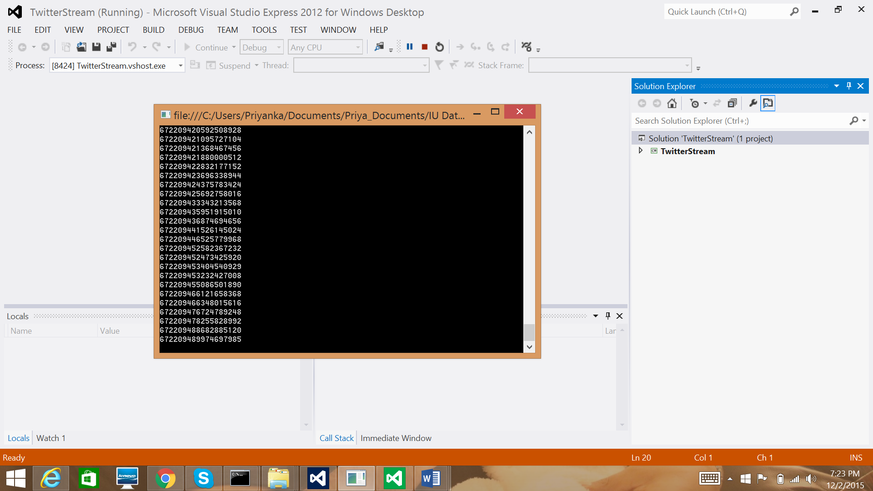

- In order to confirm that documents are stored in ‘Tweets’ collection, run this command in mongo shell –
db.tweets.find().pretty()
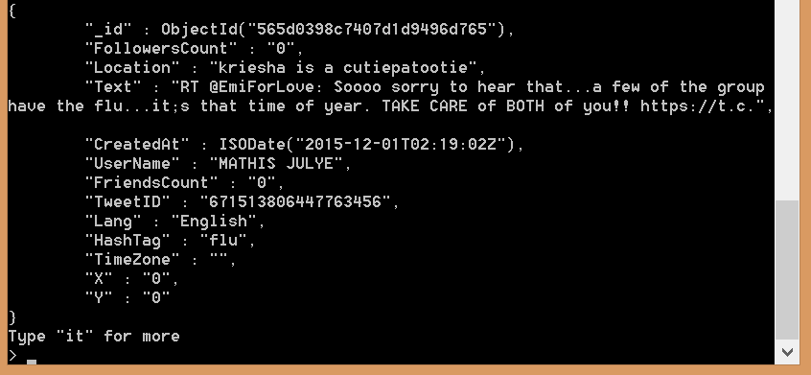
This screen shows an example of a document in tweets collection. A document would hold the User ID, Followers Count, Location, Text (holds the tweet), User Name, Location, etc.
NOTE: An additional column “HashTag” was introduced to hold the category of the tweet example “cancer”, “flu” etc. This is done in order to query the database based on these categories.
- Import additional data into ‘tweets’ collection into MongoDB – we have been collecting live data for days now. This step is needed only to see full visualization potential, else the visualization will have very few data to display the streaming live data. Download and extract tweets.json file prior to running this command from bin folder. Provide the path to the tweets.json file.
mongoimport --db DiseaseMonitor --collection tweets --type json --file c:\..\tweets.json

Part C - Visualization using Text Mining, Geographic Mining, and Temporal analysis of Twitter data
- Create an index on ‘Text’ in the collection ‘Tweets’ in ‘DiseaseMonitor’ database
- Open Mongo shell.
- Type ‘use DiseaseMonitor’ and press enter.
- Run the command db.tweets.createIndex({Text:'text'})
- Download ‘ProcessEngine.py’ and DMChart.zip from the Archive folder. Extract DMChart.zip.
- Run ProcessEngine.py file - a one-time task to fetch counts of individual FluSymptoms and CancerTypes. It also talks to google API to fetch locations of users that tweeted for Flu and Cancer and stores in FluLocationCount and CancerLocationCount collections.
- Open command prompt and change directory to where Python program bin folder is. For example ‘CD C:\Python34’.
- Make sure you have MongoDB open in a separate command prompt window and you have it set on the same database used previously by typing ‘use DiseaseMonitor’.
- Type ‘python.exe C:\Python34\Priyanka\ProcessEngine.py’ use the path to your local copy of ProcessEngine.py.
- This should create additional collections in ‘DiseaseMonitor’ database namely ‘cancerCount’, ‘FluSymptoms’, ‘FluLocationCount’, and ‘CancerLocationCount’. You can check this by running ‘show collections’ in MongoDB.
- This will print and store the sum of cancer type count, and flu symptom counts. It will also fetch the location of users who have tweeted on Flu and cancer for the data that is already in the collection ‘tweets’. All these are stored back to the above collections respectively, and will be used to create visualizations.
- Open TweetCountStream folder after extracting and run the solution file using TweetCountStream.sln in Visual Studio 2012 Window Desktop version. Start the application and leave it running as a background process. Wait for 10 mins for the first time before running the visualization for better graphic displays.
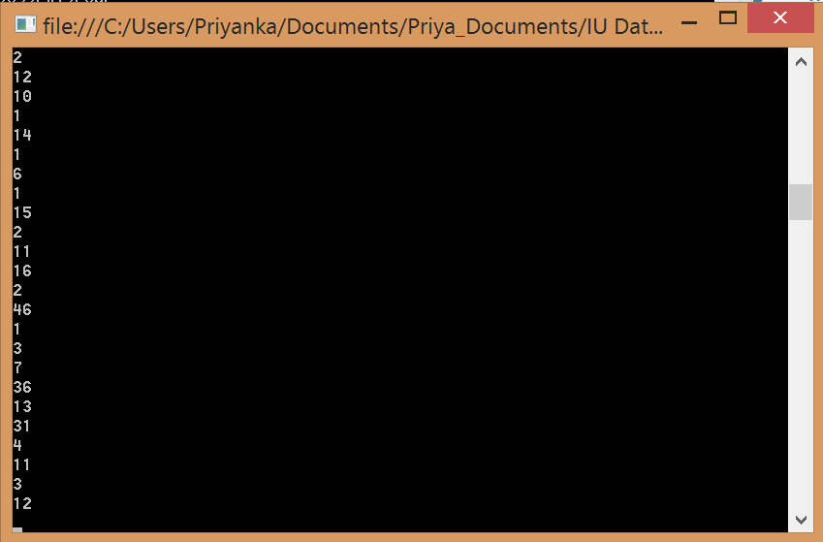
- Open DMChart.sln from DMChart folder using Visual Studio Express for Web. Right click on ‘FLU-HomePage.aspx’ and set it as the start page. Start the project by clicking on the green arrow on the toolbar. This will open the visualization in a web browser.
- Visualization Results – These are the three visualizations that open up in a web browser on the ‘Flu-HomePage.aspx’. There is, however, a navigation button on the page which take to the Cancer visualization page (refer to section 7 for more information on this). You can click on the button ‘Go to Cancer page’ for the visualizations on cancer.

  - Geographical Heat Map –

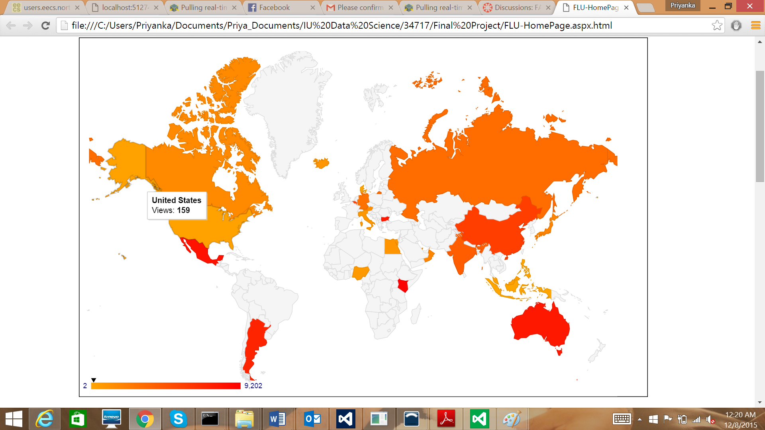

  - Temporal Tweet count for Flu –

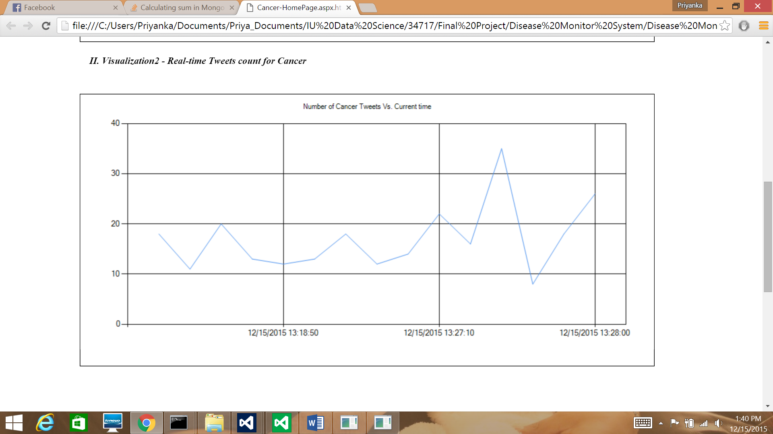

  - Pie-chart Distribution of Flu Symptoms –

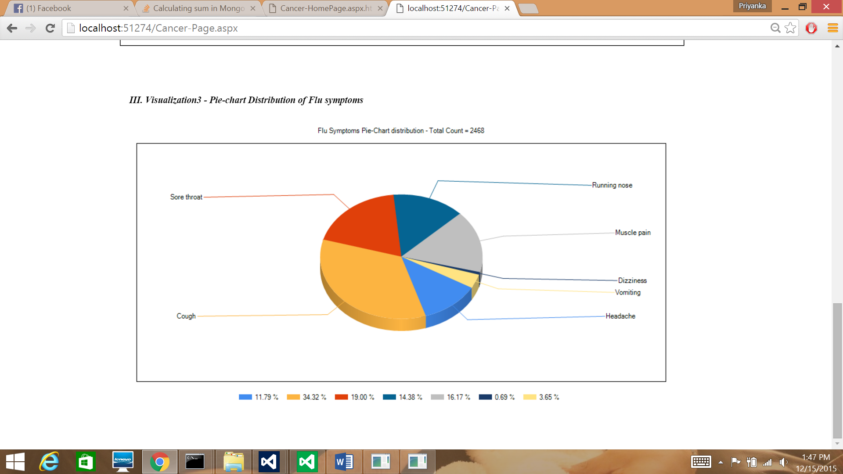

Section 6

Scalability

In order to demonstrate the scalability of the application, an attempt was made to extend the Disease Monitor System to Cancer. The tweets with the keyword ‘Cancer’ were exacted from the Twitter API and stored in MongoDB database ‘DiseaseMonitor’ in the same collection (‘Tweets’) as the Flu tweets were. Furthermore, these tweets are categorized based on the type of Cancer and the count of the types are stored in a separate collection called ‘CancerTypes’. This collection is similar to the collection ‘FluSymptoms’. Please refer to section 3 ‘Database Objects’ to get details on the collection ‘CancerCount’.

The visualization page for ‘Cancer’ is similar to that of ‘Flu’. Refer to the ‘Sample Run’ folder in the archive file for the html visualization pages generated during one of the application runs on the local machine.

Section 7

Conclusion
In this project, a near real-time Disease Monitor System was built that uses Twitter data to track disease activities and their progression. It primarily was focused on tracking the Flu and Cancer across the world. It analyzes the spread of Flu symptoms and Cancer types and gives a fair estimate of the impact of the two diseases. It also analyzes the rate at which the spread happens across the world. This can easily be localized to one country or state, which can give more useful insights. This system can be used to analyze the outbreaks easily. Disease Monitor System is highly scalable and can be easily extended to analyzing other Diseases. This system could find multiple applications in healthcare industry including (but not limited to) Disease Management (DM), Population Health Management (PHM) etc.

Section 8

Acknowledgements

We would like to thank Prof. Geoffrey Fox and his team for the valuable insights into Big Data Analytics and its Applications and also for their guidance in helping us understand the various Technologies relevant to Data Science.

References
- http://www.sqlservercentral.com/articles/StreamInsight/
- http://www.zaiste.net/2012/08/importing_json_into_mongodb/
- https://blog.twitter.com/2015/twitter-data-public-health
- https://technet.microsoft.com/en-us/library/ee362541(v=sql.111).aspx
- https://www.aaai.org/ocs/index.php/WS/AAAIW14/paper/viewFile/8723/8218
- http://www.dtic.mil/ndia/2012bio/Coberly.pdf
- http://www.crowdbreaks.com/
- https://tweetinvi.codeplex.com/
- https://www.nuget.org/packages/TweetinviAPI/
- http://wwwn.cdc.gov/nndss/

