**xScheduler**

**Web Button Control**

**for**

**Mobile Audience Interaction**

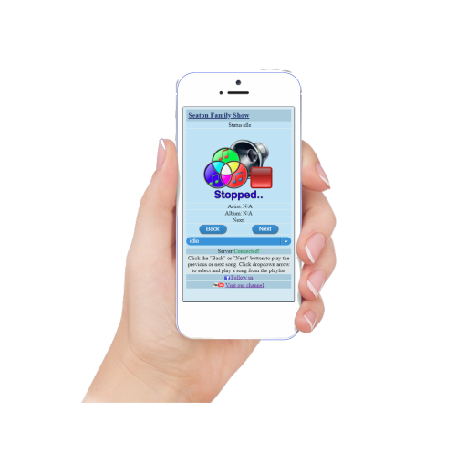

Introduction

Last Christmas I designed an inactive controller with two buttons (Back/Next) to allow spectators watching my Christmas lightshow to skip to the next, or go back to a previous song during the show.

I was so excited to see people walking by and using the buttons to interact with the show. However, there were many mobile spectators who did not have the same opportunity to interact, so I needed to find a way to also engage the people who were driving up to watch or those who did not get close enough to interact with the buttons.

This inspired me to find a solution that would allow viewers driving up (or walking) to interact with the show using their mobile phones.

This design parameters:

1. Simple
2. Intuitive
3. Secure (as is possible)
4. Responsive
5. Persistent data (Client browser must support local storage)

Xlights xScheduler

I use a great software called xLights to schedule my Christmas lightshow and although it ships with a web application, it was not designed to be used as a spectator portal.

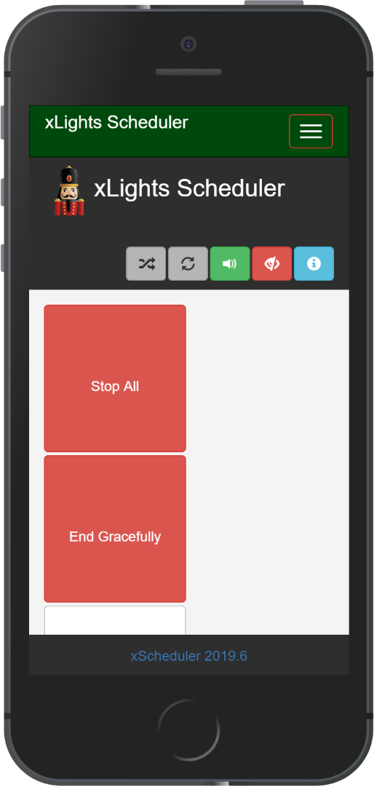

Fortunately the designers allow the default web directory to be replaced with a custom design and provides an easy to use API to make it possible.

The really great thing about the xLights Scheduler is that it is not only a HTTP server but also a Web Socket server. This means that there is a persistent connection between a client and the server that facilitates real-time data transfer, so both parties can send and receive data at any time with lower overheads.

**The Design**

I designed my application as a WebSocket client, with two buttons and a dropdown combo box that not only allow the viewer to move back and forward in a playlist, but also to jump to a specified song in a playlist. This design also allows for the addition of a song image in addition to the artist and album name.

|  |  |
| --- | --- |
|  |  |

At the top of the screen is the custom show title and at the bottom are links to a favorite Facebook group and YouTube channel. These custom values are pulled for the show’s setting file “show.dat”

There are several options for implementing a custom web application but I think the the simplest way is to replace the default xScheduleWeb folder with your own folder containing the files for the custom web application. In my example I replaced it with xLightsShowWeb. The folder with the custom site should be on the same xLights machine.

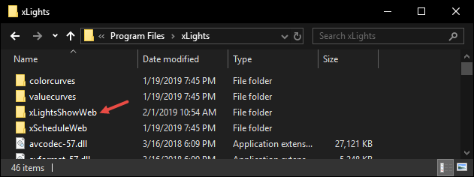

Open the xLights Scheduler and select “Edit” – “Options”: from the main menu.

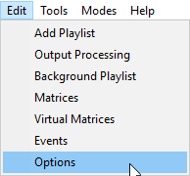

Enter the folder name in the “Web Directory” field and click “Ok”

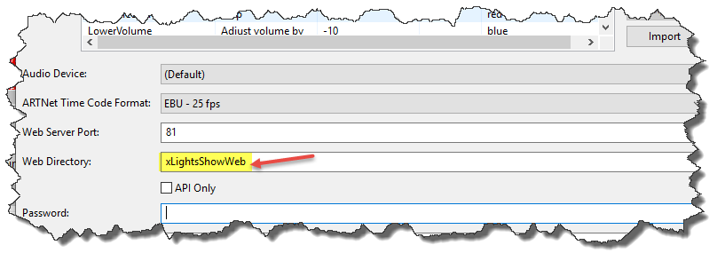

An example of the customer app featured in this article may be downloaded from my [GitHub repository](https://github.com/futuretechguy/xLightsShowWeb.git)

When the client connects for the xScheduler Socket server for first timer, it request the songs in current playlist and stores them to local (browser) storage, it then uses this stored list to update the screen from this point on. It will not have the album/song image, album, and artist name initially because this information is not provided by the xLights Scheduler Socket server and has to be manually entered as an initial setup process after the local storage data is created. To see the data in a Chrome browser, press Ctrl+Shift+I and select the application menu – Local Storage on the left and click the localhost IP.

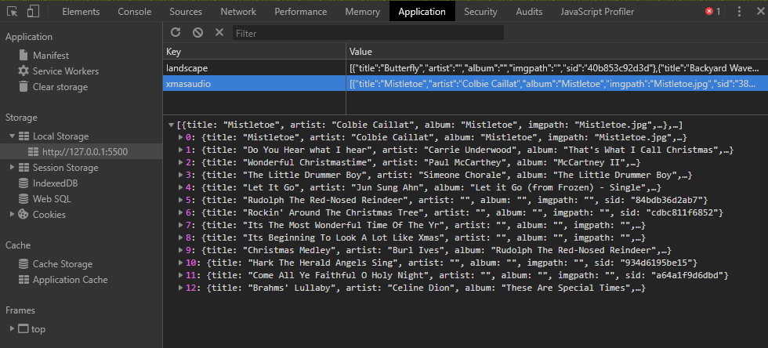

The song title, artist, album and image names are stored in the local storage. There is a file called playlist.html that should be run in the browser on the local server, to edit the data in the local store and add the missing information.

Once all the information in the local store is updated, click the “Upload” button to manually upload the data to the server (\xLights\xScheduleData). The server will then push the new data to the local stores of all connected clients. More detailed information will be provided in the “How To” section.

The client will first look in the /img subfolder on the server for the actual files referenced in “imgpath” field of the local store. If the client does not find the image, it will look for a *.png image file that matches the name of the step/song, if one does not exist, it will use the default img/ShowPlaying.png file. If the artist and album fields are not populated in the local store, they are left blank on the screen.

Open [Server:Port]/xLightsShowWeb/Pages/playlist.html and click on the “X” to the left of a title and the available information will populate the relevant fields. Enter the additional information (image file should be 218X218 *.png) and click save. Continue until all the missing information is updated.

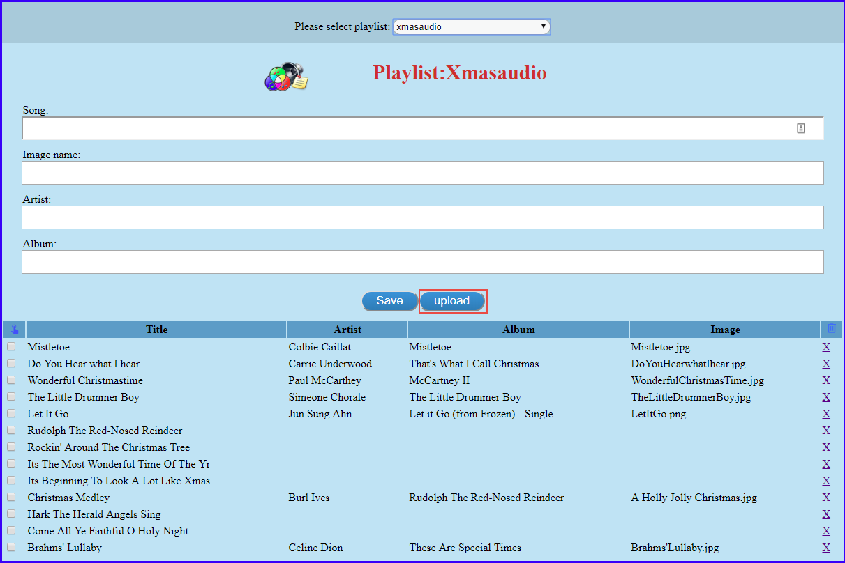

The file save dialog window will open and prompt to store the data, select the default xLights data store folder (\xLights\xScheduleData). Get[PlayListName].dat will be provided in the file name field of the file save dialog; ALWAYS USE THE NAME PROVIDED.

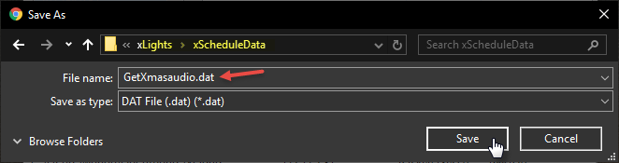

The GetShow.dat file stores the custom data for the show, it created when the client loads.

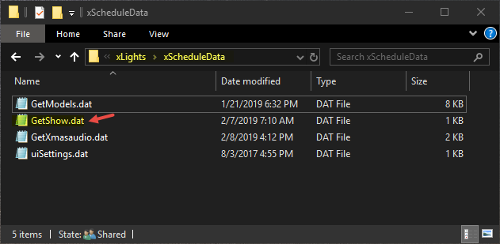

The data is in JSON format and may be changed to include relevent custom data.

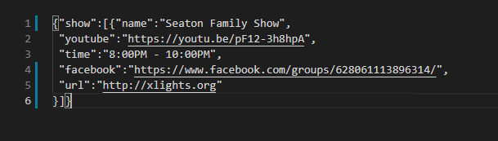

The show title and links are pulled from the GetShow.dat file. The default for the title is “Our Family Show” and the links will be blank if the file can’t be loaded. The Youtube link in the file is to the “Christmas lights from around the world show” and the Facebook link is to the the Xlights group. So please be sure to change them.

|  |
| --- |
|  |
|  |
|  |
|  |
|  |

Implimentation

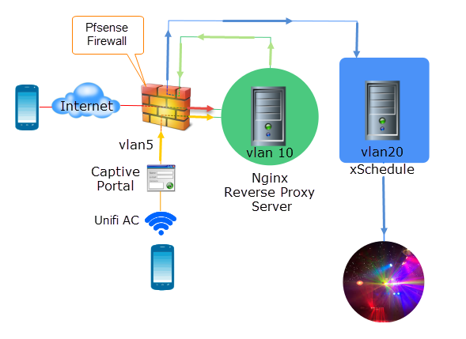

There are two ways to impliment the web button controller:

1. Using a domain URL (http://lightshow.seatonplace.com) that resolves to the firewall (WAN).
2. A WiFi access point (SSID= lightshow) that connects to a Captive Portal (on isolated VLAN) and authentictes the client.

**Domain URL:** This is the prefered method because it is a simple process for the end user, they are only required to type a URL in the browser on their mobile device (no port number). This obviously requires a domain name (or dynamic DNS).

In this configuration the domain name resolves WAN traffic to a firewall (router) with some form of intrusion detection software. The firewall rule, (which has a schedule that matches the show times), forwards port 80 traffic to a Reverse Proxy server (on VLAN x) that in turns forwards the traffic to a Windows (Or Linux) machine running the xScheduler (on VLAN y). The Reverse Proxy server is the only IP on network x that is allowed to send traffic through the firewall to the xScheduler on network x.

NGINX is a free, open-source reverse proxy server that offers many security and protection benefits over a straight through (port forwarding) connection. The Nginx server also supports Hop-by-hop headers which are essential for forwarding web Socket request. The connection from WAN to the Reverse Proxy server should be secure HTTPS, this requires a certificate.

**WiFi Access Point:** This method requires a few more steps including authentication for the user, this and the fact that they are connecting to an unknown WiFi AC may be a deterant for some users.

The first step in this method is to locate the SSID (eg:“xmashow”) and enter the provided password to connect to the network.

The user is then redirected to a Captive portal to accept the terms, redirect to the web controller page. The DHCP for this network (VLAN z) will ony assign a maximum of 4 IPs and only those 4 will be allowed through the firewall during show time. The Captive Portal will disconnect the user after 5 minutes and the connection cannot be reestablished before 10 minutes has expired.

|  |  |
| --- | --- |
|  |  |

On benefit of the WiFi AP over theDomain URL is that an attacker would have to be within the range of the wireless AP.

Infrastructure

**Access Point:**

The (outdoor) [Ubiquiti UAP-AC-M-US Unifi Access Point](https://www.amazon.com/Ubiquiti-UAP-AC-M-US-Unifi-Access-Point/dp/B01N9FIELY/ref=sr_1_7?crid=VB1VR7MUDGEQ&keywords=unifi+access+point&qid=1549973764&s=gateway&sprefix=unify+ac%2Caps%2C204&sr=8-7) is a good option because it allows up to 5 wireless access points (encapsulated in VLANS) in the same device. It uses a mesh technology so users don’t have to decide between 5 or 2.4Ghz. It also includes a Captive Portal, guest and group accounts with event reporting and alerting.

**Firewall:**

An open source software like Pfsense is ideal. One that will run on a Raspberry PI or older computer with a 4 port (or 4 single port ) NIC. Pfsense can not only send an alert when a client is logged on, but also trace a client activity from start to finish. Pfsense Snort plugin has some predefined algorythm that can detect and block network anomalies

**Virtual Machines**:

The xScheduler must be installed on a physical machine because of hardware requirements, but other software like the Reverse Proxy or Pfsense will run sucessfully from HyperV, VMware ESXi, or Virtual Box which are all free. Virtual machines provide good fault tolerance because snap shots allow quick recovery

**Switch:**

A layer 3 switch is recommended when working with multiple VLANs and/or subnets A layer 3 switch allows each port or group of ports to be configured as a different network/subnet. Many pre-owned Cisco switches like the [Cisco WS-C3750G-24T-S](https://www.ebay.com/itm/Cisco-WS-C3750G-24T-S-Switch-24-Port-Layer-3-Gigabit-EnterpriseSwitch/301698023821?epid=74089572&hash=item463e9a818d) may be purchased at a reasonable price on Ebay.

**Reverse Proxy:**

Nginx is one of the few options for Reverse Proxy when using Web Sockets because of its support for the Hop-by-hop protocol. It has a small footprint and can handle a large number of concurrent clients. It can enforce Content-Security-Policy and Strict-Transport-Security using HTTP headers.

A Reverse Proxy hides the topology and characteristics of your back-end machine and prevents attacks like DDOS. It handles incoming HTTPS connections, decrypting the requests before sending it, reducing the load and the need to install certificates on back end web server.