Optane DIMM for HPC (1): Intels ‘s Optane DIMM: features, usages and characteristics.
Intel’s Optane DIMM Persistent Memory is a big disruptive change to both data storage and high-performance computing. In this series of writings, I would like to first review the “generic” characteristic of the Optane DIMM Persistent Memory. In the second one, I will cover the case for HPC. In the third, I may cover specifically for file system usage.
Let us take a closer look the Optane DIMM first.
Inte’s Optane DIMM was formally known as “Intel’s DC PM (Persistent Memory)”. The name was a bit misleading given that Optane DIMM has two operating modes, but only one keeps the “persistent memory” nature. That is why it is renamed to “Optane DIMM” as of today. For the ease of use, this paper will refer it to Optane in following context.
Before we know the Intel Optane, let us take a quick look of it general characteristics:
First, we look at the price. Cheaper per unit price than DRAM is a huge advantage for Optane. According to Memory Guy, “That is, the 512GB Optane DIMM is priced 43% cheaper than the 256GB DRAM DIMM, and the 256GB Optane DIMM is priced 44% lower than the 128GB DRAM DIMM.”
Second, Optane is not to the DRAM performance level yet. The slowness of the Optane, accordingly to blog on Memory Guy, are due to following reasons:
First, the medium, 3D XPoint Memory, writes more slowly than it reads. Some say that a write takes three times as long as a read. If this chip were to communicate with the processor over a standard DDR4 interface then all reads would have to be slowed to the same speed as writes.
The Second factor is from the wear leveling protection for protecting 3D XPoint Memory life that requires address translation be inserted into the critical timing path, slowing down every access, reads as well as writes.
The third one is totally different. Since Optane is designated as “persistent media”, industrial organizations require the data on persistent media to be encrypted before it is stored and decrypted when it is read, further slowing the I/O path. Of course this critical precaution prevents the Optane falls into the hand of wrong party.
Before the introduction of Optane, the NVDIMM that industry expected would have the behavior that is very close to the DIMM but just larger in size and lower in performance. However, now study shows that assumption is incorrect! This blog is to summarize how complicated the new Optane Optane performance behavior could be.
Optane supports two modes: Memory Mode and App Direct Mode. It is noted that in memory mode the IO size is 64B, same as the App Direct memory access. But in other App Direct Modes, the IO size is 4KB. Table 1 depicts the settings for different mode.
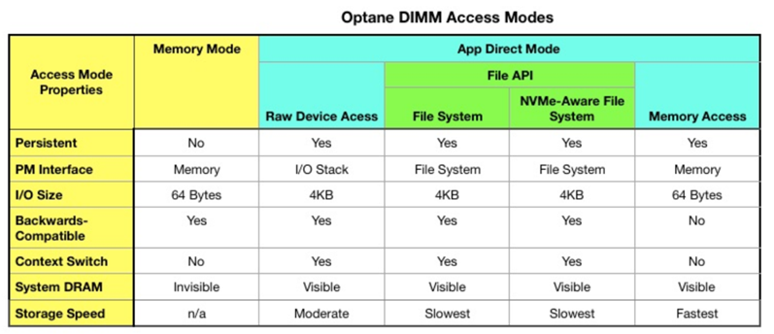
Table 1 Optane DIMM Access Modes

- Memory Mode
In Memory Mode, Optane does not support the persistency nature of persistent memory. Optane will be paired with a size of DRAM on the channel and only be exposed as a larger “virtual” DRAM at near PM size. That specific DRAM is treated as L4 cache but is not shown in the memory footprint. For example, when a size of 32G DRAM is pairing with 512G Optane in Memory Mode, only 512G will be shown as memory size to the OS, and 32G will be treated as hidden L4 cache.
In Memory Mode configuration, the DRAM will be used as cache for Optane, helps to bring up the memory access performance closer to DRAM. While Optane is the real memory pool to hold data. When power outage happens, the data in DRAM will be lost. That is why Memory Mode does not guarantee data persistency.
Even Memory Mode does not provide data persistency, it still comes with some salient advantage for customer in the short term.
First, in the same form factor, DIMM go with size 16G to 64G, but Optane can go from 128G to 512G. Memory Mode of Optane allows a much larger “virtual” DRAM footprint while still provide close to DRAM performance at a much economical price than the real DRAM at that size.
Second, the large “virtual” DRAM provided from Memory Mode Optane comes does not require any code change to OS or application to utilize the larger capacity, making it easy to get adapted by end-user.
One may ask the next critical question. How much is the right ratio of DRAM and Optane to pair together for the large “virtual” DRAM system to optimize the equilibrium of capacity and price? The rule of thumb is outlined below.
According to Lenovo Optane Using Guide, key to performance and price is the ratio of total DRAM to total Optane. The recommended range of DRAM and Optane is between 1:4 and 1:16. 1:16 means 1GB of DRAMs (used for cache) for every 16GB of Optane capacity (used as system memory). A larger number than 16 means potentially worse performance since the chances of a cache hit in memory will be lower. 1:4 means 1GB of DRAMs for every 4GB of Optane capacity. 1:4 is recommended as the best. The trade-off between performance and cost. A number smaller than 4 means system memory may be underutilized as cache and not worth the expense of the DRAM.
In the following, I would like to touch the basic of Memory Mode Performance. The following figures are coming from Lenovo's Analyzing the Performance of Intel Optane DIMM as of April of 2019. Even though Intel’s iMC scheme will have profound impact to the performance result, we believe the performance should still be true for now.
First of all, the testing was set up with following configuration:
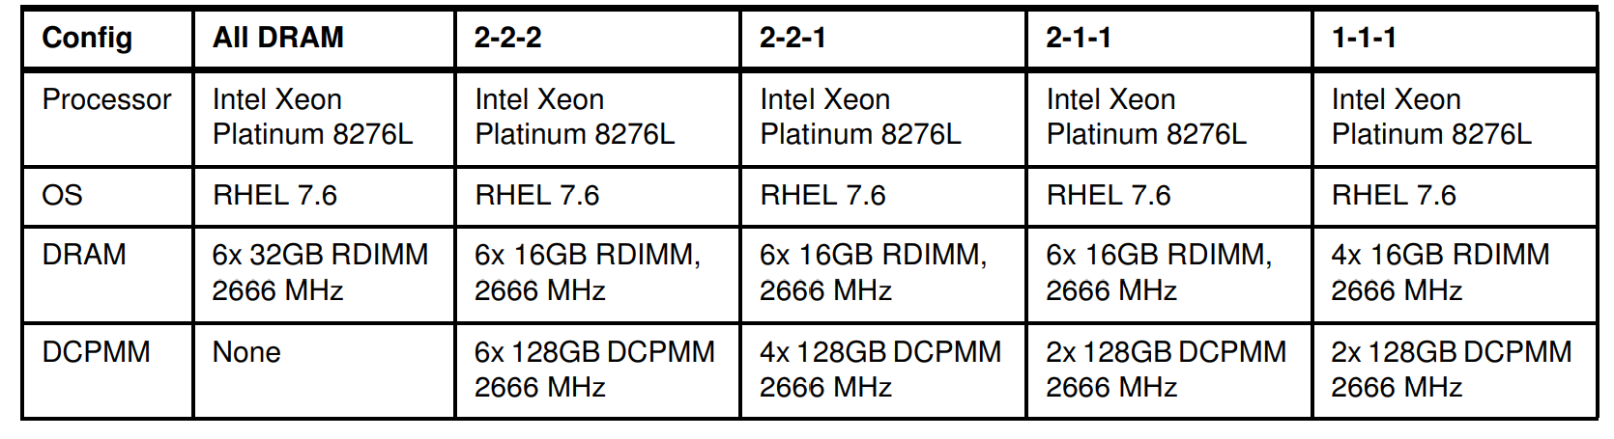
Table 2 Lenovo Memory Mode Test Configuration
The DRAM to Optane ratio for each configuration is:
Config | 2-2-2 | 2-2-1 | 2-1-1 | 1-1-1
DRAM/Optane Ratio | 12.5% | 18.75% | 37.5% | 25%

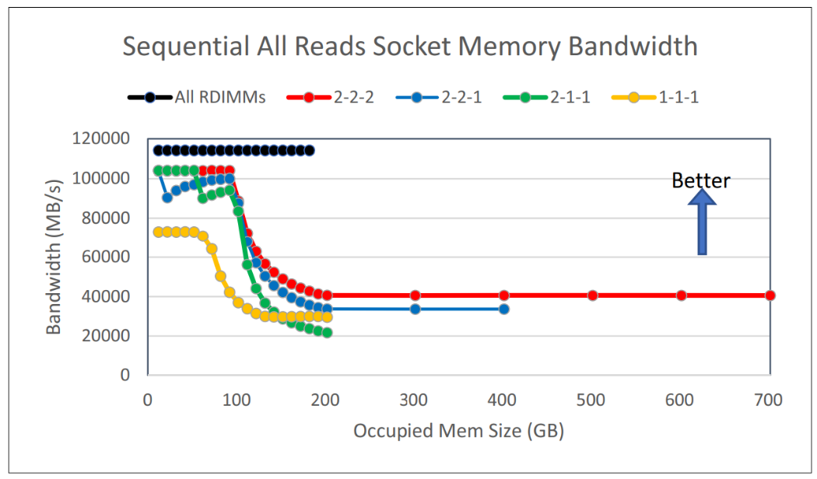
Figure 1 Memory-Mode Sequential All Read Bandwidth
It is clear that the Memory Mode performance degrading sharply, eventually to less than half of the original bandwidth, when memory usage is beyond the L4 DRAM size. This is because in sequential all read case, the channel bandwidth matters. 2-1-1 is worst in this case is likely because the three DRAMs on the same channel are competing the channel bandwidth with the only Optane. It is even worse than 1-1-1 in which Optane has its own share of channel.
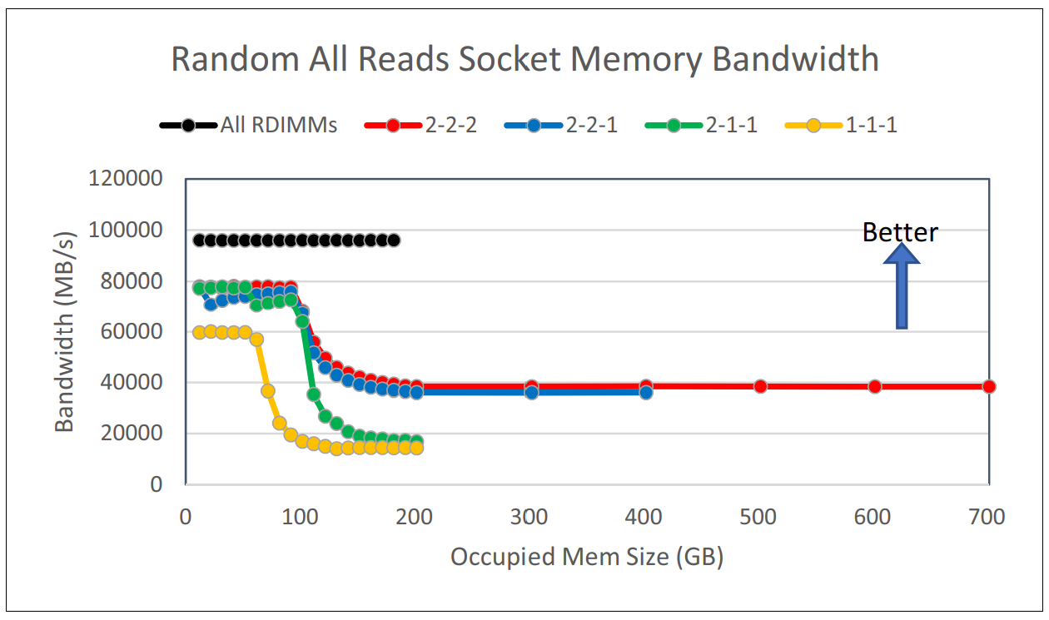
Figure 2 Memory-Mode Random All Reads bandwidth
It is interesting to note that in random all read case, even the top performance has been pushed down when data set is within L4 cache size, the performance doesn’t diverge much for 2-2-2 and 2-2-1 when data set exceeds L4 cache size, indicating they are likely channel bandwidth bounded in both cases.
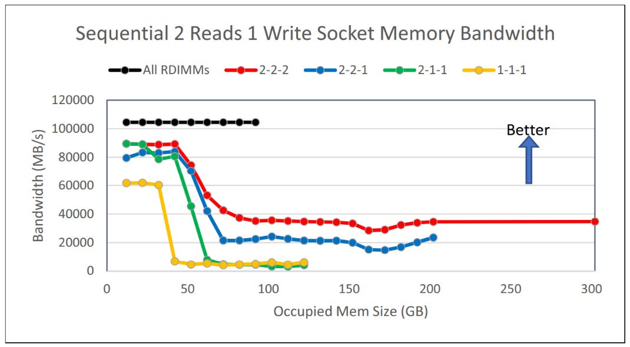
Figure 3 Memory-Mode Sequential Mixed bandwidth
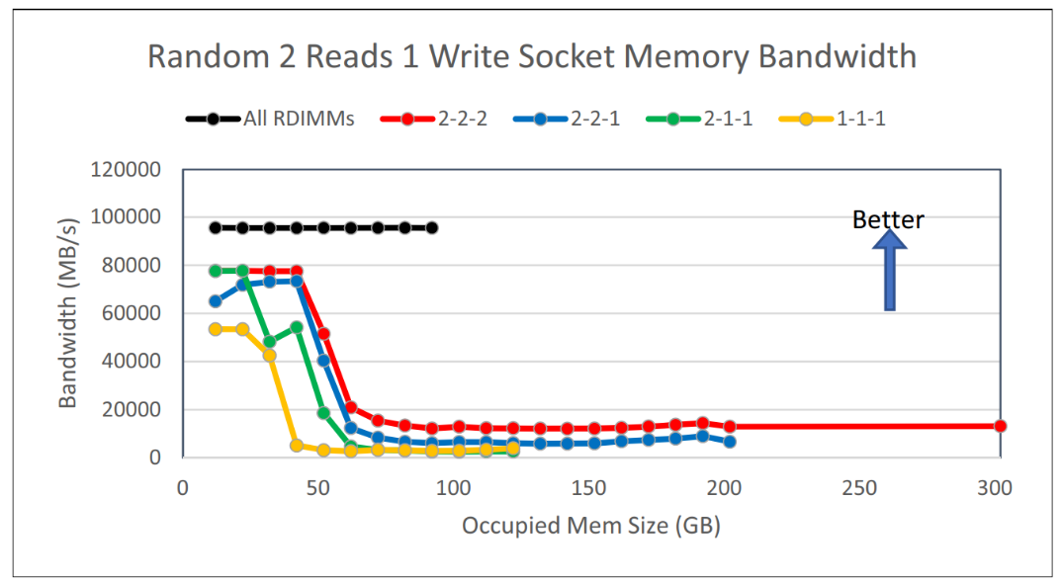
Figure 4 Memory-Mode Random Mixed bandwidth
In both the sequential and random read and write, it is obvious the L4 cache ratio doesn’t matter. In both cases, the 2-2-2 performs the best but 2-1-1 and 1-1-1 perform the worst. It is also noted that when data set exceeds the 50G, the throughput starts to drop. This may come from the exceeding cache missing.
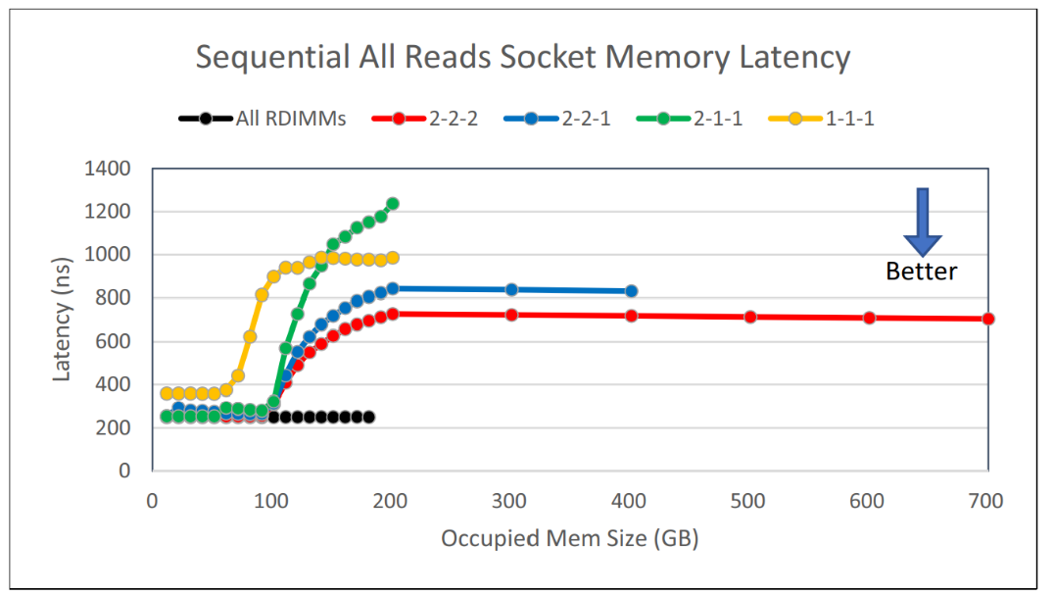
Figure 5 Memory-Mode Sequential Read Latency
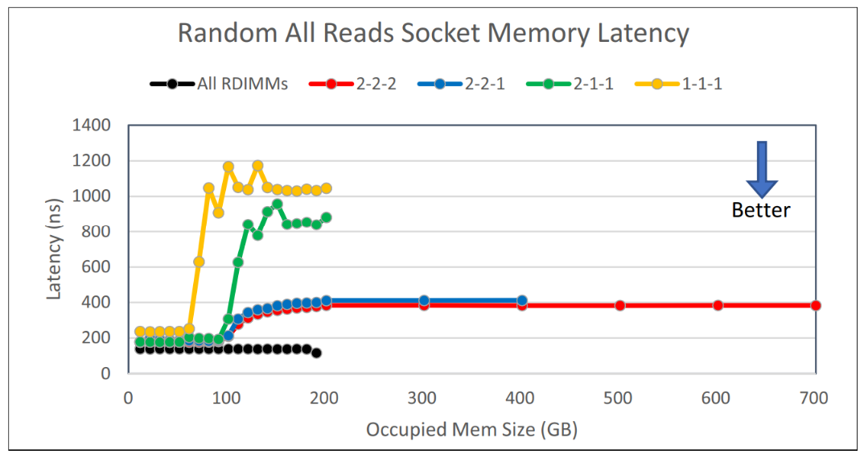
Figure 6 Memory-Mode Random All Read Latency
Figure 5 and Figure 6 shows sequential and random all read latency per se. The 2-2-2 still leads the latency performance and 2-1-1 and 1-1-1 is the worst.
Figure 7 and 8 shows that in read/write combined data access, the latency is low only when data set is within the L4 cache size (DDR size). When data set grows out of this “comfort zone”, the latency can pick up dramatically for all type of setting except 2-2-2, which can still retain close to 2us latency for random read/write combined access when data set is over L4.
For all other settings the latency can grow over 3us. Some even reaches above 10us, for which the latency is even exceeding the remote access through RDMA (3 – 3.5us RTT).
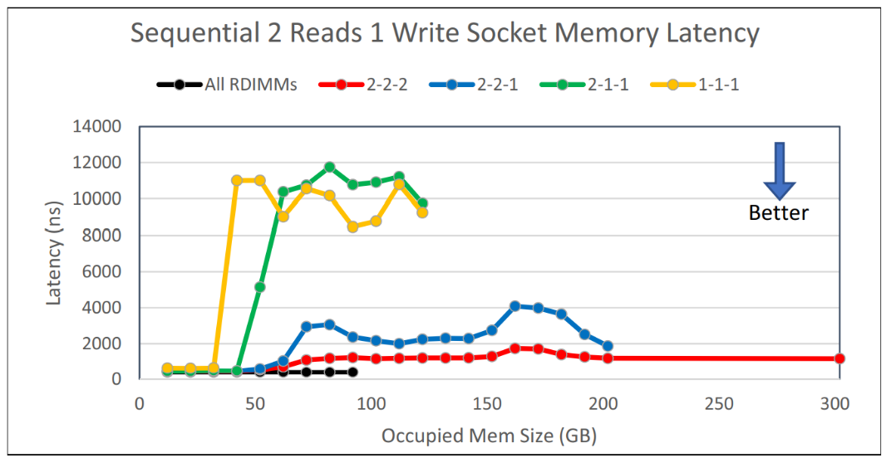
Figure 7 Memory-Mode Sequential Mixed Latency
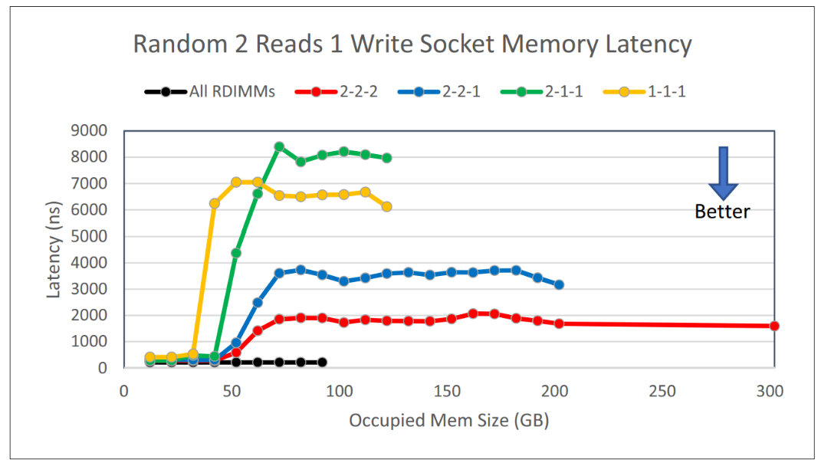
Figure 8 Memory-Mode Random Mixed Latency
All above test results demonstrate that the Memory Mode is still far from perfect comparing to DRAM as claimed by some blogs. No matter in sequence or random access, and no matter in read only vs read combined with write, the throughput and latency could be a lot worse than DRAM. But the certain factor such as configuration layout matters.
UCSD NVSL lab report in 2019 contains the test using Optane in memory mode for both Memcached and Redis in-memory database service. The comparison of the Optane memory mode in such real service is more realistic and closer to the reality.
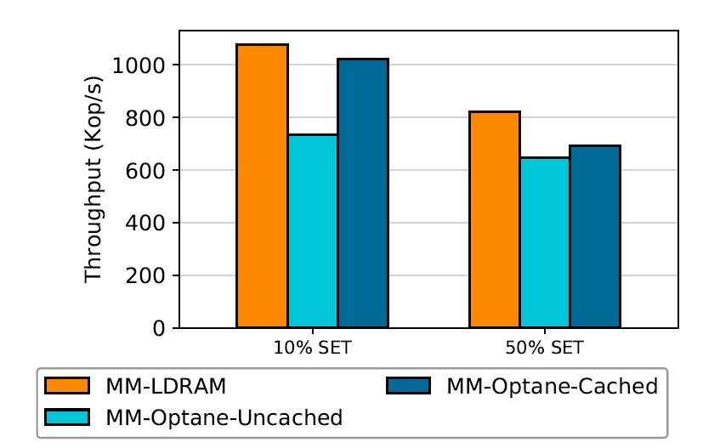
Figure 9 Memcached on read/write workload (MM-Optane-Cached is Memory Mode Optane)
Figure 9 shows the Memcached throughput under different mix of read and write. From the figure, we can tell that L4 DRAM cache is effective in hiding read latency, but it is not that effective in hiding write latency.
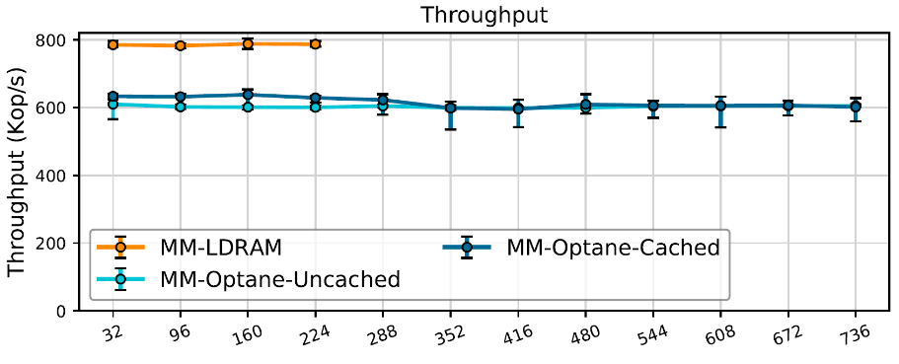
Figure 10 Memcached 50% set throughput (x-axel is workload size in GB) (MM-LDRAM is regular DRAM)
Figure 10 shows Memcached throughput as the total size of data store grows. According to the NVSL report, each output is the average of 5 run with bar representing stdev. Note that at 288GB the store no longer fits in DRAM L4 cache. Interestingly, even when the workload is less than L4 cache, the DRAM cache can’t absorb all latency. Optane Memory Mode is about 20% - 25% lower in IOPS performance compared with DRAM, even data can be fit into L4 DRAM. This may be from that long write latency not well hidden by L4 DRAM, and may be related to Memcache’s specific dataset write operation.
Figure 11 shows that for Redis both read and write throughput is quite good comparable to that from DRAM when dataset is less than L4 cache size. The throughput is even good for a while when the dataset is bigger than the L4 cache size. In this case, I can only envision that Redis’ specific data operation makes the difference, and it produces different performance output Optane.
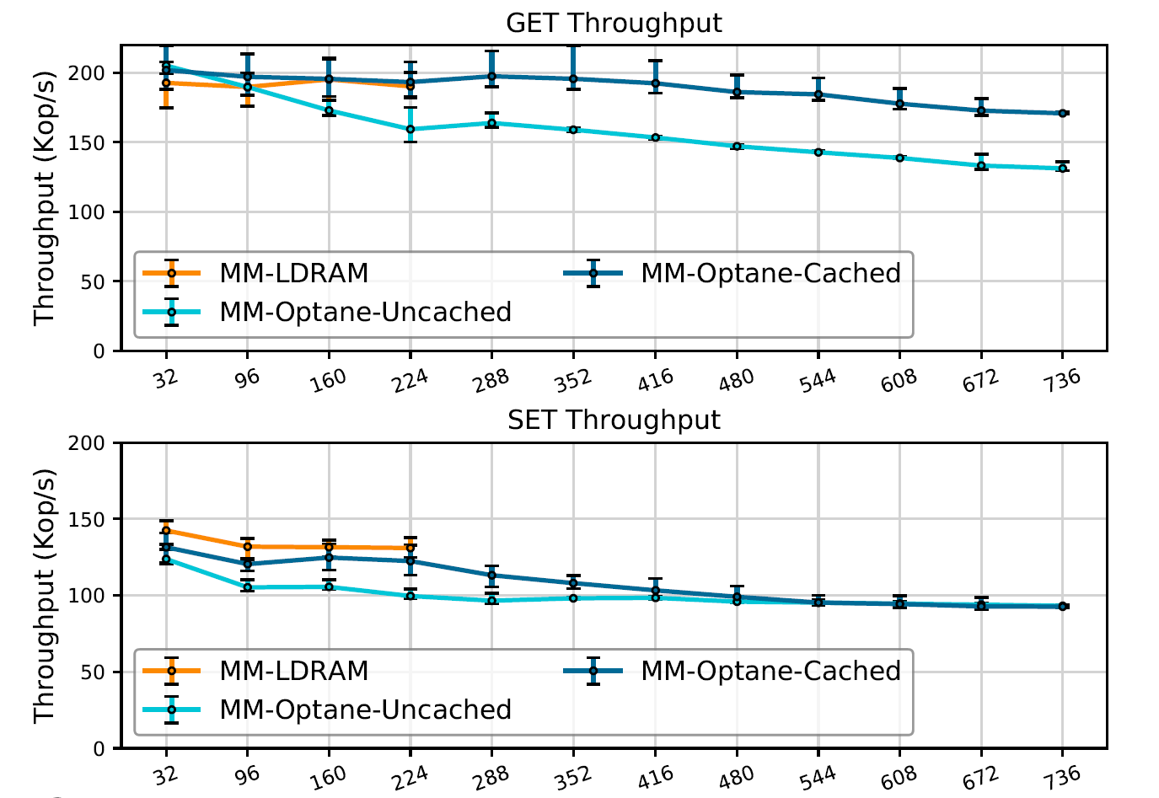
Figure 11 Redis througput performance using Optane Memory Mode (MM-LDRAM is standard DRAM case)
Here are a few take away about Optane Memory Mode:
- Optane using in Memory Mode does provide a huge benefit that there is no need to change the application software. However, there are still some pit hole that needs to avoid in application that needs to utilize the feature.
- Intuitive thought that ratio between L4 cache (DRAM) and Optane matters to the read/write performance and latency is incorrect. From the result, the ratio is less important factor compared to layout of the DRAM and Optanes.
- Within all the layout, 2-2-2 wins over all others in almost all both throughput and latency, even with lowest DRAM to Optane ratio. 1-1-1 and 2-1-1 is usually the worse. For customer who don’t want to fill up the the DDR slots with Optane, this could be a painful dilemma.
- When data set size is beyond L4 DDR size, the performance could be degraded dramatically.
- After all, the “generic” testing such as those from Lenovo must be used with salt and wit. It may or may not be applicable to all use cases and scenarios. So doing a trailing experiment before deploy a certain application using Optane Memory Mode always helps.

- App Direct
Application Direct (simplified as “App Direct” in later context) is an other interesting access mode for Optane. Simply in this mode, the Optane is directly visible to the application through different means. Some people also call it DAX (direct access) mode. However, there are still subtle difference in the accessing details, as outline in the figure 1.
App Direct Mode --- Raw Device Access
In this mode, the application can do direct read/write to the Optane. It sounds simply and effective however following few factors impedes its speed. First, the data access to the DIMM is not through h/w that can happen without interruption. Second, the data on Optane is accessed in the 512B or 4KB block. So the speed is not as fast as App Direct Mode --- Memory Access.
App Direct Mode --- File System
The Optane is accessible through an intermediate File System. And Optane is treated the same as block device underneath. This provides a simple backward compatibility. However, the file system takes time to do its work so the performance can’t be ideal.
App Direct Mode --- NVMe File System
Similar to the “file system” case but take advantage of NVMe-aware filesystem that with further optimization in stack to reduce filesystem overhead. But essentially, the filesystem overhead is still there.
App Direct Mode --- Memory Access
This is a most speedy solution, in which the Optane is being accessed through iMC the same way with other DIMM. Not only the Optane is byte-addressable, it is also obtained a
One outstanding benefit for App Direct mode is that the data is directly written to Optane and is persistent. But this is based upon the assumption that application can recognize the Optane and deliberately write persistent data to it. In former programing model, however, the memory is volatile and persistency only happens to the external storage. To fully utilize the Optane with its performance potential, either the user applications or OS need modification to use App Direct mode.
In addition, unlike that for DRAM, the performance for App Direct (Memory Access) is not universally consistent across all different access patterns. In FAST 2020 conference, UCSD NVS lab published their experimental result at FAST 2020 conference outlined the characteristics of the App Direct access limitation and draw a few important lessons from there.
Note all figures and result mentioned here are citing from the conference paper and its presentation.
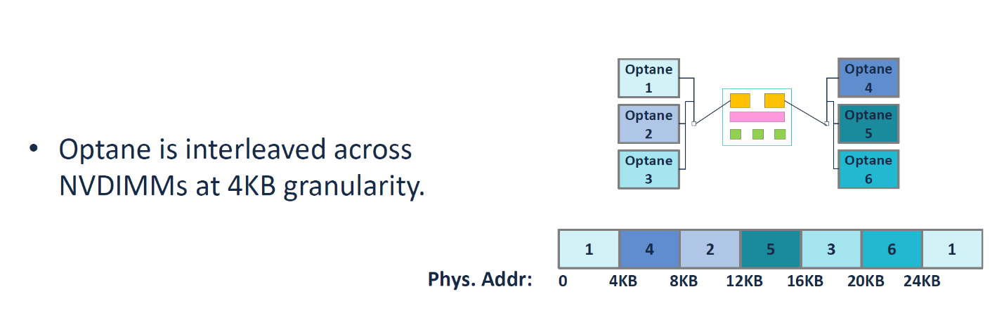
Figure 12 Optane Interleaving Details
Figure 12 shows when 2-2-2 fully populated, the Optane is accessed in the interleaved way. There is certain impact to the performance from the interleaving, which we will see later.
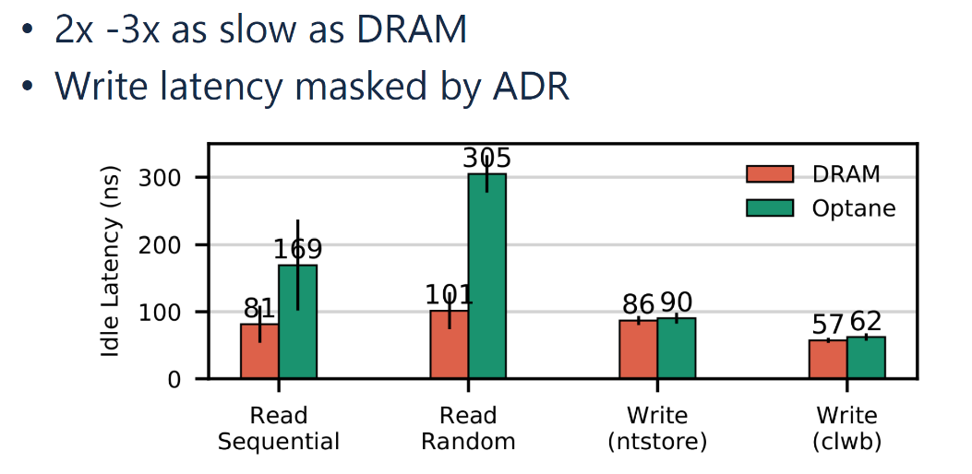
Figure 13 Best-case latency. Shows sequential/random read latency as well as write latency using cache write with clwb and ntstore instructions. Error Bars show stdev.
Typical latency for Optane App Direct access compared with DRAM in various cases is shown in Figure 13. Note that the biggest performance gap is at random read. However, at write side, the difference ignorable because the store and fence instruction is committed once the data reaches ADR at iMC, and DRAM and Optane shows the similar latency. Also, Optane is more “pattern-dependent”, in which the random vs sequential gap is about 80%, much more than the 20% for DRAM.
However, we should be aware that this is only for the best-case performance baseline. And we will see the other factors that may affect the Optane performance in the following.

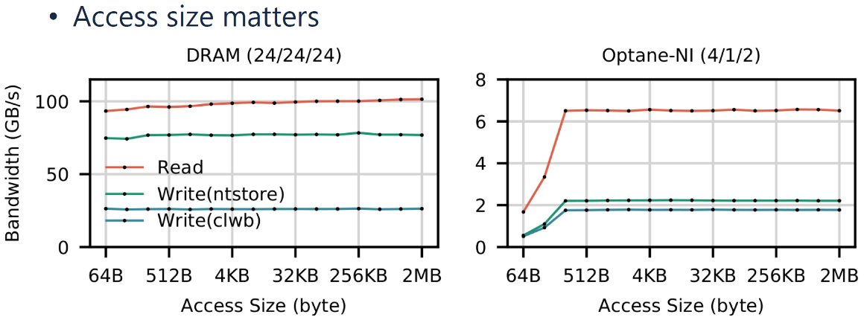
Figure 14 Bandwidth over access size.
In Figure 14, the Optane bandwidth losses bandwidth when random access data size is smaller than 256B. This can be well explained by the below figure that Optane controller has its own buffer that can cache the data in 256B. The smaller random read/write less than 256B will be padded to 256B before turn into a request to Optane media. Certain bandwidth to Optane media is lost in this case.
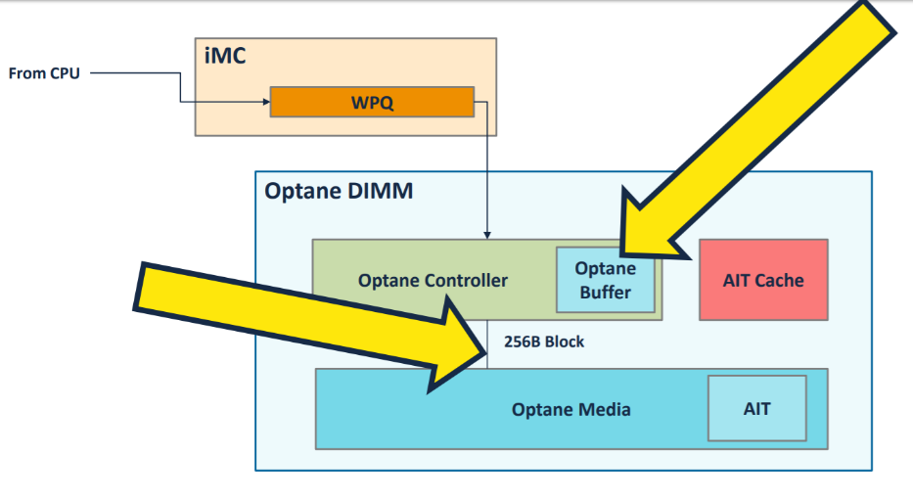
Figure 15 Optane Dimm Controller and XPBuffer details
Please note in Figure 15 the Optane buffer size (also called XPBuffer) is about 16KB, which means that any data set larger than 16KB may cause contention to the buffer and may reduce the effectiveness of the write.
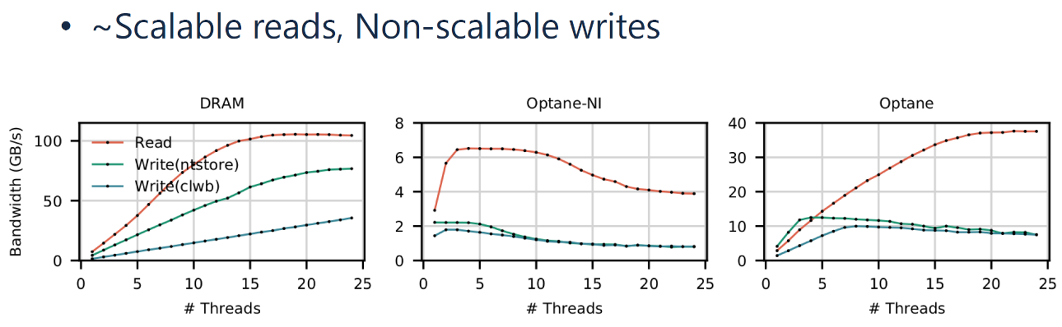
Figure 16 Bandwidth vs thread count. All threads use a 256B access size.
Figure 16 shows the maximum bandwidth as thread count increases. Note Optane-NI is for non-interleaving access that all read/write happen to single Optane DIMM. It is also obvious from the bandwidth test that interleaved Optane scales up much better. The test result above shows that the interleaved Optane achieves close to 6X bandwidth increase than without interleaving. This speedup matches the number of Optane DIMM in the system. It also reflects per DIMM bandwidth limitation of Optane.
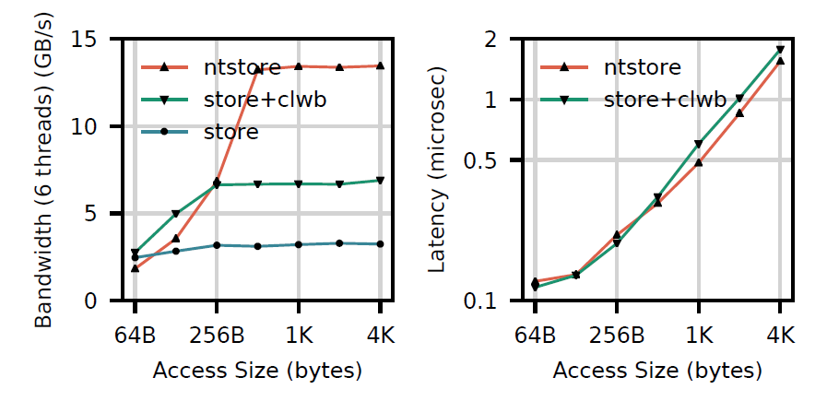
Figure 17 Performance achievable with persistency instruction, with both bandwidth and latency.
Figure 17 shows using AVX-512 stores with three different instruction sequences: ntstore, store+clwb, and store, followed by a sfence. Even the store flush instruction has lower latency for small access, ntstore has better latency for large dataset accesses. The reason can be explained by Figure 17. Flush must load the cacheline into CPU’s local cache before executing store, thus lost bandwidth and locality.
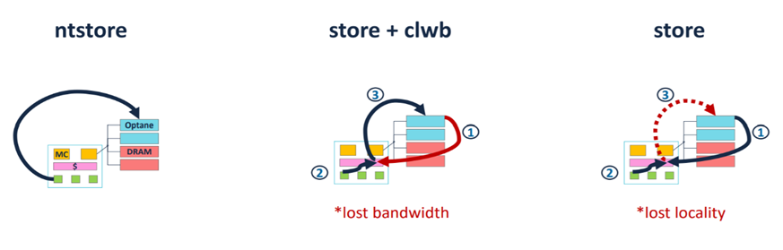
Figure 18 Different store instruction sequence
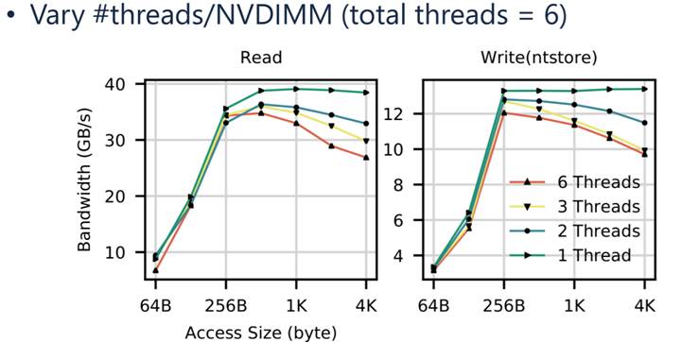
Figure 19 Plotting iMC contention for number of threads accessing each NVDIMM.
Figure 19 shows that with fixed 6 threads, when the dataset access by each thread grows, the bandwidth first increases. However, after dataset is bigger than 256B, the throughput can only be sustained when there is only one thread to each Optane DIMM. One explanation is that the data traffic from iMC to NVDIMM hits the threshold at 256B dataset, thus increasing the thread count will drag down the bandwidth performance.
Figure 19 shows that there is a dip of bandwidth performance when access dataset is 4K. The contention at iMC also explains the bandwidth dip in performance at 4KB dataset (figure below). According to the paper, the dip is likely caused by the contention with interleaving so that a 4K dataset can’t be divided among multiple DIMM. And it is maximized when thread does random access close to that interleaving size, which is just 4KB. This can also be verified by write’s bandwidth peak at 24KB and 48KB dataset.
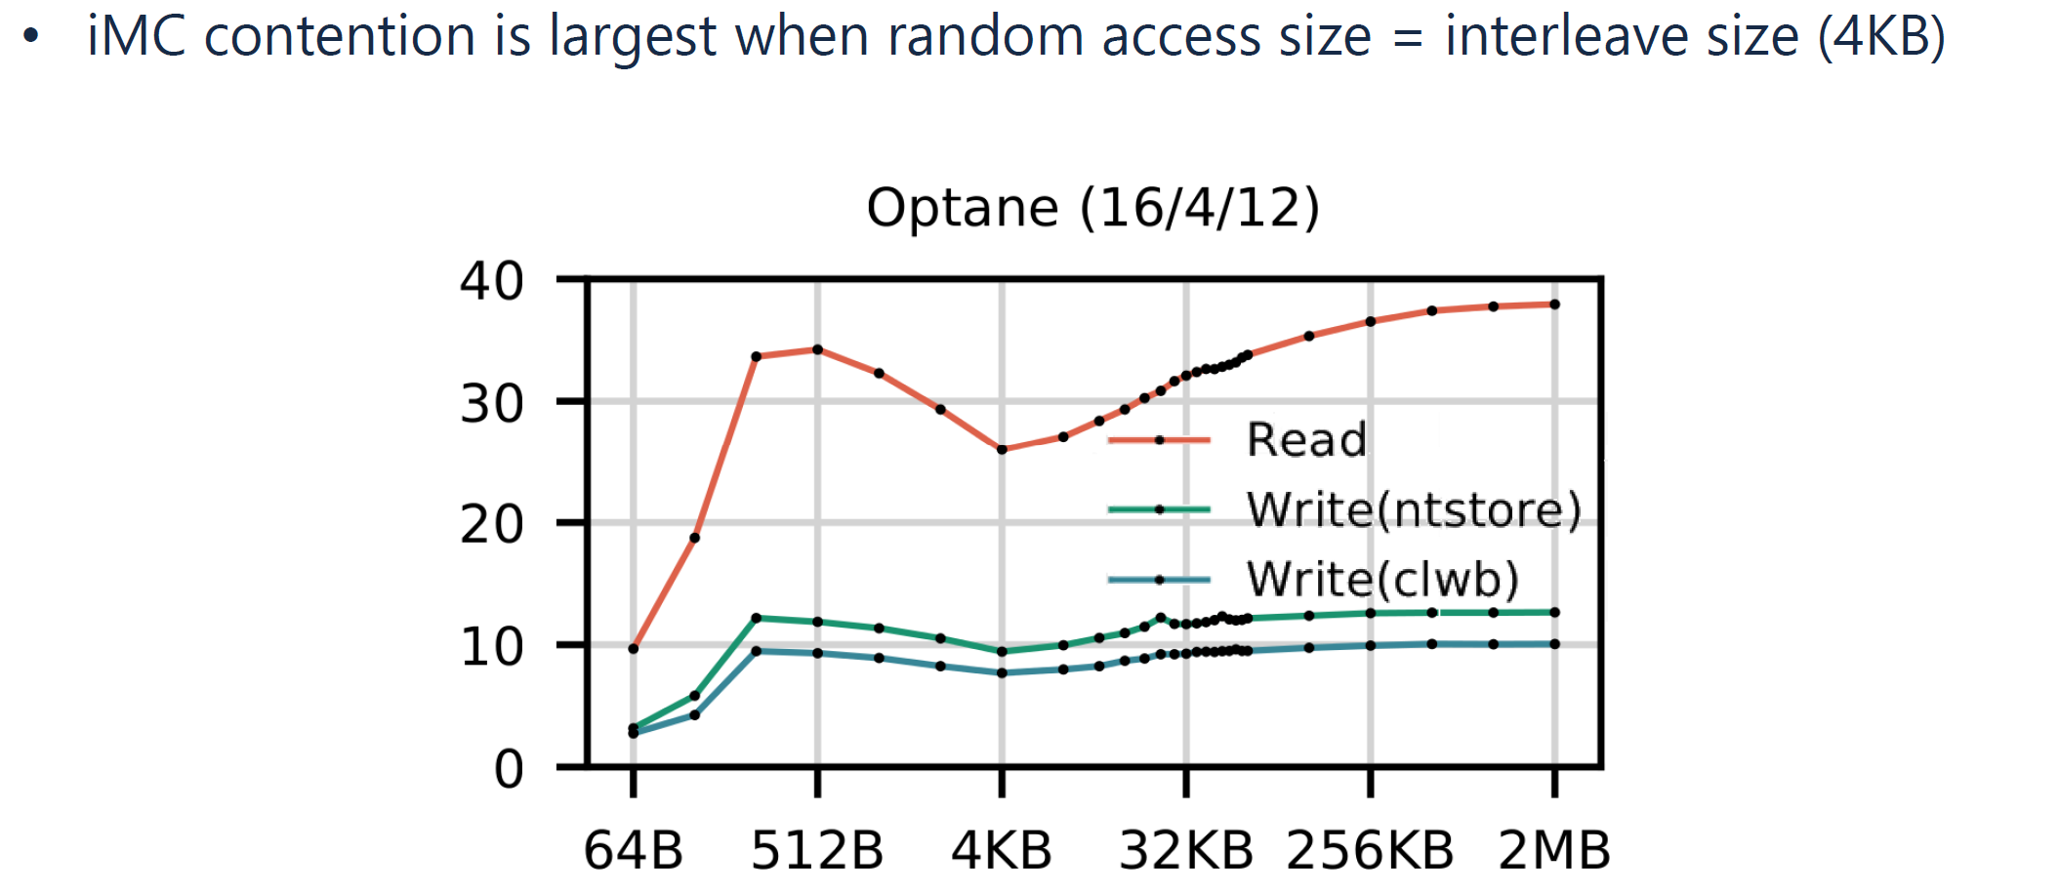
Figure 20 Dip of bandwidth when dataset is 4K
NUMA architecture matters to the Optane performance as well.
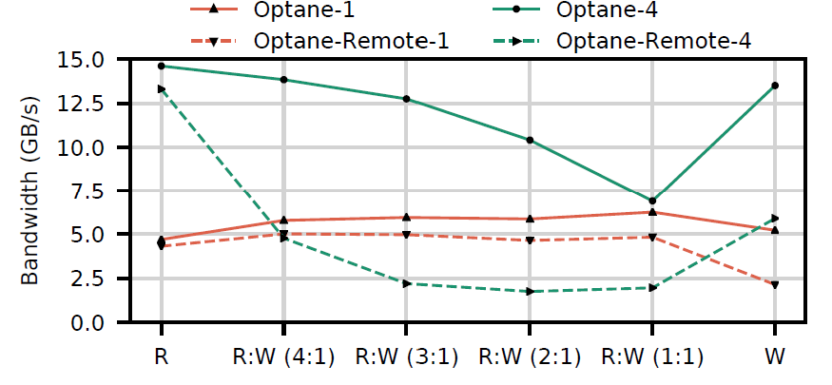
Figure 21 Memory bandwidth on optane, local and remote. Optane-1 means one thread.
Figure 21 overall bandwidth the mix of read/write access is varied for one and four threads. It can tell that pure read and pure write performs better in NUMA than mixed traffic. And more thread hurts the performance in NUMA environment.
The paper draws some very useful guideline for Optane App Direct Mode usage:
- Avoid small random access.
- Use ntstore for large write (>=256B)
- Limit threads accessing one NVDIMM
- Avoid mixed and multi-threaded NUMA accesse

