Optane DIMM (2): Optane’s performance impact to HPC Seven Dwarf BenchmarksPe
Optane Persistent Memory is very much like the traditional DRAM. It sits on the memory bus and connects to the processor’s onboard memory controller (iMC). In the traditional view, Optane can be essentially treated as a new type of DIMM with larger capacity but slower performance and data persistency in the same form factor with DRAM. Yet the other advantage is at the lower unit energy cost and much cheaper price for unit capacity. Such device provides a valuable bridge to the huge performance gap between fast DRAM to traditional NVMe.
HPC application today can be very demanding for memory size and storage performance for the need of saving the extracting the input data, and intermediate & final result. IO is essentially a big bottleneck when the dataset is huge, which is very popular in most of HPC type of calculation. With the introduction of byte-addressable, memory alike (in both semantic and latency) Optane, everyone is excitingly expecting a fundamental change to HPC. However, using fine granularity of Optane persistency nature (App Direct Mode) requires a major code change to HPC application. The industrial world is wondering, if there is any low hanging fruit that can boost the HPC performance without any major application change.
Multiple studies have been conducted in academia to investigate this topic. I would like to review two of them that are representative and outline some of the lessons and experiences in quickly using Optane to boost HPC.
The first publication is Demystifying the Performance of HPC Scientific Applications on NVM-based Memory Systems, published at 2020. The paper comes from Prof Dong Li’s research team at UC Merced who keeps a close tie with Lawrence Livermore National Lab and continuously focusing on new technologies boosting HPC .
The paper evaluates the famous seven dwarfs --- the seven well known HPC benchmarks running on various Optane configuration and evaluate the performance. The following tables list the seven dwarfs and their correspondent benchmark used in the paper and platform configuration.
Sevne Dwarfs of HPC | Benchmark Name | Features:
Dense Linear Algebra | ScaLAPACK | Dense array data structure, strided mem access. Typical vector operation.
Sparse Linear Algebra | SuperLU | Data is compressed into dense format through indirect mem access.
Spectral | NPB | 3D FFT solving diff-equation, with a lot of matrix transpose.
N-Body | HACC | High computational complexity of $O\left(N^{2}\right)$
Structured Grids | Hypre/Laghos | Regular grid structure with high spatial locality in accesses.
Unstructured Grids | BoxLib | Irregular grid structure, with multiple level mem indirect references.
Monte Carlo | XSBench | Repeated random access for numerical computation.
Table 1 Bench mark used

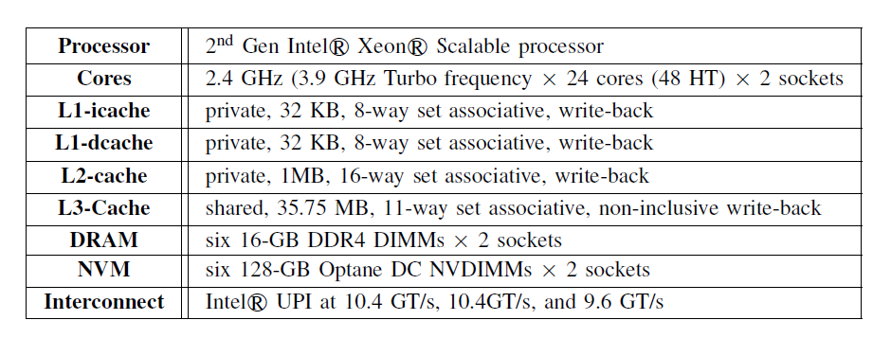
Table 2 Platform Configuration
- Overall performance
Figure 1 outlines the overall performance (in MFlops and time) for each benchmark, under both cached (Memory Mode) and non-cached (App Mode memory access) for Optane. Note that the dataset is smaller than the L4 cache size (DRAM size) in Memory Mode. The figure shows that when dataset is within L4 (DRAM size in Optane Memory Mode), the Memory Mode performance is in par with DRAM performance for all benchmark.
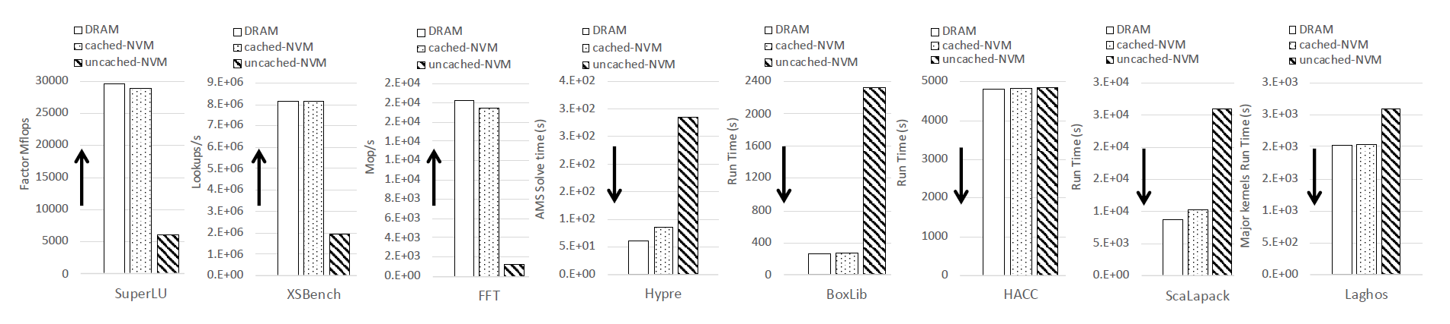
Figure 1 An overview of performance.
However, using Non-cached (App Direct Memory Access Mode Optane) will experienced huge divergence in the performance among different benchmarks compared with DRAM. Without any code change, the benchmark on “unstructured grid” and “FFT” performs the worst compared with DRAM. On the other end, the “N-Body” and “Structured Grid” barely see much performance degrade when directly setting the benchmark on non-cached Optane.
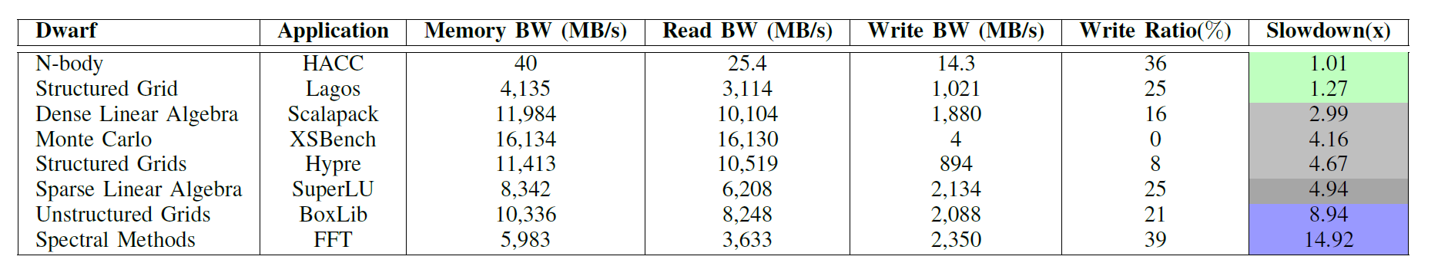
Table 3 Overall benchmark sensitivity for non-cached Optane
- Memory Mode (Caching) Effect
The much larger capacity per form factor, plus relatively cheap unit price and no code change makes Optane Memory Mode a very handy and attractive scaling method in adapting Optane for HPC. This makes the scaling the dataset bigger than the L4 DRAM for Memory Mode Optane usage is an important test to evaluate the handies Optane use case to boost “large memory” for HPC performance enhancement.
Figure 2 shows the Memory Mode Optane’s performance for three benchmarks, SuperLU, BoxLib and Hypre. When dataset size is bigger than L4 DRAM size, the cached effect of NVM is still there, even it is degrading with size increasing. It is easy to tell that SuperLU takes a good advantage of L4 cache and does not see much performance degradation when data size increase way beyond L4. However, for BoxLib and Hypre, there are different level of performance drop when dataset is bigger than L4 DRAM size.
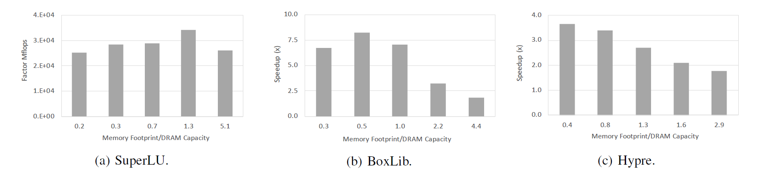
Figure 2 Speed of certain benchmark, cached vs non-cached NVM.
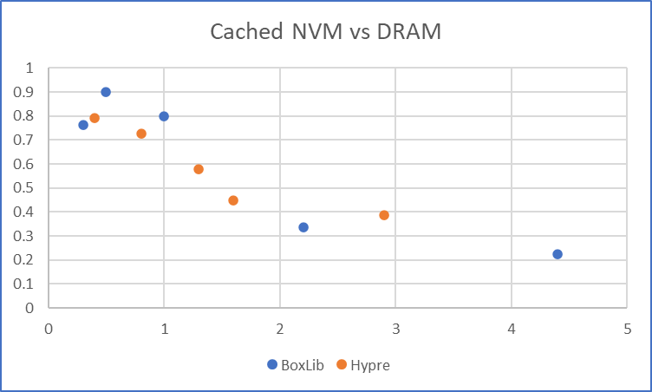
Figure 3 Performance Ratio from cached NVM to DRAM (speculative from other result)
Figure 3 is a speculative performance ratio from Optane Memory Mode compared with DRAM. For both BoxLib and Hypre, the performance drop to half of the or less of that from DRAM when dataset is far exceeding the DRAM size. However, the number must be taken with salt and wit as well. Note that for the HPC case targeting huge data that is beyond memory size, the overall performance is not limited by DRAM bandwidth but by IO, which can greatly reduce the overall performance. The “large memory” provided by Optane Memory Mode, even at the half or less of the DRAM throughput, is still a huge boost for the overall performance for the data service. From this perspective, an end-to-end running of the same benchmark with the same dataset size on DRAM vs cached NVM will make more sense.

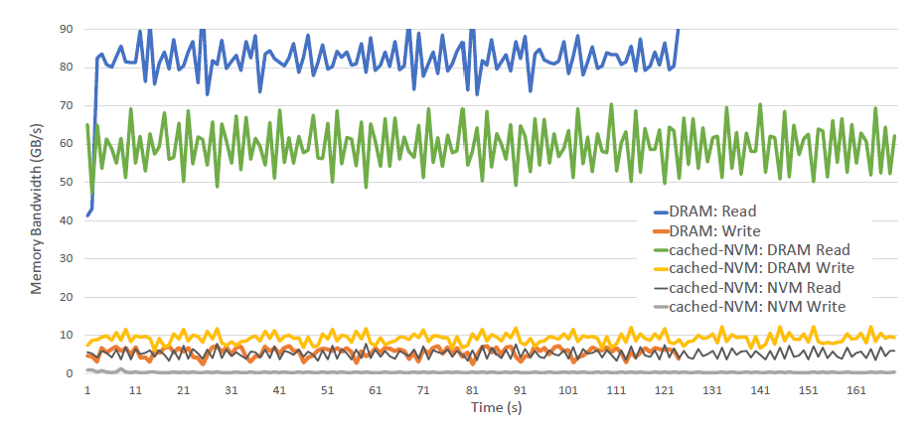
Figure 4 Hypre's read/write throughput on cached NVM vs DRAM
Figure 4 shows Hypre’s performance on read & write throughput over cached NVM and DRAM respectively. It is interesting to tell that the read throughput of Hypre in Memory-Mode is about 30% lower than that on DRAM. That matches with the result in Figure 1 for the overall performance. It shows that Hypre is read intensive and overall perf was bounded by read throughput. However, its read throughput was bounded by cache hit rate and cache replacement rate. The write throughput, however, is even more than DRAM. This extra traffic is for filling up the cache-line replaced read data from NVM for read. It is also the traffic that bounded the read throughput.
- Write Throttle
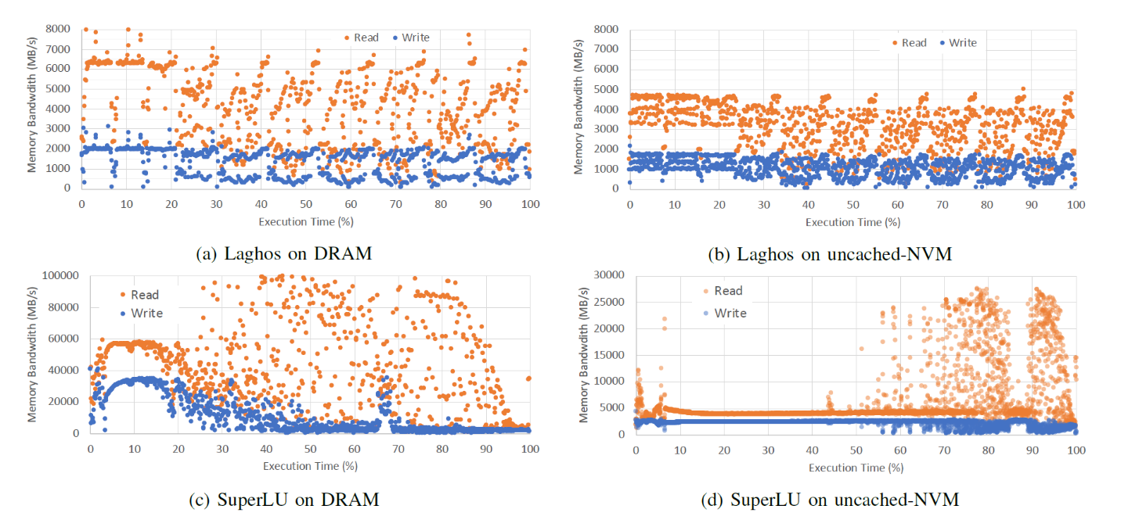
Figure 5 Write Throttling change dominant computation phase
The “write throttle” indicates the potential long latency of NVM write’s impact to benchmark. The “write throttle” effect is well reflected in Laghos vs SuperLU. In Laghos, the first phase takes around 20% of execution time in both DRAM and uncached NVM. And the throughput ratio between read and write are essentially the same. This means that the benchmark is not write bounded, and is more ideal for running on NVM.
SuperLU is different. The heavy write traffic not only holds up the read, which is reflected in lower than same ratio of read throughput compared with DRAM, it also greatly extend the phase one run time. Such type of HPC application does not fit to run on non-cache NVM.
- Concurrency Contention
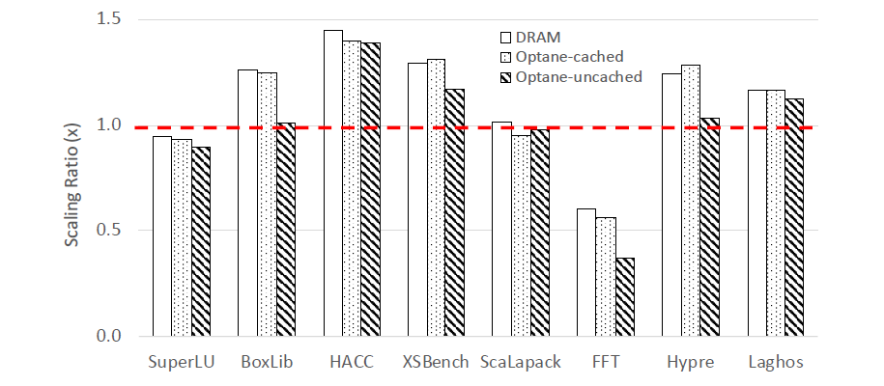
Figure 6 Scaling Ratio for three modes.
Figure 6 shows that the scaling impact to the overall performance. The performance above red-dash-line indicates that adding more thread and concurrency helps the performance. As shown in the figure, the HACC and XSBench gains the most, with 25% to 40% gain each respective. However, it also shows that for certain application, the performance gap between DRAM and Optane only is minimum, such as HACC Laghos and ScaLaPack. For certain application such as FFT, the performance hits the wall. The overall performance drops 40%.
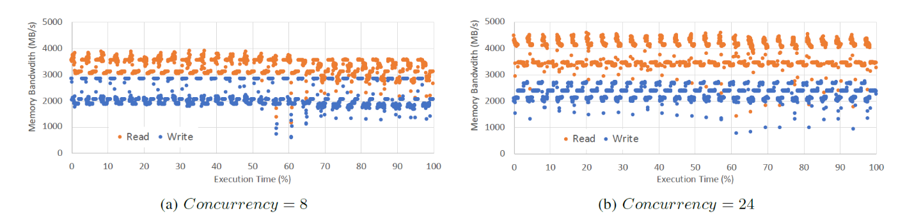
Figure 7 Detailed FT read/write chart tells more about the performance details.
Decipher of FFT performance is shown in Figure 7. It shows read and write throughput on time base. It is clear FFT is conducted in iterative phase. At different phase, the performance is different. Adding concurrency helps performance at the peak phase, however, it also drags down the performance at bottom phase, thus pulling down the overall performance. Further tuning is expected to focus on boosting the performance on the bottom phase.
Here are some immediate insights from the paper’s study.
- N-body and structured grid applications may be minimum perf loss on NVM based memory.
- Sparse linear algebra and structured/unstructured grids applications can work well on Optane Memory Mode to allow substantially larger dataset with decent performance.
- Application such as SuperLU that has large dependent write (write throttling) may need different priority in perf tuning.
- Adding concurrency may have diverge effect to performance. For each application, it may need detailed analysis to figure out the bottom-line and way to fine-tune it.
I can also draw following take-aways from the study:
- Unlike DRAM, introduction of Optane complicates the performance pattern of different HPC benchmark.
- Optane Memory Mode allows larger data set to be sit into the memory, however, the performance pattern could be complex. It may provide close to DRAM performance (70-80%) for some application, but it could hit big barrier when data set is beyond L4 DRAM size for certain application. How much the performance would be degraded depends on the memory operation pattern of the specific application and the possible optimization.
- Optane App Direct memory access mode may not see that much down on performance on certain HPC benchmarks. It depends on data operation in memory and potential contention within Optane.
- After all, Optane is not a silver bullet for HPC. The effectiveness of Optane depends on many factors such as the specific application, the dataset, the configuration of Optane, etc. The most reliable way to make the decision is to rely on the real test of the application over different configuration of Optane.

However, from the performance perspective, this paper also raises up more questions about the PM and its effective in helping to promote performance for HPC. I can tell it still has missing parts such as:
- The study of memory mode is not done in apple to apple. Memory Mode is the simplest adaption of the Optane. It provides the easiest way to upload much large dataset into “memory”. However, the performance should be compared with DRAM by overall execution time, not throughput.
- Memory Mode study should cover the performance scaled of dataset with DRAM too.
- Measuring the energy cost is meaningful too.
- Study the Optane’s persistency nature as used as file system is more meaningful. I notice there is already some study on this part. And I am expecting to write something on this topic soon.
- Study DRAM vs Optane performance of larger dataset which can not fit into DRAM system but can fit into optane memory system, since one key value of Optane is that it can provide system memory capacity which DRAM can not provide.

