Problem TO Solve:  Inefficiency, disarranged teams, Waiting on others, depending on others, Self Defense Political Environment, Long Deployment process, Lack of Automation, Lack of testing, Lack of Scalability plans, Lack of Reusability plans, Incoherent support plans, Can’t vision for Enterprise Engines.  We have separate teams who test our code. We have groups to create and run the performance test scripts. However a lot of it is manual and communication with them, scheduling work with them, project timelines, resource costs and adjusting project plans will limit us to basic levels of testing. We may end up not doing some of the important tests, like capacity tests, Stress tests, and performance numbers measurements. This can be a high risk and will make us clueless if we ever receive production issues.  With developers not having too much understanding of infrastructure that is normally managed by separate teams, we end up with not so good Scalability Plans. For a good scalability plan, enterprise level vision is important since it can go beyond one technology/tool and encompasses several technologies/teams within the organization.  Quality code, excellent architecture is a hallmark of Agility. That requires good code management. However a lot of code reviews, architecture reviews are manual. Also it is sometimes difficult to incorporate Architect’s feedback or implement enterprise strategies because of the technical debt that is carried by the previous work. Also sometimes project timelines and project pressure prevent implementing some of the out of box thinking and we end doing things we have always been doing.  With too many groups there is too much planning involved and with lack of uniform strategy and automation, Project planning becomes a hassle. This will raise question marks while planning important aspects like support plans, scalability plans, architectures supporting scalability, deployment plans, reusability Plans, current integration plans to future integration plans, build frameworks for easier product/features development, Enterprise engines.  While providing support for a platform you also depend on other teams through whom you have built your platform, like database team, infrastructure team, midrange team, middleware team, network team. Now with Incoherent support models and disengaged schedules, supporting platforms and resolving issues become complicated. This does happen that team is trying to resolve production issues but they are waiting for another team who is not currently available. While fixing something, team may find out that other team also needs to apply fixes on their side. With disarranged teams, platform support and application support will not be efficient.  Development team is ready to deliver code but they have to go through lengthy manual deployment process. With a lot of communication to get required approvals. A lot of time is spent to sync time between groups like Server Admins, Db Admins, Tool Support teams for the deployment and confirming their availability.  Sometimes it is better to empower teams versus organizing them into separate groups which can lead into disorganization. Too much organization and grouping can cause confusion, unnecessary defense lines and who is to blame political environment that may take us away from coherent models.  Latest development methodologies that are getting popular with some research backing them are Agile methodologies e.g., Scrum and they talk about Development team that have different skills, are more empowered, can achieve architectural excellence, self-organized and have more control over their work. This will make us more agile and thus DevOps is among the foundations for Agile methodologies. |  |  |  | 
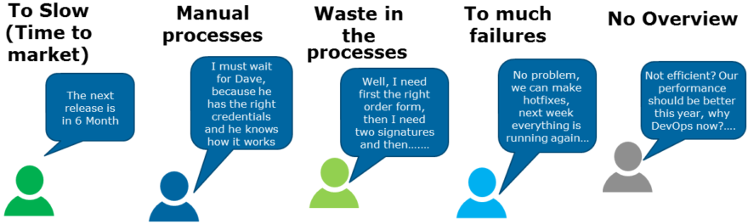
Big Idea  Agility through Empowering Team, Hybrid Collaboration, Breaking Silos, Maximum Speed to delivery, Maximum functionality, More time for innovation  Companies that incorporate DevOps practices get more done, plain and simple. With a single team composed of cross-functional members all working in collaboration, DevOps organizations can deliver with maximum speed, functionality, and innovation.  There are technical benefits:  Continuous software delivery  Less complexity to manage  Faster resolution of problems  There are cultural benefits:  Happier, more productive teams  Higher employee engagement  Greater professional development opportunities  And there are business benefits:  Faster delivery of features  More stable operating environments  Improved communication and collaboration  More time to innovate (rather than fix/maintain)  Adaption to DevOps require arrangement of teams following DevOps philosophy and then introducing right tools to implement DevOps.  TOS2020: Integration of business, technology, and operations teams, shifting mindset |  |  | 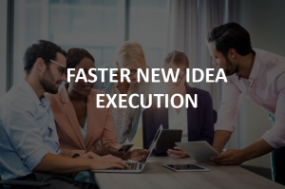
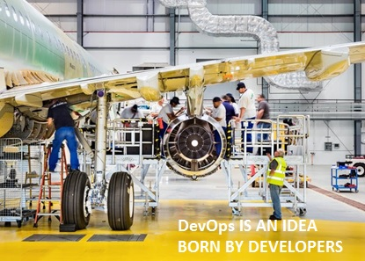 |  |  | Aspects of DevOps  Slicing the big Cake  Infrastructure: Project infrastructure setup. Scaling up infrastructure. Justify Billing through Usage numbers.  Project Planning: Planning/coordination with groups/teams and tools/technologies including DevOps tools.  Support Models/ Monitoring: Production support/ issues resolution. Monitoring production environment.  Hosting: Is technology hosted in private data center or over cloud?  Code Quality/ Architectural Excellence: Code reviews and architecture reviews to deliver best quality.  Quality Assurance/ Stress Testing: Functional testing, User Acceptance testing, stress testing, regression testing etc.  Release/Deployment: Release management, code development between different environments Dev to Test to QA to Prod.

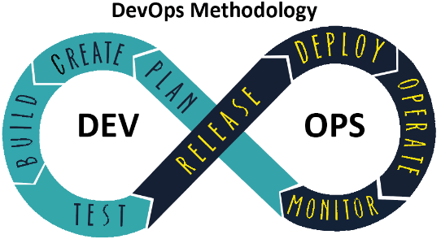
Value Additions/ targets  Building Future  Cloud: Cloud is a value addition. It houses tools for DevOps. Can Scale through online interfaces (renting Virtual Machines), Dockers versus legacy hosting where you open requests with other groups and wait following their schedules.  Empowered teams: Cross-Functional learning. Dev teams can do more.  Agility: DevOps go hands on hand with Agile Methodologies.  Auto-deployable/ Auto scalable: Building & using Frameworks/APIs that are auto-deployable and auto scalable. Consider Microservices. Scale up on demand  1-Click Deploy: If code is ready then no waiting associated with Waterfall deployment process.  Introduce features on demand: Faster features delivery and issues resolution.  Optimized Project Planning: Reduced coordination\planning with lesser groups.  Automation: DevOps tools to automate operations.  Robotic Process Automation: Using bots in DevOps operations like monitoring, testing, data entry.  AI enabled DevOps: Growth Charts, scheduling on historic data using AI  No code Development: No code/scripting while enabling operations/ features.  One Stream: DevOps tools can be plugged in to provide one stream for DevOps. |  |   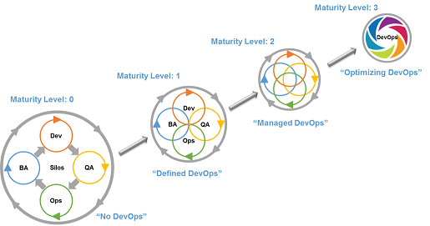
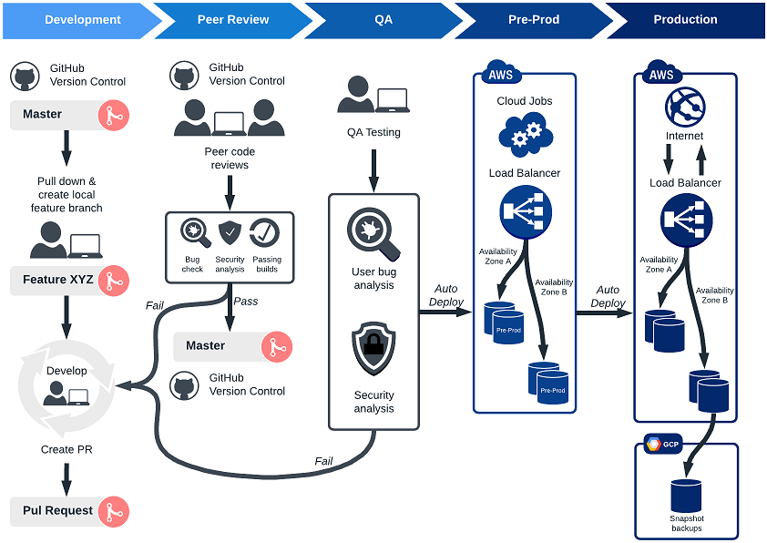  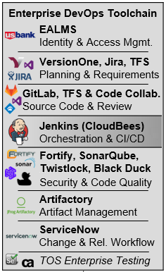 |  | WHAT’S NEXT  EnterPRISE LEVEL:  How to make it happen and Role of the Architect  To make DevOps happen teams need to be re-organized accordingly and appropriate tools need to be adopted.  Teams Organization: One Team: There should be Journey Maps current State & Future State depicting team’s organization currently and then what is the target. Journey maps show how work is done currently vs future.  Tools: Research for Possibility: Similarly there should be Journey Maps current State and Future State depicting current tools involved covered DevOps aspects/stages and then what is the future target.  Architect will lead the research on tools that are in-house or are available in market. Tools should hold following characteristics:  No Duplication: Prevent Redundant tools.  Research: Latest & greatest technologies/frameworks, expand tools usage.  1-Click Deploy.  Cloud Enabled.  One Pipe: For several DevOps operations.  Automation/ less scripting: Monitoring Bots.  Journey Map Jerseys/ DevOps templates: Different TOS Teams/ Technologies will fit into different Journey Map Jerseys for future state since they belong to different domains. For example, some technologies have in-built code management, deployment mechanisms while other technologies need external tools for the same.

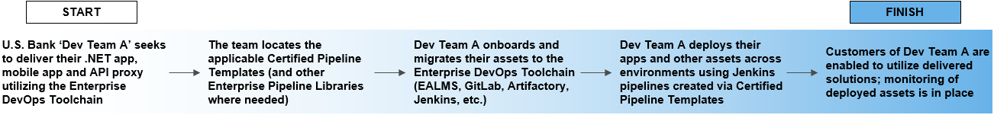
WHAT’S NEXT  Individual TOS TEAM LEVEL:  How to make it happen and Role of the Architect  Journey Maps:  Journey Maps depicting current state and future state under DevOps strategy for the individual technology/TOS team. These maps could be separated for team organization versus tools adapted.  DevOps Compatibility Comparison Charts/ Accountability Matrix:  There can be DevOps Compatibility comparison charts to compare technologies adaption towards DevOps in terms of tools and team structure. Also an accountability matrix to hold who within TOS team is responsible and accountable while TOS team journey towards DevOps. Accountability matrix can have deadlines as established by TOS teams.  While adopting DevOps tools following things should be considered or worked upon. It is always good if the technology that TOS team is managing has these characteristics:  Automation: Does their technology provide automation for DevOps operations like testing, deployment, monitoring.  Integration points: Can their technology integrate with DevOps tools.  Custom Frameworks: For example custom development for integrations with DevOps tools.  Is technology Auto-Deployable?  Is technology Auto-Scalable?  Is technology cloud enabled?  No Code Development: Technologies are evolving within their domains with no code development option. This is enabling business people to build features  AI Based DevOps: AI based growth plans. Raising capacity demands using AI over historic data.  Conference Calls/ Training & Enablement Sessions:  Having conference calls and training & Enablement sessions will help TOS teams evolve into DevOps. This can bring change in culture.  Important Tip: The communication and learning can be two way  TOS2020: It is up to TOS leaders and teams to take action and leverage these enablers.  Take the lead. | 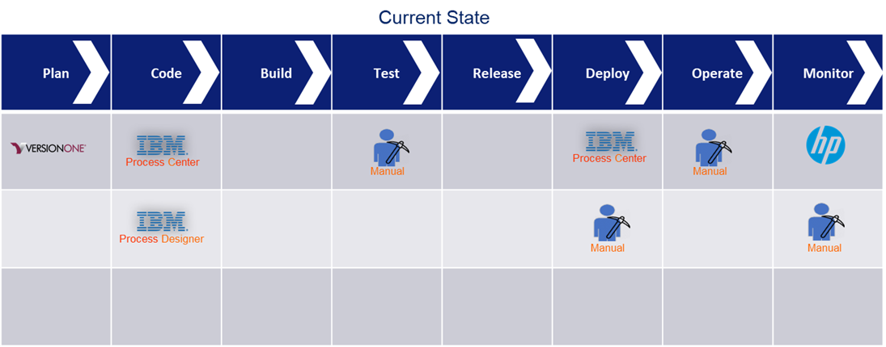  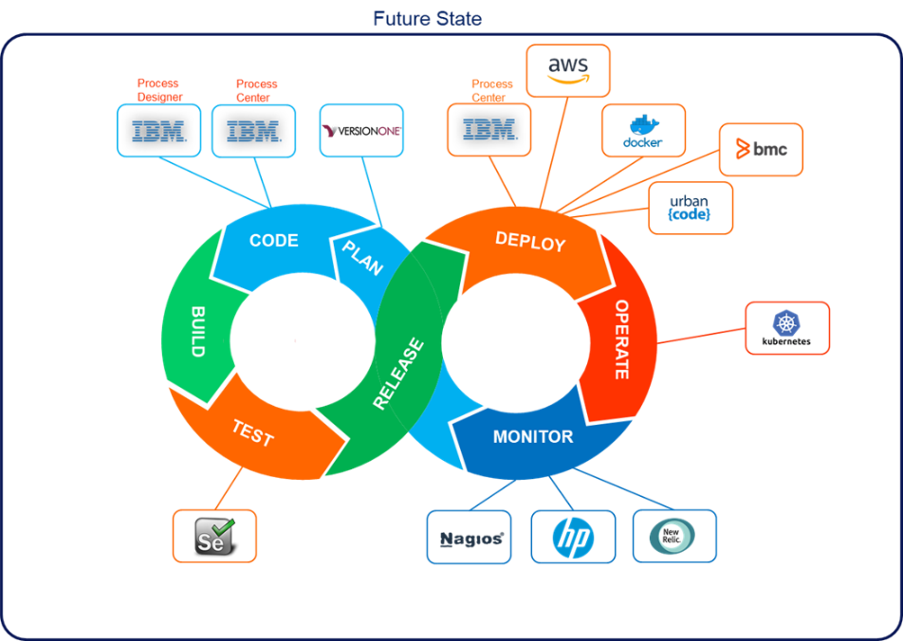

References:
DevOps Benefits: https://newrelic.com/devops/benefits-of-devops
US Bank DevOps Enablement Site: https://usbank.sharepoint.com/sites/DEC
TOS2020 Community: https://connections.us.bank-dns.com/communities/service/html/communitystart?communityUuid=6f6740d8-1655-41a1-a4ec-67e99bce3360

