Rocket Tutorial

Start by deleting the standard cube in the center of the scene. You do this by selecting it with the right mouse button and pressing ‘x’ afterwards to delete.

Now we press ‘shift’ and ‘a’ and select the ‘Cylinder’ in the ‘Mesh’ menu to add a Cylinder, our BaseMesh for the Rocket.

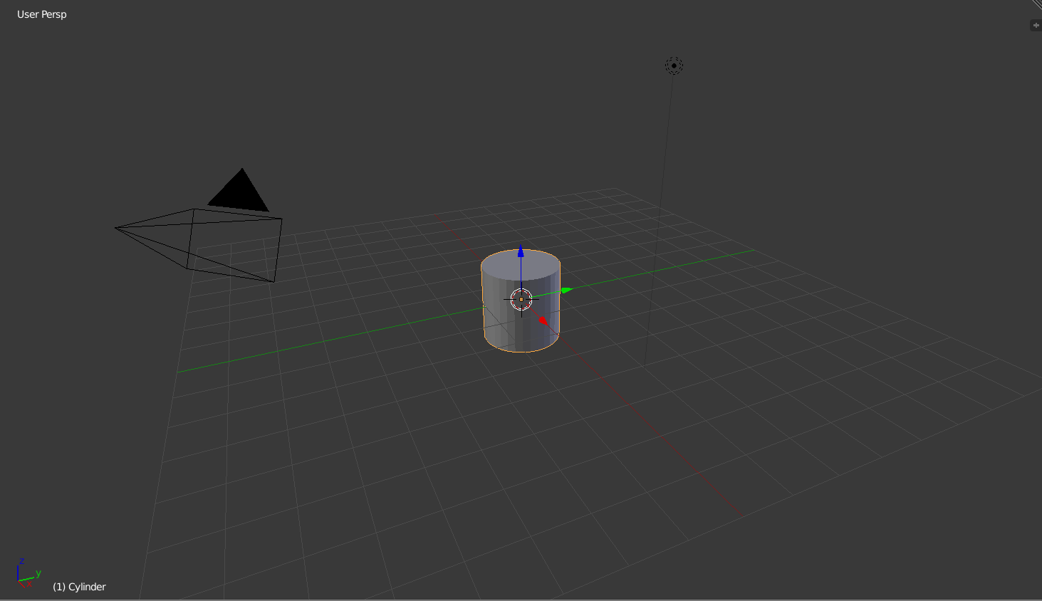

Now we change the view from perspective to orthographic by pressing ‘5’ on the NumPad. This way the proportions are better to see. You can navigate your view with the NumPad or by pressing the middle Mouse Button.

By pressing ‘Tab’ you can switch to the edit mode of the selected mesh. In the edit mode you can move vertices around and change the structure of the mesh.

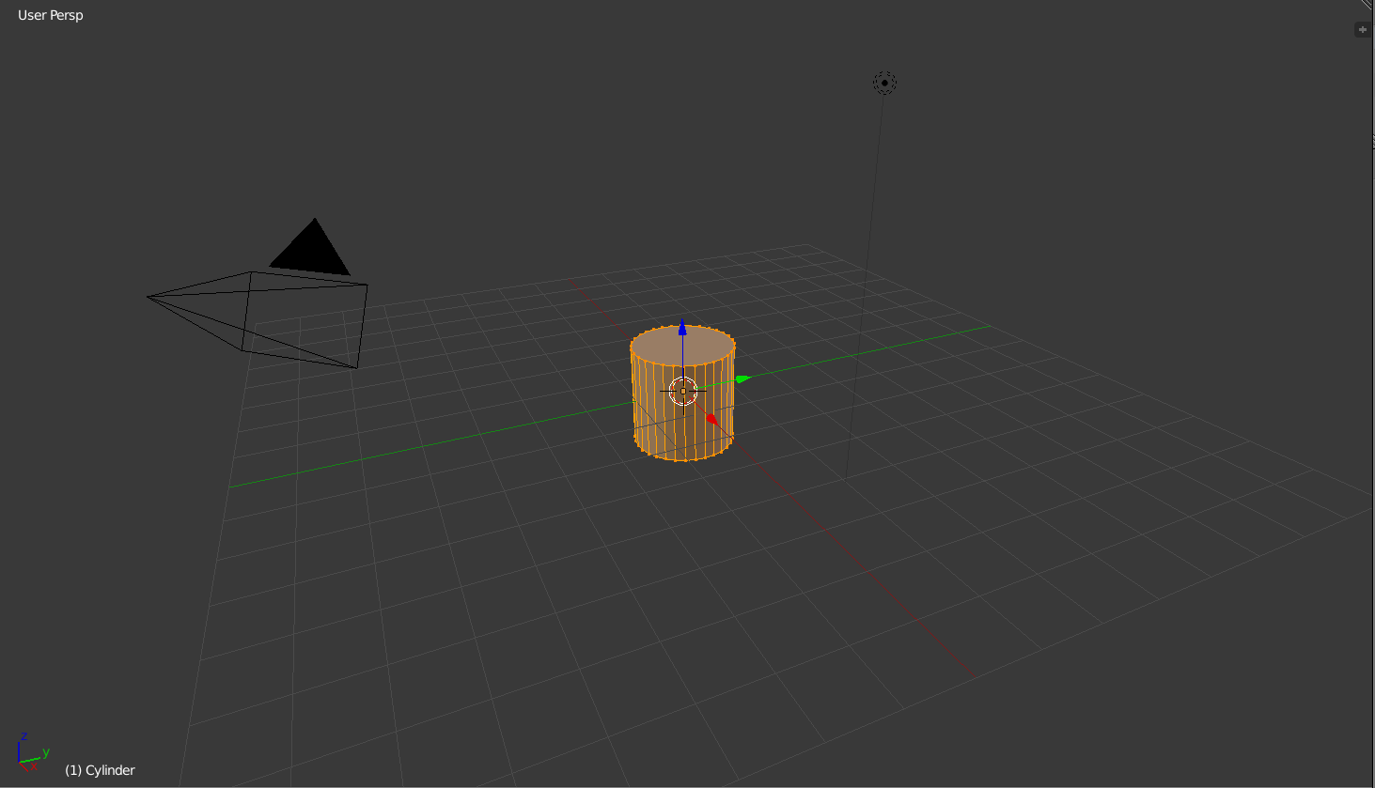

By pressing ‘e’ you can extrude faces, edges and vertices. By pressing ‘s’ you can scale the selected parts. With these two controls you can create a rough rocket shape.

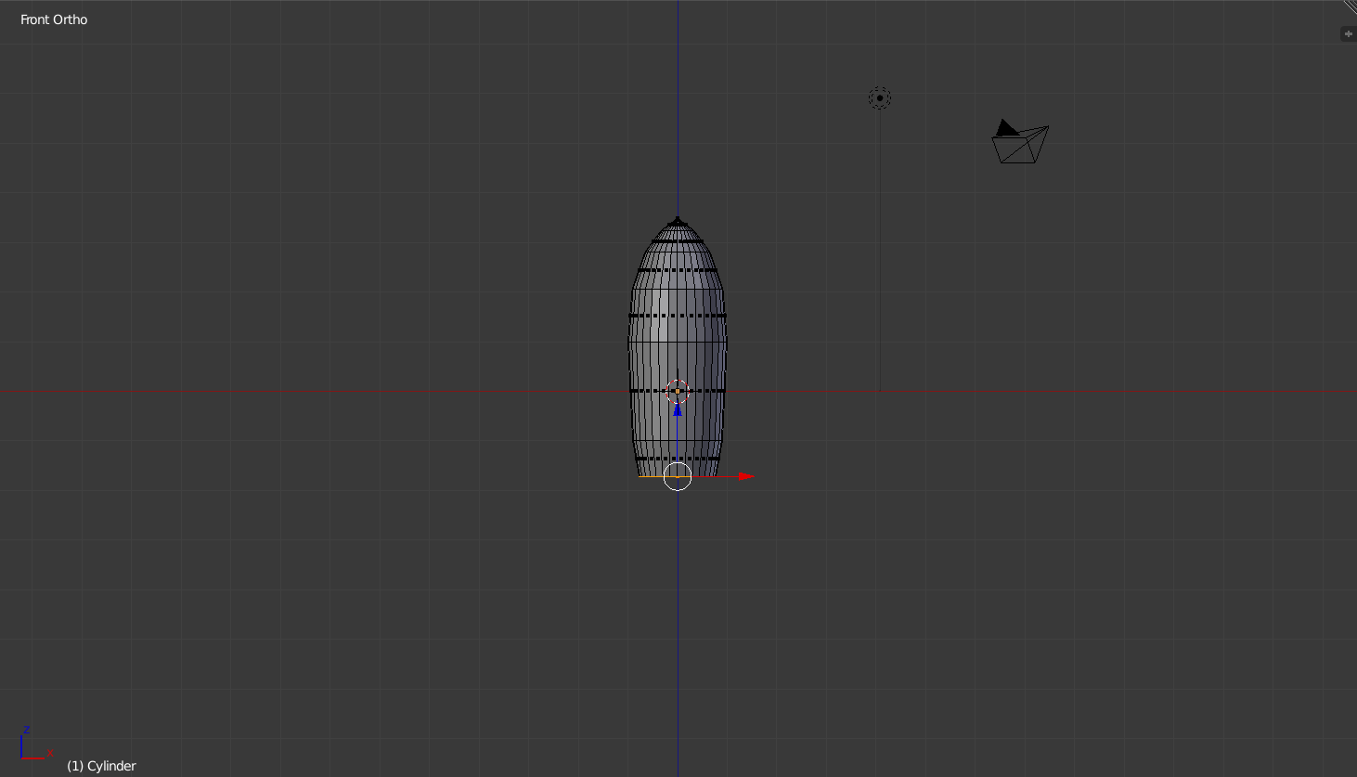

With this shape most of the Rocket is done. We just have to add the things alongside the thruster and color it. Therefore we add a cube mesh, scale it to a fitting proportion and start to extrude it into a good shape. You should end up with something like this:

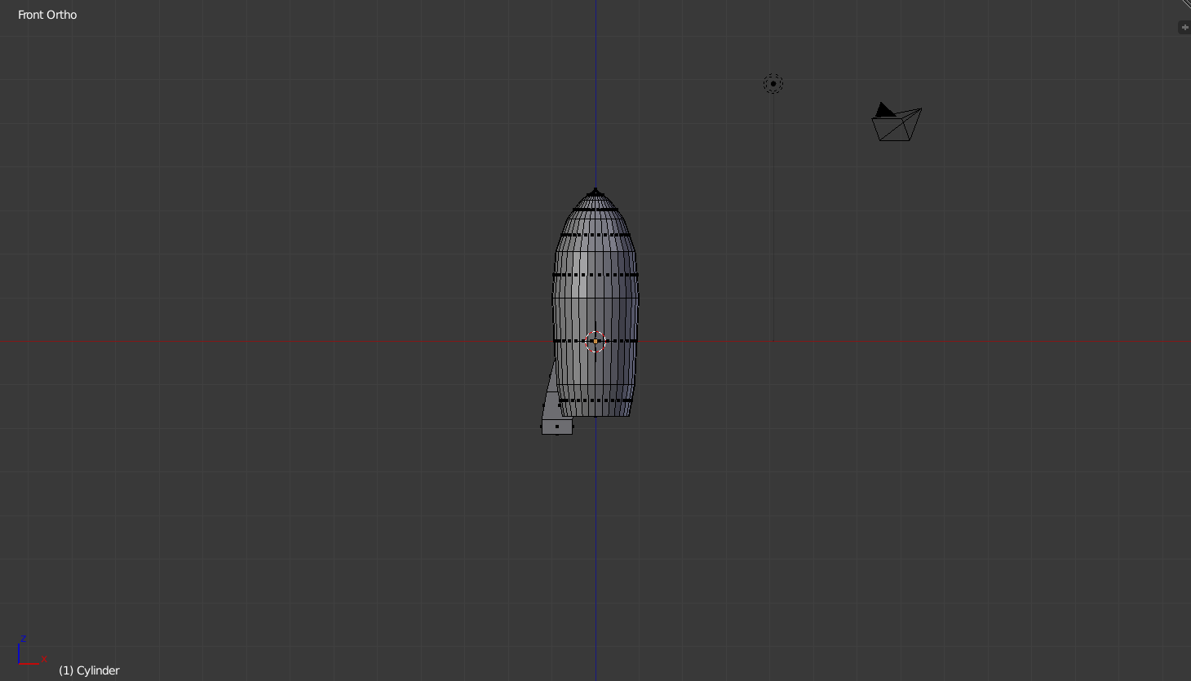

Now you select your one thruster thing by pressing ‘l’ on the keyboard while pointing at it. Afterwards you switch to top view by pressing ‘7’ on the NumPad. With ‘shift’ and ‘d’ you can duplicate the selected objects. By pressing ‘r’ you can rotate the selection and place it on the right spot by pressing ‘g’. With these controls you can place the remaining thruster things and you get this:

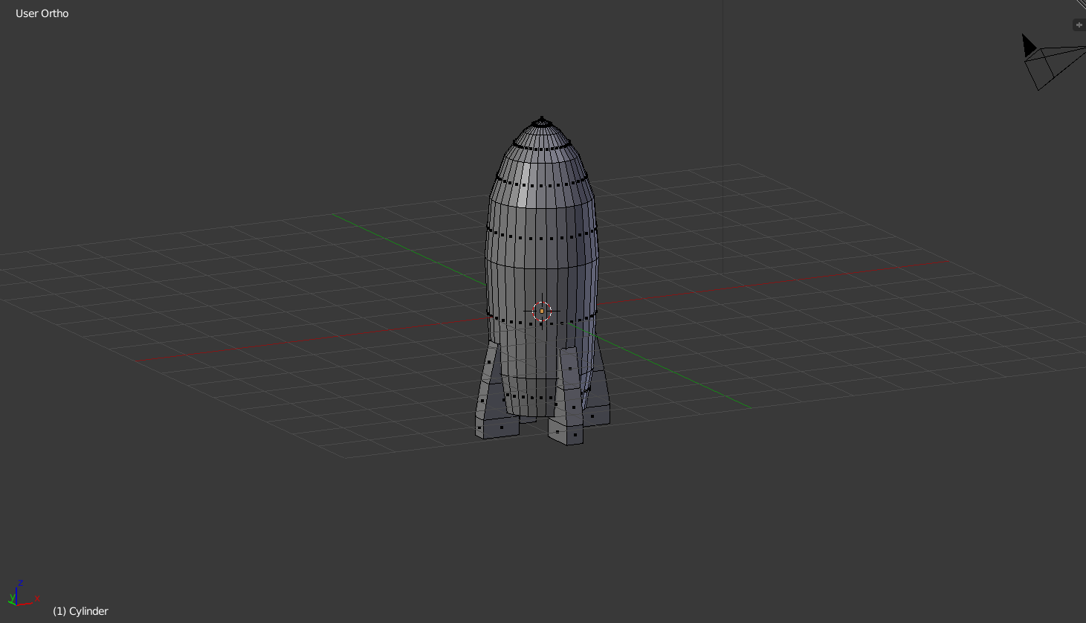

Now your Model is finished. You can color it by switching to the materials window in the right panel: 

There, you simply click ‘New’ to create your first material. By clicking on the colored(white) panel in the ‘diffuse’ section, you can select the color of this material. The first material will be assigned automatically. If you want to create a second material, you have to click the ‘+’ symbol next to the material selection. This material can be assigned by selecting certain Areas and clicking ‘assign afterwards.

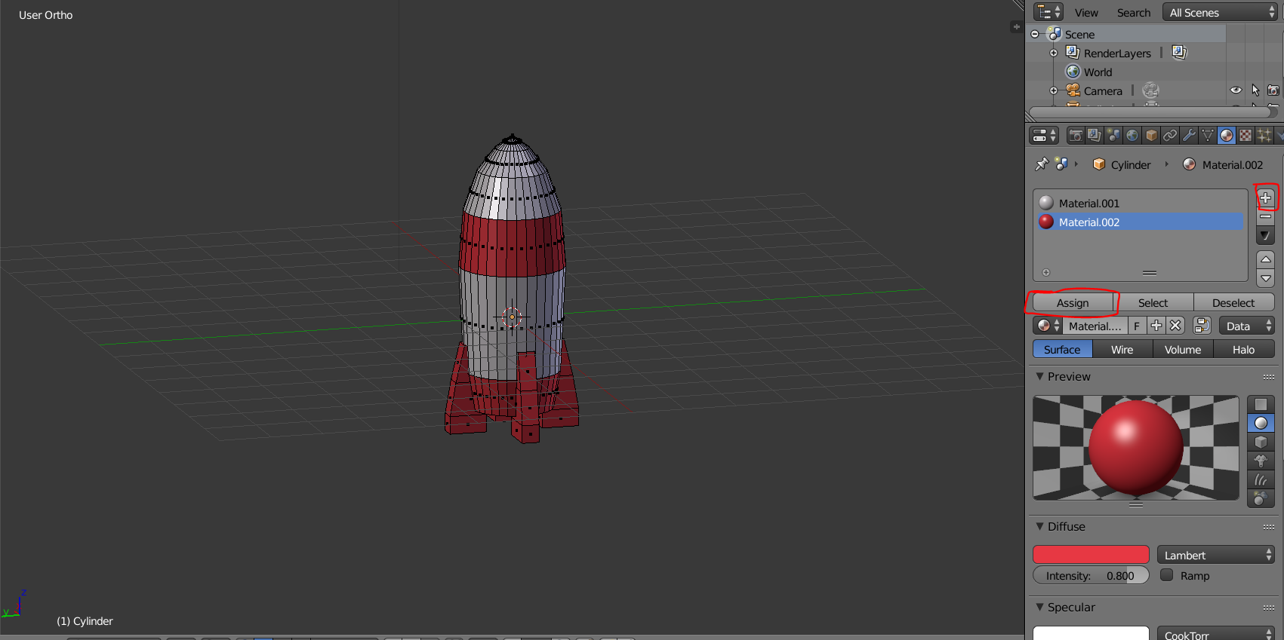

So now you created your first rocket in Blender.

If you want to learn more about modelling or Materials, search for beginner tutorials on YouTube. The channel Blender Guru publishes amazing intermediate and advanced tutorials but there are a ton of good tutorials out there so if you keep modeling you will get better and better. And if one Model is too frustrating don’t quit modelling forever, you will learn new techniques and may be able to return to your Project after a short while.