**Laporan Pengembangan Game**

**HalloFly**



**Muhammad Abdul Aziz**

**A11.2019.11790**

**A11.4501**

Daftar Isi

Tentang Game 3

1. Deskripsi 3

2. ScreenShoot 3

Detail Pengembangan Aplikasi 4

1. Flow Chart 4

2. Class Diagram 4

3. ScreenShoot Lengkap 4

4. Referensi 7

# Tentang Game

## Deskripsi

Game yang saya buat seperti game flappycopter pada tugas mingguan mata kuliah Game Programming. Cara bermainnya sama seperti flappycopter tapi dengan bbrp tambahan seperti ada pengaturan volume musik.

## ScreenShoot

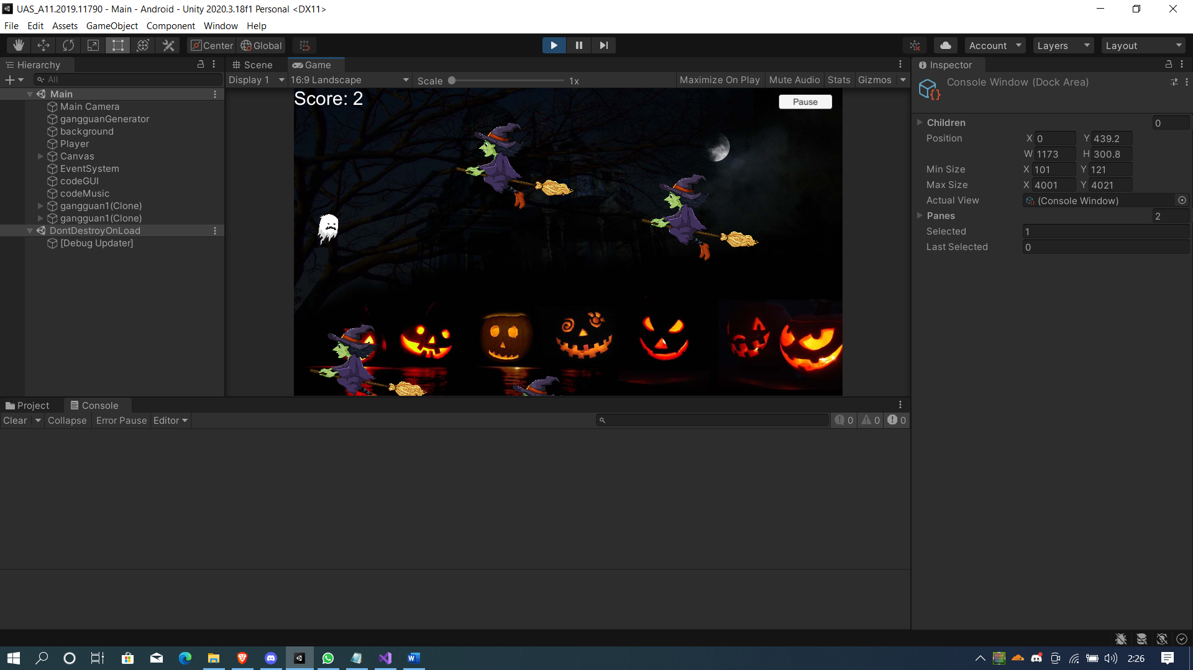

# Detail Pengembangan Aplikasi

## Flow Chart

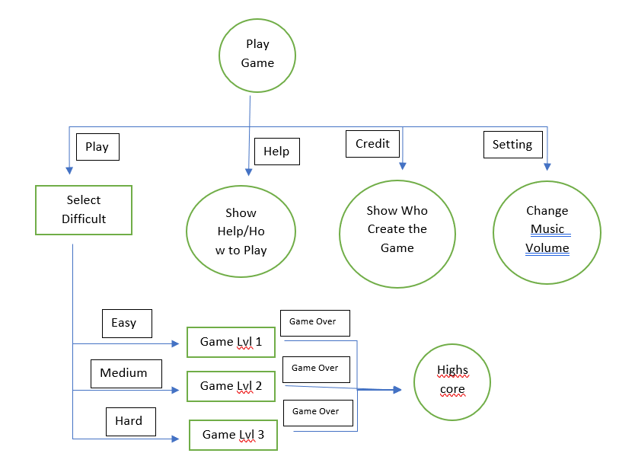

## Class Diagram

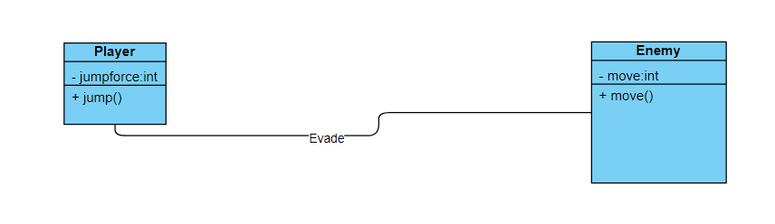

## ScreenShoot Lengkap

Credit

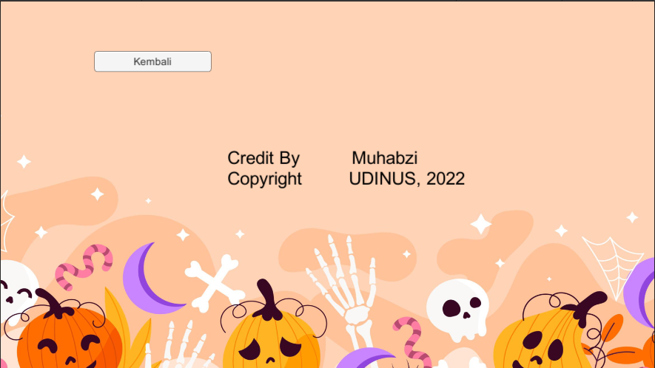

Help

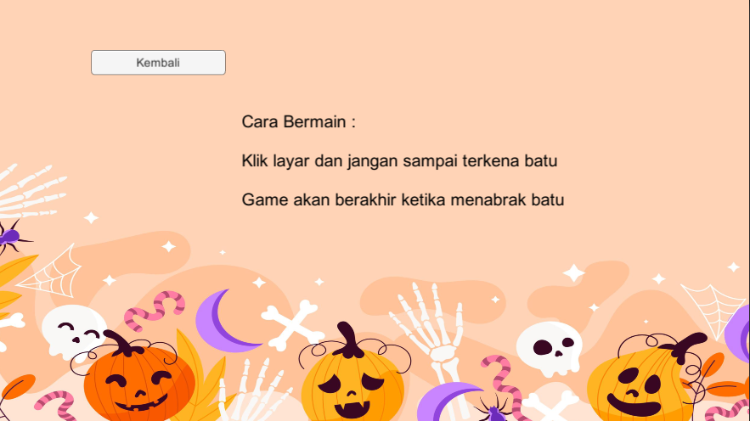

Menu

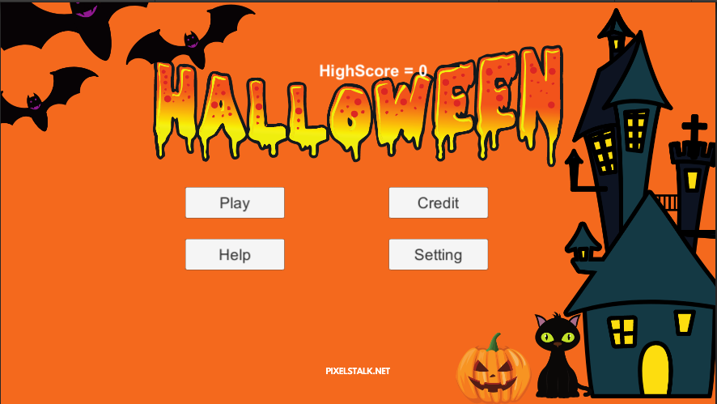

Level

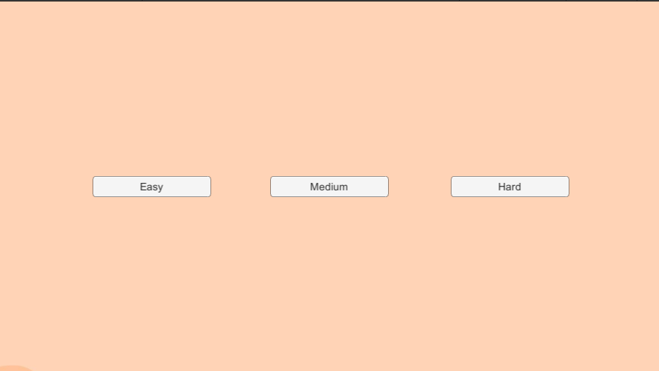

Setting

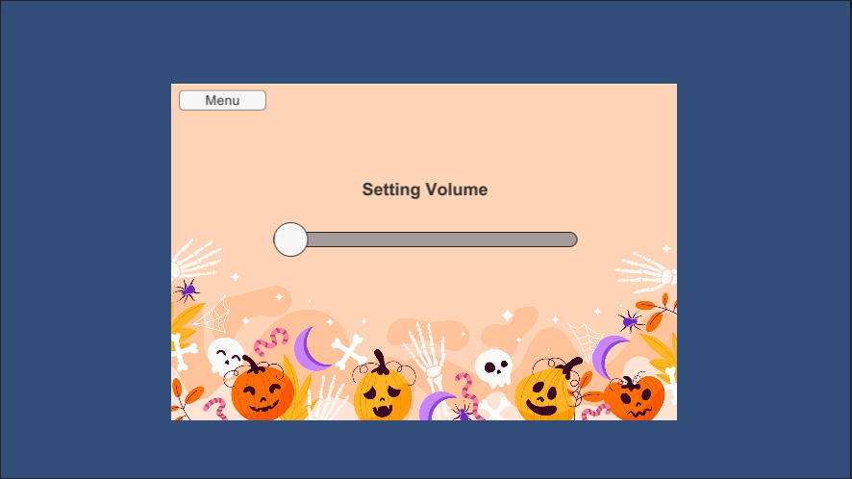

Easy Level

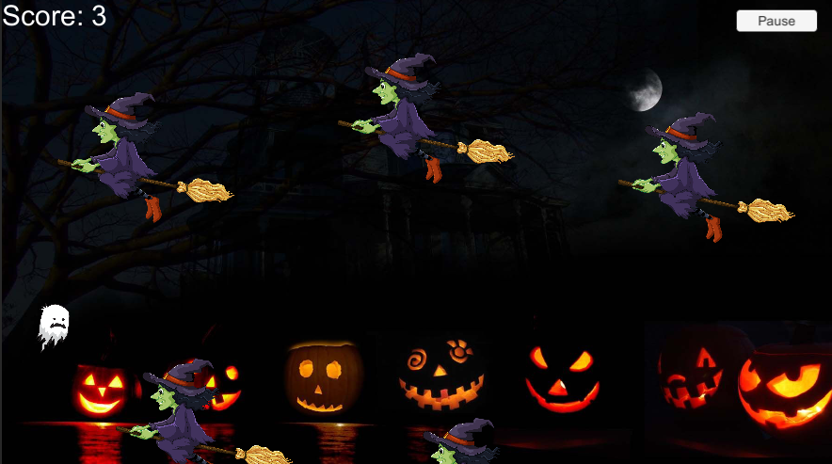

Medium Level

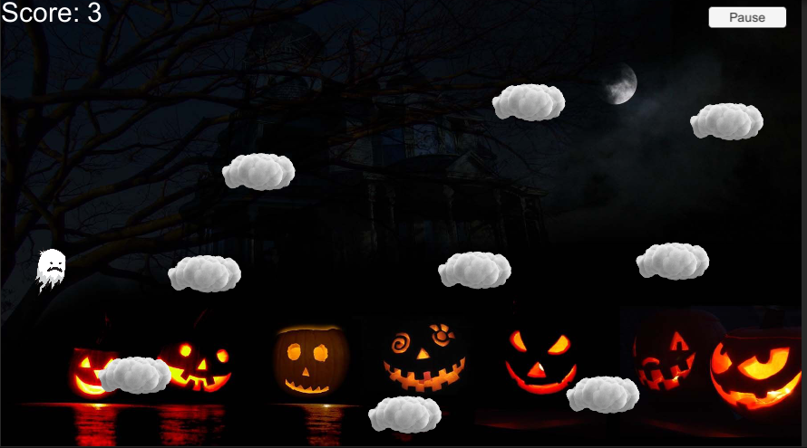

Hard Level

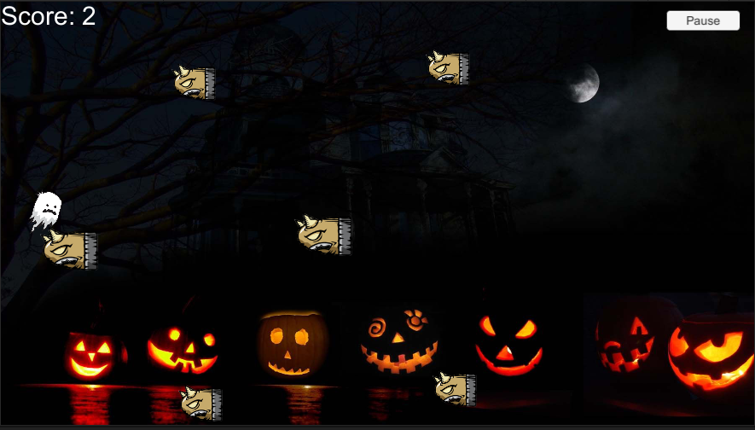

## Referensi

Gambar :

https://www.citypng.com/show_download/stock/5438

https://www.freepik.com/free-vector/hand-drawn-halloween-background_18038671.htm

https://www.pngitem.com/middle/TJihb_green-realistic-tree-png-clip-art-transparent-animated/

https://www.pngegg.com/en/png-niutx

https://www.pixelstalk.net/halloween-2021-wallpapers-hd/

https://wallpaper.dog/halloween-laptop-wallpapers

https://imgbin.com/png/4jntEbET/condensation-cloud-animation-png#

Musik :

https://www.chosic.com/download-audio/27247/

https://www.chosic.com/download-audio/29771/

https://www.chosic.com/download-audio/29669/

https://www.chosic.com/download-audio/29781/

Tutorial :

project flappycopter

https://www.youtube.com/watch?v=yWCHaTwVblk&t=184s