Problem Chosen  C | 2026  MCM/ICM  Summary Sheet | Team Control Number  2613342
“Dancing with the stars” scoring methods evaluation and improvements
Summary
In the popular TV show Dancing with the Stars, the scoring system has long faced the challenge of balancing professional judging with audience participation. To address this, we develop a series of interconnected models to reconstruct missing fan-vote data, evaluate scoring methods, analyze performance factors, and design a new integrated scoring system.
First, to estimate historically unpublicized fan votes, we build a Convex Polytope Constraint Model (CPCM). By converting weekly elimination outcomes into linear inequalities within a constrained solution space, we reliably reconstruct fan-vote proportions. Our results show high consistency with the original data (θ = 1), and certainty indices indicate strong confidence for most estimates.
Second, using a Comparability Test based on logistic regression, we compare the two historical scoring methods: the Percentage-Sum and Rank-Sum approaches. The test reveals that the Percentage-Sum method is significantly more fan-biased (61.0%) than the Rank-Sum method (53.1%) (p < 0.001). Based on extreme-case simulations, we recommend adopting the Rank-Sum method, optionally supplemented with a “Judge Save” mechanism to maintain technical standards.
Third, to identify key factors influencing scores, we apply Gradient Boosting (XGBoost) and interpret outcomes via SHAP analysis. Results show that judges’ scores are more influenced by technical factors such as contestant age and partner strength, while fan votes follow distinct patterns, highlighting a fundamental difference in evaluation criteria.
Finally, we propose a new GNS (Game-Nash Scoring) model, which integrates the Cobb–Douglas utility function with Nash social welfare. Its form $GNS=S_{J}^{α}×S_{F}^{1−α}$ (with α = 0.6) allows adjustable weighting between judge utility $S_{J}$ and fan utility $S_{F}$. Historical back testing on 66 elimination rounds shows that the model corrects 23 unfair outcomes caused by single-sided dominance, significantly improving fairness while maintaining audience engagement.
Keywords: Scoring system balance, CPCM, gradient boosting, Nash social welfare, Cobb–Douglas utility function

Content
1. Introduction 3
1.1 Background 3
1.2 Problem restatement 3
1.3 Data processing 4
1.3.1 Detailed processing 4
1.3.2 Processing results 4
1.4 Our Work 4
2. Assumptions and reasons 5
3. Notations 6
4. CPCM Model built for task 1 6
4.1 Problem analysis 6
4.2 Specific situation for season 3 to 27 6
4.3 Specific situation for season 1 to 2 and 28 to 34 7
4.4 Further restriction 7
4.5 The solution of task 1 7
4.5.1 The confidence analysis of fan voting results 8
5. Analysis of the Fan-Biased Method 9
5.1 Comparability test 9
5.2 Method bias analysis 10
5.3 Case analysis 11
5.3.1 The case of Jerry Rice (Season 2) 11
5.3.2 The case of Billy Ray Cyrus (Season 4) 12
5.3.3 The case of Bristol Palin (Season 11) 13
5.3.4 The case of Bobby Bones (Season 27) 14
5.4 Conclusion 14
6. Gradient Boosting model for task 3 14
6.1 Data analysis 15
6.2 Model building process 15
6.3 Result interpretation 16
7. GNS Model built for task 4 18
7.1 Cobb-Douglas utility function 19
7.2 Nash social welfare theorem 19
7.3 The implication of the final model 19
7.4 Fairness analysis of the model 20
7.5 Model summery 21
8. Conclusion, Strength and weakness 21
8.1 Conclusion and strength analysis 21
8.2 Weakness 22
References 23
Report on use of AI 24

Introduction

1.1 Background
"Dancing with the Stars" is a hugely popular international television show that has aired 34 seasons. Celebrities and professional dancers take to the stage every week, delivering passionate performances to the audience. This show employs a unique scoring system, where participants receive dual scores from a panel of expert judges and the fans. These two scores are combined in a special way to determine the participant's final score. However, this scoring method inevitably leads to an imbalance in scoring power between experts and the audience, forcing the production team to change the scoring combination multiple times. To reduce audience skepticism, maintain the professionalism of the show, and simultaneously enhance fan interest and excitement, the production team needs to find a scoring method that strikes a balance between fairness and satisfying fans.

1.2 Problem restatement
Taking into account the background of the problem and the existing information, we have decided to focus on solving the following issues:
- As there have no publicly available fan voting data for the contestants, it is necessary to use the disclosed information to establish a mathematical model to estimate the number of fan votes each contestant has received, and to explain the potential scale of deviation in the data.
- Input the obtained fan voting data into two different scoring methods, and determine whether there is a combination method that is more biased towards fan voting.
- Use specific extreme scenarios to test the characteristics of the two voting methods, and recommend one of them as the scoring method for future quarters. At the same time, evaluate whether to introduce a "judge's judgment" mechanism which enables judges to choose one group to be eliminated from the bottom two groups in each round.
- Propose a new scoring system which is prior to the original one to some extent, and give detailed argument.
- Write a memo about the result of the model, this memorandum is used to communicate the strategy, model and results with the program producer.

1.3 Data processing

1.3.1 Detailed processing
The original dataset we used contains complete competition records for seasons 1 through 34 of the DWTS program, comprising 51 original fields. After initial data processing, it was found that Judge 4's data was missing for most seasons, and there were inconsistencies in the units of measurement between seasons, requiring further processing before analysis.
Here are the specific process:
- Score standardization. Given the varying number of judges across different seasons, we used the average score from a single judge as the standardization metric for the model:
$${Score}_{avg}^{w} =\frac{\left(\sum_{j=1}^{N_{judges}}{{Score}_{j}^{w}}\right)}{N_{judges}}$$
- Handling missing values ​​and outliers. Replace the 0 scores of non-participating contestants with NaN to prevent them from lowering the average score, and normalize the data so that all scores are within the range of 0 to 10.
- One-hot encoding. Variables that cannot be directly used in regression analysis are processed using one-hot encoding, such as splitting a player's profession into multiple smaller variables.

1.3.2 Processing results
After processing the player data, we obtained 324 elimination events and 111 final match records, which can be directly used for model analysis.

1.4 Our Work
We use a Convex Polytope Constraint Model (CPCM) to estimate the fan voting data the contestants received. The shape of this convex polytope is restricted by the final competition ranking and the non-negativity of the amount of the number of fans. Hit-and-Run sample model is also used in out model, this sample is a kind of Markov Chain Monte Carlo method. It can quickly traverse the high-dimensional space of the convex polytope, avoiding getting stuck in local optimal.
The graph below shows the framework of our model.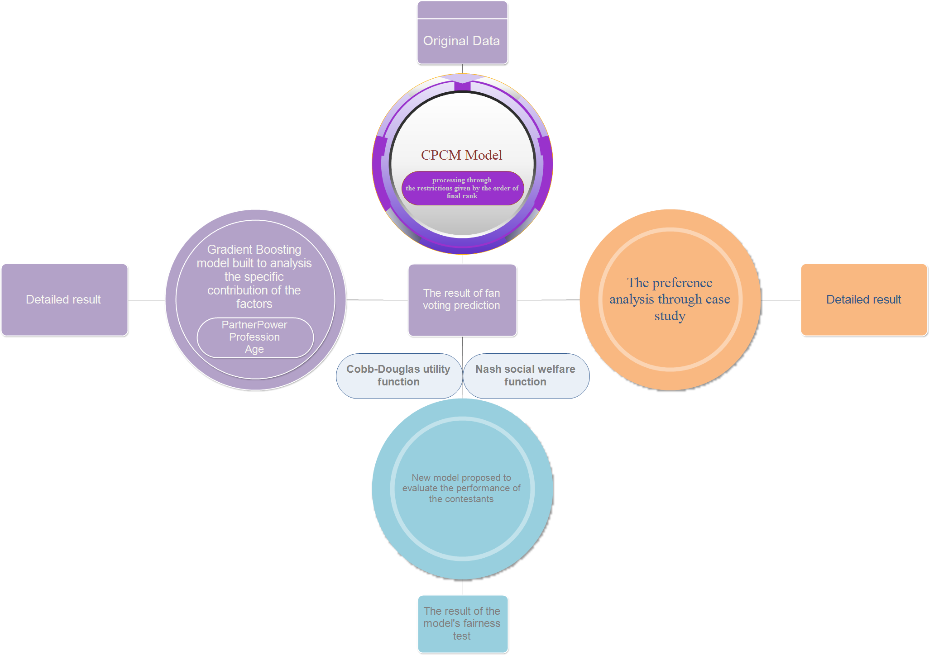

Assumptions and reasons
Since our team only use the data which is provided, we make the following assumptions.
- Assumption 1. Judges have a consistent scoring criteria throughout the week. Though scoring criteria may change between different weeks and different judges, however, the judges' scores within the same week can linearly reflect the technical proficiency of the contestants.
- Reason 1. This is the premise for the scoring by the judges to have reference significance, and only when this premise is met can the scoring by the judges be normalized.
- Assumption 2. The fan base of all contestants forms a cohesive whole, and there is no mass departure of spectators after the elimination of a specific contestant
- Reason 2. This ensures that the total number of fan votes for all contestants remains consistent, guaranteeing the effectiveness of the single convex polytope model we adopted.
- Assumption 3. In a single season, the fan base of each player remains unchanged, and there is no sudden large-scale change in the audience's support for different players.
- Reason 3. This is the premise for the model to lock onto a specific solution space through the accumulated information from multiple rounds of elimination.

Notations
Symbols | Definitions
n | Total number of participants.
$$f$$ | Fan vote vector. $f=(f_{1},f_{2},...,f_{n})$.
$$f_{i}$$ | Proportion of fan votes for the $i$-th participant (as a proportion of total fan votes).
$$J$$ | Normalized judge score vector. $J=\left(J_{1},J_{2},...,J_{n}\right).$
$$J_{i}$$ | Proportion of judge scores for the $i$-th participant (as a proportion of total judge scores).
$${\text{Rank}}_{J}(i)$$ | Ranking based on judge score proportion $J_{i}$(a smaller value indicates a higher rank).
$${\text{Rank}}_{f}(i)$$ | Ranking based on fan vote proportion $f_{i}$(a smaller value indicates a higher rank).
$$θ$$ | Indicator of consistency between model predictions and original data (1 indicates perfect consistency).
$$C_{i}$$ | Certainty Index, indicating the confidence level in the estimated fan vote proportion for the $i$-th participant.
$$A,b$$ | Coefficient matrix and constant vector for the linear inequality constraints, defining the convex polytope (solution space).
Where we define the main parameters while specific value of those parameters will be given later.

CPCM Model built for task 1

4.1 Problem analysis
In this task, we aim to deduce the number of fan votes each contestant received based on the given data distribution of jury scores and final rankings. Specifically, the fan vote vector of each contestant ($f_{i}$) must satisfy the following conditions:
$$∑_{i=1}^{n}f_{i} = 1, f_{i}≥0 ∀ i$$
As for the finals, we use the final ranking as a constraint.
This condition defines the solution space for the number of fan votes. All subsequent linear inequality constraints introduced are cutting this simplex region, ultimately yielding the solution for the number of votes.

4.2 Specific situation for season 3 to 27
In these seasons, the ranking of contestants is determined by the sum of the proportion of judge scores they receive and the proportion of fan votes they receive. The elimination rule can be transformed into a set of linear inequalities:
$J_{e}+ f_{e}≤ J_{j}+ f_{j}, ∀ j≠e$; $\left(J_{e}−J_{j}\right)+\left(f_{e}−f_{j}\right)≤ 0$
And there is also a restriction on the matrix:
$$Ax<b$$

4.3 Specific situation for season 1 to 2 and 28 to 34
In these quarters, the ranking of contestants is determined by both sides, and the contestant with the lowest total ranking will be eliminated. Translating this constraint into mathematical expression, we get:
$${rank}_{J}\left(e\right)+{rank}_{f}\left(e\right)≤{rank}_{J}\left(j\right)+{rank}_{f}\left(j\right), ∀ j≠ e$$
By applying ordinal transformation, we can obtain the inequality:
$$k_{1}+{rank}_{J}\left(e\right)<k_{2}+{rank}_{J}\left(j\right)$$

4.4 Further restriction
In the model we established, the linear constraints that have already been used are not immediately discarded, but are retained and incorporated into subsequent predictions of fan voting patterns for eliminated contestants, continuously refining later predictions.

4.5 The solution of task 1
After establishing the CAPM model, a feasibility test is required to ensure the existence of a solution that satisfies all linear constraints.
- Step1. Based on the elimination results and judges' scores of the current week, convert the elimination rules of the current season into linear inequality constraints. This constraint, together with the universal simplex constraints, forms a linear system which can be used to predict the fan voting result.
- Step2. By first using linear programming to find an interior point that satisfies all constraints, if a non-zero solution exists, it indicates that a fan vote allocation satisfying the conditions exists, and the system is feasible.
After these process, we modeled all contestants fan voting condition except 10 contestants who quit the game and 3 contestants who had special conditions.
After substituting the obtained results back into the original data, it was found that the $θ$values of all results are 1, indicating that the inferences drawn from the model regarding the number of fan votes were fully consistent with the original data. 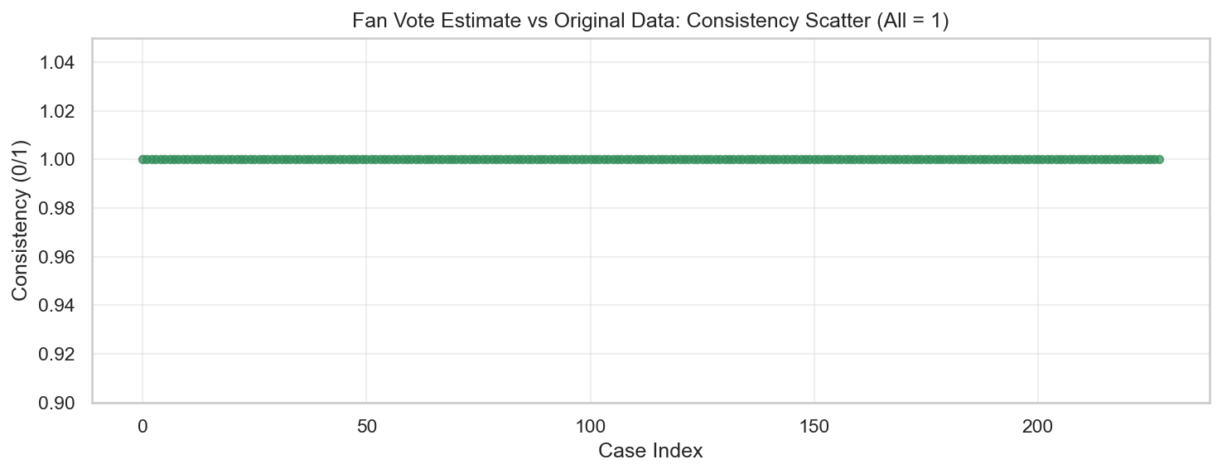

4.5.1 The confidence analysis of fan voting results
After analyzing the fan voting results given by our model, we get these graphs which indicates vital features for case study.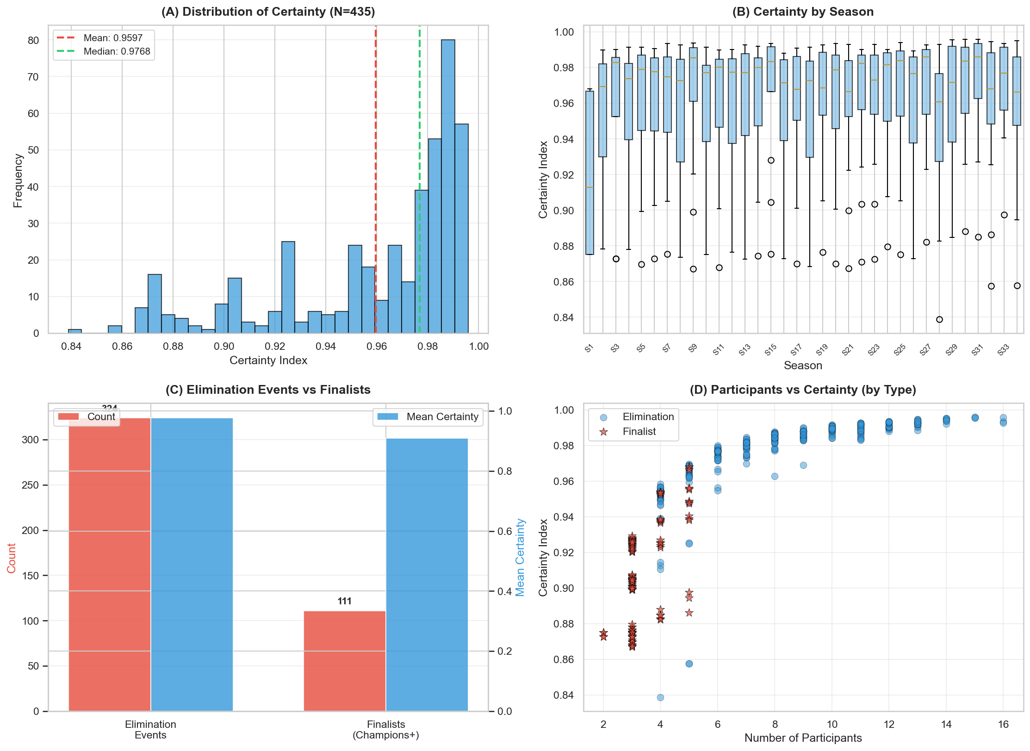
Figure A is a deterministic distribution diagram. The closer the certainty index is to 1, the more concentrated the fan proportion obtained by the model is. The red dotted line in the diagram represents the mean of the deterministic index, while the green dotted line represents the median of the deterministic index. It can be seen that both lines are biased towards the right side of the graph with only a difference of about 0.03, indicating that the algorithm can obtain a confident inference result most of the time. Moreover, there is only one peak in the diagram that appears significantly to the right, indicating that the model performance is relatively stable and can handle most of the data.
Figure B illustrates the certainty differences between seasons. Specifically, the height of the box reflects the fluctuation range of the model's interpretation of that season. A higher box position indicates that the data for that season is easier for the algorithm to recognize. Occasional dots outside the boxplot represent extreme outliers, indicating that there were special situations in the season that the algorithm could not interpret.
Figure C represents the total number of knockout rounds and finals under two different scenarios, as well as the mean values of certainty obtained under these two scenarios. It can be seen that inferring the number of fans of the finalists is relatively difficult, as the rankings of four finalists need to be determined at once in the finals, resulting in a significant loss of specific proportion information.
Figure D illustrates the certainty of estimating the number of fan votes for contestants in different scenarios using a scatter plot. It can be observed that our model maintains a high level of confidence when there are six or more participants, but its prediction for the final round is unsatisfactory, only maintaining a confidence level of 0.85 most of the time.

Analysis of the Fan-Biased Method

5.1 Comparability test
The table below shows the comparability test for the two evaluation methods.
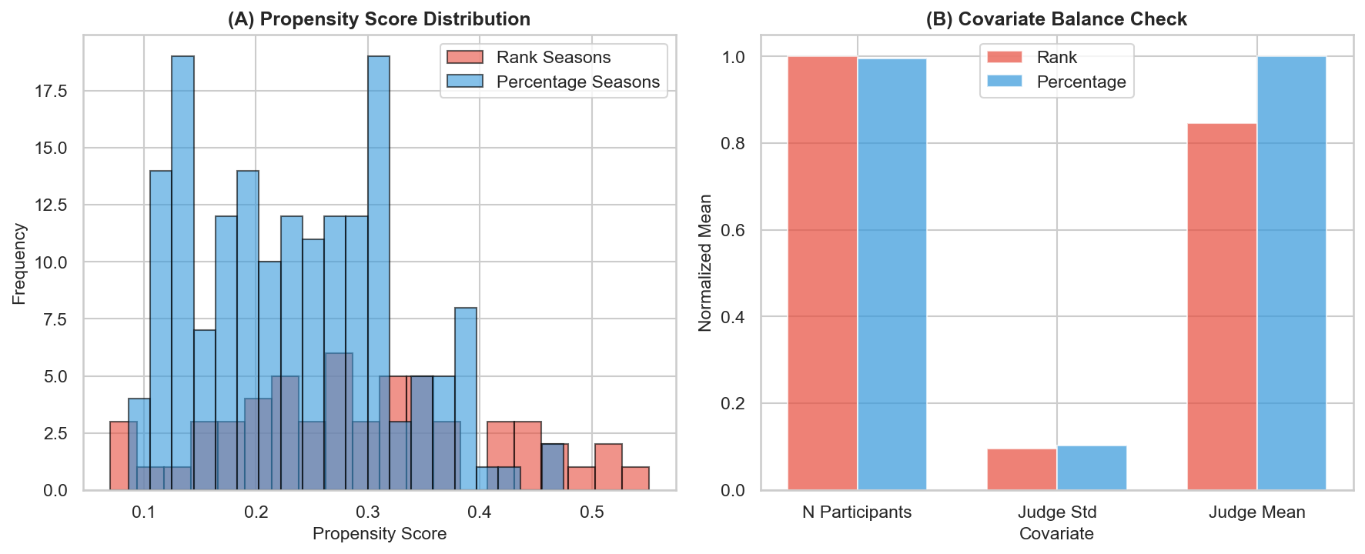
Figure A shows the distribution of propensity scores for the two evaluation methods after logistic regression calculation. Logistic regression uses the sigmoid function to map a linear combination to a probability value between 0 and 1. The specific formula is expressed as:
$$P =\frac{1}{1+e^{−z}}$$
In our model, $P$represents the propensity score, which is the probability of the sample being selected for the rank-based group’s comparison group, while $z$ is determined by the following formula:
$$z =β_{0}+β_{1}×N Participants +β_{2}×Judge Std+β_{3}×Judge Mean$$
Here, $β_{0}$represents the interception term,$β_{1}, β_{2}, β_{3}$ represent the regression coefficient, reflecting the influence of the number of participants, the covariance of judges' scores, and the mean of judges' scores on the selection of the scoring rule respectively. There is a large area of overlap between the two distributions, indicating that there is comparability between the two evaluation methods.
Figure B shows the differences in confounding variables between the groups selected for the two evaluation methods. The figure shows that the levels of confounding variables in the groups selected for both methods are basically at the same level, ruling out interference from the number of participants, the covariance of judges' scores, and the mean of judges' scores.

5.2 Method bias analysis
We define the performance of an evaluation method as "fan-biased" as follows: If during a specific elimination round, the eliminated contestant is not the one with the lowest judges' score, we say that the evaluation method demonstrated a bias towards fan in that round.
Simultaneously, we define the formula for the bias rate of the evaluation method as:
$$\text{Bias Rate}=\frac{\text{Number of weeks yielding "Fan-Biased" results}}{\text{Total sample size under that rule}\text{(weeks)}}×100\%$$
After applying the two scoring methods to all cases, we obtained the following four graphs that reflect the relationship between the two scoring methods.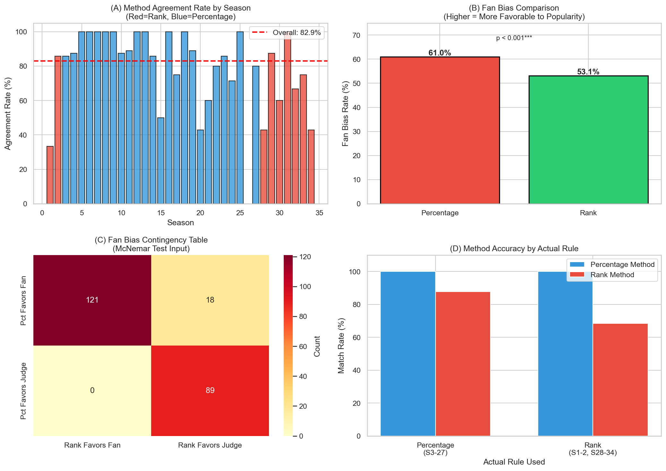
Figure A shows the proportion of cases in each season where the two methods produce the same elimination outcome. It can be observed that seasons using the percentage-based scoring method exhibit a higher degree of agreement among the two methods and its overall consistency rate reaches 82.9%.
Figure B demonstrates how both methods are biased towards fans: we define fan bias as the probability that the eliminated contestant is not the one with the lowest score from the judges. After calculating the data, the percentage method showed a 7.9% higher probability of being biased towards fans than the ranking method.
Figure C shows the detailed result of McNemar test. Indicates that the p-value is less than 0.001, showing that percentage method focus more on the fan voting result than rank method.
Figure D specifically illustrates the performance of the two evaluation methods when applied to seasons originally designed for the other method. An outstanding feature is that the matching rate of the percentage-based method remains at 100% while rank-based method don’t behave well even those seasons which adopted this method. This is because the rank-based method only features the ordinal relationship of the judges' rankings among participants, while the percentage-based method features not only the ordinal relationship but also the specific proportions of the judges' scores. This provides stricter conditions for the convergence of the convex polytope.

5.3 Case analysis
We now employ a counterfactual approach to analyze extreme cases observed during the competition. Specifically, we combine our model's predicted fan voting results with the actual judges' scores to determine if the rankings of four renowned celebrities would shift under different scoring rules. Furthermore, we simulate the introduction of a "Judges' Save" (where judge eliminates the two lowest-scored contestant) mechanism to observe its impact on their final rankings.

5.3.1 The case of Jerry Rice (Season 2)
In Season 2, which utilized the Rank-based scoring method, NFL legend Jerry Rice finished as the runner-up despite receiving the second-lowest scores from the judges.
Rice's survival can be attributed to the specific mechanics of the Rank system when the contestant pool shrinks significantly. When Rice got lowest point with the judges, only five contestants remained. At this stage, the weight of fan voting within an ordinal ranking system increases significantly. Even if ranked low by judges, as long as Rice secured the top spot in fan voting, his combined rank sum would be 6. This score is sufficient to compete with contestants who ranked at the bottom of the fan vote, effectively offsetting the judges' low scores. This aligns with our model's convergence results for Week 7, which confirm Rice held a significant lead in fan support.
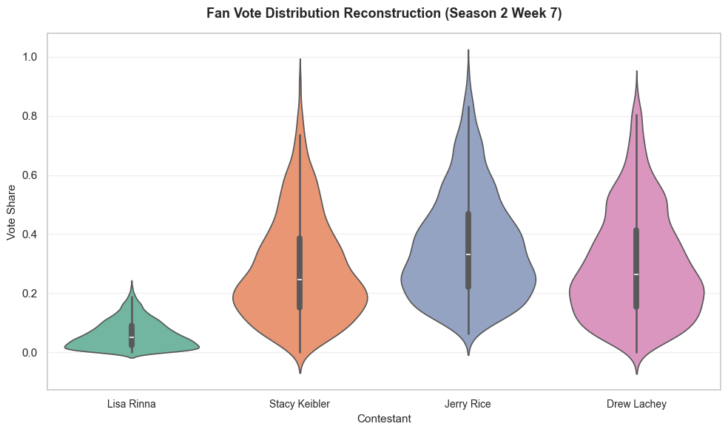
Counterfactual Simulation: Switching to Percentage-based: If Season 2 had used the percentage system, our model estimates Rice would have secured over 30% of the total fan vote. This switch would have actually amplified Rice's advantage. So we conclude that under a percentage system, Rice would have performed at least as well, if not better.
Introducing Judges' Save: Under the percentage system, his position remains safe. However, under the Rank-based system combined with the Judges' Save, he would have been eliminated in Week 7.

5.3.2 The case of Billy Ray Cyrus (Season 4)
Country singer Billy Ray Cyrus finished fifth in Season 4 under the Percentage-based system. Our model’s prediction for his fan voting distribution (Season 4, Week 6) is shown below: 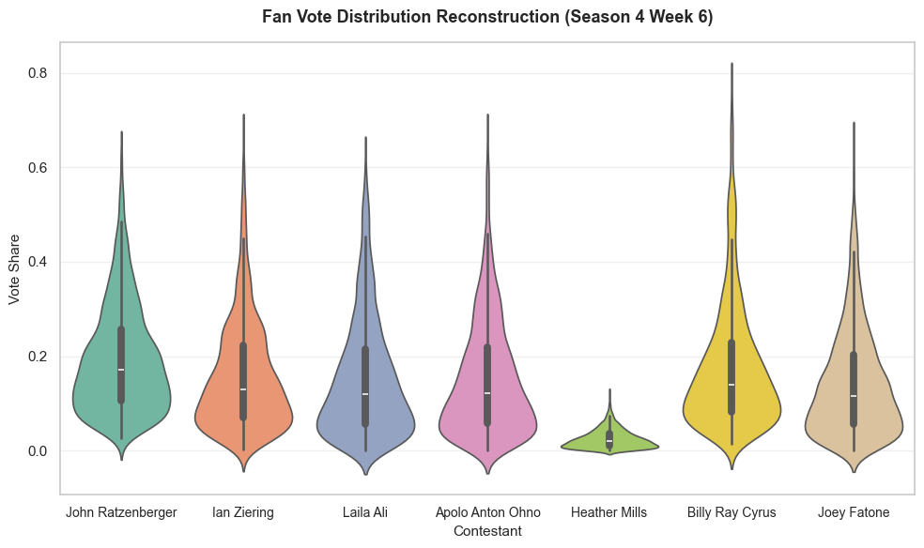
The data shows Cyrus held a distinct advantage in the volume of fan votes. Under the percentage system, this numerical advantage was sufficient to mitigate his technical flaws in dance.
Counterfactual Simulation: Had the season used the Rank method, Cyrus would likely have been eliminated in Week 6. The Rank system converts "overwhelming popularity" into a simple ordinal number, which removes the surplus of his votes.
Introducing Judges' Save: Under the percentage-based method, his rank still holds. However, if the Rank-based method were used as the foundation, the judges would have eliminated him in Week 6.

5.3.3 The case of Bristol Palin (Season 11)
In Season 11 (where percentage-based method utilized), Bristol Palin defeated Brandy despite his judges' scores lagging behind. The simulated fan voting results are as follows: 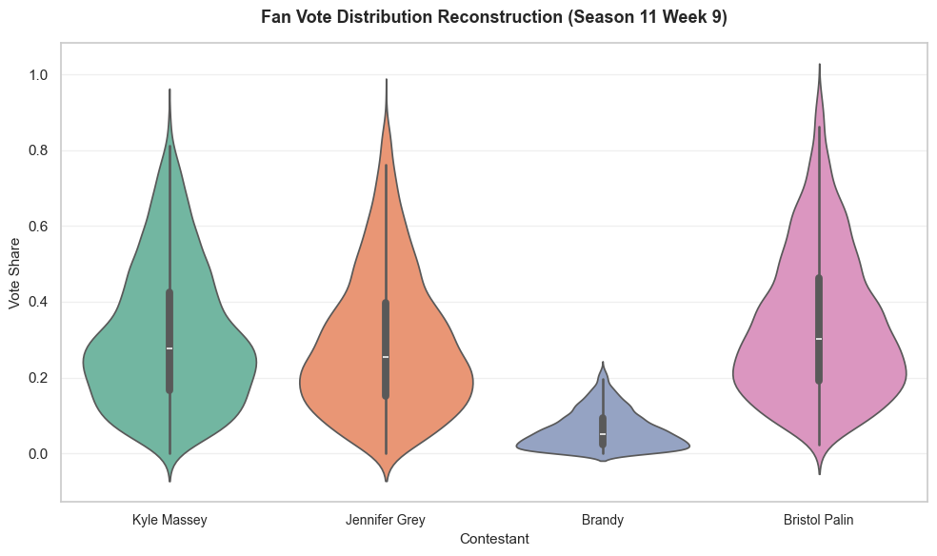
The model reveals that Palin received huge fan votes. This volume advantage was likely the decisive factor in overcoming Brandy's higher technical scores.
Counterfactual Analysis: By this stage of the competition, the number of contestants was highly compressed. Since our model indicates Palin's fan ranking was still superior to Brandy's, simply switching the scoring method would not have been enough to change the outcome.
Introducing Judges' Save: Under the percentage system, she survives. However, under the Rank-based system, the Judges' Save mechanism would have led to her elimination in Week 11.

5.3.4 The case of Bobby Bones (Season 27)
In Season 27, Bobby Bones won the championship despite consistent low judges' scores. Our analysis is as follows: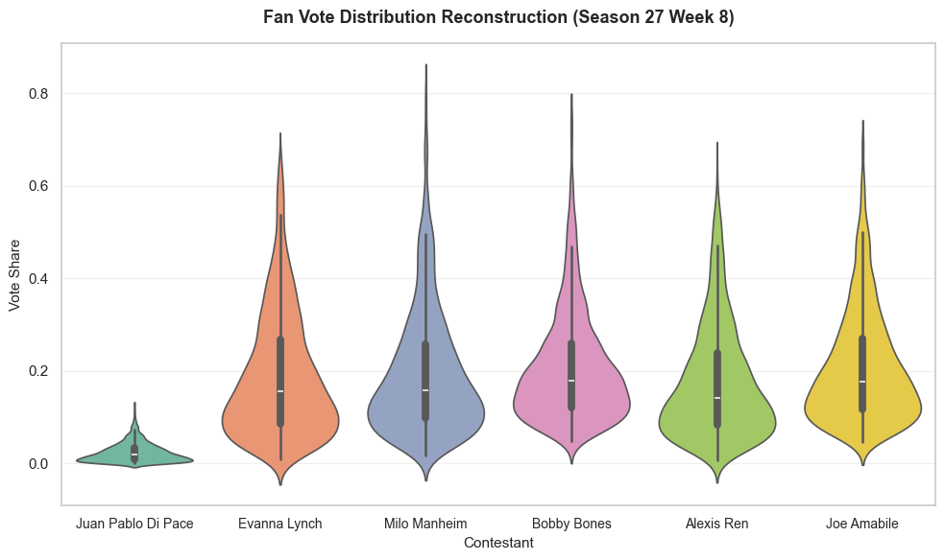
Apparently, Bobby Bones possesses a formidable advantage in fan votes.
Counterfactual Analysis: Bobby Bones would still win the championship.
Introducing Judges' Save: The fan voting advantage of Bobby Bones is so powerful that even the mechanism of Judge’s Save can not stop him from winning the championship.

5.4 Conclusion
In light of these findings, we strongly recommend that future tournaments consistently adopt the rank-based system supplemented by the judge elimination mechanism. The rank-based system effectively mitigates the disproportionate impact of extreme fan voting imbalances. Furthermore, our simulation of the four extreme cases confirms that the judge elimination mechanism serves as an efficient filter, proactively screening out contestants who lack sufficient technical proficiency at an early stage.

Gradient Boosting model for task 3
In this section, we have established three gradient boosting models based on the existing judge scores, our estimated fan voting data, and the known final ranking data to explain the specific impacts of factors such as contestant’s age and PartnerPower on the participants' final scores.

6.1 Data analysis
Since the original dataset contained variables such as participants' occupations that could not be directly used for regression, we employed one-hot encoding to decompose these variables into several sub-variables, such as Athlete, Comedian, and 01 encoding method is introduced to label the specific occupation of the participants. At the same time, in order to quantify the strength of professional dancers, we established an index of professional dancer influence which is named ParterPower, with the specific calculation formula as follows:
$$0.4×Z\left(Average Score\right)+0.4×Z\left(Survival Weeks\right)+0.2×Z(Final performance)$$

6.2 Model building process
We chose the XGboost algorithm to fit the impact of various factors on the final score of participants. This is an ensemble learning technique that obtains the final result through continuous iteration of decision trees. Specifically, this model starts with a simple initial prediction and uses the error (residual) between the initial prediction and the correct data to assist in generating the next decision tree. The subsequent decision tree is then generated using the residuals of the previous two trees, and the residuals of the resulting decision trees are continuously iterated until they are reduced to within a specific minimum value.
The graph below illustrates the mechanism of the algorithm: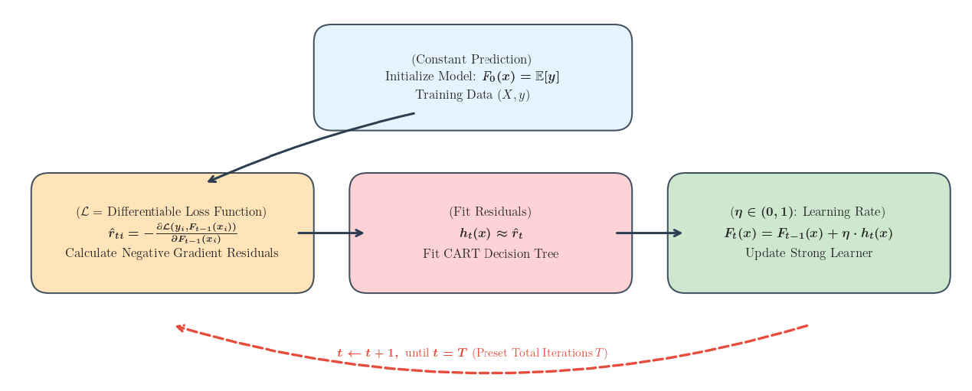
This process can be mathematically expressed as minimizing a defined loss function by continuously executing gradient descent under given conditions. In this situation, the goal is to minimize this function under strict linear inequality constraints:
$$MSE ={\frac{1}{n}∑}_{i=1}^{n}{\left(y_{i} −\hat{y_{i}}\right)}^{2}$$
The variable $y$ represents the actual data that has been given, while variable$\hat{y_{i}}$ denotes the value predicted by the model.
We also introduced the SHAP method to calculate the contribution allocation of each factor to the participation score. The SHAP value of a single feature is the weighted average of its marginal contribution across all possible feature combinations:
$$ϕ_{i}=\sum_{S⊆F\{i\}}{\frac{\left(\left|S\right|!\left(\left|F\right|\right)−\left|S\right|−1\right)!}{\left|F\right|!}[f(S∪\left\{i\right\}−f(S))]}$$
Where $ϕ_{i}$ represents the SHAP value of feature $i$, indicating its contribution to the model prediction. $S$ represents the feature subset, any combination of features that does not include feature$i$.$F$ is the set of all features, and $|S|$ represents the size of the subset $S$(number of features contained), as $|F|$ represents the total number of all features. $f(S)$ means the predicted value when the model uses only the features in subset $S$. $f(S∪\{i\})$ shows the predicted value when the model uses subset $S$plus the $i$-th feature.

6.3 Result interpretation
After training the model, we obtained the factor influence diagram shown in the table below: 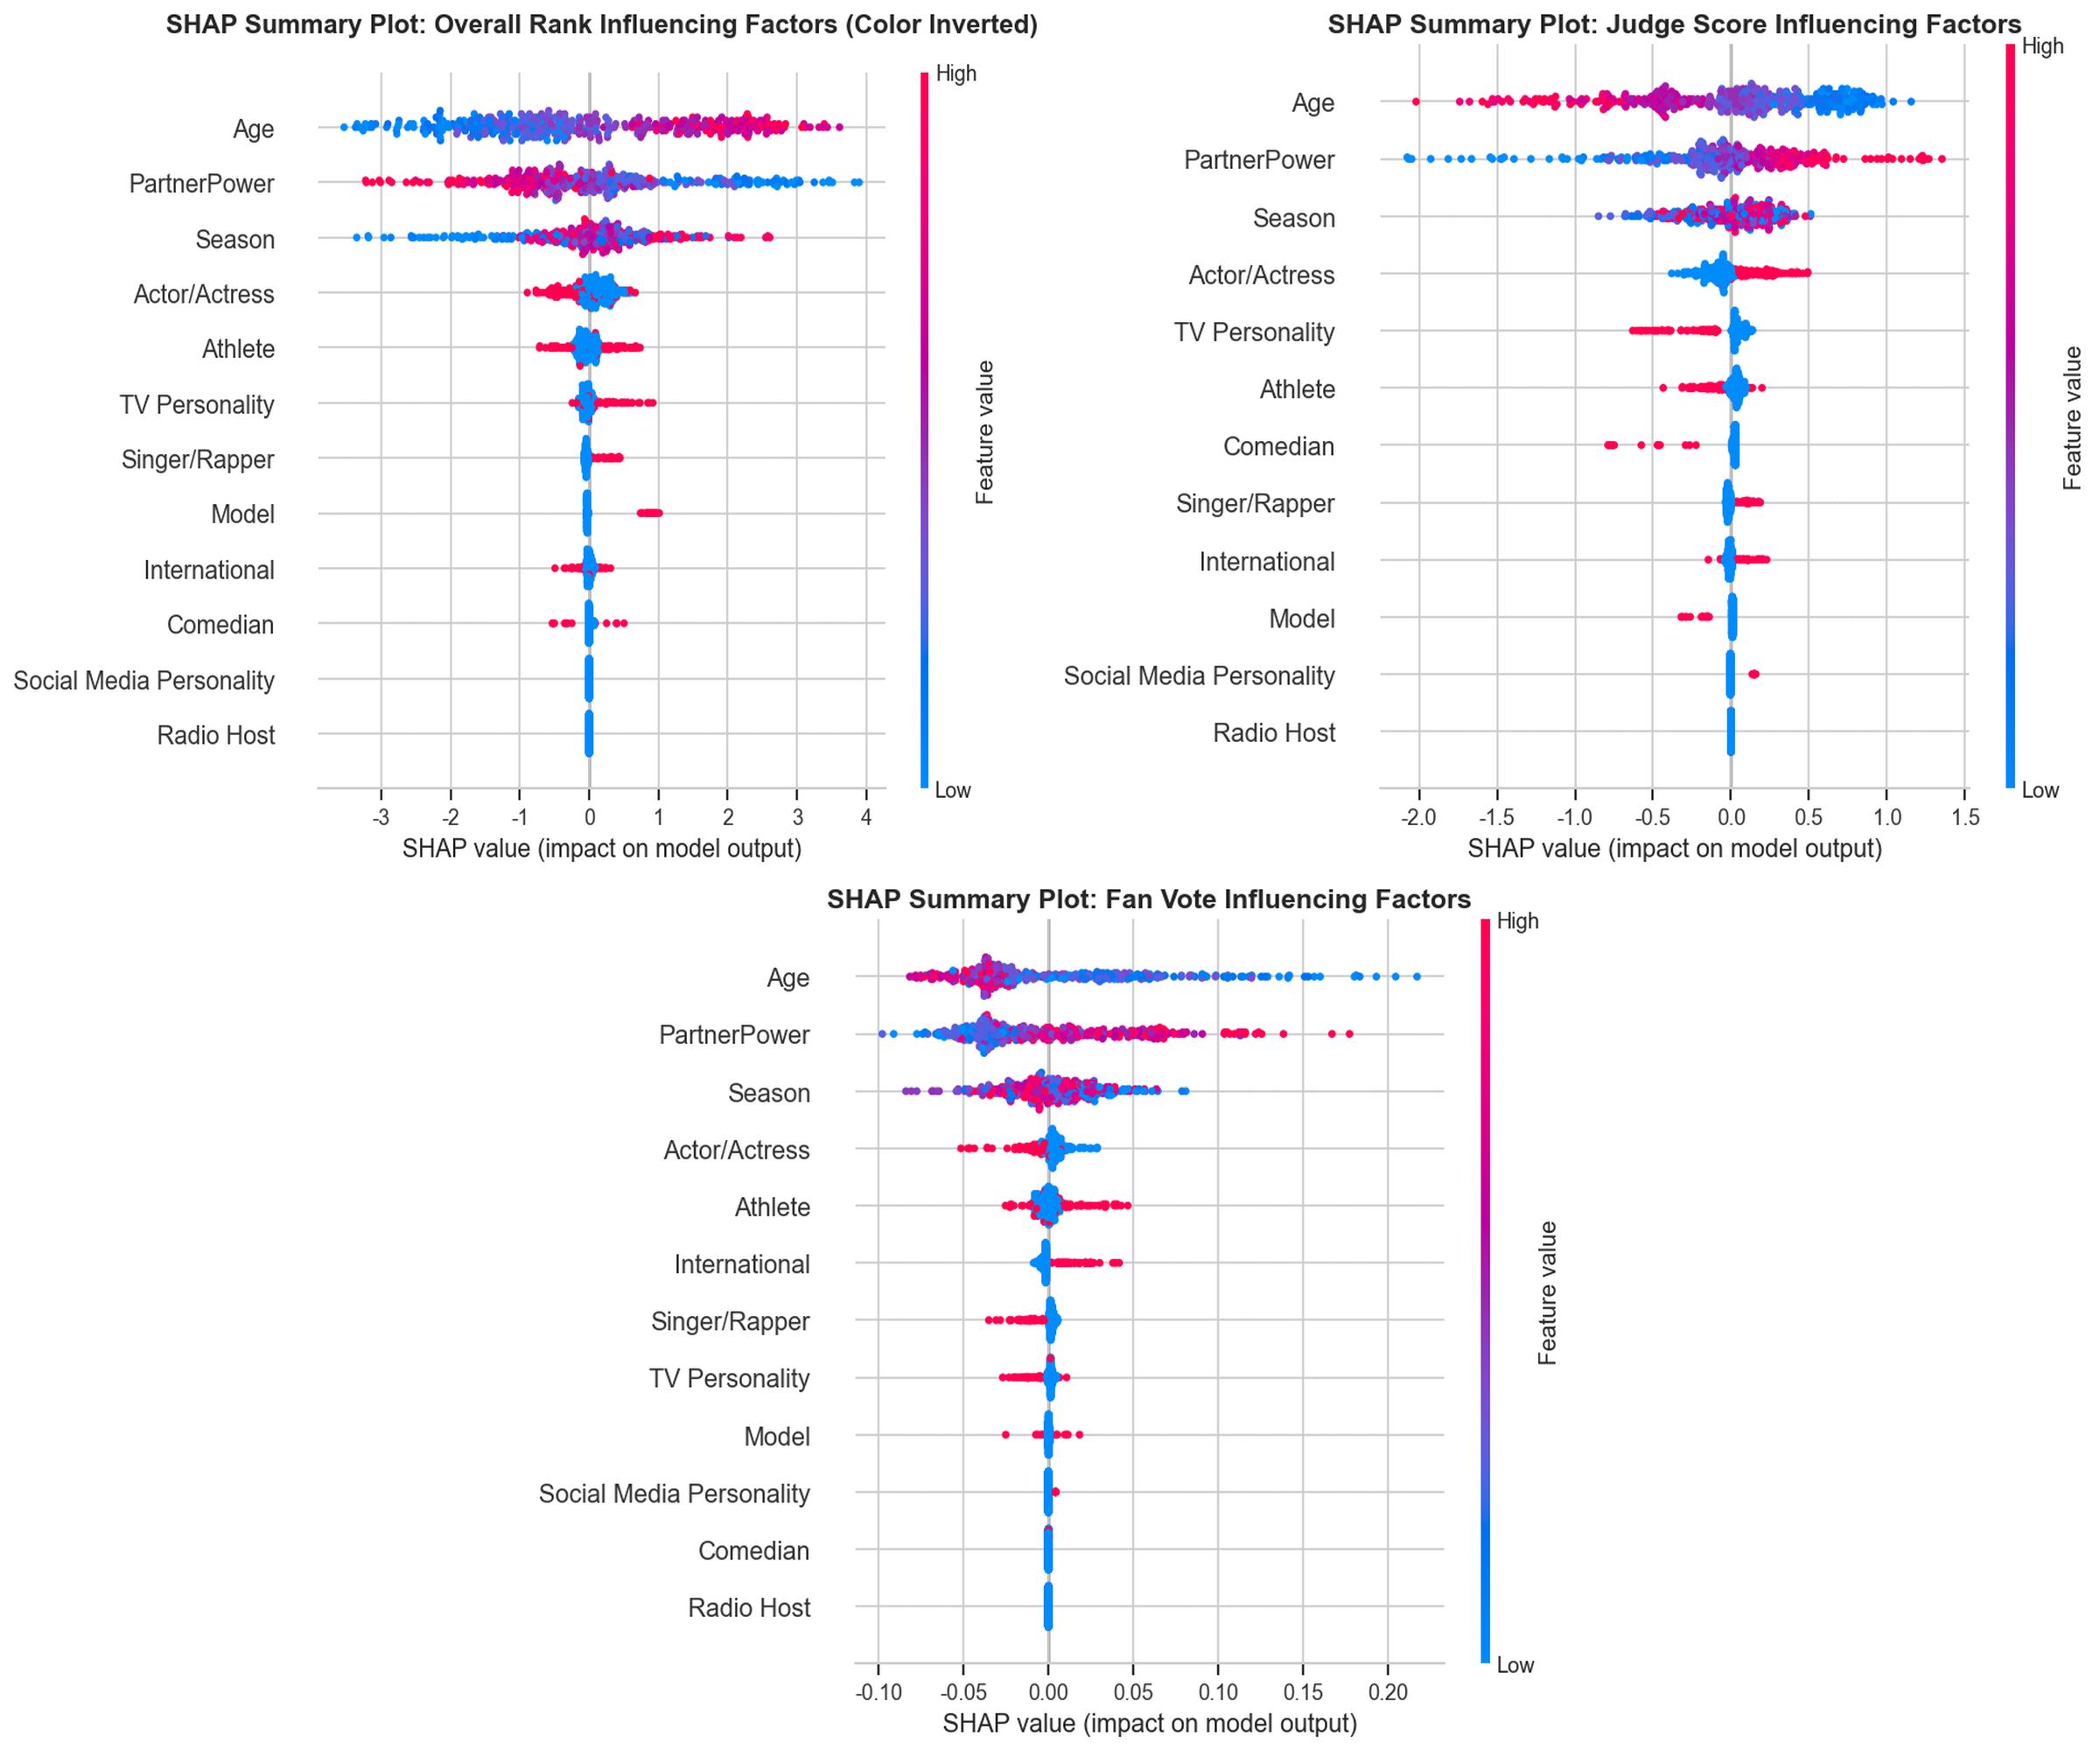
The color of the points in the graph represents the contribution of the sample represented by that point to the model's prediction, with red indicating a high value of the original feature and blue indicating a low value. The position of the point represents its influence on the prediction result. The order of features from top to bottom represents their degree of influence.
From the result of overall rank, it can be seen that the older the participant, the easier it is to obtain a higher ranking, and the stronger the dance partner, the more likely it is to obtain a higher ranking. Although the season of participation is strongly related to the ranking, there is no obvious ordinal relationship.
Next, we consider the impact of these variables on referees and fans respectively
The following results were obtained after fitting the model separately to the scores given by the referees: 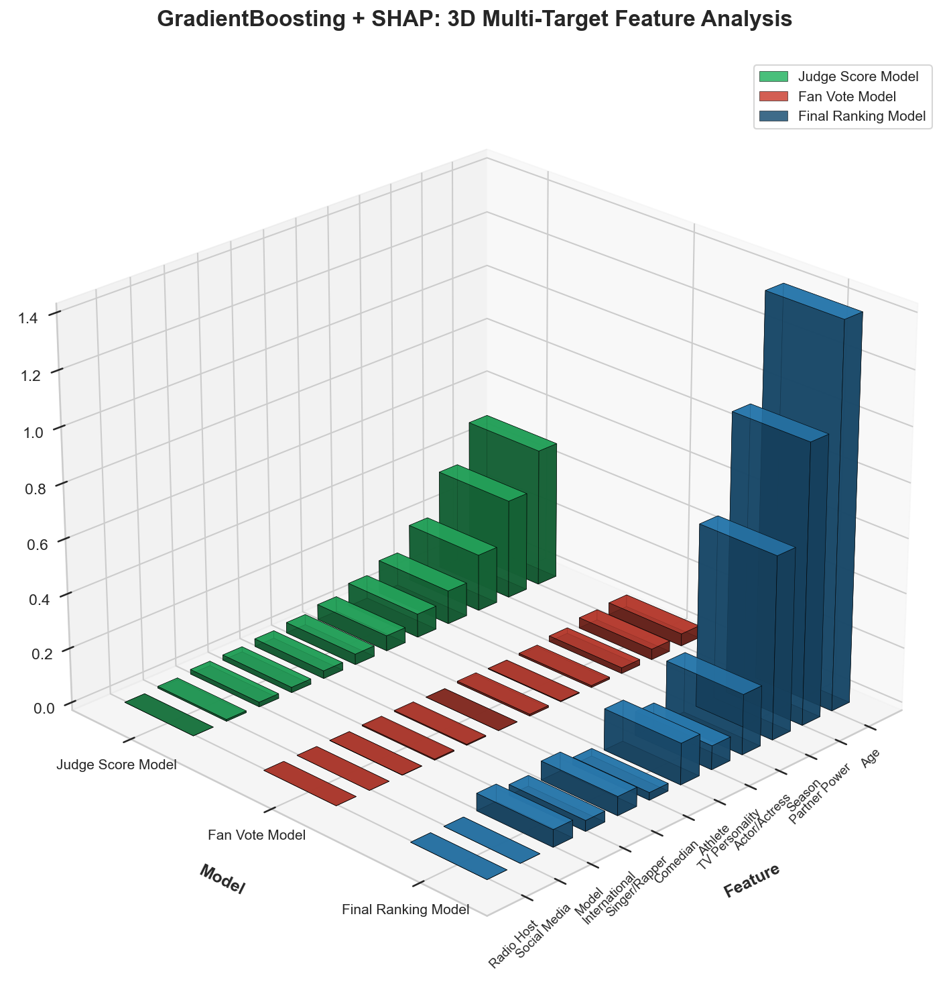
As the result of judges' scoring, the older the age, the more likely one is to receive a lower score. Having a more excellent dance partner is more likely to result in a higher score. There is a strong correlation between the season and the score obtained, but no obvious ordinal relationship.
It is noted that the result of fan voting also maintain the previously observed characteristics. However, they also have a unique characteristic, that is, the scale is very small, at a level around 0.1, significantly lower than the SHAP values of these factors and judge scoring. This indicates that fan voting seems to be more influenced by other factors outside the scene, while judge scoring is more influenced by factors that can be perceived on-site.
Meanwhile, there is another important difference to note in these three charts. The SHAP value of overall rating measures the correlation between each factor and the overall ranking, so the distribution of red and blue points in the last two charts, which evaluate based on scores, is reversed: the lower the ranking, the better the performance is, but the higher the score, the better the performance is.
Next, we will specifically analyze how fan voting and judge scoring are influenced by various factors of the contestants.
By analyzing the results of the SHAP analysis combining the judges' scores and fan votes, we obtained the results shown in the figure below: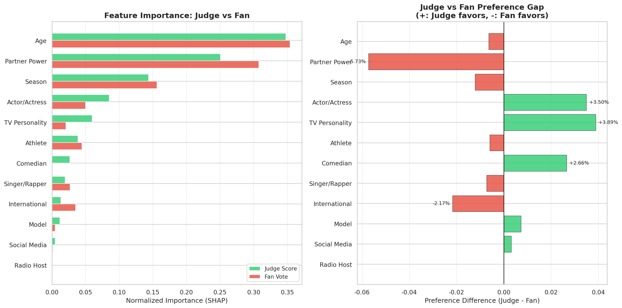
The figure in the left shows an intuitive comparison of the SHAP values of various factors based on the judges' scores and fan votes. It can be seen that the judges gave harsher evaluations on the three factors of age, dance partner, and season, while the judges and audience had their own preferences regarding the specific professions of the participants
The figure in the right illustrates the deviation scale and direction of evaluation criteria between judges and fans. From this figure, it can be observed that although judges place more emphasis on age, dance partner, and season compared to fans, they particularly emphasize the performance of the dance partner. This reflects that the judges' scoring is more based on the actual performance of the participants rather than external factors, highlighting the skill-centered characteristic of the judges' scoring.

GNS Model built for task 4
From the case of Bobby Bones mentioned earlier, it can be seen that the existing scoring mechanism has obvious flaws, with the results of fan voting exerting excessive influence. Therefore, we propose a new evaluation model by drawing on the utility function and Nash equilibrium theory from the financial sector. We employ the Cobb-Douglas utility function to capture the diminishing marginal returns of resources, ensuring that the value of the first unit of resource is higher than that of the last unit. Simultaneously, to balance overall efficiency and individual fairness, we use Nash social welfare as the objective function. Unlike utilitarian methods, if the utility of any individual is zero, NSW will impose a significant penalty on the system, thereby enforcing a more equitable distribution.
The mathematical representation of our model is as follows:
$$GNS=S_{j}^{α}×S_{F}^{1−α}$$

7.1 Cobb-Douglas utility function
This function assumes that there is a decision subject that focuses on multiple indicators (denoted as $x_{1},x_{2}$). In our model, its mathematical expression is as follows:
$$U(x) =\prod_{i=1}^{n}{x_{i}^{α_{i}}}$$
Where U(x) represents the total utility, which is the objective we need to maximize, xi is the specific value of parameter $i$, $α_{i}$ represents the elasticity coefficient, indicating the contribution of parameter $i$ to total utility.
This function achieves the mathematical expression of diminishing marginal utility by controlling the first derivative of each independent variable to be positive and the second derivative to be negative, encouraging an equilibrium distribution of variables. In our model, this represents a reasonable distribution of contributions to fan voting and judge scoring.

7.2 Nash social welfare theorem
This theory originates from cooperative game theory and is commonly used to measure the overall welfare of all participants in a system. In our model, it represents achieving a balance between fan voting and judge scoring. The mathematical definition of this theory is as follows:
$$NSW=\prod_{i=1}^{n}{(u_{i}−d_{i})}$$
In the equation, $u_{i}$represents the utility value that participant $i$ can obtain under the current resource allocation scheme, while $d_{i}$represents the utility that participant $i$ can obtain in the absence of cooperation.

7.3 The implication of the final model
After combining the two, we obtain the following mathematical expression:
$$max\sum_{i=1}^{n}{\sum_{j=1}^{m}{α_{j}ln(x_{ij})}}$$
Using the scores given by the judges and the predicted fan voting results, we fitted the model. The following figure shows the impact of the fitted α value on the GNS index of each contestant (taking Season 27 as an example):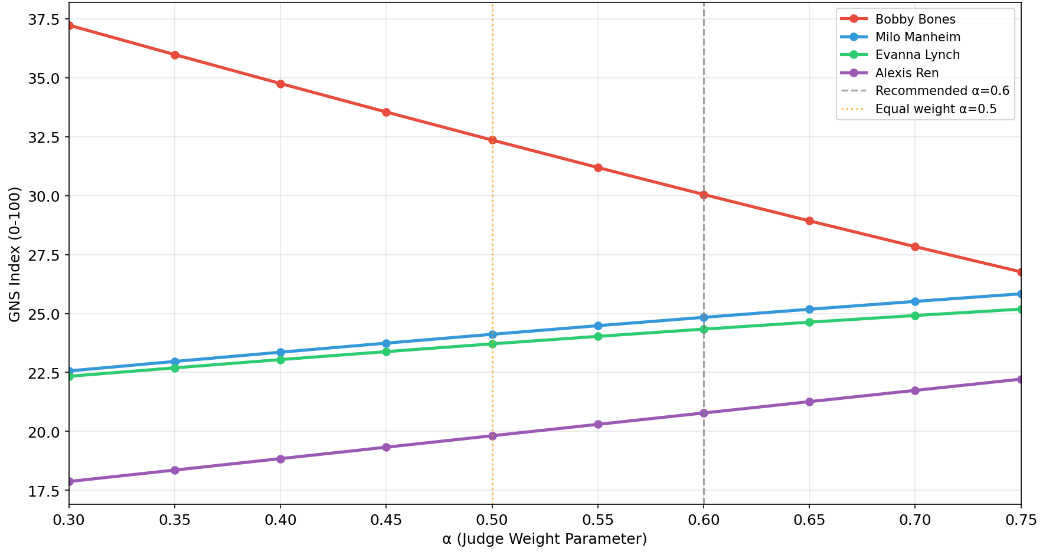
After fitting, we found that when $α$is less than 0.5, fan voting holds an absolute dominant position, while when α is greater than 0.7, the judges occupy an absolute discourse power. Therefore, we ultimately chose α=0.6. In this case, Bobby Bones' GNS index is 30.05, with a gap of 5.21 points from the second place, whereas the previously obtained score gap using the percentage method was 9.77 points. The significant reduction in the score gap indicates that our new model effectively integrates the evaluations of both parties and provides a more fair final result.

7.4 Fairness analysis of the model
We selected 66 cases from the previously eliminated scenarios as the test samples. When applying the model to these 66 cases, we found that our model provided different elimination results for 23 of them.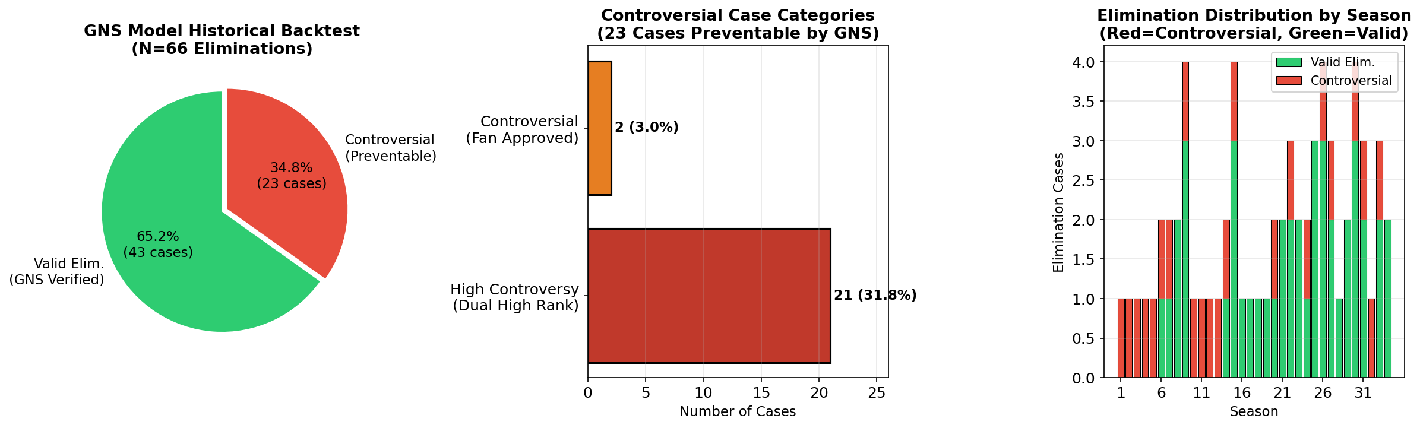
Upon observing these 23 eliminated contestants blocked by the GNS model, it was found that 21 of them had relatively balanced fan votes and judge scores, and 2 contestants had even better judge scores than their fan votes. This indicates that our model can effectively balance the weight of scores from both sides, preventing 'one-sided' contestants from advancing to the next stage.
The image below illustrates how our model performs when penalizing discrepancies between judges' and audience ratings. The graph image shows our model's evaluation of Bobby Bones and Milo Manheim's performances in the Season 27 finale, while the right graph shows the evaluation results produced by a linear evaluation model. The formula for this linear evaluation model is:
$${Score}_{linear}=w×S_{judge}+\left(1−w\right)×S_{fan}$$
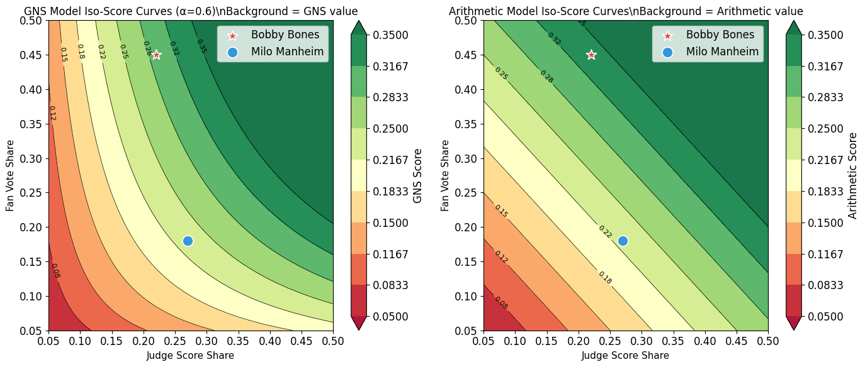
The results show that our model significantly lowered Bobby Bones's score while keeping Milo Manheim's score relatively unchanged, thus penalizing the imbalance between the judges' and audience's ratings.

7.5 Model summery
As mentioned above, the model we derived possesses the following advantages:
- Be able to comprehensively consider the opinions of both judges and audience, while fully mobilizing the enthusiasm of the audience to vote, without losing the professionalism of the program.
- The form is simple and easy to calculate, meeting the need for quick score calculation on-site during the program.
- The structure is flexible, allowing for the adjustment of the α value to determine the weight of fan voting and judge.

Conclusion, Strength and weakness
This article establishes three main models: the CPCM model, the gradient boosting model, and the GNS model. It employs counterfactual hypothesis analysis methods to complete tasks including predicting the number of historical fan votes and analyzing the impact of various factors on the overall performance of contestants

8.1 Conclusion and strength analysis
- For Task 1, we established a CPCM model to predict the historical fan voting data of contestants. We abstracted the elimination order of contestants as strict linear inequality constraints, constructed a closed-loop solution space, and ensured strict consistency between the predicted results and the actual data. At the same time, we adopted the Hit-and-Run Markov chain Monte Carlo sampling to avoid local optima and ensure the rigor of the results
- For Task 2, we processed the data using logistic regression and performed mathematical statistics after confirming comparability. We found that the percentage method favored the results of fan voting more than the rank method. We also analyzed extreme cases in the competition using counterfactual prediction, confirming this conclusion. Additionally, we hypothesized the introduction of a judge elimination method and found that the fairness of the rank method was further enhanced after the introduction of the judge analysis method. Therefore, we recommend that the program organizer use the rank method with the introduction of a judge elimination mechanism for future programs.
- For Task 3, we utilized gradient boosting models (XGboost and SHAP methods) to analyze the impact of various factors on the final performance of contestants, exploring how these factors differently influence the scores given by judges and viewers. We initially converted factors that cannot be directly analyzed numerically (such as occupation) through hot encoding, and quantified the comprehensive influence of professional dance partners on the final score by constructing a dancer influence index. The results were ultimately presented in a scatter plot, visually illustrating the extent of influence of each factor on the final score. The results are reliable and have strong interpretability.
- For the final task 4, we drew inspiration from the financial sector and achieved a balance between the importance of the opinions of the judges and the audience by combining the Cobb-Douglas utility function with the Nash social welfare function. The conclusions obtained can meet the requirements of real-time broadcasting of the program and are highly practical. Furthermore, after 66 generations of backcrossing tests, it has been proven that it can indeed correct the excessive emphasis on fans' opinions.

8.2 Weakness
Although our model has successfully completed the assigned task with high quality, there are still several aspects that can be improved:
- After entering the finals stage, the predictive ability of the CPCM model for fan voting decreases significantly when the number of contestants is extremely small. This aspect of performance can be emphasized and strengthened in the future.
- The gradient boosting model only considers the features observable in the dataset, without taking into account factors such as the off-field influence of celebrities. In the future, relevant information can be collected to supplement this part of the analysis

References
[1]
[2]
[3]
[4]

Report on use of AI
Goole Gemini 3
Query: list the controversy in scoring in program dancing with the stars
Output: Controversies over scoring on Dancing with the Stars usually stem from the tension between the professional Judges' Scores (merit) and the Fan Vote (popularity).
Here is a short list of the most notable cases:
1. The "Bobby Bones" Win (Season 27)
The most infamous scoring scandal in the show's history. Radio host Bobby Bones consistently had the lowest scores from the judges but won the trophy solely because of his massive radio fanbase.
- Result: This caused such an outcry that the show introduced the "Judges’ Save" the following season to ensure better dancers weren't eliminated by popularity alone.
2. The Simone Biles "Smiling" Critique (Season 24)
Despite near-technical perfection, judges (particularly Carrie Ann Inaba) docked points and criticized Simone for a lack of "emotion" and "smiling."
- Controversy: Simone famously replied, "Smiling doesn't win you gold medals." She was eliminated despite two perfect scores in the semi-finals, leading fans to claim the judges were scoring her on personality rather than dance.
3. The Heather Morris "Shock" Elimination (Season 24)
Heather Morris (a former backup dancer for Beyoncé) received the first perfect score of the season and was eliminated that same night.
- Controversy: Fans were outraged that the scoring system allowed a contestant at the very top of the leaderboard to go home, leading to claims that the "fan vote" was weighted too heavily.
4. Robert Irwin vs. Alix Earle (Season 34 - 2025)
In the most recent finale, Robert Irwin won despite having a lower cumulative score than Alix Earle (89 vs. 90).
- Controversy: Alix Earle received perfect scores across all three finale rounds, while Robert Irwin received a 9 from Carrie Ann Inaba for "sloppy footwork." Fans of Earle claimed the win was "rigged" for the "Disney-friendly" Irwin, reigniting the debate over how heavily the 50/50 split favors popular celebrities over higher scorers.
Goole Gemini 3
Query: explain hit-and-run MCMC advantage in doing statistics
Output: In the context of Bayesian statistics and high-dimensional modeling, the Hit-and-Run (H&R) algorithm is a specialized Markov Chain Monte Carlo (MCMC) method designed to sample from complex, often constrained, probability distributions.
While standard algorithms like Gibbs Sampling or Metropolis-Hastings (MH) are the "bread and butter" of statistics, they often struggle when the "target space" is high-dimensional or oddly shaped (like a long, thin tube).
Here is why Hit-and-Run is a significant advantage in statistical modeling:
1. Handling High-Dimensional Geometry
Standard MCMC methods typically move along the coordinate axes (changing one variable at a time, like Gibbs) or use a "square" proposal distribution (like MH). If your variables are highly correlated—forming a narrow, diagonal "ridge" in the data—these methods get stuck, taking tiny steps to avoid falling out of the high-probability zone.
- The H&R Advantage: It chooses a random direction (any angle in $n$-dimensional space) and then samples a point along the entire line intersecting the target distribution. This allows it to make "long jumps" across the distribution that coordinate-based moves cannot.
2. Efficient Sampling of Constrained Spaces
In many statistical problems, you are sampling from a convex body (e.g., a set of parameters that must all be positive and sum to less than a certain value).
- The Problem: Traditional MH often proposes points outside the constraints, leading to a high "rejection rate" and wasted computation.
- The H&R Advantage: Because H&R identifies the line segment within the boundaries before picking a new point, it stays inside the "valid" region more efficiently. It is mathematically proven to have a polynomial mixing time for convex bodies, making it much faster than simple random walks in these scenarios.
3. Avoiding the "Random Walk" Slowness
Simple Metropolis-Hastings often suffers from "diffusive" behavior, where it wanders back and forth over the same area because its step size is fixed and small.
- The H&R Advantage: By sampling a point from the entire line segment of the chosen direction, H&R effectively "re-randomizes" its position much more thoroughly in each iteration. This leads to lower autocorrelation between samples, meaning you need fewer iterations to get a representative "picture" of your data.
Goole Gemini 3
Query: except for characteristics for the celebrities available in the data (age,
industry), what other characteristics may also server as factor affecting a contestant's performance in DWTS
Output: Beyond age and industry, several nuanced characteristics act as hidden variables that significantly influence both a contestant's technical scores and their voting longevity.
1. Physical & Athletic Attributes
- Previous Movement Training ("Ringers"): This is the most debated factor. Contestants with backgrounds in gymnastics (e.g., Simone Biles, Jordan Chiles), figure skating, or Broadway have "muscle memory" for choreography, flexibility, and core strength that pure beginners lack.
- Height and Pro-Partner Match: Dramatic height differences can affect a couple’s "frame" in ballroom dances like the Waltz. For example, very tall celebrities (like NBA stars) often struggle with footwork speed, while being well-matched in height with a pro-partner often results in more "aesthetic" lines for the judges.
- Athletic Discipline: Professional athletes (NFL, MLB) often perform better than actors because they are used to grueling 8-hour practice schedules and "coaching" feedback, which is exactly what the DWTS rehearsal process requires.
2. Social Media & Digital Capital
In recent seasons (especially Season 33 and 34), digital footprint has arguably become more important than celebrity status.
- Social Media "Clout": Influencers like Charli D’Amelio or Alix Earle bring built-in "voting blocks" of millions.
- TikTok Virality: The "Rylee Arnold Effect" (referring to the young pro dancer) showed that a pro-dancer’s own social media following can save a celebrity. If a couple’s rehearsal clips go viral on TikTok, they often receive a massive surge in votes from younger demographics who may not even watch the full broadcast.
3. Psychological & Narrative Factors
The "story" a contestant tells often outweighs their dance ability in the eyes of the public.
- The "Vulnerability" Factor: Celebrities who start "closed off" and have an emotional breakthrough or cry during rehearsals (the "Transformation Arc") typically see a spike in fan votes.
- Relatability vs. Perfection: Sometimes being too good too early (the "Ringer" curse) makes a contestant less likable. Fans often gravitate toward the "underdog" who is struggling but trying hard (e.g., Andy Richter or Bill Engvall).
- Likability & Wit: Contestants who are funny in their "packages" (pre-dance videos) or witty with the judges during critiques (like Robert Irwin) build a stronger personal connection with the audience.
4. Partner Synergy & The "Pro" Factor
- The Popularity of the Pro: Some professional dancers (like Derek Hough in the past or Val Chmerkovskiy) have their own massive fanbases. A celebrity paired with a "superstar pro" has a statistical advantage in staying in the competition regardless of their own fame.
- Choreography Innovation: A pro who takes risks (e.g., Iman Shumpert’s contemporary "Us" routine) can create a "viral moment" that secures a win, even if the celebrity isn't the most technical dancer.
Goole Gemini 3
Query: Help me polish the following sentence Judges have the same scoring criteria throughout
the week. Though scoring criteria may change between different weeks and different judges,, he judges' scores within the same week can
display the technical proficiency of the contestants.
Output: Here are a few ways to polish that sentence, depending on how formal you want to be.
The biggest hurdle in the original draft is the flow between the "changing criteria" and the "technical proficiency." We want to make sure the reader understands that consistency is what makes the scores meaningful.
Option 1: Polished & Professional (Recommended)
"While scoring criteria may vary between weeks or different judging panels, the criteria remain consistent within any given week. This internal consistency ensures that scores accurately reflect the contestants' technical proficiency."
Option 2: Concise & Direct
"Judges maintain uniform scoring criteria throughout the week. Even if standards shift from one week to the next, the consistency within a single week allows for a fair assessment of each contestant’s technical skills."
Option 3: Elegant & Flowing
"Despite potential fluctuations in criteria between weeks, judges apply a consistent standard within each session, providing a reliable measure of the contestants' technical proficiency."
Key Improvements Made:
- Removed Redundancy: Changed "different weeks and different judges" to "between weeks or judging panels" to make it punchier.
- Corrected Grammar: Fixed the "he judges" typo to "the judges" (or replaced it with "consistency").
- Strengthened Logic: Used words like "uniform" and "internal consistency" to better explain why the scores are able to display proficiency.
Goole Gemini 3
Query: is it possible to use SHAP method for further study on the driving factors？
Output: It is absolutely possible—and actually highly recommended. While standard regression models or basic feature importance plots tell you that a variable matters, SHAP (Shapley Additive Explanations) tells you how it matters for every single prediction.
SHAP is based on cooperative game theory, specifically Shapley values, which distribute the "payout" (the prediction) among the "players" (the features).
Why SHAP is Excellent for Driving Factors
Using SHAP for a "further study" allows you to move beyond simple correlation and into the nuances of how driving factors behave across different scenarios.
1. Directionality and Magnitude
Traditional feature importance (like Random Forest Gini importance) is often "magnitude-only"—it tells you a factor is important but not if it pushes the outcome up or down. SHAP provides a clear direction for each factor.
2. Identifying Non-Linear Relationships
Driving factors rarely act linearly. SHAP can reveal if a factor has a "diminishing returns" effect or if there is a specific threshold where its impact spikes.
3. Local vs. Global Insights
- Global: What are the primary drivers across the entire dataset?
- Local: Why did the model give this specific result for this specific case? This is vital for case studies or outlier analysis.
A Note on Causality
It is important to remember that SHAP explains the model, not necessarily the real world. > If your model is biased or captures a "spurious correlation" (a coincidence in the data), SHAP will faithfully report that coincidence as a driving factor. To claim true causality, you need to ensure your underlying model is robust and your data is clean of confounding variables.
Goole Gemini 3
Query: How to combine the two model XGBoost and SAHP, for model building
Output: Combining XGBoost and SHAP is a "gold standard" workflow in modern data science. XGBoost provides the predictive power, and SHAP provides the transparency needed to understand the driving factors.
Here is the step-by-step process to build this pipeline.
The Workflow: Prediction to Interpretation
1. Data Preparation and Model Training
First, you train your XGBoost model as you normally would. Ensure your data is cleaned and encoded, as SHAP relies on the features used during training.
Python
import xgboost as xgb
import shap
# 1. Train XGBoost
model = xgb.XGBRegressor(n_estimators=100, max_depth=5, learning_rate=0.1)
model.fit(X_train, y_train)
2. Initializing the SHAP Explainer
SHAP has a specific optimized tool for gradient-boosted trees called the TreeExplainer. It is significantly faster than the generic KernelExplainer.
Python
# 2. Initialize Explainer
explainer = shap.TreeExplainer(model)
shap_values = explainer.shap_values(X_test)
3. Visualizing the Driving Factors
Once you have the shap_values, you can create the visualizations mentioned earlier to perform your "further study."
- Global Importance: Use shap.summary_plot(shap_values, X_test) to see which features drive the model overall.
- Individual Impact: Use shap.plots.waterfall() or shap.force_plot() to see how factors combined for one specific observation.
Strategic Implementation Tips
To get the most out of your study on driving factors, keep these three points in mind:
Use "Tree SHAP" for Speed
Because XG Boost is a tree-based model, using SHAP. Tree Explainer allows the math to be calculated in $O(TLD^2)$ time (where $T$ is trees, $L$ is leaves, and $D$ is depth), making it possible to analyze even massive datasets that would crash other interpretation methods.
Handle Multicollinearity
If two driving factors are highly correlated (e.g., "Income" and "Credit Score"), XGBoost might split the importance between them, or favor one over the other.
Pro Tip: Check for high correlation before training. If two features are 95% correlated, SHAP might give you a "diluted" view of their true impact.
Feature Interaction
One of the best things about combining these two is the SHAP Interaction Values. This shows you how two factors work together. For example, does "Temperature" only drive "Energy Demand" when "Humidity" is also high?
Goole Gemini 3
Query: explain the difference between a memo and a abstract
Output: While both documents serve to condense information, they have completely different goals, audiences, and structures. Think of an abstract as a "trailer" for a movie (scientific or academic), while a memo is a "briefing note" for a colleague or boss to spark action.
1. The Abstract
An abstract is a self-contained, short summary of a larger work, such as a research paper, thesis, or formal report.
- Goal: To help a reader decide if they want to read the full 30-page document.
- Tone: Academic, formal, and objective.
- Structure: It follows the flow of the research:
  - Objective: What was the problem?
  - Methods: How did you study it?
  - Results: What did you find? (The data).
  - Conclusion: What does it mean?
- Placement: Always found at the very beginning of the document or in a database search result.
2. The Memo (Memorandum)
A memo is a professional communication tool used within an organization to share information, make requests, or provide updates.
- Goal: To communicate information quickly and often to prompt a specific action.
- Tone: Business-professional, direct, and concise.
- Structure: It uses a standard header:
  - TO: (Recipient)
  - FROM: (Sender)
  - DATE: (Current Date)
  - SUBJECT: (Clear, descriptive title)
- Content: It gets straight to the point ("We are changing the software on Monday") and often ends with a "Call to Action" or "Next Steps."
Goole Gemini 3
Query: how to convert word to latex
Output: Converting a Microsoft Word document to LaTeX can range from a "one-click" experience to a manual cleanup process, depending on how many equations and tables your document contains.
Here are the most effective ways to handle the conversion:
1. Using Online Converters (Easiest)
If your document is relatively simple, web-based tools are the fastest route.
- Pandoc: This is the "Swiss Army Knife" of document conversion. You can use the command-line tool. It is excellent at maintaining headers, lists, and basic formatting.
- Aspose Word to LaTeX: A free web tool where you upload a .docx file and download a .tex file. It’s good for quick conversions but may struggle with complex layouts.
2. Using Specialized Add-ins
If you want to stay within the Word environment while preparing for the move, these tools are built specifically for academic workflows:
- GrindEQ: This is a very popular commercial suite for Windows. It provides a "Word-to-LaTeX" module that handles complex equations, cross-references, and bibliographies quite well.
- Mathtype: If your document is heavy on math, MathType allows you to export all equations into LaTeX code) directly within the document.
3. The "Pandoc" Command Line (Best for Professionals)
If you have a large project (like an MCM paper), using Pandoc locally via the command line gives you the most control.
- Install Pandoc.
- Run the following command in your terminal:
pandoc my_file.docx -o my_file.tex
- Pro Tip: Use the --standalone flag if you want Pandoc to generate the preamble (the \documentclass and \begin{document} parts) for you:
pandoc -s input.docx -o output.tex

