**实验二**

实验名称：类和对象的进一步讨论

实验目的：构造函数和析构函数，以及公用数据的保护

实验内容：P120 第6、7题

实验结果：

6.

#include<iostream>

using namespace std;

class Student {

public:

Student(int n,float s):num(n),score(s) {

}

void change(int n,float s){

num=n,score=s;

}

void display(){

cout<<num<<":"<<score<<endl;

}

~Student() {

cout<<" ";

}

private:

int num;

float score;

};

int main(){

Student stud(101,78.5);

stud.display();

stud.change(101,80.5);

stud.display();

return 0;

}

**结果：**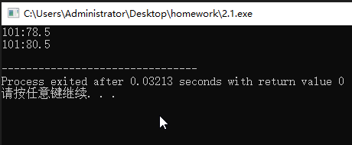

**7．（1）（2）**

#include<iostream>

using namespace std;

class Student {

public:

Student(int n,float s):num(n),score(s) {

}

void change(int n,float s) const{

num=n,score=s;

}

void display() const{

cout<<num<<":"<<score<<endl;

}

~Student() {

cout<<" ";

}

private:

mutable int num;

mutable float score;

};

int main(){

const Student stud(101,78.5);

stud.display();

stud.change(101,80.5);

stud.display();

return 0;

}

**结果：**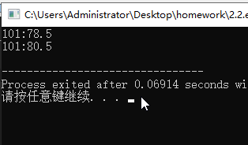

**（3）**

#include<iostream>

using namespace std;

class Student {

public:

Student(int n,float s):num(n),score(s) {

}

void change(int n,float s){

num=n,score=s;

}

void display(){

cout<<num<<":"<<score<<endl;

}

~Student() {

cout<<" ";

}

private:

int num;

float score;

};

int main(){

Student stud(101,78.5);

Student *p = &stud;

p->display();

p->change(101,80.5);

p->display();

return 0 ;

}

**结果：**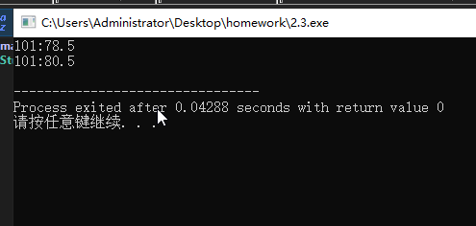

**（4）**

#include<iostream>

using namespace std;

class Student {

public:

Student(int n,float s):num(n),score(s) {

}

void change(int n,float s) const{

num=n,score=s;

}

void display() const{

cout<<num<<":"<<score<<endl;

}

~Student() {

cout<<" ";

}

private:

mutable int num;

mutable float score;

};

int main(){

Student stud(101,78.5);

const Student *p = &stud;

p->display();

p->change(101,80.5);

p->display();

return 0 ;

}

**结果：**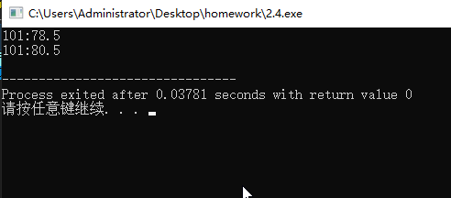

**（5）**

#include<iostream>

using namespace std;

class Student {

public:

Student(int n,float s):num(n),score(s) {

}

void change(int n,float s) {

num=n,score=s;

}

void display() {

cout<<num<<":"<<score<<endl;

}

~Student() {

cout<<" ";

}

private:

int num;

float score;

};

int main(){

Student stud(101,78.5);

Student *const p = &stud;

p->display();

p->change(101,80.5);

p->display();

return 0 ;

}

**结果：**