Results — Chapter 6: Multi-modal KG fusion for ARIA risk mapping and repurposing

6.1 A three-source co-medication liability map for ARIA-H
To identify drugs that may aggravate ARIA-H when co-administered with anti-Aβ monoclonal antibodies, we assembled a liability map for 550 approved small-molecule drugs (421 after collapsing salt and hydrate duplicates across 332 active-moiety groups). Each drug was scored by integrating three orthogonal sources: (i) clinical pharmacological bleeding liability, graded as anticoagulant (1.00), antiplatelet P2Y12-receptor antagonist (0.95), non-selective NSAID with PTGS1 engagement (0.80), or COX-2-selective (0.50); (ii) direction-aware Mendelian randomization (MR) evidence at the drug target, aligned to the pharmacological direction of effect; and (iii) GNN-predicted structural ARIA risk, ranked within each candidate pool (HGT-scored CNS-penetrant drugs vs. Open Targets expanded pool) so that missing GNN scores for expanded-pool drugs did not distort ranks.
Anticoagulants occupied the highest-liability tier. Vitamin K antagonists ranked first (acenocoumarol, phenprocoumon and warfarin, adjusted liability = 0.900), followed by the direct factor Xa inhibitors apixaban, rivaroxaban, edoxaban and betrixaban (0.800) and the direct thrombin inhibitor dabigatran (0.794). P2Y12 receptor antagonists followed (clopidogrel 0.763; prasugrel and ticagrelor 0.670), while non-selective NSAIDs formed a broad high-liability band (aspirin 0.867; indomethacin 0.858; naproxen 0.839; diclofenac, dexketoprofen and dexibuprofen 0.780). COX-2-selective celecoxib was substantially lower (0.489), consistent with its minimal effect on platelet thromboxane generation. Acetaminophen is retained in the table with a conservative annotation (0.740) despite its weak antiplatelet activity.
Genetic evidence was interpreted with explicit directionality. Higher PTGS1 expression was associated with lower intracerebral haemorrhage risk (OR 0.886, 95% CI 0.800–0.981, p = 0.020), implying that pharmacological inhibition of PTGS1—as achieved by aspirin and other non-selective NSAIDs—shifts liability in the unfavourable direction; VKORC1 showed the same protective direction (OR 0.549, 95% CI 0.330–0.915, p = 0.021). Two MR estimates that failed the Egger intercept test for directional pleiotropy (PTGS1→ICH, Egger p = 0.012; APP→SAH, Egger p = 0.006) were flagged but retained in the main analysis; a sensitivity analysis excluding pleiotropic rows is reported. For factor Xa, the MR direction (F10, risk-increasing) contradicted the clinical pharmacology of anticoagulation; these five drugs are annotated with a direction-conflict flag and were graded on clinical pharmacology alone, with the MR term neutralised.
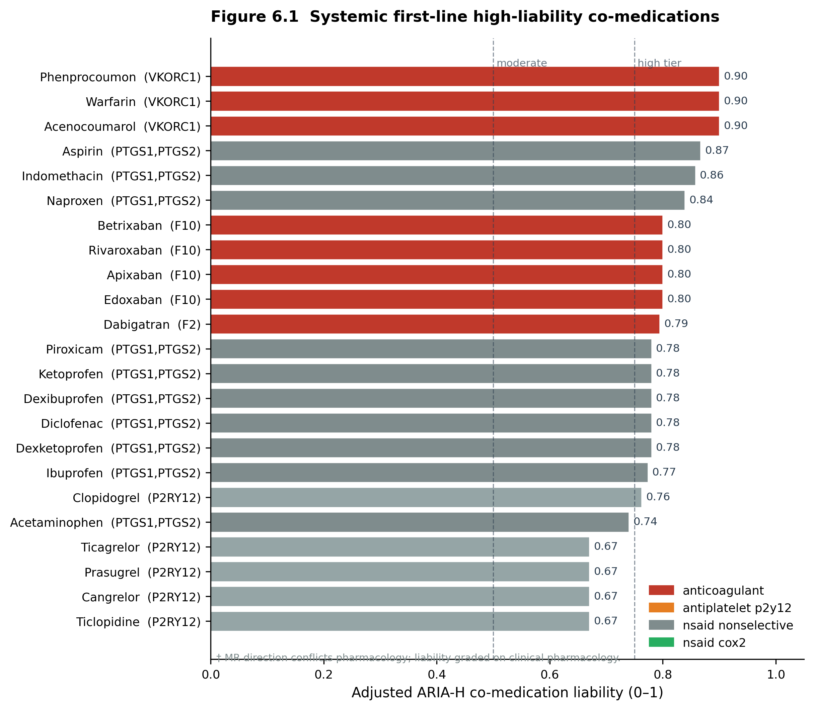
Figure 6.1 Co-medication liability map for ARIA-H (systemic first-line high-tier drugs). Colour indicates clinical pharmacological class; † marks drugs where MR direction conflicts clinical pharmacology (graded clinically with MR term neutralised).

6.2 Combination partners
Among drugs that were CNS-penetrant, free of bleeding liability and supported by at least one active mechanistic route (synergy with anti-Aβ pathways, prior-AD-gene engagement, or AD-aligned genetic evidence), eight met the eligibility criteria. Three received markedly higher partner scores: lithium carbonate (f_partner = 0.997, via GSK3A/GSK3B), bupropion (0.991) and dextromethorphan hydrobromide (0.977, via GRIN2A/SIGMAR1). Notably, bupropion and dextromethorphan are the two components of AXS-05, which is under phase 2/3 investigation for Alzheimer's disease agitation (ADVANCE-1/ACCORD). The model selected both components independently and without prior knowledge of this combination, providing an external, literature-anchored sanity check of the ranking framework. A further 397 safe-but-mechanism-unmatched drugs are reported separately as a tier-2 list.

6.3 Repurposing candidates and a target-coverage audit
Mechanistically anchored repurposing candidates were stratified into four roles: target-prior (5 drugs; e.g. lithium via GSK3B, sacubitril and racecadotril via MME), genetic-counter (15 drugs; all ACE inhibitors, since genetically higher ACE expression is protective against AD and pharmacological inhibition is therefore unfavourable in direction), false-positive-direction (1 drug), and structural-only (400 drugs, ranked by GNN score alone). No drug satisfied the highest tier of genetically aligned repurposing evidence (n_aligned = 0): within the current candidate library, no compound both engaged an AD-efficacy gene and did so in the direction implied by the MR estimate.
A target-coverage audit localised the reason. ACE is reachable only through ACE inhibitors, which we classify as direction-opposed. BIN1, LRP1 and PLCG2 are not targeted by any drug in the knowledge graph—an upstream, data-side gap rather than a scoring artefact. We therefore caution that structure-driven repurposing sensitivity is bounded by drug–target coverage, and report these gaps explicitly. Finally, nirogacestat (a γ-secretase/Notch inhibitor) was flagged as a directional false positive: although it engages PSEN1/PSEN2, these genes did not pass the MR evidence threshold, and γ-secretase inhibition has repeatedly worsened cognition in AD trials; it is retained in the table as a cautionary example of target-hit scoring without directionality.
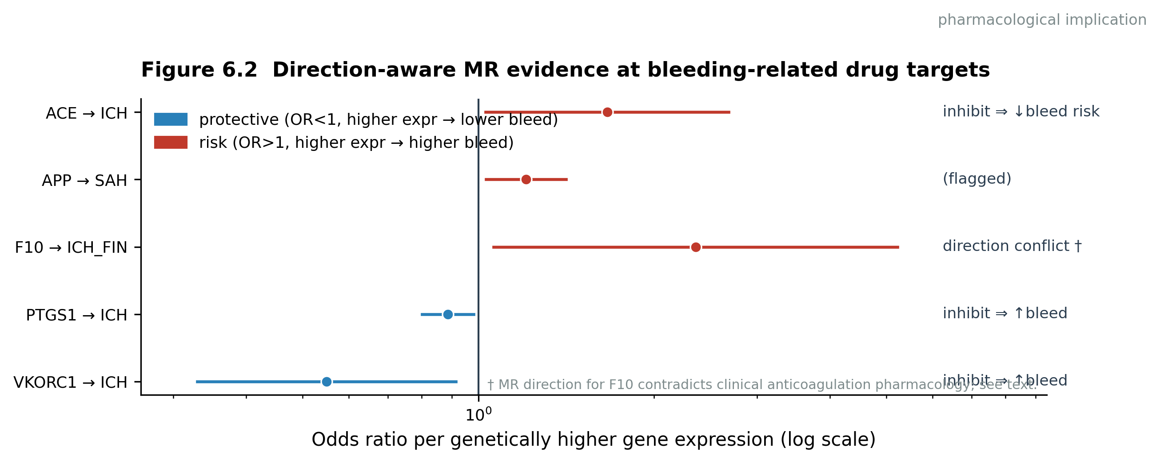
Figure 6.2 Direction-aware MR forest plot for bleeding-related drug targets. Blue denotes protective (higher expression → lower intracerebral haemorrhage risk); red denotes risk. The column to the right summarises the pharmacological implication of drug inhibition. † marks the direction conflict for F10.

Supporting tables (see paper_tables.xlsx)
- Table S1 Repurposing candidates with genetic-anchor, counter-evidence, false-positive-direction and structural-only tiers (421 rows).
- Table S2 ARIA-H co-medication liability map with clinical class, bleeding class and direction-conflict annotations (421 rows); core_risk_drugs.csv contains the 23 systemic first-line high-tier drugs shown in Figure 6.1.
- Table S3 Eligible combination partners (8) and tier-2 safe-but-unmatched drugs (303 rows).
- Audit sheet documents salt/hydrate collapsing and clinical classifications.

