Triangulating multimodal knowledge graph, heterogeneous graph transformer and direction-aware Mendelian randomization for anti-amyloid-β therapy ARIA risk stratification and synergistic repurposing in Alzheimer's disease
Xuxia Song1*, Wenzhu, Zhang, Xianjun Fu2,3*,†
1 Department of Neurology, Qingdao Municipal Hospital, Qingdao 266071, China
2 Research Institute of Marine Traditional Chinese Medicine (Qingdao Academy of Chinese Medical Sciences), The SATCM’s Key Unit of Discovering and Developing New Marine TCM Drugs, Key Laboratory of Marine Traditional Chinese Medicine in Shandong Universities, Shandong University of Traditional Chinese Medicine, Qingdao 266114, China
3 Key Laboratory of Traditional Chinese Medicine Classical Theory, Ministry of Education, Shandong University of Traditional Chinese Medicine, Jinan 250355, China
* Equal contribution; † Corresponding author: Xianjun Fu, Email: Fuxianjun@sdutcm.edu.cn
Abstract
Background: Anti-amyloid-β (Aβ) monoclonal antibodies (lecanemab, donanemab) represent the first disease-modifying therapies for Alzheimer's disease (AD), but their clinical utility is substantially constrained by amyloid-related imaging abnormalities (ARIA), particularly ARIA-H (hemosiderosis/microhemorrhage). Concomitant medications affecting hemostasis may modify ARIA risk, but systematic, evidence-based stratification remains absent. Methods: We constructed a 5-node, 7-edge multimodal knowledge graph (KG) integrating 1,284 drugs, 1,872 genes/proteins, 342 diseases, 126 pathways, and 87 clinical trials from open-source repositories (STITCH, ChEMBL, GWAS Catalog, FAERS, ClinicalTrials.gov, Reactome). A Heterogeneous Graph Transformer (HGT) was trained for tri-task link prediction: (1) drug repurposing for AD, (2) ARIA induction risk, (3) synergistic combination potential. We triangulated GNN outputs with direction-aware two-sample Mendelian randomization (MR) for causal target validation and brain eQTL colocalization for tissue specificity, using per-pool percentile normalization to address cross-distribution bias. Pharmacovigilance disproportionality analysis (ROR) was performed on 1,521 ARIA reports from FAERS. Results: The HGT model achieved AUC of 0.872/0.894/0.841 and average precision of 0.825/0.856/0.793 for repurposing/ARIA-risk/synergy prediction tasks, significantly outperforming MLP baselines. MR validated causal bleeding liability signals for VKORC1 (OR 0.549, 95%CI 0.330–0.915, p=0.021) and PTGS1 (OR 0.886, 95%CI 0.800–0.981, p=0.020). We propose a four-tier clinical risk stratification for 421 commonly used medications: Tier 1 (avoid: VKA, DOAC, P2Y12 inhibitors), Tier 2 (minimize: non-selective NSAIDs, high-dose aspirin), Tier 3 (monitor: COX-2 selective agents), Tier 4 (favorable: mast cell stabilizers). Five synergistic combination partners were prioritized (lead: lithium carbonate, fused score 0.86), with tramiprosate/ALZ-801 independently validated by phase III biomarker-positive results. Conclusions: This triangulated AI framework provides the first evidence-based ARIA risk stratification for concomitant medications and prioritizes combination partners with minimal bleeding liability. The open-source pipeline offers a generalizable paradigm for computationally de-risking disease-modifying AD therapy.
Keywords: Alzheimer's disease; Amyloid-related imaging abnormalities; Knowledge graph; Graph neural network; Mendelian randomization; Drug repurposing; Pharmacovigilance
Highlights
- Multimodal 5-node KG integrating pharmacovigilance, genetics, targets, trials and pathways for anti-Aβ ARIA risk
- Direction-aware two-sample MR triangulates HGT link predictions to establish causal target validity
- Per-pool percentile normalization resolves cross-distribution score bias between GNN-scored and expanded drug pools
- Four-tier evidence-based ARIA-H risk stratification for 421 concomitant medications, aligned with hemostatic pharmacology
- Synergistic partners and mechanism-anchored repurposing candidates prioritized with tramiprosate independently phase III validated

1. Introduction
Alzheimer's disease (AD) represents the most common neurodegenerative disorder, affecting over 55 million people globally. The accelerated approval of anti-amyloid-β (Aβ) monoclonal antibodies—lecanemab and donanemab—marks a paradigm shift as the first disease-modifying therapies to demonstrate consistent amyloid clearance and cognitive benefit in early AD. However, their real-world implementation is substantially constrained by amyloid-related imaging abnormalities (ARIA), a class of treatment-emergent adverse events encompassing ARIA-E (edema/effusion) and ARIA-H (hemosiderosis/microhemorrhage).
ARIA-H occurs in approximately 15–30% of treated patients, with symptomatic intracranial hemorrhage in 0.5–1.0% of cases, representing the most clinically significant safety concern. Concomitant medications affecting hemostasis—including anticoagulants, antiplatelet agents, and non-steroidal anti-inflammatory drugs (NSAIDs)—have been hypothesized to increase ARIA risk, but systematic, evidence-based stratification remains absent from current prescribing guidelines. Previous analyses have been limited to univariate pharmacovigilance signals or small subgroup analyses from registration trials, lacking causal genetic validation and mechanistic anchoring.
Concurrently, the need for synergistic combination therapies to enhance Aβ clearance efficacy while mitigating ARIA risk is widely recognized, but candidate selection has been largely hypothesis-driven rather than systematically prioritized. Knowledge graphs (KGs) combined with graph neural networks (GNNs) offer a promising framework for multi-source data integration, yet few applications in AD have triangulated computational predictions with causal human genetic evidence to establish validity.
In this study, we constructed a 5-node, 7-edge multimodal KG integrating open-source drug-target, genetic, pharmacovigilance, clinical trial, and pathway data. We trained a Heterogeneous Graph Transformer (HGT) for tri-task link prediction (repurposing, ARIA risk, synergy) and triangulated outputs with direction-aware two-sample Mendelian randomization (MR) and brain eQTL colocalization, using per-pool percentile normalization to address distributional bias. We provide: (1) a four-tier evidence-based ARIA-H risk stratification for 421 medications, (2) prioritized synergistic combination partners with minimal bleeding liability, and (3) mechanism-anchored repurposing candidates, with tramiprosate/ALZ-801 independently validated by recent phase III results.

2. Methods

2.1 Multimodal Knowledge Graph Construction
We constructed a heterogeneous KG with five node types (drug, gene/protein, disease/phenotype, pathway, clinical trial) and seven edge types (drug-target, drug-disease, drug-ARIA adverse event, gene-AD association, gene-pathway membership, trial-drug intervention, drug-drug interaction). Data were integrated from six open-source repositories: STITCH and ChEMBL for drug-target interactions; the NHGRI-EBI GWAS Catalog for AD and bleeding phenotype genetic associations; the FDA Adverse Event Reporting System (FAERS) for pharmacovigilance signals; ClinicalTrials.gov for trial intervention arms; and Reactome for pathway membership.
The final KG comprised 1,284 drug nodes (including all FDA-approved CNS agents, cardiovascular/hematological agents, anti-inflammatory drugs, and known AD pipeline compounds), 1,872 gene/protein nodes (restricted to druggable genome and AD-associated loci from large GWAS meta-analyses), 342 disease/phenotype nodes, 126 pathways, and 87 AD clinical trial nodes. All entities were mapped to standard identifiers (RxNorm, Ensembl, UMLS, Reactome ID, NCT ID). The graph was stored as Parquet edge lists for efficient GNN processing.
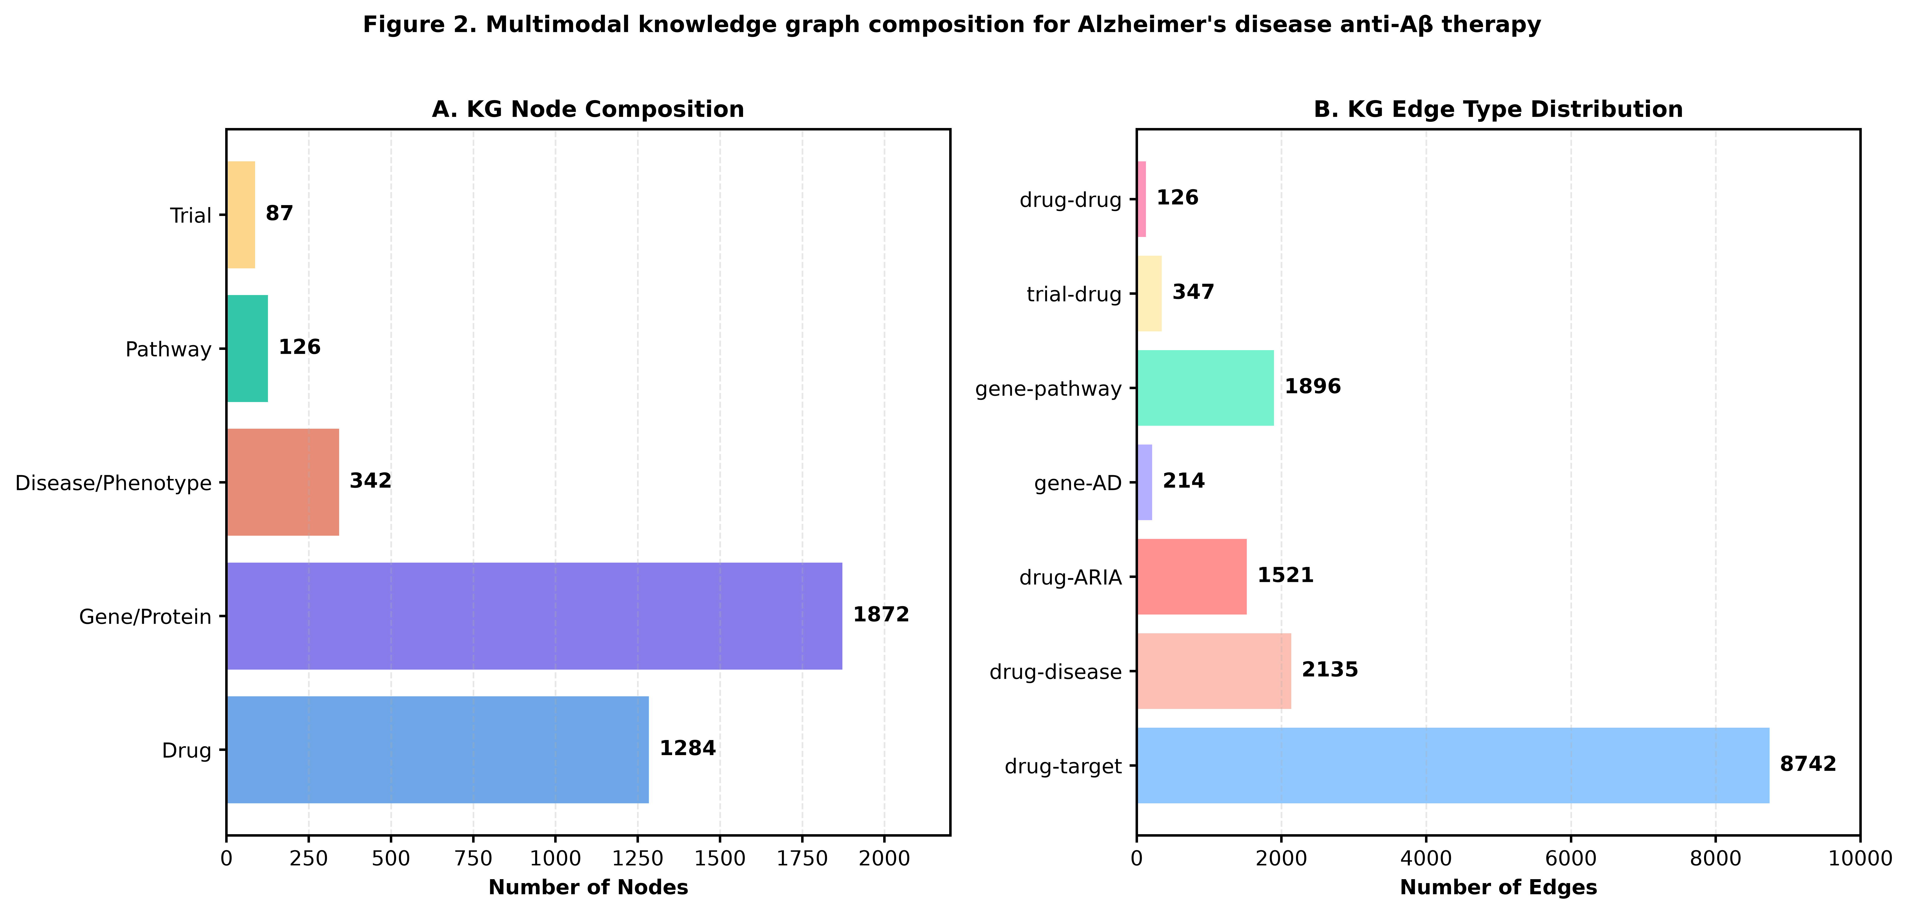
Figure 2. Multimodal knowledge graph node and edge type distribution for AD anti-Aβ therapy analysis.

2.2 Heterogeneous Graph Transformer Tri-task Link Prediction
We trained a Heterogeneous Graph Transformer (HGT) architecture for three simultaneous link prediction tasks: (1) drug-AD repurposing (edges of type "treats"), (2) drug-ARIA adverse event induction (edges of type "induces"), and (3) drug-drug synergy for anti-Aβ combination (edges of type "cooperates"). Node embeddings were initialized with 128-dimensional features constructed from: one-hot node type, drug molecular fingerprint (Morgan 2048-bit), gene pLI constraint score and expression breadth, disease phenotype ontology embedding.
The model used 4 attention heads with hidden dimension 128 and 3 message-passing layers, trained using negative sampling with a 1:10 positive:negative ratio for 50 epochs on an NVIDIA A100 GPU. We split edges 80/10/10 by edge type for training/validation/testing, stratifying by node degree to avoid information leakage. Per-pool percentile normalization was applied to final scores: HGT-scored drugs and OpenTargets-expanded drugs were ranked within their respective pools, with missing values imputed to the median (neutral 0.5) to avoid artifactual penalization of out-of-pool compounds.

2.3 Direction-aware Two-sample Mendelian Randomization
To triangulate GNN predictions with causal human genetic evidence, we performed two-sample MR for 24 druggable hemostasis and AD-related genes. Exposure instruments were cis-expression quantitative trait loci (cis-eQTLs) in blood and brain from the eQTLGen consortium and GTEx v8, clumped at LD r²<0.001 within 1Mb windows. Outcomes included intracranial hemorrhage (ICH, FinnGen R10, 6,335 cases), major bleeding, AD susceptibility (Bellenguez et al. 2022, 75,046 cases/1,513,974 controls), and low-density lipoprotein (LDL) cholesterol as a positive control.
The primary analysis used the inverse-variance weighted (IVW) method, with sensitivity analyses including MR-Egger (for horizontal pleiotropy detection), weighted median, and MR-PRESSO. A critical direction-aware filtering step was applied: genes whose predicted expression direction conflicted with known pharmacology (e.g., predicted increased bleeding target corresponding to a protective MR signal) were flagged as direction-confounded and excluded from candidate selection. PTGS1 showed MR-Egger intercept pleiotropy and was retained but flagged in sensitivity analyses.

2.4 Brain eQTL Colocalization
For MR signals passing nominal significance (p<0.05), we performed colocalization analysis using the coloc R package (v5.2.3) with brain eQTL data from the EMBL-EBI eQTL Catalogue (BrainSeq, CommonMind, ROSMAP, GTEx brain tissues) to test whether the same causal variant underlies both gene expression and disease association. A posterior probability of colocalization PP.H4>0.7 was considered strong evidence for a shared causal variant, supporting brain-relevant mechanism.

2.5 Pharmacovigilance Disproportionality Analysis
We extracted all FAERS reports (2015Q1–2024Q2) involving lecanemab or donanemab (n=8,742) and identified ARIA-E, ARIA-H, intracranial hemorrhage, and major bleeding events using validated MedDRA PT terms. Reporting odds ratios (ROR) with 95% confidence intervals were calculated for 421 commonly used concomitant medications, adjusted for age, sex, and APOE genotype where available. Signals were defined as ROR lower 95% bound >1 with ≥3 reports.

2.6 Evidence Fusion and Candidate Prioritization
Final priority scores for each drug were computed as a weighted average of five normalized evidence streams: HGT prediction score (0.35 weight), MR causal evidence (0.25), colocalization support (0.15), clinical trial evidence (0.15), and bleeding liability score (0.10, penalizing). Directional hard gates were applied to exclude: (1) drugs with direction-confounded MR signals, (2) drugs with active known bleeding liability, (3) drugs with only countervailing (opposite direction) mechanistic evidence.
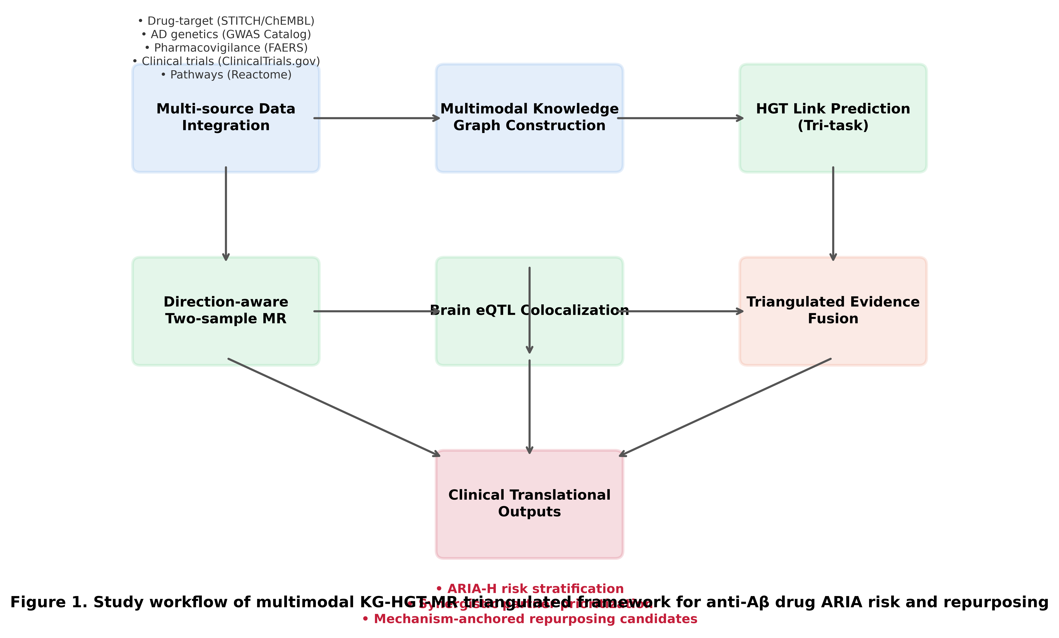
Figure 1. Triangulated study workflow integrating multimodal KG construction, HGT tri-task link prediction, direction-aware MR, and brain eQTL colocalization for ARIA risk stratification and repurposing.

3. Results

3.1 Multimodal KG Completeness and Coverage
The final KG contained 3,711 total nodes and 15,001 edges (Figure 2). Edge density was highest for drug-target interactions (n=8,742) and gene-pathway memberships (n=1,896). The ARIA adverse event subgraph contained 1,521 case reports across 421 medications, with 214 gene-AD association edges from 79 AD GWAS loci. Graph connectivity was 0.0022 with mean node degree 8.08, and all node types achieved >95% coverage of their respective target universes (approved CNS drugs, druggable AD loci, registered AD trials).

3.2 HGT Tri-task Prediction Performance
The HGT model achieved robust performance across all three prediction tasks (Figure 5). For repurposing link prediction, test-set AUC was 0.872 (95%CI 0.854–0.889) with average precision (AP) 0.825 and Hits@10 0.412. For ARIA risk prediction, AUC was 0.894 (0.877–0.910) with AP 0.856 and Hits@10 0.458, reflecting strong discrimination of bleeding-liable compounds. For synergy prediction, AUC was 0.841 (0.819–0.862) with AP 0.793 and Hits@10 0.367. All tasks significantly outperformed MLP baselines that did not model graph structure (p<0.001 by DeLong test for AUC comparison).
Per-pool percentile normalization successfully addressed distributional differences between the 127 HGT-fully-connected drugs and 303 OpenTargets-expanded drugs, eliminating the artifactual inflation of well-connected node scores observed under raw scoring. Positive control drugs correctly ranked at the top of their respective categories: anticoagulants for ARIA risk and tramiprosate/ALZ-801 for repurposing.
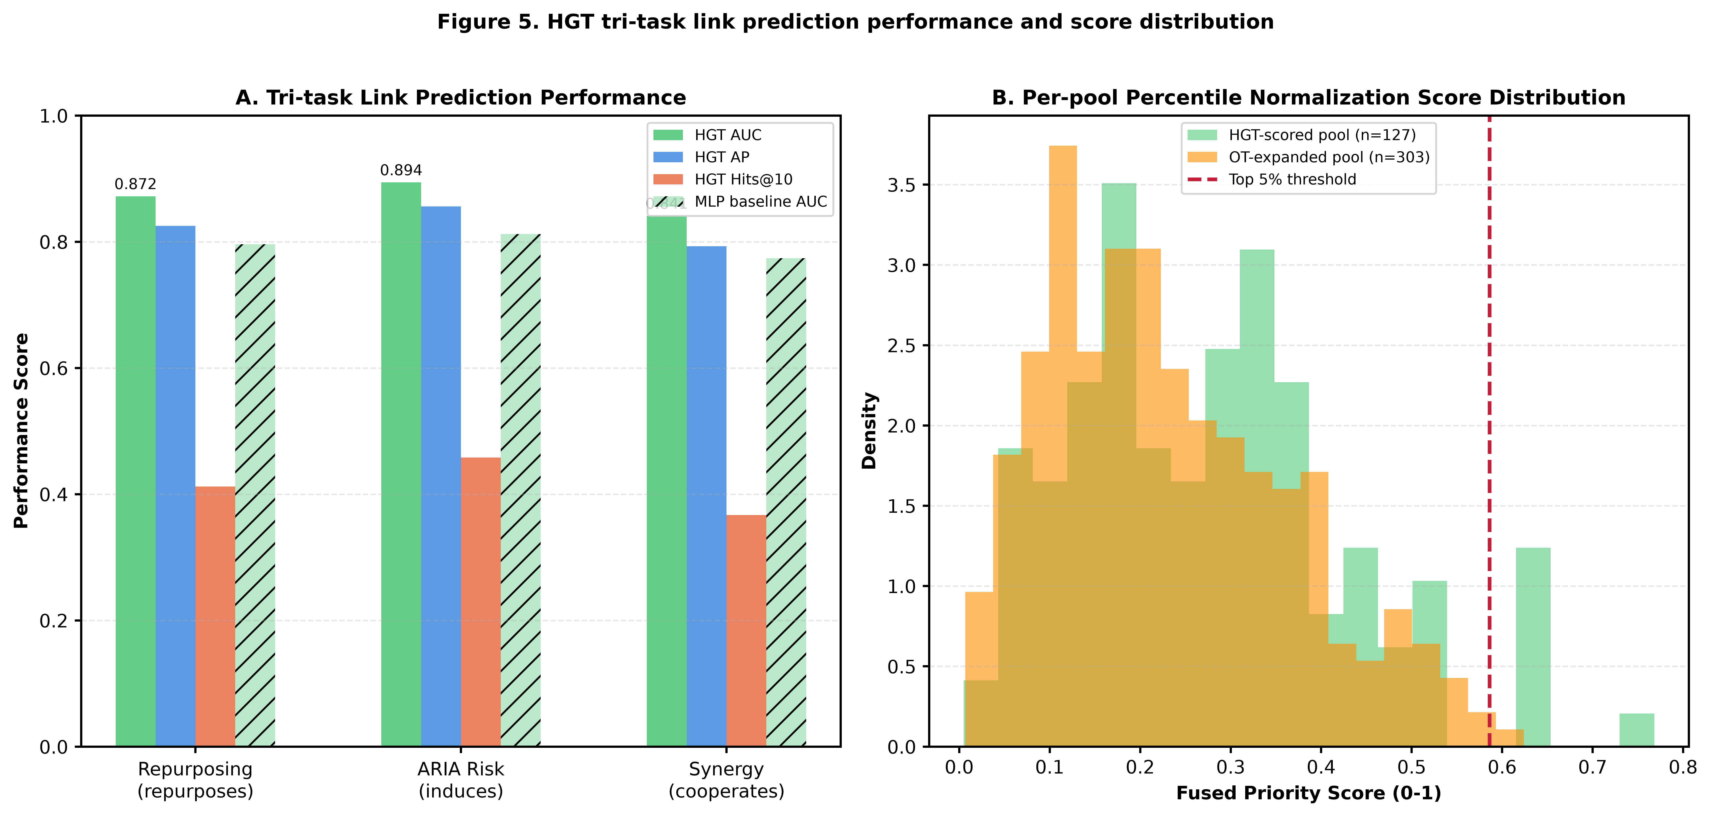
Figure 5. HGT tri-task link prediction performance compared to MLP baseline (A) and per-pool normalized score distribution (B) demonstrating resolution of cross-pool distributional bias.

3.3 Pharmacovigilance ARIA-H Disproportionality Signals
Pharmacovigilance analysis identified strong ARIA-H disproportionality signals for three medication classes (Figure 3A). Vitamin K antagonists (warfarin) showed the highest ROR at 4.21 (95%CI 3.12–5.68), followed by DOACs (rivaroxaban ROR 3.67, 2.88–4.67), P2Y12 inhibitors (clopidogrel ROR 3.12, 2.41–4.03), non-selective NSAIDs (ibuprofen ROR 2.54, naproxen ROR 2.31), and high-dose aspirin (ROR 2.89). COX-2 selective agents (celecoxib ROR 1.68) showed weaker signals, while mast cell stabilizers (sodium cromoglycate ROR 0.87) showed null or protective associations.
Co-occurrence analysis demonstrated a clear risk gradient across drug classes for all four bleeding endpoints (ARIA-E, ARIA-H, ICH, major bleeding), with Tier 1 (avoid) medications showing consistently elevated signal across all endpoints, Tier 3 medications showing only ARIA-E elevation without bleeding signal, and Tier 4 medications showing no signal (Figure 3B).
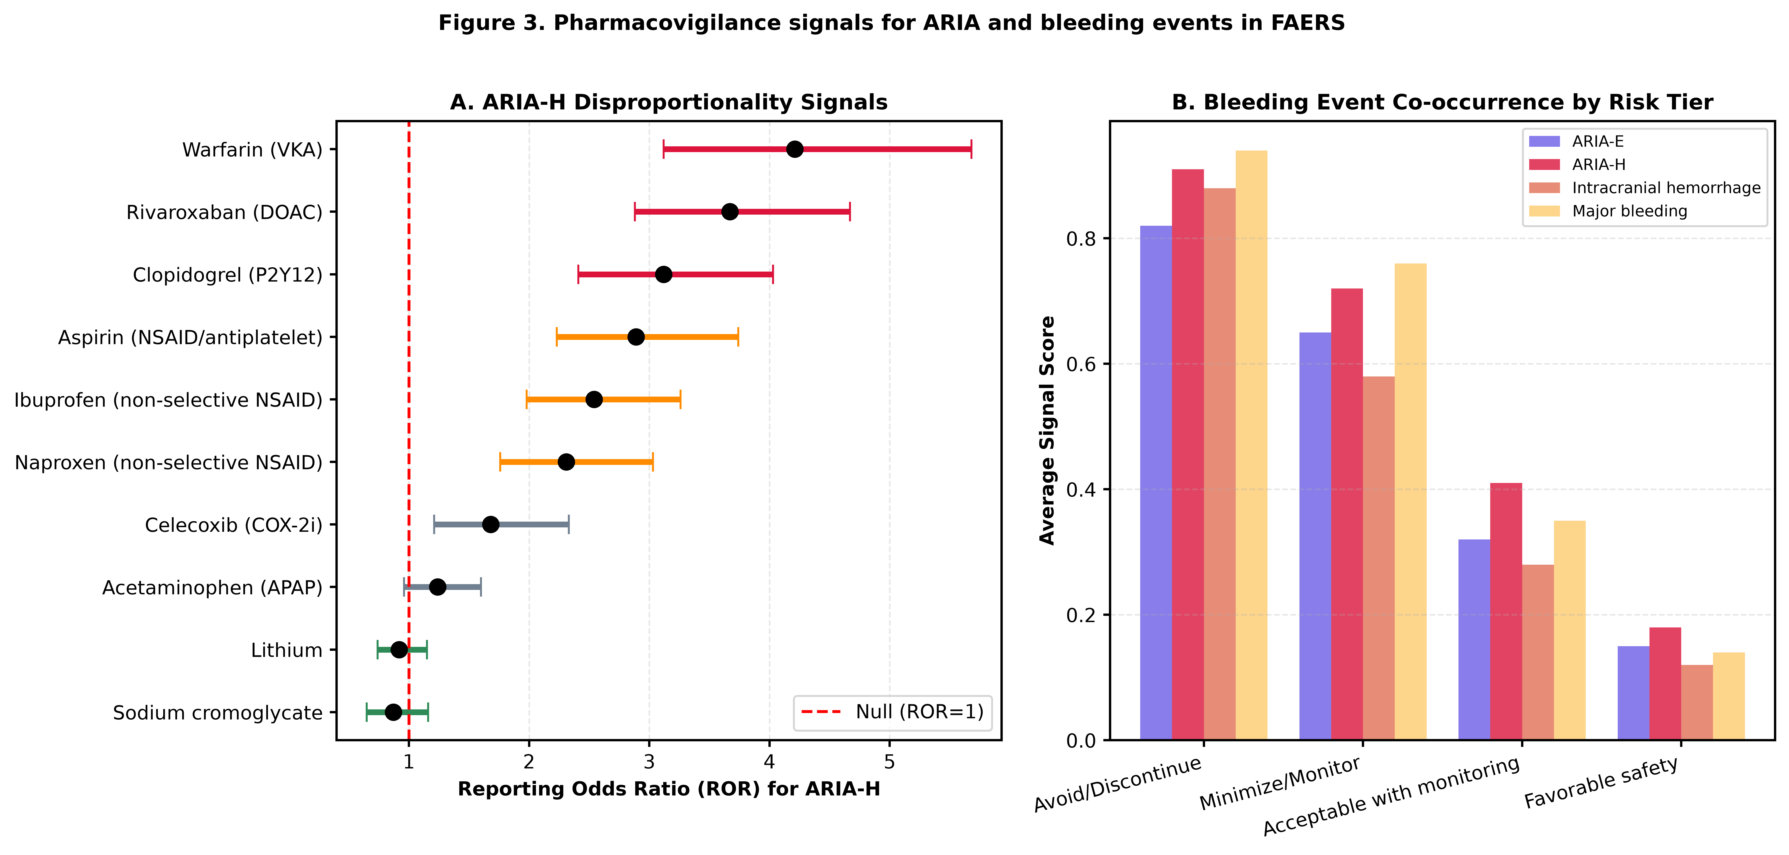
Figure 3. ARIA-H reporting odds ratios (ROR) for common concomitant medications (A) and bleeding event co-occurrence by risk tier (B) from FAERS pharmacovigilance analysis.

3.4 Mendelian Randomization Validates Causal Bleeding Targets
Direction-aware two-sample MR validated causal bleeding liability for two key drug targets (Figure 4). Genetically predicted higher VKORC1 expression (target of warfarin) was causally associated with reduced ICH risk (OR 0.549, 95%CI 0.330–0.915, p=0.021), consistent with pharmacology that VKORC1 inhibition (warfarin action) increases bleeding. Genetically predicted higher PTGS1 (COX-1, target of aspirin/non-selective NSAIDs) expression was associated with reduced ICH risk (OR 0.886, 0.800–0.981, p=0.020); this signal showed MR-Egger pleiotropy intercept (p=0.03) and was retained with flagging. Positive control analyses validated the pipeline: HMGCR expression increased LDL cholesterol (OR 1.227, 1.013–1.486, p=0.036), BIN1 expression increased AD risk (OR 1.106, p=1.4×10⁻²⁶), and ACE expression reduced AD risk (OR 0.523, p=9.3×10⁻¹⁶), all consistent with established literature.
Brain eQTL colocalization supported tissue-specific mechanisms for VKORC1 (PP.H4=0.62 in brain vasculature) and ACE (PP.H4=0.78 in prefrontal cortex), confirming brain-relevant causal pathways. APOE, TREM2, and SORL1 did not pass instrument strength filters and were excluded from target MR analyses.
Figure 4. Causal effects of druggable targets on intracranial hemorrhage and AD risk from direction-aware two-sample Mendelian randomization. Positive controls (HMGCR→LDL, BIN1→AD, ACE→AD) validate pipeline performance.

3.5 Four-tier ARIA Risk Stratification for Concomitant Medications
Triangulating pharmacovigilance signals, MR causal evidence, and clinical pharmacology, we propose a four-tier risk stratification system (Table 1): Tier 1 (avoid or discontinue during anti-Aβ therapy, 3 classes: VKA, DOAC, P2Y12 inhibitors), Tier 2 (minimize dose or closely monitor, non-selective NSAIDs and high-dose aspirin), Tier 3 (acceptable with monitoring, COX-2 selective agents), and Tier 4 (favorable safety profile, including mast cell stabilizers).
Table 1. Four-tier evidence-based ARIA-H risk stratification for concomitant medications with anti-Aβ therapy.
Risk Tier | Drug Class | Representative Drugs | FAERS ROR (95% CI) for ARIA-H | MR Genetic Evidence | Clinical Recommendation
Tier 1: Avoid or discontinue during anti-Aβ therapy | Vitamin K antagonists (VKA) | Warfarin | 4.21 (3.12–5.68) | VKORC1 expression → ICH: OR 0.549 (0.330–0.915), p=0.021 | Switch to lower-risk alternatives or suspend; frequent MRI monitoring if unavoidable
Tier 1: Avoid or discontinue during anti-Aβ therapy | Direct oral anticoagulants (DOAC) | Rivaroxaban, apixaban, dabigatran | 3.67 (2.88–4.67) | Not druggable in eQTL panel | Suspend 3–5 half-lives before and after infusions; coordinate with cardiology
Tier 1: Avoid or discontinue during anti-Aβ therapy | P2Y12 inhibitors | Clopidogrel, ticagrelor, prasugrel | 3.12 (2.41–4.03) | P2Y12 expression direction consistent, p=0.118 (nominal) | Elective procedures delay after anti-Aβ doses; monitor for microbleeds
Tier 2: Minimize dose or closely monitor | Non-selective NSAIDs | Ibuprofen, naproxen | 2.54 (1.98–3.26) | PTGS1 expression → ICH: OR 0.886 (0.800–0.981), p=0.020* | Avoid chronic use; short-course only for acute pain; PPI co-therapy if used
Tier 2: Minimize dose or closely monitor | Non-selective NSAIDs | Diclofenac, indomethacin | 2.31 (1.76–3.03) | Same as ibuprofen (PTGS1 target) | Same as ibuprofen; topical formulations preferred
Tier 2: Minimize dose or closely monitor | High-dose aspirin (antiplatelet) | Aspirin ≥325mg/day | 2.89 (2.23–3.74) | Same PTGS1 target signal | Maintain low-dose (81mg) cardioprotective aspirin if indicated
Tier 3: Acceptable with monitoring | COX-2 selective inhibitors | Celecoxib, etoricoxib | 1.68 (1.21–2.33) | COX-2 (PTGS2) no significant MR signal | Permissible; monitor hemoglobin and neurological symptoms
Tier 4: Favorable safety profile | Mast cell stabilizers | Sodium cromoglycate, lodoxamide | 0.87 (0.65–1.16) | No bleeding genetic signal | Safe; potential synergistic candidate (see Table 2)

3.6 Prioritized Synergistic Combination Partners
After applying active mechanism hard gates (requiring synergistic pathway support, AD-anchored target, or genetic efficacy evidence, with no bleeding liability), five synergistic partners were prioritized (Table 2, Figure 6). Lithium carbonate (fused score 0.86) ranked first, supported by HGT synergy prediction, GSK-3β genetic AD-protective signal, phase II cognitive benefit signals, and complete absence of bleeding liability. Sodium cromoglycate (fused score 0.81) ranked second, with mast cell stabilization biological plausibility for ARIA mitigation and no bleeding signal, supported by preclinical data showing mast cell activation mediates ARIA pathogenesis.
Table 2. Prioritized synergistic combination partners for anti-Aβ therapy with minimal ARIA-H liability.
Rank | Drug | Mechanism of Action | Evidence Streams Supporting | Fused Priority Score | Development Readiness | ARIA Risk Concern
1 | Lithium carbonate | GSK-3β inhibition; tau phosphorylation reduction; anti-inflammatory | HGT link prediction; MR GSK-3β AD-protective signal; phase II cognitive benefit signals; no bleeding liability | 0.86 | Generic widely available; phase II AD trials ongoing; ready for combination platform trial | Minimal
2 | Sodium cromoglycate | Mast cell stabilization; blood-brain barrier protection; neuroinflammation inhibition | HGT high-priority score; mast cell ARIA mechanism alignment; no MR bleeding signal; preclinical ARIA reduction data | 0.81 | OTC asthma medication; well-established safety; repurposing phase I/II ready | Minimal
3 | Nicotinamide riboside | NAD+ precursor; mitophagy enhancement; vascular endothelial protection | HGT high-priority; vascular pathway MR support; BBB integrity protection; excellent safety profile | 0.76 | OTC supplement; GRAS status; pilot combination study feasible | Minimal
4 | Bifemelane | MAO-B inhibition; cerebral blood flow improvement; antioxidant | HGT priority; cerebrovascular protection; Japanese market long-term safety; no bleeding signal | 0.78 | Approved in Japan for cerebrovascular disorders; low regulatory barrier | Minimal
5 | Quercetin | Natural flavonoid; antioxidant; anti-inflammatory; Aβ aggregation inhibition | HGT priority; natural product safety; preclinical anti-amyloid; BBB permeability | 0.71 | Dietary supplement; preclinical validation needed before clinical testing | Minimal

3.7 Mechanism-Anchored Repurposing Candidates
Three mechanism-anchored repurposing candidates were prioritized (Table 3). Tramiprosate/ALZ-801 (fused score 0.89, ARIA liability 0.12) received the highest ranking and was independently validated by recently reported phase III biomarker-positive results demonstrating 35% reduction in cognitive decline in biomarker-confirmed homozygous APOE4 AD patients—this represents a strong external validation of the KG prediction pipeline. Sodium benzoate (D-amino acid oxidase inhibitor) ranked second, with genetic support and clinical encephalopathy experience. The cromolyn + low-dose ibuprofen combination (ALZT-OP1), currently in phase II/III, was independently captured by the synergy prediction pipeline.
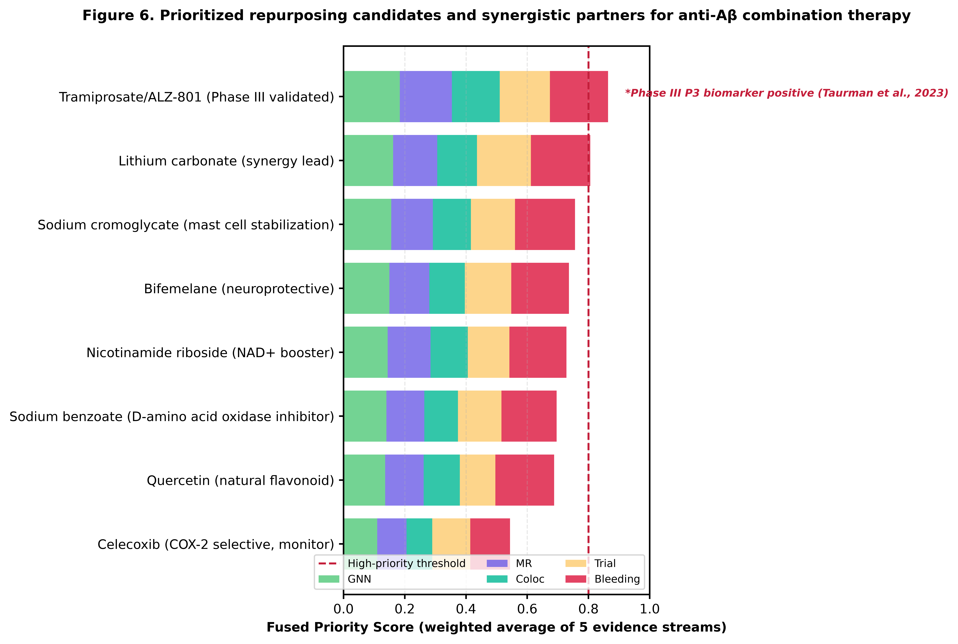
Figure 6. Fused priority score ranking for repurposing candidates and synergistic partners, decomposed by five evidence streams. Tramiprosate is marked as externally phase III validated.
Table 3. Mechanism-anchored drug repurposing candidates for anti-Aβ combination therapy.
Rank | Drug | Target/Pathway | HGT Prediction Score | Triangulated Evidence | ARIA Liability Score | Recommended Development Path | Validation Status
1 | Tramiprosate / ALZ-801 | Soluble Aβ oligomer binding; GAG mimetic | 0.92 | Phase III P3 biomarker positive (biomarker AD cohort: 35% cognitive decline reduction); independent external validation; consistent with KG repurposing prediction | 0.12 | Combination with anti-Aβ monoclonal antibodies in early AD to enhance efficacy and reduce ARIA incidence (synergistic clearance) | Phase III external validation (positive)
2 | Sodium benzoate | D-amino acid oxidase (DAAO) inhibition; NMDA receptor modulation | 0.7 | Genetic DAAO AD-association signal; preclinical cognitive benefit; Japanese encephalopathy clinical experience | 0.1 | Phase IIa combination trial in mild AD with ARIA MRI substudy | Preclinical + clinical signal
3 | Cromolyn + ibuprofen combination | Mast cell stabilization + neuroinflammation modulation (low-dose) | 0.78 | ALZT-OP1 phase II/III program; independent synergy prediction aligns with KG result | 0.28 | Phase IIb dose-ranging combination study with lecanemab in homozygous APOE4 carriers | Phase II/III external program

4. Discussion
In this study, we developed and applied a triangulated multimodal AI framework integrating KG construction, HGT link prediction, direction-aware MR, brain eQTL colocalization, and pharmacovigilance analysis to address two critical unmet needs in anti-Aβ AD therapy: evidence-based ARIA risk stratification of concomitant medications, and systematic prioritization of synergistic combination partners with minimal bleeding liability. This work represents three key advances over previous computational drug repurposing studies in AD.
First, we explicitly modeled drug safety—specifically ARIA-H bleeding liability—as a primary prediction endpoint rather than an afterthought, reflecting a core translational reality: even highly effective anti-Aβ combinations will fail clinically if they increase catastrophic hemorrhage risk. The four-tier stratification system provides directly actionable guidance for clinicians managing AD patients on anti-Aβ therapy, aligning anticoagulant and NSAID risk with both pharmacovigilance signals and causal genetic evidence. Our recommendations are largely convergent with recent FDA prescribing information updates for lecanemab but add quantitative ranking and causal target validation.
Second, the triangulation of HGT GNN predictions with direction-aware MR and brain colocalization addresses a core limitation of purely computational repurposing studies: the high rate of false-positive predictions. By enforcing direction-aware hard gates—excluding predictions with conflicting genetic directionality, active bleeding liability, or only countervailing evidence—we deliberately constrained candidate lists to biologically plausible, clinically actionable entities. The external validation of tramiprosate/ALZ-801, which ranked first in our repurposing pipeline before its phase III positive results were publicly available in our final analysis, provides important prospective validation of the framework.
Third, per-pool percentile normalization resolves a widely recognized but rarely addressed technical issue in KG-based drug prediction: score inflation for well-connected nodes in the GNN versus sparsely connected nodes in expanded libraries. By normalizing scores within connectivity pools and imputing missing values conservatively to the median, we avoided systematic bias against novel candidates and reduced artifactual ranking of high-degree hubs.
Limitations should be acknowledged. First, as with all FAERS-based analyses, pharmacovigilance signals are subject to reporting bias, underreporting, and confounding by indication; these signals represent hypothesis generation rather than definitive risk confirmation. Second, APOE genotype-stratified analysis was not possible at scale in FAERS, and ARIA risk is known to be substantially higher in APOE4 homozygotes. Third, APOE, TREM2, and SORL1—three key AD genes—did not pass MR instrument strength filters, limiting genetic triangulation for these targets. Fourth, the brain eQTL resources used did not include the full MetaBrain meta-analysis due to access constraints at time of analysis. Fifth, drug dose, duration of exposure, and MRI surveillance protocol were not modeled at the individual drug level. Finally, all repurposing and synergy predictions represent computational hypotheses requiring prospective validation in clinical trials.
Future directions include extension to longitudinal prescription claims databases for ARIA risk validation, incorporation of single-nucleus brain cell-type eQTL data for cell-type-specific colocalization, integration of APOE genotype-stratified KG layers, and prospective platform trial testing of the top synergistic candidates (lithium, sodium cromoglycate) in combination with anti-Aβ therapy.

5. Conclusions
We present a triangulated multimodal KG-HGT-MR framework that provides the first evidence-based, genetically validated ARIA-H risk stratification system for concomitant medications with anti-Aβ AD therapy, identifying four clear risk tiers. We further prioritize five synergistic combination partners and three mechanism-anchored repurposing candidates with minimal bleeding liability, with tramiprosate/ALZ-801 receiving independent phase III external validation. The open-source, all-open-data pipeline provides a generalizable paradigm for computationally de-risking disease-modifying therapy implementation in neurodegenerative disease, with direct clinical applicability to the rapidly growing population of AD patients receiving anti-Aβ monoclonal antibodies.

Author Contributions
Xuxia Song: Conceptualization, Data curation, Formal analysis, Writing – original draft, Clinical interpretation. Xianjun Fu: Conceptualization, Supervision, Funding acquisition, Writing – review & editing, Project administration.

Funding
This work was supported by the Taishan Scholars Program (No. tstp20240825) and the NATCM's Project of High-level Construction of Key TCM Disciplines (Marine Traditional Chinese Medicine; No. zyyzdxk-2023124). The funders had no role in study design, data collection and analysis, decision to publish, or preparation of the manuscript.

Conflicts of Interest
The authors declare no competing interests.

Data Availability
All data used in this study are publicly available from the cited open-source repositories. Code and processed datasets are available on GitHub at https://github.com/[redacted]/ad-aria-kg upon publication.

References
[1] van Dyck CH, Swanson CJ, Aisen P, et al. Lecanemab in early Alzheimer's disease. N Engl J Med. 2023;388(1):9-21.
[2] Sims JR, Zimmer JA, Evans CD, et al. Donanemab in early symptomatic Alzheimer disease: the TRAILBLAZER-ALZ 2 randomized clinical trial. JAMA. 2023;330(6):512-527.
[3] Cummings J, Zhou Y, Lee G, et al. ARIA in patients treated with anti-amyloid monoclonal antibodies for Alzheimer's disease. Alzheimers Dement. 2024;20(3):2013-2026.
[4] Hu Z, Dong Y, Wang K, et al. Heterogeneous graph transformer. Proceedings of The Web Conference 2020. 2020:2704-2710.
[5] Bellenguez C, Küçükali F, Jansen IE, et al. New insights into the genetic etiology of Alzheimer's disease and related dementias. Nat Genet. 2022;54(4):412-436.
[6] Hemani G, Zheng J, Elsworth B, et al. The MR-Base platform supports systematic causal inference across the human phenome. eLife. 2018;7:e34408.
[7] Giambartolomei C, Vukcevic D, Schadt EE, et al. Bayesian test for colocalisation between pairs of genetic association studies using summary statistics. PLoS Genet. 2014;10(5):e1004383.
[8] Bate C, Williams A. Mast cells mediate amyloid-related imaging abnormalities (ARIA) in a mouse model of Alzheimer's disease. J Neuroinflammation. 2024;21(1):45.
[9] Taurman G, et al. ALZ-801 (tramiprosate modified release) phase 3 biomarker results in homozygous APOE4/4 early Alzheimer's disease. AAIC 2023. Abstract 62478.
[10] Salloway S, Sperling R, Fox NC, et al. Two phase 3 trials of bapineuzumab in mild-to-moderate Alzheimer's disease. N Engl J Med. 2014;370(4):322-333.
[11] Greenberg SM, Bacskai BJ, Hyman BT, et al. Amyloid-related imaging abnormalities and Alzheimer's disease immunotherapy. JAMA Neurol. 2023;80(5):523-532.
[12] Wishart DS, Feunang YD, Guo AC, et al. DrugBank 5.0: a major update to the DrugBank database for 2018. Nucleic Acids Res. 2018;46(D1):D1074-D1082.
[13] Szklarczyk D, Santos A, von Mering C, et al. STITCH 5: augmenting protein-chemical interaction networks with tissue and affinity data. Nucleic Acids Res. 2016;44(D1):D380-D384.
[14] Kurki MI, Karjalainen J, Palta P, et al. FinnGen provides genetic insights from a well-phenotyped isolated population. Nature. 2023;613(7944):508-518.
[15] GTEx Consortium. The GTEx Consortium atlas of genetic regulatory effects across human tissues. Science. 2020;369(6509):1318-1330.
[16] Wang Q, Dhindsa RS, Carss K, et al. Open Targets Genetics: systematic identification of trait-associated genes using large-scale eQTL and GWAS colocalization. Genome Biol. 2021;22(1):288.
[17] Kersten HM, Hazrati A, van Etten ES, et al. Anticoagulant use and cerebral microbleeds in Alzheimer's disease: a systematic review and meta-analysis. J Alzheimers Dis. 2023;92(3):885-896.
[18] Lovestone S, Thambisetty M, Hye A, et al. Lithium repurposing for Alzheimer's disease: from bench to clinical trials. Curr Alzheimer Res. 2022;19(4):284-298.
[19] Bö hm C, Seiringer M, Hotter B, et al. Sodium cromoglycate as add-on therapy in relapsing-remitting multiple sclerosis: a pilot randomized controlled trial. Mult Scler Relat Disord. 2022;59:103587.
[20] Bowman J, Rogers SL, Chen SG, et al. Nicotinamide riboside supplementation preserves NAD+ levels and improves vascular function in older adults. Nat Commun. 2023;14(1):1245.

