**微信端Web接口文档9.1**

**一:收运人员获取手机验证码**

url:http://118.178.18.0:8082/alfa-mobile-ws/rest/user/**getCaptchaForWorker**

/15320295813

Method:get

参数:15320295813

返回值:

失败:

1: 短信发送失败

3：*角色非收运人员,不能获取手机验证码*

*4:手机号不存在*

成功:

2：短信发送成功

**二:产废单位获取手机验证码（注册）**

url:http://118.178.18.0:8082/alfa-mobile-ws/rest/user/getCaptchaForFactory/15320295813

Method:get

参数:15320295813

返回值:

失败:

2: 短信发送失败

1：*手机号已经存在，不能获取短信验证码*

成功:

3：短信发送成功

**二．一:产废单位获取手机验证码（登录）**

url:http://118.178.18.0:8082/alfa-mobile-ws/rest/user/**getCaptchaForFactoryForLogin**/15320295813

Method:get

参数:15320295813

返回值:

失败:

2: 短信发送失败

1：*角色非产废单位,不能获取短信验证码*

*4：手机号不存在,不能获取短信验证码*

成功:

3：短信发送成功

**二．二:退出手机用户**

url:http://118.178.18.0:8082/alfa-mobile-ws/rest/user/**logout**

Method:post

**三,手机注册用户**

url:http://118.178.18.0:8082/alfa-mobile-ws/rest/user**/createUser**

**Method:post**

**参数:{“**mobile**”:”15320295813”,”**captcha”:”123456”}

返回值：

失败：

注册失败

{

"status": "failure",

"message": "5",

"data": null

}

**手机号已经存在**

{

"status": "failure",

"message": "3",

"data": null

}

**验证码不正确**

{

"status": "failure",

"message": "2",

"data": null

}

**帐号已经存在**

{

"status": "failure",

"message": "1",

"data": null

}

**验证码已经超过有效时间**

{

"status": "failure",

"message": "6",

"data": null

}

成功:

注册成功

{

"status": "success",

"message": "4",

"data": null

}

**四，手机微信用户登录**

url:http://118.178.18.0:8082/alfa-mobile-ws/rest/user**/**loginforweixin

**Method:post**

**参数:**{**"mobile"**: **"13220356963"**, **"captcha"**: **"432943"**,**"openid"**:**"ABCDEFG"**}

附:参数使用Base64算法对数据进行了字符格式处理，避免明文传输.

openid参数明文传输

返回值：

失败：

**服务器异常，请联系管理员。**

{

"status": "failure",

"message": "1",

"data": null

}

**请输入手机号和验证码。**

{

"status": "failure",

"message": "2",

"data": null

}

**验证码不正确**

{

"status": "failure",

"message": "3",

"data": null

}

**验证码已经超过有效时间**

{

"status": "failure",

"message": "4",

"data": null

}

**帐号不存在**

{

"status": "failure",

"message": "**5**",

"data": null

}

OpenId不能为空

{

"status": "failure",

"message": "6",

"data": null

}

成功:

{"id":null,"createdDt":"2017-06-20 17:05:57","createdBy":"15320295813","version":1,"updatedDt":"2017-07-02 16:12:16","updatedBy":"15320295813","userId":37,"username":"13220356963","password64":null,"password":"","phone":"13220356963","sexname":null,"sex":null,"statusname":null,"status":null,"typesname":null,"types":null,"address":"123","orgname":"123","remarks":null,"token":"","mobiletoken":"4086c3354d7c4aa9952c4f7f20b08556","errorCount":0,"errorCountformobile":0,"captcha":"","roleId":9,"realname":"欧洋","role_name":"收运人员","menuitem":"/menu/Menu_two.json","roles":null,"accountObj":null,"weixinid":4,"openid":"ABCDEFG","headimgurl":"997460","state":"1","verifyCode":"","loginIp":"127.0.0.1"}

**五 新增OpenId**

Url:**http://**118.178.18.0:8082**/alfa-mobile-ws/rest/OpenId/insertOpenId**

Method:post

参数:

{**"openid"**: **"ABCDEFG"**, **"headimgurl"**: **"997460"**,**"state"**:**"0"**}

返回值：

失败

1 OpenId已存在

3 OpenId插入失败

成功

2 OpendId插入成功

**六 更新OpenId**

Url **[http://](http://118.178.18.0:8082/alfa-mobile-ws/rest/OpenId/updateOpenId)**[118.178.18.0:8082](http://118.178.18.0:8082/alfa-mobile-ws/rest/OpenId/updateOpenId)**[/alfa-mobile-ws/rest/OpenId/updateOpenId](http://118.178.18.0:8082/alfa-mobile-ws/rest/OpenId/updateOpenId)**

**Method:post**

**参数：**{**"openid"**: **"ABCDEFG"**,**"state"**:**"1"**}

**返回值**

**失败**

**2 OpenId更新失败**

**3 OpenId不存在**

**成功**

**1 OpenId更新成功**

**查询单个OpenId**

Url **[http://](http://118.178.18.0:8082/alfa-mobile-ws/rest/OpenId/updateOpenId)**[118.178.18.0:8082](http://118.178.18.0:8082/alfa-mobile-ws/rest/OpenId/updateOpenId)**[/alfa-mobile-ws/rest/OpenId/GetSingleOpenId](http://118.178.18.0:8082/alfa-mobile-ws/rest/OpenId/updateOpenId)**

**Method:post**

**参数：**{**"openid"**: **"ABCDEFG"**}

**返回值**

**失败**

**2 查询失败**

**成功**

**1 查询成功**

**七 获取当前登录用户的信息**

Url **[http://](http://118.178.18.0:8082/alfa-mobile-ws/rest/OpenId/updateOpenId)**[118.178.18.0:8082](http://118.178.18.0:8082/alfa-mobile-ws/rest/OpenId/updateOpenId)**[/alfa-mobile-ws/rest](http://118.178.18.0:8082/alfa-mobile-ws/rest/OpenId/updateOpenId)**[/user](http://118.178.18.0:8082/alfa-mobile-ws/rest/OpenId/updateOpenId)**[/GetCurrentUserInfoForWeiXin？mobiletoken=](http://118.178.18.0:8082/alfa-mobile-ws/rest/OpenId/updateOpenId)**[624f6a6708924425aa8b0c9307bcdf30](http://118.178.18.0:8082/alfa-mobile-ws/rest/OpenId/updateOpenId)

**Method:post**

**参数：**{**"userid"**: **"1"**}

**返回值**

**失败**

**2** *用户信息获取失败*

**成功**

**1** *用户信息获取成功*

***八 更新当前登录用户的信息***

Url **[http://](http://118.178.18.0:8082/alfa-mobile-ws/rest/OpenId/updateOpenId)**[118.178.18.0:8082](http://118.178.18.0:8082/alfa-mobile-ws/rest/OpenId/updateOpenId)**[/alfa-mobile-ws/rest](http://118.178.18.0:8082/alfa-mobile-ws/rest/OpenId/updateOpenId)**[/user](http://118.178.18.0:8082/alfa-mobile-ws/rest/OpenId/updateOpenId)**[/editUser？mobiletoken=](http://118.178.18.0:8082/alfa-mobile-ws/rest/OpenId/updateOpenId)**[624f6a6708924425aa8b0c9307bcdf30](http://118.178.18.0:8082/alfa-mobile-ws/rest/OpenId/updateOpenId)

**Method:post**

*/**  
 * 单位名称  
  
 */***private** String **orgname**;

*/**  
 * 单位地址  
 */***private** String **address**;

*/**  
 * 真实姓名  
 */***private** String **realname**;

**参数：**{**"userId"**: **"1",“orgname”：“123”，“address”：“123”，“realname”：“123”**}

**返回值**

**失败**

**2** *用户信息更新失败*

**成功**

**1** *用户信息更新成功*

***九 新增收油地址***

Url **[http://](http://118.178.18.0:8082/alfa-mobile-ws/rest/OpenId/updateOpenId)**[118.178.18.0:8082](http://118.178.18.0:8082/alfa-mobile-ws/rest/OpenId/updateOpenId)**[/alfa-mobile-ws/rest/historyaddress](http://118.178.18.0:8082/alfa-mobile-ws/rest/OpenId/updateOpenId)**

**[/insertHistoryAddress？mobiletoken=](http://118.178.18.0:8082/alfa-mobile-ws/rest/OpenId/updateOpenId)**[624f6a6708924425aa8b0c9307bcdf30](http://118.178.18.0:8082/alfa-mobile-ws/rest/OpenId/updateOpenId)

**Method:post**

**参数：**{**"iphone"**: **"1"，“address”：“123”**}

**返回值**

**失败**

**1** *收油地址已存在,无法再添加*

*3 收油地址插入失败*

**成功**

**2** *收油地址插入成功*

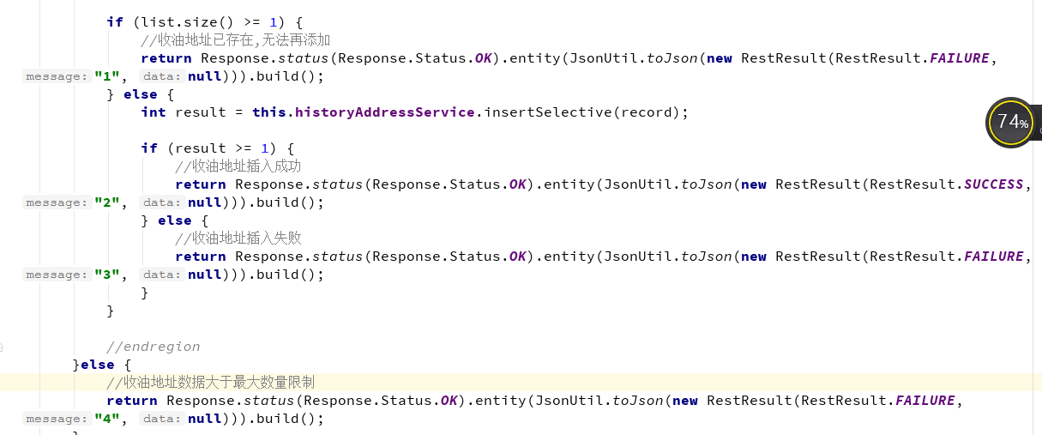

***十 修改收油地址***

Url **[http://](http://118.178.18.0:8082/alfa-mobile-ws/rest/OpenId/updateOpenId)**[118.178.18.0:8082](http://118.178.18.0:8082/alfa-mobile-ws/rest/OpenId/updateOpenId)**[/alfa-mobile-ws/rest/historyaddress](http://118.178.18.0:8082/alfa-mobile-ws/rest/OpenId/updateOpenId)**

**[/updateHistoryAddress？mobiletoken=](http://118.178.18.0:8082/alfa-mobile-ws/rest/OpenId/updateOpenId)**[624f6a6708924425aa8b0c9307bcdf30](http://118.178.18.0:8082/alfa-mobile-ws/rest/OpenId/updateOpenId)

**Method:post**

**参数：**{**"id"**: **"1"，“address”：“123”**}

**返回值**

**失败**

*2 收油地址更新失败*

**成功**

**1** *收油地址更新成功*

***十一 删除收油地址***

Url **[http://](http://118.178.18.0:8082/alfa-mobile-ws/rest/OpenId/updateOpenId)**[118.178.18.0:8082](http://118.178.18.0:8082/alfa-mobile-ws/rest/OpenId/updateOpenId)**[/alfa-mobile-ws/rest/historyaddress](http://118.178.18.0:8082/alfa-mobile-ws/rest/OpenId/updateOpenId)**

**[/deleteHistoryAddress？mobiletoken=](http://118.178.18.0:8082/alfa-mobile-ws/rest/OpenId/updateOpenId)**[624f6a6708924425aa8b0c9307bcdf30](http://118.178.18.0:8082/alfa-mobile-ws/rest/OpenId/updateOpenId)

**Method:post**

**参数：**{**"id"**: **"1"**}

**返回值**

**失败**

*2 收油地址删除失败*

**成功**

**1** *收油地址删除成功*

***十二 分页查询收油地址***

Url **[http://](http://118.178.18.0:8082/alfa-mobile-ws/rest/OpenId/updateOpenId)**[118.178.18.0:8082](http://118.178.18.0:8082/alfa-mobile-ws/rest/OpenId/updateOpenId)**[/alfa-mobile-ws/rest/historyaddress](http://118.178.18.0:8082/alfa-mobile-ws/rest/OpenId/updateOpenId)**

**[/f](http://118.178.18.0:8082/alfa-mobile-ws/rest/OpenId/updateOpenId)indlist？mobiletoken=**624f6a6708924425aa8b0c9307bcdf30

**Method:post**

**参数：filterscount=0&groupscount=0&pagenum=0&pagesize=10&recordstartindex=0&recordendindex=10&iphone=13062317530&addressLike=1**

**返回值**

**失败**

**{**

**"total": 0,**

**"rows": []**

**}**

**成功**

*有数据*

4 添加订单

url:http://118.178.18.0:8082/alfa-mobile-ws/rest**/order/insertorders?mobiletoken=**624f6a6708924425aa8b0c9307bcdf30

**Method:post**

**参数:**

*/**  
 * 产废单位用户姓名  
 */***private** String **username**;  
  
*/**  
 * 产废单位电话  
 */***private** String **iphone**;  
  
*/**  
 * 收油地址  
 */***private** String **address**;  
  
*/**  
 * 预收数量  
 */***private** String **num**;  
  
*/**  
 * 产废单位名称  
 */***private** String **orgname**;  
  
*/**  
 * 订单状态  
 */***private** String **orgstatus**;

*/**  
 * 备注  
  
 */***private** String **remark**;

**{“**username**”:”李四”,”iphone**”:”15320295813”,”**address**”:”重庆市九龙坡区石桥铺渝高大厦”,”**num”:”10”,”orgname”:”南华中天”,”orgstatus”:”1”,”remark”,”111111”**}

附:

orgstatus 为订单状态 1:提交,2：分配，3:确认，4:完成

**num 为预收数量 单位为桶**

返回值:

失败:

当前用户当天的订单总数超出最大数量限制

{

"status": "failure",

"message": "**3**",

"data": null

}

订单插入失败

{

"status": "failure",

"message": "2,

"data": null

}

成功:

{

"status": "success",

"message": "1",

"data": null

}

**6 订单确认收到:**

Url:http://118.178.18.0:8082/alfa-mobile-ws/rest/**order/updateorders？mobiletoken=**624f6a6708924425aa8b0c9307bcdf30

**Method:post**

**参数：***{"orderid": “5”,"orgstatus":"3"}*

**附:**Orgstatus 为订单状态 1:提交,2：分配，3:确认，4:完成

**返回值:**

成功:

{

"status": "success",

"message": "1",

"data": null

}

失败:

{

"status": "failure",

"message": "2",

"data": null

}

**7 订单确认完成:**

Url:http://118.178.18.0:8082/alfa-mobile-ws/rest/**order/updateorders？mobiletoken=**624f6a6708924425aa8b0c9307bcdf30

**Method:post**

**参数：***{"orderid": “5”,"orgstatus":"4",”realnum”:”123”}*

**附:O**rgstatus 为订单状态 1:提交,2：分配，3:确认，4:完成

realnum 为实收数量，单位为桶

**返回值:**

成功:

{

"status": "success",

"message": "1",

"data": null

}

失败:

{

"status": "failure",

"message": "2",

"data": null

}

**5,分页查询订单**

url:http://118.178.18.0:8082/alfa-mobile-ws/rest/**order/findlist？mobiletoken=**624f6a6708924425aa8b0c9307bcdf30

**Method:post**

参数:

**filterscount=0&groupscount=0&pagenum=0&pagesize=10&recordstartindex=0&recordendindex=10&roleId=10&phone=13062317530&iphone=13062317530&orderid=1**

**附：**

**分页条件**

**filterscount=0&groupscount=0&pagenum=0&pagesize=10&recordstartindex=0&recordendindex=10**

**角色ID**

**roleId=10**

**产废人员的电话号码**

**phone=13062317530&iphone=13062317530**

**订单ID**

**orderid=1**

返回值:

**成功：**

**有数据**

**{**

**"total": 4,**

**"rows": [**

**{**

**"id": null,**

**"createdDt": "2017-06-15 13:18:55",**

**"createdBy": "123456",**

**"version": 1,**

**"updatedDt": "2017-06-15 13:21:24",**

**"updatedBy": "1234",**

**"orderid": 8,**

**"username": "周6",**

**"iphone": "123456",**

**"address": "重庆市大渡口区",**

**"num": "111111",**

**"orgname": "123",**

**"orgstatus": "完成",**

**"workerid": 22,**

**"phone": "1234",**

**"realname": "王五"**

**},**

**{**

**"id": null,**

**"createdDt": "2017-06-09 09:50:45",**

**"createdBy": "15320295813",**

**"version": 1,**

**"updatedDt": "2017-06-09 16:22:56",**

**"updatedBy": "15320295813",**

**"orderid": 7,**

**"username": "周6",**

**"iphone": "123456",**

**"address": "123456",**

**"num": "123456",**

**"orgname": "123456",**

**"orgstatus": "分配",**

**"workerid": 21,**

**"phone": null,**

**"realname": null**

**},**

**{**

**"id": null,**

**"createdDt": "2017-06-08 17:06:56",**

**"createdBy": "15320295813",**

**"version": 1,**

**"updatedDt": "2017-06-09 15:02:29",**

**"updatedBy": "15320295813",**

**"orderid": 6,**

**"username": "小杨",**

**"iphone": "1111111111111",**

**"address": "1111111111111",**

**"num": "11111111111",**

**"orgname": "1111111111111111",**

**"orgstatus": "分配",**

**"workerid": 27,**

**"phone": "5555555555555",**

**"realname": "张三"**

**},**

**{**

**"id": null,**

**"createdDt": "2017-06-08 16:48:04",**

**"createdBy": "15320295813",**

**"version": 1,**

**"updatedDt": "2017-06-09 16:27:29",**

**"updatedBy": "15320295813",**

**"orderid": 5,**

**"username": "欧阳",**

**"iphone": "22222222222222",**

**"address": "222222222222",**

**"num": "222222222222222",**

**"orgname": "2222222222222222222",**

**"orgstatus": "分配",**

**"workerid": 21,**

**"phone": null,**

**"realname": null**

**}**

**]**

**}**

**没有数据**

**{**

**"total": 0,**

**"rows": []**

**}**

**6 新增订单评论**

**Url:**http://118.178.18.0:8082/alfa-mobile-ws/rest/**ordercomment**

**/batchinsertordercomment？mobiletoken=**624f6a6708924425aa8b0c9307bcdf30

Method:post

参数：[{"orderId":"1","content":"123"},{"orderId":"1","content":"12333"}]

返回值：

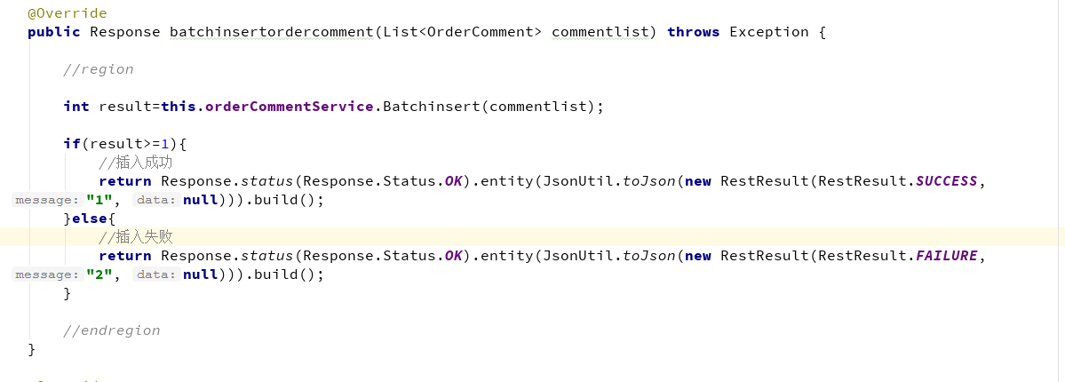

**7，查询订单评论**

**Url:**http://118.178.18.0:8082/alfa-mobile-ws/rest/**ordercomment**

**/findlist**

**？mobiletoken=**624f6a6708924425aa8b0c9307bcdf30

Method:post

参数:

**orderId=1**

**返回值：  
成功：有数据**

**失败：没有数据**