微信端Web接口文档9.2

一:收运人员获取手机验证码

url:http://118.178.18.0:8082/alfa-mobile-ws/rest/user/getCaptchaForWorker

/15320295813

Method:get

参数:15320295813

返回值:

失败:

1: 短信发送失败

3：角色非收运人员,不能获取手机验证码

4:手机号不存在

成功:

2：短信发送成功

二:产废单位获取手机验证码（注册）

url:http://118.178.18.0:8082/alfa-mobile-ws/rest/user/getCaptchaForFactory/15320295813

Method:get

参数:15320295813

返回值:

失败:

2: 短信发送失败

1：手机号已经存在，不能获取短信验证码

成功:

3：短信发送成功

二．一:产废单位获取手机验证码（登录）

url:http://118.178.18.0:8082/alfa-mobile-ws/rest/user/getCaptchaForFactoryForLogin/15320295813

Method:get

参数:15320295813

返回值:

失败:

2: 短信发送失败

1：角色非产废单位,不能获取短信验证码

4：手机号不存在,不能获取短信验证码

成功:

3：短信发送成功

二．二:退出手机用户

url:http://118.178.18.0:8082/alfa-mobile-ws/rest/user/logout

Method:post

三,手机注册用户

url:http://118.178.18.0:8082/alfa-mobile-ws/rest/user/createUser

Method:post

参数:{“mobile”:”15320295813”,”captcha”:”123456”}

返回值：

失败：

注册失败

{

"status": "failure",

"message": "5",

"data": null

}

手机号已经存在

{

"status": "failure",

"message": "3",

"data": null

}

验证码不正确

{

"status": "failure",

"message": "2",

"data": null

}

帐号已经存在

{

"status": "failure",

"message": "1",

"data": null

}

验证码已经超过有效时间

{

"status": "failure",

"message": "6",

"data": null

}

成功:

注册成功

{

"status": "success",

"message": "4",

"data": null

}

四，手机微信用户登录

url:http://118.178.18.0:8082/alfa-mobile-ws/rest/user/loginforweixin

Method:post

参数:{"mobile": "13220356963", "captcha": "432943","openid":"ABCDEFG"}

附:参数使用Base64算法对数据进行了字符格式处理，避免明文传输.

openid参数明文传输

返回值：

失败：

服务器异常，请联系管理员。

{

"status": "failure",

"message": "1",

"data": null

}

请输入手机号和验证码。

{

"status": "failure",

"message": "2",

"data": null

}

验证码不正确

{

"status": "failure",

"message": "3",

"data": null

}

验证码已经超过有效时间

{

"status": "failure",

"message": "4",

"data": null

}

帐号不存在

{

"status": "failure",

"message": "5",

"data": null

}

OpenId不能为空

{

"status": "failure",

"message": "6",

"data": null

}

成功:

{"id":null,"createdDt":"2017-06-20 17:05:57","createdBy":"15320295813","version":1,"updatedDt":"2017-07-02 16:12:16","updatedBy":"15320295813","userId":37,"username":"13220356963","password64":null,"password":"","phone":"13220356963","sexname":null,"sex":null,"statusname":null,"status":null,"typesname":null,"types":null,"address":"123","orgname":"123","remarks":null,"token":"","mobiletoken":"4086c3354d7c4aa9952c4f7f20b08556","errorCount":0,"errorCountformobile":0,"captcha":"","roleId":9,"realname":"欧洋","role_name":"收运人员","menuitem":"/menu/Menu_two.json","roles":null,"accountObj":null,"weixinid":4,"openid":"ABCDEFG","headimgurl":"997460","state":"1","verifyCode":"","loginIp":"127.0.0.1"}

四-1 手机WAP用户登录

url:http://118.178.18.0:8082/alfa-mobile-ws/rest/user/loginforwap

Method:post

参数:{"username": "13220356963", "password": "432943"}

附:参数使用Base64算法对数据进行了字符格式处理，避免明文传输.

返回值：

//服务器异常，请联系管理员
Response response = Response.status(500)
.entity(JsonUtil.toJson(new RestResult(RestResult.FAILURE, "500", null))).build();
HttpSession session = servletRequest.getSession();
//获取用户名和密码
String account = new String(Base64Util.decode(user.getUsername().trim()));
String password = new String(Base64Util.decode(user.getPassword().trim()));
//用户名密码为空返回提示
if (StringUtil.isNullOrEmpty(account) || StringUtil.isNullOrEmpty(password)) {
return Response.status(Response.Status.OK)
.entity(JsonUtil.toJson(new RestResult(RestResult.FAILURE, "1", null))).build();
}
Criteria criteria = new Criteria();
criteria.put("username", account);
criteria.put("phone", account);
// 根据用户名密码查询用户信息
List<SysUsers> users = sysUsersService.selectByParams(criteria);
if (users.size() > 0) {
SysUsers currentUser = users.get(0);
if (currentUser.getRoleId().equals(19L)) {
//region 角色为业务人员
if (!StringUtil.isNullOrEmpty(currentUser.getStatus())) {
if (currentUser.getStatus().equals("1")) {
//region 已审核
String passwordEncrypt = WebUtil.encrypt(password, currentUser.getUsername());
if (currentUser.getPassword().equals(password) || currentUser.getPassword().equals(passwordEncrypt)) {
currentUser.setMobiletoken(StringUtil.getUUID());
currentUser.setLoginIp(WebUtil.GetCustomIpAddr(servletRequest));
sysUsersService.updateByPrimaryKeySelective(currentUser);
currentUser.setPassword("");
currentUser.setCaptcha("");
currentUser.setVerifyCode("");
currentUser.setToken("");
this.sysUsersService.createSession(session, servletResponse, WebConstants.CURRENT_PLATFORM_USER, currentUser);
String json = JsonUtil.toJson(new RestResult(RestResult.SUCCESS,
"7", currentUser));
response = Response.status(Response.Status.OK).entity(json).build();
}
//endregion
} else {
//用户未审核
response = Response.status(Response.Status.OK)
.entity(JsonUtil.toJson(new RestResult(RestResult.FAILURE, "10", null))).build();
}
} else {
//用户未审核
response = Response.status(Response.Status.OK)
.entity(JsonUtil.toJson(new RestResult(RestResult.FAILURE, "10", null))).build();
}
//endregion
}else{
//角色非业务人员，不能登录
response = Response.status(Response.Status.OK)
.entity(JsonUtil.toJson(new RestResult(RestResult.FAILURE, "8", null))).build();
}
}else{
//手机号不存在
response = Response.status(Response.Status.OK)
.entity(JsonUtil.toJson(new RestResult(RestResult.FAILURE, "5", null))).build();
}
return response;

五 新增OpenId

Url:http://118.178.18.0:8082/alfa-mobile-ws/rest/OpenId/insertOpenId

Method:post

参数:

{"openid": "ABCDEFG", "headimgurl": "997460","state":"0"}

返回值：

失败

1 OpenId已存在

3 OpenId插入失败

成功

2 OpendId插入成功

六 更新OpenId

Url http://118.178.18.0:8082/alfa-mobile-ws/rest/OpenId/updateOpenId

Method:post

参数：{"openid": "ABCDEFG","state":"1"}

返回值

失败

2 OpenId更新失败

3 OpenId不存在

成功

1 OpenId更新成功

查询单个OpenId

Url http://118.178.18.0:8082/alfa-mobile-ws/rest/OpenId/GetSingleOpenId

Method:post

参数：{"openid": "ABCDEFG"}

返回值

失败

2 查询失败

成功

1 查询成功

七 获取当前登录用户的信息

Url http://118.178.18.0:8082/alfa-mobile-ws/rest/user/GetCurrentUserInfoForWeiXin？mobiletoken=624f6a6708924425aa8b0c9307bcdf30

Method:post

参数：{"userid": "1"}

返回值

失败

2 用户信息获取失败

成功

1 用户信息获取成功

八 更新当前登录用户的信息

Url http://118.178.18.0:8082/alfa-mobile-ws/rest/user/editUser？mobiletoken=624f6a6708924425aa8b0c9307bcdf30

Method:post

/**
* 单位名称
*/
private String orgname;

/**
* 单位地址
*/
private String address;

/**
* 真实姓名
*/
private String realname;

参数：{"userId": "1",“orgname”：“123”，“address”：“123”，“realname”：“123”}

返回值

失败

2 用户信息更新失败

成功

1 用户信息更新成功

九 新增收油地址

Url http://118.178.18.0:8082/alfa-mobile-ws/rest/historyaddress

/insertHistoryAddress？mobiletoken=624f6a6708924425aa8b0c9307bcdf30

Method:post

参数：{"iphone": "1"，“address”：“123”}

返回值

失败

1 收油地址已存在,无法再添加

3 收油地址插入失败

成功

2 收油地址插入成功

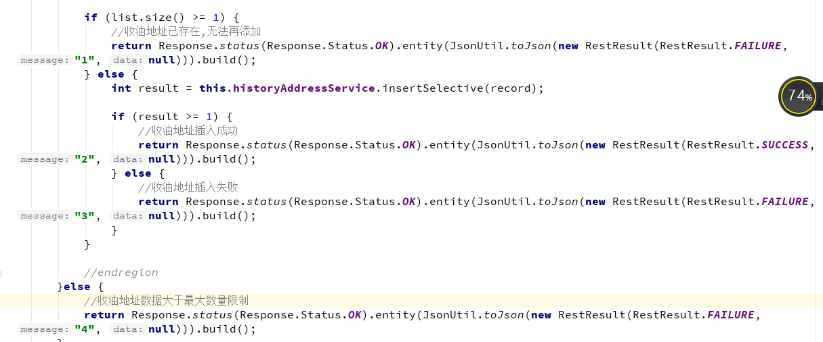

十 修改收油地址

Url http://118.178.18.0:8082/alfa-mobile-ws/rest/historyaddress

/updateHistoryAddress？mobiletoken=624f6a6708924425aa8b0c9307bcdf30

Method:post

参数：{"id": "1"，“address”：“123”}

返回值

失败

2 收油地址更新失败

成功

1 收油地址更新成功

十一 删除收油地址

Url http://118.178.18.0:8082/alfa-mobile-ws/rest/historyaddress

/deleteHistoryAddress？mobiletoken=624f6a6708924425aa8b0c9307bcdf30

Method:post

参数：{"id": "1"}

返回值

失败

2 收油地址删除失败

成功

1 收油地址删除成功

十二 分页查询收油地址

Url http://118.178.18.0:8082/alfa-mobile-ws/rest/historyaddress

/findlist？mobiletoken=624f6a6708924425aa8b0c9307bcdf30

Method:post

参数：filterscount=0&groupscount=0&pagenum=0&pagesize=10&recordstartindex=0&recordendindex=10&iphone=13062317530&addressLike=1

返回值

失败

{

"total": 0,

"rows": []

}

成功

有数据

4 添加订单

url:http://118.178.18.0:8082/alfa-mobile-ws/rest/order/insertorders?mobiletoken=624f6a6708924425aa8b0c9307bcdf30

Method:post

参数:

/**
* 产废单位用户姓名
*/
private String username;
/**
* 产废单位电话
*/
private String iphone;
/**
* 收油地址
*/
private String address;
/**
* 预收数量
*/
private String num;
/**
* 产废单位名称
*/
private String orgname;
/**
* 订单状态
*/
private String orgstatus;

/**
* 备注
*/
private String remark;

{“username”:”李四”,”iphone”:”15320295813”,”address”:”重庆市九龙坡区石桥铺渝高大厦”,”num”:”10”,”orgname”:”南华中天”,”orgstatus”:”1”,”remark”,”111111”}

附:

orgstatus 为订单状态 1:提交,2：分配，3:确认，4:完成

num 为预收数量 单位为桶

返回值:

失败:

当前用户当天的订单总数超出最大数量限制

{

"status": "failure",

"message": "3",

"data": null

}

订单插入失败

{

"status": "failure",

"message": "2,

"data": null

}

成功:

{

"status": "success",

"message": "1",

"data": null

}

6 订单确认收到:

Url:http://118.178.18.0:8082/alfa-mobile-ws/rest/order/updateorders？mobiletoken=624f6a6708924425aa8b0c9307bcdf30

Method:post

参数：{"orderid": “5”,"orgstatus":"3"}

附:Orgstatus 为订单状态 1:提交,2：分配，3:确认，4:完成

返回值:

成功:

{

"status": "success",

"message": "1",

"data": null

}

失败:

{

"status": "failure",

"message": "2",

"data": null

}

7 订单确认完成:

Url:http://118.178.18.0:8082/alfa-mobile-ws/rest/order/updateorders？mobiletoken=624f6a6708924425aa8b0c9307bcdf30

Method:post

参数：{"orderid": “5”,"orgstatus":"4",”realnum”:”123”}

附:Orgstatus 为订单状态 1:提交,2：分配，3:确认，4:完成

realnum 为实收数量，单位为桶

返回值:

成功:

{

"status": "success",

"message": "1",

"data": null

}

失败:

{

"status": "failure",

"message": "2",

"data": null

}

5,分页查询订单

url:http://118.178.18.0:8082/alfa-mobile-ws/rest/order/findlist？mobiletoken=624f6a6708924425aa8b0c9307bcdf30

Method:post

参数:

filterscount=0&groupscount=0&pagenum=0&pagesize=10&recordstartindex=0&recordendindex=10&roleId=10&phone=13062317530&iphone=13062317530&orderid=1

附：

分页条件

filterscount=0&groupscount=0&pagenum=0&pagesize=10&recordstartindex=0&recordendindex=10

角色ID

roleId=10

产废人员的电话号码

phone=13062317530&iphone=13062317530

订单ID

orderid=1

返回值:

成功：

有数据

{

"total": 4,

"rows": [

{

"id": null,

"createdDt": "2017-06-15 13:18:55",

"createdBy": "123456",

"version": 1,

"updatedDt": "2017-06-15 13:21:24",

"updatedBy": "1234",

"orderid": 8,

"username": "周6",

"iphone": "123456",

"address": "重庆市大渡口区",

"num": "111111",

"orgname": "123",

"orgstatus": "完成",

"workerid": 22,

"phone": "1234",

"realname": "王五"

},

{

"id": null,

"createdDt": "2017-06-09 09:50:45",

"createdBy": "15320295813",

"version": 1,

"updatedDt": "2017-06-09 16:22:56",

"updatedBy": "15320295813",

"orderid": 7,

"username": "周6",

"iphone": "123456",

"address": "123456",

"num": "123456",

"orgname": "123456",

"orgstatus": "分配",

"workerid": 21,

"phone": null,

"realname": null

},

{

"id": null,

"createdDt": "2017-06-08 17:06:56",

"createdBy": "15320295813",

"version": 1,

"updatedDt": "2017-06-09 15:02:29",

"updatedBy": "15320295813",

"orderid": 6,

"username": "小杨",

"iphone": "1111111111111",

"address": "1111111111111",

"num": "11111111111",

"orgname": "1111111111111111",

"orgstatus": "分配",

"workerid": 27,

"phone": "5555555555555",

"realname": "张三"

},

{

"id": null,

"createdDt": "2017-06-08 16:48:04",

"createdBy": "15320295813",

"version": 1,

"updatedDt": "2017-06-09 16:27:29",

"updatedBy": "15320295813",

"orderid": 5,

"username": "欧阳",

"iphone": "22222222222222",

"address": "222222222222",

"num": "222222222222222",

"orgname": "2222222222222222222",

"orgstatus": "分配",

"workerid": 21,

"phone": null,

"realname": null

}

]

}

没有数据

{

"total": 0,

"rows": []

}

6 新增订单评论

Url:http://118.178.18.0:8082/alfa-mobile-ws/rest/ordercomment

/batchinsertordercomment？mobiletoken=624f6a6708924425aa8b0c9307bcdf30

Method:post

参数：[{"orderId":"1","content":"123"},{"orderId":"1","content":"12333"}]

返回值：

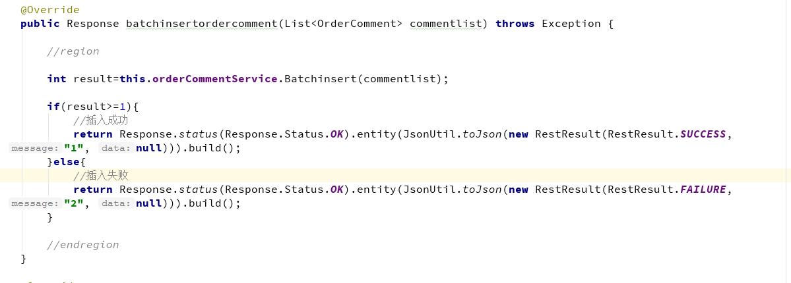

7，查询订单评论

Url:http://118.178.18.0:8082/alfa-mobile-ws/rest/ordercomment

/findlist

？mobiletoken=624f6a6708924425aa8b0c9307bcdf30

Method:post

参数:

orderId=1

返回值：
成功：有数据

失败：没有数据

查询分页消息通知

Url:http://118.178.18.0:8082/alfa-mobile-ws/rest/message/findlist

？mobiletoken=624f6a6708924425aa8b0c9307bcdf30

Method:post

参数:

filterscount=0&groupscount=0&pagenum=0&pagesize=10&recordstartindex=0&recordendindex=10&userid=10&isread=1

成功:

有数据

失败:

没有数据

消息未读变成已读

Url:http://118.178.18.0:8082/alfa-mobile-ws/rest/message/isread

？mobiletoken=624f6a6708924425aa8b0c9307bcdf30

Method:post

参数:

{“userid”:”1”,”messageid”:”1”,”isread”:”1”}

返回结果:

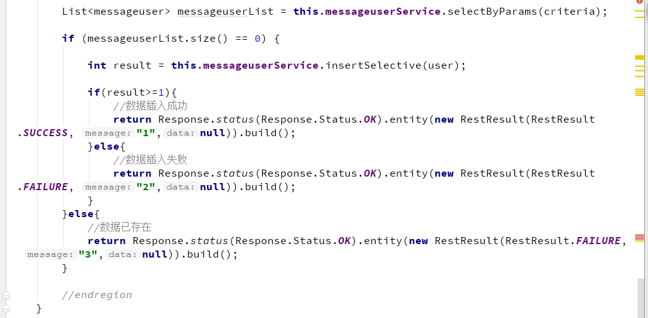

业务人员添加新用户

Url:http://118.178.18.0:8082/alfa-mobile-ws/rest/registerbehavior

/insertUser？mobiletoken=624f6a6708924425aa8b0c9307bcdf30

Method:post;

参数:

{“userid”:”1”,”realname”:”1234”,”phone”:”12345677”,”address”:”11111111”,”orgname”:”11111”,”remark”:”111111111”,”longitude”:”111”,”latitude”:”1111”}

返回值:

List<SysUsers> usersList = this.sysUsersService.selectByParams(criteria);
if (usersList.size() == 0) {
SysUsers users = new SysUsers();
users.setRealname(user.getRealname());
users.setOrgname(user.getOrgname());
users.setPhone(user.getPhone());
users.setAddress(user.getAddress());
users.setUsername(user.getPhone());
users.setRemarks(user.getRemark());
users.setPassword(WebUtil.encrypt(StringUtil.getUUID(), user.getPhone()));
users.setRoleId(10L);
users.setStatus("0");
boolean result = this.sysUsersService.insertUser(users);
if (result) {
log.info("数据添加成功!");
userregisterbehavior userregisterbehavior = new userregisterbehavior();
userregisterbehavior.setUserid(user.getUserid());
userregisterbehavior.setRegisterid(users.getUserId());
int sum = this.userregisterbehaviorService.insertSelective(userregisterbehavior);
if(sum>0){
//数据添加失败
return Response.status(Response.Status.OK).entity(JsonUtil.toJson(new RestResult(RestResult.SUCCESS, "1", null))).build();
}else{
//数据添加失败
return Response.status(Response.Status.OK).entity(JsonUtil.toJson(new RestResult(RestResult.FAILURE, "3", null))).build();
}
} else {
//数据添加失败
return Response.status(Response.Status.OK).entity(JsonUtil.toJson(new RestResult(RestResult.FAILURE, "3", null))).build();
}
} else {
//数据已存在
return Response.status(Response.Status.OK).entity(JsonUtil.toJson(new RestResult(RestResult.FAILURE, "2", null))).build();
}

业务人员查询列表

Url:http://118.178.18.0:8082/alfa-mobile-ws/rest/registerbehavior/findlist？mobiletoken=624f6a6708924425aa8b0c9307bcdf30

Method:post;

参数:

filterscount=0&groupscount=0&pagenum=0&pagesize=10&recordstartindex=0&recordendindex=10&businessphone=10&businessrealname=1

返回值:

成功：有数据

失败：没数据

图片上传

Url:http://118.178.18.0:8082/alfa-mobile-ws/rest/file/upload?mobiletoken=624f6a6708924425aa8b0c9307bcdf30

Method:post
参数：{“pathKey” : "entuser.path"}

