Time per Point in Elite Badminton: Long-Term Trend, Structural Decomposition, and a Clock-Time Profile Across Two Decades
Author information withheld for double-blind review.
Word count: 7,253 words (including tables and references, excluding supplementary material).
Abstract
Badminton time-use research relies on video-coded rally and pause times from small samples; to our knowledge, no tournament-scale measure of per-point official match-clock time exists. We introduce time per point, TPP = 60 × recorded match duration / total points, computed from published BWF results without video. The sample covers 30,059 matches with usable TPP inputs out of 30,847 elite matches: World Championships 2005–2026 and World Tour 2018–2025. The 2005 side-out year is reported separately and excluded from trend models. World Championship TPP rose from 23.7 s/point in 2006 to 33.5 in 2017 (+0.75 s/year). After 2017, no sustained increase was detected (slope −0.09 s/point/year, p = .10, seven year clusters); the post-knot slope was non-positive under every alternative break-point choice. Over 2018–2025 Tour matches lengthened by 3.37 min and TPP rose by 2.23 s/point. A point estimate assigns about nine-tenths of the increase to higher clock time per point (event-clustered 95% CI 75–117%); points per match were nearly flat. TPP is a composite clock metric that cannot separate rally from pause time, so mechanism questions require video coding. It complements video-coded time-use work with a large, reproducible sample and offers a structural profile for tournament scheduling.
Keywords: badminton; match duration; time per point; temporal analysis; world championships; match scheduling

1. Introduction
Badminton matches are getting longer. Hoffmann and Vogt (2024) reported that between 2006 and 2017 World Championships men's singles game duration rose by 54%, rally time by 62%, and pause time by 49%; Araragi (2015) found every discipline's game time rose 20–36% at Japan Open 2007–2015. In April 2026 the BWF approved a three-games-to-15 (3×15) scoring system for implementation on 4 January 2027; the alternative five-games-to-11 (5×11) format had been set aside, and trials reported favourable duration and closeness indicators for 3×15 (BWF, 2026a, 2026b, 2026c). Small-sample academic trials offer limited evidence on 11-point formats (Pugliese et al., 2015; Zhao et al., 2025).
Two gaps remain. The literature is athlete-centric, centred on how hard players work (rally time, pause time, effective playing time) rather than on the clock cost per scoreboard change at tournament scale. Dead-time's audience consequences have been documented in sport management (Meier, 1984; Liu et al., 2021) but have never been applied to badminton. Large-scale time-use evidence also mostly ends at or before 2018, so whether matches continued to lengthen is unknown at scale.
We introduce Time Per Point (TPP), defined as 60 × match duration divided by total points. TPP is computable from published BWF results (MATCH DURATION and game scores), requires no video annotation, and gives an official clock cost per scoreboard update; it does not measure how viewers respond. Using World Championships 2005–2026 (n = 4,250) and World Tour 2018–2025 (n = 26,597) datasets, we first ask how TPP has evolved at the World Championships since the 21-point reform and whether a structural break exists. We then ask how much of the 2018–2025 Tour duration increase reflects higher clock time per point versus more points per match, and how TPP varies across disciplines, event levels and rounds. The last question is whether observable video-free factors (competitive structure, rule-mandated breaks, the COVID-disrupted seasons, composition and rest intervals) explain the Tour increase, or whether it survives each exclusion. Retirements and walkovers are reported descriptively.
This paper makes four contributions: (1) it introduces TPP as a reproducible, video-free metric from published results; (2) it extends the elite badminton time-use window to 2026 on 30,847 matches; (3) it decomposes the 2018–2025 duration increase into per-point and scoring-frequency components; and (4) it provides a structural TPP profile across disciplines, levels and rounds as a scheduling reference, with non-completion rates reported separately.

2. Literature

2.1 Badminton time-use research
Phomsoupha and Laffaye's (2015) review established the notational, physiological and biomechanical profile of elite badminton. Performance analysis has converged on a three-phase decomposition of rally time (RT), pause time (PT, including rule-mandated breaks), and EPT% = RT/(RT+PT) (Abián et al., 2014; Hoffmann & Vogt, 2024), typically coding 20–60 matches from championship video. Abián et al. (2014) documented longer rallies and pauses between Beijing 2008 and London 2012; Hoffmann and Vogt (2024) extended the window to 2006–2017 World Championships men's singles (RT +62%, PT +49%; on-court pause at 11 points running 82 s against a 60 s rule), and Iizuka et al. (2020) found women's singles duration increases concentrated in the final eight rounds. Abián-Vicén et al. (2013), Gawin et al. (2015) and Hoffmann et al. (2026) documented discipline-specific temporal structures; Laffaye et al. (2015) found declining work density in men's singles Olympic finals; Gómez et al. (2019) and Torres-Luque et al. (2020) reported RT ≈ 9.1–9.9 s and EPT% ≈ 31% in Super Series and Rio 2016 play; and Winata et al. (2025), in a PRISMA review of 34 studies, estimated elite men's singles EPT% at 34.1 ± 5.3% and women's at 29.0 ± 6.6%. Samples typically number in the tens to low hundreds of matches and time windows end around 2018.
The tradition answers a training-load question rather than a broadcast-scheduling one: it cannot operate at scale, because every data point requires minutes of video coding.

2.2 From athlete time to match-clock time
Live play versus dead time has been discussed in other team sports (Meier, 1984; Wilbur, 2008; Liu et al., 2021), but we do not test audience reactions here. TPP is a clock-summation metric with potential use for on-court scheduling; its spectator and broadcast implications are left to future work.

2.3 Position of the present study
This study draws on both literatures. TPP counts every recorded second between match start and finish per scoreboard change, without attempting to separate RT from PT. Its strength is reproducibility at scale; mechanism questions are left to video-coded follow-ups, and we frame all such discussion as suggestive.

3. Materials and methods

3.1 Time Per Point (TPP)
For each completed match,
TPP = 60 T / S
where T is the BWF MATCH DURATION field in minutes and S is the sum of both players' points across all games from the published game scores, giving TPP in seconds per point (s/point). We treat MATCH DURATION as the elapsed time from the first to the final rally, including all between-rally and between-game breaks as recorded by BWF tournament software; no formal BWF definition of the field was located, so this is an operational interpretation. The field's start/stop rules may not be constant across events or software versions; cross-period comparability is an assumption, examined only indirectly and not fully verifiable with public data.
TPP is the official recorded match duration per scoreboard update, conceptually bundling rally play, retrieval, towelling, player preparation, Hawk-Eye challenges, medical time-outs and between-game breaks (Figure 1); its internal composition is not publicly specified. We do not attribute TPP changes to rally rhythm; where drivers are discussed, we cite external video evidence and limit claims to 'possible drivers'. Broadcast advertising, production and transmission occur outside the recorded match clock and do not enter TPP; links to audience response or total airtime are left to future work.
TPP is interpreted strictly as seconds per point, not seconds per rally. It is defined identically across scoring eras, but cross-era comparison carries a structural caveat: under side-out scoring (≤2005) the receiver could win a rally without winning a point, mechanically inflating TPP. We therefore report 2005 separately and exclude it from 21-point trend regressions. Chen et al. (2011) confirmed the difference experimentally (42 min/306 rallies versus 29 min/203 rallies for men's singles), and Paindaveine and Swan (2011) showed analytically that rally-count distributions differ between scoring systems. Under rally-point scoring, it aggregates the quantities the RT/PT tradition measures separately without video coding. It is a large-sample complement, not a replacement.
Data handling. Trend and stratification analyses include only completed matches; retirements and walkovers are excluded from TPP but retained for non-completion analyses. We report aggregate TPP = Σ60T/ΣS alongside the match-level mean and median, with TPP rounded to one decimal place for display only; minute-level recording bounds precision. Analyses were conducted in Python 3.13 (pandas, numpy, scipy, statsmodels, matplotlib; package versions are pinned in the replication package); all bootstrap procedures use 10,000 resamples with a fixed random seed (20261008).
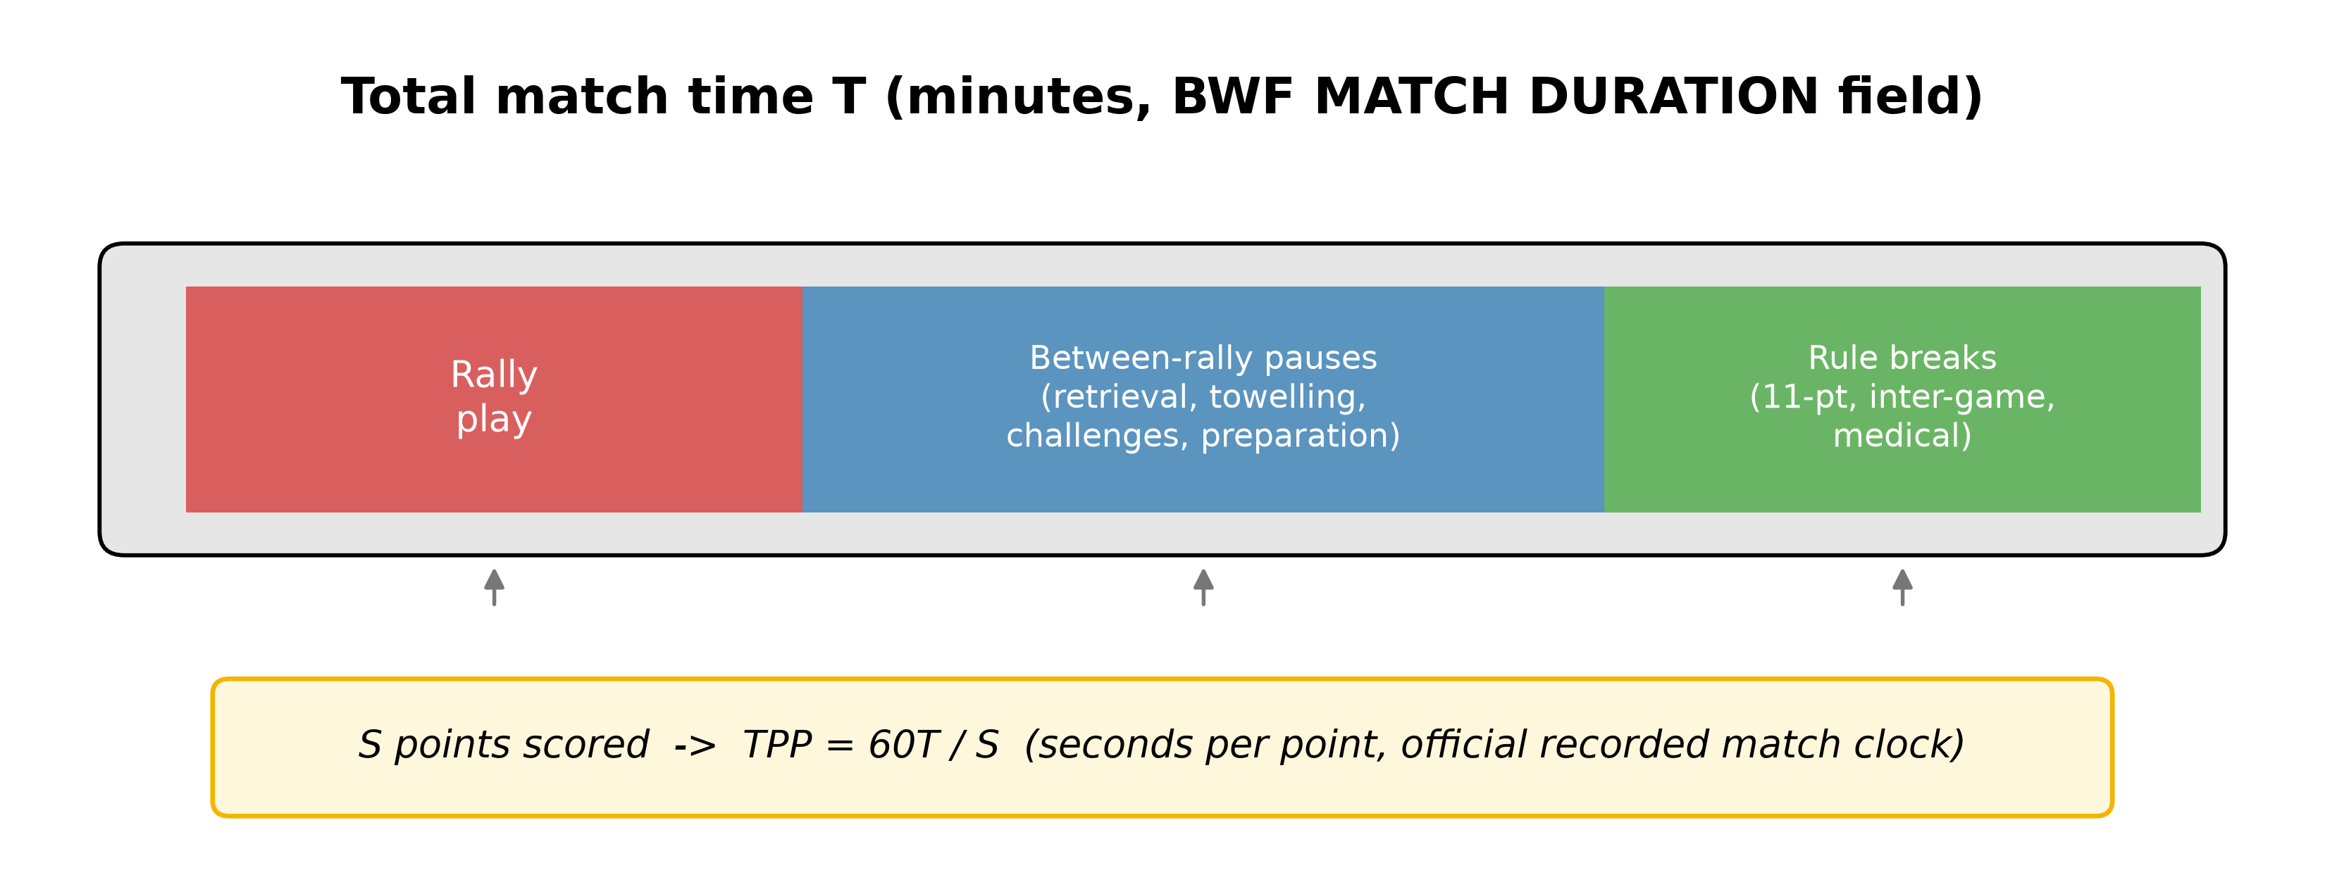
Figure 1. TPP as an official match-clock metric that bundles rally play, between-rally pauses and rule-mandated breaks. Schematic; block widths not to scale, and the components are conceptual and have not been verified against the BWF field definition.

3.2 Retirement and walkover rates
We report two non-completion rates: the in-match retirement rate (RET%, matches abandoned during play, our match-completion measure) and the pre-match walkover rate (WO%, matches not started). RET% uses completed plus retired matches as denominator, excluding walkovers; WO% uses all draw entries as denominator. All match-completion analyses use RET%; WO is reported separately and not combined with RET.

3.3 Decomposition identity
Writing T = TPP × S / 60, the change in average match duration between two years decomposes into an initial-weight identity:
ΔT = (S₀/60) ΔTPP + (TPP₀/60) ΔS + (ΔTPP · ΔS/60)
Aggregate ΣT/ΣS ensures exact accounting. We bootstrap 10,000 replicates resampling whole events within each endpoint year so matches nested within the same tournament stay together; an iid match-level bootstrap gives the same qualitative result but narrower intervals and is reported only as comparison.

3.4 Data
Dataset A: World Championships long panel. All matches at BWF World Championships 2005–2026 in the years held (n = 4,250; 4,135 completed), R64–Final for singles and R32–Final for doubles. World Championships were not held in Olympic years (2008, 2012, 2016, 2024) and were cancelled in 2020. Used for the long-run trend, slope-break test and validation against Hoffmann and Vogt (2024).
Dataset B: World Tour cross-section. All completed-draw matches at Super 300/500/750/1000 events, 2018–2025 (n = 26,597; 25,931 completed; 392 retired; 274 walkovers), R32–Final (qualifying and R64 matches excluded to keep round structure consistent across tiers). The 2020 tour was disrupted (879 completed matches versus roughly 3,900 in 2018–2019, largely behind closed doors); the annual slope is 0.298 s/year when 2020 is excluded and 0.302 when 2020–2021 are excluded, and the 2024 Olympic year (TPP = 32.5) is indistinguishable from adjacent years. Using published BWF results for large-sample analysis follows Wang (2022).
The two datasets are analysed separately (different draw sizes, player pools and annual counts). Data were downloaded on 27 September 2026, after the 2026 World Championships concluded; no interpolation is performed for missing years. MATCH DURATION was recorded for 99.98% of World Championship matches. Four completed World Championship matches with implausible durations (<10 min) and three Tour matches with missing scores or duration were excluded. TPP analysis therefore uses 30,059 matches with usable duration and total points: 4,131 World Championship matches (the 263 matches from 2005 reported separately) plus 25,928 Tour matches; the segmented regression uses n = 3,868. We do not pool the datasets. Table S3 is a data dictionary for every field; Figure S1 diagrams sample construction.

3.5 Analytical plan
For the long-run trend (Dataset A), we fit a segmented regression on completed rally-scoring matches:
TPP_ijt = α + β₁ Year_c + β₂ (Year_c × Post₂₀₁₇) + γ_j + δ_k + ε_ijt
where Year_c = Year − 2017, Post₂₀₁₇ = 1 from 2018 onward, γ_j are discipline fixed effects and δ_k round fixed effects. β₁ is the pre-2018 slope, β₂ the post-2018 slope increment, and α the 2017 baseline; the post-2017 slope β₁+β₂ refers to the segment beginning in 2018. We test (a) β₂ < 0 and (b) β₁ + β₂ = 0 (post-2018 slope indistinguishable from zero = zero slope). Standard errors are clustered by year; with only 16 rally-scoring years (seven post-2017), we also fit an annual-aggregation regression as a robustness check. Men's singles is reported separately and benchmarked against Hoffmann and Vogt (2024). Break-point sensitivity with knots placed at 2018 and 2019 is reported in Table S6.
For the decomposition (Dataset B), we decompose the 2018–2025 duration change using the identity above with bootstrap CIs, repeated within each discipline, and standardise discipline, round and event-level composition to separate within-group change from mix shifts. Decomposition uses aggregate TPP (Σ60T/ΣS), for which the identity holds exactly; the segmented regression uses per-match TPP. The two estimands differ by <1.2 s/point across years without changing conclusions.
For the structural profile (Dataset B), we tabulate aggregate and match-mean TPP by discipline, event level and round (Tables 5–6; Figure 5). Retirement and walkover rates are reported separately as non-completion characteristics (Section 4.5; Figure 6); the exploratory logistic model is confined to Supplementary Table S1.
For the robustness checks (Dataset B), we test whether observable video-free variables can explain the 2018–2025 TPP increase and summarise the checks in Table 8. The first group covers competitive structure: the three-set indicator, with deuce rate and score gap as descriptive checks. The second deducts rule-mandated breaks through net TPP, computed from rule-book allowances (240 s for two-game and 420 s for three-game matches; 120/180 s for a technical-break-only sensitivity). The third addresses the COVID-disrupted 2020–2021 seasons, and the fourth standardises discipline, round and event-level composition to 2018 weights. Rest intervals are examined only as a negative control (Supplementary Table S5), because the public calendar omits Olympic, continental, domestic-league and team events. Retired matches enter a worst-case rerun at truncated partial TPP; we also quantify the recording-change magnitude needed to alter the conclusions (stoppage-envelope and minute-shift simulations, Table S8). For singles only, we merge pre-match Elo ratings (Sun & Zhang, 2026) and refit with the absolute pre-match Elo gap as a covariate (Tables S9 and S10).

4. Results

4.1 Descriptives
Dataset A contained 4,250 matches (4,135 completed; 36 RET; 79 WO); Dataset B contained 26,597 (25,931 completed; 392 RET; 274 WO). Completed-match TPP ranged 14.8–69.7 s/point in the Tour sample; only 5 matches (0.02%) exceeded 60 s/point, and excluding them leaves the annual slope unchanged. The TPP distribution is approximately symmetric (Tour mean 31.6, median 31.2, SD 5.7; World Championships skew = 0.35), so no log transformation is needed.

4.2 Two-decade trend and slope break (World Championships)
Aggregate TPP by year is in Table 1 and Figure 2. The 2005 side-out-scoring year sits at 51.6 s/point, mechanically inflated as expected; from 2006 onward TPP rose overall from 23.7 to 33.5 by 2017, with minor year-to-year fluctuations, then oscillated around 32–34 through 2026.
Table 1. Aggregate TPP by World Championships year, 2005–2026.
Year | n | Aggregate TPP | Mean TPP | Median TPP
2005* | 263 | 51.6 | 50.5 | 50.0
2006 | 259 | 23.7 | 23.4 | 23.3
2007 | 258 | 27.3 | 26.8 | 26.5
2009 | 221 | 26.4 | 26.1 | 25.4
2010 | 238 | 29.0 | 28.6 | 28.4
2011 | 239 | 29.6 | 29.1 | 28.3
2013 | 232 | 30.4 | 29.9 | 29.6
2014 | 237 | 31.9 | 31.7 | 31.2
2015 | 235 | 31.3 | 30.9 | 30.0
2017 | 244 | 33.5 | 33.0 | 32.3
2018 | 242 | 32.3 | 31.9 | 31.2
2019 | 243 | 34.3 | 34.0 | 33.5
2021 | 216 | 33.7 | 33.2 | 32.7
2022 | 238 | 33.0 | 32.7 | 32.1
2023 | 243 | 32.9 | 32.6 | 32.1
2025 | 264 | 32.4 | 31.9 | 31.4
2026 | 259 | 32.5 | 32.1 | 30.9

Note. Completed matches with a valid duration of at least 10 min; four matches with implausible durations (<10 min) are excluded; rally-point scoring applies from 2006. *Mixed side-out scoring (15 points men, 11 points women), reported for illustration only.
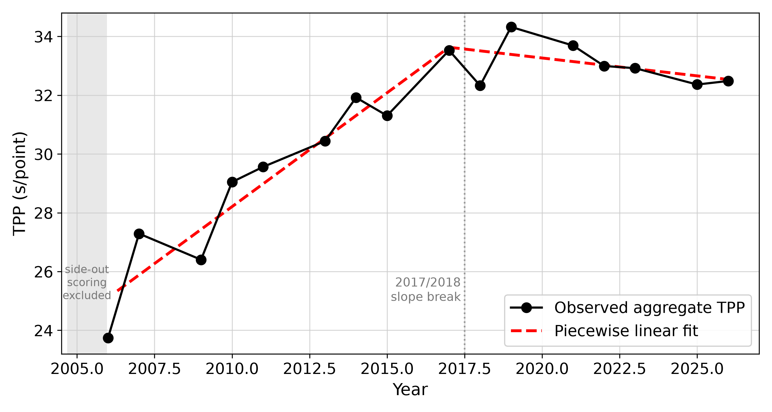
Figure 2. World Championships TPP, 2006–2026, with piecewise linear fit. The 2005 side-out year (51.6 s/point; Table 1) is excluded from the plot and the fitted trend.
The segmented regression (Table 2) gives β₁ = +0.75 s/point/year (p < .001) for 2006–2017 and β₂ = −0.84 (p < .001) for the post-2018 increment; the post-2018 total slope β₁ + β₂ = −0.09 s/year is not distinguishable from zero (p = .10), i.e. no sustained increase is detected. The Chow test rejects a single continuous slope (F(1, 3856) = 302.6, p < .001; R² = 0.476). A year-cluster bootstrap (10,000 resamples) gives a 95% CI for the post-2018 slope of [−0.23, +0.04], p = .15, with annual-aggregation estimates nearly identical. Inference is constrained by the small number of year clusters (16 years, seven in the post segment). Knots at 2018 or 2019 give post-knot slopes of −0.16 (p = .045) and −0.27 (p = .001): the post-knot slope is consistently non-positive, and negative and significant at 2018 and 2019 knots, so the conclusion is an absence of sustained increase, not a precise flat trend (Table S6). A post hoc power calculation gives a minimum detectable post-2018 slope of ≈0.26 s/year at α = .05 and 80% power (≈0.16 using match-level cluster SE), ruling out sustained increases of roughly a quarter-second and larger, but not smaller drifts.
Robustness checks (Tables S6, S11) do not change the conclusion. Excluding the 2019 peak gives a post-2018 slope of −0.006 s/year (p = .92); minute-level rounding shifts it by <0.002 s/year; an equivalence test against a ±0.3 s/year margin is passed (TOST p < .05), though this does not prove a true zero slope; starting the pre-break series in 2007, restricting to R32–Final, or excluding 2026 (n = 3,609, post slope −0.090, p = .18) leaves it unchanged. Adding a post-2017 level-shift indicator finds no significant discontinuity in the recorded-time field (level shift −1.40 min, p = .52; TPP −1.09 s/point, p = .50), so the result reflects a slope change rather than a level break.
Men's singles alone (n = 959) shows β₁ = 0.79 (p < .001) and β₂ = −0.64 (p < .001), with a post-2018 slope of +0.15 s/year (SE 0.08, p = .06), also not distinguishable from zero; the overall negative post-slope comes from the four non-MS disciplines, though neither estimate supports a discipline-specific interpretation. Because 2018 coincides with the service-height rule and World Tour reorganisation, we report a slope difference rather than a precise breakpoint; the World Championships were unaffected by the Tour reorganisation, so their trend is not mechanically driven by event-structure change.
Table 2. Segmented regression of match-level TPP (World Championships, 2006–2026, completed matches).
Term | Coefficient | Cluster SE | p
Year_c (2006–2017 slope, β₁) | 0.751 | 0.088 | <.001
Year_c × Post₂₀₁₇ (slope change, β₂) | −0.843 | 0.135 | <.001
β₁ + β₂ (post-2018 slope) | −0.092 | 0.056 | .10
Discipline FE | included
Round FE | included
Three-set (is_decider) | +2.63 | 0.16 | <.001

Note. n = 3,868; R² = 0.476. Cohen's f² for the Year_c × Post₂₀₁₇ term ≈ 0.15 (medium effect; computed from ΔR² when the interaction term is added to the fixed-effects model). 4,135 completed World Championship matches minus 263 from 2005 under side-out scoring and minus 4 with implausible recorded duration (<10 min: three at 0 min in 2011 and one at 8 min in 2013). Adding the three-set indicator leaves β₁ and β₂ essentially unchanged (0.74, −0.82). The three-set row is a separate extended model (residual df = 3,855); R², β coefficients and the Chow statistic refer to the base model. The Chow F-statistic is unadjusted for year clustering; the cluster-robust comparison is reported in the text. The year-cluster bootstrap p for the post-2018 slope is .15 (10,000 resamples, 95% CI [−0.23, +0.04]).
The 2006 men's singles aggregate TPP is 25.5 s/point (match-level mean 25.2), consistent with the 25.4 s/point back-derived from Hoffmann and Vogt's (2024) 2006 game duration and points data.

4.3 Decomposition of the 2018–2025 duration increase (World Tour)
Average completed-match duration rose from 42.5 min (2018) to 45.9 min (2025), a +3.37 min change. Aggregate tour TPP rose from 30.5 to 32.7 s/point (+2.23; annual OLS slope +0.28 s/year, Figure 3; fixed-effects 0.295; Section 4.6), with 2020 a disrupted-season outlier (n = 879). Total points per match was effectively flat (83.55 → 84.03). The decomposition (Table 3; Figure 4) assigns 92.2% of the duration increase to TPP and 7.2% to scoring frequency (interaction 0.5%); bootstrap CIs exclude zero for the TPP component only. End-of-period weights give a virtually identical share (92.5%). The event-clustered 95% CI for the TPP share is wide (75–117%), so the point estimate should be read as 'roughly nine-tenths' rather than a precise share; it is a clock-time accounting share, not a statement about rally or pause mechanism. Year-by-year inputs are in Table S4.
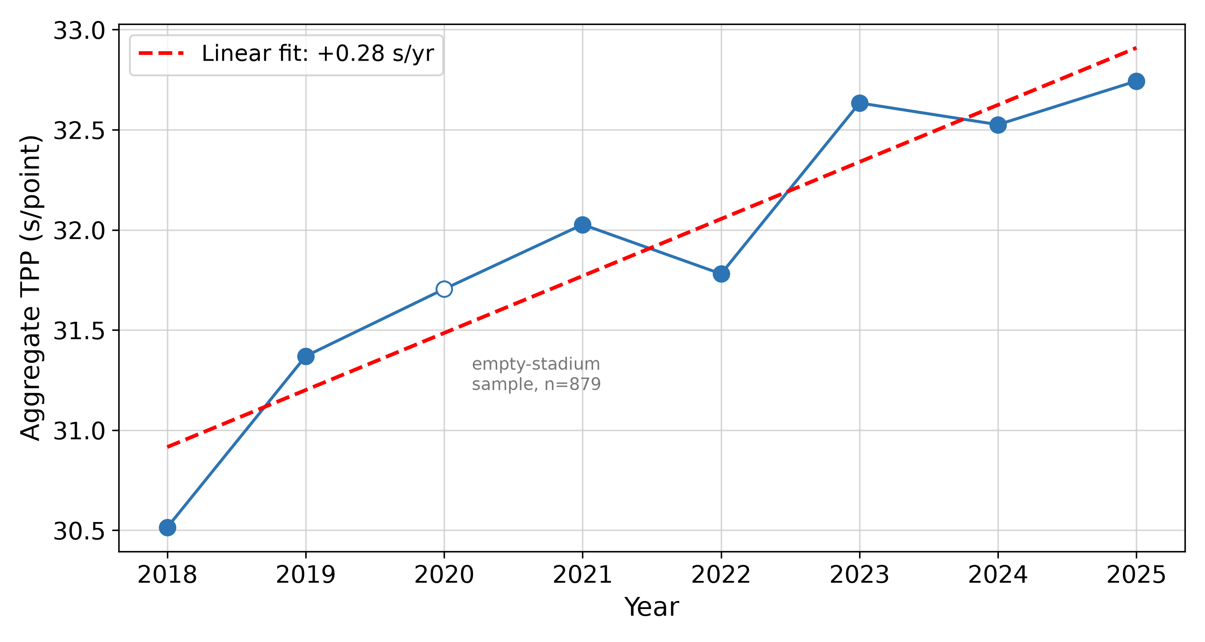
Figure 3. World Tour Super 300–1000 TPP, 2018–2025. The 2020 point (n = 879 completed matches) is a COVID-disrupted season shown with an open marker and is not interpreted as a normal season.
Table 3. Decomposition of 2018→2025 average match-duration change, World Tour completed matches.
Component | Minutes | Share | Bootstrap 95% CI
TPP component (higher time per point) | 3.10 | 92.2% | [1.82, 4.28]
Scoring-frequency component | 0.24 | 7.2% | [−0.38, 0.87]
Interaction | 0.02 | 0.5% | [−0.03, 0.07]
Total ΔT | 3.37 | 100%

Note. Components may not sum exactly to the total due to rounding. The CIs above are for the component magnitudes in minutes. The event-clustered 95% CI for the TPP share (75–117%) is obtained from the bootstrap distribution of the share itself, which is nonlinear in the components (see text); the upper bound above 100% arises when the interaction component is negative in a resample. The point estimate should be read as an approximate share rather than a precisely bounded value; it is a clock-time accounting share, not a statement about rally or pause mechanism.
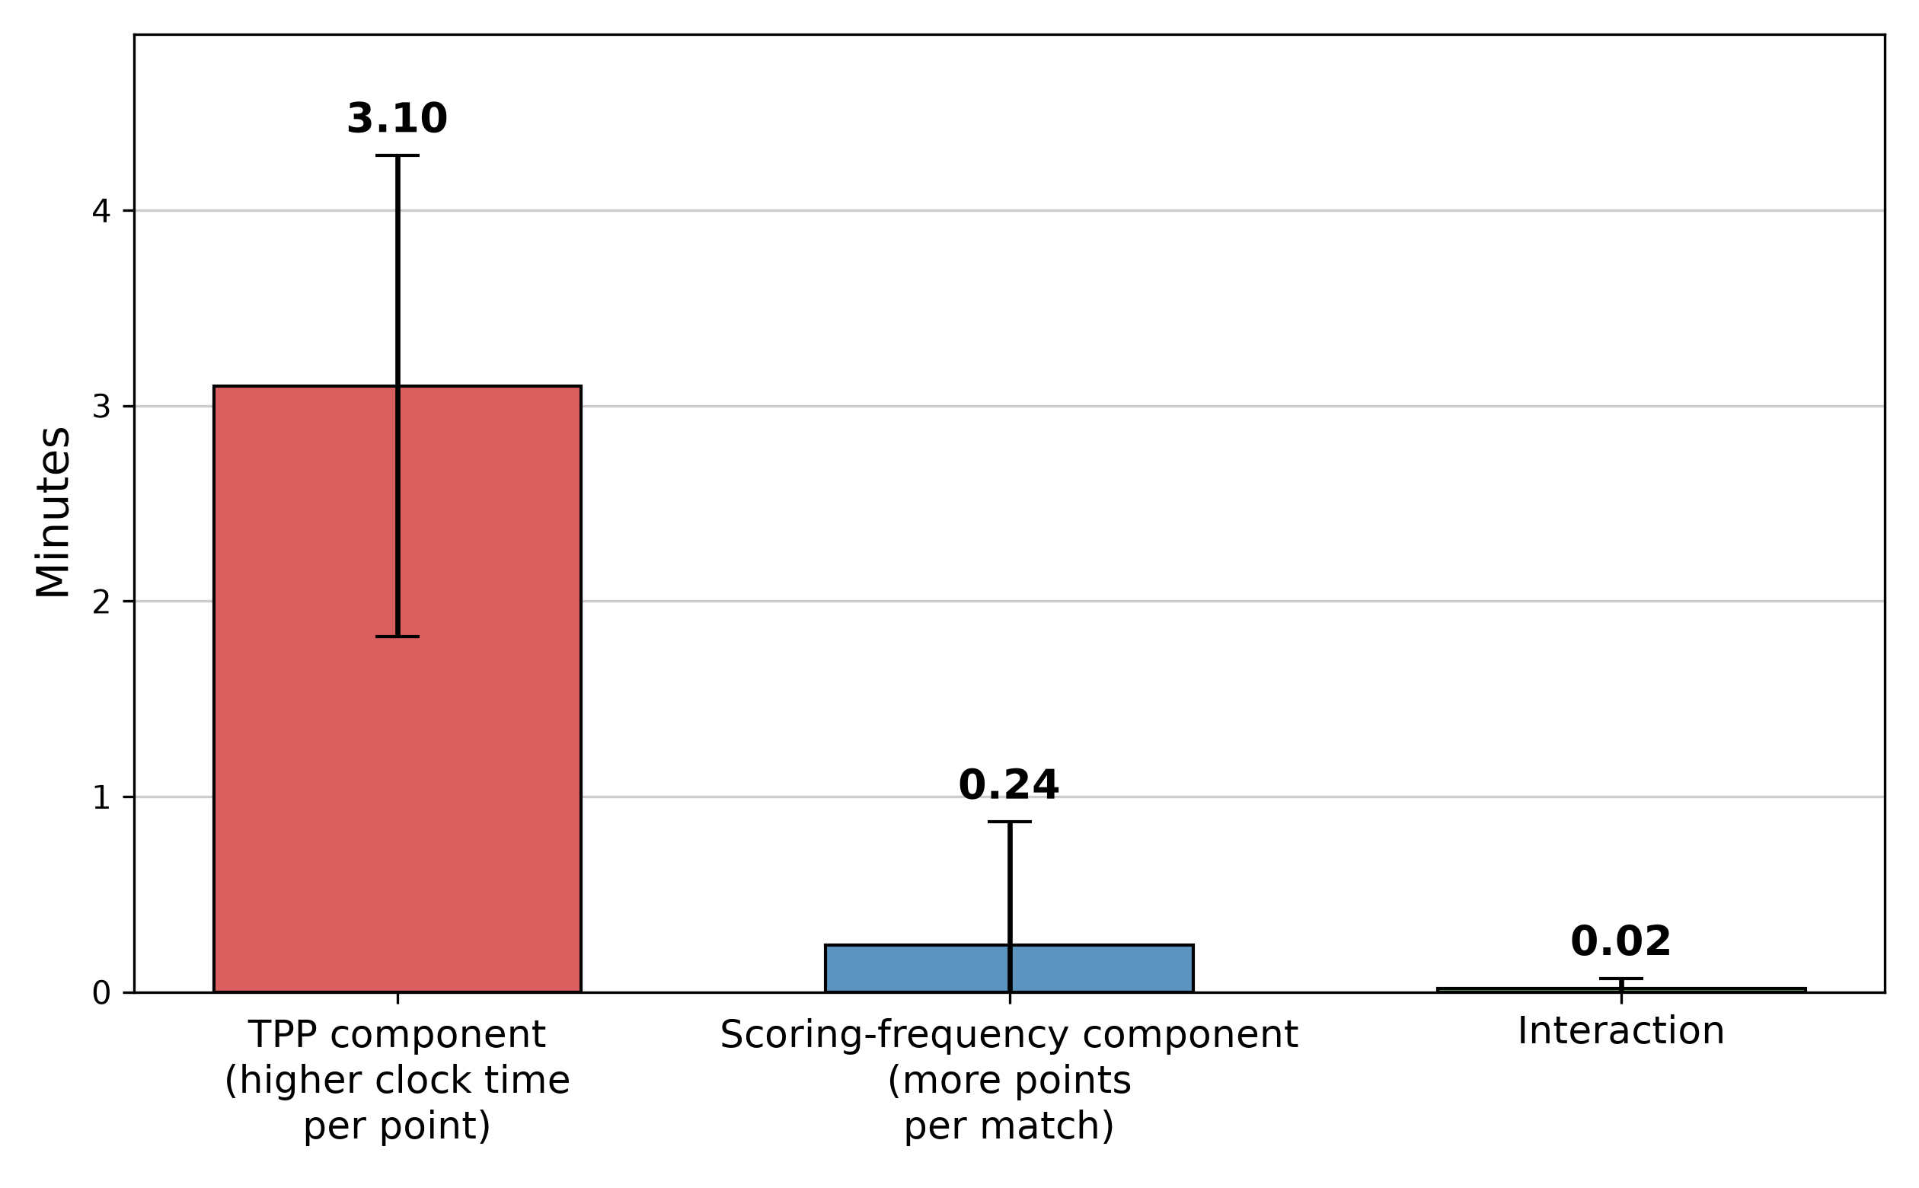
Figure 4. Decomposition of the +3.37 min increase in mean match duration, 2018→2025. Error bars show event-clustered bootstrap 95% CIs (10,000 resamples).
At fixed 2018 weights, the rise is descriptively almost entirely within group rather than a mix shift: within-discipline +2.21 s/point (mix +0.02), within-round +2.25 (mix −0.02), within-event-level +2.12 (mix +0.11; Super 1000 share 12.2%→14.0%, Super 300 41.1%→34.4%). The largest single composition term is about 0.1 s/point and the discipline and round mix terms are within ±0.02. These checks are summarised in Table 8.
Table 4. Decomposition by discipline, 2018→2025 (completed matches).
Discipline | ΔT (min) | ΔTPP (s/point) | ΔS (points) | TPP component share
Men's singles | +4.54 | +3.07 | +0.23 | 97%
Women's singles | +4.08 | +2.56 | +1.05 | 86%
Men's doubles | +2.99 | +2.01 | +0.19 | 97%
Women's doubles | +4.01 | +1.93 | +2.61 | 63%
Mixed doubles | +1.34 | +1.42 | −1.35 | 150%†
Overall | +3.37 | +2.23 | +0.48 | 92%

† TPP component share exceeds 100% because mixed-doubles points per match fell over the period, making the scoring-frequency contribution negative. Event-clustered bootstrap 95% CIs for the TPP component (min): MS [2.94, 5.85]; WS [2.22, 4.77]; MD [1.74, 4.01]; WD [0.80, 4.16]; XD [0.69, 3.28].
Table 5 disaggregates the change by event level: all four tiers rose, with the largest gains at Super 1000 (+2.9) and Super 300/500 (+2.3) and a more modest +1.1 at Super 750, whose baseline was already high (33.1 in 2018).
Table 5. Aggregate TPP by event level, 2018 vs 2025 (completed matches).
Level | 2018 TPP | 2025 TPP | Δ
Super 300 | 29.4 | 31.6 | +2.3
Super 500 | 30.3 | 32.6 | +2.3
Super 750 | 33.1 | 34.1 | +1.1
Super 1000 | 30.9 | 33.8 | +2.9

TPP component shares are 86–97% across singles and men's doubles; women's doubles is 63% (points per match +2.6, the only discipline where scoring frequency contributes meaningfully), and mixed doubles exceeds 100% because points per match fell (−1.4), coinciding with a declining three-set rate (32.5%→29.3%). The 150% figure is an arithmetic consequence of the negative scoring-frequency contribution, not an unusually strong per-point effect; the mixed-doubles decline offsets the women's-doubles gain, keeping overall ΔS at +0.5.

4.4 Structural profile of TPP across disciplines, event levels and rounds
TPP rises through the draw and differs systematically by discipline and level. Aggregate TPP increases from the round of 32 to the final within every discipline (Table 6; Figure 5): from 34.9 to 40.0 s/point in men's singles and from 27.7 to 33.4 in mixed doubles, with women's doubles finals the slowest cell at 40.8. All four Super tiers rose over 2018–2025 (Table 5): 2018 levels ranged from 29.4 (Super 300) to 33.1 (Super 750), and 2025 levels from 31.6 (Super 300) to 34.1 (Super 750). These gradients provide an empirical clock-time reference, computed from public results, for draw and session planning; non-completion rates are reported separately in Section 4.5.

4.5 In-match non-completion (descriptive)
In the World Tour sample, overall in-match retirement rate was 1.49% (retired matches as a share of completed plus retired) and pre-match walkover rate 1.03%. Retirement rate was highest in men's singles (2.24%) and women's singles (2.11%) and lowest in mixed doubles (0.78%).
Table 6. Aggregate TPP (s/point, completed matches) / in-match retirement rate (%) by discipline and round, World Tour 2018–2025.
Discipline | R32 | R16 | QF | SF | Final
Men's singles | 34.9 / 2.6 | 36.2 / 1.4 | 37.5 / 2.6 | 38.9 / 2.6 | 40.0 / 0.6
Women's singles | 30.4 / 2.2 | 31.8 / 1.7 | 33.6 / 2.0 | 35.3 / 2.9 | 36.7 / 2.3
Men's doubles | 28.5 / 1.3 | 29.6 / 0.7 | 30.8 / 0.1 | 31.6 / 0.3 | 32.4 / 1.1
Women's doubles | 31.4 / 1.6 | 33.8 / 1.3 | 36.8 / 0.9 | 39.3 / 1.4 | 40.8 / 0.6
Mixed doubles | 27.7 / 1.2 | 29.2 / 0.4 | 30.9 / 0.6 | 32.6 / 0.3 | 33.4 / 0.0

Note. Retirement rate excludes pre-match walkovers (1.03% overall). Cell n: R32 ≈ 2,800, R16 ≈ 1,400, QF ≈ 700, SF ≈ 350, Final ≈ 175 per discipline.
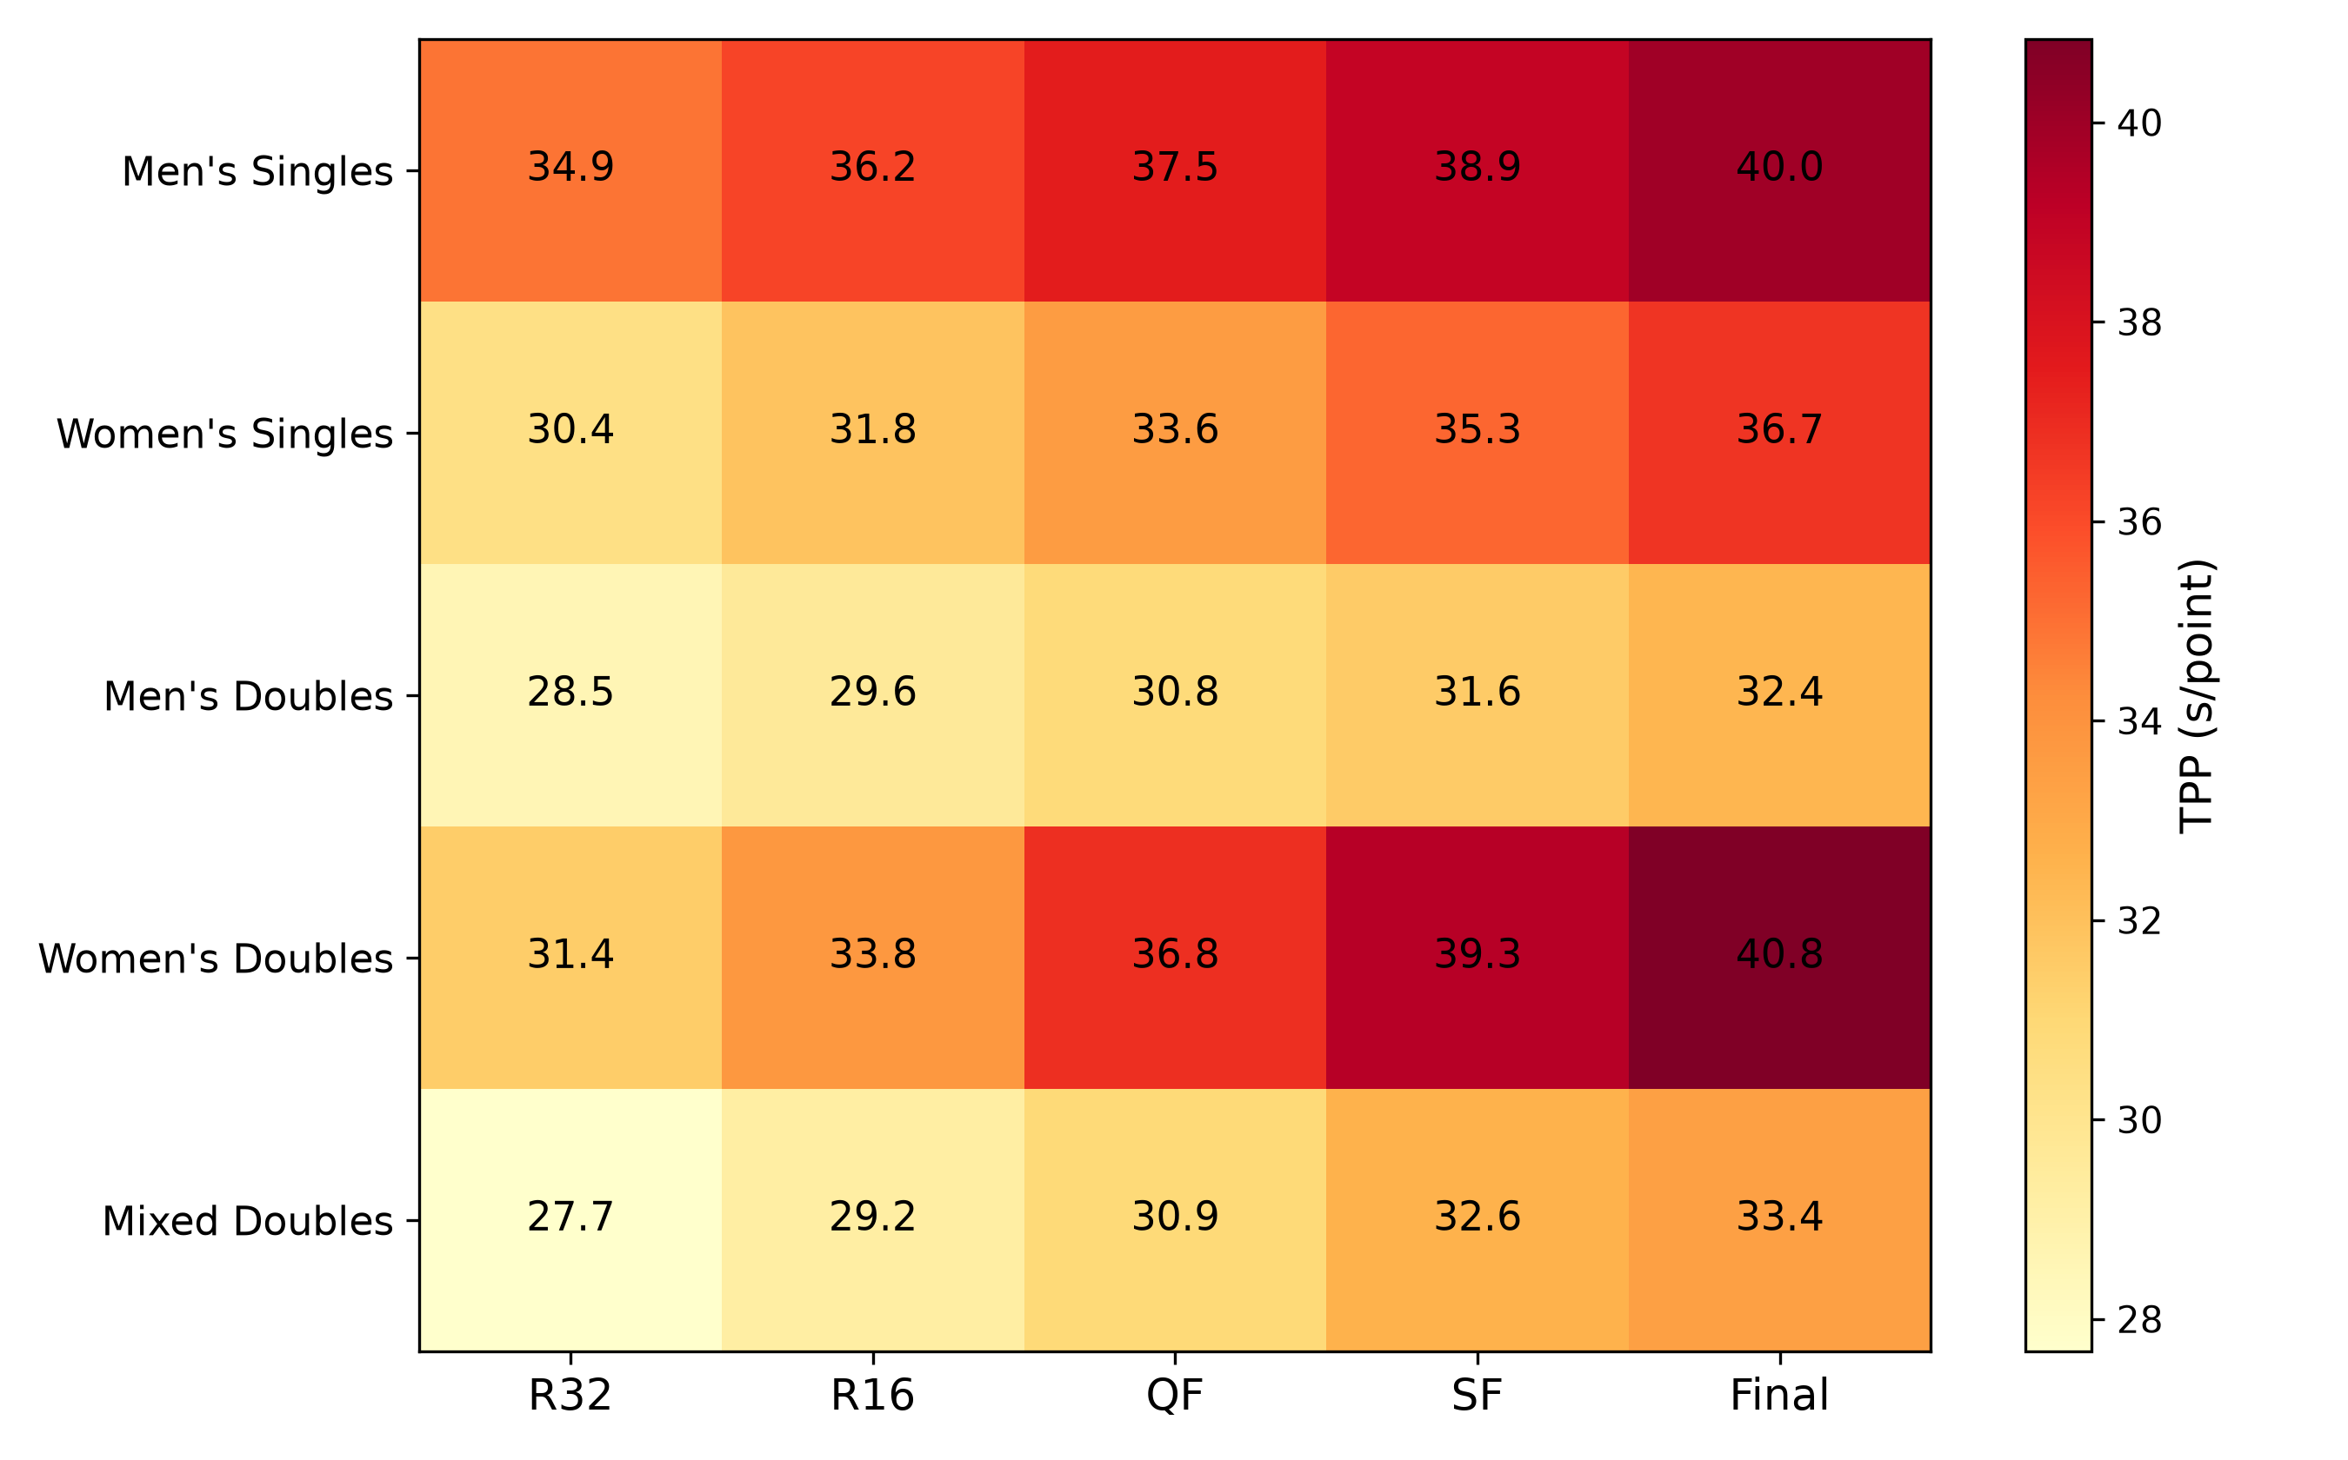
Figure 5. Mean TPP heatmap by discipline and round, World Tour 2018–2025 (completed matches).
The highest retirement-rate cells are women's singles SF (2.9%) and men's singles QF/SF (2.6%), though absolute rates stay below 3%. Across the 25 cells, TPP and retirement are weakly associated (Spearman ρ = 0.30; descriptive only), and retirement rates do not decline monotonically with round. A truncated-partial-TPP logistic specification (Table S1) is biased and not used; including all 392 retirements at partial TPP changes the Tour slope only from 0.295 to 0.297 (Table S7), so exclusion does not drive the trend. No cell has fewer than 100 matches (cell n in the note to Table 6). The higher baseline TPP at Super 750 relative to Super 1000 likely reflects event-specific factors rather than a quality gradient.
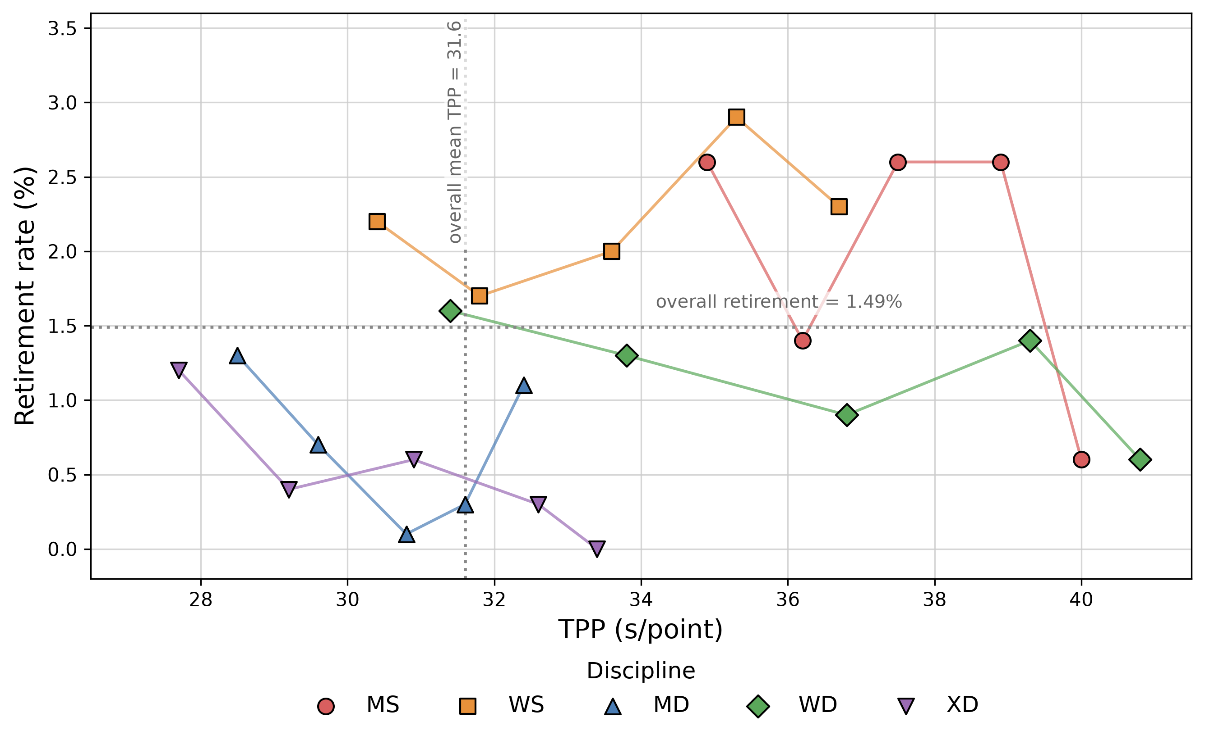
Figure 6. TPP × in-match retirement rate by discipline and round. Lines connect rounds within each discipline; they are not regression fits. Dotted reference lines mark the Tour overall means (TPP = 31.6 s/point; retirement = 1.49%). Point size is not proportional to cell n.

4.6 Robustness checks for the Tour increase
The three-set rate changed little over the window (31.9%→32.8%). Three-set matches carry +2.85 s/point on Tour (SE 0.07, p < .001; cf. +2.63 in Dataset A), of which only about 0.4 s/point reflects rule-mandated breaks (3.80 vs 3.38 s/point at mean points); the 0.9 percentage-point rise contributes only ≈0.02 s/point (about 1%) to the trend, and the year coefficient changes from 0.295 to 0.294 after adding the three-set indicator. Discipline- and round-adjusted slopes are 0.295 with all years, 0.298 excluding 2020 and 0.302 excluding 2020–2021, so the COVID-disrupted seasons do not drive the trend. Deuce rate (18.7%→20.1%) and mean per-game score gap (6.4→6.3 points) were also stable.
Deducting the rule-book allowances (BWF, 2024) leaves the trend unchanged. Raw, net-full and net-technical TPP all rise +2.23 s/point (Table 7), because the raw–net gap is stable across years (3.56 s/point in both 2018 and 2025) and the three-game share was essentially unchanged. Net TPP deducts rule-book allowances, not observed overages; any trend in overages remains inside raw TPP and cannot be separated without video.
Table 7. Raw and net TPP (s/point) on the World Tour, 2018 and 2025.
Year | Raw TPP | Net-full TPP | Net-technical TPP
2018 | 30.514 | 26.955 | 28.849
2025 | 32.743 | 29.183 | 31.081
Δ 2018→2025 | +2.23 | +2.23 | +2.23
Note. Values in s/point; net-full deducts inter-game and 11-point breaks, net-technical only 11-point breaks. Levels are shown to three decimals so that the differenced Δ matches the +2.23 s/point text. Net TPP deducts rule-book allowances, not observed overages; any trend in overages would remain inside raw TPP and cannot be separated without video.
Rest intervals do not explain the rise. A player-match negative-control panel (Supplementary Table S5; 47,428 observations) gives a coefficient of −0.0014 s/point/day (event-clustered SE 0.0005, p = .003): statistically detectable but substantively negligible (one extra week of rest ≈ −0.01 s/point, two orders of magnitude below the +2.23 trend), with a direction that does not support insufficient-rest-driven lengthening. Because the public calendar omits Olympic, continental, domestic-league and team events, this is a negative control, not a complete rest model.
Controlling for pre-match player strength also leaves the slope unchanged. We linked the Elo ratings of Sun and Zhang (2026) to 10,484/10,484 World Tour singles and 1,610/1,613 World Championships singles through 2025 (2026 is unlinkable; Table S9). Adding the absolute pre-match Elo gap per 100 points leaves the World Championships post-2018 slope at 0.04 s/year (p = .56; singles baseline 0.02) and the World Tour slope at 0.38 (baseline 0.38); larger Elo gaps are associated with shorter matches (−0.43 s/point per 100 points in the World Championships and −0.31 on the World Tour, both p < .001). Three-set, COVID-year and cold-start (2011-onward) variants give the same conclusion (Table S10); the check is restricted to singles because the external ratings are singles-only. Minimum-duration thresholds barely change the sample and leave slopes unchanged (Table S10). The singles-only estimates are not directly comparable with the all-discipline figures (Table 2 post-2018 slope −0.09; Section 4.3 Tour slope 0.295): singles events show steeper per-discipline TPP trends (Table 4), and the Table S10 models use the singles subsample only; the Elo-adjusted estimates are unchanged within each subsample.
For unobserved clock additions to account for the entire +2.23 s/point rise, they would have to add ≈26.7 s of recorded time per match per year, or ≈3.1 min cumulatively by 2025. That is roughly 19 extra Hawk-Eye-scale reviews, 6 extended towel/ball-change episodes or 3 medical time-outs per match, which is implausible relative to challenge limits. A uniform ±1–3 min mis-recording after 2018 changes only the level (slopes 0.295–0.296; −0.09); only a gradual 0→3 min ramp over 2018–2025 would move the slopes materially (to 0.62/−0.03 or +0.22/−0.41), so a large monotonic multi-year change would be needed (Table S8). A P1/P99 winsorization leaves the slopes unchanged (Table S11), and the main analysis retains the full sample. Refitting the same fixed-effects specification on unchanged-rules post-COVID windows leaves the rise positive and significant (2021–2025: 0.231 s/year, p = .003; 2022–2025: 0.278, p = .013; Table S12).
Table 8. Summary of robustness checks for the 2018–2025 World Tour TPP increase.
Analysis check | Estimate | Reading
Raw annual slope, discipline + round fixed effects (s/point/year) | 0.295 | Baseline 2018–2025 trend
+ three-set indicator | 0.294 | Three-set structure ≈ 1% of trend
excluding 2020 / excluding 2020–2021 | 0.298 / 0.302 | COVID seasons do not drive the slope
Raw 2018 → 2025 aggregate ΔTPP (s/point) | +2.23 | Total rise
net of rule breaks (net-full / net-technical) | +2.23 / +2.23 | Mandated breaks cancel in the difference
composition standardised to 2018 weights: discipline / round / level | +2.21 / +2.25 / +2.12 | Mix terms +0.02 / −0.02 / +0.11
rest interval, per additional week of rest | ≈ −0.01 | Negative control (Table S5)
singles slope with pre-match Elo gap control (Tour / WC post-2018) | 0.379 / 0.039 | Player-strength matchups do not drive the trend (Table S10; singles only)
Residual per-point clock time after the tested checks | ≈ +2.2 (the full rise) | The full rise remains; separating rally from pause time requires video coding
Note. Summary of Sections 4.3 and 4.6. The rows are separate robustness checks, not additive components; the table is a synthesis, not a statistically estimated residual decomposition. All values reproduce from the code package (Table7_attribution_ledger.csv).

5. Discussion

5.1 What the trend says
The main finding is that elite badminton's post-reform lengthening was concentrated in 2006–2017 and is statistically indistinguishable from zero in World Championship play after 2018 (slope −0.09, p = .10; seven clusters), while World Tour matches continued to lengthen. The post-knot slope is consistently non-positive across break-point choices (Table S6); we claim absence of a sustained increase, not that a flat level has been reached. Araragi's (2015) projection of continued growth was not borne out after 2018. The result survives discipline and round fixed effects, three-set controls and net-of-break recalculation.
The 2018 service-height rule primarily standardised serving technique; any effect on duration is untested here. The post-2018 pattern could reflect tactical or physical stabilisation, but it is not identified in these data. The residual Tour rise is unidentified at the match-clock level: it may reflect rally or pause time, Hawk-Eye, medical time-outs or towelling/shuttle changes, all bundled into TPP and inseparable without video. The decomposition assigns the bulk of the 2018–2025 Tour lengthening to per-point time (event-clustered 95% CI 75–117%), consistent in direction with Hoffmann and Vogt's (2024) video-coded 2006–2017 result. Points per match was nearly flat at ≈84, aggregating a 2.6-point rise in women's doubles with a 1.4-point fall in mixed doubles (Table 4).
The Tour rose (+2.2 s/point) from a lower baseline (30.5 vs 32.3 in 2018) while the World Championships did not; by 2025 the descriptive levels are 32.7 vs 32.4, but the samples are not pooled and we do not interpret this as convergence. A global recording change would affect both datasets simultaneously, which argues against a single global artifact, though tournament-level software settings cannot be excluded. Aggregate TPP rose roughly 37% from 23.7 in 2006 to 32.5 in 2026; because TPP excludes broadcast advertising and production breaks, this is a competition-clock rise, not a rise in total viewer airtime.
Three findings extend the RT/PT tradition beyond Hoffmann and Vogt (2024). The dataset spans 30,847 matches across all disciplines and two decades, and shows no sustained increase after 2017, where their men's-singles 2006–2017 window ended. The decomposition carries a conditional implication for the approved 3×15 reform: because the bulk of the Tour lengthening is per-point, the new format would be expected to change total scheduling time mainly through the number and structure of points rather than per-point clock time. Neither 3×15 nor the set-aside 5×11 is tested here; the 4 January 2027 implementation is a natural experiment for future data. The existing small-sample 5×11 and junior 11-point trials (Pugliese et al., 2015; Zhao et al., 2025) are suggestive but do not establish effects for elite adults. There is also heterogeneity: women's doubles gained points while mixed doubles lost them, and Super 750 rose half as fast as Super 1000, so a single reform would have different implications across disciplines and tiers.

5.2 Why TPP is a composite clock metric, not a rally-time decomposition
We deliberately stop short of claiming longer rallies. Hoffmann and Vogt (2024) showed both RT and PT rose in 2006–2017 men's singles; TPP cannot separate the two, and the post-2017 absence of a sustained increase is compatible with RT stabilising, PT falling, or both; these mechanisms belong to video-coded follow-up. TPP's contribution is standardised comparison at scale: it quantifies clock time per point across the full elite tour and shows that no sustained increase is detectable at World Championship level after 2017, without identifying whether rally or pause time drives the trend.
Because TPP = 60T/S, TPP and the number of points are not independent quantities: the decomposition is an algebraic rearrangement of this identity, not an independent estimate of mechanism.
This pattern is consistent with Iizuka et al. (2020), who noted a large duration increase in late-round women's singles; our TPP matrix quantifies that gradient across all disciplines.
The discipline × round profile pairs clock-time with non-completion risk. Women's doubles later rounds are the slowest cells (up to 40.8 s/point) at low non-completion risk; men's singles QF/SF combine 37.5–38.9 s/point with a 2.6% retirement rate. Men's singles TPP exceeds women's by roughly 4 s/point, and the men's singles final costs 40.0 s/point at a low retirement rate (~0.6%, n≈175). Whether these gaps reflect longer rallies, longer pauses or shuttle changes cannot be separated without video.

5.3 Limitations
Several data limitations apply. MATCH DURATION is recorded to the minute (rounding bound ≈ ±0.36 s/point at 84 points) and we take the field as given rather than re-deriving on-court time. Excluding retirement and walkover matches may introduce selection bias. The public calendar omits Olympic, continental, domestic-league and team events, so the rest-interval variable is a negative control, not a true rest measure. The sample covers elite World Tour and World Championship matches only, not junior, challenge, continental team or domestic-league events.
On the methodological side, TPP cannot isolate rally from pause time, and we found no formal BWF definition of MATCH DURATION. A post-2017 level-shift test found no discontinuity, but a gradual internal definition or software change cannot be excluded with public data and would be indistinguishable from a genuine per-point increase. Hawk-Eye, medical time-outs, towelling/ball-change frequency and let rallies are bundled into TPP. RT + PT + rule breaks equivalence is cross-checked at only two men's-singles anchors (Table S2). The public results platform has no field-level version history, so a direct software audit was not possible; we rely on indirect checks (cross-dataset divergence, Table S8 and Table S12).
On inference, the 2018 service-height rule and World Tour reorganisation coincide, so we report a slope difference, not a breakpoint. The post-2017 World Championship panel spans seven years, so inference is cautious and dataset-specific. Tournament identity, draw size and spectator presence are not controlled. Singles Elo controls leave slopes unchanged (Sun & Zhang, 2026), but no equivalent control exists for doubles, and early Elo years are cold-start sensitive (Table S10).

5.4 Future work
Four questions follow. Video-coded RT/PT on 2018–2026 World Championships men's singles would identify whether the pattern reflects RT or PT. Linking TPP to broadcast audience data would test whether per-point cost predicts audience retention. The women's-doubles rise in points per match warrants separate analysis of game scores and deuce frequency. The 3×15 system from 4 January 2027 should also be evaluated as a natural experiment (Section 5.1), by repeating the TPP decomposition and Elo-controlled singles models pre/post.

5.5 Summary
Across 30,847 elite matches (30,059 with usable TPP inputs), TPP shows a 2006–2017 rise in official recorded match time per scoreboard change, followed by no detectable sustained increase in World Championship play after 2017 (Table S6); World Tour TPP continued to rise over a seven-year window. The Tour rise is almost entirely a per-point clock-time increase (point estimate about nine-tenths of the total; event-clustered 95% CI 75–117%) rather than an identified rally/pause mechanism, and it is not attenuated by three-set rate or rule-mandated breaks. TPP complements RT/PT coding with a large, reproducible sample and offers a structural profile across disciplines, levels and rounds for tournament scheduling, pending audience-data validation and video-coded mechanism follow-up.
Disclosure statement
The authors report there are no competing interests to declare.
Author contributions
Author 1: Conceptualization, Methodology, Software, Data curation, Formal analysis, Writing – original draft; Author 2: Conceptualization, Supervision, Validation, Writing – review & editing. All authors have read and approved the final version of the manuscript.
Data availability
All match data are drawn from public BWF tournament results (tournamentsoftware.com / bwfbadminton.com). The external pre-match Elo ratings are from Sun and Zhang (2026), Harvard Dataverse (https://doi.org/10.7910/DVN/RSAYV5), released under CC BY 4.0; Elo ratings are the data authors' model estimates, not BWF official statistics. Analysis code, the derived BWF dataset and the Elo merge audit are available at a public repository (https://github.com/fuyiguiqulaibadminton/tpp-badminton-replication) during review; a persistent archive DOI will be provided at the revision/acceptance stage.
Ethics
This study uses public event records and involves no human participants, interventions, or private identifiable information; ethics approval was not required.
Generative AI use
The authors used Doubao AI assistant to assist with language editing and formatting of the manuscript. After using this tool, the authors reviewed and edited the content as needed and take full responsibility for the content of the publication.

References
Abián, P., Castanedo, A., Feng, X. Q., Sampedro, J., & Abián-Vicén, J. (2014). Notational comparison of men's singles badminton matches between Olympic Games in Beijing and London. International Journal of Performance Analysis in Sport, 14(1), 42–53. https://doi.org/10.1080/24748668.2014.11868701
Abián-Vicén, J., Castanedo, A., Abián, P., & Sampedro, J. (2013). Temporal and notational comparison of badminton matches between men's singles and women's singles. International Journal of Performance Analysis in Sport, 13(2), 310–320. https://doi.org/10.1080/24748668.2013.11868650
Araragi, K. (2015). A study on match time in badminton: Trends after the shift to rally point scoring [in Japanese]. Bulletin of Tokai Gakuin University, 1, 63–68.
Badminton World Federation. (2024). Laws of badminton (Section 4.4: Service court; Section 6: Service). https://corporate.bwfbadminton.com/documents/laws-of-badminton/
Badminton World Federation. (2026a). BWF members approve 3×15 scoring system. https://bwfbadminton.com/news-single/2026/04/25/bwf-members-approve-3x15-scoring-system/
Badminton World Federation. (2026b). What you need to know about the 3×15 scoring system proposal. https://bwfbadminton.com/news-single/2026/04/06/what-you-need-to-know-about-the-3x15-scoring-system-proposal
Badminton World Federation. (2026c). Key changes under the 3×15 scoring system. https://bwfbadminton.com/news-single/2026/04/26/key-changes-under-the-3x15-scoring-system/
Chen, H.-L., Wu, C.-J., & Chen, T.-C. (2011). Physiological and notational comparison of new and old scoring systems of singles matches in men's badminton. Asian Journal of Physical Education & Recreation, 17(1), 6–17. https://doi.org/10.24112/ajper.171882
Gawin, W., Beyer, C., & Seidler, M. (2015). A competition analysis of the single and double disciplines in world-class badminton. International Journal of Performance Analysis in Sport, 15(3), 997–1006. https://doi.org/10.1080/24748668.2015.11868846
Gómez, M.-Á., Rivas, F., Connor, J. D., & Leicht, A. S. (2019). Performance differences of temporal parameters and point outcome between elite men's and women's badminton players according to match-related contexts. International Journal of Environmental Research and Public Health, 16(21), 4057. https://doi.org/10.3390/ijerph16214057
Hoffmann, D., Brinkschulte, M., & Vogt, T. (2026). Match characteristics of women's and men's singles and doubles events in elite badminton. International Journal of Performance Analysis in Sport, 26(1), 1–18. https://doi.org/10.1080/24748668.2024.2386830
Hoffmann, D., & Vogt, T. (2024). Does a decade of the rally-point scoring system impact the characteristics of elite badminton matches? International Journal of Performance Analysis in Sport, 24(2), 105–118. https://doi.org/10.1080/24748668.2023.2272121
Iizuka, T., Hirano, K., Atomi, T., Shimizu, M., & Atomi, Y. (2020). Changes in duration and intensity of the world's top-level badminton matches: A consideration of the increased acute injuries among elite women's singles players. Sports, 8(2), 19. https://doi.org/10.3390/sports8020019
Laffaye, G., Phomsoupha, M., & Dor, F. (2015). Changes in the game characteristics of a badminton match: A longitudinal study through the Olympic Games finals analysis in men's singles. Journal of Sports Science and Medicine, 14(3), 584–590. https://www.jssm.org/hf.php?id=jssm-14-584.xml
Liu, X., Shum, M., & Uetake, K. (2021). Passive and active attention to baseball telecasts: Implications for content (re-)design (SSRN Working Paper No. 3717894). SSRN. https://doi.org/10.2139/ssrn.3717894
Meier, K. V. (1984). Much ado about nothing: The television broadcast packaging of team sport championship games. Sociology of Sport Journal, 1(3), 263–279.
Paindaveine, D., & Swan, Y. (2011). A stochastic analysis of some two-person sports. Studies in Applied Mathematics, 127(3), 221–249. https://doi.org/10.1111/j.1467-9590.2011.00517.x
Phomsoupha, M., & Laffaye, G. (2015). The science of badminton: Game characteristics, anthropometry, physiology, visual fitness and biomechanics. Sports Medicine, 45(4), 473–495. https://doi.org/10.1007/s40279-014-0287-2
Pugliese, L., Limonta, E., Rampichini, S., Venturelli, M., Cè, E., Gianfelici, A., La Torre, A., & Esposito, F. (2015). Temporal analysis of men's singles badminton matches played under different scoring systems. Sport Sciences for Health, 11(Suppl 1), S45.
Sun, M., & Zhang, F. (2026). A relational dataset of international badminton singles matches with ranking and Elo measures, 2006–2025. Scientific Data. https://doi.org/10.1038/s41597-026-08408-4. Dataset: Harvard Dataverse, https://doi.org/10.7910/DVN/RSAYV5 (CC BY 4.0).
Torres-Luque, G., Blanca-Torres, J. C., Cabello-Manrique, D., & Kondric, M. (2020). Statistical comparison of singles badminton matches at the London 2012 and Rio de Janeiro 2016 Olympic Games. Journal of Human Kinetics, 75, 177–184. https://doi.org/10.2478/hukin-2020-0046
Wang, C.-C. (2022). A binary-entropy analysis of the relationship between scoring structure and match outcome in badminton. Frontiers in Psychology, 13, 799293. https://doi.org/10.3389/fpsyg.2022.799293
Wilbur, K. C. (2008). A two-sided, empirical model of television advertising and viewing markets. Marketing Science, 27(3), 356–378. https://doi.org/10.1287/mksc.1070.0303
Winata, I. G. D., Brochhagen, J. M., Apriantono, T., & Hoppe, M. W. (2025). Match-play data according to playing categories in badminton: A systematic review. Frontiers in Sports and Active Living, 7, 1466778. https://doi.org/10.3389/fspor.2025.1466778
Zhao, Y., Zhu, A., Zhang, S., & Zhang, Y. (2025). Comparison of the temporal and technical-tactical characteristics in badminton men's singles under different competition formats. Frontiers in Psychology, 16, 1634776. https://doi.org/10.3389/fpsyg.2025.1634776

