COMP4418, 2018–Assignment 1

**Student ID: Z5097690 Name: Baixiang Guan**

**Question 1.**

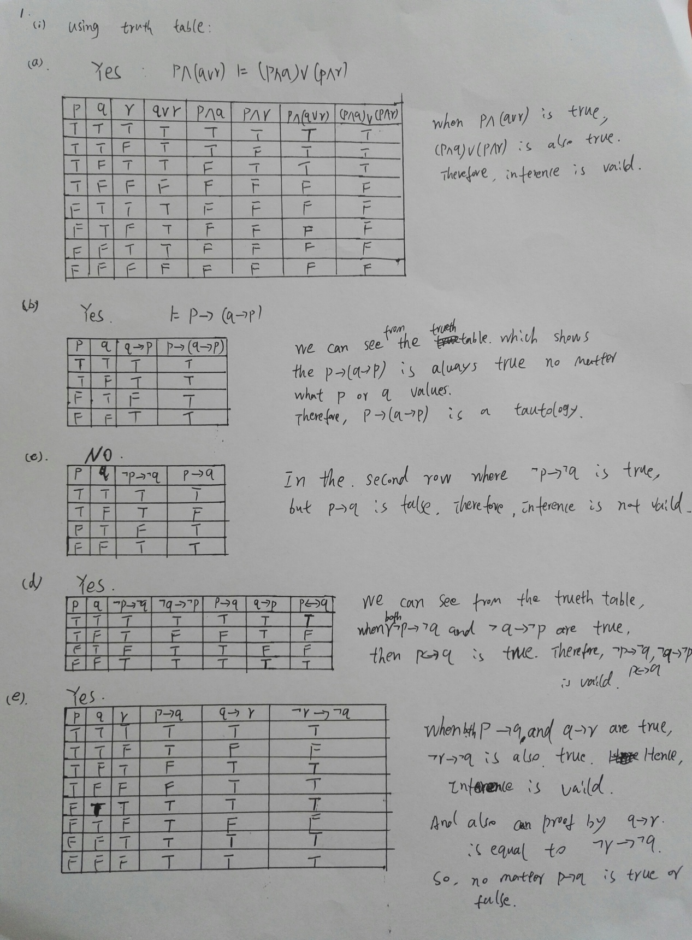

(ii) Resolution

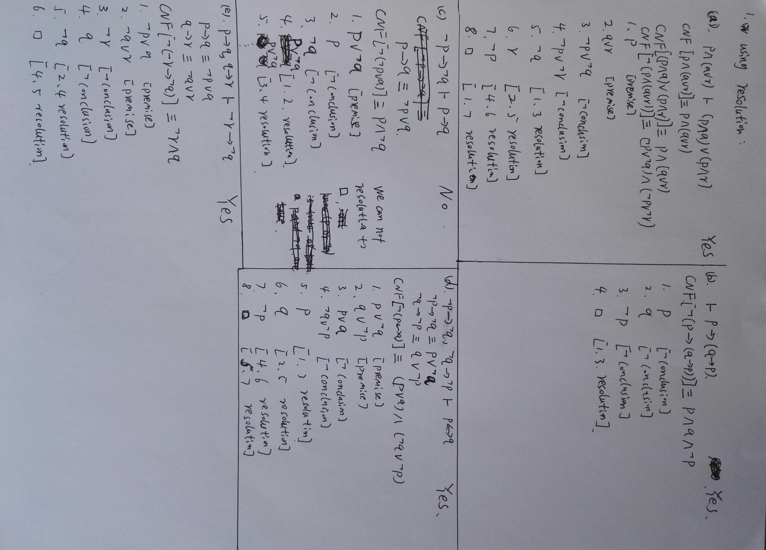

**Question 2.**

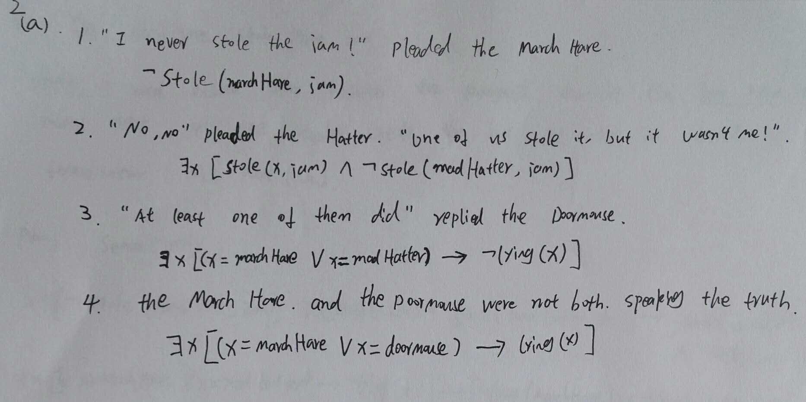

2(b):

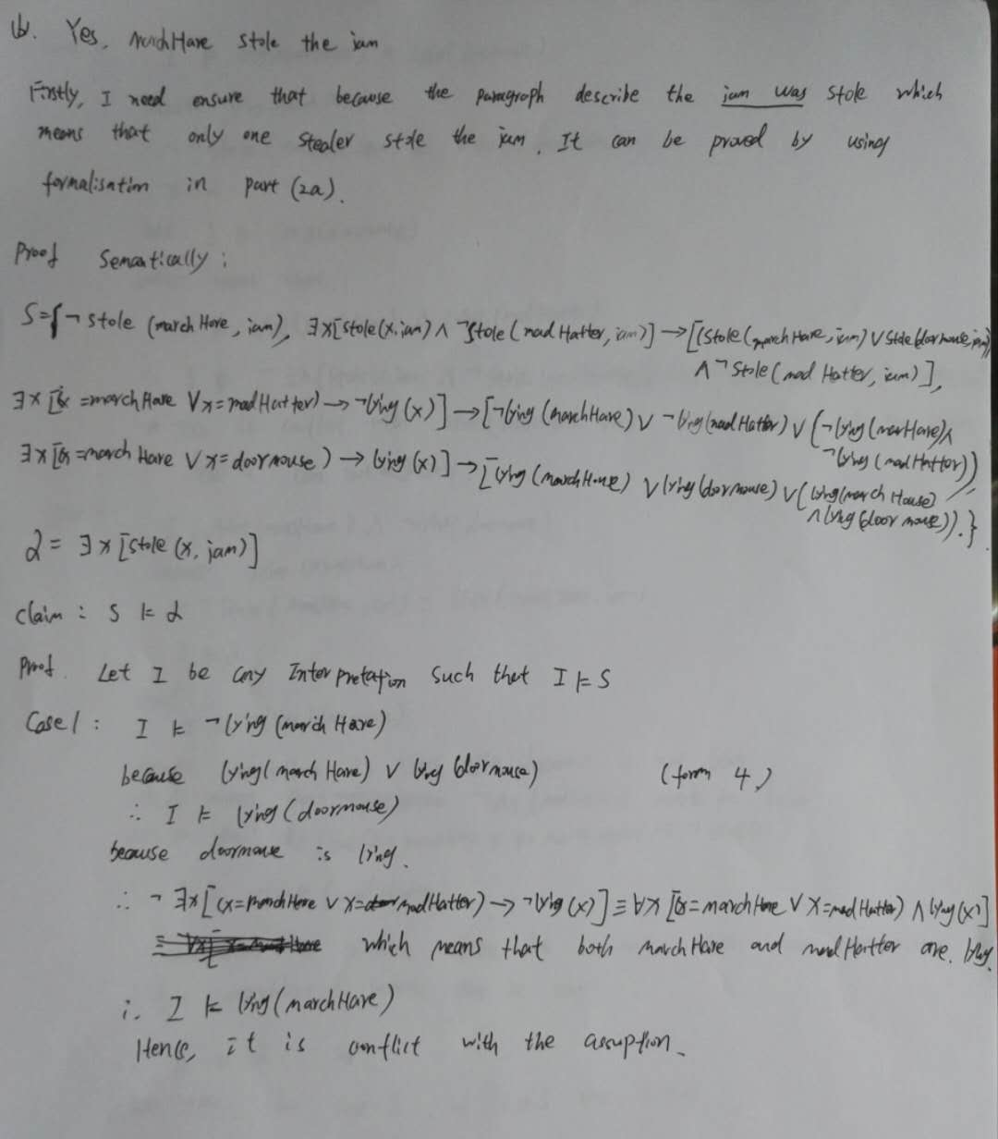

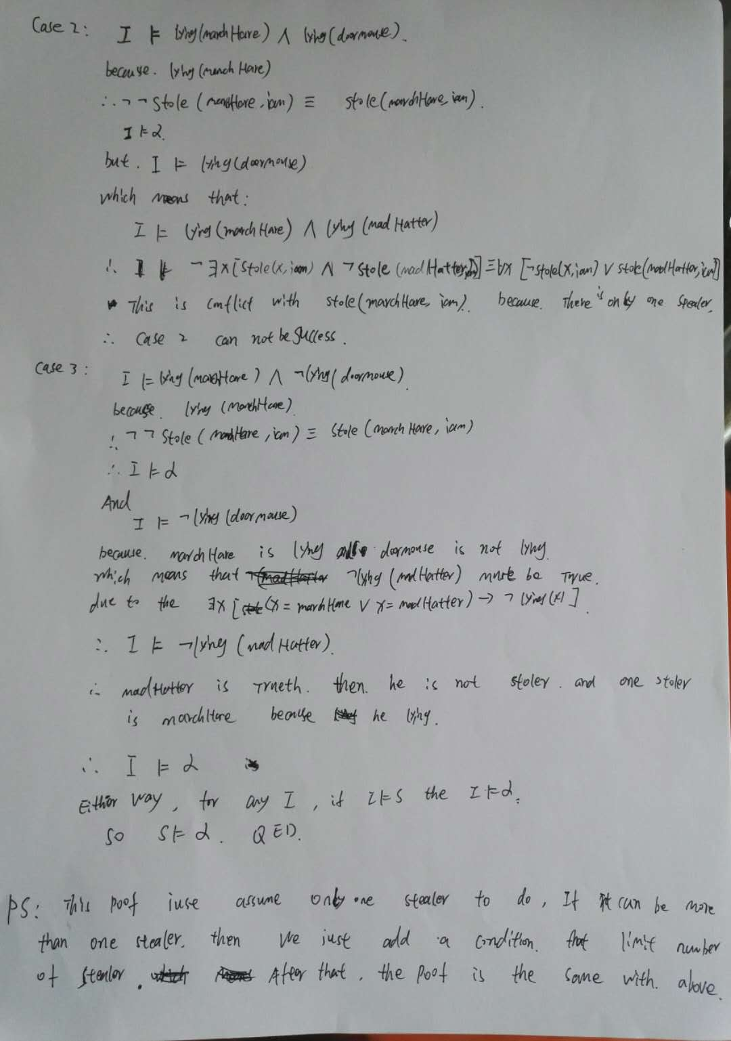

**Question 3.**

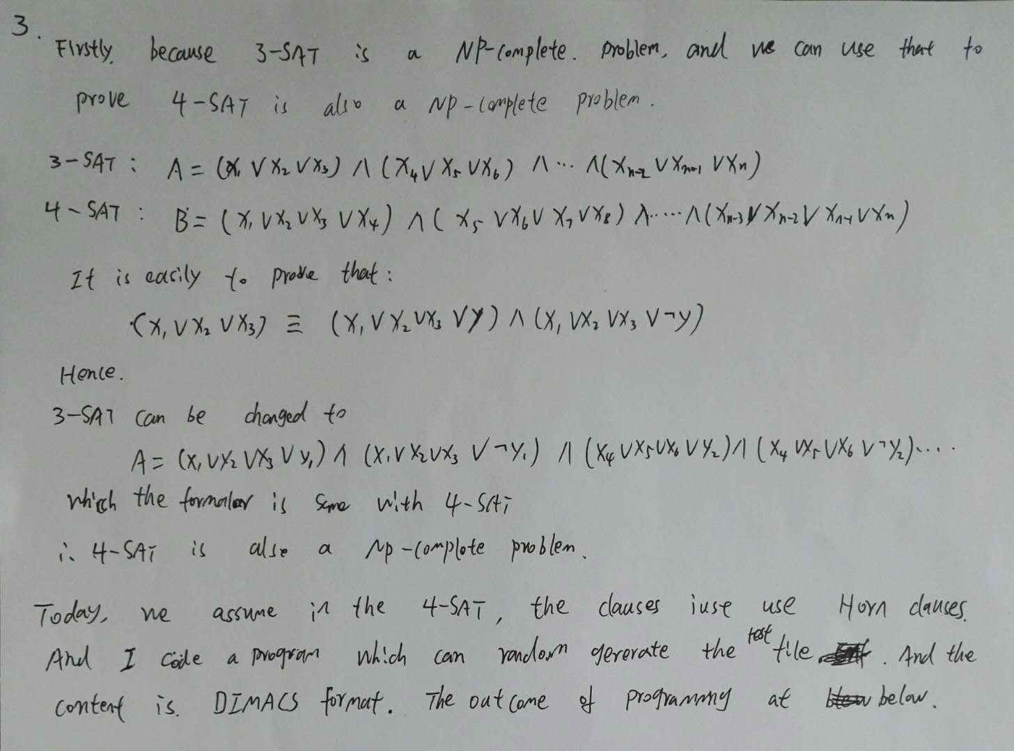

When random generate number of variables and clauses.

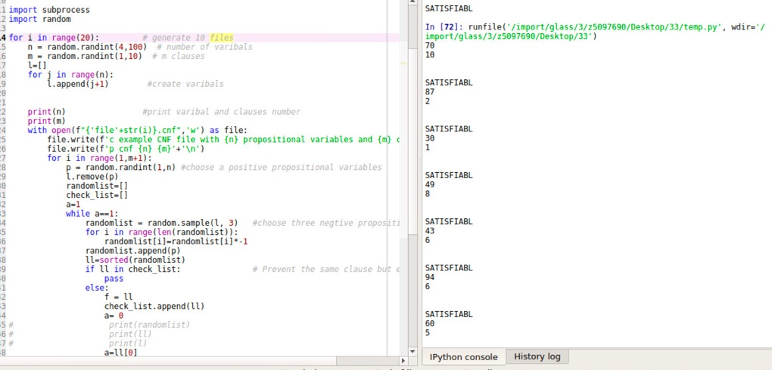

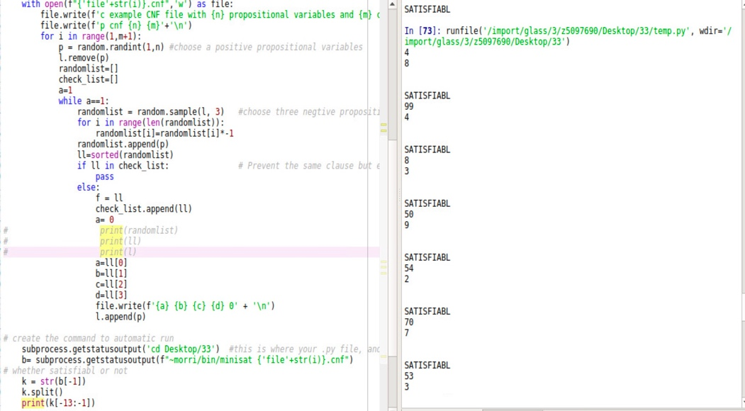

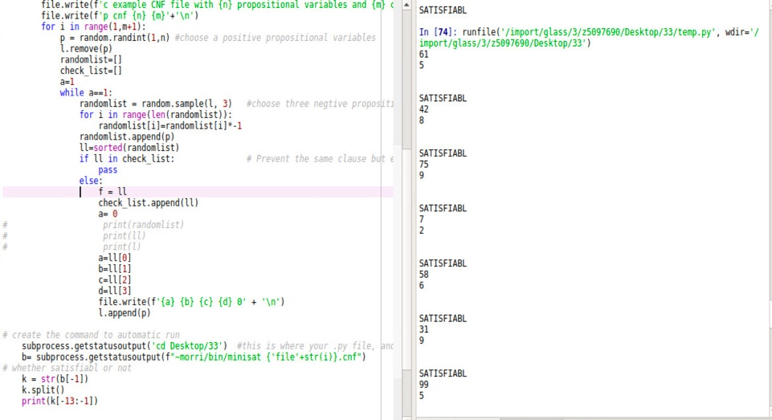

When n<C:

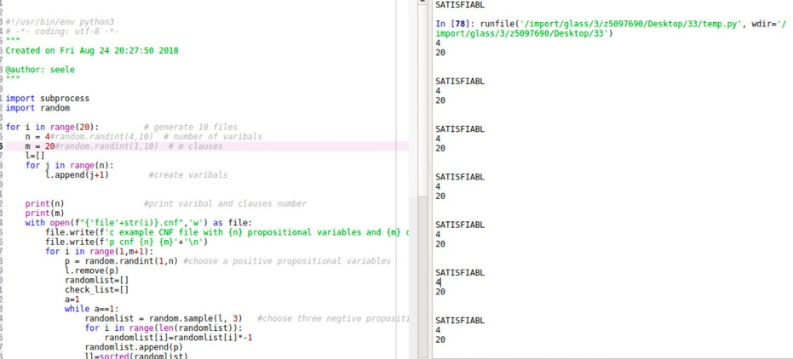

When n =c:

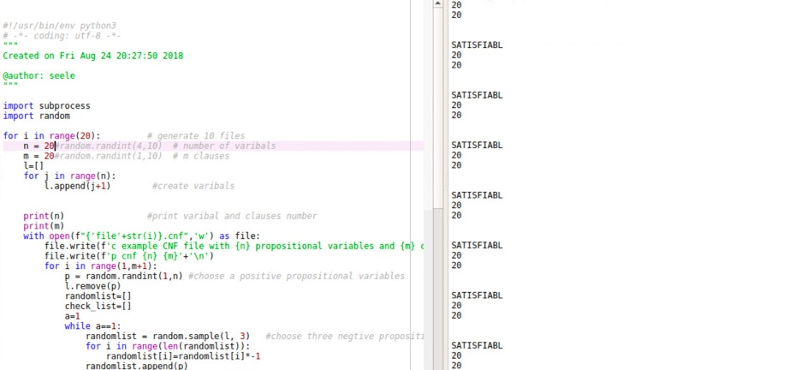

When n >c:

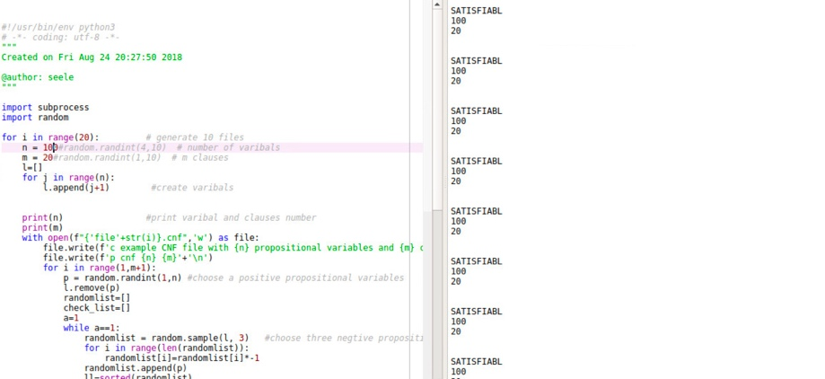

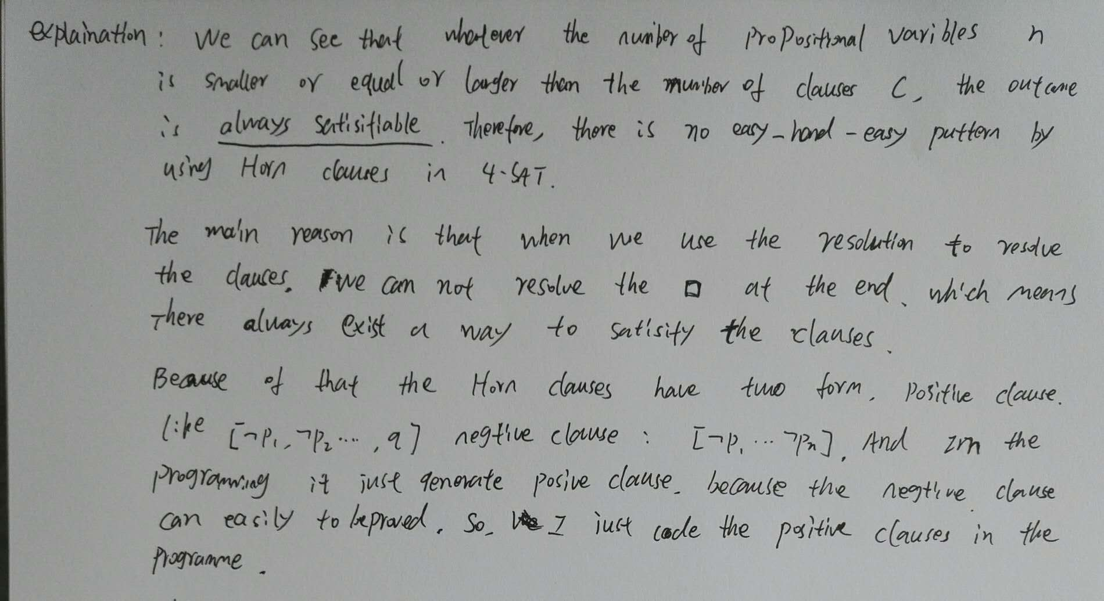

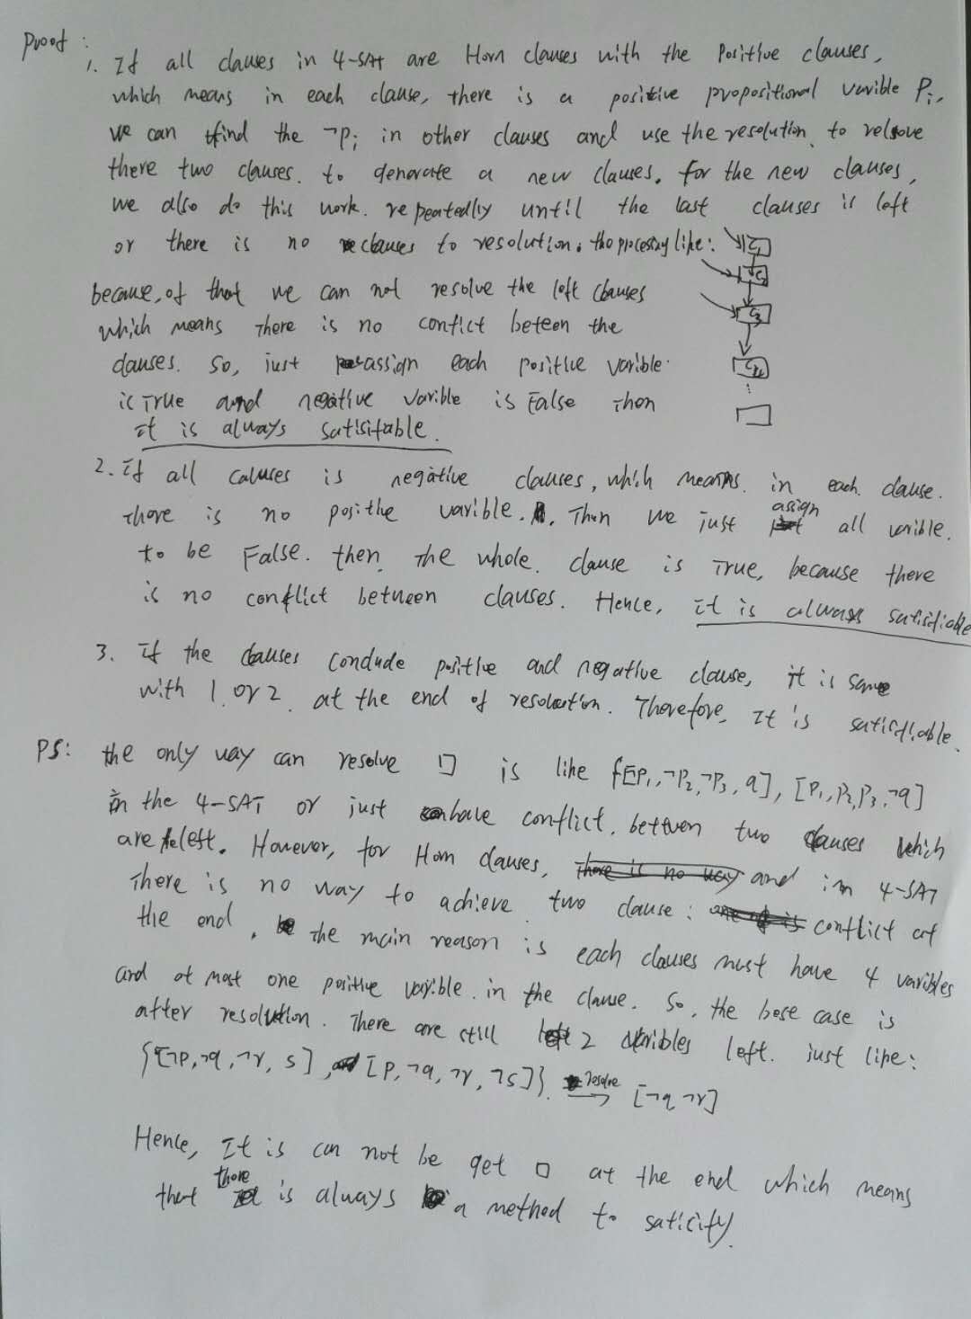

This is test file and program screenshot:



The code is:

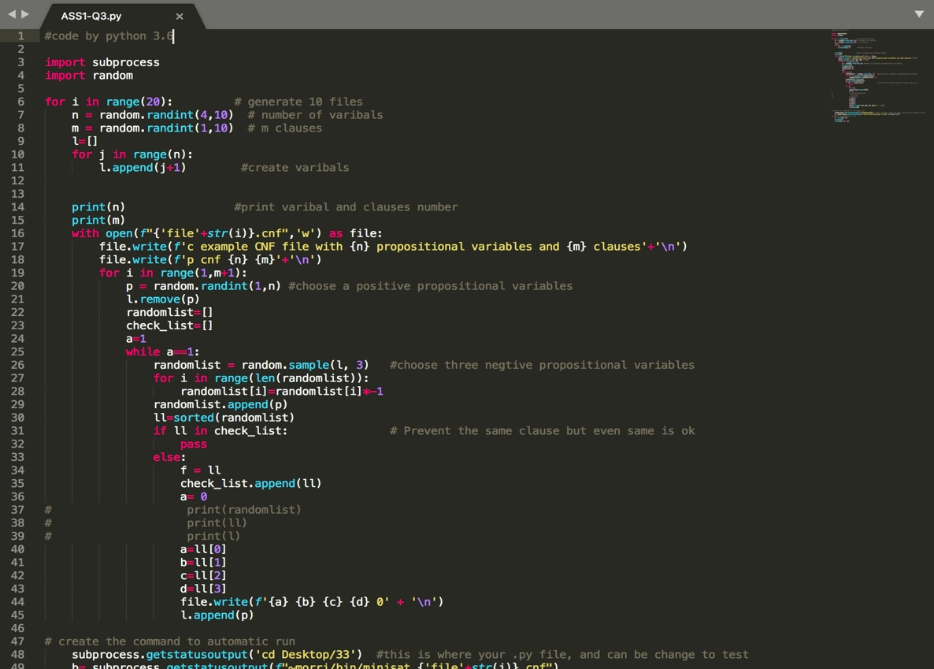

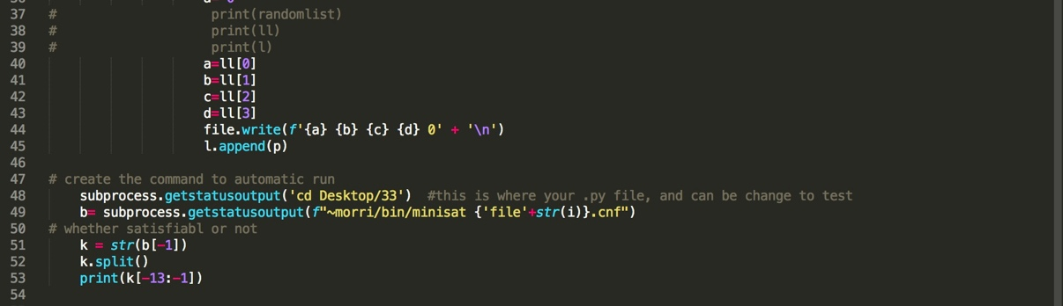

**Question 4.**

In this question, I would like to introduce a method for knowledge representation and reasoning which the Second-Order Logic .

**(a).**

**Second-Order Logic**

Firstly, the definition of Second-order logic is:

Second-order logic is base on the first-order logic and expand the syntax which means that it is extend the first-order logic by introducing quantification of predicate and functions variables of arity n (n>0).[1]

For example:

At first, suppose that x is a Human and x is a Man.

We can use First-order logic to express the knowledge that x[M(x)->H(x)].

However, we just can express and study the individual variable x and the predict/function H and M, we cannot limit that or study.

Hence, to some extent, the Second-order Logic can solve this problem.

A simple example, x is a good Man and x is Responsible father which means that there are some properties such as a good man in the Man function/predict.

We can use Second-order Logic to express the knowledge:

Mx[M(g(x))->R(x)].

This is different to First-order logic because the First-order logic just can determine the man or woman, and the sub-properties or limit of Man predict cannot be expressed.

**(b).**

**A simple knowledge base and sample: [2]**

S = {Man(good), Man(rude), Woman(beautiful), Man(bad), good(Bob), rude(Jam), beautiful(Alice), Responsible father(Bob), Responsible mother(Alice)}

Mx[M(g(x))->RF(x)].

Claim: S=>a,

Proof: let I be any interpretation and I |= S

Because of M we have two situations in S.

Case 1: I |= Man(rude).

Due to the rude(Jam).

∴ I |= Man(rude(Jam)).

Because there is no RF(Jam).

∴ I |≠ RF(Jam).

∴ I |≠ a

Case 2: I |= Man(good).

Due to the good(Bob).

∴ I |= Man(good(Bob)).

And because Responsible father(Bob)

∴ Man(good(Bob)) -> RF(Bob).

∴ I |= a.

Either way, for any I, if I |= S then I |= α.

So S |= α. QED

**(c).**

The importance issues of Second-order Logic are that this method just like the First-order Logic. And if the sentences are really complex which means that the it is limited by the complex knowledge expressing. Hence, we need Higher-order Logic to solve that. In addition, there are also some methods to express knowledge and reasoning. Such as Frame representation or Semantic network representation。

There are two references:

1. Ketland, Jeffrey. "Second-Order Logic." Macmillan Reference USA, 2005.
2. Van Harmelen, Frank, Vladimir Lifschitz, and Bruce Porter, eds. *Handbook of knowledge representation*. P16-18, Vol. 1. Elsevier, 2008.