Name: Yu Fu
SJSU ID: 010832276
Introduction & System Design:
Part1: The propose of Project part 1 is creating a calculator which has four operations: Add, sub, Multiple and Division. The design of this part is using nodejs as Client Server. We do all calculate base on operation on Java webserver. Client Server send user input and operation to webserver, then webserver do calculate and return back to client server to should user result.
Part2: The propose of Project part 2 is creating Clone Ebay App Web. In this app, user could signup, login, post new advertisement, view advertisements, which published by other users, and add item to carts, then check out them. In this web app, I use nodejs a web client server, Angularjs and Bootstrap as Front-end. Use nodejs to connect to a Java webserver. Use SOAP to transfer data between them. Java webserver will use JDBC to connect and switch data with MySQL Database Server.

Result:
Part I:
Client:
Add:
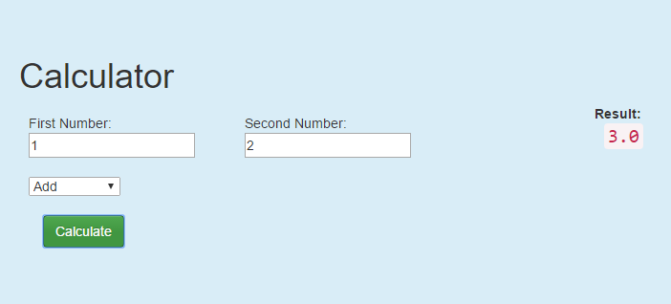
Sub:
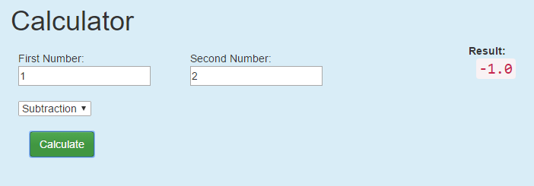
Mult:
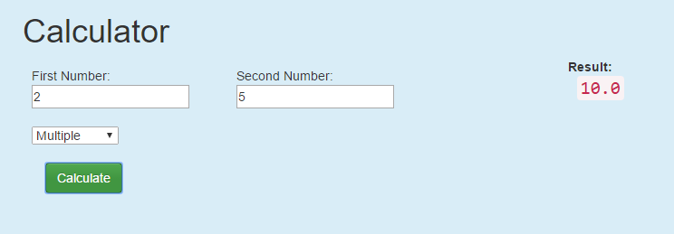
Division:
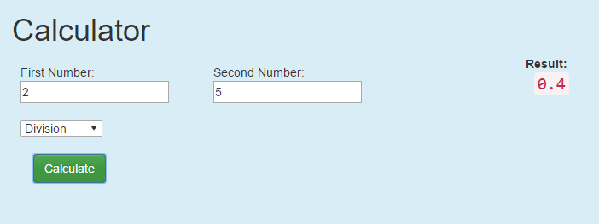
Exception:
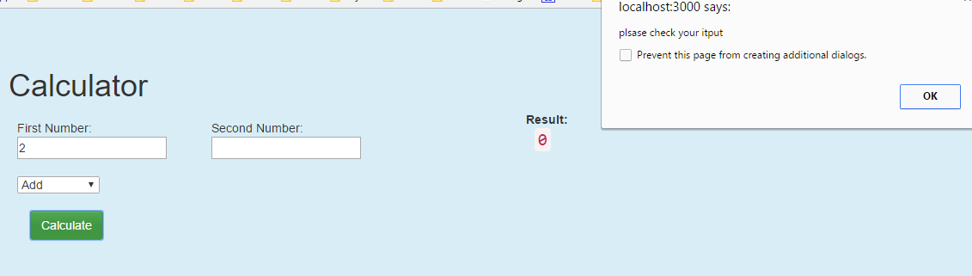
Codes:
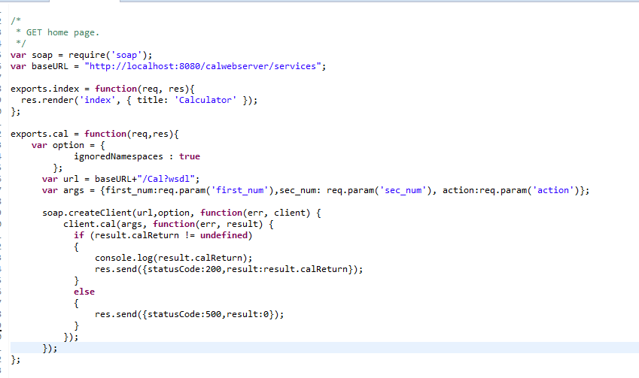
Server:
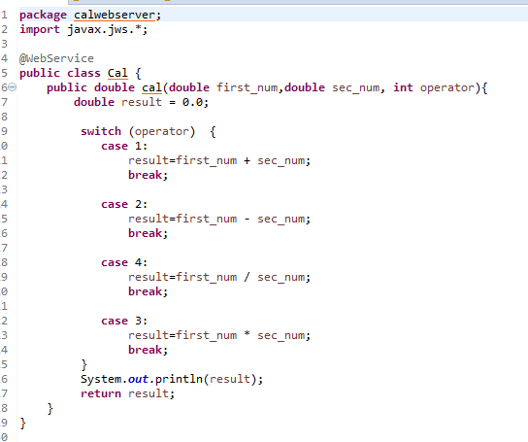
Part II:

Client:
Codes:
Register
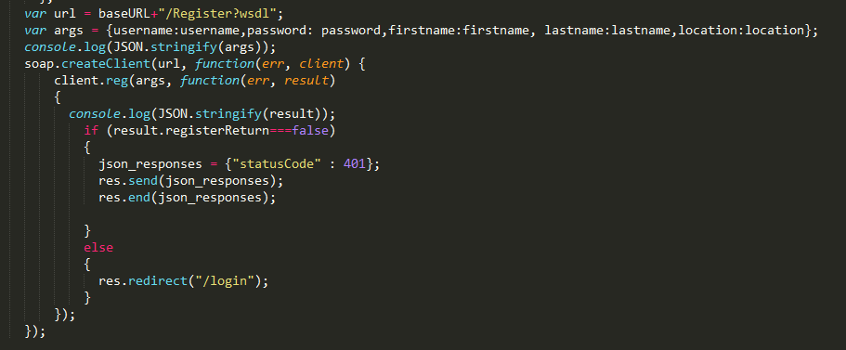
Login:
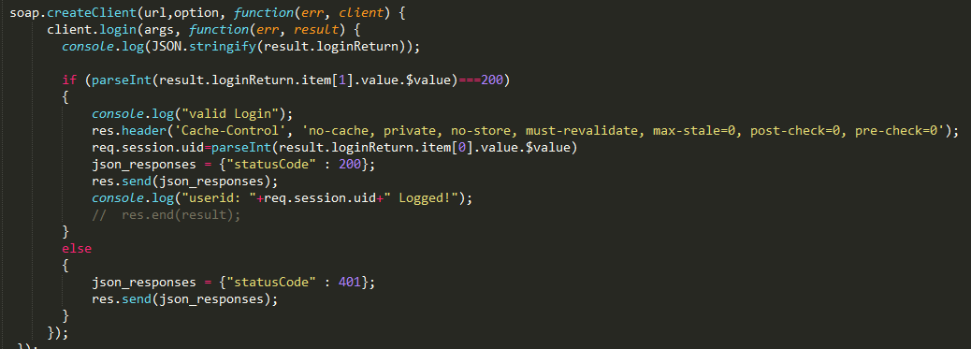
Add Item:
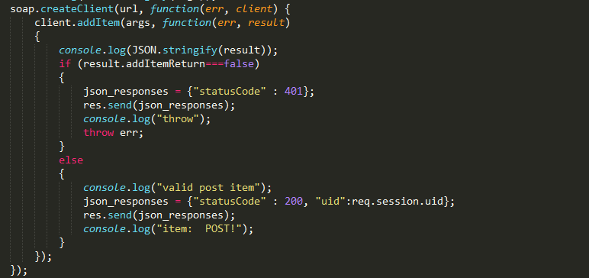
Get Item info by ID:
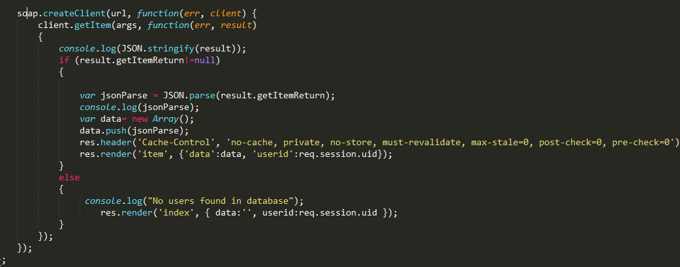
Submit Carts:
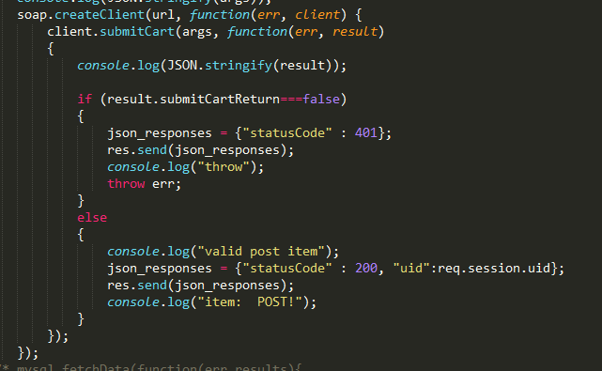
User Page:
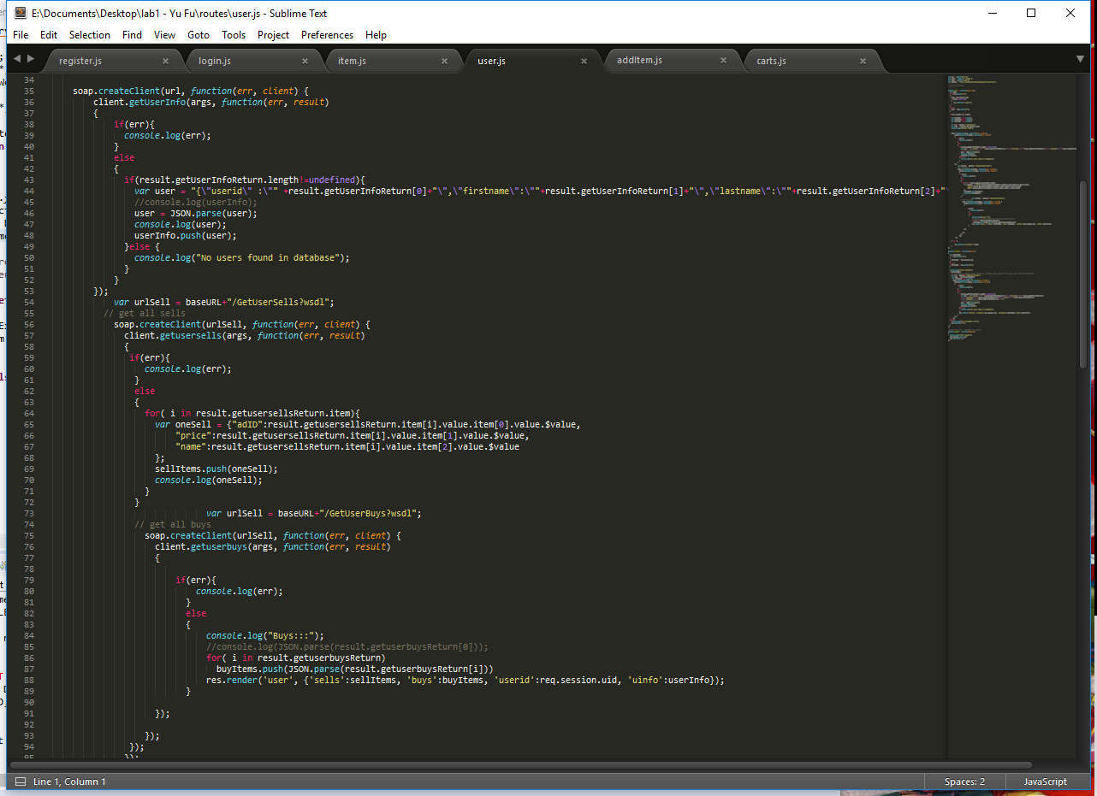
User profile:
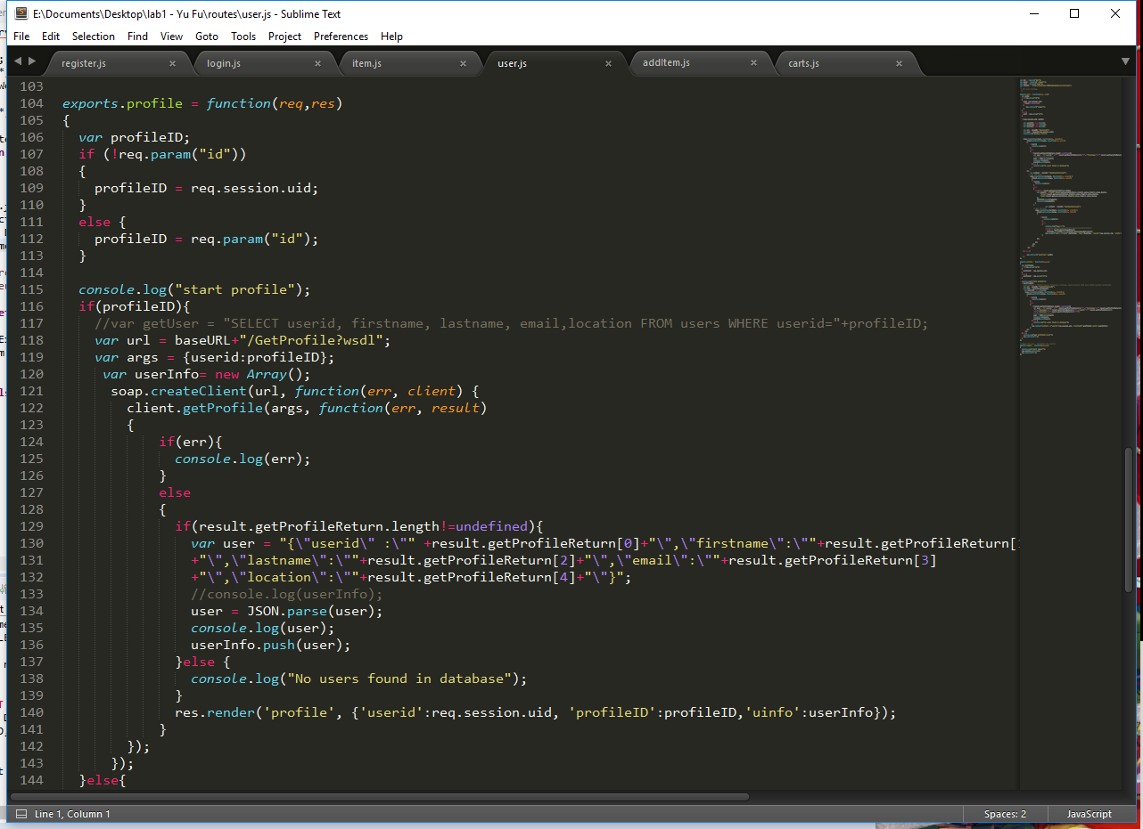
Server:
Codes:
All:
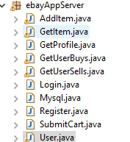
User info:
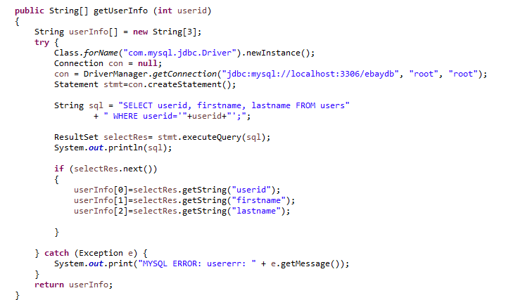
Register:
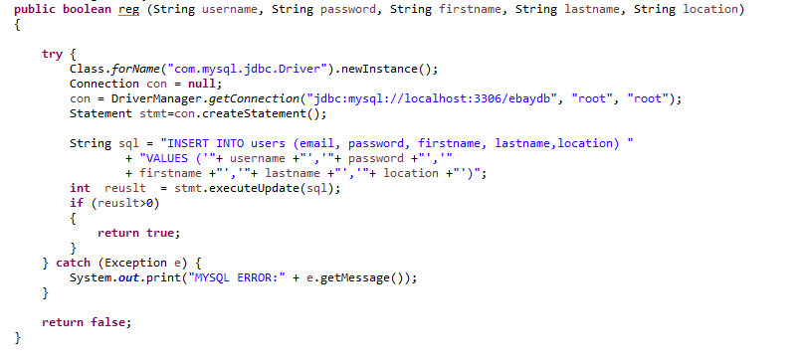
Login:
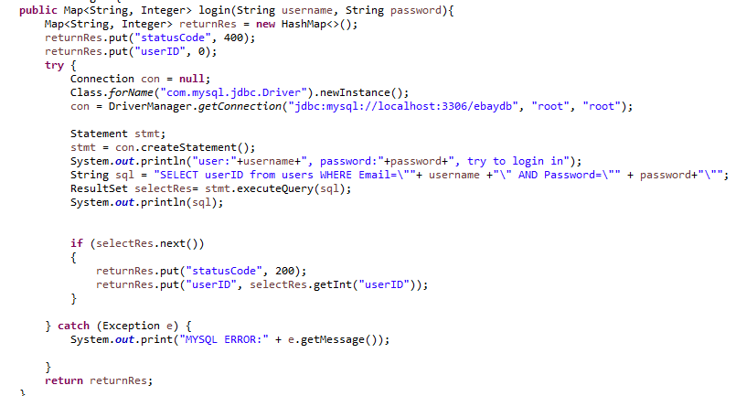
User profile
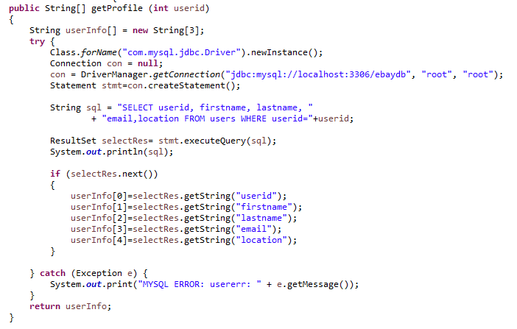
User buy History:
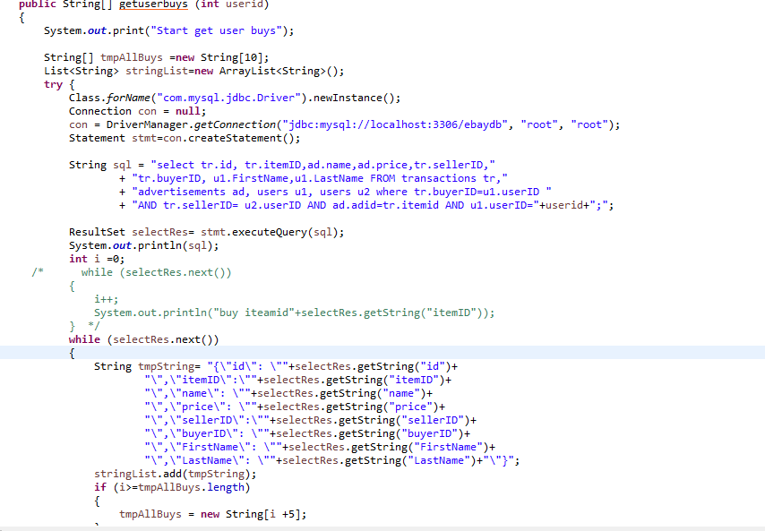
User sell History:
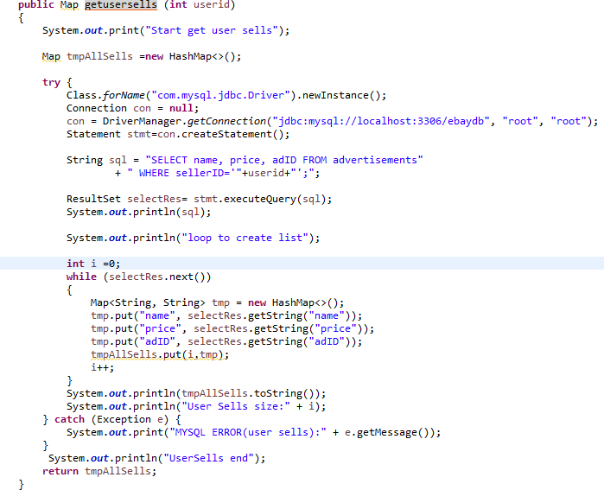
Add item:
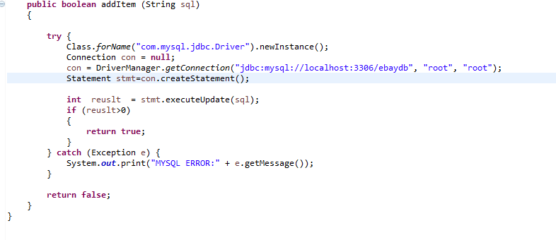
Get Item Info:
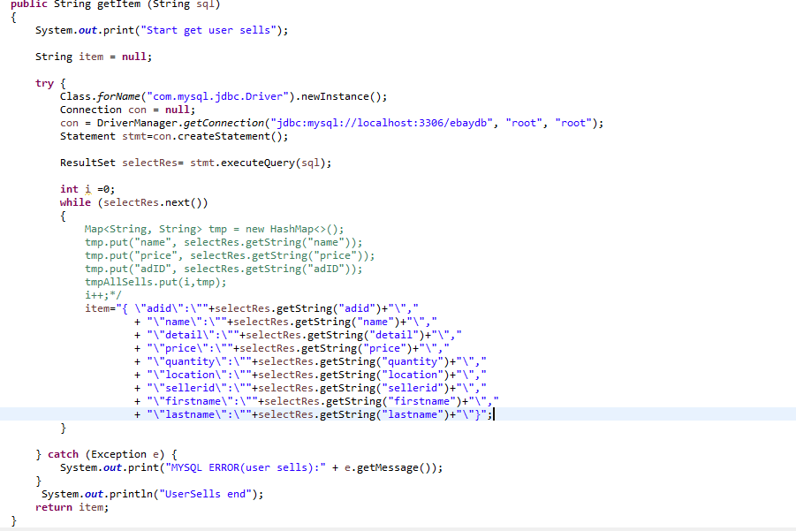
Submit Carts:
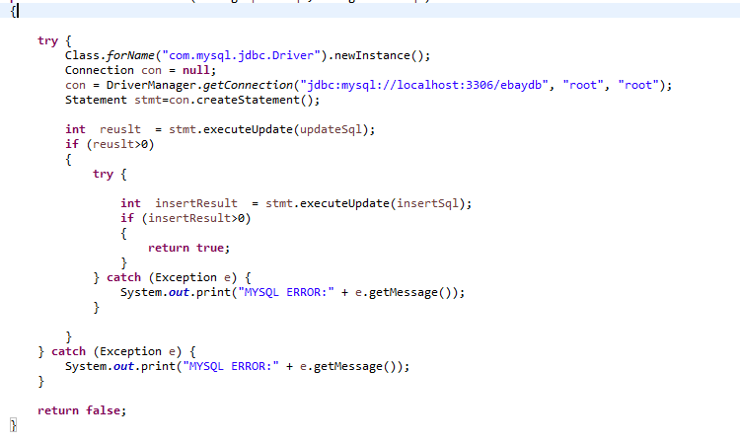
Client Screenshot:
Home:
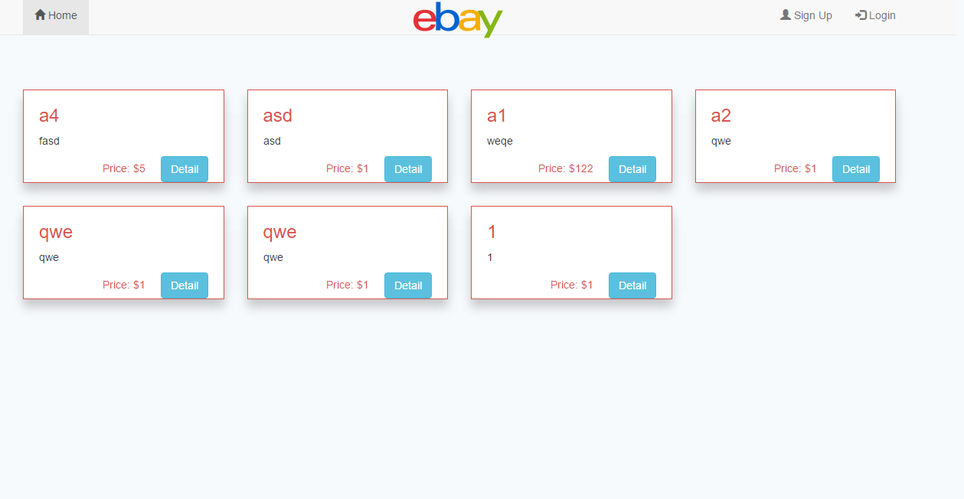
Signup:
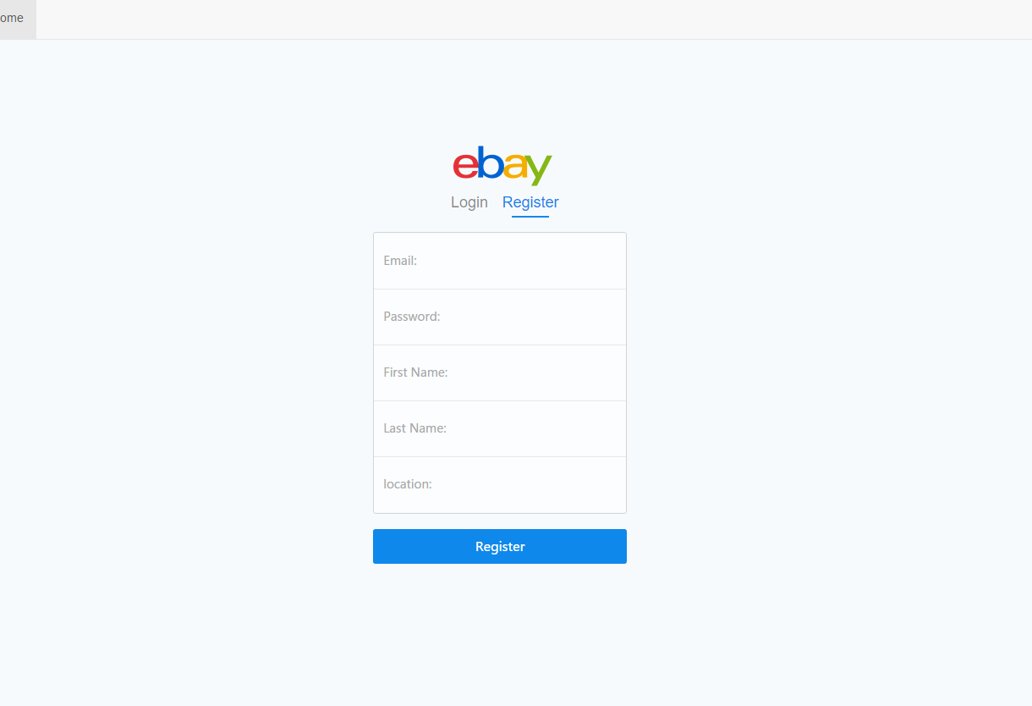
Login:
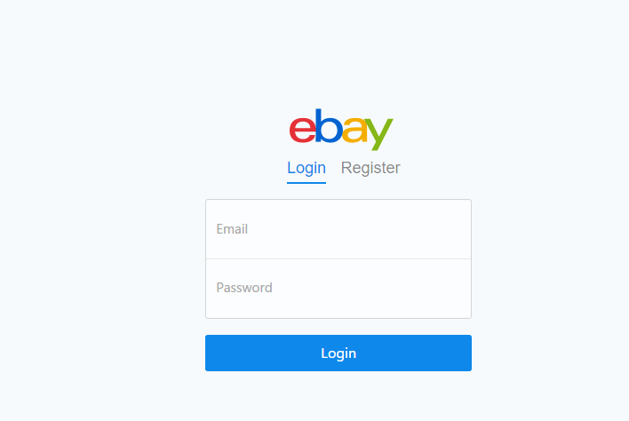
User Center:
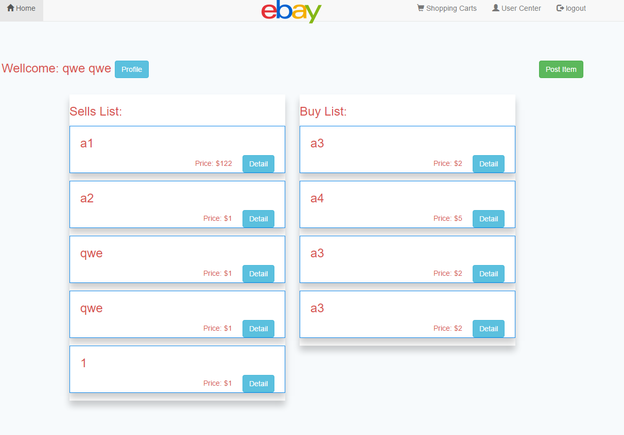
Post Item:
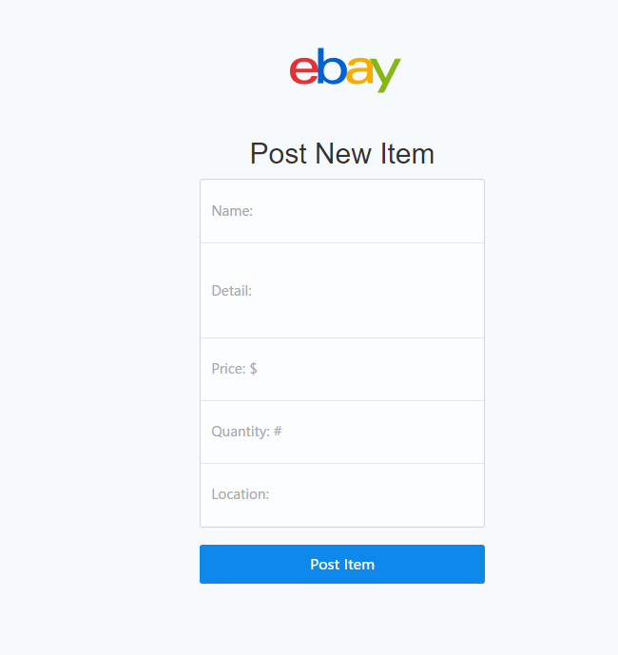
Item details:
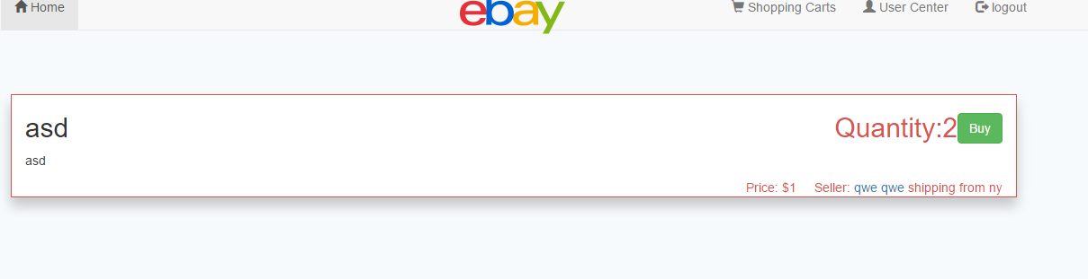
Shopping Carts:
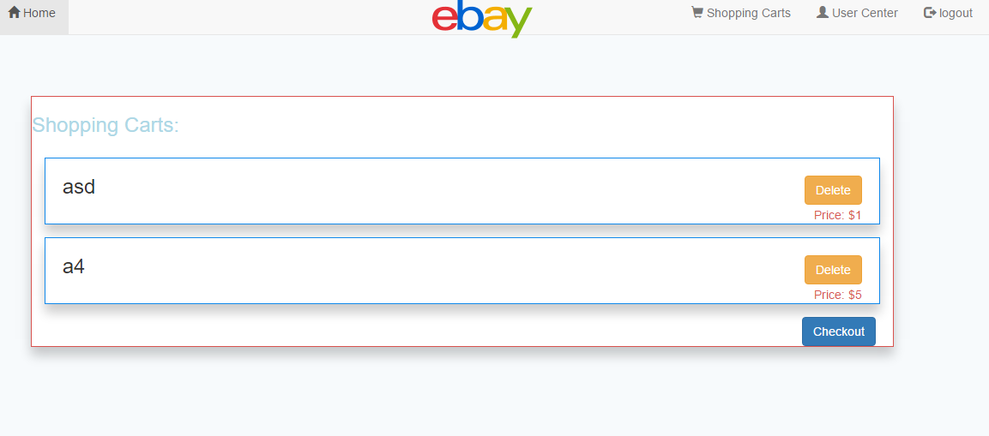
Credit Card:
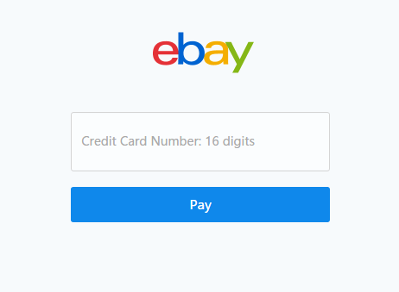
Connection pools:

JMeter:

Mocha:
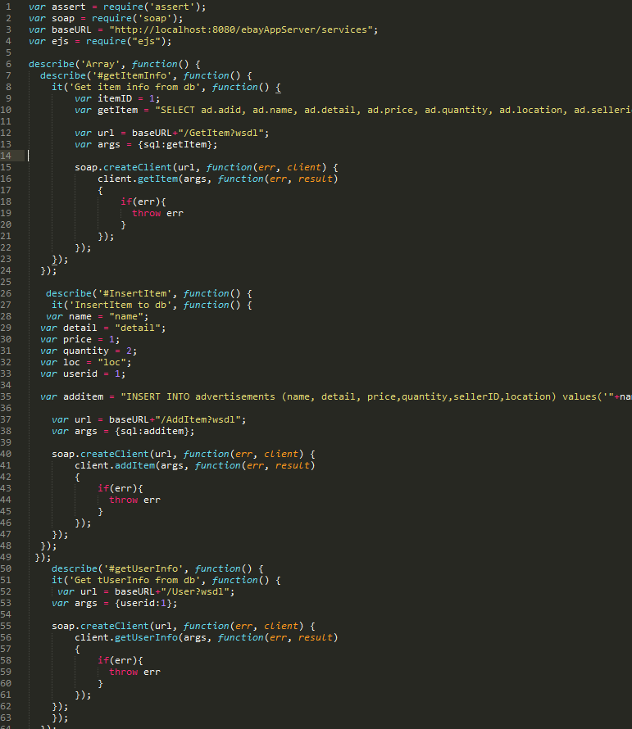
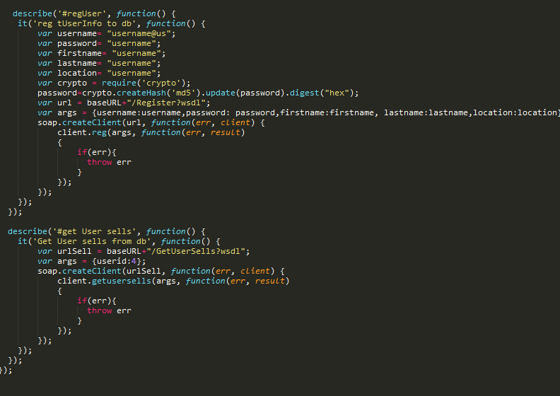
Result:
