|  |  |
| --- | --- |
| **Assignment:** | PS07 |
| **Name:** | <Yuefan Fu>, <fu194> |
| **Team-ID** | 001-05 |
| **Contributor(s):** | <name> , <Purdue login> [repeat for each] |

# Security Camera Placement

Paired Programming

**Paired Partner**

|  |  |
| --- | --- |
| Partner: | <partner name>, <partner Purdue login> |

**Test Cases**

Fill out the table with test case information.

* The *Test Case Description* is an English description of the path being tested and the variable value(s) needed to be on that path.
* The *Input Arguments* are numerical values.
* The *Flowchart Output* is an English description of the flowchart output; it is not code or MATLAB generated results.
* Add as many rows as necessary to test all possible flowchart paths.
* An example test case is included.

|  |  |  |
| --- | --- | --- |
| **Test Case Description**  **in English** | **Test Values**  (x (m), y (m)) | **Flowchart Output** |
| Test the coordinates for inside the lobby by using an x-coordinate  -1 < x < 11  and a y-coordinate  17 < y < 23 | x = 5  y = 20 | Camera location: lobby |
| Test the coordinates for inside the office by using an x-coordinate  -11 < x < -1  and a y-coordinate  17 < y < 23 | X=-3  Y=20 | Camera location: office |
| Test the coordinates for inside the exhibit hall by using an x-coordinate  -11 < x < 11  and a y-coordinate  5 < y < 17 | X=-3  Y=10 | Camera location: exhibit hall |
| Test the coordinates for inside the observatory by  X^2+y^2<25 or  using an x-coordinate  -3<x<3  and a y-coordinate  4< y <5 | X=2  Y=4.9 | Camera location: observatory |

# Fractional Distillation

Paired Flowchart Creation

Individual Programming

**Paired Partner (Flowchart Only)**

|  |  |
| --- | --- |
| Partner: | <partner name>, <partner Purdue login> |

**PS07_distillation_login.m Flowchart**

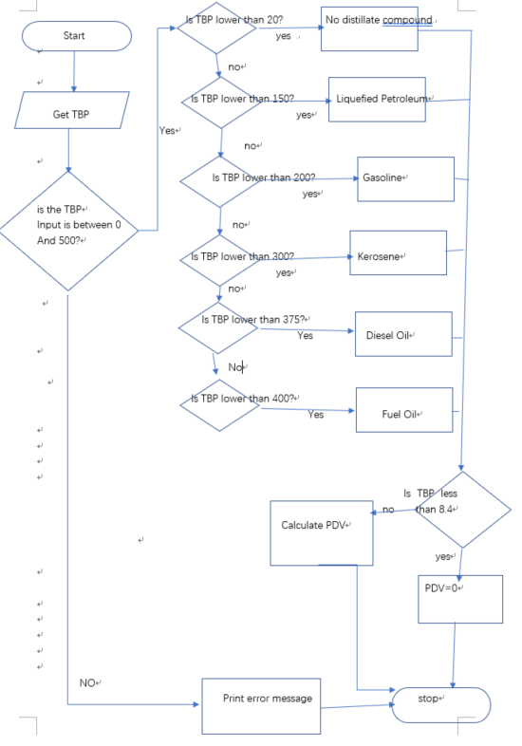

**Test Cases**

Fill out the table with test case information.

* The *Test Case Description* is an English description what is being tested.
* The *Input Argument* is a numerical value.
* The *Flowchart Output* is an English description of the flowchart; it should not be code or MATLAB generated results.
* Add as many rows as necessary to test all possible flowchart paths.
* An example test case is included.

|  |  |  |
| --- | --- | --- |
| **Test Case Description**  **in English** | **Input Argument**  **(TBP (deg C)** | **Flowchart Output**  **in English** |
| Test when temperature is valid and is distilling kerosene  200 ≤ TBP < 300 | TBP = 200 | Distillate: kerosene  PDV: 27.59 |
| Test when temperature is valid and is distilling crude oil.  0 ≤ TBP <20 | TBP=5 | Distillate:none  PDV: 0 |
| Test when temperature is valid and is distilling Liquefied Petroleum Gas  20 ≤ TBP <150 | TBP=50 | Distillate: Liquefied Petroleum Gas  PDV: 5.994 |
| Test when temperature is valid and is distilling Gasoline  150 ≤ TBP <200 | TBP=175 | Distillate: Gasoline  PDV: 23.994 |
| Test when temperature is valid and is distilling Diesel Oil  300 ≤ TBP <375 | TBP=350 | Distillate: Diesel Oil  PDV: 49.194 |
| Test when temperature is valid and is distilling Fuel Oil  375≤ TBP <400 | TBP=380 | Distillate: Fuel Oil  PDV: 53.514 |
| Test when temperature is valid and is distilling Residuals  400 ≤ TBP < 500 | TBP=420 | Distillate: Residuals  PDV: 59.274 |