|  |  |
| --- | --- |
| **Assignment:** | PS 08 |
| **Name:** | <Yuefan Fu>, <fu194> |
| **Team-ID** | 001-05 |
| **Contributor(s):** | <name> , <Purdue login> [repeat for each] |

# Hall-Petch Yield Stress

Individual Programming

**PS07_HallPetch_fu194.m Flowchart**

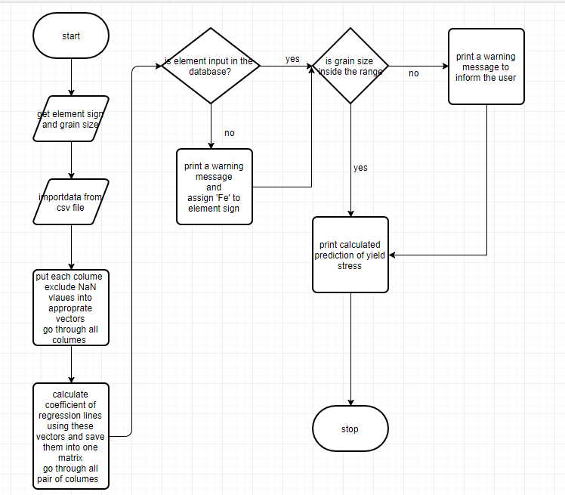**Test Cases**

Fill out the table with test case information.

* The *Test Case Description* is an English description what is being tested.
* The *Input Argument* is a numerical value.
* The *Flowchart Output* is an English description of the flowchart; it should not be code or numbers.
* Add as many rows as necessary to test all possible flowchart paths.
* An example test case is included.

|  |  |  |
| --- | --- | --- |
| **Test Case Description**  **in English** | **Input Arguments**  **(metal (string),grainsize (micron))** | **Flowchart Output**  **in English** |
| Test when the metal is iron and the grain size is within iron’s prediction range  metal = iron atomic symbol  6 ≤ grain size ≤ 2000 micron | metal = ‘Fe’  grainSize = 50 | Metal is iron  grain size is within range |
| Test when the metal is Vanadium and the grain size is within Vanadium’s prediction range  metal = Vanadium atomic symbol  0.14 ≤ grain size ≤ 735 micron | Metel=’V’  grainSize=300000 | Meter is Vanadium, grain size is out of range |
| Test when the metal is Sodium and the grain size is within Sodium’s prediction range  metal = iron atomic symbol  6 ≤ grain size ≤ 2000 micron | metal = ‘Na’  grainSize = 100 | Metal is not found in database  grain size is within range |

# Taylor Series for cos x

Paired Programming

**Paired Partner**

|  |  |
| --- | --- |
| Partner: | <Yuefan Fu>, <partner Purdue login> |

**Test Cases**

Fill out the table with test case information.

* The *Test Case Description* is an English description of the path being tested and the variable value(s) needed to be on that path.
* The *Input Arguments* are numerical values.
* The *Flowchart Output* is an English description of the flowchart output; it is not code or MATLAB generated results.
* Add as many rows as necessary to test all possible flowchart paths.
* An example test case is included.

|  |  |  |
| --- | --- | --- |
| **Test Case Description**  **in English** | **Test Values**  (x, tolerance) | **Flowchart Output** |
| Valid inputs for x and for the tolerance | (0.5,0.05) | * number of terms in series * value of (x) approximation * absolute difference between cos(x) approximation and MATLAB’s cos(x) |
| invalid input for x with any input for tolerance | ([1,1],0.01) | Print error message and terminate the function  -99，-99，-99 |
| valid input for x with Invalid input for tolerance | (pi,10) | Print error message and terminate the function  -99，-99，-99, |

**Variable Tracking Table – by hand**

Complete the necessary parts of this table for input arguments (1.5, 0.001). Add rows as necessary.

|  |  |  |  |
| --- | --- | --- | --- |
|  | nth term value | cos(*x*) approximation | Number of Terms |
| Initialization | 1 | 1 | 0 |
| Iteration 1 | -1.125 | -0.125 | 1 |
| Iteration 2 | 0.2109 | 0.0859 | 2 |
| Iteration 3 | -0.0158 | 0.0701 | 3 |
| Iteration 4 | 0.007 | 0.0708 | 4 |

# Weather Balloon Diameter

Individual Programming

**PS08_balloon_burst_fu194.m Flowchart**

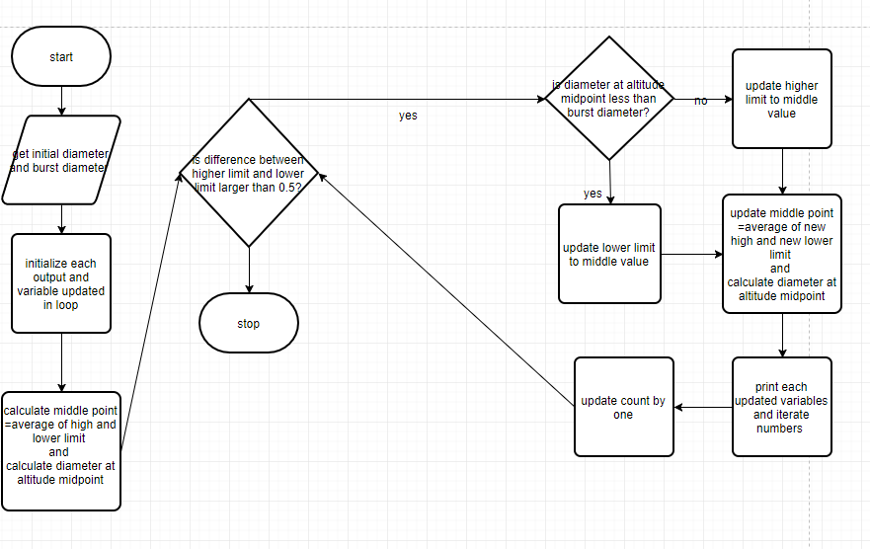 **Variable Tracking Table – by hand**

Complete all the given rows (one initialization row and four iteration rows) of this tracking table by hand. Use USAtmos_1976.p to calculate the required atmospheric temperature and pressure. Complete this table for a test balloon with a fill diameter of 1.2 m and an expected burst diameter of 4.2 m.

|  |  |  |  |  |
| --- | --- | --- | --- | --- |
|  | Altitude (km) | Temperature (deg K) | Pressure (kPa) | Balloon Diameter (m) |
| Initialization | 43 | 259.45 | 0.1875 | 9.468 |
| Iteration 1 | 21.5 | 218.15 | 4.23 | 3.13 |
| Iteration 2 | 32.3 | 229.35 | 0.84 | 5.5 |
| Iteration 3 | 26.9 | 223.52 | 1.88 | 4.16 |
| Iteration 4 | 29.6 | 226.21 | 1.25 | 4.79 |
| Iteration 5 | 28.2 | 224.87 | 1.53 | 4.47 |
| Iteration 6 | 27,5 | 224.2 | 1.7 | 4.31 |
| Iteration 7 | 27.2 | 223.86 | 1.78 | 4.24 |
| Iteration 8 | 27.0 | 223.69 | 1.83 | 4.20 |

Use your MATLAB code to determine how many iterations you will need to get the burst altitude for the test balloon above

|  |  |
| --- | --- |
| Total iterations needed: | 8 |