echarts2绘制图表时，如果同一个图表实例多次使用setOption方法重新绘制数据时，期间如果有一次查询数据为空造成设置的option中的data为空，会触发“暂无数据”动画，那么下载绘制图表时即使有数据，之前的动画也不会消失。如下图所示：

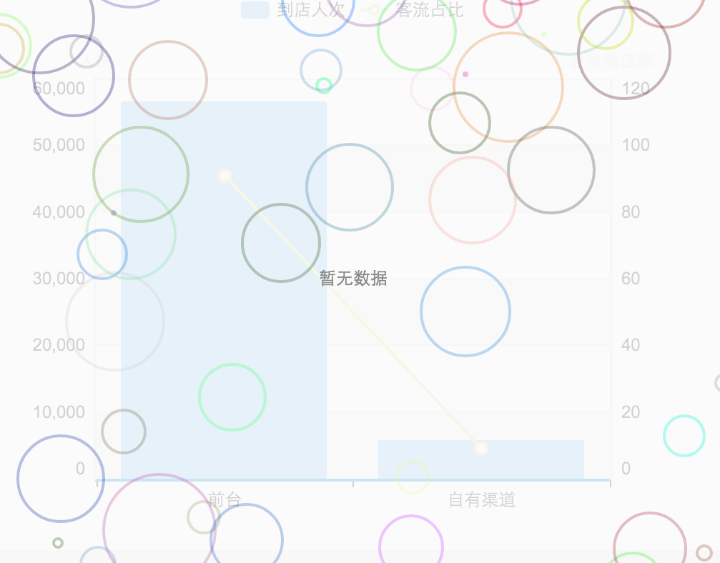

解决方案：

1.

实例调用setOption方法前，调用hideLoading方法。如：

myChart. hideLoading();

myChart. setOption(option);

2.

修改源代码_noDataCheck方法，添加如下图标黄部分：

_noDataCheck: function (magicOption) {

var series = magicOption.series;

for (var i = 0, l = series.length; i < l; i++) {

if (series[i].type == ecConfig.CHART_TYPE_MAP || series[i].data && series[i].data.length > 0 || series[i].markPoint && series[i].markPoint.data && series[i].markPoint.data.length > 0 || series[i].markLine && series[i].markLine.data && series[i].markLine.data.length > 0 || series[i].nodes && series[i].nodes.length > 0 || series[i].links && series[i].links.length > 0 || series[i].matrix && series[i].matrix.length > 0 || series[i].eventList && series[i].eventList.length > 0) {

this.hideLoading();

return false;

}

}

var loadOption = this._option && this._option.noDataLoadingOption || this._themeConfig.noDataLoadingOption || ecConfig.noDataLoadingOption || {

text: this._option && this._option.noDataText || this._themeConfig.noDataText || ecConfig.noDataText,

effect: this._option && this._option.noDataEffect || this._themeConfig.noDataEffect || ecConfig.noDataEffect

};

this.clear();

this.showLoading(loadOption);

return true;

},