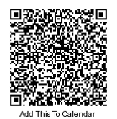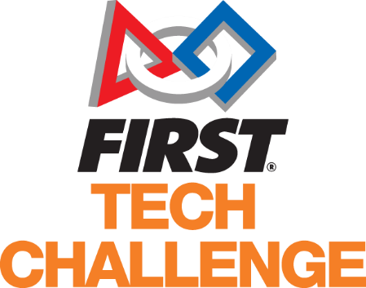Learn About Robotics

Come join us at the Lake Hills Public Library to learn about

FTC and how you can start a team too!

**NOW’S YOUR CHANCE!**

EVER WANTED TO LEARN ABOUT FTC ROBOTICS?

**September 16, 2017**