

**Presents**



**MagicHome Plugin**

**System Requirements:**  
This plugin is for [HS3](https://shop.homeseer.com/collections/home-control-software) or [HS3PRO](https://shop.homeseer.com/collections/home-control-software). It needs Microsoft .NET Framework 4.7.2 or higher.  
It is designed to interface HomeSeer with Magic Home RGB LED Controllers

**Plugin Installation:**  
Download and install from the updater ("**Lighting & Primary Technology**" section) follow instructions to install.  
  
**Plugin Configuration**  
- Start the plugin from the "PLUG-INS > Manage" page, wait a few seconds for the plugin to initialize

- go to the config page "PLUG-INS > Magic Home > Config" and specify the desired Logging Level. No further configuration is required for the plugin as lights are discovered via Lan Discovery

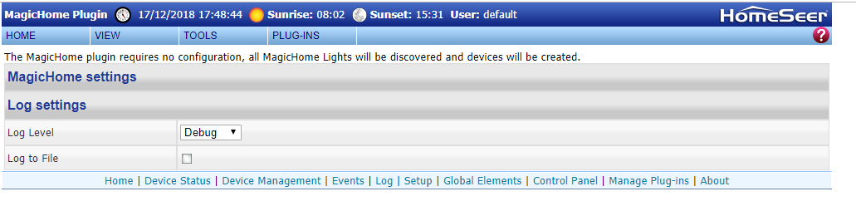

The device discovery re-runs every hour, however if you wish to speed up this process when adding new lights, just simply restart the plugin.

The following devices should have been created by default for each light, the name will contain the device MAC Address, but these can be changed as required as is shown below.  
  
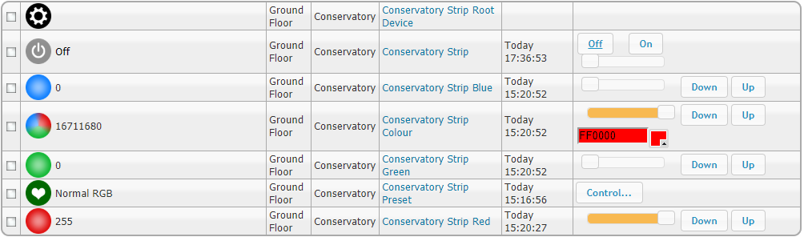

The R,G,B Channels can be controlled individually via the sliders, additionally you can use the colour picker to set the lights colour.

Also included in the plugin is the ability to configure a standard preset, just select Normal RGB from the preset list to revert back to fixed colour control.

I have also added a dimmer on the main device, this dimmer has some caveats in that the colour may change slightly when dimming, but otherwise the functionality works as expected.

A note should be made:

Please also use your 30 day Trial licence to check for and bugs or issues before purchase, Please raise any bugs or issues in the plugin forum and I will endeavour to resolve any issues in a timely manner.

The Plugin only currently supports MagicHome v3 and v4 RGB Controllers. If however you wish to have RGBW or RGBWW or Magic Home bulbs to be supported, then please forward your plugin debug log during discovery and provide me details of your device and I can create a beta version for you to test with your device.