

**ONLINE STORE FOR**

**MOTHERS AND BABIES**

**Software Requirements Specification**

– Ho Chi Minh City, 2024 –

1. **Introduction**
   1. **Purpose**The Moms & Babies Store System is an innovative web application revolutionizing the shopping experience for mothers and babies. Our platform provides the process of acquiring essential items, offering a selection of high-quality products from trusted brands. Built on the expectation of a high demand for convenience and user-friendliness, the system aims to cater to every mothers regardless of tech-savvy level. Popular credentials and payment methods are integrated. As the system evolves, our vision includes expanding product offerings and enhancing features to meet the evolving needs of our customers.
   2. **Scope***User Account Management:* Secure registration, login options via popular credentials such as Gmail, and easy account management.

*Product Search & Purchase:* Comprehensive product catalog with advanced search and filter options, wishlist functionality, and secure checkout process.

*Order Management:* User-friendly shopping cart, real-time order tracking, and notification system for order updates.

*Promotion & Loyalty Rewards:* Implementation of vouchers and exclusive gifts to reward frequent shoppers.

*Product Management:* Efficient inventory management, detailed product information, and supplier integration to ensure product availability.

*Article Management:* Creation and management of articles related to motherhood and baby care, with organized categorization and SEO optimization.

*Staff Management:* Role-based access, staff account management, and activity tracking to maintain accountability and streamline operations.

*Product Feedback:* Customer reviews and ratings, moderation tools, and feedback analytics to improve products and services.

*Chat Feature*: Real-time live chat support, no history maintenance for user privacy policy.

*Reporting & Analysis:* Generation of sales reports, customer insights, inventory reports, and performance metrics to assess system efficiency and effectiveness

1. **Diagrams & Illustrations**
   1. **Database Diagram (ERD)**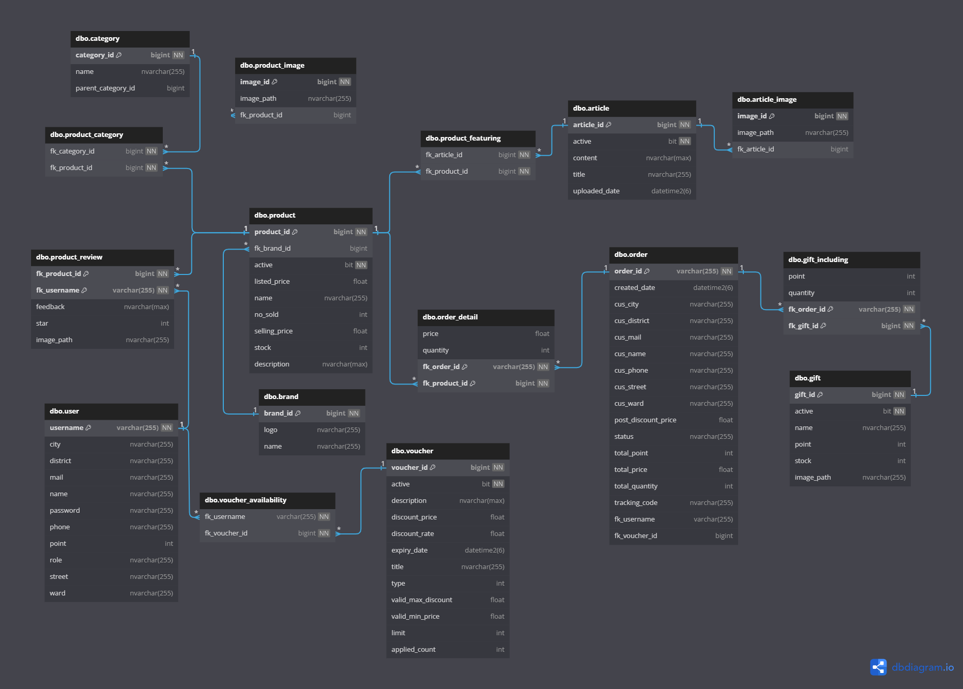
   2. **Screen flow**
      1. **Guest**
2. **User stories**

| **ID** | **User Story** | **Applicable Role** | **Description** | **Feature** |
| --- | --- | --- | --- | --- |
| US-01 | Login | Customer,  Staff,  Admin | Log into the system using username and password | User Account  Management |
| US-02 | Register | Customer | Create a new account by providing username, email address, and choosing a password | User Account  Management |
| US-03 | Password Recovery | Customer,  Staff,  Admin | Recover forgotten password by entering registered email address and following the instructions sent to email | User Account  Management |
| US-04 | Change Password | Customer,  Staff,  Admin | Update current password by entering current password and setting a new one | User Account  Management |
| US-05 | Update User Profile | Customer | Modify and update your personal information stored in the system, such as email address and contact details (excluding password) | User Account Management |
| US-06 | Search Product | Customer,  Staff,  Admin | Find products within the system by entering keywords or using filters like category or by brands | Product Search & Purchase |
| US-07 | View Product List | Customer,  Staff,  Admin | See a comprehensive list of all available products offered by the system, including details such as name and price | Product Search & Purchase |
| US-08 | View Product Details | Customer,  Staff,  Admin | Access detailed information about a particular product, including its description, price, reviews, and related products | Product Search & Purchase |
| US-09 | View Feedback | Customer,  Staff,  Admin | Read reviews and feedback provided by other users about products or services offered by the system | Product Feedback |
| US-10 | Add Product To Cart | Customer | Place a selected product into your virtual shopping cart for future purchase | Product Management |
| US-11 | View Cart | Customer | Review the contents currently placed within the shopping cart, including product names, quantities, and total cost. | Product Management |
| US-12 | Use Voucher | Customer | Apply a voucher to current shopping session to receive a discount on total order | Promotion & Loyalty Reward |
| US-13 | Redeem Gift | Customer | Apply a gift to the current shopping session by using points | Promotion & Loyalty Reward |
| US-14 | Transfer Payment | Customer | Select a preferred payment method from available options to complete purchase | Order Management |
| US-15 | Choose Payment Method | Customer | Initiate the process to transfer funds from selected payment method to complete your order transaction | Order Management |
| US-16 | View Order List | Customer | See a detailed list of all previous orders placed within the system, including order numbers, dates, statuses, and total costs | Order Management |
| US-17 | View Order Details | Customer | Access specific details for a chosen order, such as the list of items purchased, quantities, and delivery information | Order Management |
| US-18 | Write Feedback | Customer | Share thoughts and experiences by submitting feedback or reviews for products you have purchased and used | Product Feedback |
| US-19 | Chat With Customer Service | Customer,  Staff | Initiate a real-time conversation with customer service representatives to seek assistance or resolve issues | Chat Feature |
| US-20 | Write Article | Staff | Create and publish informative articles or blog posts within the system to provide valuable content to users | Article Management |
| US-21 | Update Article | Staff | Edit previously published articles or blog posts to reflect current information or correct any inaccuracies | Article Management |
| US-22 | View Article List | Customer,  Staff,  Admin | Browse through a collection of informative articles or blog posts available within the system | Article Management |
| US-23 | Add Product | Staff | Introduce new product into the system's inventory for public availability | Product Management |
| US-24 | Update Product | Staff | Modify existing product details within the system to ensure accurate information and presentation | Product Management |
| US-25 | Confirm Order | Staff | Validate and approve an order to shift it to the “Pending” status | Order Management |
| US-26 | Create Staff Account | Admin | Establish new user accounts specifically designated for staff members within the system for administrative and operational purposes | Staff Management |
| US-27 | Update Staff Account | Admin | Adjust or modify existing staff member accounts within the system to update roles, permissions, or personal information as needed | Staff Management |
| US-28 | View Account List | Admin | Access a compiled listing of user accounts registered within the system, including basic details | Staff Management |
| US-29 | View Account Details | Admin | Review comprehensive information pertaining to a specific user account, encompassing credentials, purchase history, and current account status | Staff Management |
| US-30 | View Revenue Report | Admin | Generate and examine a detailed report outlining financial metrics, such as total sales and profits, over a specified period | Reporting & Analysis |

1. **Technical Requirements**

Login

+T1: **Authentication** - System must verify the Login ID and Password.

+T2: **Error Handling** - Display "Incorrect Login ID or Password" for invalid login attempts.

Register

+T3: **Validation** - All fields must be validated server-side to ensure data integrity and security.

+T4: **Error Handling** - Display appropriate error messages for invalid inputs (e.g., "Username already taken", "Password does not meet complexity requirements").

Password Recovery

+T5: **Email** - Valid email address is required to initiate password recovery.

+T6: **Verification** - Send a password recovery link to the provided email address if it is associated with an existing account.

Change Password

+T7: **Current Password** - Verify current password against the stored password.

+T8: **New Password** - New password must meet complexity requirements (minimum 8 characters, at least one uppercase letter, one lowercase letter, one number, and one special character).

+T9: **Validation** - Validate that the current password is correct and the new password meets all requirements.

Update User Profile

+T10: **User Authentication** - User must be authenticated to update their profile.

+T11: **Validation** - All fields must be validated server-side to ensure data integrity and security.

+T12: **Error Handling** - Display appropriate error messages for invalid inputs or if any required fields are missing.

Search Product

+T13: **Search Results** - Display relevant search results based on the query.

+T14: **Search Results** - Limit the number of results per page (pagination).

+T15: **Error Handling** - Display appropriate error messages for invalid queries or no results found.

View Product List

+T16: **Error Handling** - Display "No products found" when the product list is empty or no matching results are found.

+T17: **Search Functionality** - Implement a search bar for users to search products by name or keywords.

View Product Detail

+T18: **Related Products** - Display a list of related products based on the category or user browsing history.

+T19: **Error Handling** - Display "Product not found" if the product ID is invalid or the product is no longer available.

View Feedback

+T20: **Filtering** - Provide filters to view feedback based on rating (e.g., 5-star reviews, 4-star reviews).

+T21: **Error Handling** - Display "No feedback available" if there are no reviews for the product.

Add Product to Cart

+T22: **Quantity Selection** - Allow users to select the quantity of the product to be added to the cart.

+T23: **Error Handling** - Display "Product out of stock" if the selected quantity exceeds available stock.

View Cart

+T24: **Error Handling** - Display "Cart is empty" if no products are in the cart.

+T25: **Total Calculation** - Automatically calculate and display the total cost of all items in the cart.

Use Voucher

+T26: **Discount Application** - Apply the discount associated with the voucher to the order total.

+T27: **Error Handling** - Display "Invalid voucher code" if the voucher is not recognized or has expired.

+T28: **Multiple Vouchers** - Allow users to apply multiple vouchers if applicable.

Redeem Gift

+T29: **Gift Code Validation** - System must validate the gift code entered by the user.

+T30: **Gift Application** - Apply the gift (e.g., discount, free product) to the user's account or order.

+T31: **Error Handling** - Display "Invalid gift code" if the gift code is not recognized or has expired.

Transfer Payment

+T32: **Error Handling** - Display "Payment not received" if the transfer payment is not verified within a set timeframe.

+T33: **Performance** - Ensure that payment verification completes within 5 seconds of receipt.

Choose Payment Method

+T34: **Payment Options** - Display all available payment methods (e.g., credit card, PayPal, bank transfer).

+T35: **User Selection** - Allow users to select their preferred payment method.

+T36: **Integration** - Integrate with payment gateways for processing selected payment methods.

+T37: **Error Handling** - Display appropriate error messages for payment processing failures.

View Order List

+T38: **Data Retrieval** - System must fetch and display a list of all orders placed by the user.

+T39: **Order Details** - Display key details for each order, including order number, date, status, and total cost.

+T40: **Pagination** - Display orders in a paginated format, with a default of 10 orders per page.

View Order Detail

+T41: **Data Retrieval** - System must fetch and display detailed information for a selected order.

+T42: **Item List** - Display a list of items in the order, including name, quantity, price, and total cost.

+T43: **Order Status** - Show the current status of the order (e.g., processing, shipped, delivered).

+T44: **Error Handling** - Display "Order not found" if the order ID is invalid.

Write Feedback

+T45: **Submission Confirmation** - Display a confirmation message upon successful submission of feedback.

+T46: **Error Handling** - Display appropriate error messages for feedback submission failures.

Chat With Customer Service

+T47: **Availability Status** - Display customer service availability status (e.g., online, offline).

+T48: **Message Notification** - Notify users of new messages during the chat session.

+T49: **Chat History** - Maintain a log of the chat session that users can reference later.

Write Article

+T50: **Rich Text Editor** - Include a rich text editor for formatting article content.

+T51: **Error Handling** - Display appropriate error messages for article submission failures.

Update Article

+T52: **Rich Text Editor** - Include a rich text editor for modifying article content.

+T53: **Update Confirmation** - Display a confirmation message upon successful update of the article.

+T54: **Error Handling** - Display appropriate error messages for article update failures.

View Article List

+T55: **Data Retrieval** - System must fetch and display a list of all articles.

+T56: **Pagination** - Display articles in a paginated format, with a default of 10 articles per page.

Add Product

+T57: **Image Upload** - Allow users to upload images for the product.

+T58: **Submission Confirmation** - Display a confirmation message upon successful submission of the product.

+T59: **Error Handling** - Display appropriate error messages for product submission failures.

Update Product

+T60: **Image Management** - Allow users to update or replace product images.

+T61: **Update Confirmation** - Display a confirmation message upon successful update of the product.

+T62: **Error Handling** - Display appropriate error messages for product update failures.

Confirm Order

+T63: **Order Verification** - Verify the details of the order before confirmation, including items, quantities, and total cost.

+T64: **Order Status Update** - Update the status of the order to confirmed.

+T65: **Error Handling** - Display appropriate error messages for order confirmation failures.

Create Staff Account

+T66: **Role Assignment** - Allow assigning different roles and permissions to the staff account.

+T67: **Creation Confirmation** - Display a confirmation message upon successful creation of the staff account.

+T68: **Error Handling** - Display appropriate error messages for staff account creation failures.

Update Staff Account

+T69: **Role Management** - Allow users to update roles and permissions of the staff account.

+T70: **Update Confirmation** - Display a confirmation message upon successful update of the staff account.

+T71: **Error Handling** - Display appropriate error messages for staff account update failures.

View Account List

+T72: **Data Retrieval** - System must fetch and display a list of all user and staff accounts.

+T73: **Account Details** - Display key details for each account, including name, email, role, and status.

+T74: **Pagination** - Display accounts in a paginated format, with a default of 10 accounts per page.

View Account Detail

+T75: **Data Retrieval** - System must fetch and display detailed information for a selected account.

+T76: **Account Info** - Display key information for the account, including name, email, role, status, and activity logs.

+T77: **Error Handling** - Display "Account not found" if the account ID is invalid.

View Revenue Report

+T78: **Data Aggregation** - System must aggregate sales data to generate a revenue report.

+T79: **Report Details** - Display key metrics such as total revenue, number of sales, average order value, and revenue by category.

1. **Functional Requirements  
   1. Register Feature**

* **Function trigger:** button.
* **Function description:** guests can create an account
* **Screen layout:**

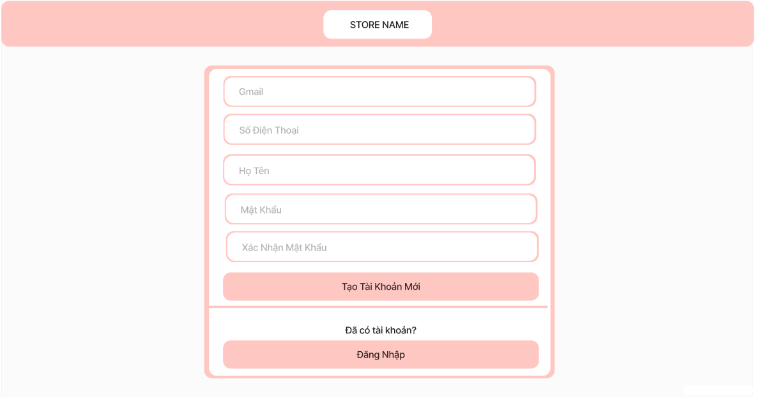

* **Function Details:** user fills in required information then presses the button to creates account. In the case that the information is invalid (Gmail: malformed, does not exist; Phone Number: malformed; Password: must be 8-32 characters, including word and number; Confirm password fail), user will have to fill in again.

## **2. Search Product Feature**

* **Function trigger:** button.
* **Function description:** guests and members can search for products
* **Screen layout:**

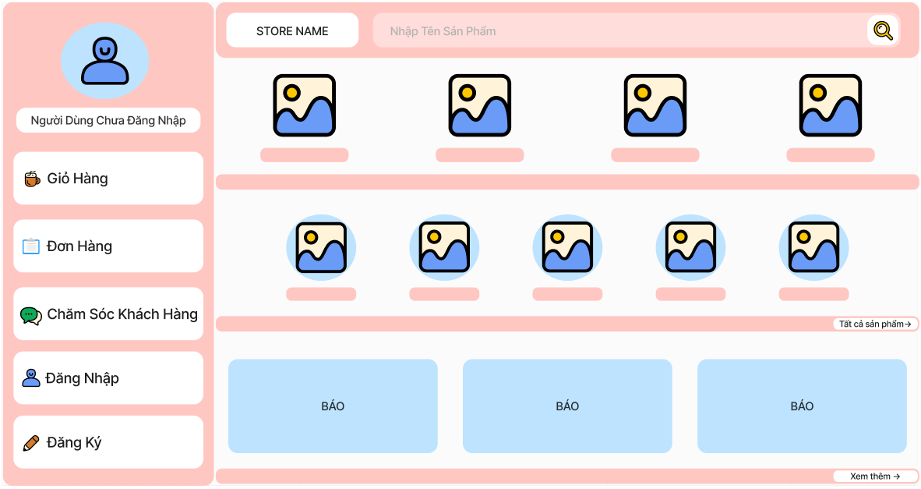

* **Function Details:** guests and members enter one character or a string into the search bar then press the button. If the search bar is blank, nothing will happen.

## **3. Login Feature**

* **Screen layout:**

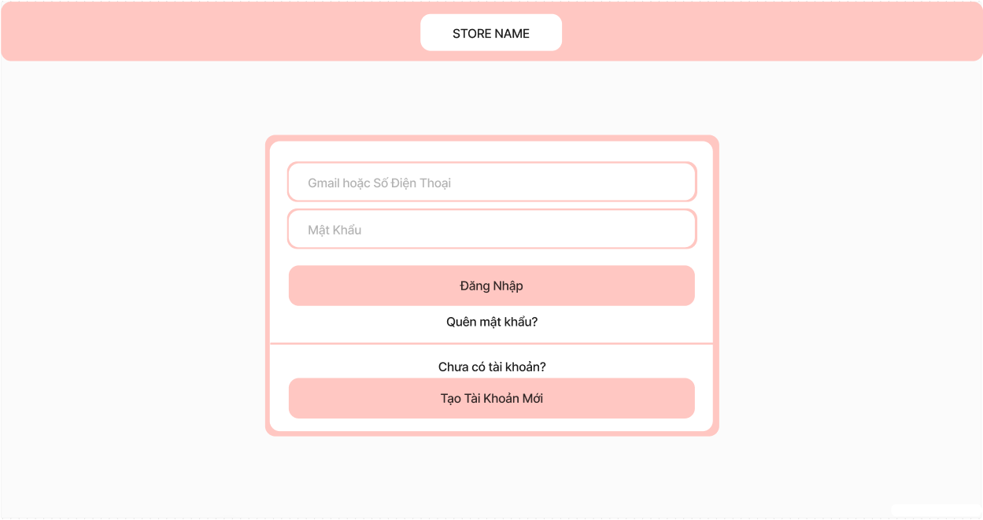

### **a. Login via Gmail**

* **Function trigger:** button.
* **Function description:** customers who have already created an account can login via Gmail and Password.
* **Function Details:** user fills in required information then presses the button to creates account. In the case that the information is invalid (Gmail: malformed, does not exist; Password failed), user will have to fill in again.

### **b. Login via Phone Number**

* **Function trigger:** button.
* **Function description:** customers who have already created an account can login via Phone Number and Password.
* **Function Details:**  user fills in required information then presses the button to creates account. In the case that the information is invalid (Phone Number: malformed, does not exist; Password failed), user will have to fill in again.

## **4. View Product List Feature**

### **Customer**

* **Screen layout:**

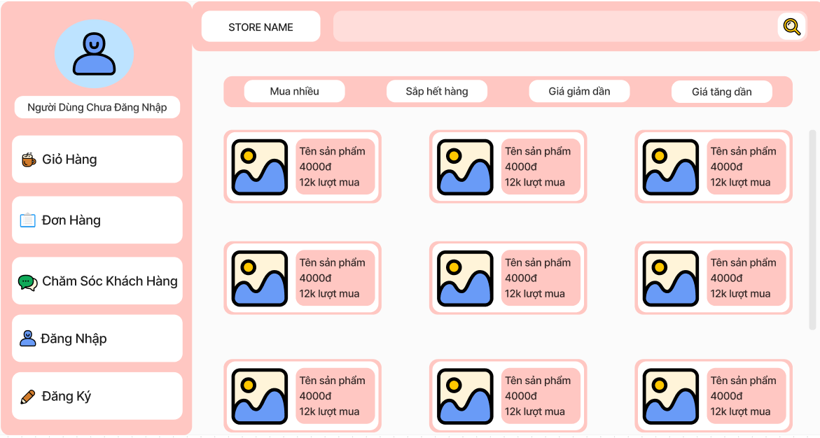

### **View All Products**

* **Function trigger:** button or navigation path.
* **Function description:** all the products will be shown.
* **Function Details:** after customers click on “show all products”, they will be redirected to the product list page.

### **View All Product by Brand**

* **Function trigger:** button or navigation path.
* **Function description:** all the products in a brand will be shown.
* **Function Details:** after customers click on a brand, they will be redirected to the product list page of that brand

### **View All Product by Category**

* **Function trigger:** button or navigation path.
* **Function description:** all the products in a category will be shown.
* **Function Details:** after customers click on a category, they will be redirected to the product list page of that category.

### **Staff**

* **Function trigger:**button or navigation path
* **Function description**: staff can view all products in the managing interface.
* **Screen layout:**

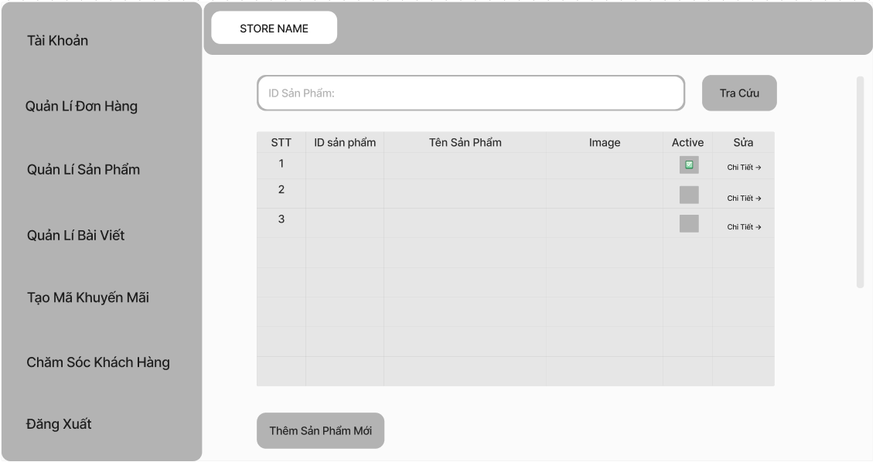

* **Function Details:** staffs click “Manage Product” so they can redirect to the product list page, and the table of products will be shown.

## **5. View Product Details Feature**

* **Function trigger:** button or navigation path.
* **Function description:** information about a product will be shown.
* **Screen layout:**

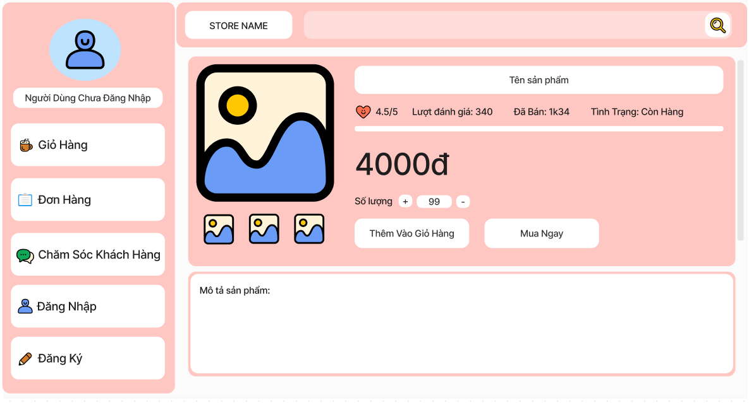

* **Function Details:** detailed product information, including name, price, feedback, status, description will be shown.

## **6. View Feedback Feature**

* **Function trigger:**button
* **Function description**: Members, guests and staffs can see all feedbacks below the product details.
* **Screen layout:**

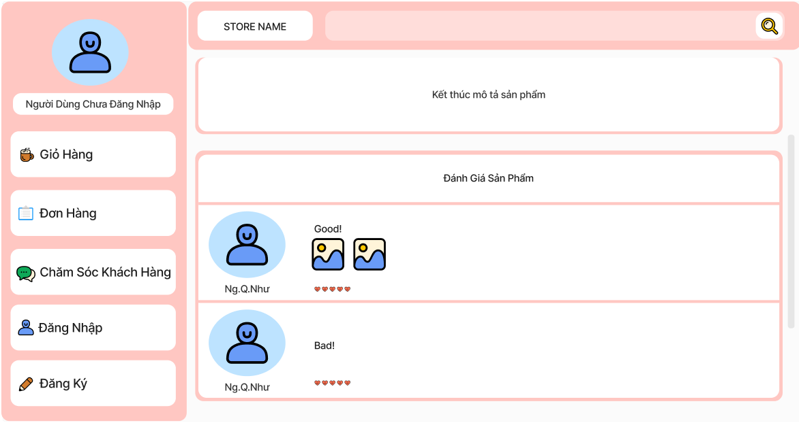

* **Function Details:**Guests, members and staffs access to the product details and scroll down to view all feedbacks.

## **7. Write Feedback Feature**

* **Screen layout:**

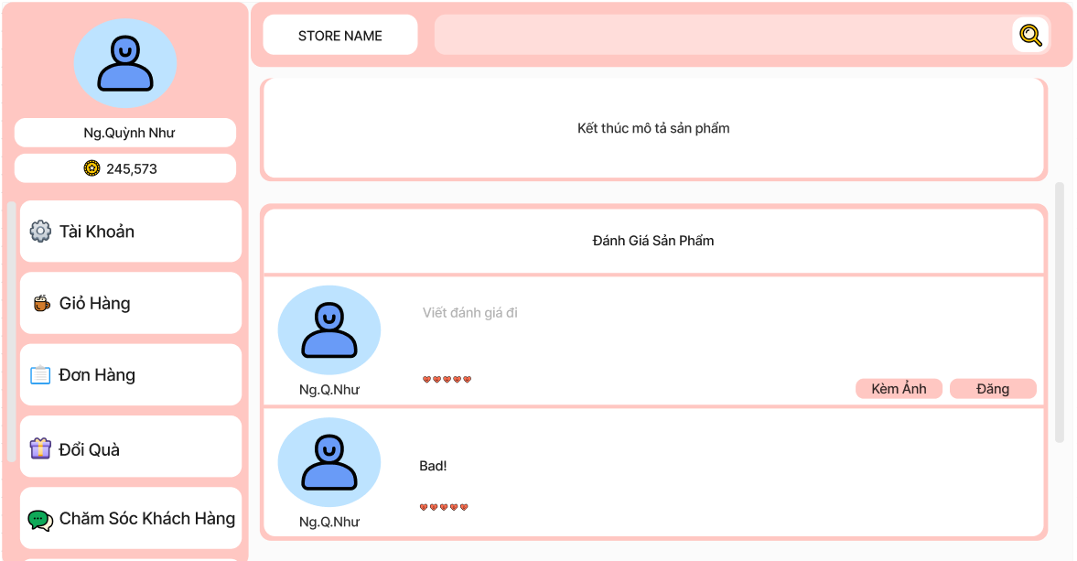

### **a. Feedback with Text**

* **Function trigger:**button
* **Function description**: Members can give their opinions about the purchased product into the text box .
* **Function Details:**After buying, a textbox will appear in the feedback part below the product details for members to write their opinions in, then click the “Upload” button.

### **b. Feedback with Image**

* **Function trigger:**button
* **Function description**: Members can upload their purchased product for others members know about quality of good
* **Function Details:**Members click the “Add Image” button to upload photos into the textbox then click the “Upload” button.

## **8. View Article List Feature**

### **Customer**

* **Function trigger:**button or navigation path
* **Function description**: Members, guests and staffs can view articles
* **Screen layout:**

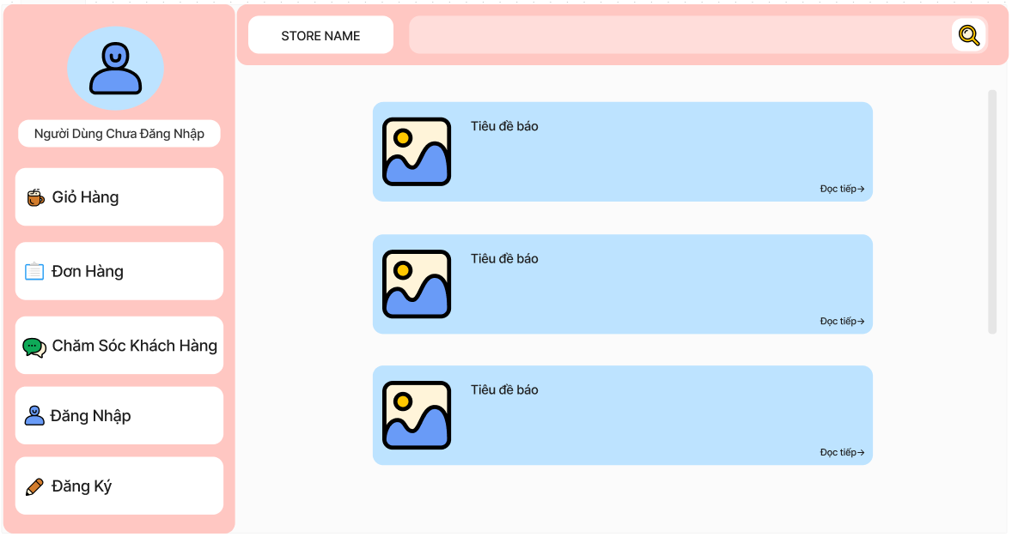

* **Function Details:** Guests, members and staffs click “View all articles” in the homepage so they can redirect to article list to see all blogs.

### **Staff**

* **Function trigger:**button or navigation path
* **Function description**: staff can view all articles in the managing interface.
* **Screen layout:**

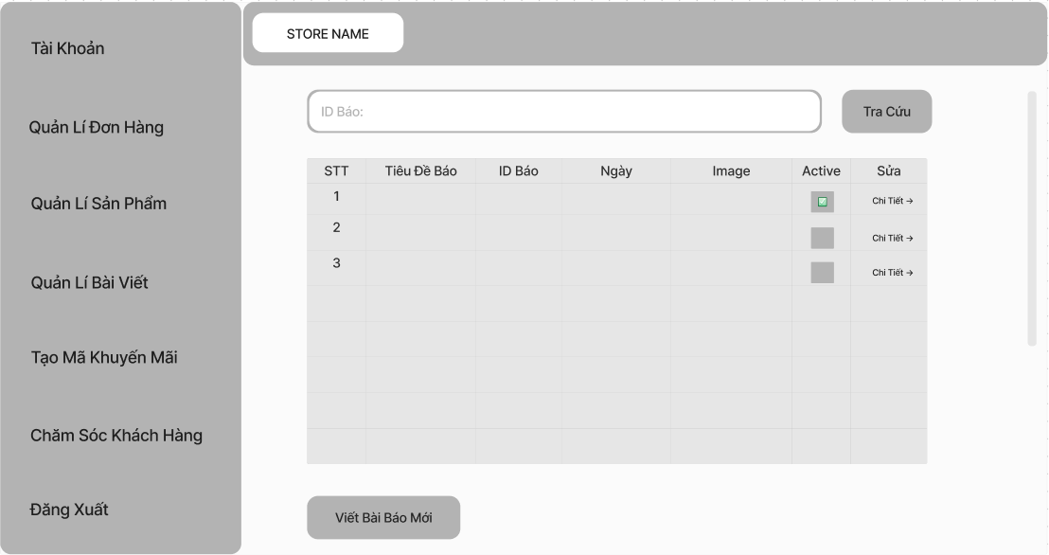

* **Function Details:** staffs click “Manage Article” so they can redirect to the article list page, and the table of articles will be shown.

## **9. View Article Details Feature**

* **Function trigger:**button or navigation path
* **Function description**: Members, guests and staffs can view the information which is written in an article.
* **Screen layout:**

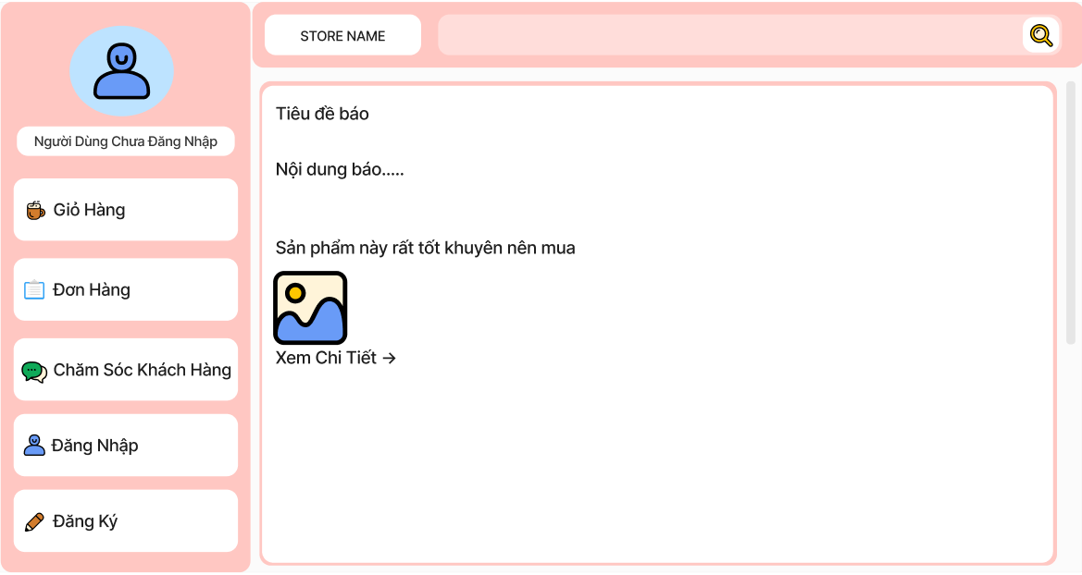

* **Function Details:** Guests, members, and staff click “Read more” in the article list to navigate and view the information in the article.

## **10. Create Order Feature**

* **Function trigger:**button
* **Function description**: Members, guests can buy products which are added into the cart
* **Screen layout:**

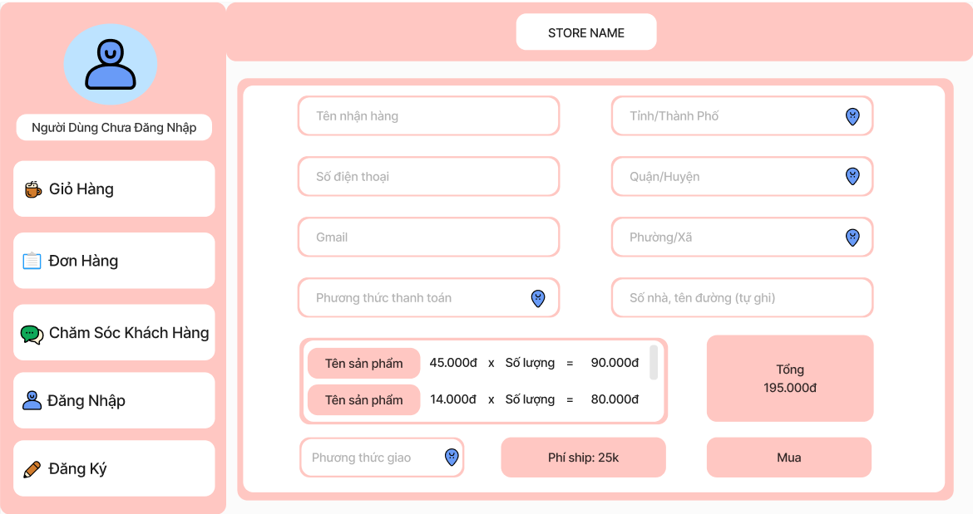

* **Function Details:** Members click “Buy Now” to access Make Order Page then fill required information and click “Checkout” to create order.

## **11. Choose Payment Feature**

### **a. Ship COD**

* **Function trigger:** button.
* **Function description:** guests and members can choose the payment method as cash on delivery.
* **Function Details:** While creating an order, customers can click on the COD payment method, meaning the order will be delivered to the customer and then collected directly from them.

### **b. E-Payment**

* **Function trigger:** button.
* **Function description:** guests and members can choose the payment method as electronic payment.
* **Function Details:** While creating an order, the customer can click on the electronic payment method, and after clicking the buy button, the customer will be redirected to the QR code scanning page to proceed with the payment.

## **12. Transfer Payment Feature**

* **Function trigger:** button.
* **Function description:** Guests and Members can transfer by scanning QR code.
* **Screen layout:**

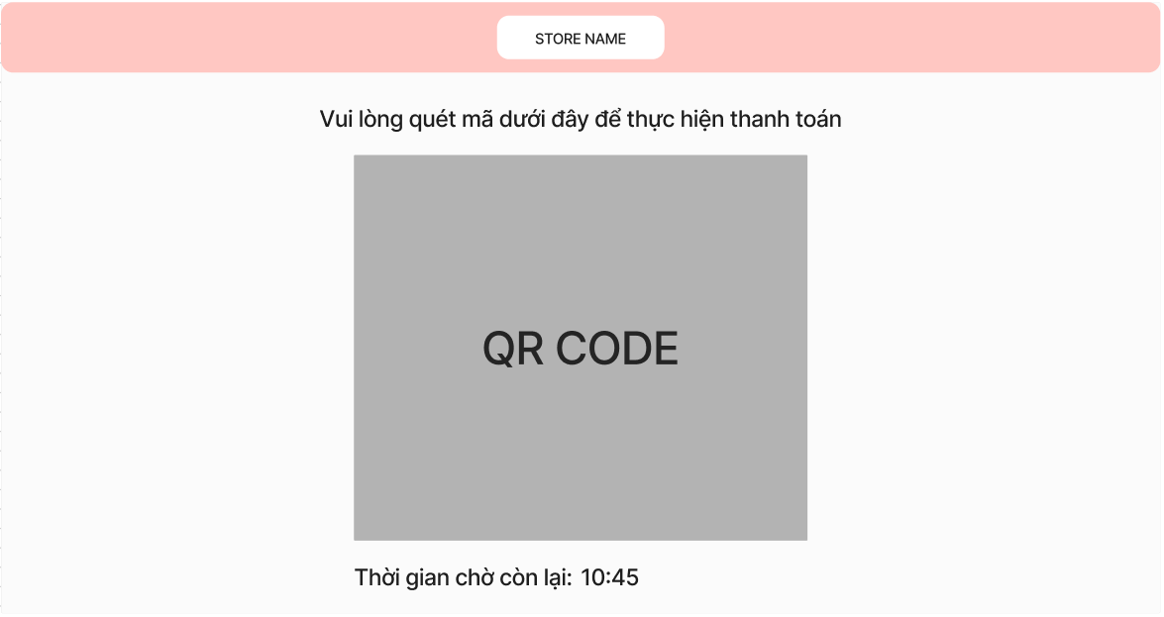

* **Function Details:**  If choosing the payment method as e-payment when creating an order, the customer is redirected to a page containing the QR code to scan the QR code. After a certain period of time, if the customer does not scan the payment code, your order will not be successful.

## **13. View Cart Feature**

* **Function trigger:**  button or navigation path.
* **Function description:** A list of products added to cart will be displayed.
* **Screen layout:**

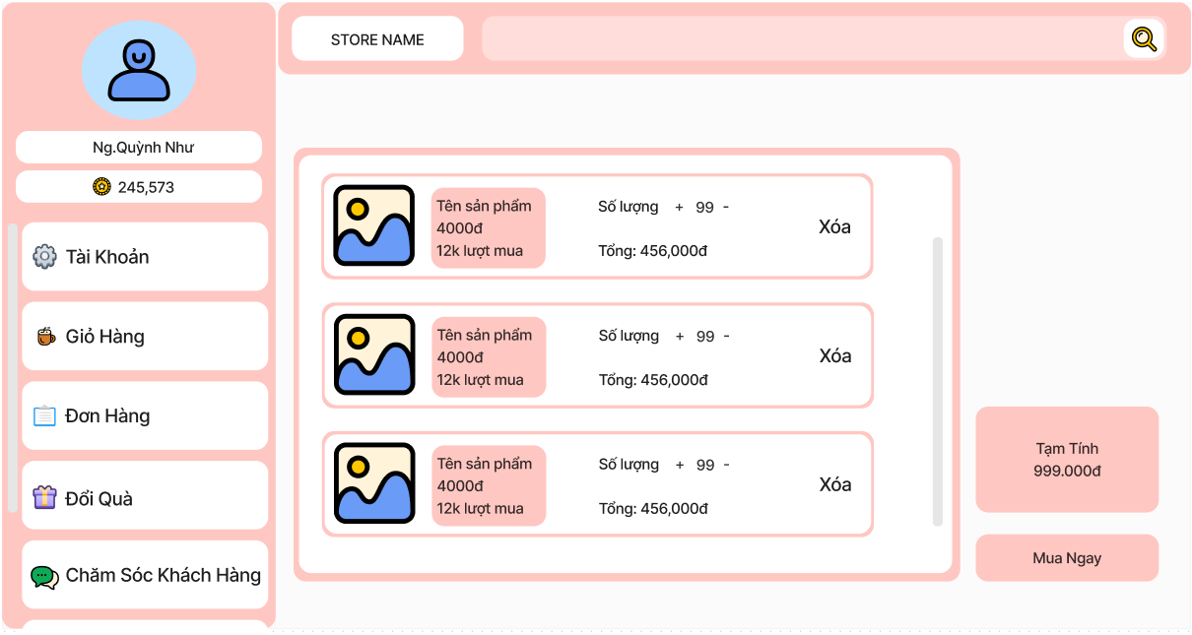

* **Function Details:** The products selected by the customer will appear on this page, including the quantity and price of each product and the total amount of the cart.

## **14. View Order List Feature**

### **Member**

* **Function trigger:** button or navigation path.
* **Function description:** A list of orders done by a member will be displayed.
* **Screen layout:**

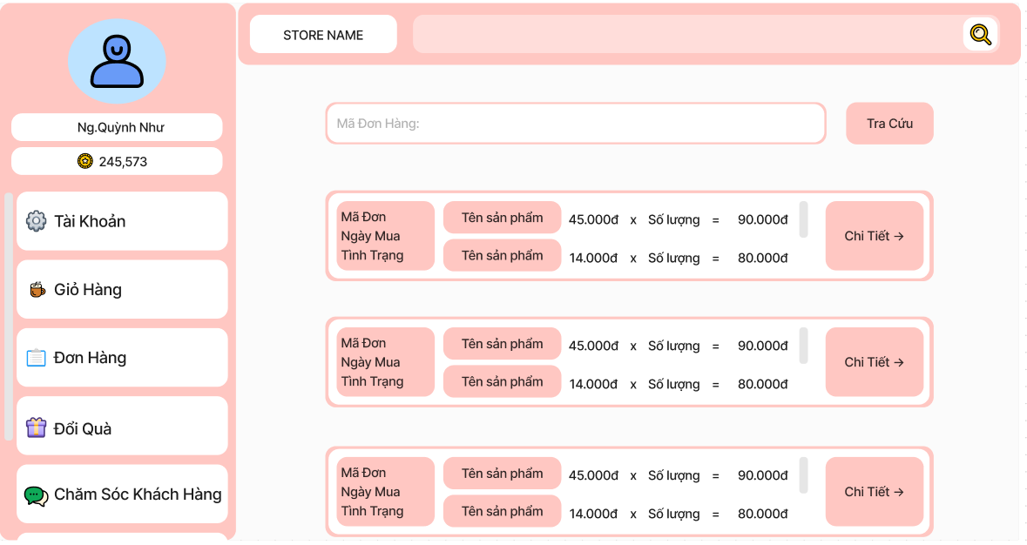

* **Function Details:** The member's purchase history will be displayed on the page, including information about the products in the order, and you can also view more details of each order.

### **Staff**

* **Function trigger:** button or navigation path.
* **Function description:** staff can view all orders in the managing interface.
* **Screen layout:**

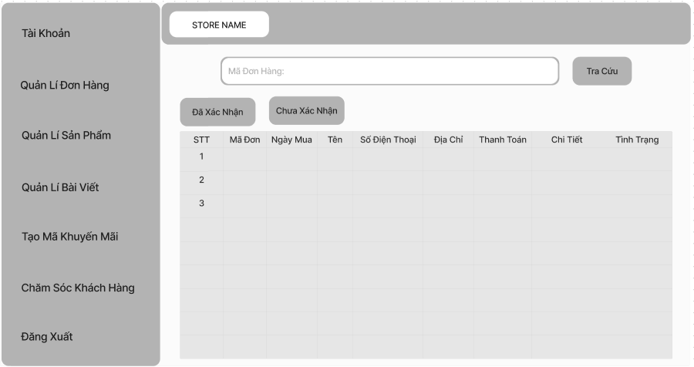

* **Function Details:** staffs click “Manage Order” so they can redirect to the order list page, and the table of orders will be shown.

## **15. View Order Details Feature**

### **Customer**

* **Function trigger:** button or navigation path.
* **Function description:** All information of an order will be displayed.
* **Screen layout:**

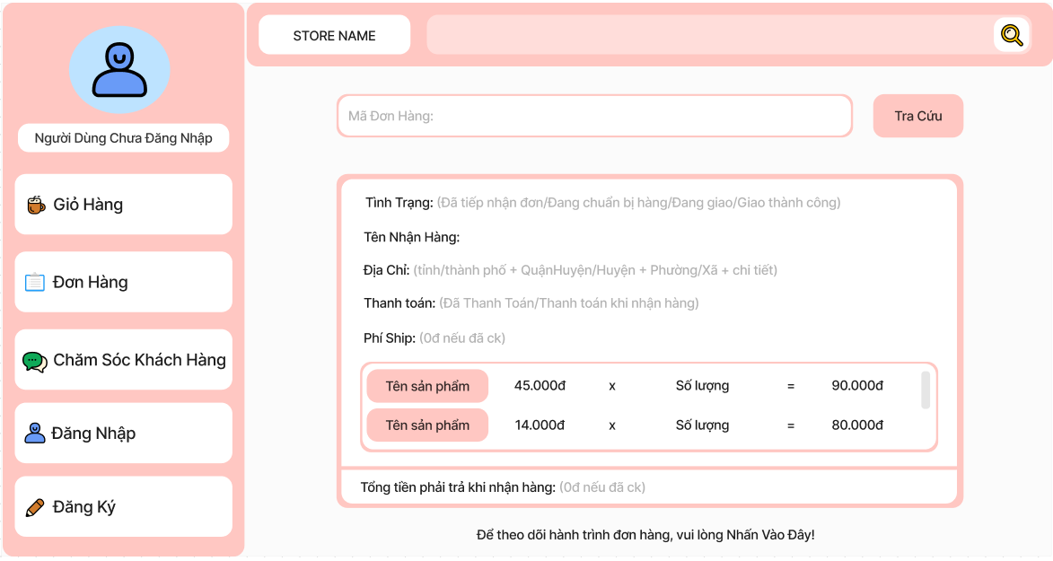

* **Function Details:** When the customer enters the order code and clicks the search button, the order information will appear, including information about the buyer and product, order status, and tracking.

### **Staff**

* **Function trigger:** button or navigation path.
* **Function description:** All information of an order will be displayed in the managing interface.
* **Screen layout:**

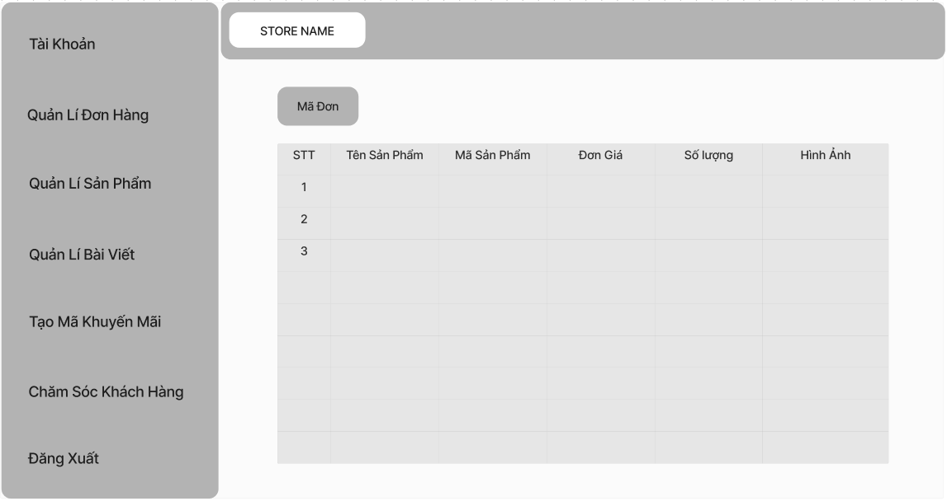

* **Function Details:** Staff click “Detail” of an order in the order list page so they can redirect to the order detail page, and the detail of that order will be shown.

## **16. Chat Feature**

* **Function trigger:** Button and navigation path.
* **Function description:** Guests and logged-in users can start a conversation with staff.
* **Screen layout:**

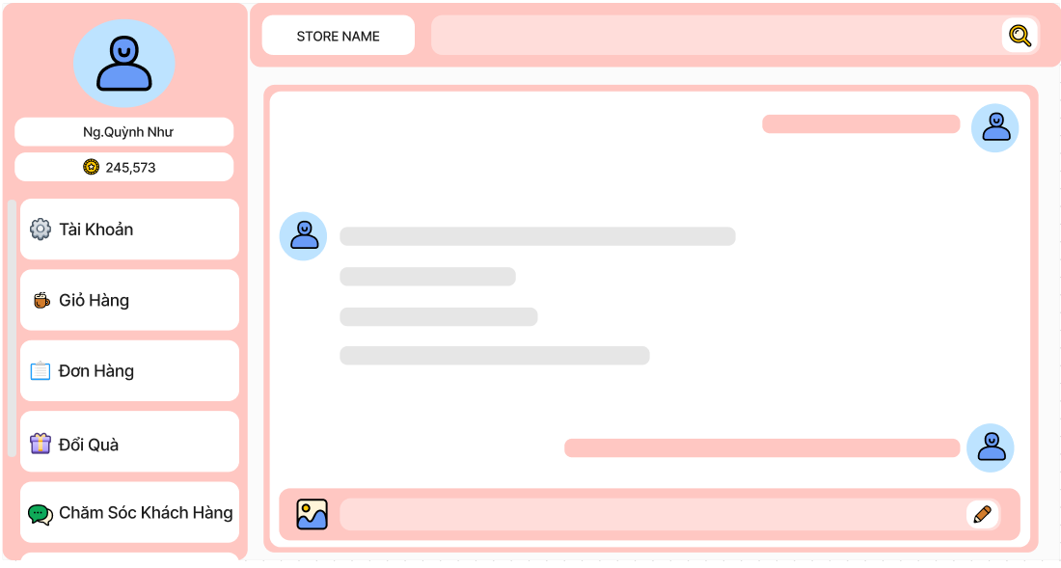

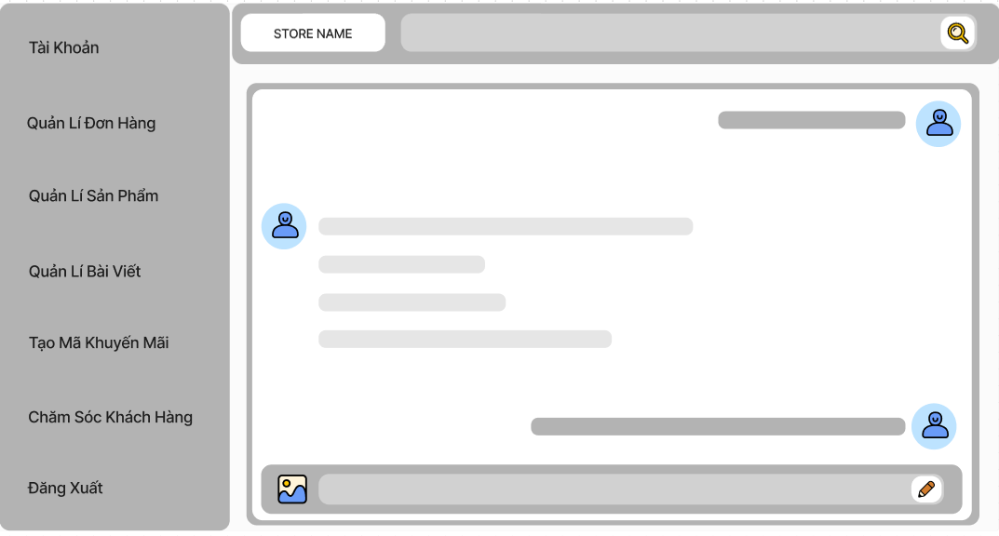

* **Function Details:** When a user clicks on the Customer Service button, they will be redirected to the messaging page where they are able to text and interact with staff. Chat history will not be saved and will be discarded as soon as the user closes the chat tab.

## **17. Redeem Gift Feature**

* **Function trigger:** Button and navigation path.
* **Function description:** A logged-in member can exchange points for some non-system product gifts.
* **Screen layout:**

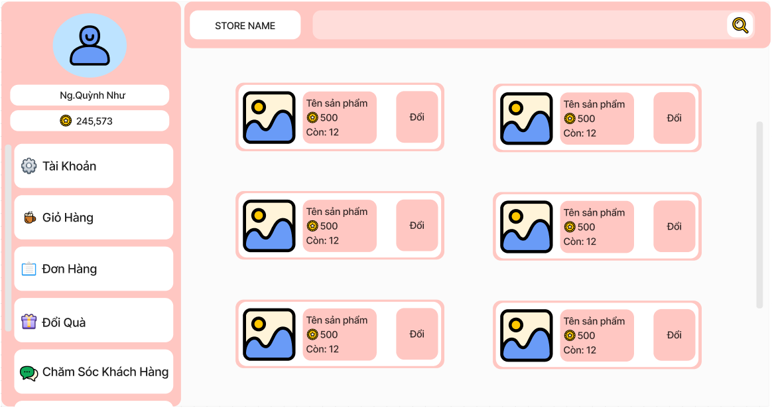

* **Function Details:** Users can use shopping points to exchange any products listed in the gift screen. They cannot revert gifts back to points once they accept the exchange confirmation. The gifts will be sent to the active cart of the user. They cannot remove or adjust the quantity of gifts in the cart.

## **18. Change Password Feature**

### **Function trigger:** Button.

* **Function description:** A logged-in member wants to change the password of their account.
* **Screen layout:**

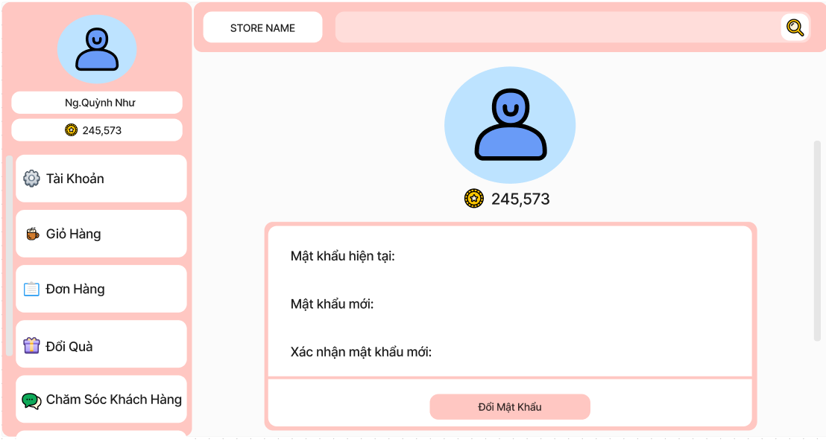

* **Function Details:** User types in their current password, new password and confirms the new one. The new password must satisfy password criteria and must not match the current password. If either the current password is not typed in properly or the new password does not satisfy those criteria, the user cannot proceed to change it.

## **19. Change Gmail Feature**

* **Function trigger:** Button.
* **Function description:** A logged-in member wants to change the Gmail address linked to their account.
* **Screen layout:**

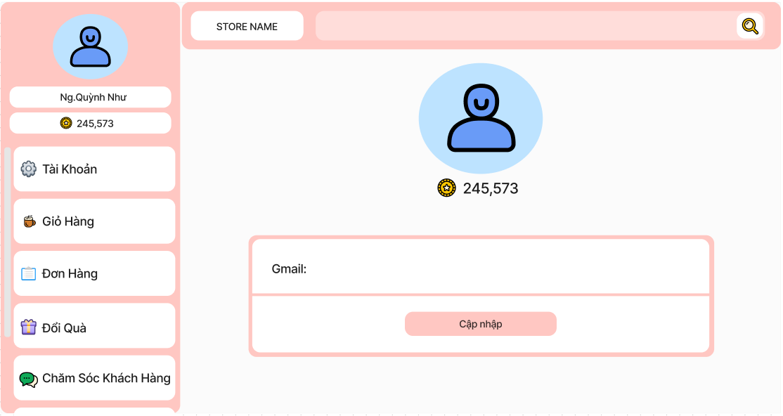

* **Function Details:** User types in their desired email address. The system will send a message to this email with a 6-digit confirmation code. If a user types in a matching code, the updating gmail process will be completed.

## **20. View Profile Feature**

* **Function trigger:** Button.
* **Function description:** A logged-in member wants to view their account information.
* **Screen layout:**

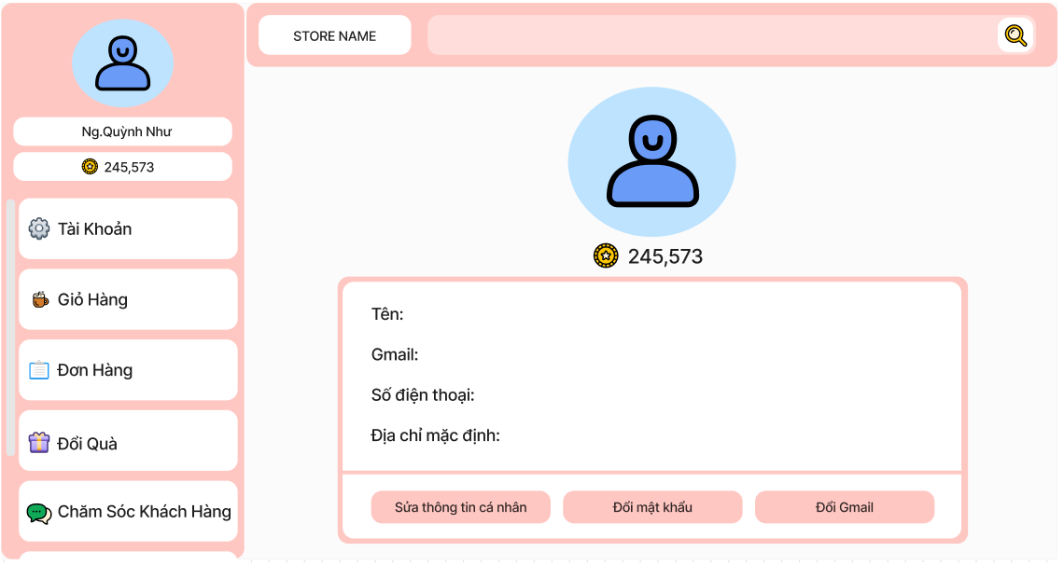

* **Function Details:** User’s basic information will be displayed, including their display name, phone, mail and delivery address.

## **21. Update Profile Feature**

* **Function trigger:** Button.
* **Function description:** A logged-in member wants to change their account information.
* **Screen layout:** 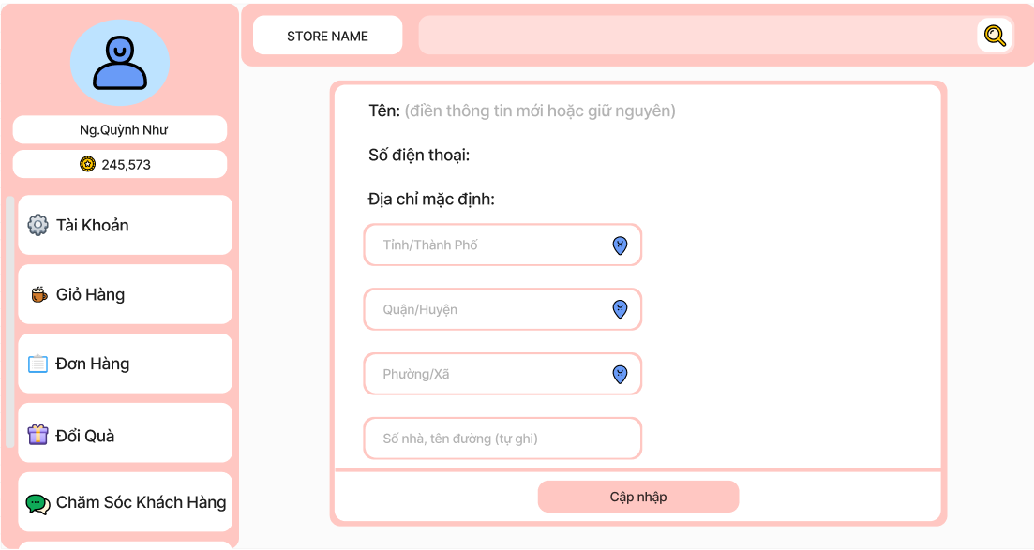
* **Function Details:** Users can change their basic information including display name, phone and delivery address. They click on the Update button to confirm the changes.

## **22. View Voucher List Feature**

* **Function trigger:** Button and navigation path.
* **Function description:** staff can view all vouchers in the managing interface.
* **Screen layout:**

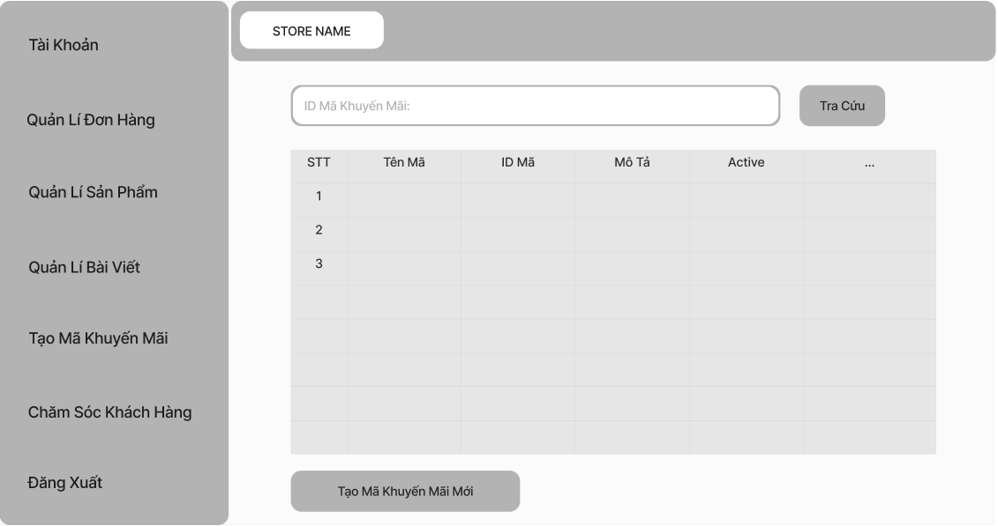

* **Function Details:** staffs click “Manage Voucher” so they can redirect to the voucher list page, and the table of vouchers will be shown.

## **23. Create Voucher Feature**

* **Function trigger:** Button.
* **Function description:** staff can create a voucher.
* **Screen layout:**

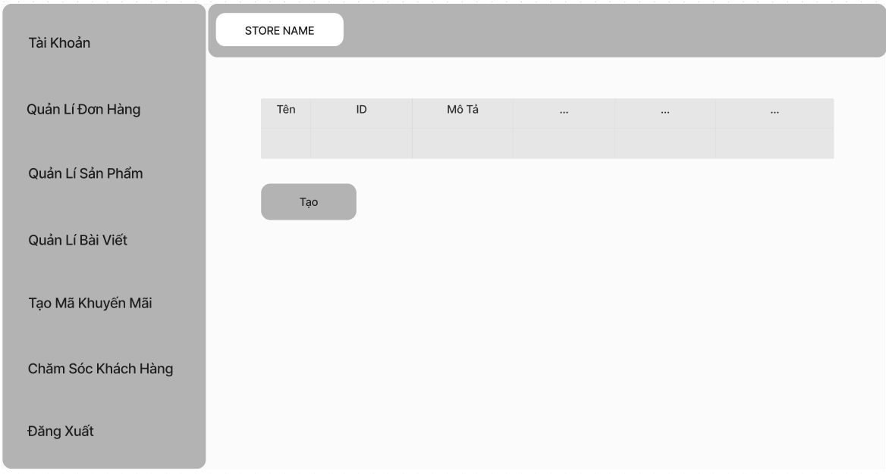

* **Function Details:** Staff click “Create voucher” to access Create Voucher Page then fill required information and click “Create” to create voucher.

## **24. Update Article Feature**

* **Function trigger:** Button.
* **Function description:** staff can update an article.
* **Screen layout:**

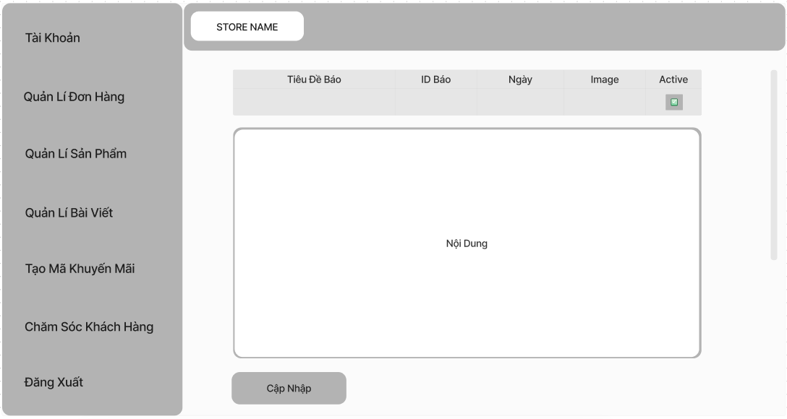

* **Function Details:** Staff can modify an article, including its information and content. Then click on the Update button to confirm the changes.

## **25. Update Product Feature**

* **Function trigger:** Button.
* **Function description:** staff can update a product.
* **Screen layout:**

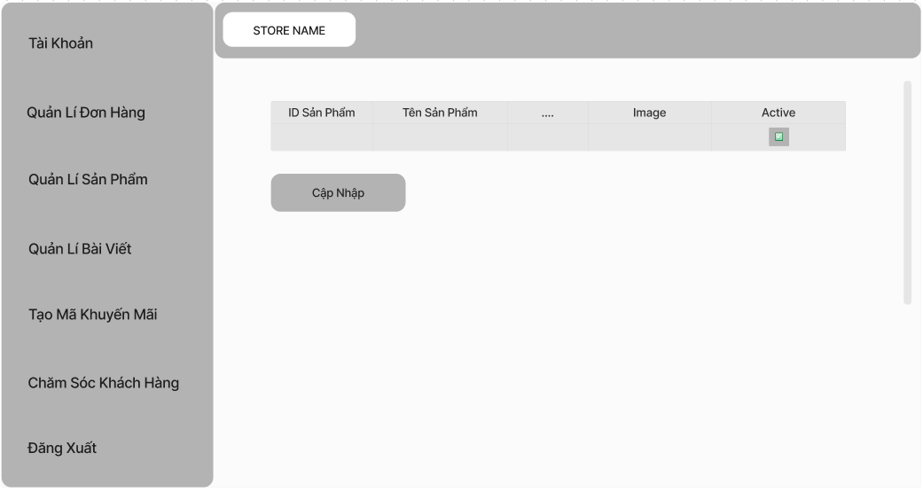

* **Function Details:** Staff can update an article, including its information and images. Then click on the Update button to confirm the changes.

## **26. Write Article Feature**

* **Function trigger:** Button.
* **Function description:** staff can write an article.
* **Screen layout:**

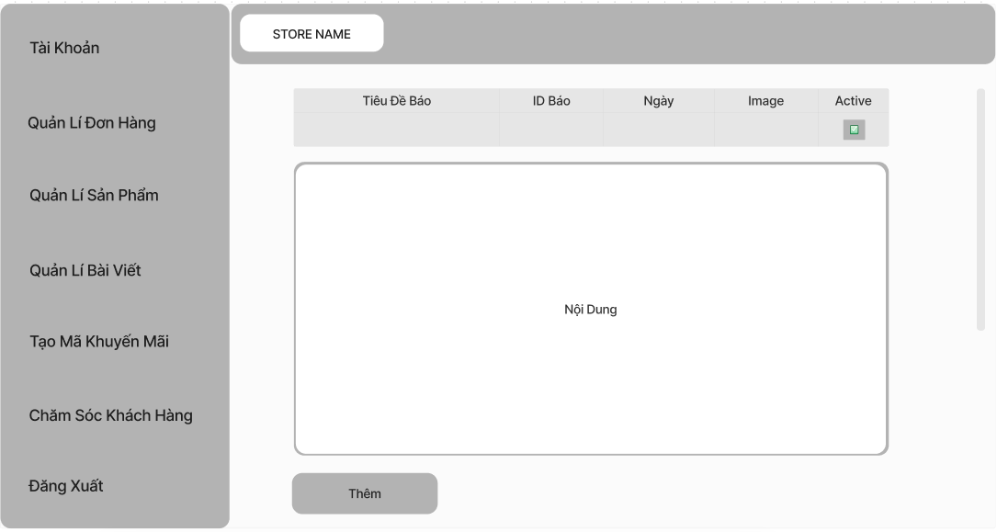

* **Function Details:** Staff can create an article by filling in the required information, writing content, and adding images. Then click “Add” to create an article.

## **27. Create Product Feature**

* **Function trigger:** Button.
* **Function description:** staff can add a product.
* **Screen layout:**

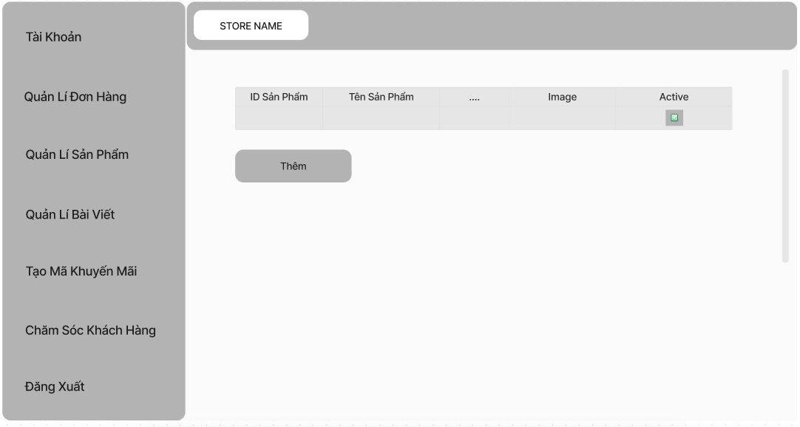

* **Function Details:** Staff click “Add product” to access Create Product Page then fill required information and click “Add” to create product..

## **28. View Account List Feature**

* **Function trigger:** Button.
* **Function description:** The registered account list will be shown for admin.
* **Screen layout:**

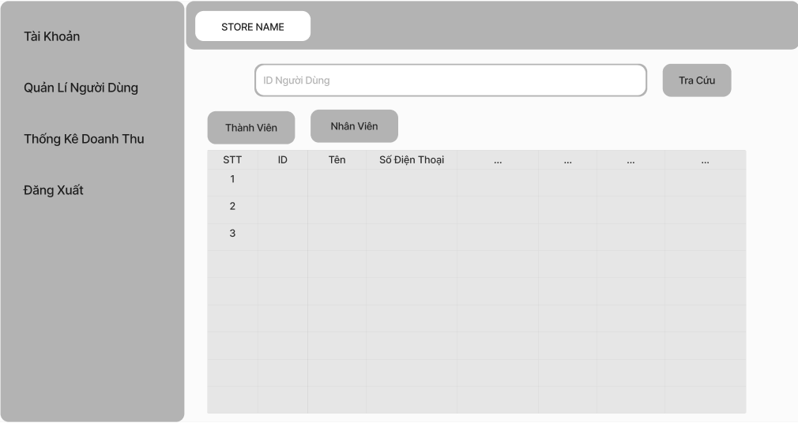

* **Function Details:** admin click “Manage Account” so they can redirect to the account list page, and the table of account will be shown.

1. **Business Rule**

| **ID** | **Rule Definition** | **User Stories** |
| --- | --- | --- |
| BR-01 | Customers can only apply up to 1 voucher in-use shopping cart. | Use Voucher |
| BR-02 | Members can only submit product feedback after purchasing it. | Write Feedback |
| BR-03 | When choosing e-payment, the order will be automatically cancelled if the customer does not transfer money within the specified time. | Transfer Payment |
| BR-04 | Members can only cancel the paid order if staff have not confirmed that order. | View Order Details, Confirm Order |
| BR-05 | Members can collect points, which are used to redeem gifts, by purchasing products. | Redeem Gift |
| BR-06 | For every 1.000đ order payments, members will earn 1 point. | <System> |
| BR-07 | Our vouchers are applied for each shopping cart and will affect the whole shopping cart instead of single product | Use Voucher |