### What do you mean by Linux? Explain its features.

Linux is a Unix-like open-source computer [operating system](https://www.interviewbit.com/operating-system-interview-questions/) (OS) , typically Linux is called Kernel that directly manages hardware and resources of a system such as CPU, memory, and storage, and manages the communication between software and hardware.

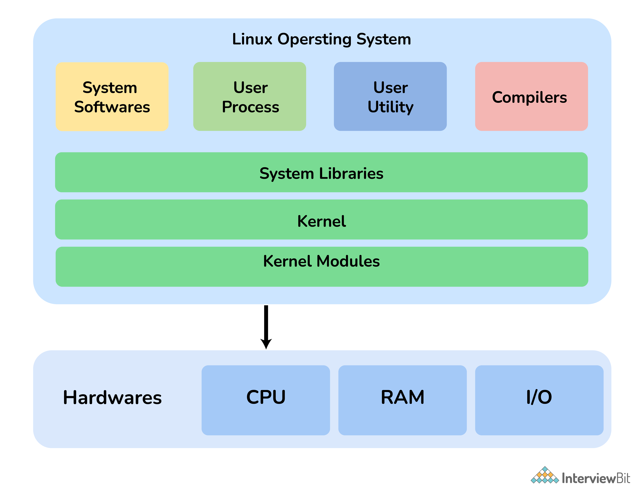

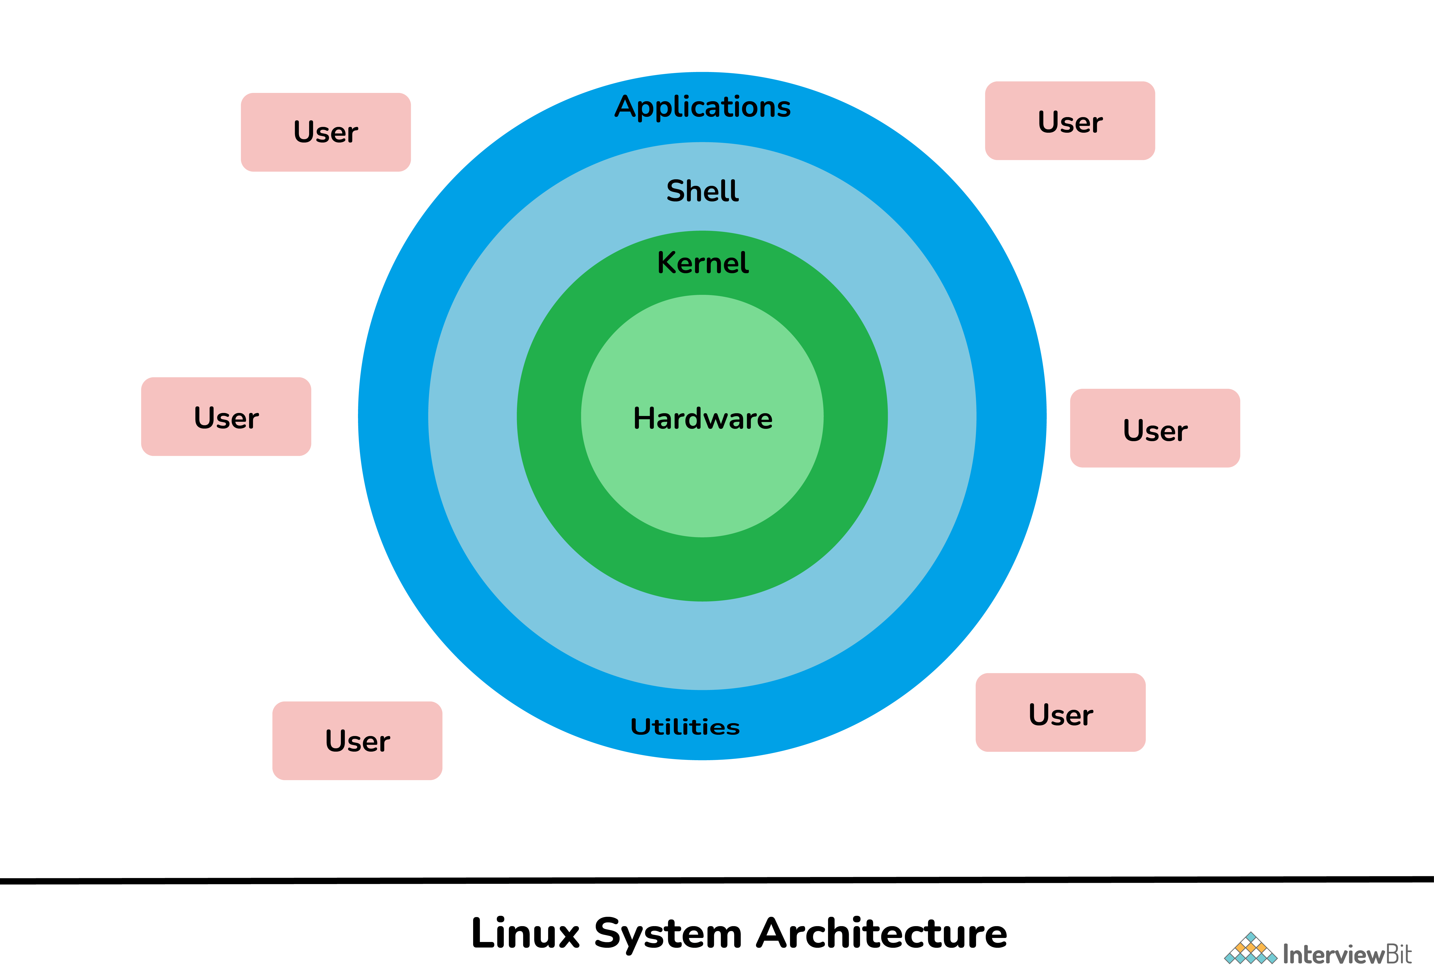

### What is Kernel? Explain its functions.

A kernel is considered the main component of Linux OS. It is simply a resource manager that acts as a bridge between hardware and software.

The kernel decides who will use a resource, for how long and when. It runs your programs or sets up to execute binary files. Its main role is to manage hardware resources for users and is generally used to provide an interface for user-level interaction. A kernel is the first program that is loaded whenever a computer system starts. It is also referred to as low-level system software.

Its other main functions include:

* Memory Management
* Process Management
* Device Management
* Storage Management
* Manage access, and use of various peripherals that are connected to the computer.

### What is Linux Shell? What types of Shells are there in Linux?

Linux shell is a user interface present between user and kernel.

It is used for executing commands and communication with Linux OS. Linux shell is basically a program used by users for executing commands. It accepts human-readable commands as input and converts them into kernel understandable language.

The shell gets started when you log in or open a console (terminal).

The shell is not part of system kernel, but uses the system kernel to execute programs, create files etc.

**Shell Prompt**

There are various ways to get shell access:

* Terminal - Linux desktop provide a GUI based login system. Once logged in you can gain access to a shell by running X Terminal (XTerm), Gnome Terminal (GTerm), or KDE Terminal (KTerm) application.
* Connect via secure shell (SSH) - You will get a shell prompt as soon as you log in into remote server or workstation.
* Use the console - A few Linux system also provides a text-based login system. Generally you get a shell prompt as soon as you log in to the system.

### How do I find out My Current Shell ?

$ cat /etc/shells

### To find out your current shell type

$ echo $SHELL

$ ps $$

$ ps -p $$