### What do you mean by Linux? Explain its features.

Linux is a Unix-like open-source computer [operating system](https://www.interviewbit.com/operating-system-interview-questions/) (OS) that directly manages hardware and resources of a system such as CPU, memory, and storage, and manages the communication between software and hardware.

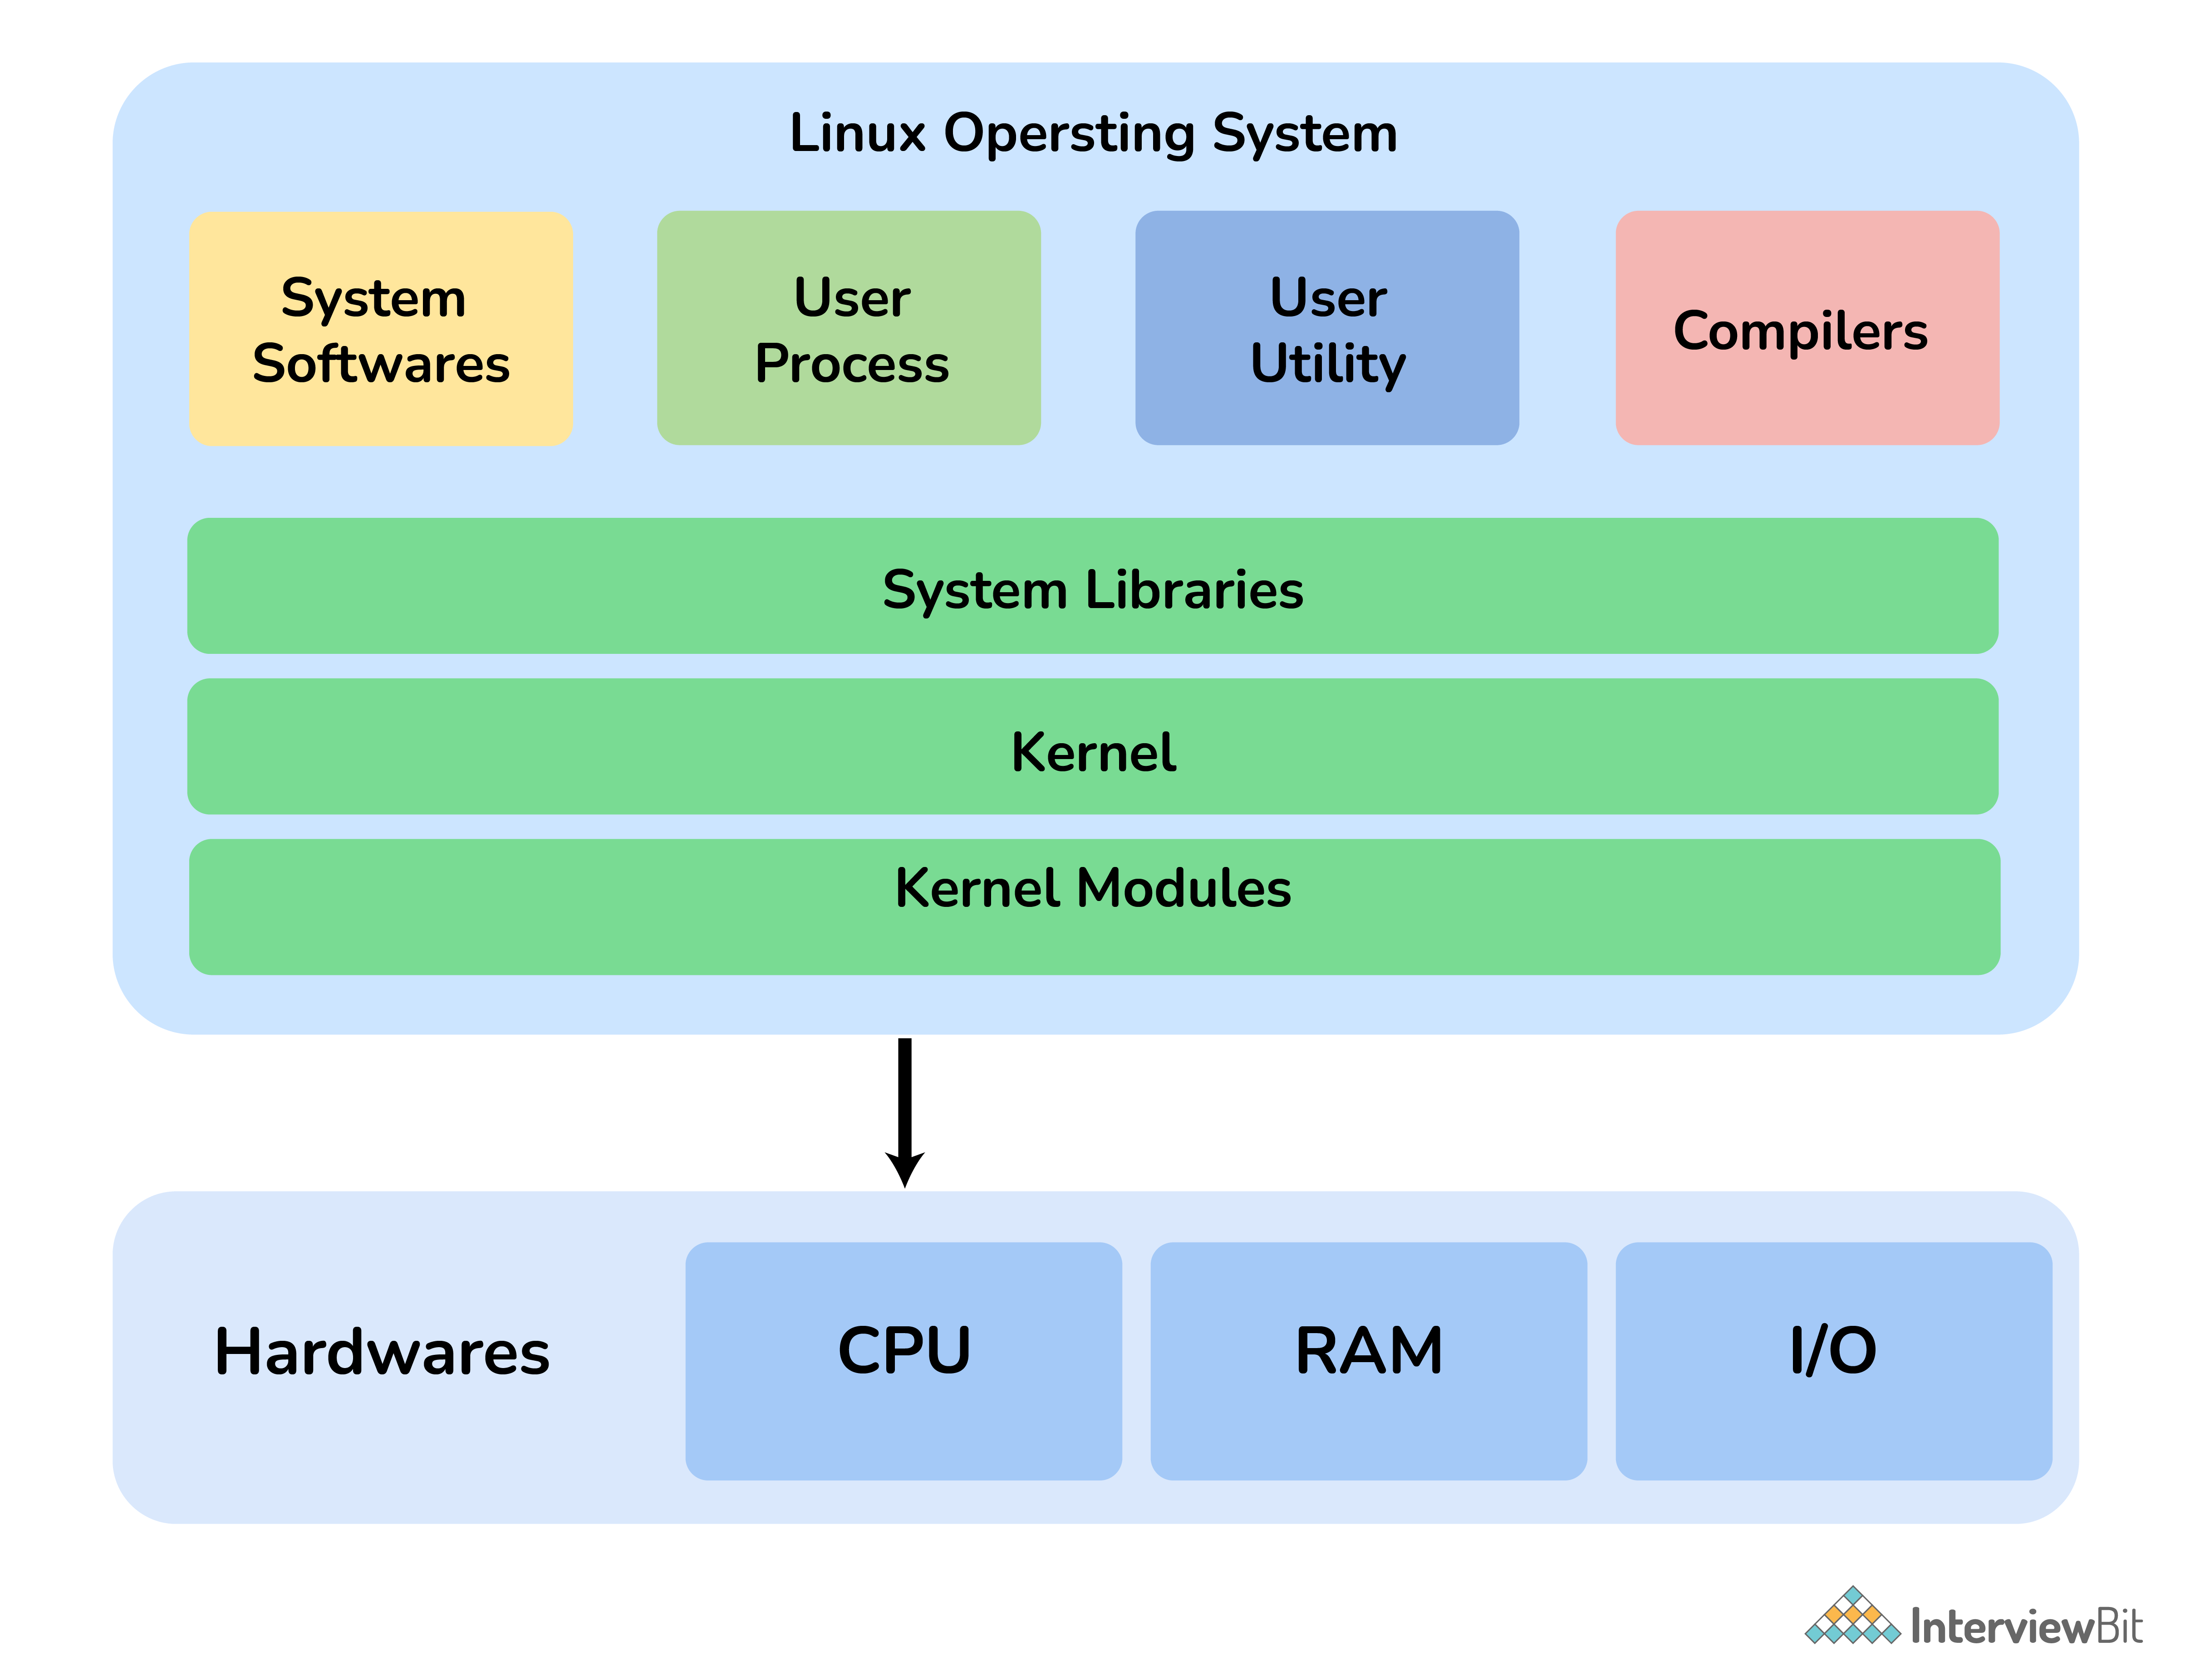

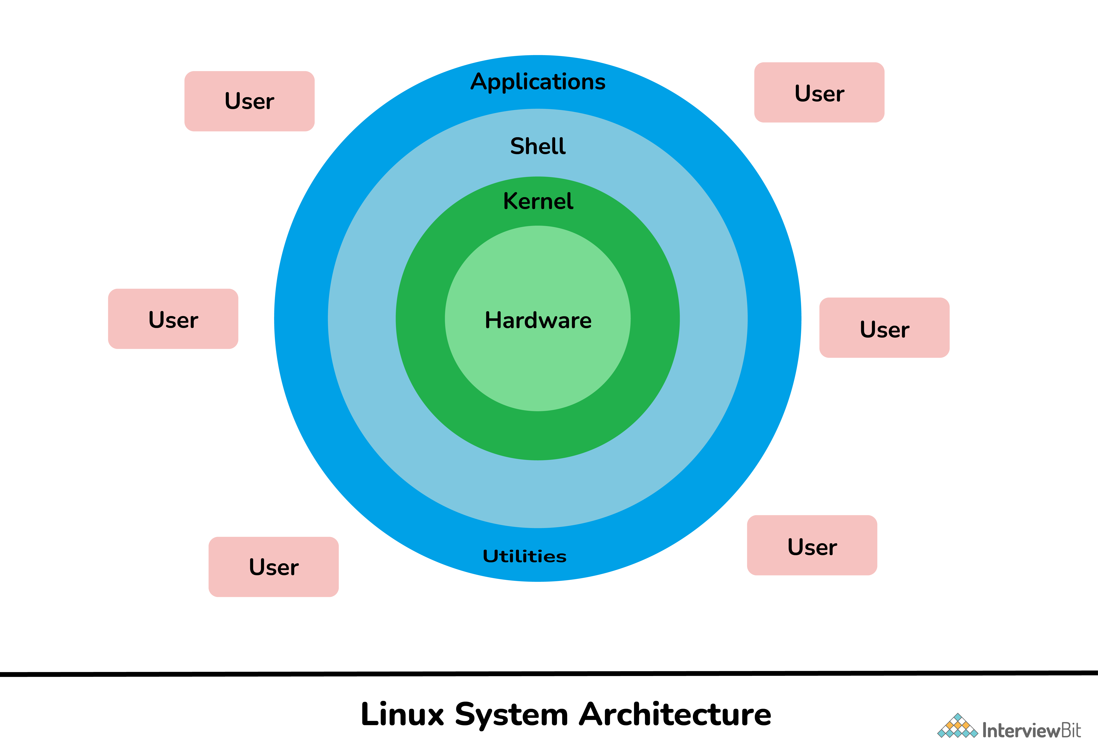

### What is Kernel? Explain its functions.

A kernel is considered the main component of Linux OS. It is simply a resource manager that acts as a bridge between hardware and software. Its main role is to manage hardware resources for users and is generally used to provide an interface for user-level interaction. A kernel is the first program that is loaded whenever a computer system starts. It is also referred to as low-level system software.

Its other main functions include:

* Memory Management
* Process Management
* Device Management
* Storage Management
* Manage access, and use of various peripherals that are connected to the computer.

### What is Linux Shell? What types of Shells are there in Linux?

Linux shell is a user interface present between user and kernel. It is used for executing commands and communication with Linux OS. Linux shell is basically a program used by users for executing commands. It accepts human-readable commands as input and converts them into kernel understandable language.

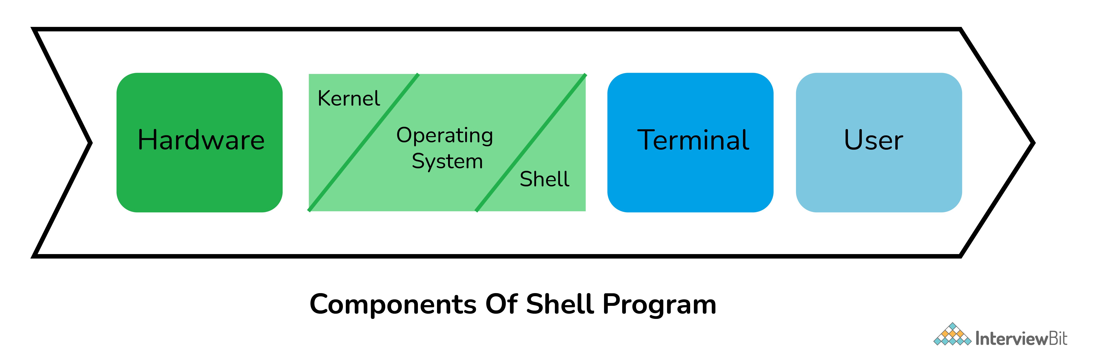

### What are filesystems?

* A *filesystem*is the methods and data structures that an operating system uses to keep track of files on a disk or partition; that is, the way the files are organized on the disk.

/bin /usr/bin :: Contains user Binaries and commands

/sbin /usr/sbin :: It contains system binaries and admin commands that can only be run by root

/etc All config file

/etc/opt :: Host specifc conifg files

/etc/skel:: When new user created files from dir copied to user home dir

/dev character device & block device [hard disk/ DVD CD]

/tmp temporary files

/boot boot files

/home user gome dir

/lib shared lib :: Libraries are basically codes that can be used by the executable binaries

/mnt Mount Dir

/opt optional software

/root rot home

/var variable data files

/var/log

/var/log/wtmp which logs all logins and logouts into the system

var/log/messages.

Contains global system messages, including the messages that are logged during system startup. There are several things that are logged in /var/log/messages including mail, cron, daemon, kern, auth, etc.

/var/log/auth.log

Contains system authorization information, including user logins and authentication machinsm that were used

/var/log/lastlog

Displays the recent login information for all the users. This is not an ascii file. You should use lastlog command to view the content of this file.

/var/log/secure

Contains information related to authentication and authorization privileges. For example, sshd logs all the messages here, including unsuccessful login.

/proc

Its virtual file system which contains information about currently running process and kernel parameters. . The content of the proc directory is used by a number of tools to get runtime system information.

**/proc/version**  Kernel version, gcc version, and Linux distribution installed

**/proc/uptime**  Uptime information (in seconds).

**/proc/stat**  Record or various statistics kept from last reboot

**/proc/swap**  Information about swap space

**/proc/mounts**  List of all mounts in use by system

**/proc/loadavg**  System load average

**/proc/filesystem**s Current filesystems supported by the kernel

**/proc/cpuinfo**  CPU & no of Processor info

**/proc/meminfo**  MemTotal Total amount of usable RAM

MemFree

Cached

### Linux FileManagement

1] Absoute path && Relative path

2] pwd || cd || ls |

## **What is Inode Number ?**

An inode is a unique number assigned to files and directories while it is created. The inode number will be unique to entire filesystem which container the metadata of the file and directories.

File types | perm | uid | gid |timestamp |no of link

The df -i command can be used to check how many inodes are free and left unused in the filesystem.

* $ df -i
* $ df -i /dev/sda1

## **Soft link vs Hard link**

|  |  |
| --- | --- |
| **Soft Link {l}** | **Hard Link {-}** |
| $ln -s <source_file> <link_fle>  link file should be already exist in same directory | $ln <source_file> <link_file> |
| A symbolic or soft link is an actual link to the original file.  It does contain the content just only the link | hard link is a mirror copy of the original file. |
| Inode number & permission is different | Inode number & permission is same.  permissions will be updated if we change the permissions of source file |
| If you delete the original file, the soft link has no value, because it points to a non-existent file. This situation is referred to as a *dangling soft link* | If you delete the original file, the hard link can still has the data of the original file. Because hard link acts as a mirror copy of the original file. |
| Span Across the file system, | Only within filesystem |
| Both files & directories | Only files |
| Usage  If one file system hass no memory but need to create 1gb, you can create in another filesystem & make softlink  #mkdir script/hello.sh  #ln -s script/hello.sh welcome  #./welcome | Backup |

## **Linux Redirection**

> file Redirect standar output to overwrite the file

>> file append

2> file redirecting std error

2>/dev/null Discarding error

> filename 2<&1 output and error in same file

>> filename 2<&1 append

## **Linux Pipe and Tee**

**Pipe**

Pipe connects std output of first command to the standard input of next command

$ ls -l /usr/bin | wc -l

**Tee**

Will copy it std input to std output also redirects its std output to the files names as arguments

$ ls -l | tee /tmp | less

$ ls -l > /tmp | less >>>> wrong way

## **User Mgmt**

**1] /etc/passwd** Keeps the user account and password information

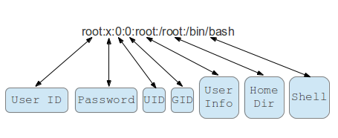

**2] /etc/shadow**

Holds the encrypted password of the corresponding account

**3] /etc/login.def**

The /etc/login.defs file provides default configuration information for several user account parameters. The useradd, usermod, userdel, and groupadd commands, and other user and group utilities take default values from this file. Each line consists of a directive name and associated value.

Umask | UID | GID | Password Ageing control

**USERADD | USERMOD**

**-d** = To modify the directory for any existing user account.

**-m** = moving the contents of the home directory from existing home dir to new dir

**USERDEL**

**To find “unowned files and directories by running**

$ find / nouser -o -nogroup 2> /dev/null

## **Group Mgmt**

* /etc/group
* /etc/gshadow

**Primary or login group**

* The **primary group** is the one that’s recorded in the **/etc/passwd** file.
* Each user can belong to exactly one primary group
* By default primary group owns new files created by the user
* The name of the primary group is the same as the name of the user. Each user must belong to exactly one primary group.

**Secondary or supplementary group**

* Secondary group memberships show up in the /etc/group file.
* Users can belong to up to 15 secondary groups.
* Used to grant certain privileges to a set of users. A user can be a member of zero or more secondary groups.

## **Switch User**

***SU VS SU –***

*su - invokes a login shell after switching the user. A login shell resets most environment variables, providing a clean base.*

su – *changes our path to the path of the target user, while*su *doesn’t*

*su just switches the user, providing a normal shell with an environment nearly the same as with the old user.*

## **Sudo Access**

*SUDO configuration file : /etc/sudoers*

* *The visudo command opens a text editor like normal, but it validates the syntax of the file upon saving. This prevents configuration errors from blocking sudo operations, which may be your only way of obtaining****root****privileges.*

*User Host = (Runas) Command*

%wheel ALL = (ALL) ALL

## **/etc/skel**

The**/etc/skel** directory contains files and directories that are automatically copied over to a new user’s [**home directory**](https://www.linuxgurus.in/linux-home-directory/) when such a user is created by the useradd program. skel is derived from the “skeleton”. Below is shown a picture.

These files are known as **skeleton files**. Typically, they’re hidden files that affect the user environment, such as**.bash_history**, which records each command you run, and **.bashrc**, which sets the default values used with the **bash shell**.

## **File Permission**

Chmod chown chgrp

Setuid setguig stickybit

## **Access Control List ??**

*particular user is not a member of group created by you but still you want to give some read or write access,*

***setfacl****and****getfacl****are used for setting up ACL and showing ACL respectively*

* *Access ACLs: Access ACLs are used for granting permissions on any file or directory.*
* *Default ACLs: Default ACLs are used for granting/setting access control list on a specific directory only.*

*“+” at the end indicates that there are ACL settings assocated with this file | directory*

## **General Commands**

Less && more

File File command is used to determine the type of a file.

wc word count

-l lines

-w words

-c characters

dd