LSTM + 100

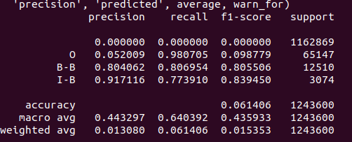

LSTM + CRF + 100

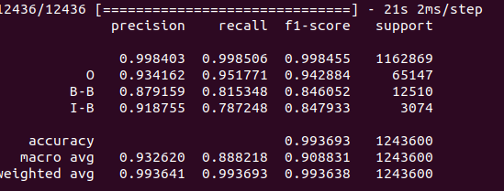
CNN + LSTM + CRF (100)

