Supplementary Methods
Selection criteria
Prevalent cases of MDD were identified in the UK Biobank data, i.e., patients with records indicating that they received an MDD diagnosis before their proteomics blood sample was collected were included in this cohort. To find these prevalent cases, we used the structured and semi-structured data available in UK Biobank. ICD-9 and ICD-10 diagnosis records from the hospital inpatient data, first occurrences records, and death register records, indicating a patient had MDD, were included in the selection for the discovery cohort based on the structured data, and in addition, ICD-9 and ICD-10 records from the semi-structured primary care UK Biobank data was used to find any MDD patients not yet identified in the structured data. Using these inclusion criteria, we found 565 MDD patients with ICD-10 records, an additional 7 patients with only ICD-9 records, and another 3,789 patients based on first occurrences records. Most of the patients with ICD-9 and ICD-10 inpatient hospital records were also identified as MDD patients based on the first occurrences data, but vice versa many patients with first occurrences MDD records did not have inpatient hospital data, as the first occurrences data is also based on self-report of medical conditions and does not require hospitalization. No records indicating MDD were found in the death register data. This cohort comprised the Replication cohort.
Clinical exclusion criteria were subsequently applied to create a focused MDD cohort, i.,e., the Discovery cohort. Patients that took certain medications (antidepressants, antipsychotic agents, mood stabilizers, stimulants, opioids, or benzodiazepines) in a 24-month period before blood collection were excluded, as well as patients with HIV, HBV, or HCV infection records, patients with abnormally high levels of creatinine, total bilirubin, or aspartate aminotransferase, patients with records of comorbid disorders (bipolar disorder, psychotic disorder, borderline personality disorder, antisocial personality disorder, OCD, PTSD, dementia, intellectual disability, other neurocognitive disorders, significant cardiac disorder, seizures, hepatitis, liver disease, or systemic illness), patients with records of a drug or alcohol addiction, or indicating a risk for suicide. Applying these exclusion criteria resulted in a cohort of 1,403 prevalent MDD cases from the UK Biobank data.

Nested Random Forest
A workflow for performing nested Random Forest via 5 outer x 5 inner loops is illustrated in Supplementary Figure 1.
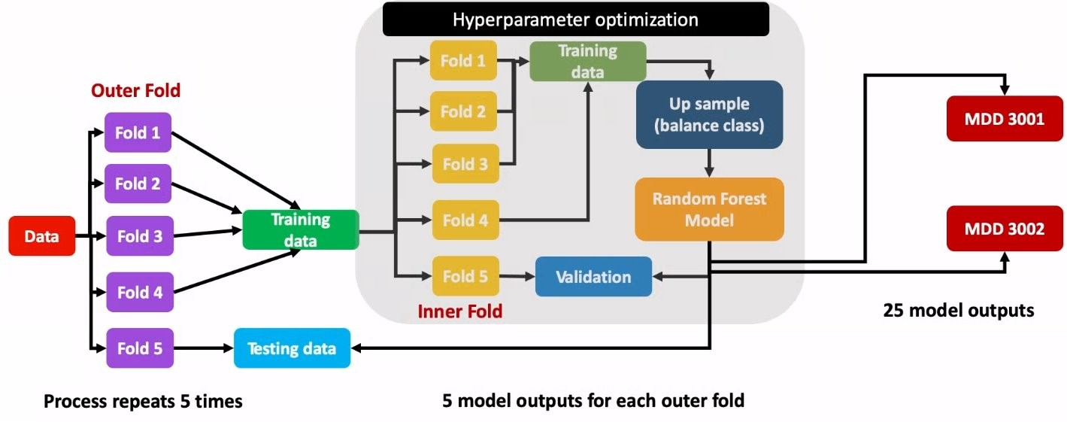
Supplementary Figure 1 - illustration of nested Random Forest procedure consisting of 5 outer x 5 inner loops.

Mental Well-Being Questionnaire
Since the introduction of the mental well-being questionnaire in the UK Biobank, data has been collected for each participant and can inform researchers about common disorders (such as depression) but also disorders for which little is known in the age group of 40-69 years, and environmental context. Categories in this questionnaire include adverse life events, alcohol use, anxiety and panic, COVID-19, cannabis use, depression, eating patterns, general health, general well-being, harm behaviors, mental health, mood changes, and social situation. The data was extracted, encoded, and transformed for each of the 209 fields included in the questionnaire (corresponding to 298 data columns) to create analysis-ready curated phenotype tables.

Cluster associations were made against questions from all questionnaires: adverse life events; alcohol use; anxiety and panic; cannabis use; covid19; depression; eating patterns; general health; general well-being; harm behaviors; mental health; mood changes; social situation. To define the terms (answers) from each question to compare, a ‘code book’ was manually defined to group terms together logically. Continuous variables were encoded as quartiles. The different frequency of sets of terms were then compared across clusters via a Pearson’s χ² test on 2x3, 3x3, 4x3, etc contingency tables, depending on the specific grouping of terms from the code book.

UK Biobank PheCode Associations
The enrichment of each PheCode across the clusters was determined via the Gini coefficient - a Pearson’s χ² test was also performed. For this, incident and prevalent cases were combined, and then compared to controls, which resulted in a 2x3 contingency table. For better interpretation, the PheCode counts were additionally normalized to their respective overall sample n per cluster.

Length of Depression
Length of depression was calculated based on self-reports and primary care / general practitioner (GP) data. For self-reports, the length of depression was calculated as the number of days from first occurrence for F32 ('depressive episode') (data-field 130894) or F33 ('recurrent depressive disorder') (data-field 130897) to blood collection date. Episodes after blood collection were removed. This gave data-points for every MDD participant from the discovery cohort (100%; n=1 403). The GP data had much less coverage (10.6%; n=149). Primary care / GP data was prepared from terminologies: ‘Depressive episode’, ‘Major depression’, ‘Moderate major depression’, ‘Recurrent major depressive episode’, ‘Recurrent major depressive episodes’, ‘Single major depressive episode’, ‘Single major depressive episode, mild’, ‘Single major depressive episode, moderate’, ‘Single major depressive episode, unspecified’. Multi-mappings across these terms existed but were not counted for an individual participant. The length of depression was counted as days from diagnosis to blood collection date, with episodes after blood collection removed. For reporting purposes, days were converted into years via division by 365, without taking into account leap years.

Medication Data Associations
The semi-structured UK Biobank GP prescription data contains millions of records for >200,000 participants. These records contain a mix of different brand and generic drug names and Read V2 codes (a clinical coding system used in the UK), which we harmonized by mapping to standard RxNorm and MeSH terminology. In addition, Anatomical Therapeutic Chemical (ATC) Class IDs were assigned based on the standardized terms, from the most granular level (specific drug name) to higher levels, which enables grouping of drugs based on their therapeutic use and chemical properties.

For GP data, records recorded post blood draw for proteomics screening were removed, as were records >12 months prior to blood draw. The enrichment of each record across clusters was then determined via the Gini coefficient and stratified by the Anatomical Therapeutic Chemical (ATC) Classification (https://www.who.int/tools/atc-ddd-toolkit/atc-classification) - a Pearson’s χ2 test was also performed. For better interpretation, the counts of records were additionally normalized to their respective overall sample n per cluster. The self-report data was processed in the same way as the GP data except those records >12 months prior to blood draw were retained.

MRI & Imaging Associations
For testing the association of the subtypes with MRI and other imaging data, the following methods were utilized: 1, imaging-derived phenotypes (IDPs) were standardized, technical variation removed, and adjusted for age and sex; 2, correlations across all T1 MRI measures obtained for 10 pipeline atlases; 3, ratios of 444 cortical regions divided by 99 subcortical structures were developed for all subtypes; 4, log ratios were obtained after adding a constant transforming the data to a positive scale; 5, marginal regression analyses for the log ratios of regions with highly correlated measures (< -0.2 and > 0.2) were performed.

General plotting functions
Supervised (filtered) and unsupervised (unfiltered) clustering were performed using the ComplexHeatmap [1] package in R. Prior to clustering, protein expression levels were converted to the Z scale (scaled by row/protein) and then clustered via 1 minus Pearson correlation distance / Euclidean Distance and Ward's linkage. Box-and-whisker, scatter, and violin plots were generated via geom_boxplot, geom_jitter, and/or geom_violin from the ggplot2 [2] package. Other simple plotting functions from base R were used, including barplot, boxplot, and hist [3].

Principal Component Analysis (PCA)
Principal component analysis was performed using PCAtools [4]. Bi-plots were generated to compare eigenvectors, i.e., principal components (PCs), 1 to 3. The percent variation contributed by each PC to the total dataset variation was also calculated and illustrated via a scree plot, with a pairs plot subsequently generated for the first n number of PCs whose accumulative variation reached 80%. A 3-dimensional plot for PCs 1-3 was generated via axes_3D and stat_3D from ggplot2 [2].

Supplementary Results & Discussion
Rheumatoid Arthritis Positive Control
HYDRA Clustering
The Rheumatoid Arthritis (RA) cohort was comprised of 139 cases and 139 controls with expression data across 2 935 proteins. After HYDRA clustering, a value of k=2 was chosen as the ideal cluster solution based on an Adjusted Rand Index (ARI) of 0.71 (Supplementary Figure 2). At the 2-cluster solution, 85 RA cases were assigned to subtype C1, while 54 were assigned to subtype C2. A NULL distribution HYDRA model over 50 simulations for a cluster solution of k=2 was statistically significantly different from the real cluster solution (p=0.02), thus highlighting that k=2 is an ideal cluster solution.
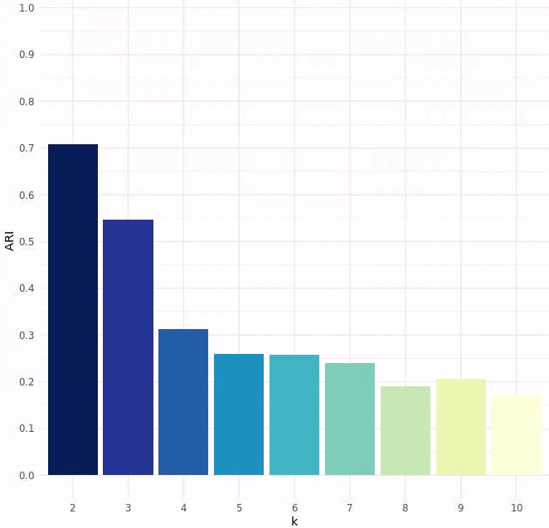
Supplementary Figure 2 - Adjusted Rand Indices (ARIs) from HYDRA clustering on RA cohort. A solution of k=2 had an ARI of 0.71 and was chosen as the ideal cluster solution.

Cluster enrichment
The 2 clusters exhibited clear differences in expression profiles across all proteins, with C1 characterized by up-regulation of many proteins, and C2 by down-regulation of these (Supplementary Table 1). Cluster C1 is dominated by the elevated expression of very well characterized RA biomarkers, such as TNF, TNFRSF1B, LGALS9, CD83, HAVCR2 (TIM3), PLAUR, and CD300E, while cluster C2 lacks the expression of these C1 biomarkers, and is a low-BMP6 PEAR1 TIA1 CD244 subtype. Enrichment via Gene-Set Enrichment Analysis (GSEA) reveals C1 as an inflammatory RA subtype, with well-known up-regulated implicated pathways: IL2, IL6, TNF, INF-α, INF-γ (Supplementary Figure 3). Further, Gene Ontology (GO) and KEGG pathway enrichments elucidated further on the potential RA histo-pathotypes represented by each cluster, with C1 exhibiting terms relating to TNF signalling, lymphocyte proliferation, and myeloid activation (Supplementary Figure 4).

Supplementary Table 1 – Top 20 highly and least expressed proteins in cluster C1 and C2 respectively. Ranking is based on mean expression per cluster members.
C1 Top 20 Most Expressed |  | C2 Bottom 20 Least Expressed
Protein | C1 Mean | Protein | C2 Mean
TNF | 1.37 | STAT5B | -0.74
TNFRSF1B | 1.37 | RNF5 | -0.74
TNF | 1.36 | FLI1 | -0.74
LGALS9 | 1.35 | BIRC2 | -0.75
TNF | 1.33 | CD244 | -0.75
TNF | 1.33 | NAGK | -0.76
CD83 | 1.29 | CASP7 | -0.76
HAVCR2 | 1.29 | HCLS1 | -0.76
PLAUR | 1.27 | ARHGEF1 | -0.76
CD300E | 1.27 | EVI5 | -0.77
TNFRSF14 | 1.22 | RRAS | -0.77
PSAP | 1.21 | DAG1 | -0.77
CD74 | 1.20 | SH2B3 | -0.77
TNFRSF4 | 1.19 | ECHS1 | -0.78
CCL7 | 1.19 | MPHOSPH8 | -0.78
PDCD1 | 1.18 | RRM2B | -0.78
TNFRSF10A | 1.17 | TOP2B | -0.79
IL18BP | 1.16 | TIA1 | -0.79
IFI30 | 1.15 | PEAR1 | -0.81
TNFRSF11A | 1.15 | BMP6 | -0.83

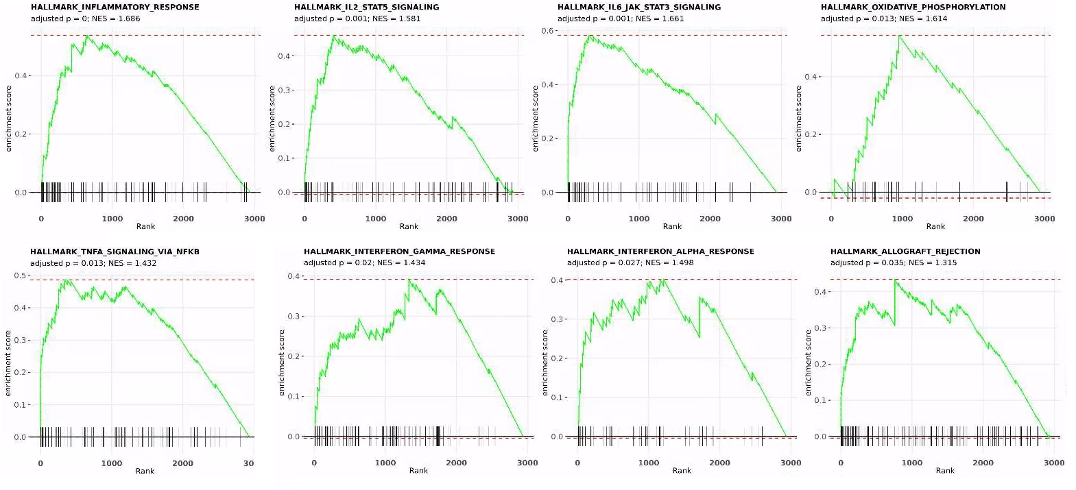
Supplementary Figure 3 – Rheumatoid Arthritis cluster C1 Gene-Set Enrichment Analysis (GSEA) reveals numerous inflammatory signatures as up-regulated in C1. Enrichment was made against Hallmark signatures. Proteins were ranked based on mean expression across all participants in cluster C1.

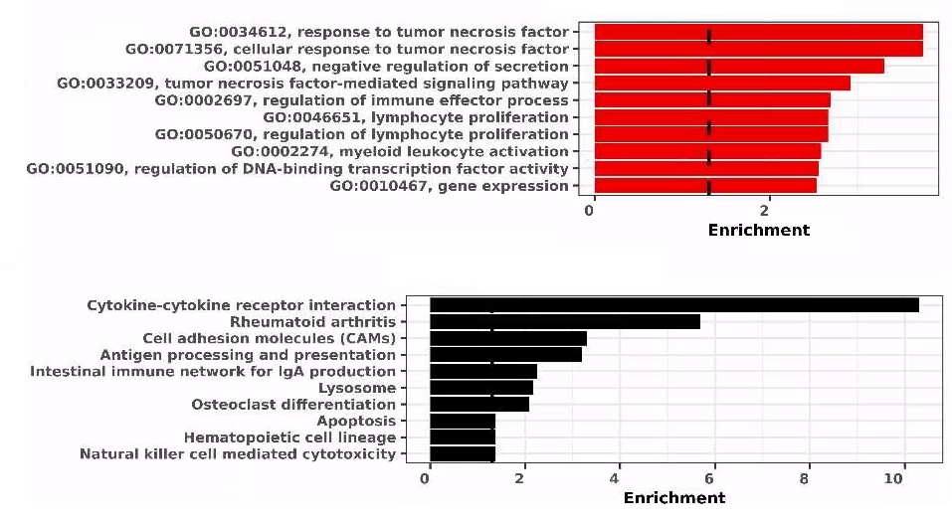
Supplementary Figure 4 – Rheumatoid arthritis cluster C1 Gene Ontology Biological Process (top) and KEGG (bottom) enrichment elaborates on RA histo-pathotypes represented by each cluster. Enrichment was made using the top 100 proteins expressed in C1 based on mean expression across all participants in cluster C1. An enrichment cut-off of p=0.05 is indicated by the vertical dashed bar in each barplot.

In summary it can be inferred that C1 is an inflammatory RA subtype, with high TNF activation and represents known Lymphoid and Myeloid histo-pathotypes, while C2, in lacking immune signalling, may represent a Pauci Immune subtype. These results confirm the clustering approach in the RA positive control cohort and support the application of the same to the MDD Discovery and Replication cohorts.

Major Depressive Disorder: Discovery cohort
HYDRA clustering
The ARI for each value of k from HYDRA clustering on the MDD Discovery cohort is presented in Supplementary Figure 5.
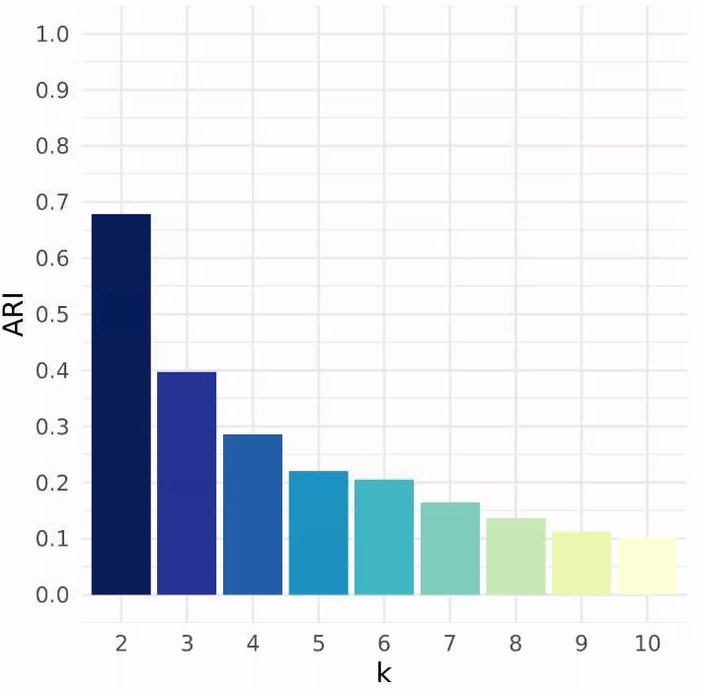
Supplementary Figure 5 - Adjusted Rand Indices (ARIs) from HYDRA clustering on MDD Discovery cohort. A solution of k=3 had an ARI of 0.40 and was chosen as the ideal cluster solution.

Cluster Enrichments
Gene-Set Enrichment Analysis, Gene Ontology, & KEGG
Enrichment via GSEA, GO, and KEGG are presented in Supplementary Figure 6-8, with complete enrichment results for all subtypes available in Supplementary File 1.

Cluster C1 is a low-metabolic subtype, characterized by synapse dysfunction. More specifically, it is characterized by low mitochondrial function and impaired levels of oxidative phosphorylation (OXPHOS). Dysfunctional mitochondrial function is known in relation to MDD in literature [5-7] - OXPHOS is also tied with mitochondrial function [8]. Cluster C1 is additionally characterized by impaired intracellular transport of proteins or 'substances' via GSEA (MSigDB, 2024) - impaired movement of neuronal signals intracellularly is known in depression [9]. The enrichment results also indicate that impaired synaptic function is implicated at the post-synapse, i.e., the synaptic part that receives the neurotransmitter signal released from the presynaptic terminal. Apoptosis is also strongly associated with this subtype (assumed reduced apoptosis) but unsure of exact pathophysiology. There are strong links between apoptosis in different ways and depression in the literature [10, 11]. Cluster C1 also presented an association with the KEGG pathway Long Term Depression, which appears to indirectly be related to impaired synapse function: "Cerebellar long-term depression (LTD), thought to be a molecular and cellular basis for cerebellar learning, is a process involving a decrease in the synaptic strength between parallel fiber (PF) and Purkinje cells (PCs) induced by the conjunctive activation of PFs and climbing fiber (CF)" [12-14].

Cluster C2 is an immune subtype with complement and TNF involvement. More specifically, it is characterized by up-regulation of numerous immune pathways. Elevated IL2-STAT5 and IL6-JAK-STAT3 are observed, which is the opposite to the C3 subtype – there is much literature on these [15, 16]. We also observe elevated interferon-γ (IFNG) signaling; although there is much literature on IFNG, it is mixed in its relation to depression, with some studies finding elevated levels in MDD while others lower. We additionally see elevated TGF-β signaling, which has been reported previously in MDD [17], but which has a known role generally in neurological disorders, including Substance Use Disorder [18, 19]. Finally, and intriguingly, we see elevated TNF expression and activate complement, with TNF being uniquely expressed in the C2 subtype (Kruskal-Wallis ANOVA p<0.0001), while numerous complement proteins have confirmed highest expression in this subtype. There is much literature on TNF’s association in the literature [20-22].

Cluster C3 is a high-metabolic subtype, with some level of immune involvement that differs from that in the C2 subtype. More specifically, it is characterized by heightened mitochondrial function and OXPHOS, essentially being the polar opposite of the C1 subtype. It is additionally characterized by heightened cell cycle activity, activity of Myc targets, activity at mitotic spindle, and increased apoptosis. The exact nature of the immune involvement is unclear; however, there is enrichment against the GO BP terms 'immune response-regulating signaling pathway' and 'regulation of immune system process'. Elsewhere, IL2 and IL6 signalling are indicated as down-regulated via GSEA (opposite of the C2 subtype), and there is enrichment against T- and B-cell receptor pathways (KEGG) – the proteins in these pathways are confirmed as exhibiting the highest expression in cluster C3. Finally, different from the C2 subtype, there is no TNF involvement in C3. Thus, C3 is the polar opposite to C1 in terms of mitochondrial function and OXPHOS, and exhibits different immune involvement compared to C2. Cluster C3 exhibits an almost 'stressed' – the link between heightened apoptosis, MDD, and the immune system was tentatively made in small study from 1999 [11]. The connection between these was also elaborated in 2019 via the Senescence-Associated Secretory Phenotype (SASP): "The SASP comprises multiple signaling proteins involved in the immune-inflammatory response, cell growth, control of cell cycle and apoptosis, cell-to-cell communication, and tissue remodeling" [23].

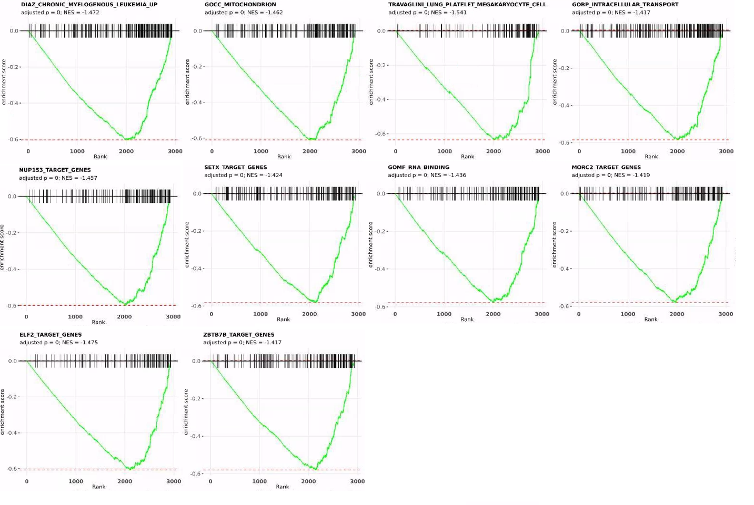
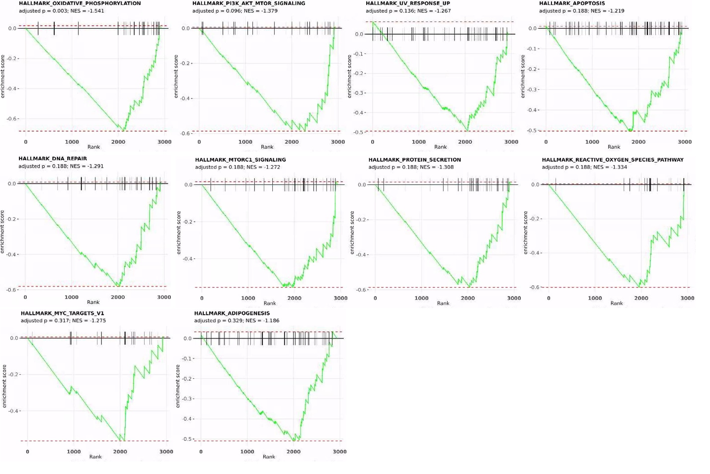
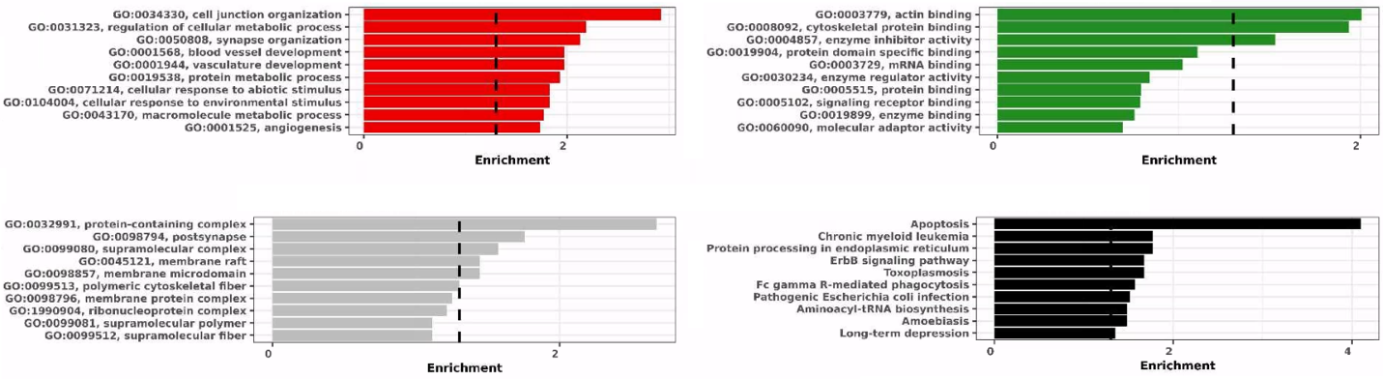
Supplementary Figure 6 – MDD Discovery cohort cluster C1 gene enrichment analysis reveals this subtype as a low-metabolic subtype, characterized by synapse dysfunction. [AB] Gene-Set Enrichment Analysis (GSEA) was made against all mSigDb signatures and then Hallmark signatures alone. Proteins were ranked by mean expression in cluster C1 participants. [C] For Gene Ontology (GO) and KEGG, enrichment was made using the top 100 proteins expressed in C1 based on mean expression across all cluster C1 participants. An enrichment cut-off of p=0.05 is indicated by the vertical dashed bar in each barplot. Top-Left / Red, GO Biological Process; Top-Right / Green, GO Molecular Function; Bottom-Left / Grey, GO Cellular Component; Bottom-Right / Black, KEGG.

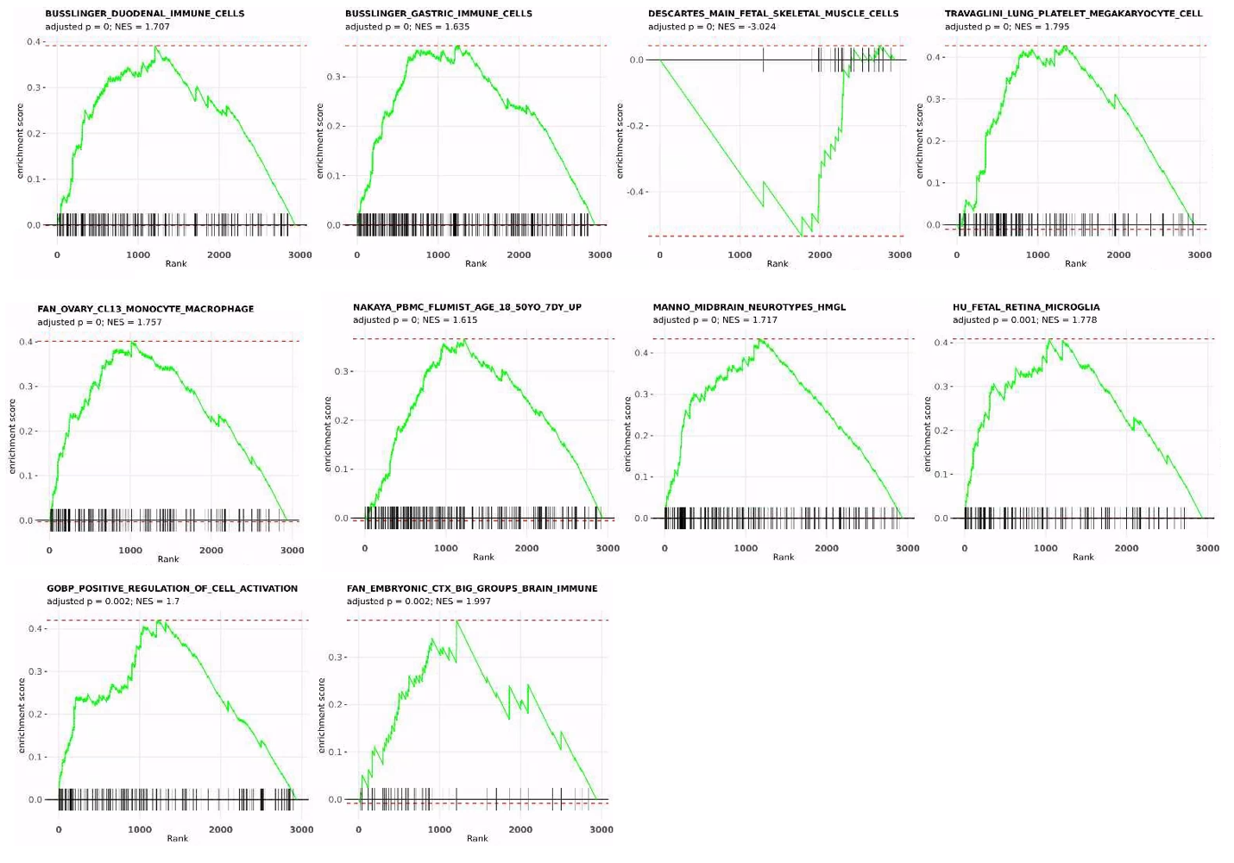
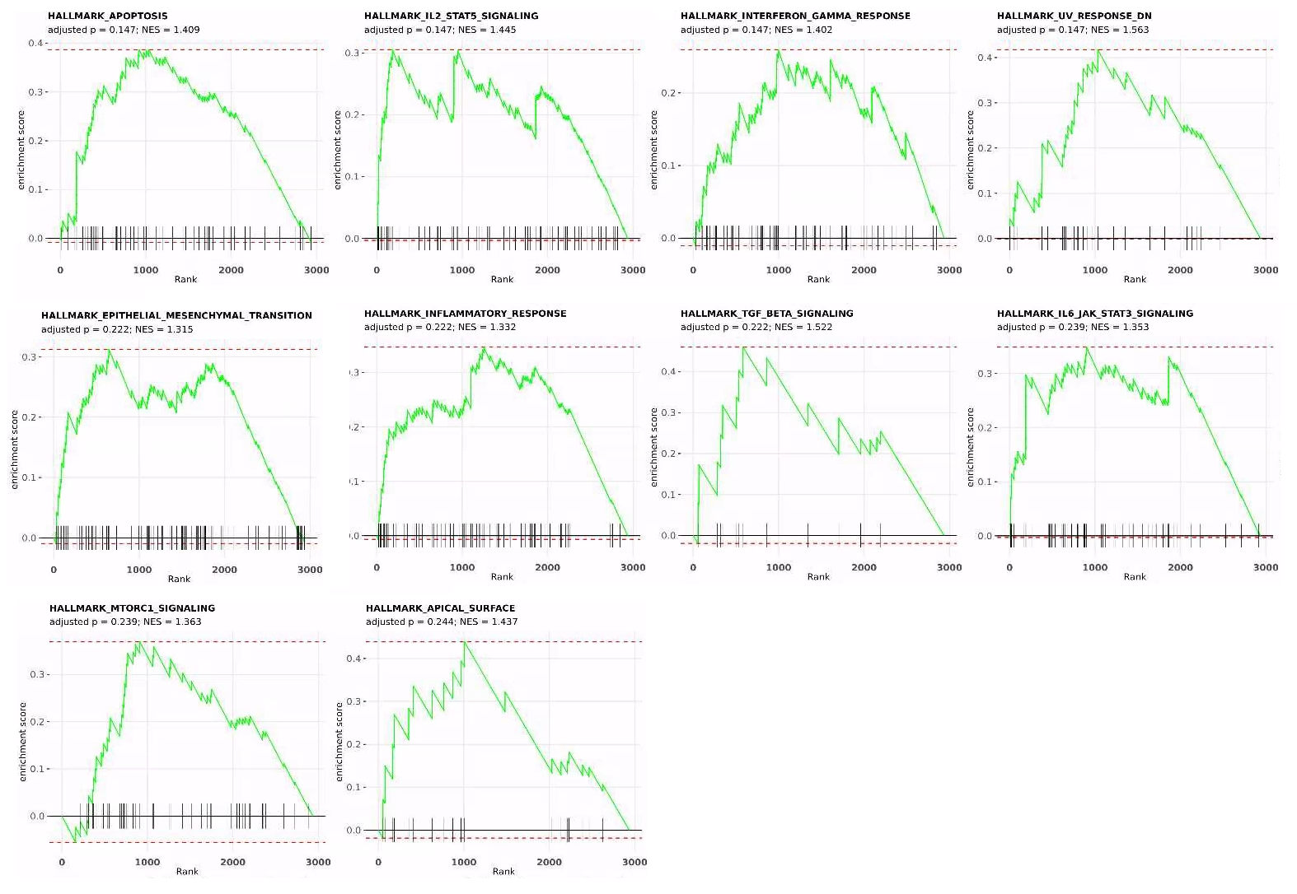
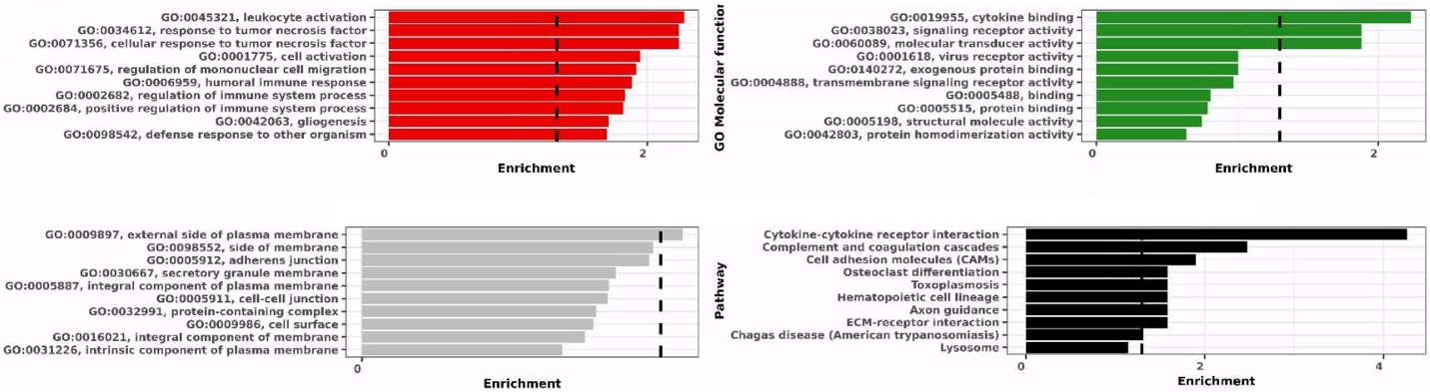
Supplementary Figure 7 – MDD Discovery cohort cluster C2 gene enrichment analysis reveals this subtype as the immune subtype with complement and TNF involvement. [AB] Gene-Set Enrichment Analysis (GSEA) was made against all mSigDb signatures and then Hallmark signatures alone. Proteins were ranked by mean expression in cluster C2 participants. [C] For Gene Ontology (GO) and KEGG, enrichment was made using the top 100 proteins expressed in C2 based on mean expression across all cluster C2 participants. An enrichment cut-off of p=0.05 is indicated by the vertical dashed bar in each barplot. Top-Left / Red, GO Biological Process; Top-Right / Green, GO Molecular Function; Bottom-Left / Grey, GO Cellular Component; Bottom-Right / Black, KEGG.

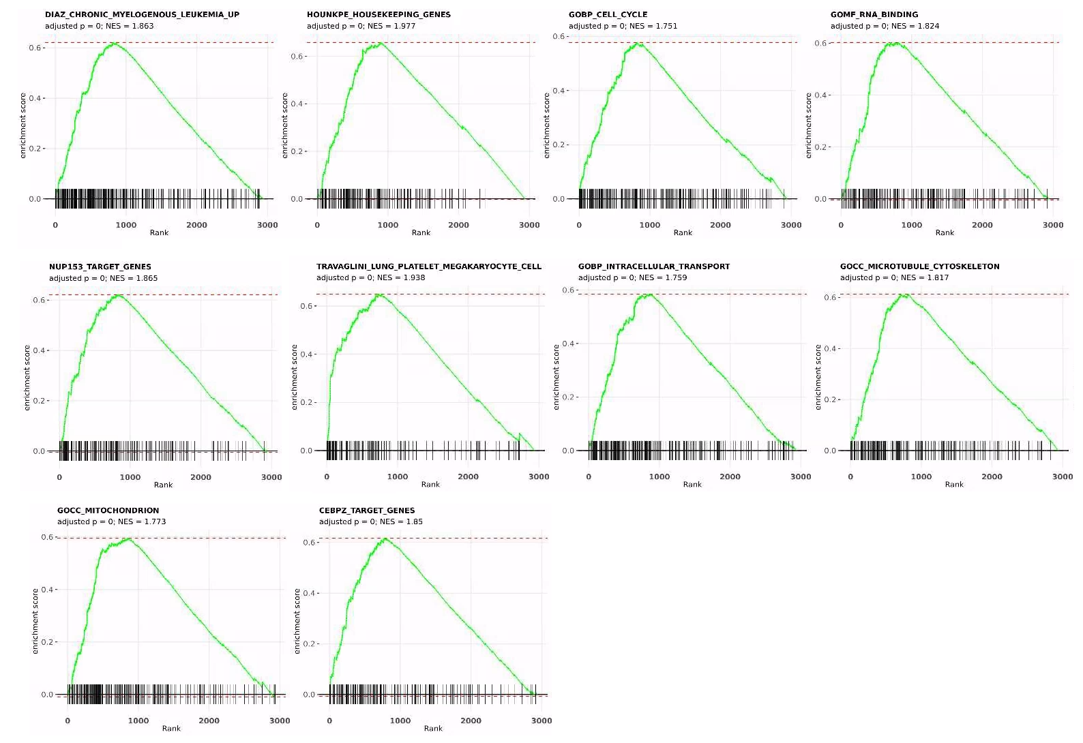
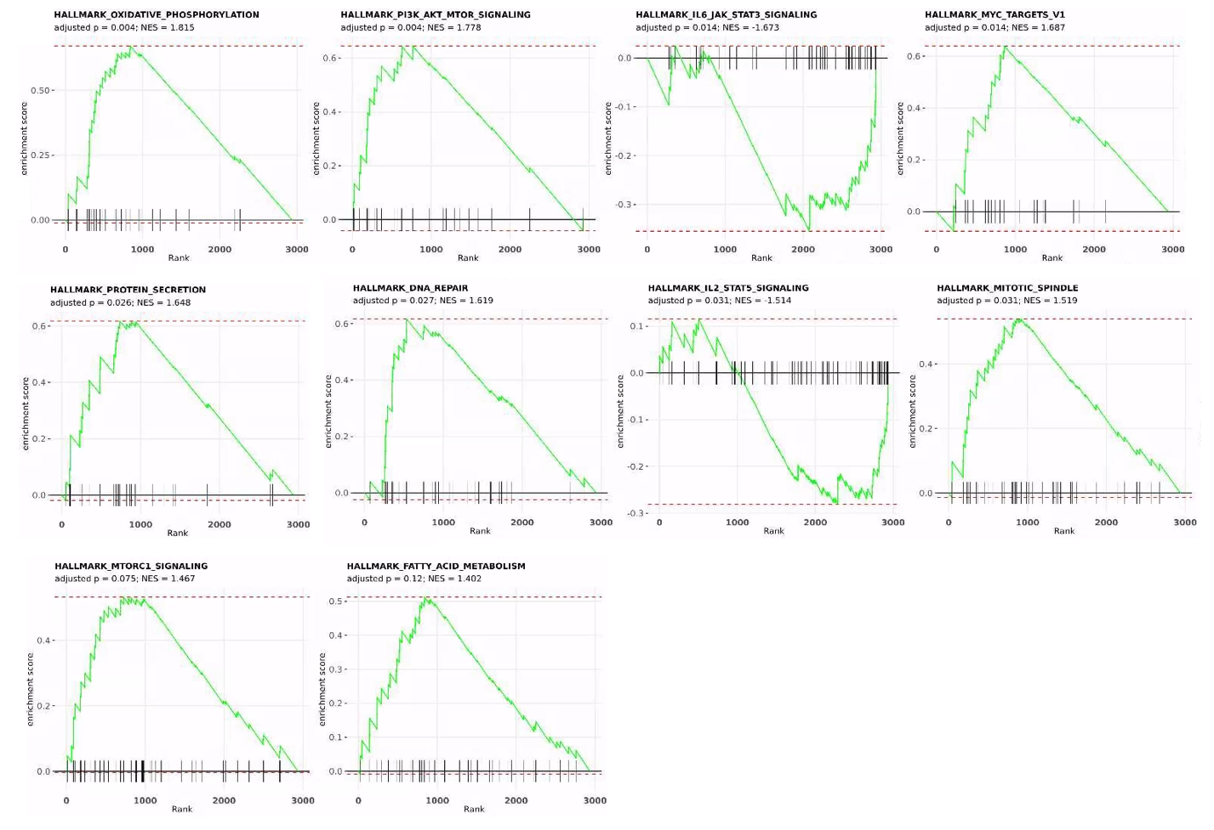
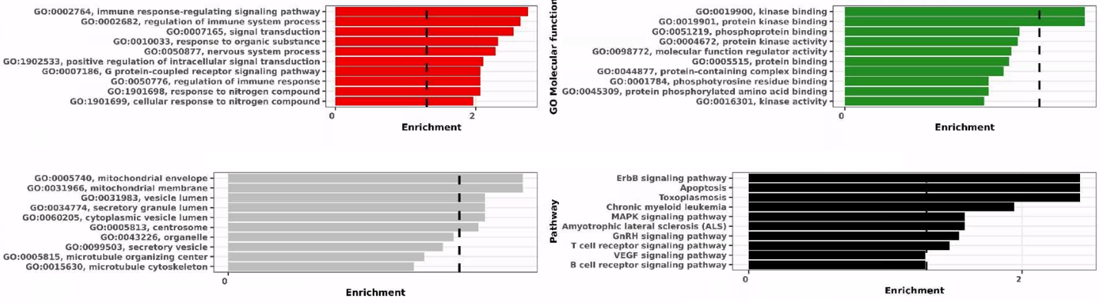
Supplementary Figure 8 – MDD Discovery cohort cluster C3 gene enrichment analysis reveals this subtype as a high-metabolic subtype, with some immune involvement. [AB] Gene-Set Enrichment Analysis (GSEA) was made against all mSigDb signatures and then Hallmark signatures alone. Proteins were ranked by mean expression in cluster C3 participants. [C] For Gene Ontology (GO) and KEGG, enrichment was made using the top 100 proteins expressed in C3 based on mean expression across all cluster C3 participants. An enrichment cut-off of p=0.05 is indicated by the vertical dashed bar in each barplot. Top-Left / Red, GO Biological Process; Top-Right / Green, GO Molecular Function; Bottom-Left / Grey, GO Cellular Component; Bottom-Right / Black, KEGG.

UK Biobank PheCode Associations
After filtering the PheCode results based on total participants across all subtypes of >20, Gini coefficient >0.4, and Pearson’s χ2 p<0.05, 8 PheCodes remained (Supplementary Table 2).

Supplementary Table 2 – UK Biobank PheCode associations with discovery cohort subtypes. Results were filtered based on total participants across all subtypes of >20, Gini coefficient >0.4, and Pearson’s χ2 p<0.05.
Parameter | C1 | C2 | C3 | Sum | Gini | Chisqp
chronic renal failure (CKD) | 17 | 30 | 6 | 53 | 0.45 | 0.000003
inguinal hernia | 24 | 6 | 36 | 66 | 0.45 | 0.000059
inflammatory and toxic neuropathy | 6 | 16 | 4 | 26 | 0.46 | 0.00049
other chronic nonalcoholic liver disease | 5 | 16 | 6 | 27 | 0.41 | 0.00077
hypovolemia | 2 | 13 | 8 | 23 | 0.48 | 0.0012
other disorders of testis | 22 | 6 | 6 | 34 | 0.47 | 0.016
curvature of spine | 15 | 1 | 8 | 24 | 0.58 | 0.025
epilepsy recurrent seizures convulsions | 17 | 4 | 5 | 26 | 0.50 | 0.041

Nested Random Forest
The proteins that defined the nested Random Forest parsimonious model were enriched against the SynGO Portal [24] to determine the relationship with synaptic function - we observed enrichments against synapse-related ontology terms (Supplementary Table 3). Finally, we performed a metabolite enrichment analysis for these proteins via MetaboAnalyst [25] and found that these proteins were associated with numerous compounds / metabolites that are related to depression, including Adenosine triphosphate (ATP), L-Glutamic acid, L-Glutamine, Acetaldehyde, and Resveratrol (Supplementary Table 4). Dopamine was also enriched, but with a degree of 2 and betweeness of 24.

Supplementary Table 3 – Statistically significant enrichments for nested Randon Forest proteins against SynGO portal. It was revealed that the proteins that are highly predictive of each subtype are statistically significantly related to biological function as the synapse.
GO Term ID | GO Term Name | p-value | Protein
GO:0098693 | regulation of synaptic vesicle cycle | 0.001 | SNAP29; CASP3
SYNGO:synprocess | process in the synapse | 0.01 | SNAP29; CASP3; BCL2L1; ERBIN; SIRT2; DBNL; CRKL
GO:0099504 | synaptic vesicle cycle | 0.01 | SNAP29; CASP3; BCL2L1
SYNGO:presynprocess | process in the presynapse | 0.03 | SNAP29; CASP3; BCL2L1
GO:0008021 | synaptic vesicle | 0.046 | SNAP29; BCL2L1

Supplementary Table 4 – Statistically significant enrichments for nested Randon Forest proteins against SynGO portal.
Name | Degree | Betweeness
CASP3 | 9 | 181.38
MARS | 5 | 64.74
BCL2L1 | 5 | 32.42
Gamma-Tocopherol | 5 | 47.72
Adenosine triphosphate | 4 | 47.93
MSRA | 3 | 11.68
Hydrogen peroxide | 3 | 12.02
L-Glutamic acid | 3 | 25.27
L-Glutamine | 3 | 36.85
Acetaldehyde | 3 | 67.62
Resveratrol | 3 | 25.62

MRI & Imaging Associations
To be completed.

Major Depressive Disorder: Replication cohort
The altering expression profiles of the 3 replication cohort clusters are presented and illustrated in exhibited clear differences in Supplementary Table 5 and Supplementary Figure 15, respectively.

Supplementary Table 5 – MDD Replication cohort top 20 highly and least expressed proteins in cluster C1 and C2 respectively. Ranking is based on mean expression per cluster members.
Top 20 Up Regulated
C1 |  | C2 |  | C3
Protein | Mean | Protein | Mean | Protein | Mean
BGN | 0.37 | TNFRSF1A | 0.95 | GCC1 | 0.92
APLP1 | 0.25 | CD83 | 0.94 | TMED8 | 0.91
CCER2 | 0.24 | TNFRSF1B | 0.94 | OTUD7B | 0.91
PRL | 0.22 | HAVCR2 | 0.92 | CACYBP | 0.91
EDIL3 | 0.21 | FSTL3 | 0.91 | MYDGF | 0.91
ADIPOQ | 0.2 | TGFBR2 | 0.91 | MESD | 0.9
GH1 | 0.18 | NPC2 | 0.9 | DOK1 | 0.9
LPL | 0.16 | GFRA1 | 0.89 | CIRBP | 0.9
NPPB | 0.15 | LGALS9 | 0.89 | TWF2 | 0.9
PZP | 0.15 | EFNA4 | 0.89 | ERBIN | 0.9
NTproBNP | 0.14 | COL6A3 | 0.89 | SNAP29 | 0.9
SHBG | 0.14 | FABP4 | 0.88 | CHMP6 | 0.9
GAST | 0.14 | TNFRSF10B | 0.88 | PLCB2 | 0.9
PLA2G10 | 0.12 | SHISA5 | 0.87 | JPT2 | 0.9
UMOD | 0.12 | BTN2A1 | 0.87 | ERP29 | 0.89
BPIFB1 | 0.11 | EFNA1 | 0.86 | NUDC | 0.89
CRNN | 0.11 | COLEC12 | 0.86 | CRKL | 0.89
FSHB | 0.11 | CLMP | 0.86 | YARS1 | 0.89
MSLN | 0.11 | THY1 | 0.86 | UFD1 | 0.89
GHRL | 0.11 | CKAP4 | 0.86 | RILPL2 | 0.89
Top 20 Down Regulated
C1 |  | C2 |  | C3
Protein | Mean | Protein | Mean | Protein | Mean
FGD3 | -0.7 | GIPC3 | -0.26 | WFIKKN1 | -0.26
UBE2L6 | -0.7 | RAB6A | -0.26 | NOTCH3 | -0.26
HS1BP3 | -0.7 | CA13 | -0.26 | KITLG | -0.26
CRKL | -0.7 | MAP2K6 | -0.26 | MCAM | -0.26
METAP2 | -0.7 | SRC | -0.26 | HBQ1 | -0.26
LACTB2 | -0.7 | PTPN6 | -0.26 | RGMA | -0.26
SERPINB6 | -0.7 | TIMM8A | -0.26 | DCN | -0.27
IST1 | -0.7 | EDAR | -0.26 | MEPE | -0.27
SNAP29 | -0.71 | DOK1 | -0.27 | MSTN | -0.28
CIAPIN1 | -0.71 | CA6 | -0.27 | KAZALD1 | -0.28
DFFA | -0.71 | FKBP1B | -0.27 | CD248 | -0.28
MYDGF | -0.71 | DARS1 | -0.27 | BMP4 | -0.28
SERPINB1 | -0.71 | CSNK2A1 | -0.28 | MXRA8 | -0.29
TWF2 | -0.72 | GP2 | -0.29 | NCAM1 | -0.29
GPI | -0.72 | PON3 | -0.3 | LRRN1 | -0.29
PCBP2 | -0.72 | SULT1A1 | -0.31 | ADAMTS8 | -0.31
TRIAP1 | -0.72 | NT5C3A | -0.31 | NTRK3 | -0.31
LAT | -0.72 | APOF | -0.32 | EFHD1 | -0.34
MSRA | -0.72 | APOD | -0.33 | APLP1 | -0.34
DAG1 | -0.74 | UMOD | -0.36 | BGN | -0.35

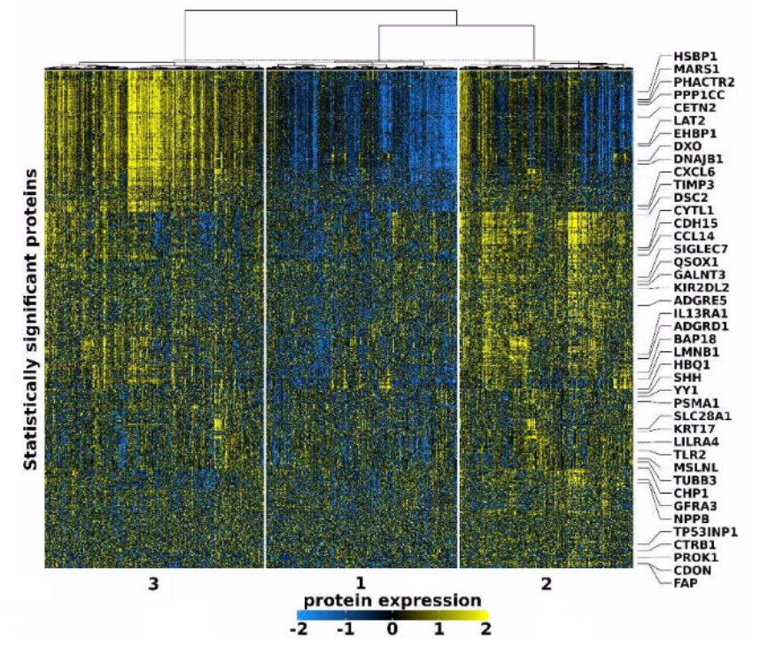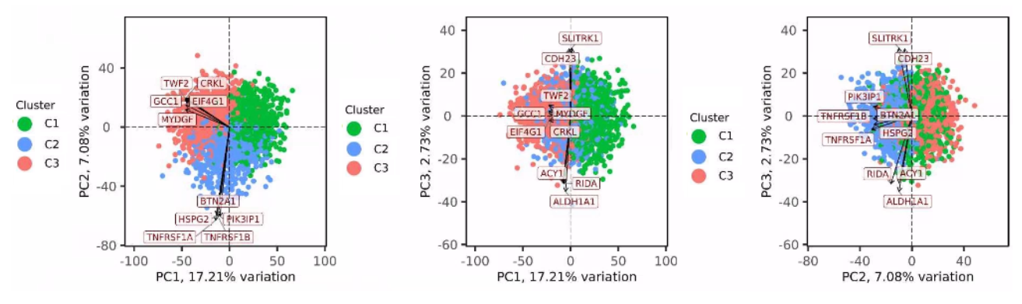Supplementary Figure 15 – Hierarchical clustering and PCA of the MDD Replication cohort using all panel proteins. The clustering and heatmap is forced to split based on the 3-cluster solution for 1 (C1), 2 (C2), and 3 (C3). The expression profiles for each resembles that for the Discovery cohort, with cluster C1 being dominated by extreme down-regulation of a set of proteins (‘Set 1’), which are elevated in expression in C2 and C3. Meanwhile C2 and C3 distinguish from each other based on slightly altered expression of another larger set of proteins (‘Set 2’). Via PCA, the subtypes distinguish from each other along PC1 and PC2.

The C1 subtype in the replication cohort has major overlap with the same subtype in the discovery [cohort]. It remains a hypo-mitochondrial subtype, with the following notable overlaps:
- characterized by low mitochondrial function and impaired levels of oxidative phosphorylation
- impaired synaptic function is implicated at post-synapse [association to synapse again exclusively in this subtype]
- apoptosis is strongly associated

However, it differs in the association with impaired intracellular transport of proteins or 'substances', which was not enriched here.

The C2 replication cohort subtype also overlaps with the same subtype in the discovery cohort, i.e., it remains the immunometabolic subtype with complement and TNF involvement. All key characteristics were enriched here, i.e., characterization by up-regulation of numerous immune pathways:
- elevated IL2-STAT5 and IL6-JAK-STAT3
- elevated interferon-γ signaling
- elevated TGF-β signaling
- elevated TNF expression
- activated complement

Finally, the C3 replication cohort subtype also retains similar characteristics as the same subtype from discovery, i.e., the hyper-mitochondrial subtype. The similarities with the discovery cohort subtype were:
- characterized by heightened oxidative phosphorylation
- characterized by increased apoptosis

Meanwhile, the differences were:
- C3 replication had no statistically significant enrichment for heightened mitochondrial function
- C3 replication had no statistically significant enrichment for heightened cell cycle activity, activity of Myc targets, and activity at mitotic spindle

As per the discovery cohort, we created a parsimonious Random Forest model that had good performance metrics based on the top 20 proteins from 5 outer fold models: accuracy, 0.82; precision, 0.75; recall, 0.75; F1, 0.75; AUC, 0.81. Across all 5 outer folds, the top 20 proteins from each summed to a total of 31 proteins, 61% (n=19) of which were also identified in the top proteins from the discovery cohort (Supplementary Table 6).

Supplementary Table 6 – Proteins selected from nested Random Forest as having high predictive capability.
Protein | Frequency | Protein | Frequency
CACYBP | 1 | MARS1 | 0.6
CASP3 | 1 | AKT2 | 0.4
DBNL | 1 | DPY30 | 0.4
ERP29 | 1 | ERBIN | 0.4
GMFG | 1 | MYDGF | 0.4
HARS1 | 1 | PLA2G4A | 0.4
MAP2K6 | 1 | TNFRSF1B | 0.4
MESD | 1 | VPS4B | 0.4
PSAP | 1 | BTN2A1 | 0.2
TMED8 | 1 | DDAH1 | 0.2
TNFRSF1A | 1 | DOK1 | 0.2
TWF2 | 1 | GCC1 | 0.2
CRKL | 0.8 | IST1 | 0.2
DCTD | 0.8 | NRGN | 0.2
RILPL2 | 0.8 | TIMP1 | 0.2
TBCB | 0.8

References (Supplementary)

1. Gu, Z., R. Eils, and M. Schlesner, Complex heatmaps reveal patterns and correlations in multidimensional genomic data. Bioinformatics, 2016. 32(18): p. 2847-9.
2. Wickham, H., Ggplot2: Elegant Graphics for Data Analysis. 2009: 2nd Edition, Springer, New York.
3. R Development Core Team, R: A language and environment for statistical computing. 2010, Vienna, Austria: R Foundation for Statistical Computing.
4. Blighe, K.L., A, PCAtools: PCAtools: Everything Principal Components Analysis. R package version 2.18.0,. 2024.
5. Khan, M., Y. Baussan, and E. Hebert-Chatelain, Connecting Dots between Mitochondrial Dysfunction and Depression. Biomolecules, 2023. 13(4).
6. Visentin, A.P.V., et al., Targeting Inflammatory-Mitochondrial Response in Major Depression: Current Evidence and Further Challenges. Oxid Med Cell Longev, 2020. 2020: p. 2972968.
7. Bansal, Y. and A. Kuhad, Mitochondrial Dysfunction in Depression. Curr Neuropharmacol, 2016. 14(6): p. 610-8.
8. Allen, J., et al., Mitochondria and Mood: Mitochondrial Dysfunction as a Key Player in the Manifestation of Depression. Front Neurosci, 2018. 12: p. 386.
9. aan het Rot, M., S.J. Mathew, and D.S. Charney, Neurobiological mechanisms in major depressive disorder. Cmaj, 2009. 180(3): p. 305-13.
10. Lucassen, P.J., et al., Hippocampal apoptosis in major depression is a minor event and absent from subareas at risk for glucocorticoid overexposure. Am J Pathol, 2001. 158(2): p. 453-68.
11. Eilat, E., et al., Increased apoptosis in patients with major depression: A preliminary study. J Immunol, 1999. 163(1): p. 533-4.
12. Kanehisa, M., Toward understanding the origin and evolution of cellular organisms. Protein Sci, 2019. 28(11): p. 1947-1951.
13. Kanehisa, M. and S. Goto, KEGG: kyoto encyclopedia of genes and genomes. Nucleic Acids Res, 2000. 28(1): p. 27-30.
14. Kanehisa, M., et al., KEGG for taxonomy-based analysis of pathways and genomes. Nucleic Acids Res, 2023. 51(D1): p. D587-d592.
15. Suhee, F.I., et al., Elevated Serum IL-2 Levels are Associated With Major Depressive Disorder: A Case-Control Study. Clin Pathol, 2023. 16: p. 2632010x231180797.
16. Hodes, G.E., C. Ménard, and S.J. Russo, Integrating Interleukin-6 into depression diagnosis and treatment. Neurobiol Stress, 2016. 4: p. 15-22.
17. Davami, M.H., et al., Elevated IL-17 and TGF-β Serum Levels: A Positive Correlation between T-helper 17 Cell-Related Pro-Inflammatory Responses with Major Depressive Disorder. Basic Clin Neurosci, 2016. 7(2): p. 137-42.
18. Mitra, S., C. Werner, and D.M. Dietz, Neuroadaptations and TGF-β signaling: emerging role in models of neuropsychiatric disorders. Mol Psychiatry, 2022. 27(1): p. 296-306.
19. Qiu, A., et al., Canonical TGF-β signaling regulates the relationship between prenatal maternal depression and amygdala development in early life. Transl Psychiatry, 2021. 11(1): p. 170.
20. Yao, L., et al., Tumor Necrosis Factor-α Variations in Patients With Major Depressive Disorder Before and After Antidepressant Treatment. Front Psychiatry, 2020. 11: p. 518837.
21. Zhou, R., et al., Effects of tumor necrosis factor-α polymorphism on the brain structural changes of the patients with major depressive disorder. Translational Psychiatry, 2018. 8(1): p. 217.
22. Ma, K., H. Zhang, and Z. Baloch, Pathogenetic and Therapeutic Applications of Tumor Necrosis Factor-α (TNF-α) in Major Depressive Disorder: A Systematic Review. Int J Mol Sci, 2016. 17(5).
23. Diniz, B.S., et al., Major depression and enhanced molecular senescence abnormalities in young and middle-aged adults. Transl Psychiatry, 2019. 9(1): p. 198.
24. Koopmans, F., et al., SynGO: An Evidence-Based, Expert-Curated Knowledge Base for the Synapse. Neuron, 2019. 103(2): p. 217-234.e4.
25. Xia, J., et al., MetaboAnalyst: a web server for metabolomic data analysis and interpretation. Nucleic Acids Res, 2009. 37(Web Server issue): p. W652-60.

