Bash Tutorial

Dr James Martin
Associate Professor
School of Computing
Clemson, SC
jmarty@clemson.edu

Last update: 3/6/2018

Source of information for an;ything Linux is at The Linux Documentation Project or at GNU’s site;
- The Linux Documentation Project’s home page : www.tldp.org
- The tldp’s Advanced Bash-Scripting Guide is a very useful source of information
  - http://www.tldp.org/LDP/abs/html/index.html
  - http://www.tldp.org/LDP/abs/html/abs-guide.html
  - http://www.tldp.org/LDP/abs/abs-guide.pdf

And for anything GNU:
- www.gnu.org
- https://www.gnu.org/manual/manual.html
- Gnu’s Bash home : https://www.gnu.org/software/bash/
  - https://www.gnu.org/software/bash/manual/html_node/index.html
  - https://www.gnu.org/software/bash/manual/bash.html
  - https://www.gnu.org/software/bash/manual/bash.pdf

This tutorial is meant to be used to support courses taught at Clemson University. Much of the material is from GNU’s bash manual.

Introduction

Bash is an acronym for ‘Bourne-Again Shell’. The Bourne shell is a Unix shell written by Stephen Bourne. Bash supports all Bourne builtin commands, uses Posix rules for syntax related to standard. The Bourne shell is a Unix shell written by Stephen Bourne. Bash supports all Bourne builtin commands, uses Posix rules for syntax related to standard shells.

Beyond the shell syntax, the building blocks are:
- Commands
- Control structures
- Shell functions
- Shell parameters
- Shell expansions
- Redirections

The following summarizes the shell’s operation as it reads and processes a command:
- Reads its input from either: a file, a string supplied as an argument, or from the user’s terminal.
- Breaks the input into words and operators (i.e., tokens), making sure to follow the quoting rules. These tokens are separated by metacharacters.
  - Alias expansion is performed by this step
- Parses the tokens into simple and compound commands
- Performs the various shell expansions, breaking the expanded tokens into lists of filenames and commands and arguments.
- Performs any necessary redirections which removes the redirection operators and their operands from the argument list.
- Executes the command
- Possibly waits for the command to complete, or if the command is operating in background
mode, moves onto the next command without waiting.

Bash - bits and pieces….

Quoting Rules/Syntax:

Shell Parameters -
A parameter is an entity that stores values. It can be a name, a number, or one of the special characters listed below. A variable is a parameter denoted by a name. A variable has a value and zero or more attributes. Attributes are assigned using the declare builtin command A parameter is set if it has been assigned a value. The null string is a valid value. Once a variable is set, it may be unset only by using the unset builtin command. A variable may be assigned to by a statement of the form
name=[value]

If value is not given, the variable is assigned the null string. All values undergo tilde expansion, parameter and variable expansion, command substitution, arithmetic expansion, and quote removal (detailed below). If the variable has its integer attribute set, then value is evaluated as an arithmetic expression even if the $((...)) expansion is not used. Word splitting is not performed, with the exception of "$@" as explained below. Filename expansion is not performed. Assignment statements may also appear as arguments to the alias, declare, typeset, export, readonly, and local builtin commands (declaration commands). When in posix mode these builtins may appear in a command after one or more instances of the command builtin and retain these assignment statement
properties.

In the context where an assignment statement is assigning a value to a shell variable orarray index, the ‘+=’ operator can be used to append to oradd to the variable’s previous value. This includes arguments to builtin commands such asdeclare that accept assignment statements (declaration commands). When ‘+=’ is applied to a variable for which the integer attribute has been set, value is evaluated as an arithmetic expression and added to the variable’s current value, which is also evaluated. When ‘+=’ is applied to an array variable using compound assignment the variable’s value is not unset (as it is when using ‘=’), and new values are appended to the array beginning at one greater than the array’s maximum index (for indexed arrays), or added as additional key-value pairs in an associative array. When applied to a string-valued variable, value is expanded and appended to the variable’s value.

A variable can be assigned the nameref attribute using the -n option to the declare or local builtin commands to create a nameref, or a reference to another variable. This allows variables to be manipulated indirectly. Whenever the nameref variable is referenced, assigned to, unset, or has its attributes modified (other than using or changing the nameref attribute itself), the operation is actually performed on the variable specified by the nameref variable’s value. A nameref is commonly used within shell functions to refer to a variable whose name is passed as an argument to the function.

For instance, if a variable name is passed to a shell function as its first argument, running
declare -n ref=$1 inside the function creates a nameref variable ref whose value is the variable name passed as the first argument. References and assignments to ref, and changes to its attributes, are treated as references, assignments, and attribute modifications to the variable whose name was passed as $1.

If the control variable in a for loop has the nameref attribute, the list of words can be a list of shell variables, and a name reference will be established for each word in the list, in turn, when the loop is executed. Array variables cannot be given the nameref attribute. However, nameref variables can reference array variables and subscripted array variables. Namerefs can be unset using the -n option to the unset builtin Otherwise, if unset is executed with the name of a nameref variable as an argument, the variable referenced by the nameref variable will be unset.

A positional parameter is a parameter denoted by one or more digits, other than the single
digit 0. Positional parameters are assigned from the shell’s arguments when it is invoked,
and may be reassigned using the set builtin command. Positional parameter N may be
referenced as ${N}, or as $N when N consists of a single digit. Positional parameters may
not be assigned to with assignment statements. The set and shift builtins are used to
set and unset them (see Chapter 4 [Shell Builtin Commands], page 42). The positional
Chapter 3: Basic Shell Features 20
parameters are temporarily replaced when a shell function is executed (see Section 3.3
[Shell Functions], page 17).
When a positional parameter consisting of more than a single digit is expanded, it must
be enclosed in braces.

Expansion is performed on the command line after it has been split into tokens. There are
seven kinds of expansion performed:
- brace expansion
- tilde expansion
- parameter and variable expansion
- command substitution
- arithmetic expansion
- word splitting
- filename expansion

The order of expansions is: brace expansion; tilde expansion, parameter and variable expansion,
arithmetic expansion, and command substitution (done in a left-to-right fashion);
word splitting; and filename expansion.

Brace expansion is a mechanism by which arbitrary strings may be generated. This mechanism
is similar to filename expansion but the filenames generated need not exist. Patterns to be brace expanded take the form of an optional preamble, followed by either a series of comma-separated strings or a sequence expression between a pair of braces, followed by an optional postscript. The preamble is prefixed to each string contained within the braces, and the postscript is then appended to each resulting string, expanding left to right. Brace expansions may be nested. The results of each expanded string are not sorted; left to right order is preserved. For example,

bash$ echo a{d,c,b}e
ade ace abe

If a word begins with an unquoted tilde character (‘~’), all of the characters up to the first unquoted slash (or all characters, if there is no unquoted slash) are considered a tilde-prefix. If none of the characters in the tilde-prefix are quoted, the characters in the tilde-prefix following the tilde are treated as a possible login name. If this login name is the null string, the tilde is replaced with the value of the HOME shell variable. If HOME is unset, the home directory of the user executing the shell is substituted instead. Otherwise, the tilde-prefix is replaced with the home directory associated with the specified login name.

The ‘$’ character introduces parameter expansion, command substitution, or arithmetic expansion. The parameter name or symbol to be expanded may be enclosed in braces, which are optional but serve to protect the variable to be expanded from characters immediately following it which could be interpreted as part of the name. When braces are used, the matching ending brace is the first ‘}’ not escaped by a backslash or within a quoted string, and not within an embedded arithmetic expansion, command substitution, or parameter expansion. The basic form of parameter expansion is ${parameter}. The value of parameter is substituted. The parameter is a shell parameter as described above

The braces are required when parameter is a positional parameter with more than one digit, or when parameter is followed by a character that is not to be interpreted as part of its name. If the first character of parameter is an exclamation point (!), and parameter is not a nameref, it introduces a level of variable indirection. Bash uses the value of the variable formed from the rest of parameter as the name of the variable; this variable is then expanded and that value is used in the rest of the substitution, rather than the value of parameter itself. This is known as indirect expansion. If parameter is a nameref, this expands to the name of the variable referenced by parameter instead of performing the complete indirect expansion. The exceptions to this are the expansions of ${!prefix*} and ${!name[@]} described below. The exclamation point must immediately follow the left brace in order to introduce indirection.

Here are some examples illustrating substring expansion on parameters and
subscripted arrays:
$ string=01234567890abcdefgh
$ echo ${string:7}
7890abcdefgh
$ echo ${string:7:0}
$ echo ${string:7:2}
78
$ echo ${string:7:-2}
7890abcdef

The following examples illustrate substring expansion using positional parameters:
$ set -- 1 2 3 4 5 6 7 8 9 0 a b c d e f g h
$ echo ${@:7}
7 8 9 0 a b c d e f g h
$ echo ${@:7:0}
$ echo ${@:7:2}
7 8
$ echo ${@:7:-2}

Command substitution allows the output of a command to replace the command itself. Command substitution occurs when a command is enclosed as follows:

$(command)
or
‘command‘

Bash performs the expansion by executing command in a subshell environment and replacing the command substitution with the standard output of the command, with any trailing newlines deleted. Embedded newlines are not deleted, but they may be removed during word splitting. The command substitution $(cat file) can be replaced by the equivalent but faster $(< file). When the old-style backquote form of substitution is used, backslash retains its literal meaning except when followed by ‘$’, ‘‘’, or ‘\’. The first backquote not preceded by a backslash terminates the command substitution. When using the $(command) form, all characters between the parentheses make up the command; none are treated specially. Command substitutions may be nested. To nest when using the backquoted form, escape the inner backquotes with backslashes. If the substitution appears within double quotes, word splitting and filename expansion are not performed on the results.

Arithmetic expansion allows the evaluation of an arithmetic expression and the substitution of the result. The format for arithmetic expansion is:

$(( expression ))

The expression is treated as if it were within double quotes, but a double quote inside the parentheses is not treated specially. All tokens in the expression undergo parameter and variable expansion, command substitution, and quote removal. The result is treated as the arithmetic expression to be evaluated. Arithmetic expansions may be nested. The evaluation is performed according to the rules listed below If the expression is invalid, Bash prints a message indicating failure to the standard error and no substitution occurs.

After word splitting, unless the -f option has been set Bash scans each word for the characters ‘*’, ‘?’, and ‘[’. If one of these characters appears, then the word is regarded as a pattern, and replaced with an alphabetically sorted list of filenames matching the pattern, If no matching filenames are found, and the shell option nullglob is disabled, the word is left unchanged. If the nullglob option is set, and no matches are found, the word is removed. If the failglob shell option is set, and no matches are found, an error message is printed and the command is not executed. If the shell option nocaseglob is enabled, the match is performed without regard to the case of alphabetic characters.

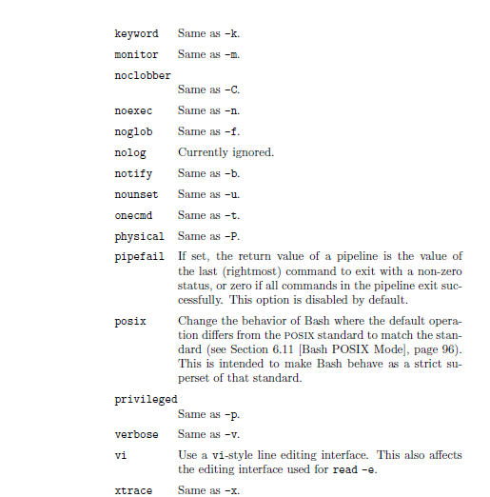

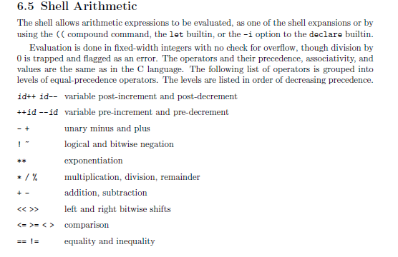

Regular Expressions:
Metacharacter | Description
^ | Matches the starting position within the string. In line-based tools, it matches the starting position of any line.
. | Matches any single character (many applications exclude newlines, and exactly which characters are considered newlines is flavor-, character-encoding-, and platform-specific, but it is safe to assume that the line feed character is included). Within POSIX bracket expressions, the dot character matches a literal dot. For example, a.c matches "abc", etc., but [a.c] matches only "a", ".", or "c".
[ ] | A bracket expression. Matches a single character that is contained within the brackets. For example, [abc] matches "a", "b", or "c". [a-z] specifies a range which matches any lowercase letter from "a" to "z". These forms can be mixed: [abcx-z] matches "a", "b", "c", "x", "y", or "z", as does [a-cx-z].  The - character is treated as a literal character if it is the last or the first (after the ^, if present) character within the brackets: [abc-], [-abc]. Note that backslash escapes are not allowed. The ] character can be included in a bracket expression if it is the first (after the ^) character: []abc].
[^ ] | Matches a single character that is not contained within the brackets. For example, [^abc] matches any character other than "a", "b", or "c". [^a-z] matches any single character that is not a lowercase letter from "a" to "z". Likewise, literal characters and ranges can be mixed.
$ | Matches the ending position of the string or the position just before a string-ending newline. In line-based tools, it matches the ending position of any line.
( ) | Defines a marked subexpression. The string matched within the parentheses can be recalled later (see the next entry, \n). A marked subexpression is also called a block or capturing group. BRE mode requires \( \).
\n | Matches what the nth marked subexpression matched, where n is a digit from 1 to 9. This construct is vaguely defined in the POSIX.2 standard. Some tools allow referencing more than nine capturing groups.
* | Matches the preceding element zero or more times. For example, ab*c matches "ac", "abc", "abbbc", etc. [xyz]* matches "", "x", "y", "z", "zx", "zyx", "xyzzy", and so on. (ab)* matches "", "ab", "abab", "ababab", and so on.
{m,n} | Matches the preceding element at least m and not more than n times. For example, a{3,5} matches only "aaa", "aaaa", and "aaaaa". This is not found in a few older instances of regexes. BRE mode requires \{m,n\}.

