Fernando Jr. T. Villanueva CS201A Computer Programming 1 PT

Allowance Calculator

This is a Java console program that is designed to compute total monthly and semestral allowance based on user inputs. I made my code to follow Object-Oriented approach and to implement an event-driven mechanism to display the results.

# Methods:

* calculateTotalMonthlyAllowance()
  + This method calculates the total monthly allowance based on this formula:
* calculateTotalSemestralAllowance()
  + This method calculates the total semestral allowance (with 3% daily allowance increase per 2 semesters) based on this formula:

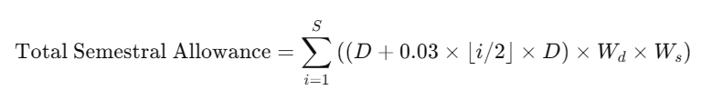Where:

* + S is the number of semesters
  + D is the initial daily allowance
  + Wd is the working days per week
  + Ws is the weeks per semester
  + 0.03 * [i / 2] * D is the 3% increment applied every 2 semesters
* start()
  + initializes BufferedReader to read user input then asks user if they want to calculate monthly allowance or semestral allowance
* queryMonthly()
  + makes the user input the daily allowance and the number of months
  + then calls calculateTotalMonthlyAllowance()
* querySemestral()
  + makes the user input the daily allowance the the number of semesters
  + then calls calculateTotalSemestralAllowance()

Both calculateTotalMonthlyAllowance() and calculateTotalSemestralAllowance() methods send the results of their work via OnCalculationResultListener, where a listener method onResultSend() prints the program’s outputs.

# Data Models:

Both MonthlyResultModel and SemestralResultModel store results of calculateTotalMonthlyAllowance() and calculateTotalSemestralAllowance() respectively. Each has their own printResult() method which will print their instance’s stored values when called.

# Calculator interface:

The Calculator interface defines the structure for classes that will implement the allowance calculations. It contains the constants for calculations such as the number of working days in a week and number of weeks per semester, and declares both calculateTotalMonthlyAllowance() and calculateTotalSemestralAllowance().

# OnCalculationResultListener:

This interface is used by the program to handle calculation results. With it, AllowanceCalculator class does not directly print results, but instead pass its results to a listener, which decides what to do with them.

This makes the code more modular and maintainable, and promotes loose coupling, because the AllowanceCalculator does not depend on the Main class. This also makes the result-handling logic easily changeable without modifying or even touching the calculator logic in AllowanceCalculator. Meaning, if we later want to log results to a file or display them using a UI for example, we just need to implement a different listener.

This also implements an event-driven mechanism, where Main class could perform other functions while waiting for the results from AllowanceCalculator to be sent, allowing for a non-blocking program flow.