**FINAL PROJECT**

**PART :1**

**PART:2**

**TABLES:**

Q1

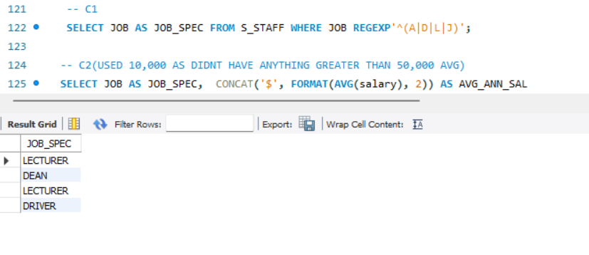

Q2

Q3

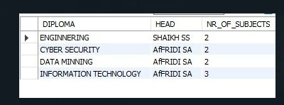

Q4

Q5 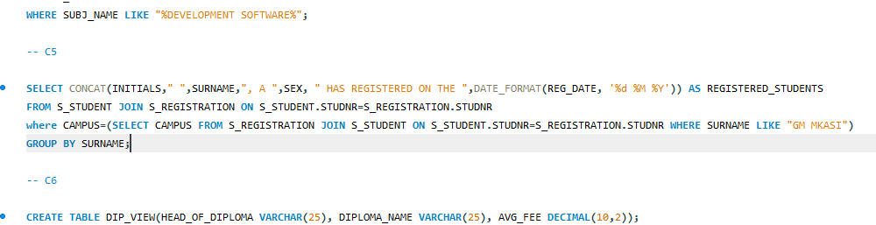

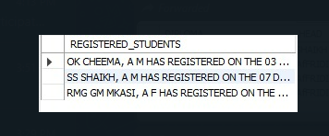

Q6

