**Documentation to get a VM up and running from a Previously Corrupted System**

FOR ALL MACHINES

1. Sudo apt-get install git
2. Sudo apt-get install php
3. Sudo apt-get install mysql-server
4. Sudo apt-get install php-mysqli
5. Make Sure you add your IP in the /etc/networks/interfaces

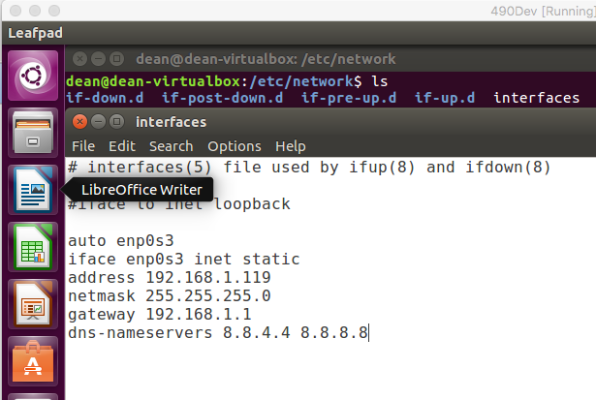

1. Sudo apt-get install ssh
2. Add user deploy to /etc/sudoers
3. Sudo apt-get install sshpass



FOR APACHE SERVER

1. Sudo apt-get install apache2
2. Sudo apt-get install libapache2-mod-php7.0
3. Sudo apt-get install sendmail

FOR RABBITMQ SERVER

1. Sudo apt-get install rabbitmq-server
2. Sudo apt-get install php-amqplib
3. Sudo apt-get install php=amqp
4. Go to 127.0.0.1:15672
   1. Create host named “testHost”
   2. Create a user named “test”, and assign as an admin for “testHost”
   3. Create an exchange named “testExchange” and make it topic in “testHost”
   4. Create a queue named “testQueue” under “testHost”
   5. Make any other queues according to your needs

FOR DMZ SERVER/DEPLOYMENT

1. Sudo apt-get install curl