Fahad Wahid

ITMD 411

Final Project

Ticket APP

**Description:**

I focused primarily on the user aspect of the way the system worked. I thought of it as a real-life app that we could implement. I wanted it to be easy to use and navigate through. It’s a powerful app that allows a user to request, view, and edit tickets. The admin can do all of that as well as close a ticket along with getting analytic reports, exporting data, and purging data. It only takes a few clicks to get the desired outcome for both the user and the admin panel. The .jar file is located in the fixed-Final_proj folder.

**ADMIN**

user: admin

pass: admin

**USER**

user: user

pass: user

**Main login screen**

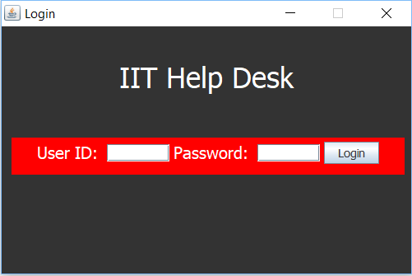

**Admin Panel**

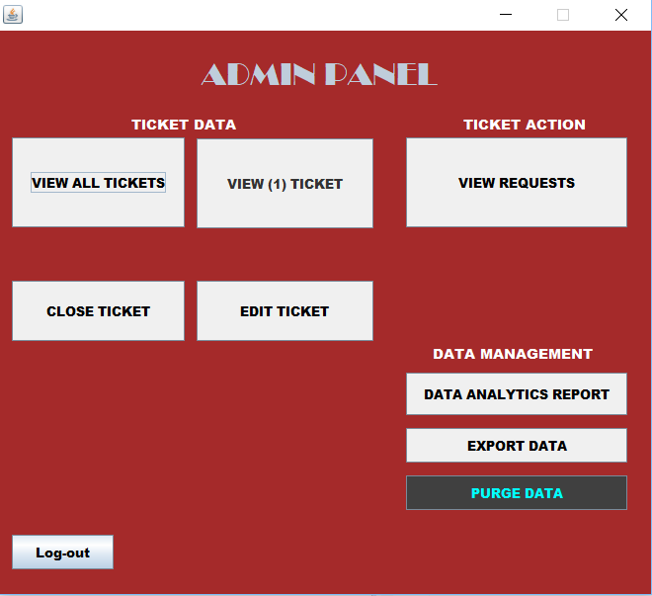

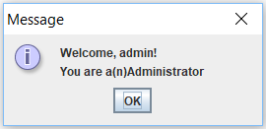

**User screen**

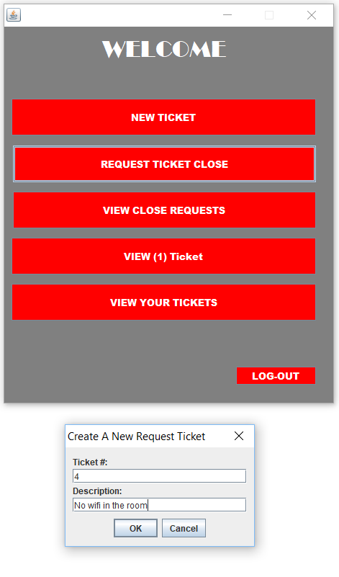

**Created ticket**

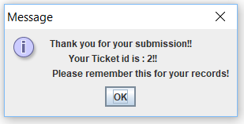

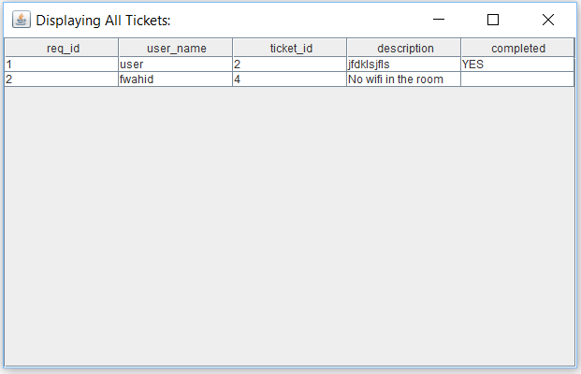

**Editing ticket**

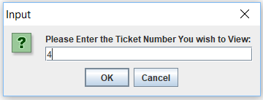

**Closing ticket**

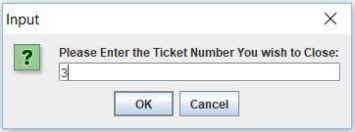

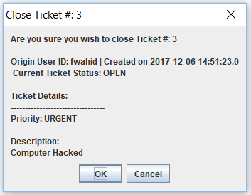

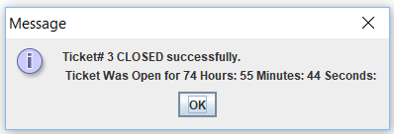

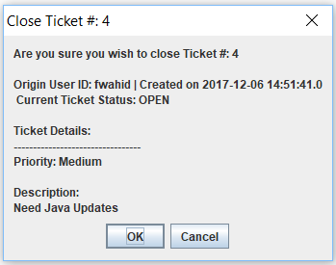

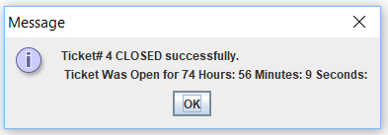

**Displaying all tickets in admin panel**

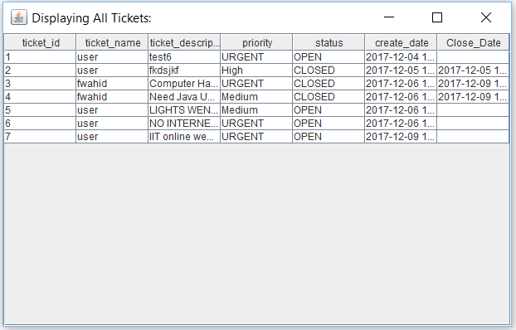

**Data analytics report**

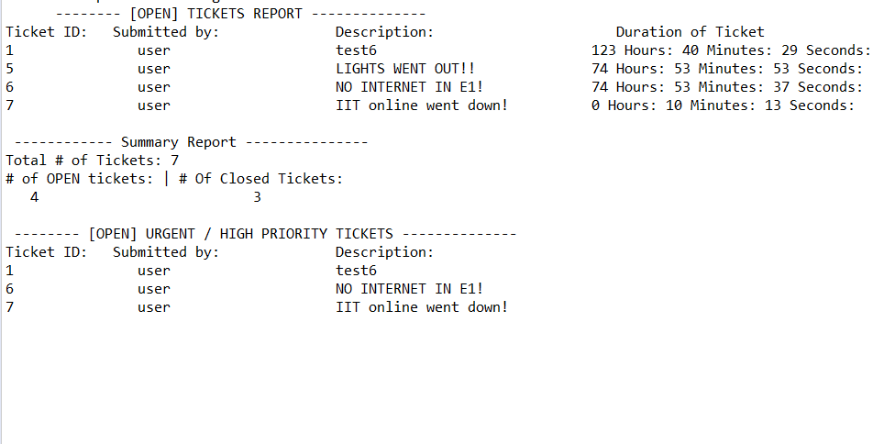

**Extra Credit:**

**Exporting data**

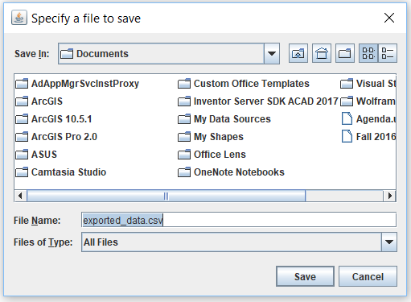

**Purging Data**

