Codebook for dataset

Autogenerated data summary from dataMaid

2025-02-23 21:38:08

# Data report overview

The dataset examined has the following dimensions:

| Feature | Result |
| --- | --- |
| Number of observations | 4424 |
| Number of variables | 19 |

# Codebook summary table

| Label | Variable | Class | # unique values | Missing | Description |
| --- | --- | --- | --- | --- | --- |
|  | **Marital.status** | integer | 7 | 10.44 % |  |
|  | **Application.order** | integer | 9 | 10.33 % |  |
|  | **Course** | integer | 18 | 9.90 % |  |
|  | **Daytime.evening.attendance** | integer | 3 | 9.70 % |  |
|  | **Previous.qualification** | integer | 18 | 9.76 % |  |
|  | **Previous.qualification..grade.** | numeric | 97 | 10.13 % |  |
|  | **Nacionality** | integer | 22 | 9.99 % |  |
|  | **Admission.grade** | numeric | 613 | 8.91 % |  |
|  | **Displaced** | integer | 3 | 10.38 % |  |
|  | **Educational.special.needs** | integer | 3 | 10.87 % |  |
|  | **Debtor** | integer | 3 | 10.31 % |  |
|  | **Gender** | integer | 3 | 9.97 % |  |
|  | **Scholarship.holder** | integer | 3 | 9.65 % |  |
|  | **Curricular.units.1st.sem..enrolled.** | integer | 24 | 9.61 % |  |
|  | **Curricular.units.1st.sem..approved.** | integer | 24 | 9.67 % |  |
|  | **Curricular.units.2nd.sem..enrolled.** | integer | 23 | 10.83 % |  |
|  | **Curricular.units.2nd.sem..approved.** | integer | 21 | 9.83 % |  |
|  | **Unemployment.rate** | numeric | 11 | 9.72 % |  |
|  | **Target** | character | 3 | 0.00 % |  |

# Variable list

## Marital.status

| Feature | Result |
| --- | --- |
| Variable type | integer |
| Number of missing obs. | 462 (10.44 %) |
| Number of unique values | 6 |
| Median | 1 |
| 1st and 3rd quartiles | 1; 1 |
| Min. and max. | 1; 6 |

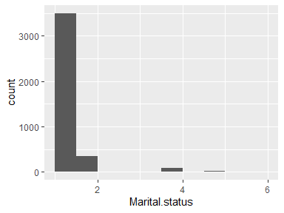

## Application.order

| Feature | Result |
| --- | --- |
| Variable type | integer |
| Number of missing obs. | 457 (10.33 %) |
| Number of unique values | 8 |
| Median | 1 |
| 1st and 3rd quartiles | 1; 2 |
| Min. and max. | 0; 9 |

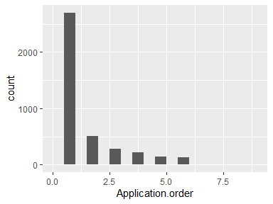

## Course

| Feature | Result |
| --- | --- |
| Variable type | integer |
| Number of missing obs. | 438 (9.9 %) |
| Number of unique values | 17 |
| Median | 9238 |
| 1st and 3rd quartiles | 9085; 9556 |
| Min. and max. | 33; 9991 |

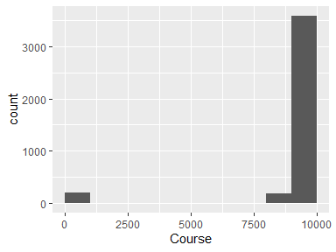

## Daytime.evening.attendance

| Feature | Result |
| --- | --- |
| Variable type | integer |
| Number of missing obs. | 429 (9.7 %) |
| Number of unique values | 2 |
| Median | 1 |
| 1st and 3rd quartiles | 1; 1 |
| Min. and max. | 0; 1 |

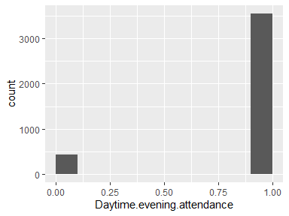

## Previous.qualification

| Feature | Result |
| --- | --- |
| Variable type | integer |
| Number of missing obs. | 432 (9.76 %) |
| Number of unique values | 17 |
| Median | 1 |
| 1st and 3rd quartiles | 1; 1 |
| Min. and max. | 1; 43 |

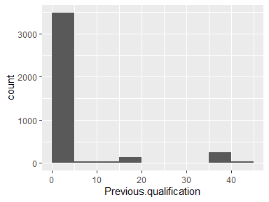

## Previous.qualification..grade.

| Feature | Result |
| --- | --- |
| Variable type | numeric |
| Number of missing obs. | 448 (10.13 %) |
| Number of unique values | 96 |
| Median | 133.1 |
| 1st and 3rd quartiles | 124; 140 |
| Min. and max. | 95; 190 |

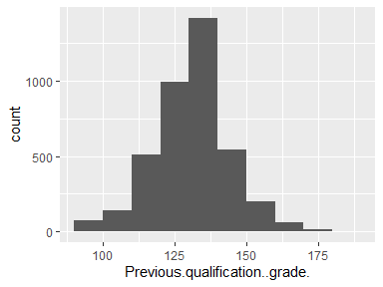

## Nacionality

| Feature | Result |
| --- | --- |
| Variable type | integer |
| Number of missing obs. | 442 (9.99 %) |
| Number of unique values | 21 |
| Median | 1 |
| 1st and 3rd quartiles | 1; 1 |
| Min. and max. | 1; 109 |

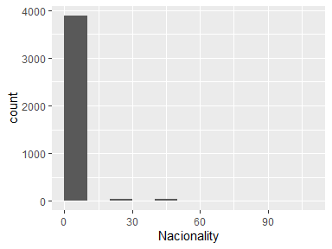

## Admission.grade

| Feature | Result |
| --- | --- |
| Variable type | numeric |
| Number of missing obs. | 394 (8.91 %) |
| Number of unique values | 612 |
| Median | 126.2 |
| 1st and 3rd quartiles | 118; 134.98 |
| Min. and max. | 95; 190 |

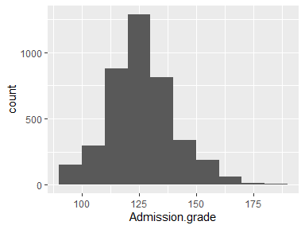

## Displaced

| Feature | Result |
| --- | --- |
| Variable type | integer |
| Number of missing obs. | 459 (10.38 %) |
| Number of unique values | 2 |
| Median | 1 |
| 1st and 3rd quartiles | 0; 1 |
| Min. and max. | 0; 1 |

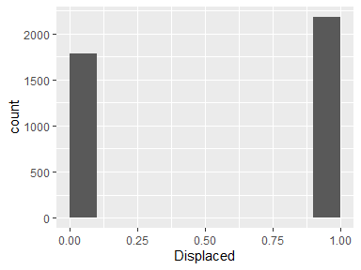

## Educational.special.needs

| Feature | Result |
| --- | --- |
| Variable type | integer |
| Number of missing obs. | 481 (10.87 %) |
| Number of unique values | 2 |
| Median | 0 |
| 1st and 3rd quartiles | 0; 0 |
| Min. and max. | 0; 1 |

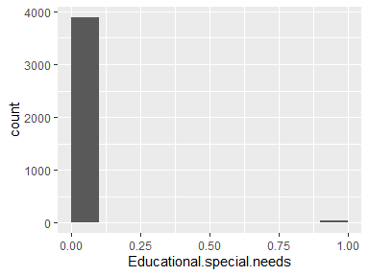

## Debtor

| Feature | Result |
| --- | --- |
| Variable type | integer |
| Number of missing obs. | 456 (10.31 %) |
| Number of unique values | 2 |
| Median | 0 |
| 1st and 3rd quartiles | 0; 0 |
| Min. and max. | 0; 1 |

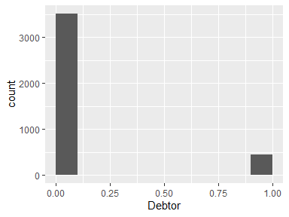

## Gender

| Feature | Result |
| --- | --- |
| Variable type | integer |
| Number of missing obs. | 441 (9.97 %) |
| Number of unique values | 2 |
| Median | 0 |
| 1st and 3rd quartiles | 0; 1 |
| Min. and max. | 0; 1 |

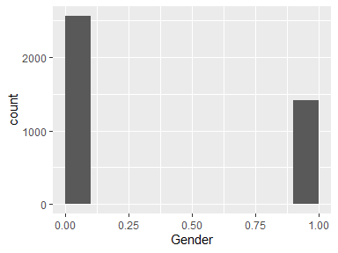

## Scholarship.holder

| Feature | Result |
| --- | --- |
| Variable type | integer |
| Number of missing obs. | 427 (9.65 %) |
| Number of unique values | 2 |
| Median | 0 |
| 1st and 3rd quartiles | 0; 0 |
| Min. and max. | 0; 1 |

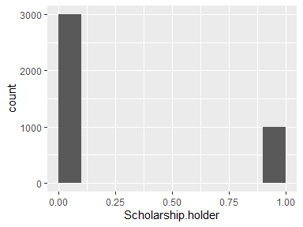

## Curricular.units.1st.sem..enrolled.

| Feature | Result |
| --- | --- |
| Variable type | integer |
| Number of missing obs. | 425 (9.61 %) |
| Number of unique values | 23 |
| Median | 6 |
| 1st and 3rd quartiles | 5; 7 |
| Min. and max. | 0; 26 |

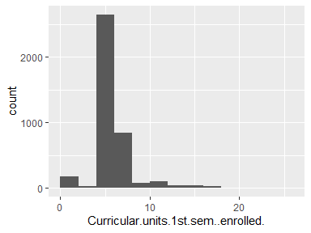

## Curricular.units.1st.sem..approved.

| Feature | Result |
| --- | --- |
| Variable type | integer |
| Number of missing obs. | 428 (9.67 %) |
| Number of unique values | 23 |
| Median | 5 |
| 1st and 3rd quartiles | 3; 6 |
| Min. and max. | 0; 26 |

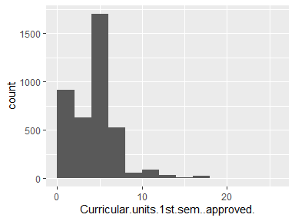

## Curricular.units.2nd.sem..enrolled.

| Feature | Result |
| --- | --- |
| Variable type | integer |
| Number of missing obs. | 479 (10.83 %) |
| Number of unique values | 22 |
| Median | 6 |
| 1st and 3rd quartiles | 5; 7 |
| Min. and max. | 0; 23 |

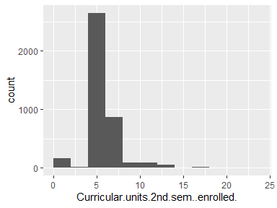

## Curricular.units.2nd.sem..approved.

| Feature | Result |
| --- | --- |
| Variable type | integer |
| Number of missing obs. | 435 (9.83 %) |
| Number of unique values | 20 |
| Median | 5 |
| 1st and 3rd quartiles | 2; 6 |
| Min. and max. | 0; 20 |

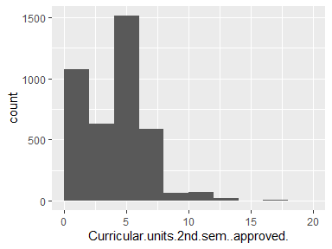

## Unemployment.rate

| Feature | Result |
| --- | --- |
| Variable type | numeric |
| Number of missing obs. | 430 (9.72 %) |
| Number of unique values | 10 |
| Median | 11.1 |
| 1st and 3rd quartiles | 9.4; 13.9 |
| Min. and max. | 7.6; 16.2 |

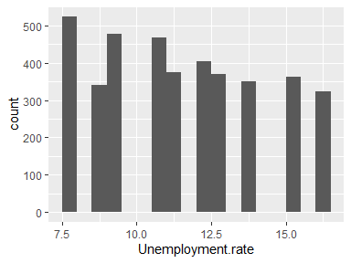

## Target

| Feature | Result |
| --- | --- |
| Variable type | character |
| Number of missing obs. | 0 (0 %) |
| Number of unique values | 3 |
| Mode | “Graduate” |

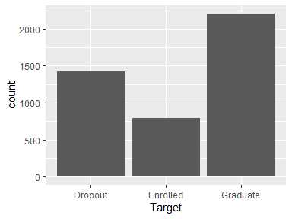

* Observed factor levels: "Dropout", "Enrolled", "Graduate".

Report generation information:

* Created by: davigo2411 (username: david).
* Report creation time: do. feb. 23 2025 21:38:10
* Report was run from directory: C:/Users/david/Documents/MD-QP-25
* dataMaid v1.4.1 [Pkg: 2021-10-08 from standard (@1.4.1)]
* R version 4.2.1 (2022-06-23 ucrt).
* Platform: x86_64-w64-mingw32/x64 (64-bit)(Windows 10 x64 (build 22631)).
* Function call: dataMaid::makeDataReport(data = dataset, mode = c("summarize", "visualize", "check"), smartNum = FALSE, file = "codebook.html", checks = list(character = "showAllFactorLevels", factor = "showAllFactorLevels", labelled = "showAllFactorLevels", haven_labelled = "showAllFactorLevels", numeric = NULL, integer = NULL, logical = NULL, Date = NULL), listChecks = FALSE, maxProbVals = Inf, codebook = TRUE, reportTitle = "Codebook for dataset")