1. Environment

1)Node(include NPM)

<https://nodejs.org/en/download>

2) Typescript

npm i --save-dev typescript

3)Visual studio code

<https://code.visualstudio.com/download>

2. Create application with typescript

<https://www.sencha.com/blog/how-to-create-react-app-typescript/>

npx create-react-app ts-app --template typescript

3. Create component

<https://felixgerschau.com/react-typescript-components/>

call web API to get data

<https://www.freecodecamp.org/news/how-to-consume-rest-apis-in-react/>

Develop Restful API with Node(optional) you could get data from json file directly

<https://robkendal.co.uk/blog/how-to-build-a-restful-node-js-api-server-using-json-files>

use ag-grid to display data

<https://www.ag-grid.com/react-data-grid/getting-started/>

Project

Start with one component to show medication data like screenshot below

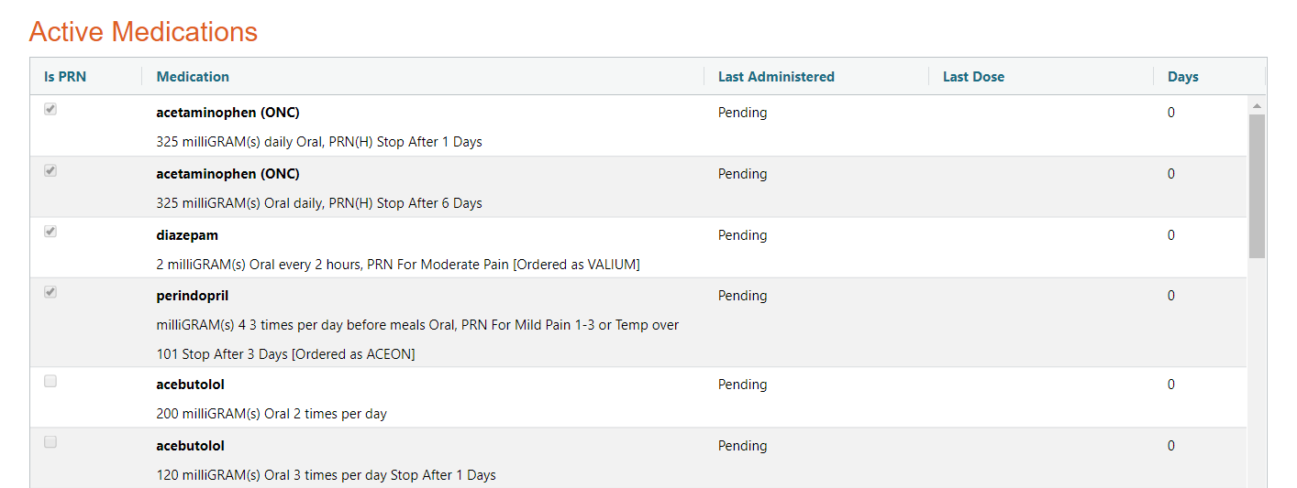

You can retrieve data from medicatin.json file.