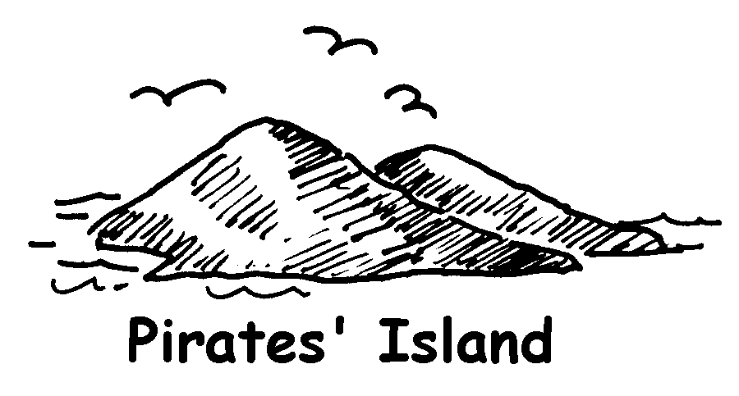 |  |  | 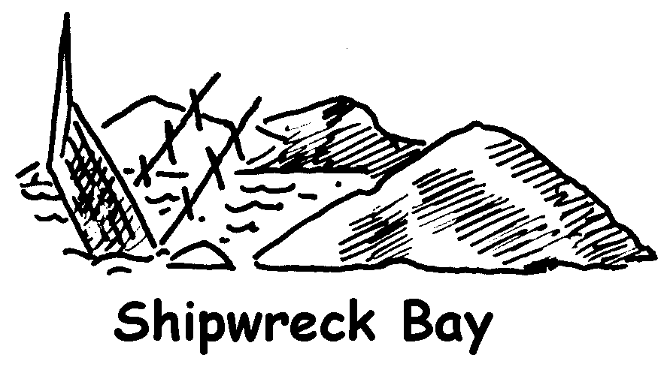
A → |  |  | A →
B → | 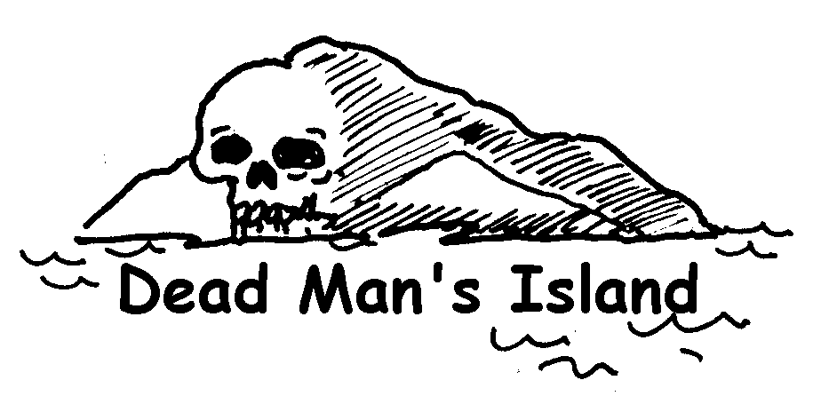 |  | B →

No ships sail from
Dead Man’s Island!

A → |  |  | A → | 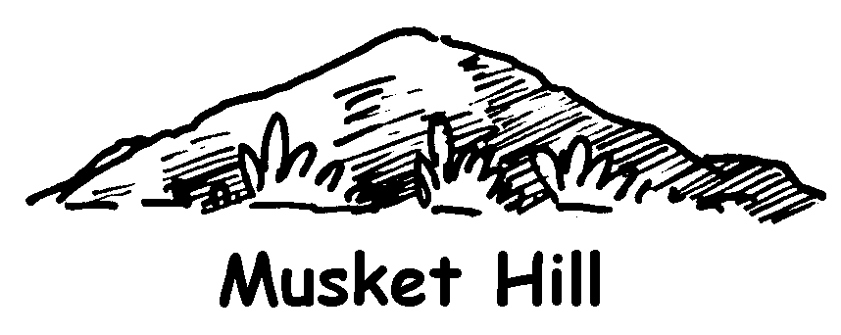
B → |  |  | B →

A → |  |  | A →
B → | 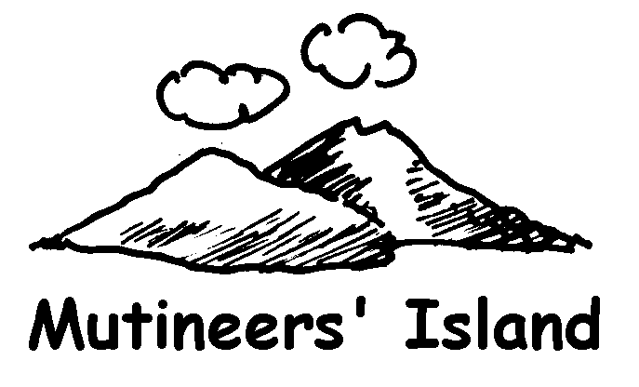 |  | B →

 |  |  | 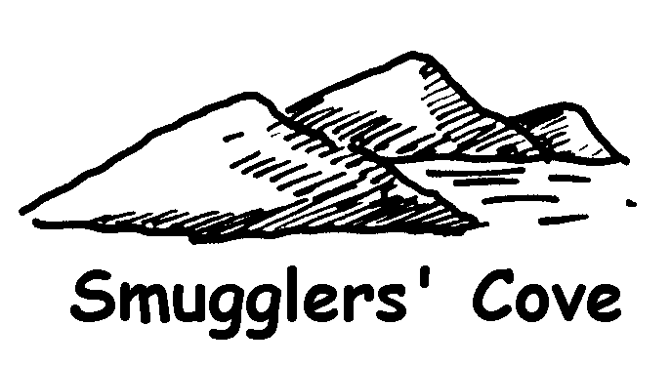
A → |  |  | A →
B → |  |  | B → | 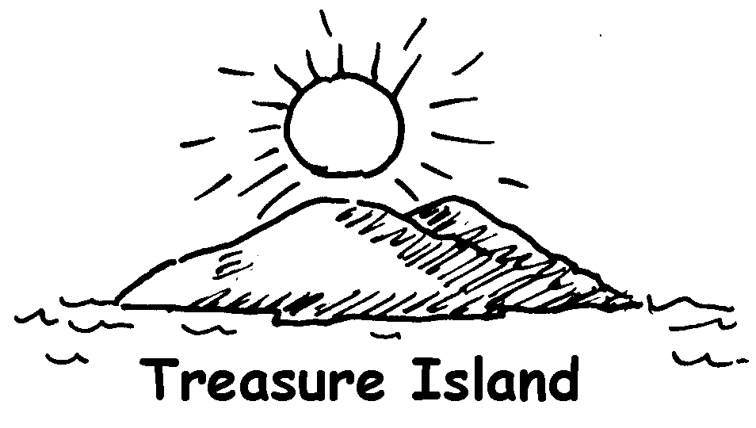

Congratulations!

