Nevada Builders Alliance Insurance Solutions, LLC
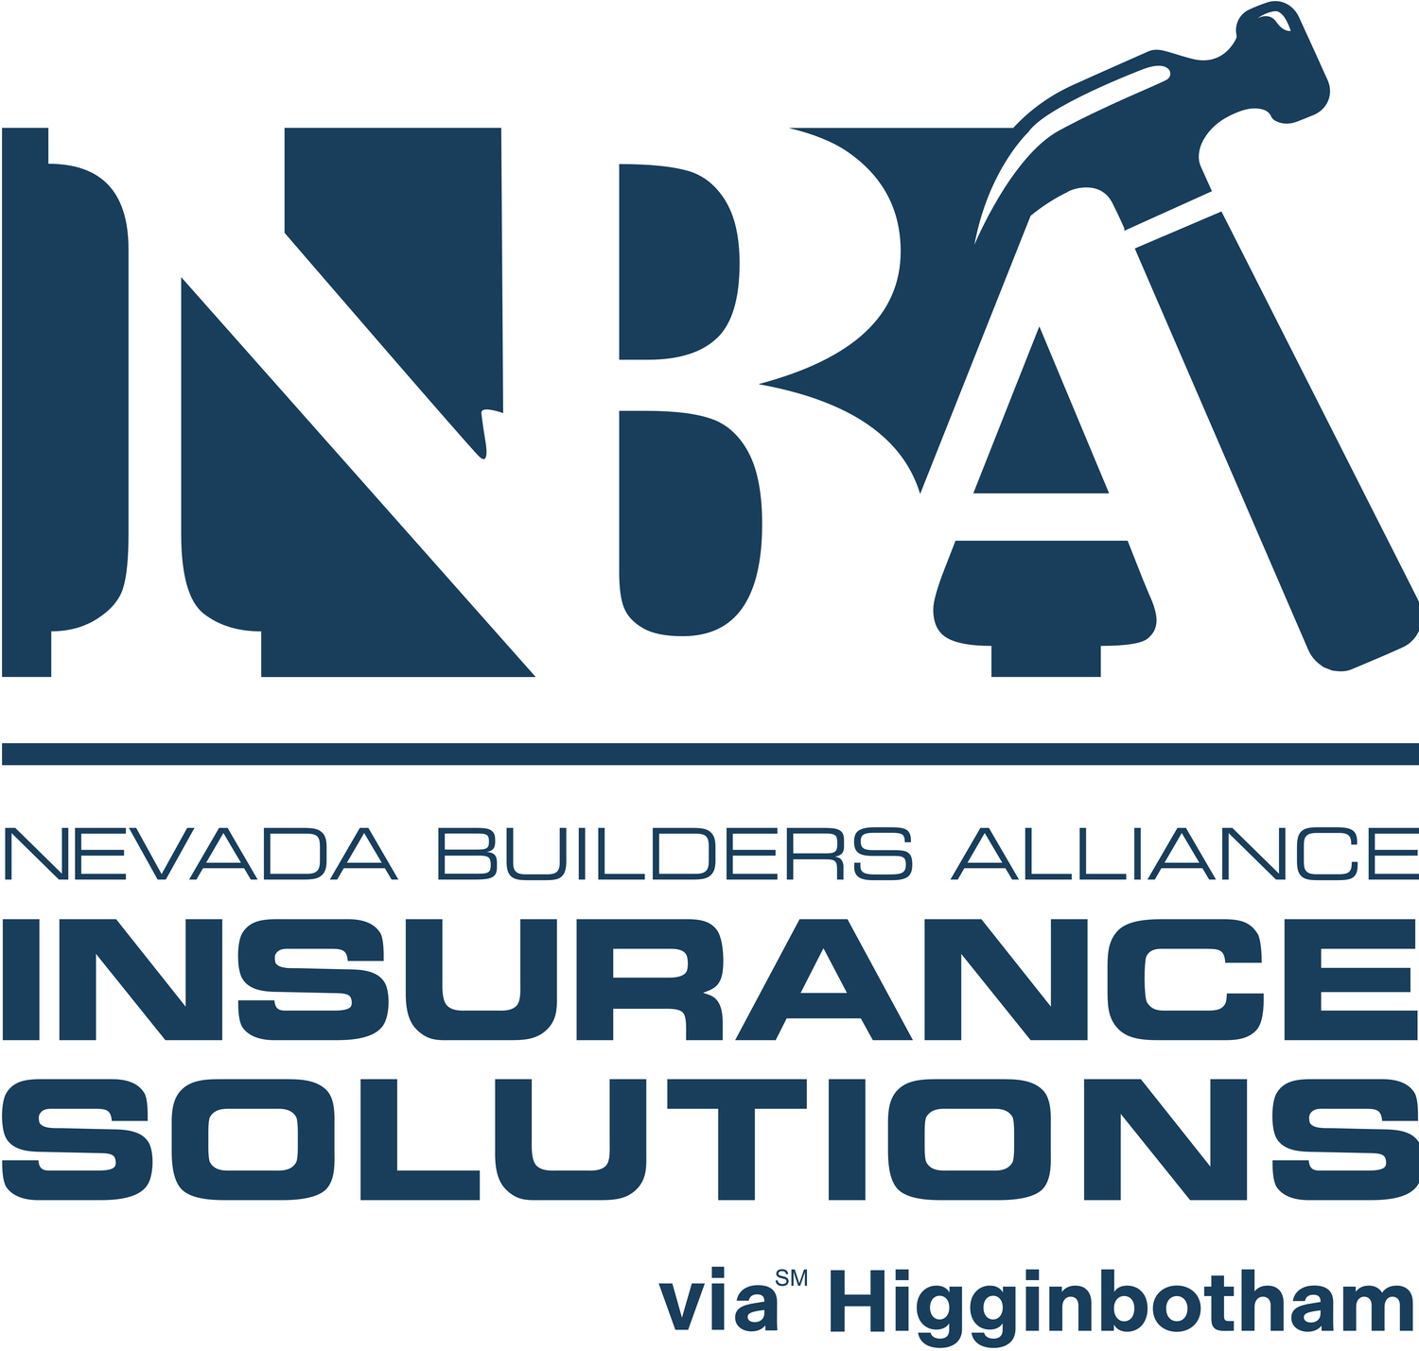
Workers’ Compensation
Insurance Proposal
Prepared exclusively for Nevada Builders Alliance members
Prepared For | Integrity Roofing
Policy Period | 05/28/2026 – 05/28/2027
Prepared By | Dianne Slater
Date | 05/27/2026
Program | Nevada Builders Alliance — NBAIS Member Program

About this proposal
On behalf of Nevada Builders Alliance Insurance Solutions (NBAIS), we are pleased to present this Workers’ Compensation Insurance proposal exclusively for members of the Nevada Builders Alliance (NBA). This proposal has been prepared specifically for your organization and reflects the competitive program rates and enhanced coverage options available through your NBA membership.
NBAIS was established to serve the unique risk management needs of Nevada’s construction industry — from residential and commercial builders to specialty trade contractors. As an NBA member, your organization has access to a Workers’ Compensation program designed around the realities of your trade, not a one-size-fits-all solution.
Program Highlights
• Exclusive NBA member pricing — competitive group rates unavailable in the open market
• Construction-class expertise — underwriting built around Nevada’s trades, not a one-size-fits-all program
• 24/7 nurse triage and incident reporting through Company Nurse
• Prescription benefits through Prodigy Care Services — First Fill card means $0 out of pocket at the pharmacy
• Claims management by CCMSI focused on fast return-to-work outcomes
• Safety and risk management services through Applied Risk Solutions, including OSHA 10/30 training
• Concierge medical scheduling and care coordination through Reli
• Program administration and member portal through Lusense
• Dedicated producer support — direct access to your NBAIS team throughout the policy period
What is included in this proposal
This proposal package contains the following for your review:
• Premium Summary — a summary of your proposed coverage terms and estimated premium.
• Workers’ Compensation Coverage Details — a detailed outline of the proposed coverage terms, limits, and exclusions applicable to your operation.
• Carrier Quote — the carrier quotation secured for your review, including the class code and payroll basis used to develop this quote. Please review for accuracy and notify us of any changes prior to binding.
• Coverage Recommendations — a comprehensive list of additional coverage lines for your consideration across commercial, personal, bond, employee benefits, and life planning categories.

Premium Summary
Your estimated cost for the coverage period 05/28/2026 – 05/28/2027. All figures are subject to final payroll audit.
Premium Summary
Estimated Manual Premium | $40,802.82
Experience Modification Rate | 0.95
Estimated Annual Premium | $38,762.68
Surplus Contribution (8%) | $3,101.01
Employers’ Liability Fee | $120.00
Total Estimated Cost | $41,983.69
Down Payment Due at Binding (25%): $10,495.92. | Balance payable online via secure payment link provided upon binding.
Surplus Contribution
As a self-insured group (SIG), BAWNSIG requires a surplus contribution in addition to the estimated premium. This contribution — calculated at 8% of the estimated premium — is a regulatory requirement for SIG participation in Nevada and supports the financial reserves of the group. It is not a fee retained by NBAIS or your producer.
What’s next
Review the Coverage Details on the following page, confirm payroll and class code accuracy, and contact your NBAIS producer to bind. Final premium will be reconciled at audit.

Policy Summary
Policy Information
Carrier | Builders Association of Western Nevada Self-Insured Group (BAWNSIG)
Program Manager | Lusense
Delivered By | Nevada Builders Alliance Insurance Solutions (NBAIS) via Higginbotham
Policy Period | 05/28/2026 – 05/28/2027
Coverage | Workers’ Compensation
States Covered | Nevada
Named Insured
Integrity Roofing
Coverage & Limits
Coverage | Limit
Part I — Workers’ Compensation | Statutory per State of Nevada
Part II — Employers’ Liability: Each Accident | $1,000,000
Part II — Employers’ Liability: Disease – Each Employee | $1,000,000
Part II — Employers’ Liability: Disease – Policy Limit | $1,000,000

Policy Details
Employee Classification Schedule
State | Class Code | Description | Est. Annual Payroll | Rate | Est. Premium
NV | 5551 | Roofing--All Kinds & Drivers | $275,000.00 | $11.694 | $32,158.50
NV | 5551 | Roofing – LLC Member/Manager | $36,000.00 | $11.694 | $4,209.84
NV | 5551 | Roofing-Foreman | $36,000.00 | $11.694 | $4,209.84
NV | 8742 | Outside Sales | $36,000.00 | $0.624 | $224.64
Total Estimated Manual Premium |  |  |  |  | $40,802.82
Self-Insured Group Disclosure
BAWNSIG is a Nevada-regulated self-insured group, not a traditional insurance carrier, and therefore does not carry an AM Best financial strength rating. BAWNSIG operates under the regulatory oversight of the Nevada Division of Industrial Relations and maintains reserves in accordance with state requirements. Members of NBAIS benefit from the group’s long-standing solvency and claims-paying history as a construction industry SIG in Nevada.

Next Steps & Member Authorization
To bind coverage or to discuss this proposal in further detail, please contact your NBAIS producer using the information below. Please review all coverage details carefully and confirm payroll and class code accuracy prior to binding, as final premium is subject to audit.
Your NBAIS Producer  Dianne Slater  Account Manager  877-888-4140  dslater@nbainsurancesolutions.com |  | NBAIS Program Office  Nevada Builders Alliance Insurance Solutions  603 South Carson Street, Carson City, NV 89701  nbainsurancesolutions.com
Member Authorization
By signing below, the undersigned acknowledges receipt of this Workers’ Compensation Insurance proposal and authorizes Nevada Builders Alliance Insurance Solutions (NBAIS) to bind coverage as described herein, effective on the policy period stated above. The undersigned confirms that the payroll, classification codes, and excluded persons listed in this proposal are accurate to the best of their knowledge and understands that final premium is subject to audit. The required initial down payment will be remitted online via the secure payment link provided upon binding.
By
Print Name
Title
Date
This proposal is not a binder or guarantee of coverage. All coverage is subject to underwriting approval, policy terms, conditions, and exclusions. Premium estimates are subject to final payroll audit. NBA Insurance Solutions, LLC is an insurance program administered on behalf of Nevada Builders Alliance members.

Coverage Recommendations
The following list identifies common coverage areas for your consideration. Please review with your NBAIS producer to determine which lines are recommended, currently insured, or not applicable to your operation.
Commercial Lines
Property Coverages  • Building / Business Personal Property  • Business Income & Extra Expense  • Equipment Breakdown  • Inland Marine / Contractors Equipment  • Installation Floater  • Builders Risk | Liability Coverages  • Commercial General Liability  • Products & Completed Operations  • Contractual Liability  • Personal & Advertising Injury
Cyber / Identity Theft / Crime  • Cyber Liability  • Data Breach / Privacy Liability  • Identity Theft Protection  • Commercial Crime / Employee Dishonesty | Automobile Coverage  • Commercial Auto Liability  • Physical Damage (Comp & Collision)  • Hired & Non-Owned Auto  • Motor Truck Cargo
Workers’ Compensation Coverages  • Workers’ Compensation — Statutory  • Employers’ Liability  • Stop Gap / Employers Liability (Monopolistic States) | Umbrella / Excess Liability  • Commercial Umbrella  • Excess Liability
Directors & Officers / EPL / Fiduciary  • Directors & Officers Liability  • Employment Practices Liability (EPLI)  • Fiduciary Liability | Errors & Omissions / Professional  • Professional Liability / E&O  • Contractors Professional Liability  • Design-Build Professional Liability

Coverage Recommendations (continued)
Commercial Lines (continued)
Wind / Hail, Earthquake, Flood  • Wind & Hail Coverage  • Earthquake Coverage  • Flood Coverage (NFIP or Private) | Foreign Coverages  • Foreign Voluntary Workers’ Compensation  • Foreign General Liability  • Foreign Auto  • Foreign Package Policy
Pollution Liability
• Contractors Pollution Liability
• Environmental Impairment Liability
• Site Pollution Legal Liability
Personal Lines
Personal Insurance  • Automobile  • Home / Homeowners  • Flood / Earthquake  • Personal Umbrella | • Farm & Ranch  • Watercraft / Recreational Vehicles  • Personal Articles Floater
Bond Recommendations
Surety & Bonds  • Contract Bond  • Court Bond  • Fidelity Bond  • Financial Institution Bond | • License & Permit Bond  • Probate Bond  • Public Official Bond  • Surety Bond

Employee Benefits Recommendations
Group benefits, life planning, and retirement plan services available through NBAIS for member consideration.
Group Benefits
Health & Welfare  • HR Solutions  • Group Medical  • Group Dental  • Vision  • Group Life and Accidental Death & Dismemberment (AD&D) | Disability & Supplemental  • Long Term Care  • Short Term Disability  • Section 125 Cafeteria Plans  • Individual Medical / Dental
Life Department
• Business Planning
• Estate Planning
Retirement Plan Solutions
• Qualified Plans
• Non-Qualified Plans

Discuss with your producer. Your NBAIS producer can help you assess which of these coverage lines apply to your operation and identify any potential gaps in your current insurance program.

