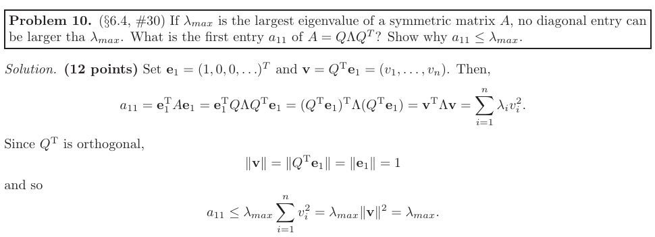
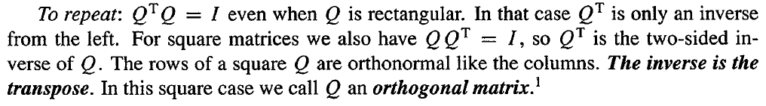
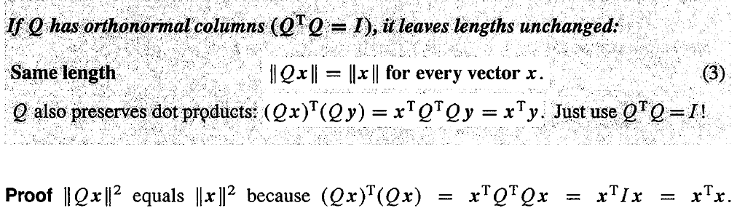
总是无法区分Q is square 和 Q is rectangular

