**Name______________________**

**Chapter 12 HW**

1. Which of the following compounds can be assigned to the spectra shown below?



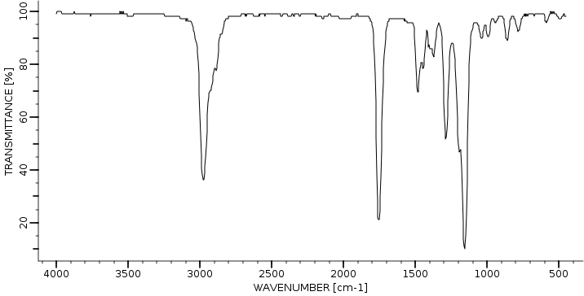

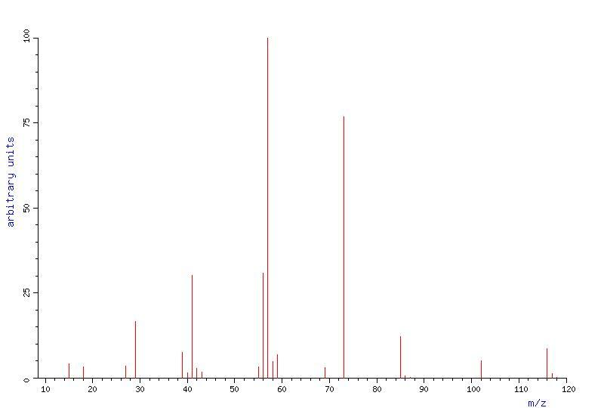

2. Two infrared spectra are shown. One is the spectrum of cyclohexane, and the other is the spectrum of cyclohexene. Identify them, and explain your answer

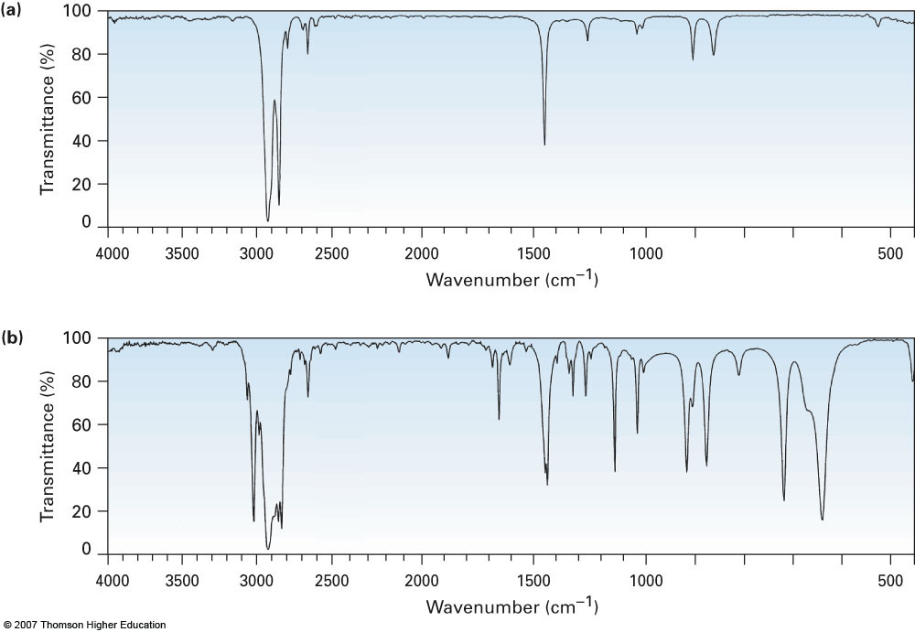

3. At what approximate positions might the following compounds show IR absorptions?

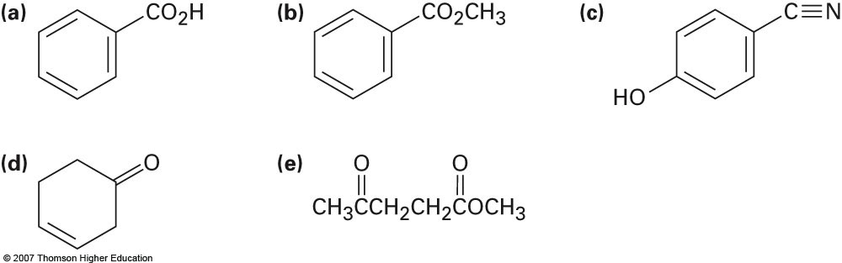

4. Assume you are carrying out the dehydration of 1-methylcyclohexanol to yield 1-methylcyclohexene. How could you use infrared spectroscopy to determine when the reaction is complete?

5. The mass spectrum and infrared spectrum of an unknown hydrocarbon are shown. Propose a structure that agrees with the spectra. There may be more than one correct answer.

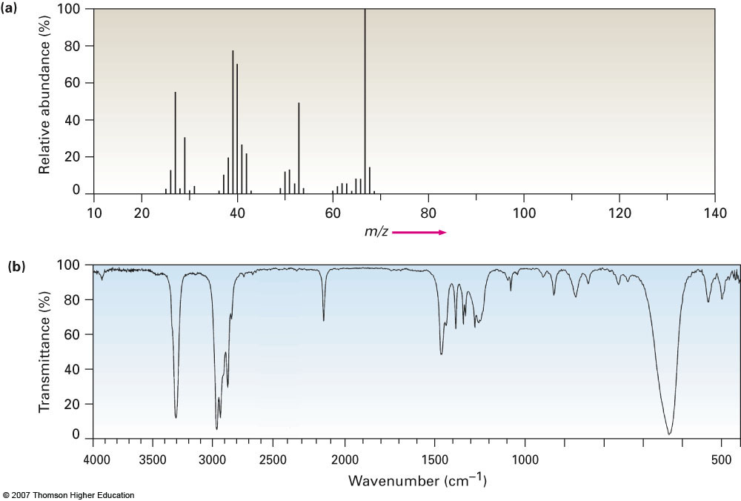

5. The mass spectrum and infrared spectrum of an unknown hydrocarbon are shown. Propose a structure that agrees with the spectra. There may be more than one correct answer.

