**Name_____________________**

**Homework Set #4**

1. What is the nucleophile in the following substitution reaction?  
  


2. Which of the following mechanistically depicts the protonation of *tert*-butyl alcohol by hydrogen bromide?  
  
  
  
  
  
  
  
 

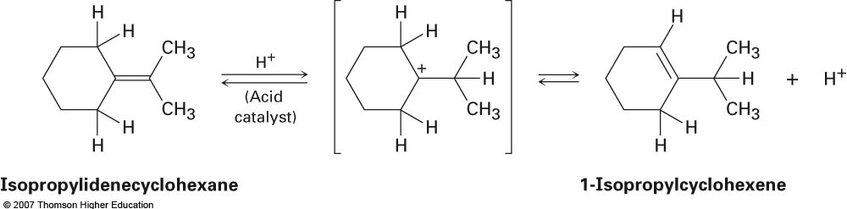 3. When isopropylidenecyclohexane is treated with strong acid at room temperature, isomerization occurs by the mechanism shown below to yield 1-isopropylcyclohexene:

At equilibrium, the product mixture contains about 30% isopropylidenecyclohexane and about 70% 1-isopropylcyclohexene.

a.) What is an approximate Keq for the reaction?

b.) Draw an energy diagram for the reaction.

4. 2-Chloro-2-methylpropane reacts with water in three steps to yield 2-methyl-2-propanol. Add curved arrows to the mechanism shown below to indicate electron movement in each step.

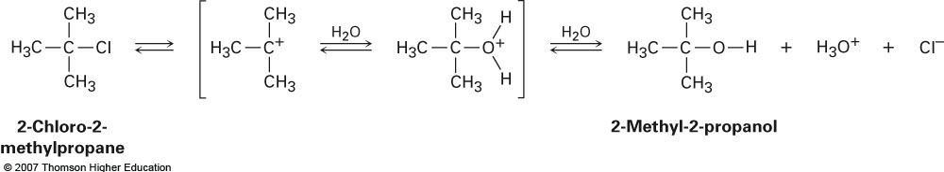

5. Refer to the diagram below for the following questions.

a.) Is ΔG° for the reaction positive or negative? Label it on the diagram.

b.) How many steps are involved in the reaction?

c.) How many transition states are there? Label them on the diagram.

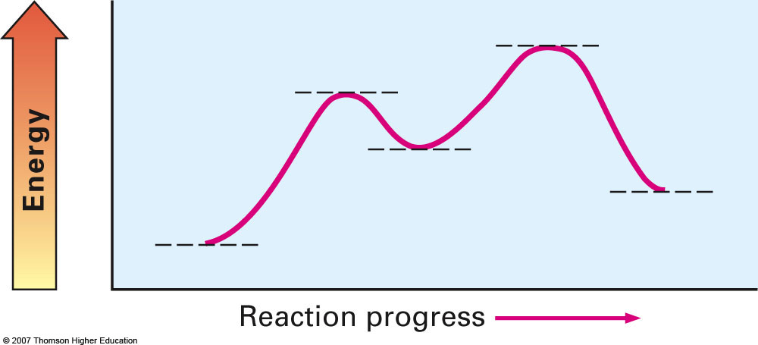

6. Identify the following reactions as additions, elminations, substitutions, or rearrangements:

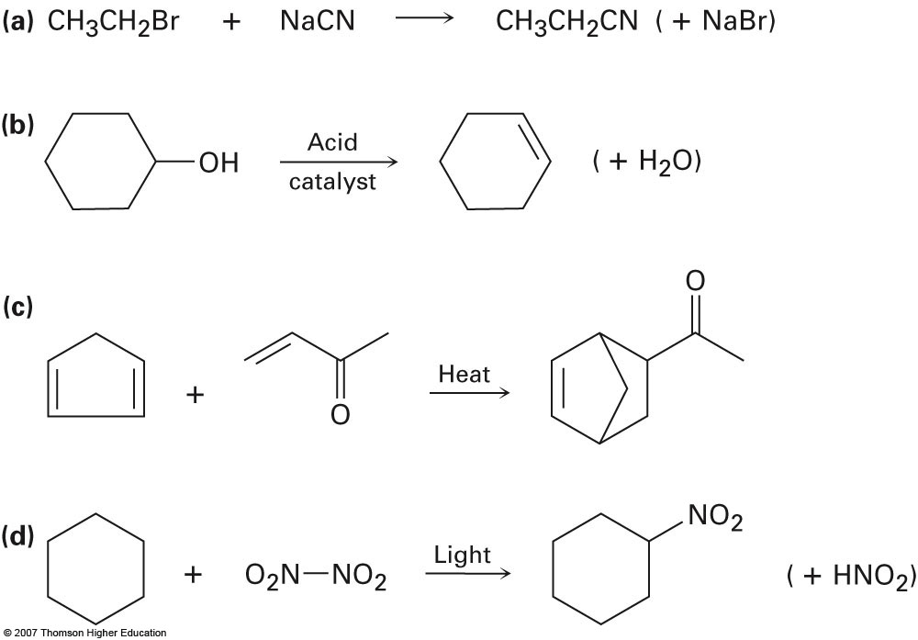

7. Draw an energy diagram for a two-step exergonic reaction whose second step is faster than its first step.

8. Follow the flow of electrons indicated by the curved arrows in each of the following reactions, and predict the products that follow:

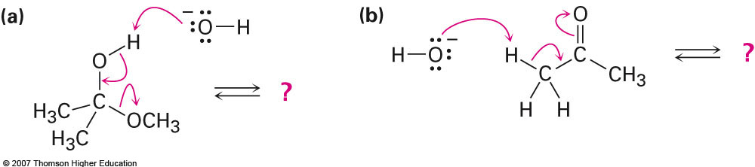

9. Predict the product(s) of each of the following biological reactions by interpreting the flow of electrons as indicated by the curved arrows:

