**Name______________________**

**HW Set #7**

1. The product(s) in the following reaction is(are)  
  
  

A. only *trans*-1-4-dimethylcyclohexane.

B. only *cis*-1-4-dimethylcyclohexane.

C. both *trans* and *cis*-1-4-dimethylcyclohexane.

D. methylcyclohexane.

2. What is(are) the product(s) of the following hydroboration-oxidation reaction?  
  
 

3. What is the IUPAC name of the following compound?  
  
  

4. Which of the following describes the orbital overlap of the C(1) - C(2) sigma bond of 1-butyne, shown below?  
  
  

A. sp-sp

B. sp2-sp2

C. sp3-sp3

D. 2p-2p

5. Which of the following gives only one organic product on ozonolysis? 

A. 2-hexene

B. 3-hexene

C. 2-heptene

D. 3-heptene

6. Predict the major product(s) in the reactions below.  
  
 

7. Which sequence of reactions works best in synthesizing *cis*-3-nonene?  
  
  

8. Draw the enol intermediate in the acid-catalyzed addition of water to propyne.  
  


9. Which reagent below would be used to convert 2-pentyne to *trans*-2-pentene? 

A. NaNH2, NH3

B. Li, NH3

C. H2, Lindlar Pd

D. H2O, HgSO4/H2SO4

10. Select the best method to carry out the following conversion.  
  
   
  


11. Identify compound Y.  
  
 

12. Terminal alkynes react with Br2 and water to yield bromo ketones. For example:

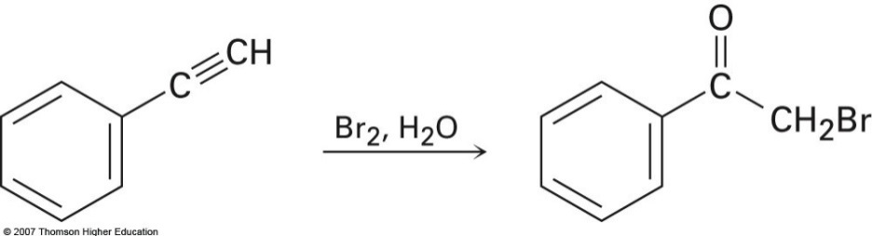

Propose a mechanism for the reaction. To what reaction of alkenes is the process

analogous?

13. What is the major product of the reaction shown below?  
  
